[Enter Post Title Here]

THE TARGET AUDIENCE ON MARKETING FUNDAMENTALS

Student name: Ileana Cristina Greurus
Student ID: 2122653
Module: LCBB4004

Table of Contents
1. Branding Strategy 3
2. Range of Nike: 4
3. Features of products: 6
4. Nike Prices: 7
5. Where can you have found Nike’s product (Place)? 8
6. Nike Promotion: 9
7. References 11

Marketing Fundamental

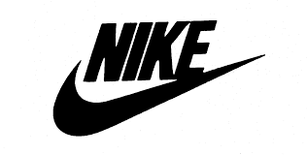
Nike Sports equipment, footwear, and gear that Nike manufactures for the sporting industry make its brand one of the most well-known around the world. Blue Ribbon Sports was first called Blue Ribbon Sports in 1964, then Nike in 1971, naming itself after the goddess of victory in Greek mythology. There are approximately 76,000 Nike employees spread across the world, which makes it one of the most valuable brands in the sports goods industry. Nike and Jordan Brand, which are subsidiaries of the company, market and distribute garments under the Nike name (DeLong, 2009). Reconditioning previously owned shoes so that they can be sold at a reduced price in 2021 is part of the firm's effort to reduce garbage production and fight climate change.

Branding Strategy

It has been decided that Nike will use an umbrella branding strategy for their company. A brand already established on the market uses this strategy to brand new products. Nike has used the iconic slogan "Just do it" for many years, and we're all familiar with it. Since several decades ago, Nike has steadily grown in popularity among customers because of its prominent athlete sponsorships and trademark swoosh emblem. It was their creative and insightful marketing strategies that helped place them on the map as a leading company, not only their iconic "Nike" logo. As one of the most popular companies at the time, Nike was more than its iconic logo. Branding is the key to Nike's brand strategy - creating a brand that is so powerful that it elicits zealous consumer loyalty from all over the world. In Nike's advertising, archetypes, especially the Hero narrative, are used as emotive branding strategies. Additionally, it does not require a lot of technical expertise. The firm must, however, present consumers with both genuine and relevant values for this approach to be successful. Marketing plans that are successful follow this pattern.

Range of Nike:

The Nike company manufactures a wide variety of athletic apparel for men, women, and children of all ages, including shoes, jerseys, shorts, and cleats, as well as cross training clothing, for sports such as basketball, football, track and field, tennis, American football, golf, and hockey (Um, 2021).
  - Nike footwear
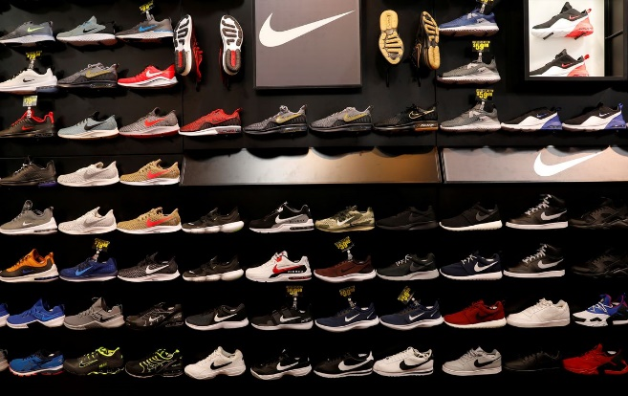
The NIKE Brand focuses its efforts on nine primary areas when it comes to launching new products: Running, NIKE Basketball, the Jordan Brand, Football (Soccer), Men's Training, Women's Training, Action Sports, Sportswear (our sports-inspired lifestyle items), and Golf. In the Men's Training category, we offer products that are used in baseball and American football. Additionally, to children's items, we also sell sports and leisure items for exercise, such as cricket, lacrosse, tennis, volleyball, wrestling, and walking. NIKE's sports footwear products are first and foremost designed to help athletes perform their best, regardless of whether they are worn for recreation or non-sporting activities. We place a high value on innovative ideas and high-quality construction when it comes to the design and production of our products. We expect that Sportswear, Running, and Jordan Brand will continue to lead our sales volume in the years to come.

  - Nike Sports equipment:
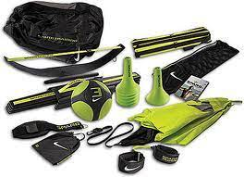
Aside from the categories of sports clothing, we offer various other items. The main marketing and distribution channels of these products are the same as the ones for our athletic footwear. As with our athletic footwear, our sports gear is designed primarily for athletic use and shows our dedication to innovation and quality workmanship. We offer both product categories in this way. Our current sales trends indicate that Sportswear, Men's Training, and Running will continue to be the top-selling clothing categories. Most of the time, we promote our footwear, clothes, and accessories as "collections" for similar purposes or grouped by category. As well as providing clothing with officially licensed team and league logos, we also offer clothing with our own logos.

  - Performance Accessories:
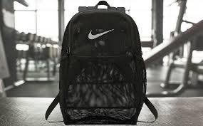
A range of performance equipment and accessories are available under the NIKE Brand, including bags, socks, sports balls, sunglasses, watches, digital devices, bats, gloves, protective equipment, and other equipment for sports. Additionally, we sell smaller quantities of plastic goods to other manufacturers through our wholly owned subsidiary Nike IHM, Inc

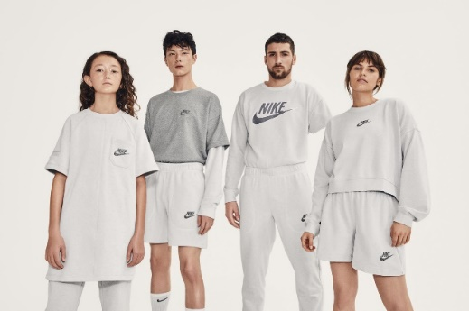

  - Nike Clothing Apparel:
Under the Nike Brand, performance products and accessories are available, including bats, gloves, protective equipment, sports balls, sunglasses, watches, and digital devices. Nike IHM, Inc., a wholly owned subsidiary of our company, also produces smaller quantities of plastic goods.

Features of products:
- High quality: Sneakers made by Nike are lightweight and durable at the same time. However, Nike sneakers are very lightweight despite their high level of comfort and flexibility. You can be confident that you will enjoy the advantages for a considerable time if you invest in quality Nike shoes made for your sport.
- Comfortable: Nike sneakers reduce the risk of foot injuries, which is one of the major factors contributing to the brand's success. These shoes have characteristics that will protect your feet when you engage in any kind of activity. It is less likely that you will suffer a serious foot injury if you wear shoes.
- Styles: Nike shoes come in a variety of styles. Sports shoes differ in their patterns and silhouettes. Various sports have different footwear requirements, which is due to the nature of the sport. Nike shoes should be selected according to the activity you will be performing when purchasing them. Running and walking sneakers are also available from Nike.
- Various uses: Most people who purchase Nike sneakers do not participate in any sports. Whenever they attend an event or take an informal trip, they wear their favourite pair of Nike sneakers. There are several reasons why Nike sports shoes are often considered to be among the best sports shoes on the market today.

Nike Prices:
Nike employs several different pricing schemes (2022). The following list provides them.
Value-Based Pricing Strategy of Nike
Based on customer perceptions of the items' value, Nike sets its prices according to value-based pricing. Sports gear, shoes, and equipment are priced according to the maximum price the customer is willing to pay. Nike's pricing strategy proved successful, because the corporation became aware of consumers' value and began generating profits.
  - Nike Price Leadership Strategy:
Nike does business in markets characterized by oligopoly, so this approach is right for the kind of market the company operates in. The sports goods manufacturing industry is an oligopolistic market, with Nike as a major player.
  - Premium Pricing Strategy of Nike:
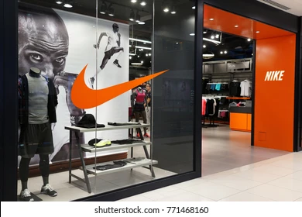
Because Nike's items are superior to those of their competitors, they implement a pricing strategy called premium pricing, which results in higher prices. In addition to the quality of the items being produced by the company, the founders and employees of the corporation understand the importance of the image that customers who wear Nike clothing will portray. Nike is uniquely identifiable to consumers when its unique items are marketed to them in the market. Also contributing to Nike's perceived value is its premium price strategy.
  - Nike Skimming Pricing Strategy:
A pricing strategy used by Nike to establish initially high prices for items with fresh designs that it introduces to the market is called "price skimming." Price skimming refers to the process of establishing high costs for expensive items, particularly limited-edition items. In this way, Nike aims to maximize profits by targeting clients who are ready to pay the asking price for the product and have shown interest in the product. There are also a couple of additional pricing models Nike employs, but they do not contribute to the overall number. Pricing methods such as penetration pricing, psychological pricing, and segmented pricing are examples of these methods.

Where can you have found Nike’s product (Place)?
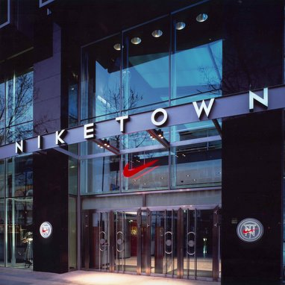
Sports goods companies can purchase, obtain, or distribute their wares to customers in a variety of places on the marketing mix. Through this 4P variable, Nike hopes to reach as many potential customers as possible. Athletic footwear, clothing, and equipment are distributed by the corporation through a large network.
Aside from the United States, Nike has over 1,000 retail outlets and offices in over forty-five countries. Most of Nike's products are available through retail locations since consumers prefer to try them on in a retail setting. Retail Nike stores are conveniently located in every city across the globe, making shopping for Nike products a breeze. As part of its retail strategy, Niketown is its retail outlet. Large establishments with four stores that offer a large selection of goods and services along with a luxurious shopping experience. A Niketown shop sells innovative and cutting-edge products at an upscale retail location.

As well as providing a customized booth, they provide service and a zone staffed by experts to assist you with your product choices. Consumers are treated with high regard during the shopping experience.

Nike Promotion:
Nike places a great deal of emphasis on advertisements featuring well-known athletes and celebrities when it comes to marketing its products. As well to using discount codes to encourage prospective customers to make purchases of Nike products, Nike uses other sales promotion techniques.

  - Mass customization:
Is it possible to design your own shoes? As a Nike fan, you can take advantage of this opportunity. The purpose of this marketing strategy is to attract customers.
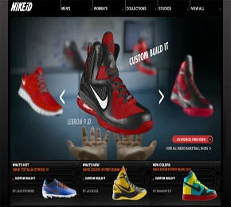
By combining mass customisation with modularity and efficiency of mass manufacturing, mass customization allows the individual customer's requirements to be incorporated into the products, making them inexpensive owing to economies of scale.
As a result of Nike's "mass customization" program, consumers can create their own products, which Nike then manufactures in large factories, combining the efficiency of traditional craft manufacturing with modern technology.
As part of its supply chain for sneakers, Nike uses a three-tiered, individually tailored approach. It takes a lot of skill to make a pair of shoes by hand.
Anyone can watch or purchase customized shoes from here: https://www.nike.com/nike-by-you

  - Celebrity endorsement:
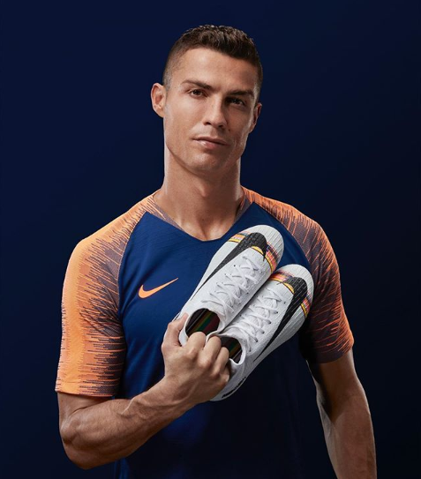
It is also widely known that Nike frequently uses celebrities as brand ambassadors. In the history of business and celebrity partnerships, Nike has partnered with Michael Jordan in one of the most beneficial partnerships. Jordan and Nike introduced the Air Jordan line of athletic shoes as a result of their successful relationship.
Strong brand identity and brand personality have been developed by Nike over the years. Asian firms, on the other hand, tend to use celebrity endorsements at the beginning stages of their brand-building process. An organization should consider three primary factors before partnering with a celebrity (Cole, 1996). Other promotional methods are also used by Nike.
Social Media: By using social media, Nike successfully communicates with its millions of customers and reaches new customers throughout the world. There are a number of social media accounts on multiple social networks, such as Facebook, Twitter, YouTube, and LinkedIn. Nike's new markets have been attracted by several social media campaigns.
Advertisement: Increasing brand recognition among prospective buyers is one of Nike's most effective marketing strategies. In recent years, Nike has produced a number of advertisements that have gained widespread recognition for their quality. As part of their advertising strategy, Nike collaborates with large corporations and endorses megastars and celebrities in order to expand their market. In the Nike Free Power to your feet television advertisement, players like Cristiano Ronaldo and Maria Sharapova joined Roger Federer on the pitch.
Public Relations: As a part of their marketing strategy, Nike uses public relations to reach out to prospective customers. Both consumers and the market are important to the company's management. An organization like this is eager to maintain a relationship with its clients and displays a pleasant and accessible demeanour toward them. As part of its customer care channel, Nike has integrated its public relations department.
Sponsorship: In addition to sponsoring multiple sporting events and elite athletes, Nike has gained global exposure through the sponsorship of several sporting events. As a direct engagement strategy, Nike sponsored numerous athletic events.
Direct Marketing: Direct marketing is used to expand Nike's advertising campaign. Using new items to attract customers and gain a competitive advantage over its competitors, the corporation exploits the market for its new products.

References
Cole, C., 1996. American Jordan: P.L.A.Y., Consensus, and Punishment. Sociology of Sport Journal, 13(4), pp.366-397.
DeLong, M., 2009. Innovation and Sustainability at Nike. Fashion Practice, 1(1), pp.109-113.
Ijbmer.com. 2022. [online] Available at: <https://www.ijbmer.com/docs/volumes/vol6issue3/ijbmer2015060302.pdf> [Accessed 29 July 2022].
Um, N., 2021. Korean Consumers’ Responses to Nike’s “Women’s Just Do It” Femvertising Campaign. Journal of Promotion Management, 28(5), pp.650-668.

