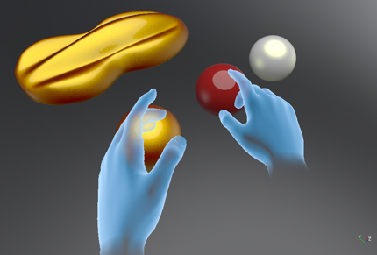

Identifying the impact of Affordance in Virtual Reality and its technological considerations.
  - Games design and critical analysis
Adam Head | Creative Computer Games Design – Level 6

Abstract
There are significant benefits in respect to using affordance based design when creating virtual reality video games and experiences. On the one hand, real world perceptions and affordances injected into a virtual experience can increase a user’s fundamental understanding of both a created environment and their place in it; making the medium more accessible to a wider audience and on the other hand, it can be argued that too much affordance can lead to an overbearing presence from the experiences creator; possibly giving users too much guidance and hand holding when using a medium that is widely used to encourage discovery on the users terms.
By using research and case studies of relevant virtual reality experiences, affordance theory and a consideration of future technologies; this paper aims to present a discussion that promotes the creation and transference of real world affordances into virtual reality video games and experiences. Psychological studies will also be referenced and cited in order to ensure a balanced, evidenced explanation of the reasons why affordance affects in-game immersion and how a lack thereof can lead to a serious disconnect in player-character identity. This report will also aim to improve upon already established theory regarding affordance in games design, while also providing an opportunity to showcase any possible shortfalls that could be presented or resolved by current/future technologies.

Aims
This paper will look to cover the impact of affordance in designing a virtual reality experience by:
- Identifying ways that different forms of Affordance can enrich the Virtual Reality experience and how a lack thereof can lead to confusion and loss of focus; causing a break in overall immersion.
- Exploring ways that Virtual Reality technology can develop further with Affordance in mind.
- Examining if too much Affordance based design can lead to more linear Virtual Reality experiences and a perception by players of “handholding”; also, to address the psychological implications of player representation on a physically interactive virtual plane.

Context
“Affordance describes all actions that are made physically possible by the properties of an object/environment. A bottle screw cap affords twisting. A hinged door affords pushing or pulling.”
[Dwivedi; 2017]
This report aims to explore how both design and technology can be further utilized to promote affordance in virtual reality experiences, in order to increase accessibility for the average user. Affordance based design in video games, for example, involves the creation of objects/interfaces that give the player a clear perception of what can be interacted with in a game environment and what cannot.
When affordances are implemented correctly, an objects function and usability should be clear to the user/player; while a lack of affordances can lead to the ambiguity of a player’s perception of a simulated reality by a lack of a clear focus as to the user’s role and abilities in the virtual environment. By reinforcing real world affordances, it can be argued that creators/developers are bringing virtual reality users closer to an uncanny depiction of the real world, with affordance being one of the main contributors to achieving this.

Literature Review
“When affordances are successfully employed in a design, it will seem inconceivable that the design could function or be used otherwise.”
[Lidwell, Holden, Butler; 2010.]
Research will be used in order to discuss the benefits of using an affordance-based model for design in the medium of virtual reality, whilst also considering the possible implications this could have on a players/user’s freedom, effectively instilling themes of linearity. Further discussions will also focus on addressing the possible psychological implications of virtual reality users’ representation in the game world and whether this affects a perception of what is interactable in a virtual environment with further considerations as to ways technology could be developed/utilized to accommodate this.

Case Study: Gibson’s Affordances

[Greeno, 1994]
"Gibson developed an interactionist view of perception and action that focused on information that is available in the environment."
[Greeno, 1994.]
When looking deeper into the triggers regarding a person’s perception of an affordance, James G. Greeno’s 1994 paper “Gibson’s Affordances” gives an insight into the place of the Gibsonian affordance in design. In 1966, J.J. Gibson created the term “Affordance” to describe the way an object or environment can be presented in such a way as to explain its function. It is also described that affordances are greatly effected by a user/viewers environment and that certain environments present constraints which can change the perception of how an object functions. [Greeno, 1994]
For example, as shown the diagram below:
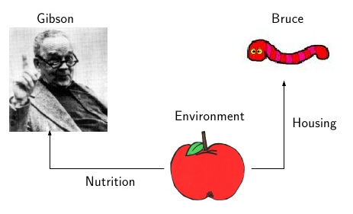
[Fig 1.- Diagram explaining concept of Gibson’s environmental affordances]
There are already preconceived opinions on what the human brain perceives as afforded in a conventional environment. For instance, as the diagram shows; both “Gibson” and “Bruce” are connected in sharing an environment (the apple) but each individual has an opposing preconceived notion as to the environment/objects afforded use. While “Gibson” can see the apple as a source of nutrition, “Bruce” sees it as housing, and this causes a conflict on how affordances should be implemented when designing on a medium that contorts reality. [Greeno, 1994.]
Video Games have the potential to completely juxtapose these associated behaviours and can lead to challenges as to how certain objects or environments are psychologically perceived upon their introduction to a player. This could similarly attest, for example; to the reason that the majority of Virtual Reality experiences give the player a human set of hands while in play; as a player’s preconceived affordances on interactive objects in a game’s environment are largely based around putting their reality into the same context as a virtual one. [Grabarczyk; Pokropski, 2016]
Creators of virtual reality experiences often follow the convention of giving their users/players a representation of a pair of human hands, mimicking their own, when interacting with a virtual environment. This creative decision is usually taken in order to give the user a familiar platform with which to interact with the virtual world around them, but when this conventional approach is swapped for a more conceptual or outlandish approach; it can have dire consequences on both overall player identity in the game world and the perception of affordances. This affects the way in which the user/player is able to apply these new, unconventional methods of interacting with objects around them when using their hands in virtual space. [Grabarczyk; Pokropski, 2016]
“Being virtually killed by a virtual laser in a virtual space is just as effective as the real thing, because you are as dead as you think you are.
[Adams; 1993]
There are deep, underlying issues to be considered when creating a virtual reality experience in which a non-anthropomorphic set of hands are given to the player to use. When the player is presented with an alien representation of their real world hands and/or limbs, it can lead to a complete breakdown in immersion of perception and often lead to a substantial disorientation of player identity; in which the users/players learned and perceived affordances taken from the outside the game world conflict with the confusion of what their new hands are capable of. When this is performed correctly (often by creating a more anthropomorphic style representation of the players in-game hands), it creates a psychological phenomenon known as the ‘Body Transfer Illusion’, in which the brain temporarily overrides baseline (top-down) knowledge of how one’s body and proportions are perceived, leading to a transfer of body ownership; creating an increased sense of presence and investment in the players physical existence in the virtual world. [Carr; England, 1995]
This new brand of phenomenology can also bring about another, more relevant psychological occurrence in the form of the I.V.R. (Immersive Virtual Reality) Arm Ownership illusion, originally stemming from the Rubber hand experiment conducted in 2004 by Ehrsson, Spence and Passingham. In the 2004 study, it was found that subjects would perceive a rubber hand as being their own if it met two strict criteria; that the rubber hand would have to resemble that of the subjects and would have to be of a similar proportion/distance from their body, simulating the natural length of the arm. IVR Arm Ownership is simply the rubber hand experiments results, put into the context of a modern, virtual reality based medium, giving scientific evidence and reasoning to the creative decision of giving virtual reality users/players an anthropomorphic set of hands with which to navigate the created environment around them. Because of this phenomenon, not only are the users’ perceptions of their physical identity transcended to a virtual plane, but so is their established, experience based knowledge of real world affordances and the bounds of which they can typically interact with objects and the world around them. [IJsselsteijn, de Kort, Haans; 2006]
“People who experience immersion tend to only consider choices that make sense in the context of the imaginary world.”
[Madigan; 2010]
The role of affordances in the creation of virtual reality experiences/games play a much larger role than that of more conventional platforms, as by nature the medium can be seen as the most immersive form of entertainment due to its use of all-encompassing screens and surround sound mounted on the head; causing the user to be completely isolated in the experience, with it momentarily becoming their primary form of reality and perception of the world around them. This depth of immersion experiences by the user/player, coupled with the aforementioned scientific evidence of I.V.R. Arm Ownership creates a situation in which the player must use their knowledge of experiences affordances to effectively learn how to use their hands again, in the same way a baby would play with building blocks; both using hands (controllers) that do not lend themselves to fine motor skills.

Case Study: Robo Recall

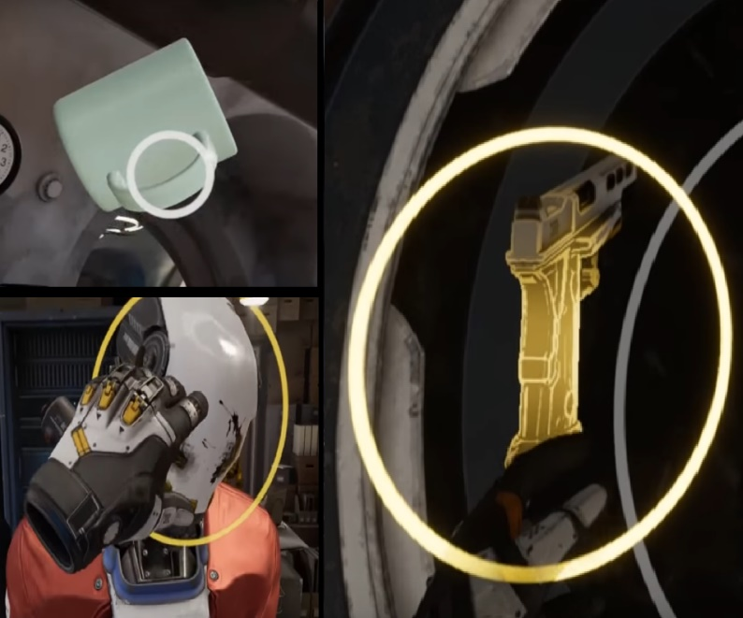
[Epic Games, 2017]
(Fig.2- Left Upper, Lower; Examples of circle prompts used to show interactable props to the player – Right; Example of the games method of highlighting weapons to show their proper function.) [Robo Recall; Epic Games, 2017.]

Robo Recall is a first-person shooter that uses virtual reality, created by Epic Games in 2017. This game uses an affordance-based design model to display interactable objects, weapons and characters to players through the use of circular visual prompts (e.g. Pictured above, Left; on objects such as a mug and also with the enemy characters detachable parts.) and highlight effects (e.g. pictured above, Right; handles of weapons glow when in proximity to the players hands.).
These design elements are introduced early in the game via. a “safe zone” that takes the form of a workshop environment; allowing the players to be introduced to the aforementioned affordances; thus, granting the player the knowledge of both the intended functions of the game’s mechanics/objects and the players perception of their place in this virtual world through understanding the bounds of what’s interactable. [Epic Games, 2017]
Robo Recall approaches affordances in a considered and balanced approach by showing these interactable props/objects in a clear, efficient and easily understandable way. It makes it clear to a user at a glance, what can be interacted with in the world around them. This approach of designing a virtual reality experience places player/user accessibility above all else by ensuring that from the very beginning of the game, players are shown a clear representation of their hands performing multiple real world actions (e.g. Grabbing, lifting, pointing etc.), as well as an early show of the players relative strength in this virtual world. This is introduced when the player enters the safe zone in the games introduction and is presented with an interactable model of one of the titular Robots (the enemies the player will eventually face upon leaving the introduction area) along with a circular prompt that appears over the models arms or head when the users hands enter into their close proximity (As shown in above image; Right).
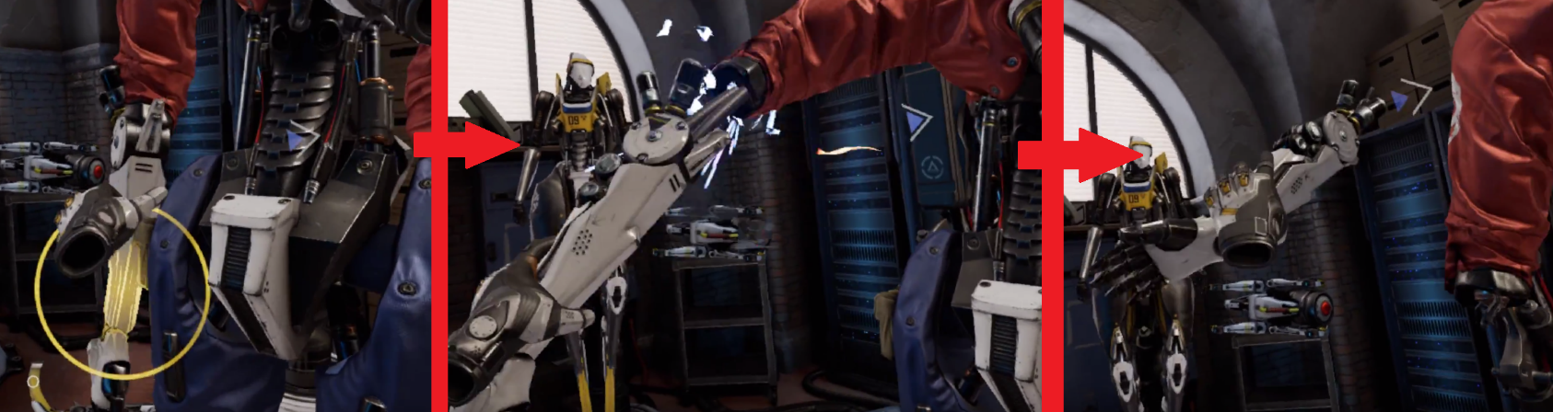
The player is then given instructions on how to interact with the individual pieces of the model, showing that they react in a different way to that of a typical prop or asset and teaching the player this new affordance for interacting with an outlandish, fantastical object in a way familiar to them in a situation/experience that is only possible in a virtual world.
[Fig.3- Transition showing Player dismantling Robot; Robo Recall.]
Upon grabbing the a select body part of the Robot character, the player is then able to dismantle and disconnect the object by pulling on it with a certain amount of force for a certain distance; the amount of force needed from the player is indicated by using both sound and visual effects. As the player pulls the Robots limbs further away from the torso/disconnect point an rising audio cue sounds, giving a representation of the force the player is exerting on the machinery; as well as visual cues in the form of sparks of electricity and wires disconnecting which are used in order to give the player further reinforcement of their relative strength not only in the virtual world around them, but in relation to the enemies they will be facing further into the game.
Robo Recall was created as an exclusive release for the ‘Oculus’ virtual reality system, making use of its ergonomically designed ‘touch’ controllers made specifically for the purpose of giving players the ability to physically interact with a virtual environment. The ‘Touch controllers’ are built with affordance in mind; this is evident by the inclusion of an inner button, often utilised to grab objects in the game world. The action of the user closing a hand around the controller in order to activate a grabbing mechanic in a virtual environment is comparable to reality; as this familiar action of interacting with object reinforces any affordances presented to the player/user by using real world experiences and thus reinforcing the illusion of I.V.R Arm Ownership; further blurring the barrier between the virtual and the real when interacting with in-game objects. [IJsselsteijn, de Kort, Haans; 2006]

Case Study: Skyrim and Porting to Virtual Reality.

[Bethesda Softworks, 2017]
There is a growing trend in the games industry among the major studios to adapt select games from their catalogue to function using the virtual reality platform with accompanying touch controllers as a form of modernizing/updating already released content. While this practice has been commonplace in the games industry since its inception (porting games between different consoles/platforms that use the same control schemes), the act of adapting an already established medium to a completely new method of interacting with the game world (i.e. virtual reality, with physical presence) is not without its risks. An example of this can be seen in the Bethesda Softworks’ 2017 “VR Re-release” of the critically acclaimed “Skyrim”.
Skyrim is a single player, open world role playing game, originally released in 2011 by Bethesda Softworks in which the player plays the role of the “Dragonborn”; a powerful warrior in a fantasy themed world. Skyrim grants the player the ability to travel and traverse to any named or visible location using the standard analog stick/keyboard based movement system thus immersing the player in an expansive world; in which the player is rewarded for navigating over large distances in order to complete quests.
While the Virtual Reality version of Skyrim released in 2017 retained the exact same landscape and areas that require traversal, the games new adaptation received some critical responses from fans of the franchise directed at the introduction of a teleportation system; which allows the virtual reality user to travel, scale and perambulate large distances in relation to the player that would usually have required considerable effort and time to achieve. Though this is largely a criticism regarding the base gameplay of the experience, there are also questionable choices in the games design; greatly hampering the accessibility to both new players of the game itself and first time users of virtual reality peripherals. Upon entering the playable game world for the first time in virtual reality, the player is introduced to the same opening sequence as that of the original 2011 release with one major difference, in that the user can freely use their hands to interact with the in-game objects around them.
In a direct contrast to Robo Recall which uses a system of highlight effects and prompts to display the potential for interaction with objects in the game; Skyrim gives no such visible cues pointing towards affordances within the game; showing only an on-screen message indicating the player when an object is able to be sored in their inventory, instantaneously. This lack of direction and education of what is interactable in an environment leads to a disconnect between a player and the environments/props around them, causing the user to actively question which of the vast library of objects in the game can be influenced by the virtual representation of their hands.

“Interactive Virtual Reality environments, when effective, reignite our youthful interest in finding the affordances available to us.”
[Powell; 2017]
This juxtaposition of player expectation and interactability only achieves the alienation of first time explorers of the franchise as the knowledge of interacting with the environment comes inherently from having played the original 2011 version of the game. This example further reinforces the idea of Gibson’s work on affordances being applied to video games and more specifically, Virtual reality. With the concept that all perceptions of affordances are completely based on the individual’s experiences and environment; much akin to the earlier shown diagram (Fig.1) detailing the hypothetical environmental effects on affordances using both a mand and a worm’s perception of an apple. Except in this situation, Skyrim VR takes the place of the apple; with both a player of the original 2011 release of Skyrim and a completely new inductee to the franchise.
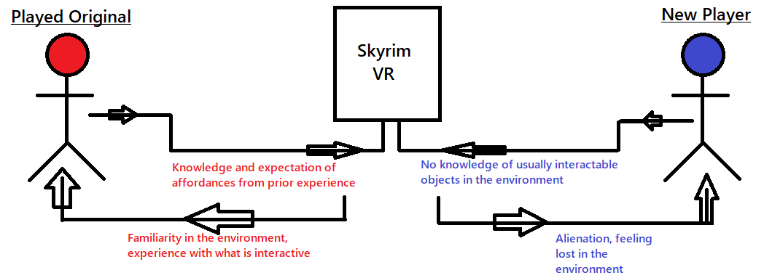
[Fig 4.- Diagram detailing the application of Gibson’s environmental affordances in relation to Skyrim VR.]
The above diagram shows the figure representing a player of the original version taking and using their knowledge and experience of what was originally interactable and applying these to the new virtual reality platform, allowing for a seamless, accessible and familiar experience in which there are no distractions or time spent learning what their in-game hands or objects in the game are capable of. Whereas the other figure in the diagram representing a completely new player to Skyrim in general (let alone the virtual reality adaptation) is shown to be given a completely opposite experience with the majority of their time in the virtual world spent having to question the bounds of their interactive presence in the game environment. This is again in a direct contrast to that of Robo Recall which introduces and educated new players to its in-game affordances via. An introductory phase that adapts the players real world knowledge of affordances to the virtual one in a matter of minutes.
When looking at the portrayal of affordances in Skyrim VR it is clear that there are lessons to be learnt by the video games industry with regards to porting released games to a virtual reality environment. The act of porting such games by nature is itself a flawed practice as with both the general gameplay and overall design treating virtual reality as more of an afterthought than a completely separate, new method of play. This supports the argument that virtual reality games should be made with the fact that they are for virtual reality systems first and foremost in order to ensure an accurate representation of affordances; creating the optimum usability and accessibility for the player/user.
“Virtual Reality is going to be defined by the content that is designed explicitly for virtual reality.”
[Luckey; 2017]

Case Study: Future Technologies.
While ground is being broken with regards to the representation of affordances in video games (e.g. the aforementioned ‘Robo Recall’), there is still progress that could be made with regards to peripherals to aid in presenting the player with a closer experience to the real world when interacting with objects. For example, full finger touch controllers are now in development, that will allow players/users to utilize all four fingers and thumb independently in Virtual Reality environments, which would allow for full articulation of the hand and fingers in game. This full, uninhibited movement of the hand would create a more immersive experience for the user/player, allowing a completely accurate portrayal of real world dexterity on a virtual plane, bringing the user closer to a completely accessible experience.
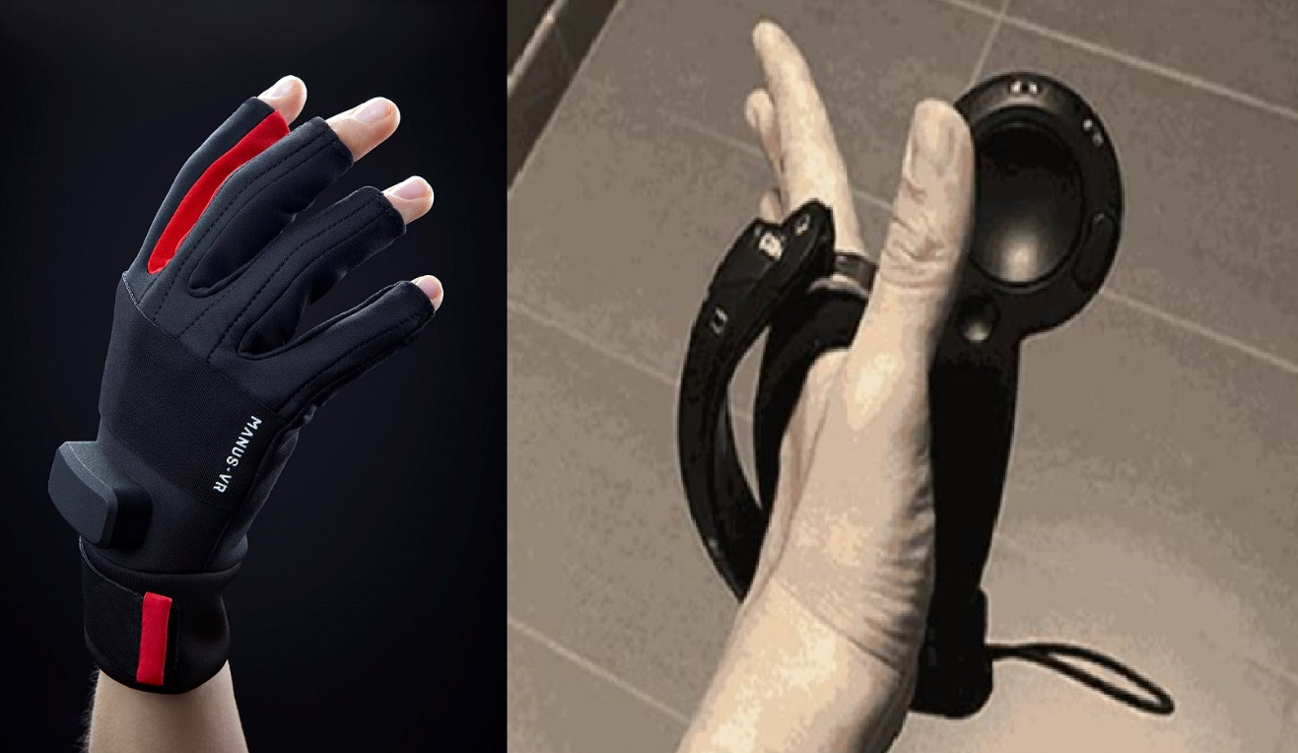
While this increase in usability would be greatly beneficial for the players’ overall experience when using virtual reality, issues arise regarding the work of the developer as an increase in player hand/finger freedom leads to virtual reality games designers effectively having to go back to the drawing board when creating experiences, as retaining the usual, conventional method of ‘object snapping’ while also granting the player the freedom of full finger dexterity could have a pernicious effect on the perception of interactable affordances in a virtual environment. This means that instead of using a system in which objects ‘snap’ to the developers desired orientation; interactable props would instead need to be created in such a way that would make not only their interactability and use clear at first glance, but also the correct, afforded way with which they are held in the real world.
(Fig.5-Left; The ‘Manus VR’ Glove Controller – Right; Steam’s “Knuckle” Controller.) [Manus VR, Valve; 2017.]
With the arrival of these new controllers/peripherals for virtual reality users, the progress towards the I.V.R. Arm Ownership illusion becoming an even more commonplace, widespread phenomenon increases; with the human hand and fingers being almost perfectly replicated in the virtual world, as opposed to the current hardware available in which (via. The use of the Oculus Touch and Vive Controllers) only basic, grabbing movements are available with purely gross motor skill movements performed by the player/user. This promotes the players perception of their in-game limbs/hands being a projection of their own, allowing them to transcend finer knowledge of experienced affordances into the game world in a far more fluid and efficient way with the additional use of their fingers. The inherent psychological evidence between supports the possibilities for taking the players’ hands presence further with the use of glove-like controllers that have no external pieces/apparatus, such as the ‘Manus’ system or Valve’s ‘Steam Knuckles’. [IJsselsteijn, de Kort, Haans; 2006]
The “Manus VR Glove” allows for wireless, full finger/hand tracking in virtual reality environments; also providing haptic feedback upon touching an in-game object with your virtual fingers. This haptic response from the interaction of touching physical objects is further bridging the gap in terms of immersion, bringing simulation closer to reality by emulating not only the act of interacting/grabbing in-game objects, but also giving the player/user a physical response when doing so. While ‘Manus’ are developing a glove style controller that covers the whole hand, the ‘Steam Knuckles’ controller currently in development by ‘Valve’ is creating a combination between the familiarity of conventional virtual reality controllers with the freedom of full finger and thumb articulation. The ‘Steam Knuckles’ employ a design similar to that of the Oculus Touch controllers, by using a wide sensor bar that instead of being positioned at the forefront of the controller; wraps around the back of the players hand that detects finger movements and articulation.
While controllers are rapidly moving into the future, there are also technological advancements being made with the head mounted virtual reality equipment itself. In January 2019, HTC revealed the Vive Pro Eye at the CES technology convention in Las Vegas. The HTC Vive Pro Eye features many of the same features of the original Vive head mounted display, with updated high definition cameras/lenses, 3D spatial audio and the new, much anticipated addition of eye tracking. With eye tracking capabilities, the Vive Pro Eye is able to fully adapt to the current position of the players eyes, influencing the scene around them and effectively acting as a new form of controller in the virtual environment. This addition of eye tracking and its impact on player presence in the respective created environments further pushes the boundaries of perception of reality, making the need for realistic affordances a much more pressing issue; with the camera controlled by the players eyes adding a completely new dimension to the appearance of otherwise static/planar objects in the game-world.
With the combination of both fully articulated, wireless controllers allowing for player hand/finger movement and advanced head mounted displays adapting to include both higher definition screens and active eye tracking; the players presence has greatly increased both mentally and physically in the virtual reality world. These technological breakthroughs will also have vast implications in terms of the psychological evidence provided earlier in the essay, as when a far greater, more accurate representation of the players anatomy is portrayed in the virtual world, the more immersive the experiences becomes; possibly creating a new form of the results scene in the “rubber hand experiment” in which not only are the players virtual hands believed to be their own but also their in-game eyes/vision.
“Virtual reality is the representation of possible worlds and possible selves, with the aim of making them appear as real as possible”
[Thomas Metzinger]

Practical Considerations and Conclusion
When considering the place of affordances in virtual reality experiences, this critical analysis has compiled evidence and formed arguments identifying examples of both positive and negative practices that have been employed in an effort to grant the user/player improved usability when interacting with virtual reality environments. By analyzing the contrasting examples of Robo Recall and Skyrim VR, a considered argument has been formed for the inclusion of both visual effects and on-screen cues in order to guide the player/user in interacting with the in=game objects in the virtual world around them. Although this overbearing presence of the developers could also be seen as “hand holding”’ instilling themes of linearity in the experience, removing any form of player based discovery. In retrospect, when a virtual reality video game experiences utilises no such form of guidance to the player as seen in Skyrim VR; it can lead to an alienation of new users and create the feeling of being lost in the environment with no instruction on how or what to interact with. There needs to be work done in order to achieve a middle ground between both polarizing experiences, with the elements of player based discovery retained alongside a gameplay and design model that promotes usability for all.
While progression can be made in relation to the overall design practices of virtual reality experiences, it is the technology itself that will ultimately dictate the future of this growing medium. With rapid advancements being made in player hand controllers in the form of recent and upcoming releases of both the “Manus VR Glove” and “Steam Knuckles”; there is a greater emphasis on not only the players mental immersion/place in the virtual world, but their physical one; bridging the gap between realities closer to an almost uncanny level. With these advancements also come new constraints with which to create such virtual environments, that would allow the newly equipped players/users to be able to fully utilise this new hardware in order to get the most realistic depiction of real world affordances possible.
With virtual reality technology also moving into the realms of uncanny depictions of reality by using new methods such as eye tracking, brain scans and heart monitors; it is important for creators of any virtual environment to remember the theory behind affordances proposed by thinkers like Gibson and Nielsen to truly incorporate real world experiences with objects to a simulated plane by paying attention to showcasing not only what to interact with, but how.

Bibliography
Awad, M., Ferguson, S. and Craig, C. (2014). Designing games for older adults: an affordance based approach. 2014 IEEE 3nd International Conference on Serious Games and Applications for Health (SeGAH). [online] Available at: https://core.ac.uk/download/pdf/30620469.pdf [Accessed 11 Oct. 2018].
Flügge, A. and Schulz, H. (2018). Affordances. [online] Slideshare.net. Available at: https://www.slideshare.net/cijat/affordances-presentation [Accessed 12 Oct. 2018].
Greeno, J. (1994). Gibson's affordances. Psychological Review, [online] 101(2), pp.336-342. Available at: http://ftp.idiap.ch/pub/courses/EE-700/material/31-10-2012/gibsonAffordances.pdf [Accessed 13 Oct. 2018].
Norman, D. (1999). Affordance, conventions, and design. interactions, [online] 6(3), pp.38-43. Available at: http://edithlaw.ca/cs449/2018/files/norman99.pdf [Accessed 11 Oct. 2018].
Robo Recall. (2017). Epic Games.
William Lidwell, K. (2012). Universal Principles of Design Revised and Updated: 125 Ways to Enhance Usability, Influence Perception, Increase Appeal, Make Better Design Decisions, and Teach through Design
Adams, D. (1993). Mostly harmless. New York: Ballantine Books.
Carr, K. and England, R. (1995). Simulated and virtual realities: elements of perception. London: Taylor & Francis.
Chemero, A. (2003). An Outline of a Theory of Affordances. Ecological Psychology, 15(2), pp.181-195.
Dickey, M. (2003). Teaching in 3D: Pedagogical Affordances and Constraints of 3D Virtual Worlds for Synchronous Distance Learning. Distance Education, [online] 24(1), pp.105-121. Available at: https://www.tandfonline.com/doi/abs/10.1080/01587910303047 [Accessed 14 Nov. 2018].
Fictum, C. (2017). VR UX. [S.l.]: Casey Fictum.
Grabarczyk, P. and Pokropski, M. (2016). Perception of Affordances and Experience of Presence in Virtual Reality. AVANT. [online] Available at: http://avant.edu.pl/wp-content/uploads/GrabarczykPokropski-Perception_VR-1.pdf [Accessed 18 Nov. 2018].
Jonasdottir, H. (2018). Innovation in Game Development: IT Enablement and Affordances on Kickstarter. The Computer Games Journal.
Moloney, J., Spehar, B., Globa, A. and Wang, R. (2018). The affordance of virtual reality to enable the sensory representation of multi-dimensional data for immersive analytics: from experience to insight. Journal of Big Data, 5(1).
Powell, L. (2017). Gibsonian Affordances as Applied to Interactivity in VR. [online] Medium. Available at: https://medium.com/vr-first/gibsonian-affordances-as-applied-to-interactivity-in-vr-52099752a69a?fbclid=IwAR1SNeXK59gac25jl9Rwz6JrE7ziKF4Z406VnhJUsNvMriHp8pJ-dQLCXy8 [Accessed 7 Nov. 2018].
Regia-Corte, T., Marchal, M., Cirio, G. and Lécuyer, A. (2012). Perceiving affordances in virtual reality: influence of person and environmental properties in perception of standing on virtual grounds. Virtual Reality, 17(1), pp.17-28.
Shin, D. (2017). The role of affordance in the experience of virtual reality learning: Technological and affective affordances in virtual reality. Telematics and Informatics, 34(8), pp.1826-1836.
Turchet, L. (2015). Designing presence for real locomotion in immersive virtual environments: an affordance-based experiential approach. Virtual Reality, 19(3-4), pp.277-290.
Adolph, K, Eppler, MA & Gibson, EJ 1993, Development of perception of affordances. in C Rovee-Collier & LP Lipsett (eds), Advances in infancy research. vol. 8, Ablex Publishers, Norwood, NJ, pp. 51-98.
HEFT, H. (1989). Affordances and the Body: An Intentional Analysis of Gibson's Ecological Approach to Visual Perception. Journal for the Theory of Social Behaviour, 19(1), pp.1-30.
Jones, K. (2003). What Is an Affordance?. Ecological Psychology, 15(2), pp.107-114.
Vive.com. (2019). The New VIVE Pro. [online] Available at: https://www.vive.com/uk/pro-eye/ [Accessed 11 Jan. 2019].

List of Images
Fig.1: Diagram explaining concept of Gibson’s environmental affordances.
Fig.2: Examples of Affordance Based Visual Effects; Robo Recall
Fig.3: Transition showing Player dismantling Robot; Robo Recall.
Fig 4: Diagram detailing the application of Gibson’s environmental affordances in relation to Skyrim VR.
Fig 5: Image of Manus VR Glove (Left) and Steam Knuckles Controller (Right).

