University of Wales Trinity Saint David
Wales Institute of Science and Art


Electronic Circuits Testing and Applications
Electrical Control Systems
ACHA4010

Sami Naas
2203564

02/04/2023
Contents
1 Task 1 1
1.1 A 1
1.2 B 1
1.3 c (i) 1
1.4 c (ii) 1
1.5 c (iii) 1
1.6 c (iv) 1
1.7 d 1
1.8 e 2
1.9 f 2
1.10 g 2
2 Task 2 3
2.1 Scope Time Division Calculations 3
2.2 Function Generator output sine wave 3
2.3 Unsmoothed Rectifier Wave 4
2.4 Smoothed Rectifier Wave 4
2.5 Drop in Voltage Question 5
2.6 Rectifiers use in Automotive applications Question. 5
2.7 Probing Question 5
3 Task 3 6
3.1 Scope Time Division Calculations 6
3.2 Capacitor charge and discharge wave marked at correct points. 6
3.3 Basic Capacitor Calculations 7
3.4 Capacitor discharge table 7
3.5 Gradient Plot and calculations 8
3.6 Inaccuracies Question 8
4 References 10

Task 1

A
$$R=\frac{0.6}{0.6}=1.2Ω$$

B
$$0.5A-0.3A=0.2A$$
$$\frac{0.2A}{2}=0.1A$$

c (i)
$$P=I^{2}R$$
$$R=\frac{P}{I^{2}}=\frac{0.9}{{0.3}^{2}}=10Ω$$

c (ii)
$$v=\frac{p}{I}=\frac{0.9J}{0.3A}=3v$$
$$R=\frac{3v}{0.1A}=30Ω$$
$$B=30Ω$$
$$C=30Ω$$

c (iii)
A,B and C are all at 3V as they are resistors in parallel

c (iv)
$$5v-3v=2v$$
$$D+E=2v$$
$$E=0.6v \left(voltage drop for a diode\right)$$
$$2v-0.6v=1.4v$$
$$\frac{1.4v}{0.5I}=2.8Ω$$
$$D voltage=1.4v$$
$$D resistance=2.8Ω$$

d
$$0.5÷4=0.125=I at r_{1}$$
lost volts= Ir
$$2=0.125×r_{1}$$

$\frac{2}{0.125}=16Ω$ (Internal resistance)
$\frac{1}{16}+\frac{1}{16}+\frac{1}{16}+\frac{1}{16}=\frac{1}{0.25}=4Ω$(Total resistance)

e
$$0.5×6=3v at F$$

f
A, B,C= $\frac{1}{10}+\frac{1}{30}+\frac{1}{30}=6Ω$
D=2.8Ω
E=1.2Ω
F=6Ω
R internal=4Ω
R battery= $\frac{v}{I}=\frac{12}{0.5}=24Ω$
Total= 43Ω

g

$$ε=I\left(R+r\right)$$
$$0.5\left(43+4\right)=23.5v$$

Task 2

Scope Time Division Calculations
Using a 10Hz sine wave signal from the function generator we can calculate the time division to see one full period.
$$\frac{1}{f}=t$$
$$\frac{1}{10}=0.1 seconds$$
  - seconds in mS= 100mS
oscilloscope was set to 50mS per division so it would need 2 full divisions to make up 1 full period. This is proven in figure 1 which shows the output signal from the function generator.

Function Generator output sine wave

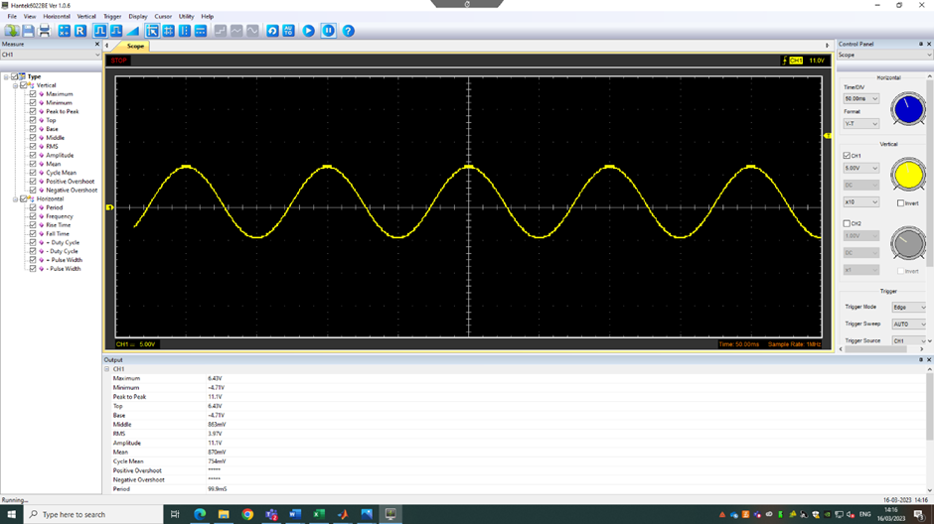
This graph shows the signal outputted by the function generator when set to 10Hz. It outputs a sine wave with a peak to peak voltage of 11.1v
Maximum= 6.43v
Minimum= -4.75v
Peak to peak= 11.1v
Time period= 99.9mS

Unsmoothed Rectifier Wave
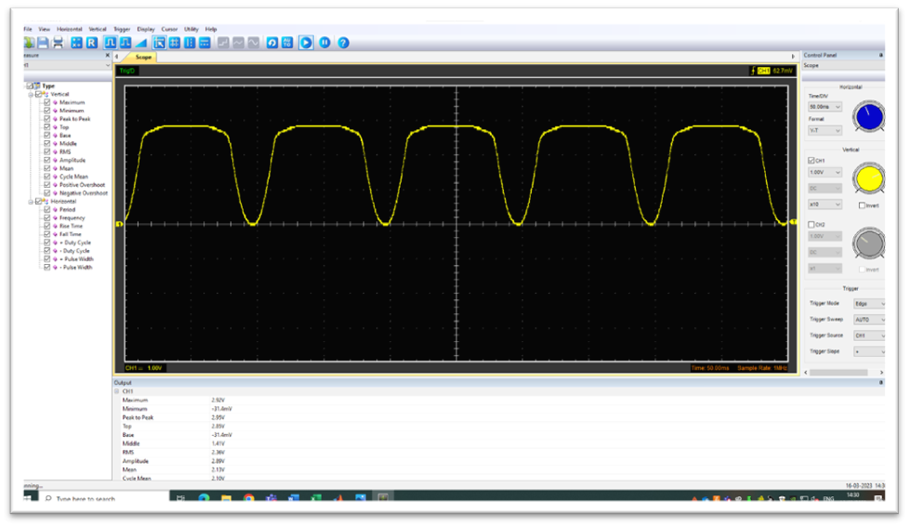
This wave shows the signal outputted by the rectifier. The AC signal form the function generator is converted to DC. This causes the rectifiers signal to go from 0 to its maximum and back to 0 without going negative as the diodes are able to filter it out.
Maximum= 2.92v
Minimum=-31.4 mV
Peak to peak= 3.95v

Smoothed Rectifier Wave
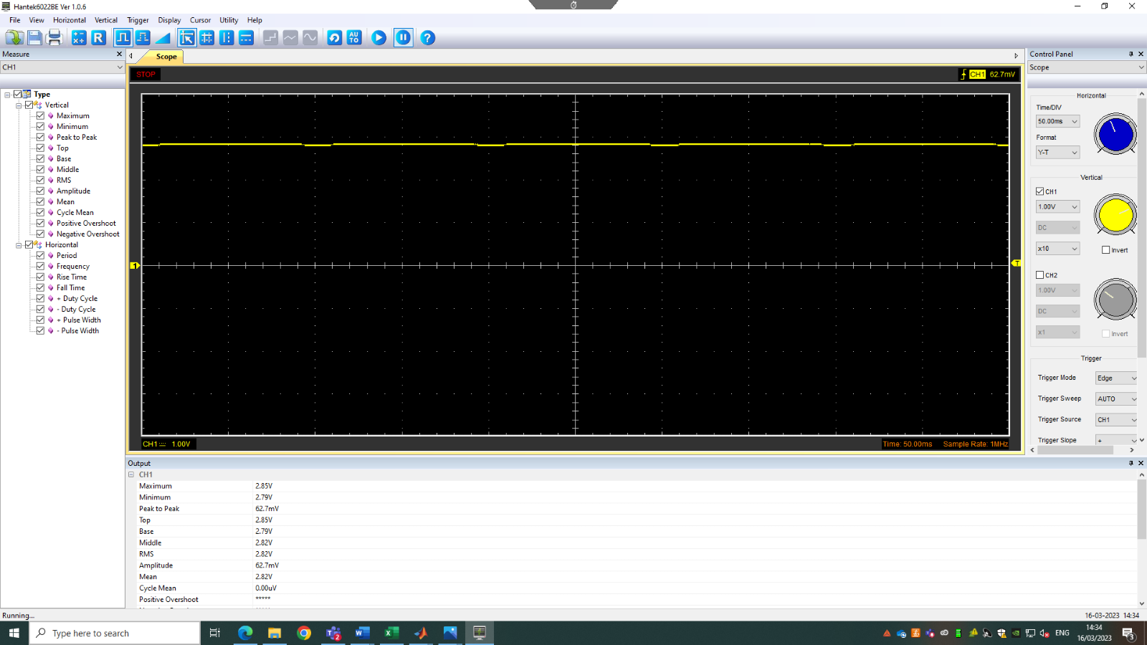
This wave shows the signal generated by the rectifier when a capacitor is added. As the rectifier has converted the AC signal to DC it is able to rapidly charge and discharge the capacitor. As the capacitor is in parallel with the LED where the probe was placed the signal becomes constant as the capacitor is able to power the LED when the rectifiers voltage drops as the capacitor discharges

Drop in Voltage Question
When the sine wave is put through the full bridge rectifier the electros flow through 4 diodes. All diodes have a voltage drop of around 0.6 volts. This will cause the circuit to lose 2.4 volts over the diodes. this is known as the threshold voltage which shows the amount of voltage needed to make a diode work and for electrons to flow through it.

Rectifiers use in Automotive applications Question.
The main use for rectifiers in the automotive industry is converting the AC current from the alternator into DC current to charge the battery. Typically there are 6 diodes on the rectifier that is connected to the alternator.( technobazz.com,2022)

Probing Question
When measuring the output of the function generator and the full bridge rectifier it had to be done separately as it could not be done using the 2 different channels. This is due to having a 2 grounds to measure the outputs which can cause a ground loop or short circuit. A ground loop happens when there are multiple paths for the current to flow. This can cause a voltage differences between the ground points causing a interface between signals making it hard for the oscilloscope to read the signals for the different channel. A short circuits can cause damage to the circuit due to the potential difference between the ground points.
To be able to measure two points simultaneously special equipment can be used. for example using differential amplifier which is able to amplify the potential difference between 2 points but able to supress any common voltage which would corrupt the signal(AnalogueDevices,2022).

Task 3

Scope Time Division Calculations
The function generator was set to 5Hz and outputting a square wave.
Using this we can work out the number of divisions needed to display 1 full period.
$$\frac{1}{f}=t$$
$$\frac{1}{5}=0.2 seconds$$
0.2seconds= 200ms
50ms per division therefore 4 divisions are needed.

Capacitor charge and discharge wave marked at correct points.
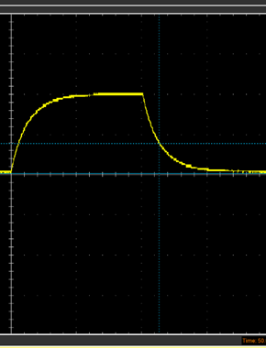
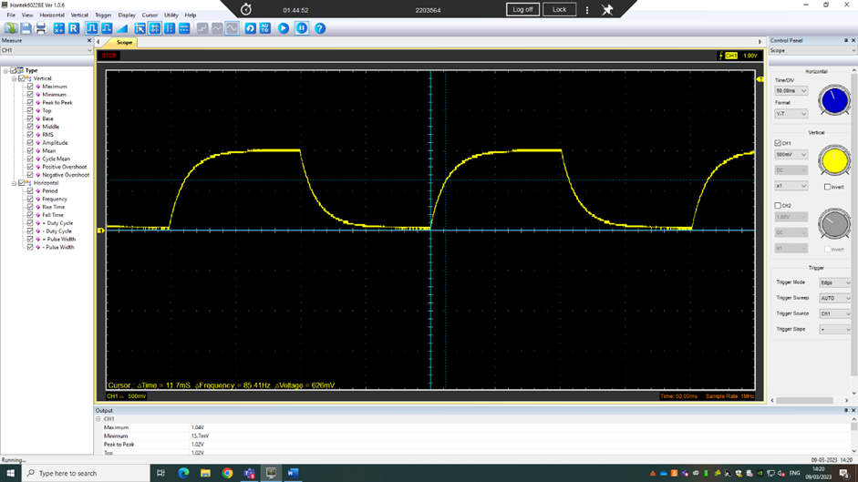
Line shows the τ (time constant) which is equal to the time to charge the capacitor by 67%
Line shows the time constant which is equal to the capacitor discharging by 37%

Basic Capacitor Calculations

Resister used= 1k Ω
Capacitor used= 4.7 $μF$

$$R×C=time constant$$
$$\left(1{×10}^{3}\right)×\left(4.7×{10}^{-6}\right)=4.7×10^{-3}$$
Time constant= $4.7×10^{-3}$

Capacitor discharge table
Using the log of the voltage allows for a straight line to be plotted in which the gradient will allow us the work out the capacitance of the capacitor

Gradient Plot and calculations

Gradient= -0.1853
$$grad=\frac{1}{-RC}$$
$$RC=time constant RC=\frac{1}{-grad}$$
$$RC=\frac{1}{0.1853}$$
$$time constant=5.4$$
$$\frac{5.4}{1×10^{6}}=5.4×10^{-6} or 5.4 μf$$

The calculated capacitance % error

$$\frac{5.4μf-4.7uf}{4.7μf}×100=14.89\%$$

Inaccuracies Question
the calculated capacitance from the test is$5.4μf$which give as % error of 14.89% which shows there are inaccuracies in the experiment. There could be several reasons why there are inaccuracies, the first of which is the temperature of the components. As the temperature increases in the capacitor or other components used in the test the values measured can change. In the capacitor as temperature rises the capacitors capacitance can change which will result in different charge and discharge characteristics(TAIYO YUDEN,2022). In addition to this as the capacitor is charged and discharge over time it causes the capacitor to ware down over time. This would cause a smaller peak voltage in the charging graph. In addition to this the equipment used to measure the capacitor will have their own resistances and inaccuracies which will cause variations in the results.

References
Differential amplifier (2022) Definition of Differential Amplifier | Analog Devices. Available at: https://www.analog.com/en/design-center/glossary/differential-amplifier.html (Accessed: April 1, 2023).
haris13501 (2022) What is car alternator rectifier full information 2023, Techno Bazz. Available at: https://technobazz.com/what-is-car-alternator-rectifier/ (Accessed: March 28, 2023).
Q&A corner : Answer (2022) Does capacitance of ceramic capacitors change by temperature? / What are capacitance temperature characteristics in capacitors?｜Q&A Corner | TAIYO YUDEN CO., LTD. Available at: https://www.yuden.co.jp/eu/product/support/faq/q009.html (Accessed: April 1, 2023).

