MOVING AWAY
FROM
TRADITIONAL EDUCATION

Outdoor Education and Learning

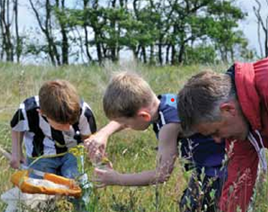
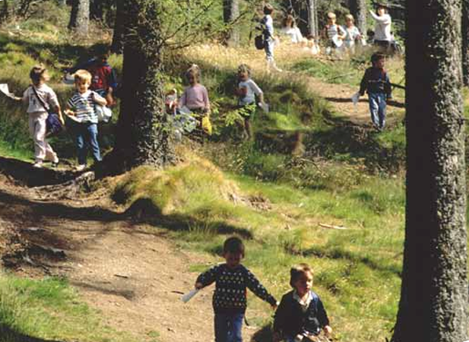
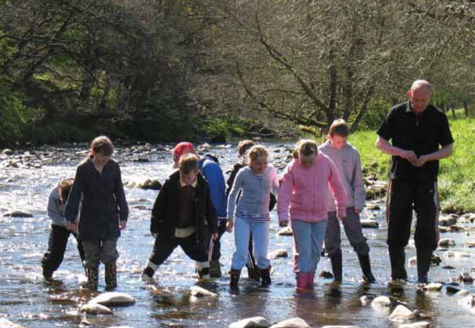
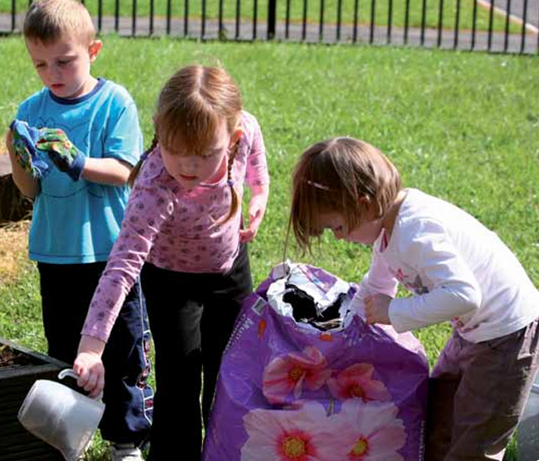

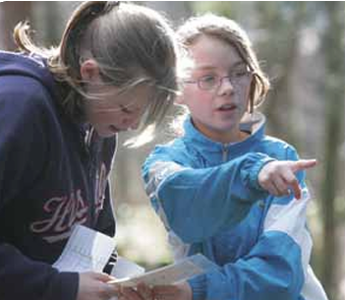

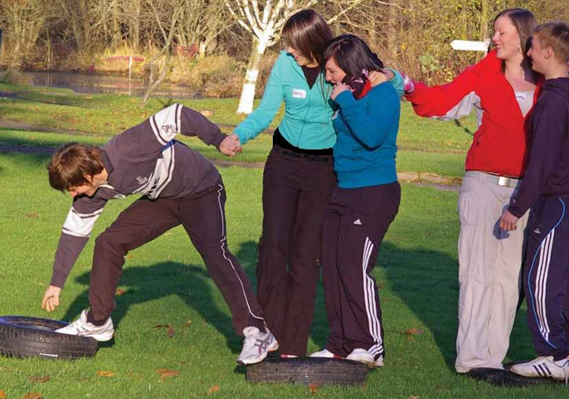

Images Credited to
Learning & Teaching Scotland 2010

CONTENTS

Word Count Target = 4000 +/- 10% range = 3600 to 4400
Actual Word Count = 4345 excluding references and quotes

Essay | - | 3
Flyer | - | 11
Risk-Benefit Analysis | - | 12
Literature Review | - | 13
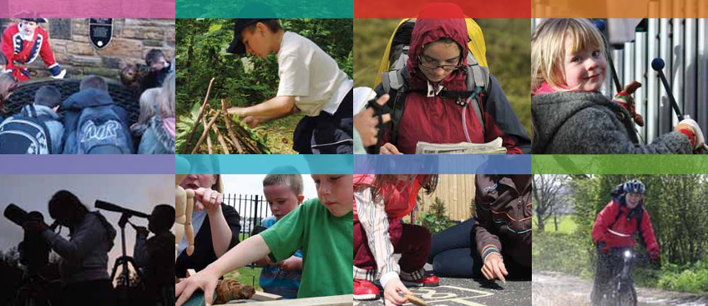

Images Credited to
Learning & Teaching Scotland 2010

Essay
‘COMPARE AND CONTRAST THE SCOPE AND APPROACH TO OUTDOOR PROVISION IN TWO TYPES OF SETTING’
Word Count = 1432 (1502 less 70 words used in quotes)
This essay will begin by summarising the importance of outdoor education. It will then explore the scope and approach to outdoor learning, along with the associated benefits and challenges, within two Welsh educational contexts: early-years and secondary-age. The discussion will examine, compare, and contrast how these settings utilise outdoor provision to support curriculum learning, promote learner well-being, and enhance environmental awareness, whilst drawing on relevant theory and policy. Finally, the essay will synthesise the key comparative findings and present a critical evaluation of the effectiveness of outdoor provision across both educational contexts.
The Welsh Government’s (WG) 2023 report on the current state of outdoor education in Welsh schools, argues that outdoor learning is widely recognised as a pedagogical approach, that offers long-term benefits for learners’ academic outcomes, physical and mental well-being, and environmental awareness, at a personal, societal, and global level.
This essay first examines the scope and approach of outdoor education in early-years provision for 3-5-year-olds, in state-maintained nursery and reception classes. WG guidance (2009, 2014) requires practitioners to place strong emphasis on using the outdoor environment to support all learners’ progress towards early-years learning outcomes, while ensuring equitable access, this links with the ALN Code for Wales (2021). The guidance advises practitioners to design outdoor learning that promotes discovery, exploration, and independent learning across a wide range of activities and diverse outdoor spaces. It further recommends planning purposeful, free-flowing outdoor experiences on a daily-basis, enabling children to follow their own interests while enhancing and consolidating learning outcomes. Additionally, the guidance highlights the importance of maintaining accessible resources enabling children to revisit and deepen their own learning.
Outdoor learning may take place in a dedicated, purposefully designed and benefit/risk-assessed outdoor area within the school grounds, as well as in forest-school spaces, local parks, nearby green areas, and on day visits to locations such as city-farms, beaches, and ponds. Accessing this range of environments, each managed by different authorities, supports children’s sense of local and wider societal belonging. This approach reflects Bronfenbrenner’s (1979) ecological systems theory, which emphasises that children’s development is shaped by multiple interacting environmental systems. (WAG, 2009, 2010, WG, 2014, 2015, Beames et al, 2024).
Learning activities within these outdoor spaces can support a wide range of curriculum aims. Literacy may be developed through tasks such as writing names with natural materials, while numeracy can be reinforced by collecting and arranging pebbles to represent numbers. Digital-skills can be fostered through creating videos of outdoor activities, and social development through collaborative tasks undertaken in pairs or small groups. Opportunities to introduce Welsh might involve identifying animals in Welsh during visits to a city-farm. Gross-motor skills can be enhanced through digging and balancing activities, and creative skills through making art with natural materials. Environmental awareness may be promoted through beach-cleans/litter-picks, while age-appropriate, nature-based assault-courses can help develop early risk-assessment skills. (WAG, 2009, 2010, WG, 2014, 2015, Beames et al, 2024).
All of these activities align with Fröbel’s (1899) emphasis on self-directed, play-based learning and with Bruner’s (1961) view that children learn effectively through personal experience. They also reflect Bandura’s (1977) and Vygotsky’s (1978) theories on the importance of social-modelling by peers and more knowledgeable others. The hands-on, exploratory nature of early-years outdoor learning is additionally consistent with Piaget’s (1964) cognitive developmental stages. Such an approach supports the development of a growth mindset by recognising the value of learning through mistakes. Learning and Teaching Scotland’s (2010) ‘Curriculum for Excellence Through Outdoor Learning’, advises that outdoor education for learners aged 3 to18, should follow progressive cycles of learning, which build on previous experiences to deepen understanding, reflecting Kolb’s (1984) experiential learning model of, repeated experience, reflection, experimentation, and conceptualisation. Furthermore, practitioners are encouraged to engage in outdoor learning CPD, and school leaders are advised to develop a whole-school outdoor learning policy. The guidance also recommends assessing and documenting children’s progress through digital means, such as videos, photographs, and digital-diaries, supported by observational notes recorded during activities. (WAG, 2009, 2010, WG, 2014, 2015, Beames et al, 2024).
Turning to the benefits and challenges of early-years outdoor learning, WG’s 2023 report states that outdoor education enhances academic outcomes by providing practical, real-world experiences that help children grasp abstract or hypothetical concepts. It also supports long-term physical development and mental wellbeing by modelling regular outdoor exercise, fostering a sense of grounding, connection with nature, and increased environmental awareness. Boulton and Thomas (2022) further concur that outdoor learning develops soft-skills that contribute to improved self-esteem, confidence, and long-term success. However, the report identifies several challenges, including budget constraints and, more fundamentally, the persistence of entrenched pedagogical beliefs that continue to prioritise traditional, classroom-based teaching and assessment as the primary means of achieving curriculum aims.
Shifting focus now to secondary-age outdoor learning for 11-16-year-olds, in state-maintained comprehensive schools. WG’s 2023 report highlights that no WG pedagogical guidance currently exists for secondary-age outdoor provision. It further notes that the Curriculum for Wales (2022) only makes limited reference to the benefits of outdoor learning beyond the foundation phase. Consequently, many secondary-age practitioners continue to regard outdoor learning as extra-curricular enrichment activities such as residential trips, the Duke of Edinburgh Award, and sporting opportunities. Thus, secondary-age curriculum learning remains largely delivered and assessed within traditional classroom environments. This stands in stark contrast to the improved integration found in early-years provision.
Factors of effective secondary-age outdoor learning are collectively identified by Learning Through Landscapes (2014, 2023) and Learning and Teaching Scotland (2010), who advocate embedding outdoor education across all secondary-age subjects and curricula to maximise its benefits for learners. This includes using outdoor spaces for project-work, GCSE coursework, and cross-curricular key-skill mapping. Providing inclusive, real-world outdoor learning experiences enhances academic understanding and retention, which can be especially valuable for particular neurodiverse learners who may struggle within traditional classroom environments and have disengaged with their education. This aligns with the ALN Code for Wales (2021). Good practice also involves creating opportunities that develop transferable leadership and soft-skills relevant to future employment and adult-life, while supporting regular physical activity and connection with the natural environment. Practitioners are further encouraged to adopt a balanced benefit–risk approach and to engage in CPD that builds the skills and confidence needed to deliver and assess curriculum aims outdoors. Collectively, these strategies demonstrate considerable pedagogical alignment with the effective practices already established in early-years provision.
Learning Through Landscapes (2014, 2023) and Learning and Teaching Scotland (2010) identify the benefits of outdoor learning in secondary-age education as broadly comparable to those seen in early-years provision. However, they note that some benefits may be even more pronounced for adolescents. Increased engagement is highlighted as a key advantage, particularly given the higher levels of disengagement many young people experience with traditional, classroom-based learning. This aligns with Ryan and Deci’s (2000) self-determination theory, which proposes that optimal motivation and wellbeing, depend on fulfilling the psychological needs of autonomy, competence, and connection. When these needs are supported, motivation is strengthened, when they are not, both motivation and wellbeing decline. Outdoor learning provides valuable opportunities for physical-activity, social-interaction, and communication for young people who are increasingly leading sedentary, digital, and socially-isolated lives. This additionally corresponds with Tajfel and Turner’s (1979) social-identity theory, which proposes that individuals gain self-esteem and confidence through membership of social groups. This is particularly relevant in secondary-age outdoor education, where group-based activities can foster positive shared identities that strengthen social bonds and support adolescent development. These experiences can contribute to improved mental health and resilience, helping to counter the rising levels of poor wellbeing, observed among adolescents.
In addition to the financial constraints and the persistence of traditional classroom-based pedagogies identified earlier, WG’s 2023 report highlights several further barriers specific to secondary-age outdoor learning. These include the previously noted absence of WG pedagogical guidance for secondary-age provision, alongside the teaching-time pressures associated with delivering GCSE programmes. The report also acknowledges that adolescent body-image anxieties and experiences of body-shaming can reduce learners’ willingness to participate in activities that may make them feel physically exposed or vulnerable.
Synthesising the above comparisons’ findings, it is very clear that whilst early-years provision is making excellent progress regarding realising the benefits of integrating outdoor education across the curriculum, secondary-age provision is being left behind. This is particularly concerning in view of the increasingly, alarming statistics regarding Welsh young people’s physical and mental-health wellbeing, alongside worsening PISA educational outcomes (PHW, 2025, OECD, 2024). Thus, Wales is falling behind, on fulfilling its obligations towards adolescents, regarding the UN’s (1989) children’s rights, linked to education, health and play.
Finally, this essay concludes with a quote from the WG 2023 report regarding the state of outdoor education in Wales.
“The findings suggest that a coherent strategy and budget allocation are required to support schools and local authorities in curating outdoor learning resources in an accessible format and single location/repository, providing professional development opportunities for the education workforce and increasing awareness of outdoor learning as a viable and effective pedagogy rather than an enrichment activity in both the existing workforce and in programmes of initial teacher training.” (WG, 2023, p.1)

Reference List - Essay
Bandura, A. (1977) Social learning theory. Englewood Cliffs: Prentice-Hall.
Bates, B. (2019) Learning Theories Simplified. 2nd Edn. London: Sage.
Beames, S., Higgins, P., Nicol, R., and Smith, H. (2024) Outdoor Education Across the Curriculum: Theory and Guidelines for Practice. 2nd Edn. Abingdon: Routledge.
Boulton, P. and Thomas, A. (2022) ‘How does play in the outdoors afford opportunities for schema development in young children?’, International Journal of Play, 11(2), pp. 184-201. Available at: How does play in the outdoors afford opportunities for schema development in young children?: International Journal of Play: Vol 11 , No 2 (Accessed: 17 March 2026).
Bronfenbrenner, U., (1979) The Ecology of Human Development: Experiments by Nature and Design. Cambridge, MA: Harvard University Press.
Bruner, J. S. (1961) ‘The act of discovery’, Harvard Educational Review, 31(1), pp. 21-32. Available at: Jerome Bruner Theory of Cognitive Development (Accessed: 16 March 2026).
Kolb, D. A. (1984) Experiential learning: Experience as the source of learning and development. Englewood Cliffs, NJ: Prentice Hall.
Learning and Teaching Scotland (2010) Curriculum for Excellence through Outdoor Learning. Available at: Curriculum for Excellence through outdoor learning (Accessed: 12 March 2026).
Learning Through Landscapes (2023) Secondary Outdoor Learning. Available at: Secondary Outdoor Learning | Learning through Landscapes (Accessed: 17 March 2026).
OECD (2024) PISA: Wales Results 2024. Available at: Pisa: Wales Results 2024 (Accessed: 18 March 2026).
Piaget, J. (1964) ‘Cognitive Development in Children: Development and Learning’, Journal of Research in Science Teaching, 2(0), pp. 176-186. Available at:
http://dx.doi.org/10.1002/tea.3660020306 (Accessed: 14 March 2026).
Public Health Wales (2025) Joint Statement on Children and Young People’s Mental Health and Wellbeing: November 2025. Available at: Joint Statement CYP MHWB (Accessed: 13 March 2026).
Ryan, R. M. and Deci, E. L. (2000) 'Self-determination theory and the facilitation of intrinsic motivation, social development, and well-being', American Psychologist, 55(1), pp. 68–78. Available at: 0080.tif (Accessed: 18 March 2026).
Tajfel, H. and Turner, J. C. (1979) ‘An integrative theory of intergroup conflict’, pp. 33-47, in Austin, W. G. and Worchel, S. (eds.) The social psychology of intergroup relations. Monterey: Brooks/Cole.
UNCRC (1989) United Nations Convention on Rights of a Child (UNCRC). Available at: UN Convention on Rights of a Child (UNCRC) - UNICEF UK (Accessed: 14 March 2026).
Vygotsky, L. S. (1978) Mind in society: The development of higher psychological processes. Cambridge, MA: Harvard University Press.
Welsh Assembly Government (2009) Foundation Phase: Outdoor Learning Handbook. Available at: foundation-phase-outdoor-learning-handbook.pdf (Accessed: 16 March 2026).
Welsh Assembly Government (2010) First steps outdoors: making the most of your outdoor spaces – Learning through Landscapes Cymru. Available at: https://hwb.gov.wales/api/storage/79a90e4b-0385-4cc8-be9b-2b20be3a85d0/first-steps-outdoors.pdf (Accessed: 16 March 2026).
Welsh Government (2014) Further Steps Outdoors Guidance. Play – Learn – Grow. Available at: Further Steps Outdoors Guidance. Play – Learn – Grow. (Accessed: 16 March 2026).
Welsh Government (2015) Curriculum for Wales: Foundation Phase Framework: Available at: foundation-phase-framework.pdf (Accessed: 16 March 2026).
Welsh Government (2021) The ALN Code for Wales. Available at: 250124-the-additional-learning-needs-code-for-wales-2021.pdf (Accessed: 12 March 2026).
Welsh Government (2022) The Curriculum for Wales. Available at: Curriculum for Wales - Hwb (Accessed: 14 March 2026).
Welsh Government (2023) Teaching and learning in the outdoors: the current state of outdoor learning in schools in Wales, Available at: Teaching and learning in the outdoors: the current state of outdoor learning in schools in Wales (Accessed: 16 March 2026).

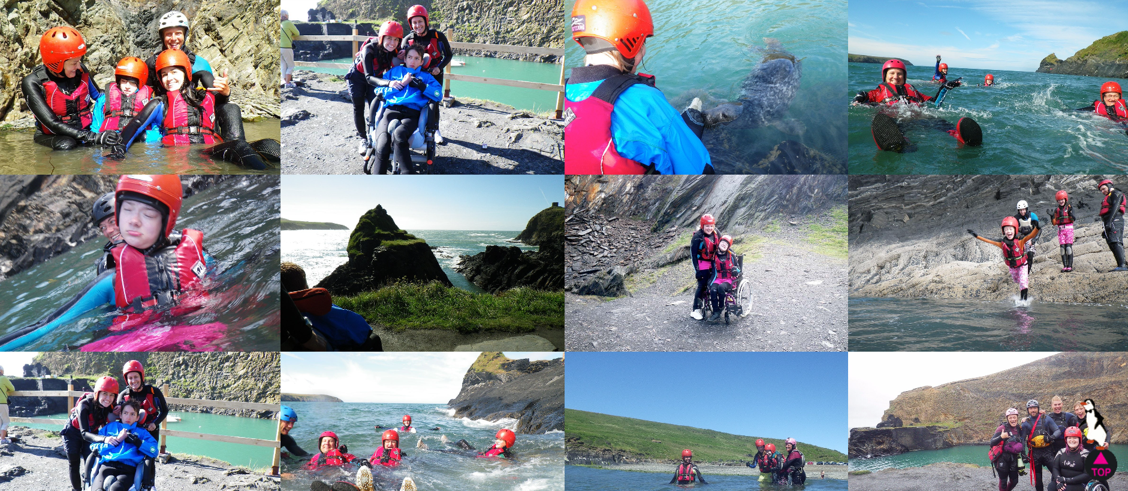
FREE
COASTEERING EVENT
FOR YEARS 8 & 9
YSGOL HARRI TUDOR
Project Financed
By Penfro LNG
Delivered by the Prestigious
Cymru Odessey Co.
www.cymru odessey.co.uk

SUNDAY 26 APRIL 2026
10AM-5PM
NECESSARY: OLD TRAINERS & SWIMMING COSTUME
NOT NECESSARY: PACKED LUNCH/DRINKS/SNACKS OR TRANSPORT
FULLY ACCESSIBLE ACTIVITY FOR ALL ABILITIES
Join in with Cymru’s fastest growing adrenaline adventure sport!
For more information and registration contact your Form Tutor today!
Images credited to

Maps to KS Stage 3 Curriculum Aims: Developing Skills in Competency, Resilience and Risk-Management

RISK BENEFIT ASSESSMENT

Location / Activity: | SCHOOL GROUNDS - WILD GROWTH AREA / STORY LANDSCAPES  Creating natural art to depict a class story | Date: | 27/03/2026
Assessor: | Nicola Parsons 2115499 | Review date: | Before each use of the activity and whenever significant changes occur

The boxes in the table below will expand as you type into them; pre-entered text is simply for illustration. You should delete irrelevant items and replace with text relevant to your circumstances.
Your overall risk rating – Low, medium or high – is based on your judgement about whether the BENEFITS of the activity or opportunity outweigh the RISKS.

ACTIVITY | How will young people BENEFIT from this activity? | Possible hazards | Who is at risk? | PRECAUTIONS in place to reduce the risk of injury | Overall risk RATING: L/M/H
STORY LANDSCAPES  Creating natural art to depict a class story, with natural materials found in the wild growth area of the school grounds. | By utilising the wild growth area of the school grounds to collect natural materials, to create visual expressive art, depicting a class story, will benefit each learner by enabling opportunity for their:  SOFT-SKILLS DEVELOPMENT OF: collaboration; communication; visual/spatial awareness; fine and gross motor skills; innovation; mindfulness; wellbeing; confidence; belonging to the local environment.  ACADEMIC SKILLS DEVELOPMENT OF: critical-thinking; planning; design; applying literacy; artistic expression; reflectiveness.  ENVIRONMENTAL SUSTAINABILITY AWARENESS SKILLS DEVELOPMENT OF: intimate experience with the natural world; respect of the environment; value of the natural world to express yourself. | 1)  Hazard= The Environment  Risk= Interaction with uneven topography, plants, insects, animals which could cause cuts, grazes, abrasions, thorn injuries, eye injuries, plant or insect stings, animal bites, exacerbation of medical conditions such as allergies or anaphylactic reactions.  Probability= Low to Medium  2)  Hazard= The Weather  Risk= Sun, high-temperatures which could cause sunburn, heatstroke or dehydration. Precipitation, wind, cold-temperatures, presence of ice which could cause falling debris injuries or slip injuries.  Probability= Low | All Children & Adults Present | - Introductory briefing to children to explain the environment’s hazards  - Registered first-aider carrying the pre-activity checked, first-aid kit back-pack and wearing the first-aider tabard  - Learners’ medical alert information folder carried in the first-aid back-pack, along with any pre-indicated epi-pens, allergy, epilepsy, diabetic or other medications  - Pre-activity weather assessment and postponement of activity if extreme adverse weather conditions prevail  - Check of each child to ensure wearing of appropriate weather/activity related clothing, hat and footwear  - Check of each child to ensure in possession of a full drink bottle  - Check of each child to ensure permission slips held for and sun-screen application undertaken, in sunny weather conditions  - Good hygiene habit, hand-washing on return inside, for all attending individuals  - Annual check of school-grounds for tree safety and integrity by tree surgeon | LOW

Literature Review
‘THE ROLE OF OUTDOOR EDUCATION’
Word Count = 1813 (1958 less the 145 words used in quotes)

This literature review will begin by examining several definitions of outdoor education as proposed by leading professionals and organisations. It will then explore the principal themes and roles commonly associated within the field of outdoor education. Subsequently, it will undertake a critical analysis of a selection of literature relating to three of these themes. Finally, it will synthesise the analysis findings and offer a critical evaluation of the impact of the selected themes in the context of outdoor education.
All of the following definitions of outdoor education emphasise learning in the natural environment, yet each presents unique nuances.
“The term outdoor learning covers all kinds of curricular learning that might take place outside the classroom in the local environment” (Beames, 2023).
The Beames’ (2023) definition is an overarching simple definition with zero expansion.
“Outdoor learning is an educational approach that extends beyond the traditional classroom, utilising natural environments to enhance student engagement, well-being, and academic achievement. This method encompasses a range of activities, from structured lessons in school gardens to exploratory sessions in local parks, aiming to provide holistic development opportunities for students” (The Muddy Puddle Teacher®, 2025).
The Muddy Puddle Teacher® (2025) definition further develops the field’s key themes by emphasising enhanced learner engagement, wellbeing, and academic achievement. However, it may be critiqued for its implication that ‘structured’ lessons should be delivered within the local environment, a practice that diverges from Fröbel’s learning theory, which prioritises children’s self-directed play in outdoor settings (Fröbel, 1899, Bates, 2019).
“Outdoor learning is an umbrella term for actively inclusive facilitated approaches that predominantly use activities and experiences in the outdoors which lead to learning, increased health and wellbeing and environmental awareness” (The Institute for Outdoor Learning, 2025).
The final definition, from the Institute for Outdoor Learning (2025), additionally includes the theme of the provision being ‘fully-inclusive’ outdoor activities and experiences, which facilitate learning, increased health, mental wellbeing and environmental awareness. This definition acknowledges the importance of inclusivity as is legislated for in the ALN Code for Wales (WG, 2021).
Expanding on these definitions, this literature review will now discuss the principal themes and roles of outdoor education. Papadopoulou and Vincent (2025) opine that outdoor education aims to provide memorable learning experiences, which offer students self-initiated, collaborative, and practical learning opportunities in natural environments. Arguing, such experiences positively influence learners’ physical health and mental wellbeing, while also fostering meaningful engagement with the natural world and supporting the development of sustainability awareness. Additionally, they believe that outdoor education positively contributes to the cognitive growth of learner’s key soft-skills, including interpersonal communication, problem-solving, risk-awareness, and self-confidence. These skills translating into improved employability and higher lifetime earnings potential. Whilst, Learning and Teaching Scotland (2010) agree with this view, they additionally argue that outdoor learning for students aged 3 to18 should offer a progressive sequence of sustainable outdoor learning opportunities. Their guidance promotes, that repeated outdoor experiences, at different educational stages, enable learners to move through a cycle of learning, multiple times during their educational journey, facilitating their growth of deeper understanding. This aligns with Kolb’s experiential learning theory (1984), which believes learning is a cyclical process involving concrete experience, reflection, conceptualisation, and active experimentation. Finally, Learning Through Landscapes (2022) extends these viewpoints by affirming the established benefits of outdoor education while emphasising its potential to enhance inclusivity and learner engagement. They argue that the practical, experiential nature of outdoor environments can improve academic attainment by making complex concepts more accessible for learners who struggle within traditional classroom settings. However, they caution that all benefits are dependent on the formal and consistent integration of outdoor learning across the whole curriculum, rather than being confined to early years provision or the occasional activity in primary and secondary years.
This literature review now turns to its first theme: the role of outdoor learning experiences in improving mental health and wellbeing. This theme aligns with the Curriculum for Wales (WG, 2022) aim to develop ‘healthy, confident individuals, ready to lead fulfilling lives as valued members of society’, as outdoor education supports improved mental health, through learner’s increased exposure to natural environments and development of soft-skills. Public Health Wales (2025) reports that approximately one in six children aged 8-10, one in five aged 11-16, and one in four young people aged 17-24 in Wales, have a diagnosable mental health condition. Cardiff University (2023) similarly identifies that 24% of Welsh secondary-age learners experience very high levels of anxiety and depression, warning that these figures will continue to rise without intervention. Evidence-based research indicates that outdoor learning can improve learners’ mental health and well-being (UEL, 2025), a view echoed by Lomax et al (2024), who concluded that time spent in natural environments has a beneficial effect on young people’s mental health and wellbeing. Regular outdoor activities reduce obesity risks and boost mental health, leading to improved behaviour and attainment, aiding health services to reduce long-term costs (NECR, 2022). However, several barriers continue to limit the effective implementation of outdoor education. Otter (2023) identifies key constraints including financial pressures that restrict transportation and access to appropriate outdoor clothing, as well as the additional administrative demands of planning, risk-assessment, curriculum-mapping, and evaluation. Further challenges include the difficulty of reliably assessing learners’ wellbeing outcomes and the lack of targeted CPD to equip teachers to deliver high-quality outdoor learning. These limitations are compounded by wider pressures to prioritise teaching that aligns closely with formal examination requirements.
The second theme critically examined in this literature review is outdoor education’s role in fostering meaningful connections with the natural environment and developing learners’ sustainability awareness. This theme aligns with the Curriculum for Wales (WG, 2022) purpose of creating ‘ethical, informed citizens of Wales and the world’, as outdoor education directly supports sustainability learning. The UN Sustainable Development Goals (2015) set out 17 global priorities centred on tackling climate change, protecting natural environments, reducing inequality, and improving education and economic growth by 2030. Wales has embedded these goals into its own seven national wellbeing objectives through the Wellbeing of Future Generations Act (WG, 2015). Active Learning Centres (2023) argue that outdoor education provides authentic opportunities for learners to develop environmental and sustainability awareness through hands-on activities such as rock-pooling, pond-dipping, and growing vegetables, and by experiencing first-hand the impacts of habitat destruction, littering, and pollution. Similarly, Attenborough (2015) contends that without daily engagement with nature, children cannot develop the understanding needed to value and protect it. Gessiou and Mart (2023) identify the principal barrier to outdoor education successfully developing learners’ sustainability awareness as, outdoor education alone is insufficient to change negative systemic behaviours. They argue that the sustainability awareness fostered through school-based outdoor experiences requires wider reinforcement at multiple levels, including school policies (e.g., litter-prevention practices), community initiatives, home-life reinforcement, and national policy. The importance of systemic support is reflected in the UNCRC (1989) Article 31, which establishes children’s right to play. Subsequently, the Welsh Assembly Government, in 2010, became the first country to place a statutory duty on local authorities to provide sufficient play-opportunities. Without wider systemic alignment, sustainability behaviours developed through outdoor education, risk becoming tokenistic. This perspective aligns with Bronfenbrenner’s (1979) ecological systems theory, which opines that development occurs when the microsystem, mesosystem, exosystem, macrosystem, and chronosystem operate cohesively around the individual. Gessiou and Mart (2023) further contend that without targeted teacher expertise in outdoor education, practice can remain superficial and fail to become embedded in learners.
The final theme critically examined in this literature review is outdoor education’s role in developing learners’ soft-skills. This theme aligns with both the ‘ambitious, capable learners, ready to learn throughout their lives’ and the ‘enterprising, creative contributors, ready to play a full part in life and work’ purposes of the Curriculum for Wales (WG, 2022), as outdoor education supports the development of the soft-skills required to achieve these aims. Mann et al (2022) argue that outdoor education enhances learners’ educational engagement through real-world contexts for learning and their autonomy to understand and transfer skills, while also developing social and collaborative competencies, critical-thinking skills, risk-assessment/management and self-concept.
However, Cure, Hill and Cruickshank (2018) argue that further research is required to determine whether outdoor education is delivered with sufficient professionalism to cultivate learners’ belief that making mistakes is a constructive part of the learning process. This perspective aligns with constructivist theories, including Piaget (1964) and Dweck’s (2012) work (Bates, 2019), which propose that mistakes made during concrete interactions with the environment, provide meaningful learning opportunities and support the development of a growth mindset. Furthermore, Papadopoulou and Vincent (2025) identify several barriers to outdoor education fostering soft-skill development, including learners’ low self-confidence, insufficiently differentiated activities to ensure inclusivity, and some students’ preference for indoor or digital activities. Otter (2023) additionally argues that assessing learners’ attainment in soft-skills remains challenging, further hindering the effective development of these competencies through outdoor education. Tinney (2023) concurs that outdoor education positively influences learners’ exploratory, physical, and curiosity-driven development, as well as their sense of belonging. However, Tinney notes that realising these benefits requires educators to be confident in applying robust risk–benefit assessment practices when planning outdoor activities and in fostering parental support. Tinney further emphasises the importance of systematically mapping outdoor learning across all key-stages of the Curriculum for Wales (WG, 2022), to ensure alignment with the four purposes of education. Consistent with Gessiou and Mart (2023), Tinney argues that the intended benefits of outdoor education must be embedded across the macro, meso, and micro systems surrounding the learner. Extending this perspective, Tinney concludes that the successes observed in early years outdoor learning must now be sustained and equally expanded throughout all phases of education.
In synthesising this analysis, the literature presents significant and credible evidence demonstrating the positive contributions that outdoor education can make to learners’ development. Anderson (2024), as cited by the Institute for Outdoor Learning (2025), argues that outdoor education offers a range of short, medium, and long-term benefits: in the short-term, it supports individuals in developing self-reflection, interpersonal awareness, and connection with the environment; in the medium-term, it enhances academic achievement, personal and social development, employability, wellbeing, and mental health; and in the long-term, it contributes to lifelong physical activity, sustained learning, an appreciation of diversity, a stronger sense of place and community, and greater care for the global environment. Kuo et al (2019) similarly argue that the skills and benefits fostered through outdoor education, equip children with attributes that are particularly valuable, for navigating the demands of the modern world. Furthermore, the Institute for Outdoor Learning (2025) concludes that outdoor education contributes positively to the development of social-capital, pride, belonging, and stronger community cohesion. This can be aligned to Coleman’s (1986) social theory, which views social-capital as a societal asset. Building on these perspectives, Truong and Clayton (2020) argue that the growing phenomenon of ‘experience extinction’, in which learners become increasingly disconnected from the natural environment, due to greater urbanisation and digital engagement, makes the provision of outdoor learning experiences evermore essential within education. The barriers to implementing outdoor education, including financial and time-constraints, plus the administrative pressures related to curriculum-mapping, assessment and risk-management, together with the need to strengthen practitioner expertise and parental engagement, must be addressed, to ensure outdoor learning can effectively support the three strands of environmental awareness, academic equity and excellence, and learners’ physical and mental wellbeing, across Wales. Achieving these aims also requires outdoor education to be embedded within the wider systems that shape learners’ development. Furthermore, realising these intentions depends on securing sufficient resourcing to overcome the identified barriers, combined with the systematic and consistent integration of outdoor learning across the whole curriculum and all key-stages. Adopting such an approach would ensure that outdoor education is delivered holistically and afforded the status necessary, to maximise its contributions to learners’ lifelong development, as well as wider societal and global benefits.

Reference List - Literature Review
Active Learning Centres (2023) How outdoor education promotes environmental awareness. Available at: activelearningcentres.co.uk how-outdoor-education-can-promote-environmental-awareness. (Accessed: 13 March 2026).
Attenborough, D. (2015) 'David Attenborough - Conserving Wonder' Learning Through Landscapes. Available at: CONSERVING WONDER with Sir David Attenborough - sustainable video production (Accessed: 13 March 2026).
Bates, B. (2019) Learning Theories Simplified. 2nd Edn. London: Sage.
Beames, S., Higgins, P., Nicol, R. and Smith, H. (2023) Outdoor Learning Across The Curriculum. Abingdon: Routledge.
Bronfenbrenner, U., (1979) The Ecology of Human Development: Experiments by Nature and Design. Cambridge, MA: Harvard University Press.
Cardiff University (2023) Research by School Health Research Network. Available at: Nearly a quarter of young people in Wales are reporting very high levels of mental health symptoms following the pandemic - News - Cardiff University (Accessed: 13 March 2026).
Coleman, J. S. (1986) ‘Social Theory, Social Research, and a Theory of Action’, The American Journal of Sociology, 91(6), pp.1309-1335. Available at: http://www.jstor.org/stable/2779798 (Accessed: 14 March 2026).
Fröbel, F. (1899) Education by development. New York: D. Appleton and Company.
Gessiou, G. and Mart, M. (2023) Outdoor play and learning practices from a comparative case study perspective. Available at: Outdoor-play-and-learning-practices-from-a-comparative-case-study-perspective.pdf (Accessed: 13 March 2026).
Institute For Outdoor Learning (2025) High Quality Outdoor Learning: A Guide For All. Available at: IOL015-Outdoor-learning-guides-online.pdf (Accessed: 12 March 2026).
Kolb, D. A. (1984) Experiential learning: Experience as the source of learning and development. Englewood Cliffs, NJ: Prentice Hall.
Kuo, M., Barnes, M. and Jordan, C. (2019) ‘Do Experiences With Nature Promote Learning? Converging Evidence of a Cause-and-Effect Relationship’, Frontiers: Psychology, Environmental Psychology, 10(305), Available at: doi: 10.3389/fpsyg.2019.00305 (Accessed: 14 March 2026).
Learning and Teaching Scotland (2010) Curriculum for Excellence through Outdoor Learning. Available at: Curriculum for Excellence through outdoor learning (Accessed: 12 March 2026).
Learning Through Landscapes (2022) Five Key Benefits of Outdoor Learning. Available at: 5 key benefits of outdoor learning (Accessed: 13 March 2026).
Lomax, T., Butler, J., Cipriani, A., and Singh, I. (2024) Effect of nature on the mental health & wellbeing of children and adolescents: A meta-review. The British Journal of Psychiatry: The Journal of Mental science, 225(3), pp. 401-409. Available at: Effect of nature on the mental health and well-being of children and adolescents: meta-review - PMC (Accessed: 13 March 2026).
Mann, J., Gray, T., Truong, S., Brymer, E., Passy, R., Ho, S., Sahlberg, P., Ward, K., Bentsen, P., Curry, C. and Cowper, R. (2022) ‘Getting Out of the Classroom and Into Nature: A Systematic Review of Nature-Specific Outdoor Learning on School Children’s Learning and Development’, Frontiers in Public Health, 10(Article No: 877058) pp. 1-12. Available at: Getting Out of the Classroom and Into Nature: A Systematic Review of Nature-Specific Outdoor Learning on School Children's Learning and Development (Accessed: 14 March 2026).
NECR (2022) Social and economic benefits of learning in natural environment. Available at: NECR442 Edition 1 Social and economic benefits of learning in natural environment_V1.1.pdf (Accessed: 14 March 2026).
Otter (2023) Barriers to outdoor education. Available at: Barriers to outdoor education | OTTER (Accessed: 13 March 2026).
Papadopoulou, M. and Vincent, K. (2025) ‘Making the invisible visible: the pedagogical affordances of outdoor learning in a nursery and primary school’, Education 3-13 International Journal of Primary, Elementary and Early Years Education, Online Article No: DOI: 10.1080/03004279.2025.2469724, Available at: Making the invisible visible: the pedagogical affordances of outdoor learning in a nursery and a primary school (Accessed: 12 March 2026).
Piaget, J. (1964) ‘Cognitive Development in Children: Development and Learning’, Journal of Research in Science Teaching, 2(0), pp. 176-186. Available at:
http://dx.doi.org/10.1002/tea.3660020306 (Accessed: 14 March 2026).
Public Health Wales (2025) Joint Statement on Children and Young People’s Mental Health and Wellbeing: November 2025. Available at: Joint Statement CYP MHWB (Accessed: 13 March 2026).
The Muddy Puddle Teacher® (2025) What is Outdoor Learning in Schools? Available at: What Is Outdoor Learning in Schools? The Muddy Puddle Teacher (Accessed: 12 March 2026).
Tinney, G. (2023) ‘Big changes! The Great Outdoors and the Curriculum for Wales’, FORUM for promoting 3 - 19 comprehensive education, 65 (1), pp. 63-75. Available at: Big changes! The Great Outdoors and the Curriculum for Wales - Research Repository (Accessed: 14 March 2026).
Truong, M. A. and Clayton, S. (2020) ‘Technologically transformed experiences of nature: A challenge for environmental conservation, Biological Conservation, 244(Article No: 108521), Available at: Technologically transformed experiences of nature_ A challenge for environmental conservation? (Accessed: 14 March 2026).
UN (2015) The 17 Goals. Available at: THE 17 GOALS | Sustainable Development (Accessed: 13 March 2026).
UNCRC (1989) United Nations Convention on Rights of a Child (UNCRC). Available at: UN Convention on Rights of a Child (UNCRC) - UNICEF UK (Accessed: 14 March 2026).
University of East London UEL (2025) Outdoor learning linked to lower stress and better focus. Available at: Outdoor learning linked to lower stress and better focus | University of East London (Accessed: 13 March 2026).
Welsh Assembly Government (2010) Children and Families (Wales) Measure 2010. Available at: Children and Families (Wales) Measure 2010 (Accessed: 14 March 2026).
Welsh Government (2015) The Wellbeing of Future Generations Act. Available at: The Well-being of Future Generations | GOV.WALES (Accessed: 13 March 2026).
Welsh Government (2021) The ALN Code for Wales. Available at: 250124-the-additional-learning-needs-code-for-wales-2021.pdf (Accessed: 12 March 2026).
Welsh Government (2022) The Curriculum for Wales. Available at: Curriculum for Wales - Hwb (Accessed: 14 March 2026).

