An individual reflective response to the Professional Teaching Experience
Reflection is a process that enables trainees to learn from an experience to develop practice and understanding (Jasper, 2003). Welsh Government states that reflective practice is a “process of thinking through professional issues, problems or dilemmas, which do not have an obvious solution” (Welsh Government, 2015). ESTYN has reported on how Hafod Primary school’s senior management and teachers have begun to reflect on teaching methods and learning opportunities to improve the educations of their pupils (ESTYN, 2019). The Assisted Reflective Conclusions (ARC) model of reflection is an accumulation from Gibbs’ reflective cycle and features similar themes (Dye, 2011, pg. 230). The ARC model of reflection has been developed to enable trainees to transform their practice and understanding upon reflecting on their experiences whilst conducting a professional teaching experience.
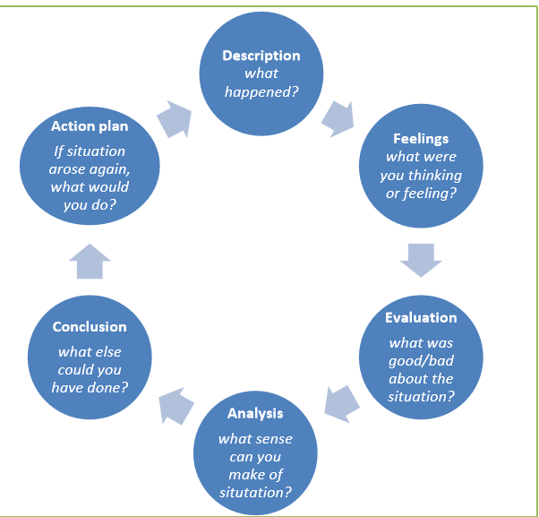
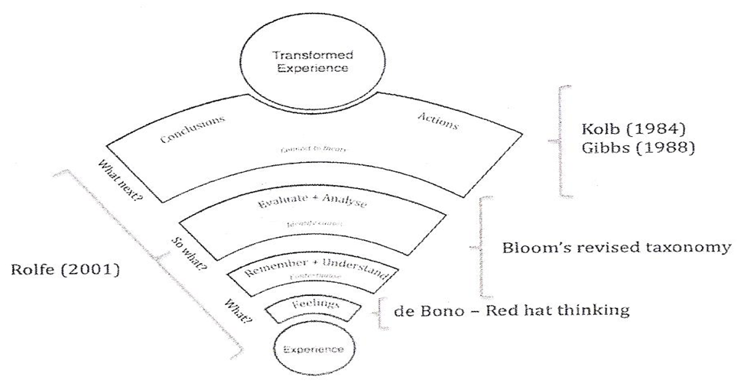

Theorist John Dewey notes that reflection in relation to a learning context is an “active process” and not just an inactive recall of events. Dewey deemed that the reflection process could be highly useful in helping to understand why situations and events were initially hard to explain and understand (Dewey 1933 pg. 118). Donald Schön enhanced Dewey’s work focusing more on professional development and professional practice. Schön detailed that reflection allows practitioners to make “tacit” knowledge. This knowledge supports what practitioners often do by nature. Schön recognised two different types of reflection: reflection on action and reflection in action. Reflection on action is assumed with hindsight whereas the reflection in action is when the practitioner reflects whilst working. Schön anticipated that repeating the reflecting on action process would help practitioners to improve upon previous experiences. This would help the practitioners to build an “extensive repertoire of rehearsed experiences” which they may later rely on in new or unexpected situations (Schön, 1983).
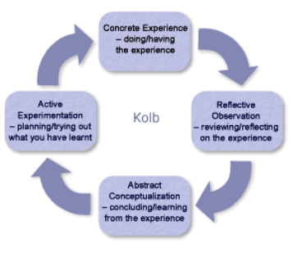
David Kolb and Ronald Fry studied essential parts of reflection and went on to create a “learning cycle framework”. Kolb established four parts of the learning cycle: concrete experience, reflective observation, abstract conceptualization and active experiment. Kolb realised that individuals prefer certain aspects of the learning cycle over others. He deemed it not to be problematic as long as the other aspects were maintained to a certain level. However, he believed that neglecting certain aspects of the learning cycle may deem the individual to become “deskilled” in those areas. Kolb believed that it could lead to unbalanced learning and the inability to maintain a level of competence in all aspects of the learning cycle which is “essential to ensure comprehensive learning” (Kolb and Fry, 1975). Both Dewey and Schön recognise that reflection is an important process that allows practitioners to improve professional development and professional practice. However, they fail to mention how emotions may affect reflection and should be considered. Schön’s reflection theory focused only on improving professional practice and developing a skilled practitioner. Whereas Kolb’s reflection theory, was deemed to be too theoretical and had no acknowledgement of the practitioners’ feelings in regard to reflection. Theorists David Boud, Rosemary Keogh and David Walker contest this judgement. They trust that emotions are an integral part of reflection especially in relation to learning and must be considered. They note that emotions can influence how an individual may recall events. They even infer that strong emotions may distort the way individuals interpret aspects of an event whilst reflecting. Boud, Keogh and Walker believe that by not including emotion in the reflection process may lead to an ineffective learning process (Boud, Keogh and Walker, 1985).
The first critical incident I have chosen to reflect on was the first mathematics lesson on Multiplication. My chosen QTS standard that I wanted to meet was “S3.1.1 To set challenging teaching and learning objectives which are relevant to all learners in their classes” (Welsh Government, 2009, pg. 8). Therefore, my target was to plan an appropriate lesson that developed the learning of the learners within the lower ability mathematics group. Russell Grigg states that planning is “part of the dynamic cycle of the classroom professional activities that feed into teaching, assessment, evaluation and reporting” (Grigg, 2015, pg. 264). However, upon reflection shown in appendix 1: I did not meet my target as I was unable to provide appropriate learning objectives for two learners in the group. To improve from this critical incident, I would further differentiate my planned lessons to accommodate the learning needs of every learner within the currently low attaining group. Lev Vygotsky developed the concept of the “more knowledgeable other (MKO)” which refers to an individual who has a better understanding than the learner in respect of a certain task. The MKO does not necessarily have to be an adult but may be a child’s peer. This is a concept I could adopt with the currently low attaining group as there were learners who flourished during the session and could easily act as an MKO for the learners who found the session very difficult. Vygotsky then developed the “Zone of Proximal Development (ZDP)” as he discovered that children are most optimally engaged in learning when tasks are set just above what they can do on their own. He noticed how children can become withdrawn and often frustrated with work that is too difficult or too easy. The ZDP is a concept that relates to what the learner can achieve on their own and what the learner can achieve with guidance from a capable partner (Vygotsky, 1978). This is another concept I could adopt in my teaching methods especially with this cohort as it was evident that one of the learners that found the session difficult began to understand the learning objective once I was there to support him and guide him to an understanding he reached independently.
However, Jerome Bruner believes that learners need “scaffolding” when learning a new concept as they actively need support from teachers or other adults. Bruner’s social constructivist theory conditions that learners beginning a new concept of learning are dependent on the support of an adult. However, as they become more independent learners that need new skills and knowledge, the adult support dissipates. Therefore, the scaffold designed by the teacher is slowly dismantled and replaced by the learner’s own knowledge and newly developed abilities. This is another concept I could adopt in my teaching methods, as the scaffolding I designed for learners may have been to much for some and not enough for others. Therefore, by focusing on the scaffolding I provide, the learners could improve their ability to be more independent learners and less dependent on me.
The next critical incident I have chosen to reflect on is the session that superseded the first mathematics lesson I planned and taught. My chosen QTS standard that I wanted to meet was “S3.3.7 They organise and manage teaching and learning time effectively” (Welsh Government, 2009, pg.11). Consequently, my target was to effectively implement suitable teaching and learning time for a group of learners. Russell Grigg notes that the only way to effectively use time in learning session is to “analyse how the existing time is being used and then to consider ways of redistributing the time more efficiently” (Grigg, 2015, pg. 47). Moreover, when I reflected on this session shown in appendix 2, it was evident that I did not manage my time effectively. Stephen R Covey notes that there are “four generations” of time management and each needs to build on the one before. Covey states that if we are unable to manage time effectively it can greatly affect the time we have to influence and educate learners. Each of Covey’s generations heavily focuses on developing the ability to be constantly aware of time whether it is in the near or distant future (Covey, 2004).
Ivan Pavlov used classical conditioning as a method to create a specific behaviour in the dogs from his experiment. He found by having a conditioned stimulus it would create a conditioned response which is now referred as a “Pavlovian response” (Pavlov, 1928). This behaviourism theory could be used to manage my time more effectively. This may be achieved by using a stimulus such as a timer to condition myself to use the time in my teaching sessions more effectively. The timer could be a stimulus that may later be a condition stimulus once a conditioned response is formed. Alternatively, the timer could be used as a support as I would be able to visually see how much time in the session I have and to use it to effectively to support the learners. Moreover, Pavlovian conditioning could also be a behaviourism that may support the learners’ time management. This may help the learners challenge themselves as they have to work under a time constraint which could develop into a routine. This in time may mean they would need to rely heavily on prior knowledge, which would develop them into independent learners of their own education. Welsh government states that “Routines help to minimise behavioural challenges in the classroom and are key to a well-managed and organised classroom” (Welsh Government, 2012, pg. 8).
To close, reflective practice enables practitioners to become reflective decision makers in an everyday classroom situation. It allows them to develop intrinsic abilities that allow them to think on their feet in challenging situations. This improves their professional abilities through change and growth. Reflection also enhances practitioner’s abilities to teach as they are able to conduct themselves professionally and in an effective way for their learners.

Appendix 1

Model Beirniadau Wedi Adfyfyrio (BWA)

Assisted Reflective Conclusions (ARC) Model
Dyddiad/Date: 07/03/19
Digwyddiad critigol (Ffocws)/Critical incident (focus): Mathematics Lesson 1 – Multiplication

Profiad/ Experience

Teimladau/  Feelings  Beth yw eich teimladau ynghylch y profiad?  What are your feelings regarding the experience? | Overall, I was very pleased with how the mathematics lesson went. However, I was a bit worried as by the end of the session some of the children did not understand what a multiplication sign was.
Cofio a Deall/  Remember and Understand  Allwch chi restru’r agweddau ar y profiad dysgu a aeth yn dda?  Can you list the aspects of the learning experience that went well?  Pa elfennau o'r profiad dysgu oedd yn siomedig?  What were the elements of the  learning experience that were disappointing? | One aspect that I feel went well was that one pupil really struggled with the concept of multiplication. But after I explained it in a different way, I could see that the concept made sense to them and they got excited to complete the sheets I had created for them.  An element I found disappointing was that two pupils within the group are currently low attaining and should have one-to-one support. Therefore, it was hard to focus my full attention on the rest of the group as I constantly had to support those two children as they could not cope with the level of work I had set.
Gwerthuso a dadansoddi/  Evaluate and analyse  Beth fyddwch chi'n cadw'r un fath i sicrhau dysgu ac addysgu effeithiol yn y dyfodol?  What will you keep the same to ensure effective teaching and learning in the future?  Beth oedd achos yr elfen siomedig bwysicaf?  What was the cause of the most important disappointing element? | I would keep the way I explained multiplication the same as a lot of the children understood the concept of multiplication and made links between the calculation and times tables. They realized that the two times table was the same as a multiplication calculation.  The cause of the most disappointing element was that the two pupils who are currently low attaining need to be assessed for Special Education Needs. However, the parents of the pupils do not wish for their children to be assessed. This means the children are not receiving the required support that they need in order to learn effectively.
Casgliadau a chamau gweithredu/  Conclusions and actions  Beth yw eich atebion posibl i'r materion siomedig a nodwyd?  What are your possible solutions to the disappointing issues identified?  Beth ydych yn mynd i’w wneud nesaf?  What will you do next? | A possible solution would be that I would need to differentiate further for those two pupils when planning suitable sessions. Also, I could try and set time aside for them within the session to support them whilst the other pupils are getting on with their work.  What I would do next time is plan a different session for the two pupils who are currently low attaining so that they have work to carry out that is suitable for them.
Y profiad newydd / Transformed experience

Appendix 2

Model Beirniadau Wedi Adfyfyrio (BWA)

Assisted Reflective Conclusions (ARC) Model
Dyddiad/Date: 08/03/19
Digwyddiad critigol (Ffocws)/Critical incident (focus): Mathematics Lesson 2 – Multiplication

Profiad/ Experience

Teimladau/  Feelings  Beth yw eich teimladau ynghylch y profiad?  What are your feelings regarding the experience? | Overall, I was very pleased with how the mathematics lesson went. However, I felt a bit panicked as many of the learners finished the worksheets I had created sooner than anticipated and I did not have sufficient resources for them.
Cofio a Deall/  Remember and Understand  Allwch chi restru’r agweddau ar y profiad dysgu a aeth yn dda?  Can you list the aspects of the learning experience that went well?  Pa elfennau o'r profiad dysgu oedd yn siomedig?  What were the elements of the  learning experience that were disappointing? | One aspect that I feel went well was that the learners enjoyed completing the worksheets and needed very little support considering it was a new concept they had only been introduced to the day before.  An element I found disappointing was that several learners completed the worksheets quicker than I had anticipated. This led to the session ending sooner than planned.
Gwerthuso a dadansoddi/  Evaluate and analyse  Beth fyddwch chi'n cadw'r un fath i sicrhau dysgu ac addysgu effeithiol yn y dyfodol?  What will you keep the same to ensure effective teaching and learning in the future?  Beth oedd achos yr elfen siomedig bwysicaf?  What was the cause of the most important disappointing element? | I would keep the way I conducted the session the same as the learners really seemed to enjoy the lessons as they required little support and were able to make learning connections themselves.  The cause of the most disappointing element was that I did not manage my time effectively. I did not spend enough time explaining the session and recapping the previous session. As that may have extended the time of the session instead of running short.
Casgliadau a chamau gweithredu/  Conclusions and actions  Beth yw eich atebion posibl i'r materion siomedig a nodwyd?  What are your possible solutions to the disappointing issues identified?  Beth ydych yn mynd i’w wneud nesaf?  What will you do next? | A possible solution would be to spend more time going over previous session to ensure the learners fully understand before building on their prior learning. I also need to be aware of how much time I allocate for each activity, by making sure there is enough time for the activities. Also, I need to make sure I meet the entire time of the session.  I will improve my time management of sessions by adopting different methods such as a timer.
Y profiad newydd / Transformed experience

Boud, D. Keogh, R. & Walker, D. (1985). Reflection: Turning Experience into Learning. London: Kogan Page.
Covey, S. R. (2004). The 7 habits of highly effective people: Restoring the character ethic. New York: Free Press.
Dewey, J. (1933). How we think: A restatement of the relation of reflective thinking to the educative process. New York: D.C. Heath and Company.
Dye, V. (2011) ‘Reflection, Reflection, Reflection. I’m thinking all the time, why do I need a theory or model of reflection?’, in McGregor, D. and Cartwright, L. (ed.) Developing Reflective Practice: A guide for beginning teachers. Maidenhead: McGraw-Hill Education.
ESTYN. (2019). Creating a culture of professional reflection and learning. Cardiff: ESTYN. Available at: https://www.estyn.gov.wales/effective-practice/creating-culture-professional-reflection-and-learning (Accessed: 20 March 2019).
Jasper, M. (2003). Beginning reflective practice. Cheltenham: Nelson Thornes.
Kolb. D. A., & Fry, R. (1975). Towards an applied theory of experiential learning. In C. Cooper (Ed.), Theories of Group Process. London: John Wiley.
Pavlov, I. P. (1928). Lectures on conditioned reflexes. (Translated by W.H. Gantt) London: Allen and Unwin.
Schon, D. (1983). The Reflective Practitioner: How professionals think in action. 1st edition. London: Temple Smith.
Vygotsky, L. S. (1978). Mind in society: The development of higher psychological processes. Cambridge, MA: Harvard University Press.
Welsh Government (2009) Qualified Teacher Status Standards Wales 2009. Cardiff: Welsh Government.
Welsh Government. (2012). Practical approaches to behaviour management in the classroom A handbook for classroom teachers in primary schools. Cardiff: DCELLS.
Welsh Government. (2015). Reflective Practice. Cardiff: Welsh Government.

