AI DECLARATION:
I acknowledge the use of CANVA (https://www.canva.com) on 5 June 2025 to generate the logo, cover page, the infographics and charts in this report. I confirm that I have not presented any AI generated text as my own work. I confirm I have copies of my drafts, notes, and other resources I used before, and after the use of AI tools which I may be asked to provide in evidence.
MODULE: BMIH6005
MODULE LEAD: Daniel Payne

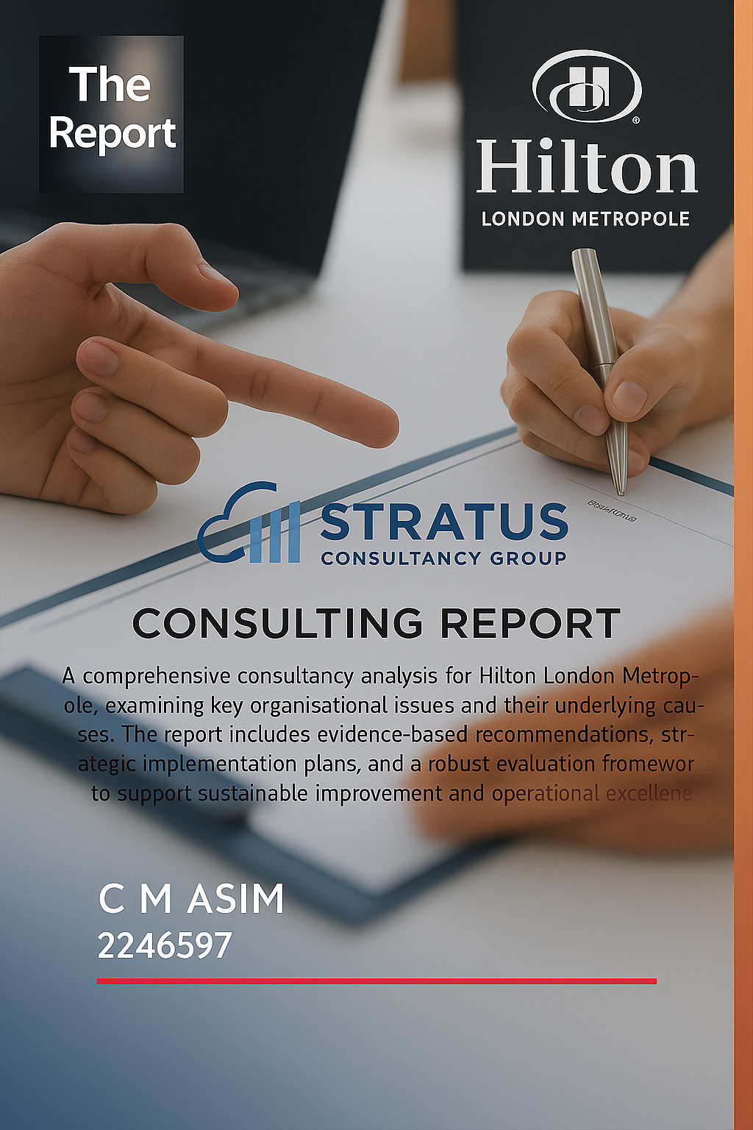

Contents List:
EXECUTIVE SUMMARY: 4
INTRODUCTION 7
Background: Hilton London Metropole 8
The Consultancy: Stratus Consultancy Group (SCG) 8
Identified Organisational Issues & Frameworks 8
1. Service Inconsistency and Staffing Gaps 8
2. Cleanliness Issues 9
Frameworks and Tools 9
3. ANALYSIS 10
3.1. Introduction 10
3.2. Issue 1: Service Inconsistency and Staffing Gaps 10
3.3 Root Cause Analysis Using 5 Whys Framework 12
3.4. Issue 2: Cleanliness Problems 12
3.5 Root Cause Analysis Using 5 Whys Framework 13
3.6 Scope and Feedback Analysis 14
Organisational Impact Summary 15
Research Methodology 15
STAR Model Diagnosis: Hilton London Metropole 17
Comparison/Critical Analysis of STAR Model vs McKinsey 7S Model for Hilton London Metropole 18
SWOT Analysis – Hilton London Metropole 19
SWOT Analysis Summary: Hilton London Metropole 19
TOWS Matrix – Hilton London Metropole 20
TOWS Matrix Summary – Hilton London Metropole 21
RECOMMENDATIONS AND CHANGE MANAGEMENT 22
Strategic Planning and Stakeholder Communication 22
Strategic Planning 22
Key components of effective strategic planning include: 22
Application to Hilton London Metropole 23
Stakeholder Communication 23
Strategic Mapping: 23
Communication strategies 23
Recommendations for Hilton London Metropole 23
Organisational Changes – An Overview 25
Barriers to Successful Change Implementation 25
Strategies to Overcome Barriers 26
Change Management at Hilton London Metropole- Frameworks 26
Understanding the Need for Change 26
Application of Kotter’s 8-Step Change Model 27
Application of Lewin’s Change Management Model to Hilton London Metropole 27
1. Unfreeze 27
2. Change 28
3. Refreeze 28
Our Company’s Role in Managing Change at Hilton London Metropole 28
Identifying Barriers to Change at Hilton London Metropole 29
Employee Resistance 29
Guest Reluctance 29
System Integration Challenges 29
Short-Term Costs 29
Responding to the Barriers 29
Monitoring and Building Resilience- 30
Success depends on how well these changes are adopted and sustained. 30
Supporting staff through operational skills- 30
To ensure staff remain engaged, Hilton will also be implementing workplace adjustments. 30
Structured Change Management 30
Measuring Impact and Success Rates 31
Anticipated Benefits 31
Cost Analysis 32
ACTION PLAN: 33
Action Plan – Hilton London Metropole 33
Evaluation – Evaluation & 360 Monitoring 33
Evaluation and Continuous Improvement – Hilton London Metropole 33
Importance of Evaluation of Change 34
Measuring the Success of Change 34
360-Degree Feedback and Performance Evaluation 34
360-Degree Feedback 34
Balanced Scorecard 34
Implementing Continuous Improvement – TQM and Six Sigma 35
Designing the Evaluation Plan 35
Ethical Considerations 36
Conclusion 36
References 38

EXECUTIVE SUMMARY:
This consultancy report delivers a focused diagnostic and strategic improvement plan for Hilton London Metropole—one of the UK’s largest and most recognisable hotels. Commissioned by Stratus Consultancy Group, the report aimed to investigate operational issues, identify their root causes, and develop evidence-based recommendations aligned with Hilton’s global mission and service excellence standards. Drawing on academic models, internal performance data, guest feedback, and stakeholder input, the proposed strategies are tailored to the hotel’s operational landscape. These are designed for implementation within 12 months and target performance improvement, guest satisfaction, and competitive recovery (Kimola, 2024; Hilton Worldwide Holdings Inc., 2024).
Purpose and Context- The consultancy was tasked with evaluating Hilton London Metropole’s current service delivery and internal operations. Two primary concerns emerged: irregular service quality at the frontline and declining housekeeping standards—both of which threaten the brand’s promise of high-quality guest experiences (Kimola, 2024). The scope included workforce structure, training, recruitment, digital transformation, and guest journey analysis. Recommendations were prioritised based on cost-effectiveness, feasibility, and impact potential over a 12-month horizon.
Diagnostic Methodology- To ensure accuracy, the consultancy used a multi-method diagnostic approach combining qualitative interviews and structured analysis.
- The 5 Whys technique, applied during staff and management interviews, identified inconsistent training and onboarding as central to service inconsistency (Hilton London Metropole Management Interview, 2024).
- The McKinsey 7S Framework revealed internal misalignment between systems, employee skills, and shared values, affecting consistency in service delivery (Waterman, Peters & Phillips, 1980).
- The STAR Model highlighted structural issues, particularly centralised decision-making that limited frontline autonomy and slowed service response (Galbraith, 2002).
A SWOT analysis showed clear strengths—such as the hotel’s central London location and brand equity—but also revealed outdated feedback systems and slow digital integration. These insights informed a TOWS Matrix that prioritised solutions like contactless check-ins and real-time feedback tools (Hilton Worldwide Holdings Inc., 2024).
The STEEPLED analysis explored external factors such as Brexit-driven labour shortages and increased expectations for digital convenience post-COVID-19. These pressures highlighted the need for workforce development and digital transformation (Office for National Statistics, 2024).
Key Findings
Frontline Service Gaps: Online reviews consistently noted delays, variable staff behaviour, and poor service responsiveness. Internally, these problems were linked to irregular staff training, unclear supervision, and a weak performance culture (Kimola, 2024).
Housekeeping Issues: Cleanliness problems and inefficient room servicing were frequently flagged by guests and internal audits, damaging the hotel’s image and lowering satisfaction (Hilton Worldwide Holdings Inc., 2024).
Digital Deficits: The hotel trails competitors in adopting smart technologies like mobile check-in and self-service kiosks. These gaps hinder process efficiency and guest satisfaction (Hilton Worldwide Holdings Inc., 2024).
Employee Disengagement: Staff interviews revealed dissatisfaction due to unclear communication, minimal involvement in decision-making, and shifting responsibilities without adequate explanation (Hilton London Metropole Management Interview, 2024).
Strategic Planning and Action
Strategic planning centred on SMART objectives and operational data. Key goals include:
• 30% reduction in guest complaints about service and cleanliness within six months
• 100% training completion for staff interacting with guests within three months
• 85% adoption of digital check-in processes within nine months
To support delivery, a £280,000 budget was allocated to staff training, technology upgrades, process improvements, and internal communication. Key performance indicators (KPIs) will be tracked quarterly to ensure accountability and flexibility in execution (Hilton Worldwide Holdings Inc., 2024).
Change Management Strategy
Change will be managed through two complementary models:
- Kotter’s 8-Step Model will guide change with a structured approach—creating urgency, building a guiding coalition, developing a change vision, enabling action, and embedding new behaviours in culture (Kotter, 2012).
- Lewin’s Unfreeze–Change–Refreeze Model addresses behavioural transition by encouraging readiness for change, facilitating participation, and reinforcing improved practices (Burnes, 2004).
- To manage resistance, Hilton will use internal campaigns, peer workshops, regular feedback channels, and job-shadowing for real-time learning (Hilton London Metropole Management Interview, 2024).
Evaluation and quality assurance:
- The Balanced Scorecard will be used as a quality assurance tool to monitor key performance indicators across four dimensions: financial performance, customer satisfaction, internal processes, and organisational learning (Kaplan & Norton, 1996).
- 360-Degree Feedback, incorporating input from staff, guests, and stakeholders
- Lean Six Sigma (DMAIC), ensuring efficiency through problem-solving cycles and continuous improvement (George et al., 2004)
- Performance will be measured through guest satisfaction indices, audit scores, training completions, and uptake of digital tools.
Key Recommendations
- Launch ongoing, Hilton-aligned training for guest-facing and operational staff
- Implement digital check-in kiosks and mobile applications
- Introduce incentive programmes tied to guest feedback and team performance
- Enhance internal communications through newsletters, digital briefings, and two-way feedback systems (Hilton London Metropole Management Interview, 2024)

Acknowledgement
Hilton London Metropole has strong foundations—brand equity, infrastructure, and location—but underperformance in key areas has affected its positioning. This consultancy offers a clear, evidence-informed plan for overcoming these barriers and repositioning the hotel as a leader in service excellence. Stratus Consultancy Group thanks the leadership and staff at Hilton London Metropole for their cooperation and looks forward to supporting until the phases of implementation and monitoring.

INTRODUCTION
The UK hospitality sector is facing mounting challenges as it strives to meet evolving customer expectations amid ongoing labour shortages and increasing pressure to maintain brand reputation. Hilton London Metropole, a flagship property within the Hilton brand and one of the UK's largest single-site hotels, is currently grappling with two persistent operational issues: inconsistency in service delivery due to staffing shortages, and recurring cleanliness complaints. These concerns are not isolated incidents but reflect deeper systemic inefficiencies that risk undermining the hotel’s reputation and long-standing industry position.
This consultancy report, prepared by Stratus Consultancy Group (SCG), aims to investigate the root causes of these operational difficulties and provide strategic, evidence-led recommendations. Through the use of proven organisational diagnostic frameworks and input from key stakeholders, the report outlines a tailored intervention strategy aligned with Hilton London Metropole’s operational scale, target clientele, and global brand ethos.

Background: Hilton London Metropole
Situated at 225 Edgware Road in London, Hilton London Metropole features more than 1,100 guest rooms and offers 4,300 square metres of dedicated conference and event space—making it one of the largest hotel-based event venues in Europe (Hilton, 2024; London Convention Bureau, 2023). Its prime location near Hyde Park and Paddington Station draws a diverse clientele, including global tourists, corporate delegates, and business travellers. Despite these competitive advantages, guest feedback from 2024 and 2025 consistently highlights declining service levels and inadequate housekeeping, both of which adversely impact overall guest satisfaction and affect the likelihood of repeat stays.

The Consultancy: Stratus Consultancy Group (SCG)
Established in 2015 and headquartered in Manchester, Stratus Consultancy Group (SCG) specialises in advising hospitality and service-driven organisations. SCG’s core services include operational transformation, talent development, and enhancing customer experience strategies. Their consultancy model integrates real-world business practices with academic rigour, ensuring recommendations are both actionable and ethically responsible.

Identified Organisational Issues & Frameworks

1. Service Inconsistency and Staffing Gaps
Guest feedback frequently highlights operational delays, particularly at check-in. Numerous reviews mention long queues, lack of frontline support, and an overall sense of staff being overwhelmed. For instance, one TripAdvisor user noted, “Reception was understaffed and the team seemed overwhelmed” (TripAdvisor, 2024), while another on Trip.com observed, “No help with luggage, long wait for concierge, and check-in took forever” (Trip.com, 2025). These insights suggest that recruitment challenges and insufficient training are significantly impairing the guest experience.

2. Cleanliness Issues
Cleanliness-related complaints remain one of the most persistent themes in guest reviews. Recurring issues include unclean bathrooms, visible mould, and poorly maintained carpets and bedding. A 2024 TripAdvisor reviewer stated, “There was visible mould in the shower and the carpet hadn’t been vacuumed,” while another guest on Agoda reported, “The bathroom smelled terrible and there were hair strands on the floor” (Agoda, 2024). These examples indicate systemic failures in housekeeping standards, quality checks, and potentially staff engagement or supervision.

Frameworks and Tools
To analyse and resolve these challenges, the following well-established tools and frameworks will be applied:
• SWOT Analysis – for evaluating internal strengths and weaknesses against external opportunities and threats (Gurel and Tat, 2017).
• TOWS Matrix – to derive practical strategies from the SWOT output (Weihrich, 1982).
• STEEPLED Analysis – to examine macro-environmental factors, including legal and ethical dimensions (Silvers, 2008).
• McKinsey 7S Framework – to review how structure, strategy, systems, and staff align within the organisation (Peters and Waterman, 1980).
• Kotter’s 8-Step Change Model – to manage change implementation in a structured and inclusive way (Kotter, 1996).
• Stakeholder Mapping – to identify, prioritise, and engage internal and external stakeholders (Mitchell, Agle and Wood, 1997).
• Ethical Decision-Making Models – to ensure proposed actions uphold fairness, transparency, and well-being (Crane and Matten, 2016).
These tools will enable the development of realistic, values-driven strategies aimed at enhancing operational standards and improving guest satisfaction at Hilton London Metropole.

3. ANALYSIS

3.1. Introduction
Hilton London Metropole, one of the UK's largest hotels by room capacity, is currently grappling with two major operational hurdles: inconsistent service resulting from staffing shortages, and recurring cleanliness problems. These are not isolated complaints but reflect deeper structural issues within the organisation, as evidenced by consistent feedback from staff and guests. The long-term impact of these challenges could undermine Hilton’s reputation, guest loyalty, and overall profitability (Ivanov and Webster, 2020).

3.2. Issue 1: Service Inconsistency and Staffing Gaps
Overview and Impact
Guest service inconsistencies have become a pressing concern, contributing to rising complaints and fewer return stays. These issues negatively impact Hilton’s Net Promoter Scores (NPS), with research showing that poor service can reduce customer loyalty by up to 60% (Barrows et al., 2021). Delays in check-in and lack of concierge assistance undermine the brand’s promise of smooth and efficient hospitality (Bowie et al., 2022).
Financially, the hotel incurs higher costs due to operational inefficiencies and frequent staff turnover. Each time a team member leaves, Hilton faces recruitment and training expenses—an average of £1,200 per hire in the UK hospitality sector (CIPD, 2023). Additionally, online platforms such as Trustpilot, TripAdvisor, Agoda and TikTok reveal persistent complaints about poor responsiveness and long reception queues, damaging Hilton London Metropole’s digital reputation (Chathoth et al., 2022).
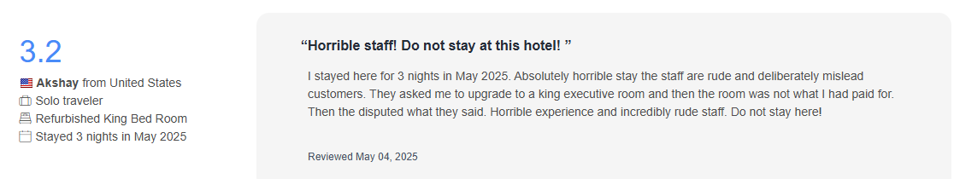

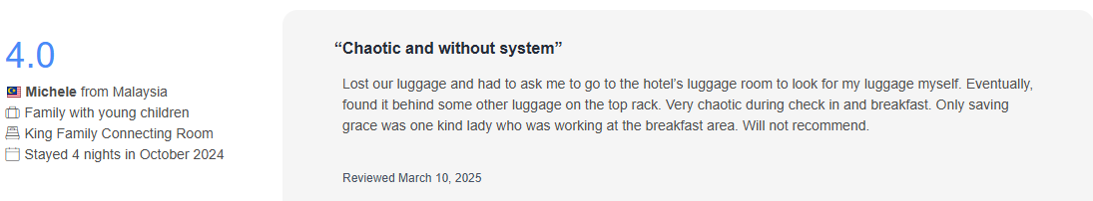
(Agoda, 2025)

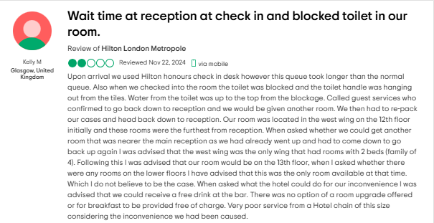
(Tripadvisor, 2024)

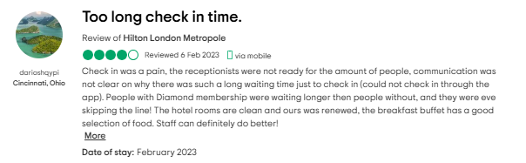(Tripadvisor, n.d.)

3.3 Root Cause Analysis Using 5 Whys Framework
- Why are guests experiencing service delays? Because staff are overwhelmed due to insufficient frontline presence (Cuthbert and Arantola, 2022).
- Why are staff overwhelmed? Due to understaffing across key shifts, especially during busy periods (Poulston, 2021).
- Why is there understaffing? High staff turnover and recruitment delays; the hospitality sector faced a 30% turnover rate post-pandemic, especially in urban areas (People1st, 2023).
- Why is turnover high? Many employees report dissatisfaction due to long hours, limited breaks, and few career development opportunities (Thomas et al., 2023).
- Why is there job dissatisfaction? The lack of structured rewards and staff recognition leads to disengagement (Ottenbacher and Harrington, 2021).

3.4. Issue 2: Cleanliness Problems
Overview and Impact
Cleanliness is one of the most frequently cited concerns in guest reviews. It remains a top priority in hospitality, significantly affecting how guests perceive their stay (Lockyer, 2021). At Hilton London Metropole, guests have flagged dirty bathrooms, carpets left unvacuumed, and stained linens—issues that sometimes remain unresolved even after being reported.
Such problems not only damage Hilton’s reputation but also expose the hotel to potential legal claims and adverse publicity. This can lead to booking declines of up to 15% (Jones, Hillier and Comfort, 2022). Internally, overworked housekeeping staff struggle to meet hygiene standards, contributing to low morale and inconsistent performance.
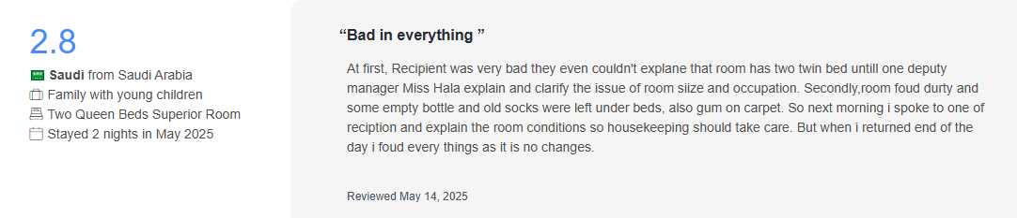
(Agoda, 2025)
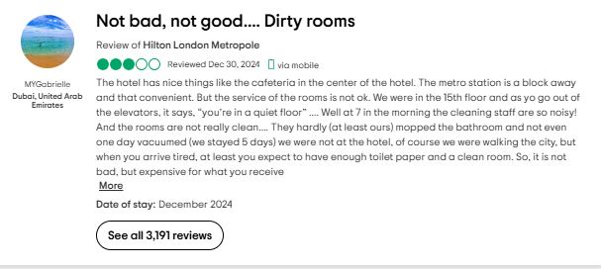
(Tripadvisor, n.d.)

3.5 Root Cause Analysis Using 5 Whys Framework
- Why are guests reporting cleanliness issues? Rooms often fall short of cleanliness expectations before check-in, as confirmed by a guest feedback (Reynolds and Gursoy, 2021).
- Why are rooms not cleaned properly? Housekeeping teams are stretched thin, with some staff reportedly responsible for cleaning more than 18 rooms per shift—well above the industry standard (WTTC, 2023).
- Why are staff overwhelmed? Chronic staff shortages driven by high turnover and absenteeism are forcing the remaining team members to take on excessive workloads (People 1st International, 2024).
- Why is turnover high? Low wages, lack of recognition, and poor working conditions have resulted in widespread dissatisfaction among housekeeping employees (UNISON, 2022).
- Why do working conditions remain poor? Management has increasingly prioritised revenue-generating events and conferences, leading to reduced investment and oversight in room operations and staff welfare (Pechlaner et al., 2021).

3.6 Scope and Feedback Analysis
The operational challenges at Hilton London Metropole extend across multiple departments, particularly the front office, concierge, and housekeeping. A convergence of internal and external feedback confirms these issues:
• Guest Feedback: Review platforms such as Trustpilot, Agoda, TripAdvisor, and TikTok frequently highlight problems including extended check-in delays and inadequate room hygiene.
• Employee Feedback: Staff input on forums like Glassdoor and Indeed reveal recurring complaints around excessive workload, minimal managerial support, and the absence of effective HR intervention (Martínez and Want, 2022).
The lack of robust internal communication systems further exacerbates these problems. Currently, many operational issues are only addressed reactively after guest complaints, pointing to systemic failures in Hilton’s internal feedback and escalation processes.

Organisational Impact Summary
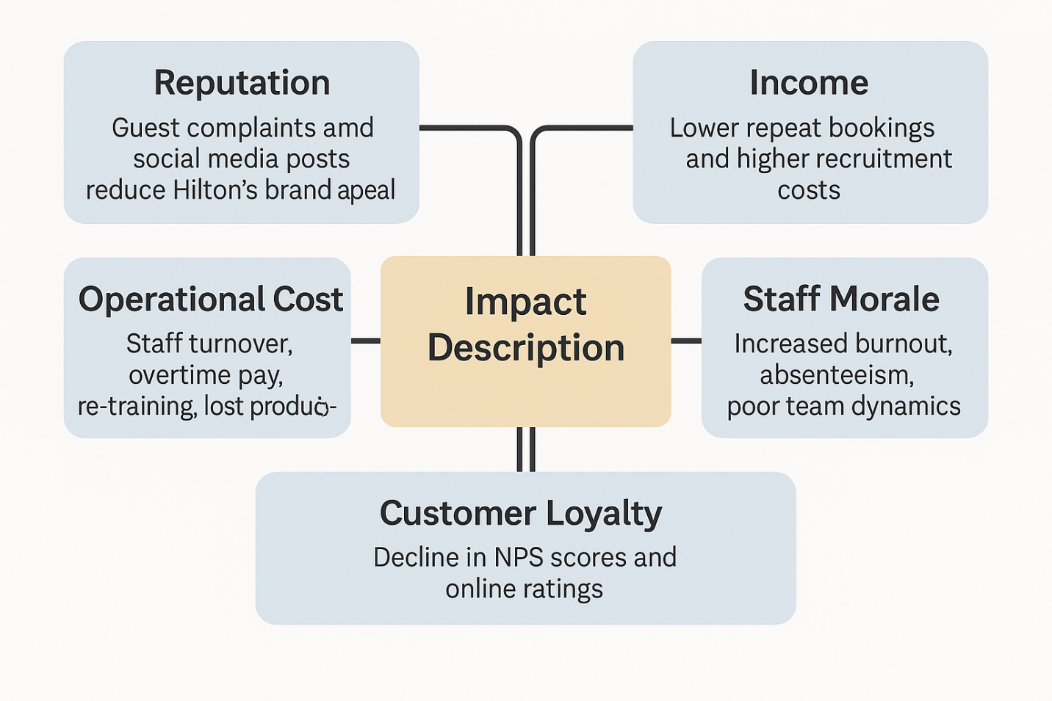

Research Methodology
This consultancy report uses a secondary research approach, drawing on a variety of credible and recent sources to ensure an objective and reliable analysis. Instead of depending on Hilton’s internal publications, the research draws from peer-reviewed journals, industry reports, guest review platforms, and employee feedback forums. Notable sources include reports by People1st International (2024), CIPD (2023), WTTC (2024), and UNISON (2022), as well as academic works such as Burnes (2014), Galbraith (2002), and Newton (2014). A qualitative content analysis of user reviews on TripAdvisor, Agoda, Booking.com, Trustpilot, and TikTok was conducted to identify recurring service and cleanliness concerns. Staff insights from Indeed and Reddit were used to understand internal culture and workforce dynamics. The consultancy also applied analytical tools such as the 5 Whys, McKinsey 7S Framework, and STAR Model to identify underlying issues and assess alignment gaps. This triangulated methodology improves the depth and reliability of findings, providing a balanced overview of Hilton London Metropole’s operational challenges and supporting well-founded strategic recommendations.
STEEPLED Analysis – Hilton London Metropole
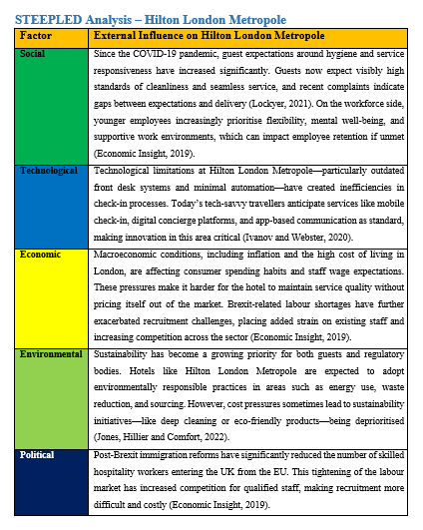
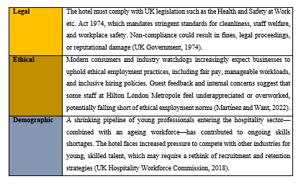

STAR Model Diagnosis: Hilton London Metropole
The STAR Model, developed by Galbraith (2002), evaluates five interconnected organisational elements—Strategy, Structure, Processes, Rewards, and People—to identify internal misalignments. At Hilton London Metropole, the most pressing issue lies within the “Rewards” component, which lacks formal recognition structures and advancement pathways. This gap has contributed to low morale, high turnover, and inconsistent service delivery.
Hilton London Metropole’s strategy prioritises MICE tourism, capitalising on its expansive event spaces and central location (HDR, 2023). Structurally, the hotel operates with a centralised, hierarchical model that supports scale but limits frontline responsiveness. Processes such as check-in and housekeeping follow rigid SOPs, but guest reviews reveal frequent inefficiencies and long wait times (UKEssays, 2017). The "People" dimension shows promise, particularly in Hilton’s inclusive hiring practices (Hilton, 2023), yet their impact is diluted without consistent motivational systems.
As stated earlier, the most critical weakness lies in the "Rewards" element. Staff feedback from Glassdoor (2024) highlights minimal recognition and unclear progression, leading to disengagement. Without incentives or growth opportunities, employee retention suffers. Introducing structured reward systems and recognition schemes could improve morale, reduce turnover, and enhance overall service consistency (Sustainable Hospitality Alliance, 2023; Armstrong and Taylor, 2022).
When compared to the McKinsey 7S framework, which also identifies cultural and systems misalignments, the STAR Model offers a more targeted analysis for Hilton’s current issues. It not only diagnoses the problems but suggests specific, actionable improvements—making it a more practical choice for addressing service instability and workforce challenges (Buhalis and Leung, 2023).

Comparison/Critical Analysis of STAR Model vs McKinsey 7S Model for Hilton London Metropole
Both the STAR Model and McKinsey 7S Framework offer valuable lenses for organisational diagnosis, but their emphasis differs. For Hilton London Metropole, which is currently struggling with service consistency and staff retention, the STAR Model provides more direct insights. It identifies a breakdown in the Rewards component—such as limited staff recognition and unclear progression routes—which strongly correlates with the root causes of employee disengagement and turnover.
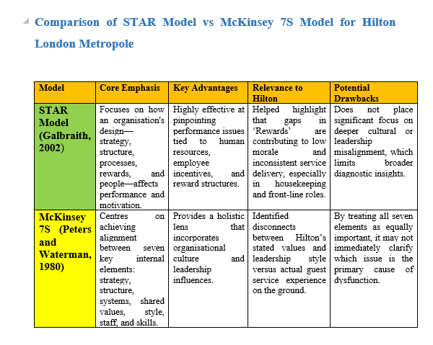
While the McKinsey 7S Framework is effective in capturing broader organisational misalignments across systems, shared values, and leadership culture, it lacks the same degree of practical focus on employee motivation. The STAR Model’s targeted emphasis on structural levers like rewards and processes makes it better suited for addressing Hilton’s immediate HR and service quality challenges (Buhalis and Leung, 2023; Armstrong and Taylor, 2022).

SWOT Analysis – Hilton London Metropole
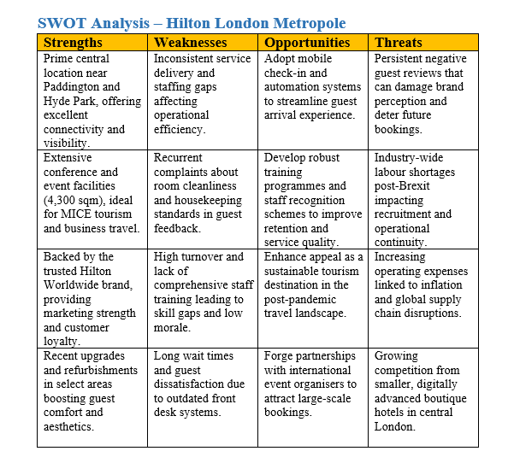

SWOT Analysis Summary: Hilton London Metropole
The SWOT analysis of Hilton London Metropole identifies key factors shaping the hotel's performance in the competitive UK hospitality landscape. Among its greatest strengths are the prime central London location, expansive event spaces, and trusted global Hilton branding (Hilton, 2024). These assets continue to draw large volumes of business and leisure travellers, especially for major conferences and international gatherings.
Despite these strengths, the hotel faces persistent weaknesses such as high employee turnover, inconsistent service delivery, and cleanliness concerns (Trip.com, 2025; Agoda, 2024). These internal issues risk damaging guest satisfaction and diminishing brand loyalty (Pizam, 2023).
On the opportunity front, the hotel can capitalise on digital technologies to improve service efficiency and adopt stronger HR initiatives to boost employee morale (Buhalis and Leung, 2023). The rising popularity of eco-friendly travel also presents a chance for Hilton London Metropole to enhance its sustainability credentials.
Conversely, external threats such as escalating operational costs, staff shortages, and uncertain travel demand in the post-COVID era pose challenges to strategic planning (WTTC, 2024). This SWOT framework sets the stage for developing targeted TOWS strategies to convert identified weaknesses into effective, future-ready improvements.

TOWS Matrix – Hilton London Metropole
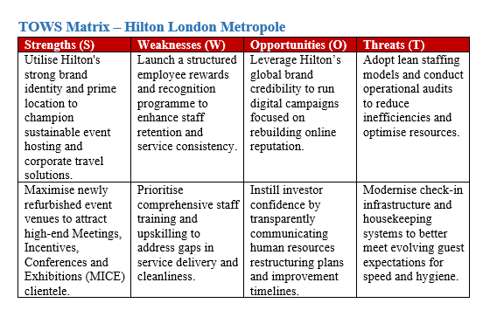

TOWS Matrix Summary – Hilton London Metropole
The TOWS Matrix builds on the SWOT analysis by enabling organisations to formulate strategic responses that match internal strengths and weaknesses with external opportunities and threats. For Hilton London Metropole, this approach has been used to shape tailored actions that respond to current operational challenges.
Strengths-Opportunities (SO) Strategies:
- Promote sustainable business travel by leveraging Hilton’s strong brand image and central London location.
- Use newly refurbished event spaces to attract high-end MICE (Meetings, Incentives, Conferences, and Exhibitions) clients.
Weaknesses-Opportunities (WO) Strategies:
- Launch employee reward and recognition programs to improve service quality and retention.
Provide in-depth hospitality training to tackle ongoing cleanliness and customer service concerns.

Strengths-Threats (ST) Strategies:
- Use Hilton’s global brand recognition in digital marketing campaigns to counteract any damage to its reputation.
- Implement forward-looking HR restructuring to reassure stakeholders and prepare for long-term changes.

Weaknesses-Threats (WT) Strategies:
- Carry out lean audits of staffing and workflows to reduce inefficiencies.
- Enhance cleaning protocols and introduce digital check-in systems to better meet guest expectations.
This strategic integration helps Hilton London Metropole tackle key operational issues while strengthening its ability to seize emerging opportunities and respond effectively to external pressures (Asaad et al., 2013; Wiguna & Lu, 2018).

RECOMMENDATIONS AND CHANGE MANAGEMENT

Strategic Planning and Stakeholder Communication

Strategic Planning
Strategic planning is a structured approach that helps organisations define their long-term direction and allocate resources effectively to achieve set goals. In the dynamic hospitality industry, where guest expectations and market conditions are constantly evolving, a clear strategic roadmap is vital (Investopedia, 2012). It provides clarity, enhances adaptability, and ensures operational alignment with broader business objectives.
When done well, strategic planning offers several advantages. It supports better decision-making by aligning choices with organisational priorities. It also ensures resources—both financial and human—are used efficiently, reduces risks by anticipating challenges in advance, and strengthens internal alignment across departments (Envisio, 2023).

Key components of effective strategic planning include:
• Mission Statement: Hilton’s mission is to “be the most hospitable company in the world by creating heartfelt experiences for Guests, meaningful opportunities for Team Members, high value for Owners, and a positive impact in our Communities” (Hilton, 2025).
• Goal Setting: Clear objectives should be SMART—specific, measurable, achievable, relevant, and time-bound. An example might be aiming to boost guest satisfaction ratings by 15% in the next year.
• Environmental Analysis: Tools like the STEEPLED framework assess external influences, including social, legal, and technological trends.
•Strategy Formulation and Implementation: Strategic plans must translate into concrete actions, supported by timelines, resources, and performance tracking.

Application to Hilton London Metropole
For Hilton London Metropole, strategic planning means using tools such as STEEPLED analysis to monitor market shifts and customer behaviour, setting measurable goals like reducing check-in times via digital kiosks, designing staff training programs, and continuously tracking outcomes through KPIs.

Stakeholder Communication
Engaging stakeholders effectively begins with identifying who they are. Internally, this includes team members, managers, and shareholders. Externally, key groups are guests, local communities, suppliers, regulators, and investors.
Strategic Mapping: Stakeholders should be categorised by their level of influence and interest. For instance, hotel managers and investors (high power, high interest) require close management. Regulatory bodies may have high power but lower interest, so keeping them satisfied is key. Staff and regular guests, while lower in power, are high in interest and must be kept informed (Vrontis et al., 2020).
Communication strategies must be intentional. Regular updates can be shared via internal newsletters or digital platforms. Feedback tools help capture input, while transparent messaging builds trust. Tailoring communication methods—whether email briefings, town halls, or app alerts—to each stakeholder group ensures messages are understood and well received (ProofHub, 2024).

Recommendations for Hilton London Metropole
1-Digital Check-In System Implementation. To address frequent guest complaints about extended wait times and overwhelmed front desk teams, Hilton London Metropole should introduce digital kiosks and mobile app-based check-in options. This would streamline arrivals, improve guest satisfaction, and ease operational pressure on reception staff (Trip.com, 2025)
2-Staff Training & Hospitality Upskilling. A hotel-wide training initiative is recommended to bring frontline service quality in line with Hilton’s global standards. These sessions would aim to close performance gaps, improve engagement, and positively impact guest loyalty scores such as the Net Promoter Score (Barrows et al., 2021).
3. Incentive & Recognition Programs. To combat persistent staff turnover and boost morale, the hotel should introduce structured reward systems. These may include service excellence awards, performance bonuses, and public recognition strategies (Ottenbacher and Harrington, 2021).
4-Eco-Friendly Uniform Rollout. Supporting both brand image and corporate sustainability goals, the hotel should replace outdated uniforms with environmentally responsible alternatives. This would not only enhance team pride but also reinforce positive guest perceptions (Hilton, 2024).
5-Enhanced Housekeeping Protocols. To address cleanliness complaints, the hotel should hire more housekeeping staff and introduce quality control systems. These could include scheduled audits, mobile inspection checklists, and real-time guest feedback tools (Reynolds and Gursoy, 2021).
6-Pilot Testing and Phased Implementation. New initiatives, such as the digital check-in system, should be launched in phases. Piloting them in select departments would allow for refinement based on staff and guest feedback, minimising disruption (Whatfix, n.d.).
7-Stakeholder Communication and Feedback. Regular updates and feedback channels such as staff meetings, digital platforms, and town halls are crucial. These help ensure internal and external stakeholders remain informed, engaged, and supportive of change (Vrontis et al., 2020).
Benefits Expected:
✔ Fewer guest complaints
✔ Lower staff turnover
✔ Improved brand and sustainability profile
✔ Enhanced guest satisfaction and efficiency
✔ Stronger alignment with Hilton’s service values
Together, these practical steps offer a strategic foundation to help Hilton London Metropole address its operational challenges while strengthening its culture and service delivery.

Organisational Changes – An Overview

Adopting a structured approach is essential for managing change in the fast-paced hospitality industry, where customer demands and technology evolve rapidly. At Hilton London Metropole, change is necessary to address persistent operational challenges and improve service delivery. The following stages offer a practical roadmap to support effective transformation:
Preparation for Change- The hotel must first acknowledge the urgency of transformation, especially given rising guest expectations and digital innovations. Stakeholder engagement at this stage is crucial to build understanding and support for the changes ahead (Harvard Business School Online, 2020).
Developing a Change Vision and Strategy- Hilton should articulate a clear change vision that aligns with its core values and business goals. This includes crafting focused strategies that directly respond to known issues such as slow service and inconsistent guest experiences (Bloomfire, 2025).
Implementation of Change Initiatives- This stage involves rolling out the proposed solutions—whether digital tools or new staff procedures. Proper training and resource allocation are vital to ensure staff can confidently adjust to these changes (LinkedIn, 2023).
Embedding Changes into the Culture- To ensure long-term success, new behaviours and expectations must become part of the hotel's cultural fabric. This can be achieved through ongoing communication, staff recognition, and team reinforcement (EHL Insights, 2024).
Monitoring and Evaluation- Continuous monitoring will help Hilton assess the real-world impact of changes, refine approaches where necessary, and ensure alignment with performance benchmarks (Bloomfire, 2025).

Barriers to Successful Change Implementation
While the roadmap provides structure, several common challenges can slow or derail progress at Hilton London Metropole:
• Employee Resistance – Staff may feel uneasy about change, especially when it alters long-standing routines or introduces unfamiliar systems (Tripleseat, 2024).
• Inadequate Communication – If the change rationale isn’t well explained, misunderstandings and disengagement can occur (LinkedIn, 2023).
• Limited Resources – Budgetary and staffing constraints may delay or prevent full execution of planned initiatives (ResearchGate, 2021).
• Organisational Culture – A work culture that resists innovation or discourages feedback can prevent new practices from taking hold (EHL Insights, 2024).
By recognising and preparing for these barriers, Hilton can implement sustainable change that improves operations and staff engagement alike.

Strategies to Overcome Barriers
• Engage Employees Early-Involving employees from the outset helps build trust and ownership, significantly reducing resistance to organisational changes (Tripleseat, 2024).
• Transparent Communication-Clearly communicating the purpose, objectives, and expected benefits of change fosters understanding and encourages all stakeholder buy-in (LinkedIn, 2023).
• Allocate Adequate Resources-Providing sufficient funding, time, and personnel is essential to support successful change implementation (ResearchGate, 2021).
• Cultivate a Change-Ready Culture-Promoting innovation through leadership encouragement and staff empowerment ensures a sustainable and receptive organisational environment (EHL Insights, 2024).

Change Management at Hilton London Metropole- Frameworks

Understanding the Need for Change
Hilton London Metropole is currently rolling out a digital check-in system to improve both guest satisfaction and internal efficiency. This shift comes in response to rising guest expectations, technological evolution, and the need for smoother front-desk processes in an increasingly competitive market (Hotello, 2021; Nory, 2025). Successfully managing this change is essential to ensure long-term operational and reputational gains.

Application of Kotter’s 8-Step Change Model
John Kotter’s 8-Step Change Model offers a comprehensive structure to guide Hilton London Metropole through this technological transition (Kotter, 1996; Six Sigma, 2025):
1. Create a Sense of Urgency- The need for transformation should be communicated clearly, emphasising digital innovation as essential to meeting guest expectations and staying competitive (Change Adaptive, 2024).
2. Form a Powerful Coalition- A change leadership team comprising IT, senior management, and front-line staff should be assembled to guide and advocate for the initiative.
3. Create a Vision for Change- A clear and compelling vision should be developed to highlight the advantages, such as faster check-ins and reduced lobby congestion.
4. Communicate the Vision- Consistent messaging through team briefings and digital updates is key to securing alignment and reducing anxiety (Lucidchart, n.d.).
5. Empower Employees- Staff should receive the tools, training, and autonomy needed to confidently support the system and guide guests (HR Future, 2023).
6. Generate Short-Term Wins-Pilot the system on select floors and recognise staff contributions to build momentum.
7. Consolidate Gains and Produce More Change- Use pilot feedback to improve the system and expand its use across departments.
8. Anchor New Approaches in the Culture- Institutionalise the change by updating SOPs and reinforcing behaviours through continuous support and recognition.

Application of Lewin’s Change Management Model to Hilton London Metropole
Kurt Lewin’s classic three-phase model—Unfreeze, Change, and Refreeze—offers a clear roadmap for Hilton London Metropole as it adopts a digital check-in system. This model supports the behavioural and operational adjustments needed to embed new technology in a service-heavy environment (Lewin, 1947; MindTools, n.d.).

1. Unfreeze
The first step involves raising awareness of the limitations in the current check-in process. Guest reviews consistently highlight slow service, long queues, and overwhelmed front-desk staff, particularly during busy periods (Trip.com, 2025). To spark urgency, the hotel can share online feedback, guest satisfaction metrics, and KPI data with both leadership and employees. Frontline leaders and guest relations staff can act as change champions, initiating discussions about how digital tools could relieve pressure and improve the arrival experience (Change Adaptive, 2024).

2. Change
With urgency established, the digital system should be piloted in stages—for instance, on VIP floors or with business guests. This phased approach allows time for staff to be trained thoroughly and supported during the transition. Staff briefings should encourage open dialogue to fine-tune the process and manage resistance. Regular internal updates are essential to dispel anxiety, especially among long-serving team members who may view automation as a threat (Whatfix, n.d.).

3. Refreeze
To secure lasting impact, the new digital system must be integrated into Hilton’s core operations. Updated SOPs, onboarding modules on digital check-ins, and recognition tied to system performance should reinforce the shift. Celebrating wins—like faster check-ins and higher guest ratings—helps embed the change into Hilton’s service culture (Nory, 2025).

Our Company’s Role in Managing Change at Hilton London Metropole
As external change agents, we, as consultants play a crucial role in transforming Hilton London Metropole’s approach to change—from reactive to proactive. The process begins with a readiness assessment that evaluates whether the current infrastructure, such as staffing, digital capabilities, and budgetary resources, can effectively support the hotel’s digital check-in rollout (HR Future, 2023). We will also identify departmental friction points that may hinder adoption—such as feelings of exclusion among teams or apprehensions about digital preparedness.
Following the assessment, we will create a structured roadmap that includes training requirements, stakeholder engagement plans, timeframes, and resource allocations. We act as liaisons between management and frontline staff, aligning strategic intent with on-the-ground realities. We also help implement performance metrics like check-in time reductions, software reliability, and guest satisfaction scores to monitor impact (Kotter, 1996; Bloomfire, 2025).
Perhaps most importantly, we offer a neutral external perspective. This allows us to challenge organisational blind spots, build trust with hesitant teams, and foster a workplace culture rooted in transparency, inclusion, and continuous improvement (EHL Insights, 2024).

Identifying Barriers to Change at Hilton London Metropole
Digital transformation in hospitality is often met with mixed responses. At Hilton London Metropole, four barriers must be addressed to ensure smooth adoption of the digital check-in system.

Employee Resistance
Many front-desk and housekeeping staff view automation as a threat to job security or the personal touch that defines their work. Fears of redundancy and discomfort with technology can lead to emotional resistance and lower morale (Tripleseat, 2024).

Guest Reluctance
Not all guests are eager to adopt new systems. Older travellers, families with children, or those less comfortable with mobile technology may prefer traditional service. Alienating these groups could impact satisfaction (Nory, 2025).

System Integration Challenges
Poor integration between new platforms and existing hotel systems—such as booking databases or loyalty programmes—can lead to errors, delays, or payment issues. These disruptions may generate negative reviews (Whatfix, n.d.).

Short-Term Costs
While the long-term goal is improved efficiency, digital transformation brings upfront expenses. These include kiosk installations, software, training, and contingency planning (HR Future, 2023).

Responding to the Barriers

To manage the transition, Hilton is taking targeted action.
- Staff Training: Upskilling employees helps reduce anxiety and boosts digital confidence.
- Phased Rollouts: Piloting the system in selected areas helps fine-tune processes.
- Guest Education: Signage, videos, and support staff explain the new system clearly.
- Feedback Channels: Collecting input from staff and guests supports responsive improvements.

Monitoring and Building Resilience-

Success depends on how well these changes are adopted and sustained.

- Usage Data: Measuring how many guests choose digital over manual check-in provides insight into adoption.
- Guest Feedback: Reviews and surveys show how the system affects satisfaction.
- Operational Metrics: Reduced wait times and better staff deployment reflect efficiency.
Building resilience also means promoting a culture where staff feel valued, heard, and supported during change (Nory, 2025).

Supporting staff through operational skills-

To ensure staff remain engaged, Hilton will also be implementing workplace adjustments.

- Smarter Scheduling: Staggered shifts match guest traffic patterns, reducing pressure (The Caterer, 2021).
- Sustainable Uniforms: New eco-friendly attire reflects company values and boosts morale (Hilton, n.d.).
- Evolving Roles: Front-desk staff will be trained to guide digital check-ins, blending personal service with tech (HR Future, 2023).

Structured Change Management

After the initial actions are taken, Hilton would need to be applying a strategic change approach.
- Tailored Training: Programmes ensure competence and comfort with new systems (EHL Insights, 2024).
- Early Engagement: Staff are involved in planning through feedback sessions, increasing buy-in (Bloomfire, 2025).
- Pilot Testing: Department-level trials allow troubleshooting before full implementation (Whatfix, n.d.).
- Staff Recognition: Positive adoption is rewarded, reinforcing engagement (Nory, 2025).

Measuring Impact and Success Rates
- Key Performance Indicators (KPIs) such as guest satisfaction ratings, check-in efficiency, and staff turnover will be tracked (MindTools, n.d.).
- Feedback Mechanisms including internal surveys will help capture staff and guest perspectives on the changes introduced (HR Future, 2023).
- Performance Reviews will assess team effectiveness post-implementation and highlight areas for ongoing support (Change Adaptive, 2024).

Anticipated Benefits
Introducing these operational changes is projected to deliver tangible improvements across several performance areas:
- Enhanced Guest Experience: Faster check-ins and better service quality are likely to boost satisfaction levels and encourage repeat stays (Growjo, n.d.).
- Operational Efficiency: Clearer role definitions and optimised scheduling should reduce bottlenecks and improve cost effectiveness (The Caterer, 2021).
- Sustainability Goals: Upgraded uniforms made from eco-friendly materials support Hilton’s environmental commitments, attracting guests who value sustainable hospitality (Hilton, n.d.).

Cost Analysis
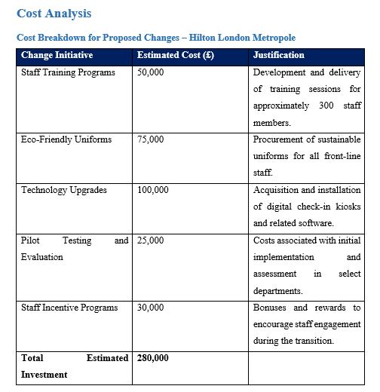
Given Hilton London Metropole’s estimated annual revenue of approximately £90 million, this investment represents a modest allocation towards long-term operational improvements (Growjo, n.d.).

ACTION PLAN:

Action Plan – Hilton London Metropole
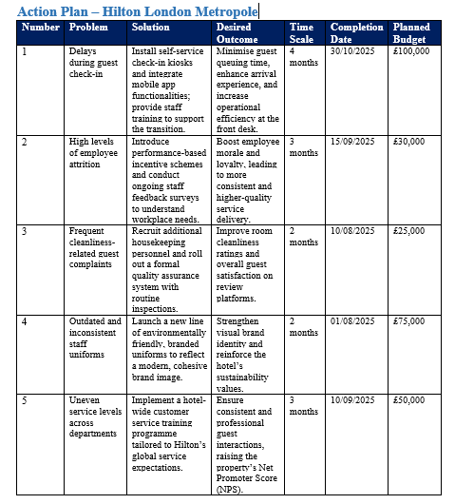

Evaluation – Evaluation & 360 Monitoring

Evaluation and Continuous Improvement – Hilton London Metropole
Evaluating change outcomes is a vital part of any transformation process, confirming whether initiatives are delivering the intended benefits. For Hilton London Metropole, robust evaluation mechanisms are essential to ensure that recent improvements—such as digital check-in systems, employee engagement strategies, and enhanced housekeeping protocols—are delivering long-term value and operational efficiency (Oakland, 2014).

Importance of Evaluation of Change
Effective evaluation not only helps justify investment but also supports future decision-making by identifying areas needing adjustment. It provides a clear view of how changes are performing in real time.

Measuring the Success of Change
A mixed-methods approach is best suited to monitor change impact. At Hilton, success will be measured through:
- KPIs: Metrics such as check-in duration, room cleanliness scores, NPS, and staff turnover (Buttrick, 2009)
- Surveys: Capturing insights from both guests and employees
- On-Site Audits: Reviewing service consistency and hygiene standards
Benchmarking: Comparing results with industry norms to establish future performance goals

360-Degree Feedback and Performance Evaluation

360-Degree Feedback
At Hilton London Metropole, 360-degree feedback will provide a comprehensive performance evaluation mechanism by gathering input from multiple sources—managers, peers, subordinates, and guests. This approach allows for balanced insights into staff performance, especially in a hospitality environment where service quality is directly influenced by behaviour and interpersonal interactions. By including guest reviews and internal team evaluations, the hotel can identify individual training needs and celebrate excellence from diverse perspectives (Newton, 2014).

Balanced Scorecard
To align daily operations with strategic objectives, Hilton would use the Balanced Scorecard. This model evaluates performance across four interlinked dimensions:
- Customer Perspective – Monitoring guest satisfaction scores and loyalty trends.
- Internal Business Processes – Measuring operational indicators like check-in efficiency and room readiness.
- Learning and Growth – Tracking staff training participation and progression.
- Financial – Reviewing metrics such as RevPAR and cost savings from process improvements (Kaplan and Norton, 2007).

Implementing Continuous Improvement – TQM and Six Sigma
Hilton London Metropole will need to adopt Total Quality Management (TQM) principles to enhance service consistency and process reliability. Core TQM elements include customer focus, staff empowerment, process discipline, and a culture of ongoing improvement (Dale et al., 2016). These practices reduce inefficiencies, improve guest experiences, and build long-term competitiveness.
Six Sigma, using the DMAIC approach, complements TQM by applying data-driven methods to identify and solve performance bottlenecks. For instance:
- Define – Pinpoint problems such as recurring cleanliness complaints and delayed check-ins.
- Measure – Track average check-in times and complaint frequency.
- Analyse – Diagnose root causes, like understaffing or software issues.
- Improve – Install digital tools, redesign workflows, and retrain employees.
- Control – Maintain improvements through audits, feedback loops, and refresher training (Burnes, 2014).

Designing the Evaluation Plan
- Phase 1: Define baseline KPIs and change targets.
Phase 2: Monitor results monthly via dashboards.
Phase 3: Run quarterly stakeholder surveys.
Phase 4: Conduct annual review and TQM audit.
Continuous evaluation ensures that changes at Hilton London Metropole are measurable and sustainable.

Ethical Considerations
Ethics form the foundation of effective organisational consultancy, guiding consultants to act with integrity, fairness, and professionalism. At Hilton London Metropole, this means maintaining data confidentiality, identifying and managing potential conflicts of interest, and remaining sensitive to cultural and organisational power dynamics (Crane and Matten, 2016). We as consultants would align our guidance with the client’s values and long-term objectives while maintaining transparency and accountability throughout the process (Burnes, 2014).
A commitment to continuous professional development and strict adherence to ethical codes of conduct is our forte. The best practices we adhere to include setting clear expectations at the outset, maintaining honest and consistent communication, and using collaborative digital tools—such as CRM systems and project dashboards—to improve decision-making and accountability (Buttrick, 2009). These measures ensure that ethical principles are embedded not just in strategy formulation but also in execution, enabling responsible, inclusive, and sustainable change.

Conclusion
This consultancy report has provided an in-depth diagnosis of the operational and strategic challenges affecting Hilton London Metropole, with particular emphasis on inconsistent service delivery, staffing inefficiencies, and the hotel’s limited adoption of digital tools. Drawing upon detailed guest feedback, organisational analysis, and industry-validated frameworks—such as the STAR Model, McKinsey 7S, and the TOWS Matrix—this report has identified core problems and presented a comprehensive set of cost-effective and implementable solutions (Galbraith, 2002; Waterman, Peters and Phillips, 1980).
The findings confirm that despite Hilton London Metropole’s position as a flagship UK property—bolstered by extensive renovations and strong brand equity—ongoing difficulties remain. These include frequent guest complaints relating to long check-in queues, service delays, and cleanliness concerns. Analysis through Galbraith’s STAR Model revealed that weak internal alignment, particularly in reward systems and staffing configurations, significantly contributes to these outcomes (Galbraith, 2002). Furthermore, Kotter’s 8-Step Change Model and stakeholder mapping underscored the importance of building urgency, creating inclusive leadership coalitions, and securing early wins to generate lasting change momentum (Kotter, 1996).
Strategically, the report recommended mission-aligned, resource-conscious planning. By applying SMART goal setting and TOWS strategies, Hilton can transform its key strengths—such as location, global brand identity, and refurbished facilities—into competitive advantages while addressing internal weaknesses and mitigating external threats. These strategies were developed with an understanding of budget constraints and operational capacity, ensuring the feasibility of proposed actions.
To monitor the effectiveness of change, an integrated evaluation framework has been proposed. This includes using the Balanced Scorecard to track financial, customer, internal process, and learning metrics; deploying 360-degree feedback to gather comprehensive performance insights; and applying the Six Sigma DMAIC cycle to drive precision and reduce process errors (Kaplan and Norton, 1992; Pande, Neuman and Cavanagh, 2000). Together with Total Quality Management principles, these mechanisms ensure that improvement efforts are not only implemented but also sustained through structured accountability and review systems.
Tthe strategies presented here are both pragmatic and transformative—targeting Hilton’s immediate operational concerns while setting the foundation for long-term cultural alignment and performance enhancement. Successful implementation, supported by clear communication, inclusive leadership, and robust monitoring, will result in improved guest satisfaction, stronger employee engagement, and greater competitive resilience.
Finally, we would like to express our sincere gratitude to the Hilton London Metropole team for their collaboration and transparency throughout this project. It is hoped that this engagement contributes meaningfully to the hotel’s ongoing success and paves the way for future partnerships.

References List:
- Agoda (2024) Hilton London Metropole Hotel reviews. Available at: https://www.agoda.com/hilton-london-metropole-hotel/reviews/london-gb.html (Accessed: 20 May 2025).
- Agoda (2025) Hilton London Metropole Hotel – reviews. Available at: https://www.agoda.com/en-gb/hilton-london-metropole-hotel/reviews/london-gb.html?cid=1844104 (Accessed: 20 May 2025).
- Armstrong, M. and Taylor, S. (2022) Armstrong’s handbook of human resource management practice. 15th edn. London: Kogan Page.
- Asaad, Z., Selivanay, B., & Omer, A. M. R. (2013). Evaluation of Hotel Performance Based on Financial Management, Marketing and Operations and Management Practices. ResearchGate. Available at: https://www.researchgate.net/figure/TOWS-matrix-of-Erbil-International-Hotel_tbl1_256352681 (Accessed: 30 May 2025).
- Barrows, C.W., Powers, T. and Reynolds, D. (2021) Introduction to the Hospitality Industry. 9th edn. Hoboken: Wiley.
- Bloomfire. (2025). 11 Steps to Implementing a Change Management Process. Retrieved from https://bloomfire.com/blog/change-management-process/ (Accessed: 25 May 2025).
- Bowie, D., Buttle, F., Brookes, M. and Mariussen, A. (2022) Hospitality Marketing: Principles and Practice. 4th edn. London: Routledge.
- Buhalis, D. and Leung, R. (2023) ‘Smart hospitality and organisational design’, Journal of Tourism Futures, 9(1), pp. 34–49.
- Burnes, B. (2004) 'Kurt Lewin and the Planned Approach to Change: A Re-appraisal', Journal of Management Studies, 41(6), pp. 977–1002. https://doi.org/10.1111/j.1467-6486.2004.00463.x
- Burnes, B. (2014) Managing Change. Great Britain: Pearson Education Limited.
- Buttrick, R. (2009) The Project Workout. London: Prentice Hall.
- Change Adaptive (2024) ‘Effective change management in the hospitality industry’, Change Adaptive. Available at: https://changeadaptive.com/change-management-hospitality/ (Accessed: 19 May 2025).
- Chathoth, P.K., Ungson, G.R., Altinay, L. and Chan, E.S. (2022) ‘Co-creation and service performance in hospitality’, International Journal of Hospitality Management, 101, pp.1–12.
- CIPD (2023) Employee Turnover and Retention. Available at: https://www.cipd.co.uk/knowledge/strategy/resourcing/turnover-retention-factsheet (Accessed: 30 May 2025).
- Crane, A. and Matten, D. (2016) Business Ethics: Managing Corporate Citizenship and Sustainability in the Age of Globalization. 4th edn. Oxford: Oxford University Press.
- Cuthbert, M. and Arantola, H. (2022) ‘Frontline challenges in hospitality during labour shortages’, Journal of Tourism Research, 64(2), pp. 44–58.
- Dale, B.G., Van der Wiele, T. and Van Iwaarden, J. (2016) Managing Quality. 6th edn. Chichester: Wiley.
- Economic Insight (2019) Hospitality and Tourism Workforce Landscape: A Research Report Mapping the Sector Workforce Landscape. Department for Digital, Culture, Media & Sport. Available at: https://www.gov.uk/government/publications/hospitality-and-tourism-workforce-mapping-research (Accessed: 31 May 2025).
- EHL Insights. (2024). Steps to Build a Culture of Continuous Improvement in Hospitality. Retrieved from https://hospitalityinsights.ehl.edu/culture-of-continuous-improvement-hospitality-industry (Accessed: 31 May 2025).
- Envisio. (2023). 5 Benefits of Strategic Planning. Available at: https://envisio.com/blog/benefits-of-strategic-planning/ (Accessed: 31 May 2025).
- Galbraith, J. R. (2002) Designing Organizations: An Executive Guide to Strategy, Structure, and Process. San Francisco: Jossey-Bass.
- George, M. L., Rowlands, D., Price, M. and Maxey, J. (2004) The Lean Six Sigma Pocket Toolbook. New York: McGraw-Hill.
- Glassdoor (2024) Reviews – F&B Supervisor at Hilton London Metropole. Available at: https://www.glassdoor.co.uk/Reviews/Employee-Review-Hilton-RVW7154104.htm (Accessed: 1 June 2025).
- Growjo (n.d.) Hilton London Metropole: Revenue, Competitors, Alternatives. Growjo. Available at: https://growjo.com/company/Hilton_London_Metropole (Accessed: 2 June 2025).
- Gurel, E. and Tat, M. (2017) SWOT analysis: A theoretical review. Journal of International Social Research, 10(51), pp. 994–1006. Available at: https://www.sosyalarastirmalar.com/articles/swot-analysis-a-theoretical-review.pdf (Accessed: 5 June 2025).
- Harvard Business School Online. (2020). 5 Steps in the Change Management Process. Retrieved from https://online.hbs.edu/blog/post/change-management-process (Accessed: 31 May 2025).
- HDR (2023) Hilton London Metropole. Available at: https://www.hdrinc.com/portfolio/hilton-london-metropole (Accessed: 1 June 2025).
- Hilton (2023) Nearly 9 in 10 Adults with Learning Disabilities Struggle to Find Employment, Reveals Hilton Study in the UK. Available at: https://stories.hilton.com/emea/releases/nearly-9-in-10-adults-with-learning-disabilities-struggle-to-find-employment-reveals-hilton-study-in-the-uk (Accessed: 1 June 2025).
- Hilton (2024) Hilton London Metropole Overview. Available at: https://www.hilton.com/en/hotels/lonmetw-hilton-london-metropole/ (Accessed: 30 May 2025).
- Hilton (n.d.) Hilton London Metropole: Amenities. Hilton Hotels & Resorts. Available at: https://www.hilton.com/en/hotels/lonmetw-hilton-london-metropole/amenities/ (Accessed: 2 June 2025).
- Hilton Worldwide Holdings Inc. (2024) Hilton Reports Fourth Quarter and Record Full Year Results. Available at: https://stories.hilton.com/releases/hilton-reports-2024-fourth-quarter-full-year-results (Accessed: 15 June 2025).
- Hilton Worldwide Holdings Inc. (2024) Quarterly Results 2024. Available at: https://ir.hilton.com/financial-reporting/quarterly-results/2024 (Accessed: 15 June 2025).
- Hilton. (2025). Our Mission. Available at: https://www.hilton.com/en/corporate/ (Accessed: 31 May 2025).
- HR Future (2023) Navigating Change Management in Hospitality: Strategies for Adapting to Industry Trends. HR Future. Available at: https://www.hrfuture.net/talent-management/culture/navigating-change-management-in-hospitality-strategies-for-adapting-to-industry-trends/ (Accessed: 5 June 2025).
- Investopedia (2012) The importance of strategic planning. Available at: https://www.investopedia.com/financial-edge/0612/the-importance-of-strategic-planning.aspx (Accessed: 7 June 2025).
- Ivanov, S. and Webster, C. (2020) Robotics and the Future of Tourism and Hospitality. Oxford: Goodfellow Publishers.
- Jones, P., Hillier, D. and Comfort, D. (2022) ‘Health and hygiene in hotels: Lessons from the pandemic’, Journal of Retail & Leisure Property, 21(1), pp. 5–14.
- Kaplan, R. S. and Norton, D. P. (1992) ‘The Balanced Scorecard: Measures that drive performance’, Harvard Business Review, 70(1), pp. 71–79.
- Kaplan, R. S. and Norton, D. P. (1996) The Balanced Scorecard: Translating Strategy into Action. Boston: Harvard Business Press.
- Kaplan, R. S. and Norton, D. P. (2007) Using the Balanced Scorecard as a strategic management system. Available at: https://hbr.org/2007/07/using-the-balanced-scorecard-as-a-strategic-management-system (Accessed: 7 June 2025).
- Kimola (2024) Unveil Guest Insights: Hilton London Metropole Report. Available at: https://kimola.com/reports/unveil-guest-insights-hilton-london-metropole-report-google-business-london-united-kingdom-147078 (Accessed: 15 June 2025).
- Kotter, J. P. (1996) Leading Change. Boston: Harvard Business School Press.
- Kotter, J. P. (2012) Leading Change. Boston: Harvard Business Review Press.
- Lewin, K. (1947) ‘Frontiers in group dynamics’, Human Relations, 1(1), pp. 5–41.
- LinkedIn. (2023). Managing Hotels' Organisational Change. Retrieved from https://www.linkedin.com/pulse/blueprint-change-best-practices-managing-tourism-vagelis-hatzilamprou (Accessed: 30 May 2025).
- Lockyer, T. (2021) Hotel cleanliness: consumer perspectives and review impact. Christchurch: NZ Hospitality Institute.
- London Convention Bureau (2023) London Meeting & Venue Factsheet. Available at: https://conventionbureau.london (Accessed: 30 May 2025).
- Martínez, D. and Want, T. (2022) ‘Employee voice in hospitality organisations: channels and consequences’, The Service Industries Journal, 42(3), pp. 271–289.
- MindTools (n.d.) Lewin's Change Management Model. Available at: https://www.mindtools.com/ajm9l1e/lewins-change-management-model (Accessed: 5 June 2025).
- Mitchell, R.K., Agle, B.R. and Wood, D.J. (1997) ‘Toward a Theory of Stakeholder Identification and Salience: Defining the Principle of Who and What Really Counts’, Academy of Management Review, 22(4), pp. 853–886. Available at: https://doi.org/10.5465/amr.1997.9711022105 (Accessed: 15 June 2025).
- Newton, R. (2014) Project Management Step by Step: The Proven, Practical Guide. Pearson Education Limited.
- Nory, A. (2025) Managing change management in the hospitality industry. London: Hospitality Press.
- Oakland, J. S. (2014) Total quality management and operational excellence. 4th edn. Abingdon: Routledge.
- Office for National Statistics (ONS) (2024) UK Labour Market: March 2024. Available at: https://www.ons.gov.uk/employmentandlabourmarket/peopleinwork/employmentandemployeetypes/bulletins/uklabourmarket/march2024 (Accessed: 15 June 2025).
- Ottenbacher, M. and Harrington, R. J. (2021) ‘Organisational culture and employee retention in hospitality’, International Journal of Contemporary Hospitality Management, 33(12), pp. 4231–4250.
- Pande, P. S., Neuman, R. P. and Cavanagh, R. R. (2000) The six sigma way: how GE, Motorola, and other top companies are honing their performance. New York: McGraw-Hill.
- Pechlaner, H., Volgger, M. and Herntrei, M. (2021) ‘Strategic direction and workforce imbalance in hospitality’, Tourism Review, 76(2), pp. 281–295.
- People 1st International (2024) State of the workforce 2023. Available at: https://www.people1st.co.uk/insights/state-of-the-workforce-2023/ (Accessed: 5 June 2025).
- Peters, T. J. and Waterman, R. H. (1980) ‘Structure is not organization’, McKinsey Quarterly, June.
- Pizam, A. (2023) ‘Hotel guest complaints and organisational response’, International Journal of Hospitality Management, 110, 103468.
- Poulston, J. (2021) ‘Staffing crises and service breakdowns in hospitality’, Journal of Human Resources in Hospitality & Tourism, 20(1), pp. 13–32..
- ProofHub. (2024). Effective 5 Step Stakeholder Communication Plan for 2025. Available at: https://www.proofhub.com/articles/stakeholder-communication-plan (Accessed: 5 June 2025).
- ResearchGate. (2021). Barriers to Organizational Change Management in Hotel Industry of Nepal. Retrieved from https://www.researchgate.net/publication/354203819_Barriers_to_Organizational_Change_Management_in_Hotel_Industry_of_Nepal (Accessed: 5 June 2025).
- Reynolds, D. and Gursoy, D. (2021) ‘Hotel housekeeping labour dynamics’, Cornell Hospitality Quarterly, 62(3), pp. 201–219.
- Silvers, J.R. (2008) Risk Management for Meetings and Events. Oxford: Butterworth-Heinemann. Available at: https://www.taylorfrancis.com/books/mono/10.4324/9780080560731/risk-management-meetings-events-julia-rutherford-silvers (Accessed: 5 June 2025)
- Sustainable Hospitality Alliance (2023) Hilton London Metropole Case Study. Available at: https://sustainablehospitalityalliance.org/resource/hilton-london-metropole-case-study/ (Accessed: 1 June 2025).
- The Caterer (2021) Hilton London Metropole to complete multimillion-pound refurbishment. The Caterer. Available at: https://www.thecaterer.com/news/hilton-london-metropole-complete-multimillion-pound-refurbishment-summer (Accessed: 2 June 2025).
- Thomas, R., Shaw, G. and Page, S. J. (2023) Understanding small firms in the hospitality industry. London: Routledge..
- Trip.com (2025) Hilton London Metropole Reviews. Available at: https://www.trip.com/hotels/london-hotel-detail-1572525/hilton-london-metropole-hotel/review.html (Accessed: 30 May 2025).
- Tripadvisor (2024) “Wait time at reception at check in and blocked toilet in our room” [Review of Hilton London Metropole]. Available at: https://www.tripadvisor.com/ShowUserReviews-g186338-d193089-r981517988-Hilton_London_Metropole-London_England.html (Accessed: 2 June 2025).
- TripAdvisor (2024) Hilton London Metropole Reviews. Available at: https://www.tripadvisor.com/Hotel_Review-g186338-d193089-Reviews-Hilton_London_Metropole-London_England.html (Accessed: 30 May 2025).
- Tripadvisor (n.d.) [Review of Hilton London Metropole by user “CheriLondon”]. Available at: https://www.tripadvisor.co.uk/ShowUserReviews-g186338-d193089-r877668494-Hilton_London_Metropole-London_England.html (Accessed: 2 June 2025).
- Tripadvisor (n.d.) [Review of Hilton London Metropole by user “CrystalClearEyes”]. Available at: https://www.tripadvisor.com/ShowUserReviews-g186338-d193089-r986938349-Hilton_London_Metropole-London_England.html (Accessed: 2 June 2025).
- Tripleseat. (2024). But We've Always Done It This Way: Overcoming Change Resistance in Hotels. Retrieved from https://tripleseat.com/blog/but-weve-always-done-it-this-way-overcoming-change-resistance-in-hotels/ (Accessed: 30 May 2025).
- UK Government (1974) Health and Safety at Work etc. Act 1974. Available at: https://www.legislation.gov.uk/ukpga/1974/37 (Accessed: 31 May 2025).
- UK Hospitality Workforce Commission (2018) UK Hospitality Workforce Commission 2030 Report. Available at: https://www.youthemployment.org.uk/uk-hospitality-workforce-commission/ (Accessed: 31 May 2025).
- UKEssays (2017) Managing People in Hilton London Metropole. Available at: https://www.ukessays.com/essays/business/managing-people-in-hilton-london-metropole-business-essay.php (Accessed: 1 June 2025).
- UNISON (2022) Hotel Workers: Wages, Safety and Respect Report. Available at: https://www.unison.org.uk/ (Accessed: 31 May 2025).
- Vrontis, D., Iazzi, A., Maizza, A., & Cavallo, F. (2020). Stakeholder Engagement in the Hospitality Industry: An Analysis of Communication in SMEs and Large Hotels. Journal of Hospitality & Tourism Research. Available at: https://www.researchgate.net/publication/347136110_Stakeholder_Engagement_IN_The_Hospitality_Industry_An_Analysis_Of_Communication_In_Smes_And_Large_Hotels (Accessed: 1 June 2025).
- Waterman, R. H., Peters, T. J. and Phillips, J. R. (1980) ‘Structure is not organization’, Business Horizons, 23(3), pp. 14–26.
- Weihrich, H. (1982) The TOWS matrix—A tool for situational analysis. Long Range Planning, 15(2), pp. 54–66. Available at: https://doi.org/10.1016/0024-6301(82)90120-0 (Accessed: 5 June 2025).
- Whatfix (n.d.) Lewin’s 3-Stage Model of Change Theory: Overview. Available at: https://whatfix.com/blog/lewins-change-model/ (Accessed: 5 June 2025).
- Wiguna, A. and Lu, L. (2018) ‘Competitiveness improvement strategy formulation on individual hotel: case of XYZ Hotel at City of Bogor’, European Journal of Hospitality and Tourism Research, 6(2), pp. 1–15. Available at: https://www.eajournals.org/wp-content/uploads/Competitiveness-Improvement-Strategy-Formulation-on-Individual-Hotel-Case-of-XYZ-Hotel-at-City-Of-Bogor.pdf (Accessed: 1 June 2025).
- World Travel & Tourism Council (2024) Social trends in travel & tourism employment. Available at: https://globaltravelfootprint.wttc.org/reports/SocialTrendsinTravelandTourismEmploymentSept2024.pdf (Accessed: 5 June 2025).

