

Student Name: KHUSHEEL PAL
Student ID: 2331150
Module Code: LCMB7002
Module Name: FINANCIAL Management
Lecturer Name: MR. KALAM

Submitted on: 21st August 2024

Table of Contents
2.0 Part A). Introduction 3
2.0 Part B). Financial performance review 5
2.1 Calculation of Key financial ratios 5
2.2 Critical evaluation of the ratio 8
2.3 Comparison to competitors 11
2.4 Analysis 12
3.0 Recommendations 15
4.0 Part C). Investment appraisal 17
5.0 Conclusion 21
Reference List 23
Appendices 28
Appendix 1: Financial statement of Rolls Royce 28

2.0 Part A). Introduction
According to the Cambridge Dictionary, Rolls-Royce is a luxurious brand name for enormous and quite exorbitant categorised car manufacturers operating from the United Kingdom (Cambridge, 2024). This assignment fosters the company’s business model, its marketplace and its major competitor(s). This report also serves as a review of the company’s major recent events which include change of leaders, profit warnings, legal issues, M&A, and/or any other strategic changes. A recommendation will be observed after the analysis, and then some investment appraisal techniques will be evaluated.
Overview of the Company
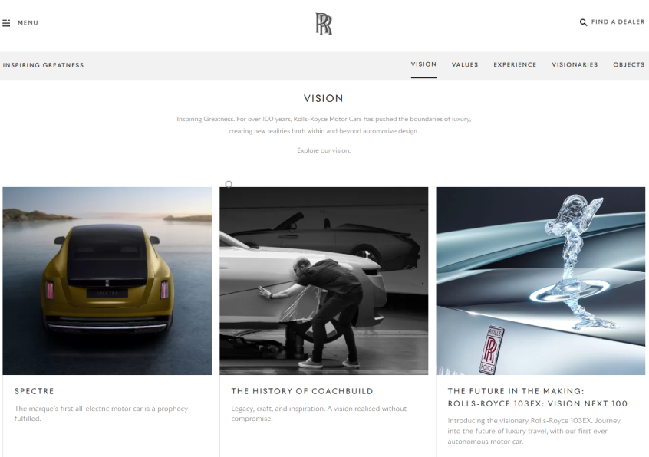
Figure 1: A Glimpse of Rolls Royce’s Vision
(Source: Vision, 2024)
Rolls Royce is one of the most intrinsic lavish possession which can embrace each and every possessor who possesses it. The brand gives a great sense of accomplishment to its owners as it is one of the most awaited dreamed about jewel for a luxury addict. It drives aspirations in many as it gives a sense of accomplishment for each and every individual. Rolls Royce is one of the most intrinsic lavish possession which can embrace each and every possessor who possesses it. The brand gives a great sense of accomplishment to its owners as it is one of the most awaited dreamed about jewel for a luxury addict. It drives aspirations in many as it gives a sense of accomplishment for each and every individual. Rolls-Royce Motor Cars Limited is considered to be the utmost luxury by a massive British automobile manufacturer headquartered in the UK region. Once a wholly owned subsidiary of the BMW AG division, this premium automobile is operated from 42 acres of land in Goodwood, West Sussex, England, United Kingdom. Rolls Royce’s exclusiveness arises from its art programme, Muse, which promotes innovation through collaboration, inspiring as much as it can be done to those who share their passions to push their boundaries. Persistently aligning with their vision for over 100 years, Rolls-Royce Motor Cars have transcended the realms of luxury. They produced some very ground breaking innovations both in the vehicle designs and also beyond. As the leaders of the company sought perfection through their creative guidance, it reflected in their extraordinary care for their products year after year.
Business Model of the Company
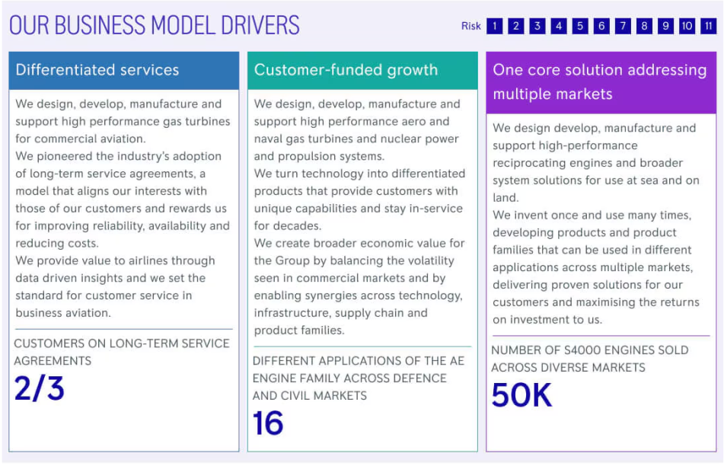
Figure 2: Business Model of Rolls Royce
(Source: Rolls-Royce, 2024)
Business-wise, Rolls Royce is all about designing and producing high-end performance power and propulsion systems for clients of aerospace as well as marine, both for commercial and military purposes. The essential tools of their business model include their own multi-billion Research and Development company, which produces cutting edge customer demanded technologies with high entry barriers competitive technologies; along with their high-performance engineering marvels with superior through-life values compared to other competitors (Rolls-Royce, 2024). The company also maintains its low-cost manufacturing principles with utterly efficient integrated supply chain management systems.
This company aims a large part of its income from the long-term after-sales support of its product, which also enables the equipment to continue to work for decades. Rolls Royce also allocates its capital to balance financial strengths and liquidity with the aim of maintaining long-term relations with its shareholders.
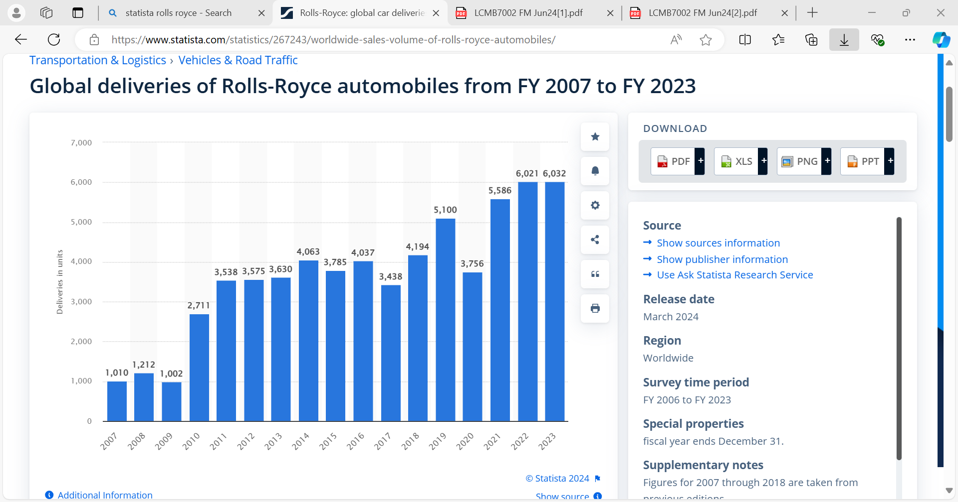
Figure 3 - Financial growth of Rolls Royce
(Source: Rolls-Royce, 2024)

Acquired Marketplace
Rolls Royce has a globally significant presence all over, mostly being present in the United States and China. The company has a strong presence in Europe as well, but recently, it has seen a massive jump in growth of its sales towards the Asia-Pacific Region, like South Korea (BMW Group PressClub, 2024). Recently, it has been noted that the automobile giant has recorded sales of more than six thousand cars worldwide (Bekker, 2024).
Rolls Royce holds its market share with its drive-away technologies and luxury car models like the Cullivan, the Ghost, and the newly introduced electric-only Spectre. The car is also seen to be highly popular in the Middle East as well, for its esteemed luxurious brand image.

Major Competitors
Rolls Royce is a huge brand, but it is still seen to have other giant automobile manufacturers competing to beat the brand, like in the cases of Mercedes and BMW. Both the competitors has worldwide reach to compete with this giant luxurious brand.

2.0 Part B). Financial performance review

2.1 Calculation of Key financial ratios
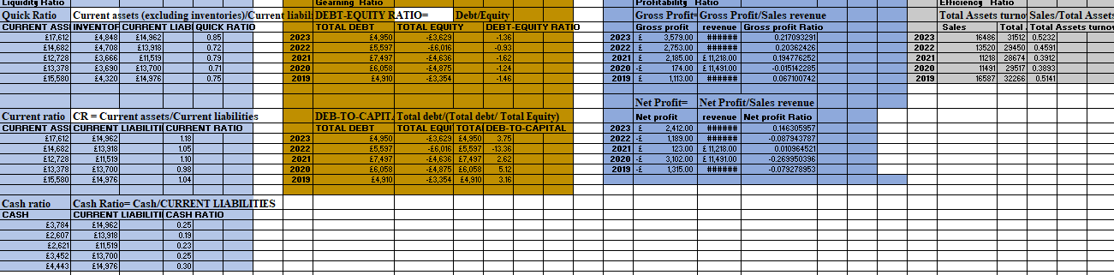
Figure 3: Financial ratio analysis of Rolls Royce
(Source: Self-created)
Profitability Ratios
The profitability ratio helps measure the ability of the company to generate profitability in relation to revenue, equity, assets and other financial aspects. It helps in providing insights on how efficiently a company is able to convert its sales into profitability and how effectively it utilises its resources for maximising earnings. The profitability ratio is considered as an analysis tool which indicates how effectively a company is generating profitability (Glossary, 2011).
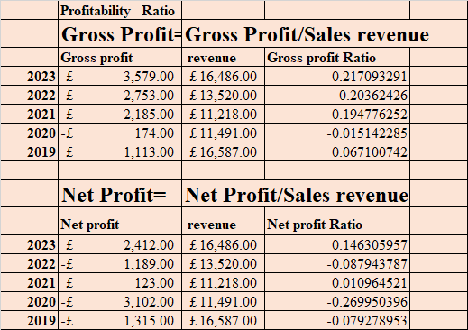

Gross profit Ratio
Gross profit Ratio is a financial metric which helps in measuring the percentage of revenue which exceeds the cost of goods sold. Gross Profit margin indicates the sales performance on the basis of the efficacy in the production process (YEC, 2024). It is generated by dividing the Gross Profits by the revenue and multiplying it by 100, and it states how efficiently the company produces and sells its products. It helps in reflecting the portion of sales revenue which is left as profit. The Gross Profit Ratio of Rolls Royce in 2019,2020,2021,2022 and 2023 is..07,-02, .19, .20 and .22

Net profit Ratio
Net profit Ratios measure the percentage of revenue, which is profit after deducting the operating expenses., interest and taxes from the revenue. It helps in indicating how efficiently the company is in turning the actual revenue into profit and reflecting the operational efficiency and profitability. For calculating the Net profit Margin, the expenses are required to be subtracted from the revenue, and the result is to be divided by the total revenue (Houston, 2023). The net profit ratio of Rolls Royce in 2019,2020,2021,2022 and 2023 is -.08,-.27,.01,-.09 and .15.
Liquidity Ratios
Liquidity ratios are the financial metrics which assess the ability of the company to meet short-term debt obligations with the help of its liquid assets. It helps in measuring how efficiently the company would be able to convert its assets into cash by paying off the liabilities.
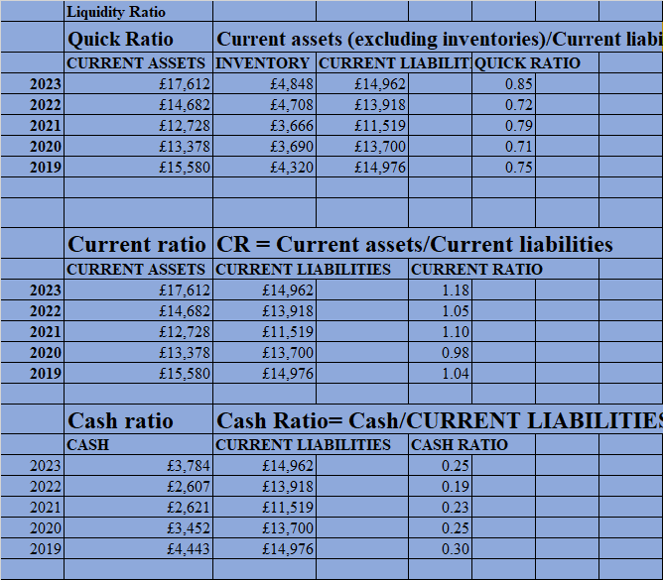
Figure 5: Liquidity Ratio of Rolls Royce
(Source: Self-created)

Current Ratio
The current Ratio is the liquidity ratio, which helps measure the ability of the company to pay its short-term obligation with the help of current assets(Hasanuddin et al., 2021). It is obtained by dividing the current asset by current liabilities. The Current Ratio of Rolls Royce in 2019,2020,2021,2022, and 2023 is 1.04,.98,1.10,1.05 and 1.18.
Quick Ratio
Quick Ratio referred to as Acid test ratio, is a liquidity metric which helps measure the ability of the company to meet its short-term liabilities by utilising its liquid assets by excluding the inventory. Inventory is considered one of the critical elements of liquid assets, and it often experiences the lowest price fluctuations which often occur(Sari et al., 2022). Quick ratios help in providing a stringent assessment of the liquidity of the company and indicate if the company is able to pay off its short-term obligation without relying on the sale of inventory. The Quick Ratio of Rolls Royce in 2019,2020,2021,2022, and 2023 is..75,.71.79.72 and .85.
Cash Ratio
The cash ratio is considered the liquidity ratio, which helps in measuring the ability of the company to pay off its short-term liabilities by utilising its cash and cash equivalents. It provides a conservative assessment of the liquidity of the company to the extent to which the company would be able to cover short-term obligations without relying on the inventory. Cash flow ratio help in measuring the ability of the business to pay off its current debts with the amount of cash flowing in that specific period (Chandi, 2024). The Cash Ratio of Rolls Royce in 2019,2020,2021,2022 and 2023 is .30,.25,.23,.19 and .25.
Gearing Ratio
The Gearing Ratio is considered a financial ratio which compares the owner's equity to the debt, and it measures the economic risks and how much of its actions are funded by shareholders. The level of financial risk associated with the company due to its dependency on the borrowed funds in comparison to its own equity is assessed with the Gearing Ratio.
Debt to equity
Debt to equity ratio helps in demonstrating the amount of debt a company has in comparison to the amount of equity or own capital (Budianto and Dewi, 2023). It is a key metric in corporate finance, and it helps in measuring the financial leverage of the company and the amount of its activities, which are funded by debt. The Debt to equity of Rolls Royce in 2019,2020,2021,2022, and 2023 is -1.46,-1.24,-1.62,-.93 and -1.36.
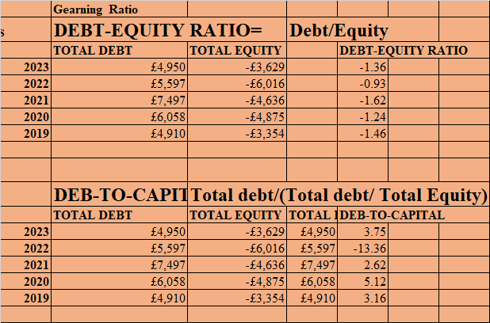
Figure 7: Debt-to-Equity Ratio of Rolls Royce
(Source: Self-created)

Debt to capital
Debt to Capital ratio helps in measuring the proportion of the total capital of the company which is financed by debt. It helps in providing detailed insights about the financial structure of the company and the level of financial leverage. The debt to capital of Rolls Royce in 2019,2020,2021,2022, and 2023 is 3.16,5.12,2.62,-13.36 and 3.75.
Efficiency Ratio
Efficiency Ratio is involved in assessing how effectively a company utilises the assets and resources for generating revenue in sales, and it evaluates the management and operational efficiency of the company.
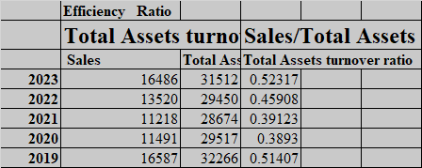
Figure 9: Efficiency Ratio of Rolls Royce
(Source: Self-created)

Asset turnover Ratio
The asset turnover ratio helps in measuring how effectively a company utilises its assets for generating sales and revenue. Business conduct analysis of the asset utilisation ratios fro determine how efficiently a firm conducts its operations in relation to its competitors (Patin et al., 2020). It compares the gross revenue generated by the company to the average total number of assets. The Asset Turnover Ratio of Rolls Royce in 2019,2020,2021,2022 and 2023 is .51,.39,.39,.46 and .52

2.2 Critical evaluation of the ratio
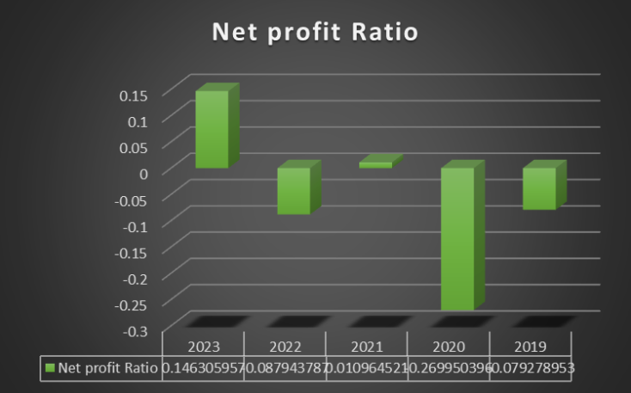
Figure 4: Net profit ratio of Rolls Royce
(Source: Self-created)
The Gross profit Ratio fluctuated from .07 in 2019, reached .20 in 2022, and then it rose back to .22 in 2023. It indicated that Rolls Royce can manage the production costs relative to the sales, and the decrease in 2022 stated the increase in the price of production. The gross profit margin reflects the financial health of the company's core function by demonstrating the revenue percentage which exceeds the cost of goods sold (West, 2024). The recovery in 2023 indicates that the company has improved its sales performance. The net profit ratio highlighted significant financial distress, with negative values originating in 2019,2020 and 2022, and the company performed worst in 2020 (0-.27), which included substantial losses. The greater the profit margin, indicates that the company is more efficient in keeping costs low to produce revenue (Houston, 2021). The positive margin of .15 in 2023, whose strong turnaround reflected the cost control.
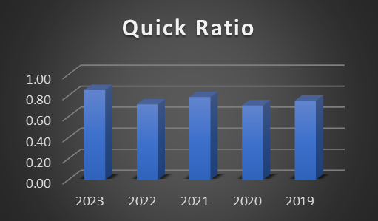
Figure 5: Quick Ratio of Rolls Royce
(Source: Self-created)
The current Ratio values implied that Rolls Royce has maintained adequate short-term liquidity. As the current ratio was greater than 1, it indicated that Rolls Royce would be able to receive short-term liabilities with short-term assets. The stability in the ratio suggested consistent liquidity, and the decline helped to ensure continued validity strength. The quick ratio showed significant improvement, which implied that Rolls Royce has become more effective in meeting the short-term debt obligation without depending on the inventory. As the ratio is below 1, it indicates that the company would need to spend on inventory sales, which would indicate liquidity concerns.
The cash Ratio of Rolls Royce has decreased in the years but stabilised at .25 in 2023. it indicated that Rolls Royce holds a limited amount of cash in relation to its liabilities, and it suggests improvement in managing cash reserves. The negative value obtained from the equity’s ratio is unusual and it conducted the negative equity is needed to be addressed. Negative Ratios are not typical and it suggests issues with the capital structure.
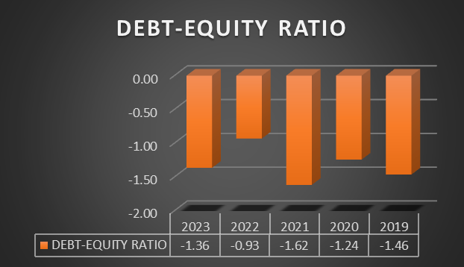
Figure 6: Debt to Equity Ratio
(Source: Self-created)
The debt-to-capital Ratio shows significant variability with anomalous values like -13.36 in 2022, which indicates financial restructuring and accounting anomalies. The ratio is supposed to stabilise at 3.75 in 2023 and it reflects a decline in the financial leverage. Results obtained from Asset turnover ratios showed fluctuation, but the trend was overall positive. It reached .52 in 2023, which indicated improved efficiency in utilising assets for generating sales, and it reflected operational effectiveness and asset utilisation.

2.3 Comparison to competitors
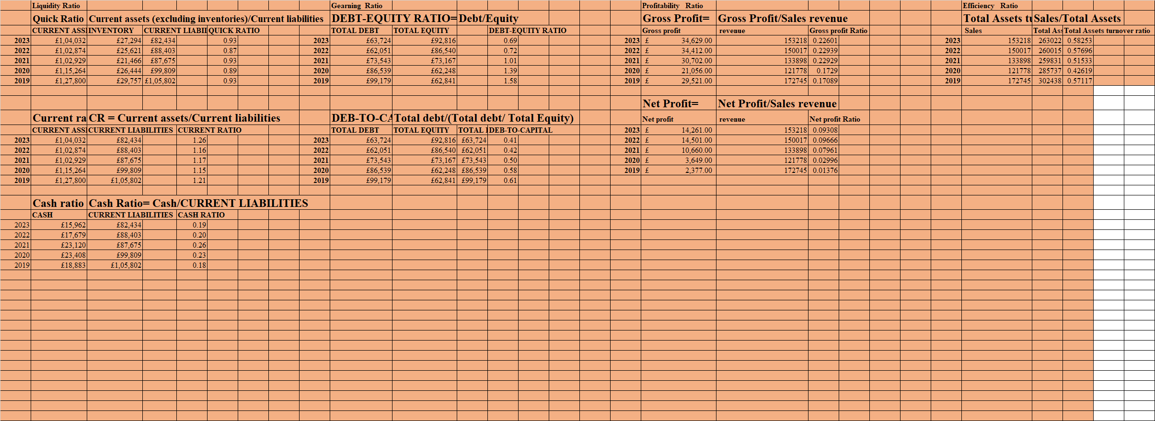
Mercedes Benz
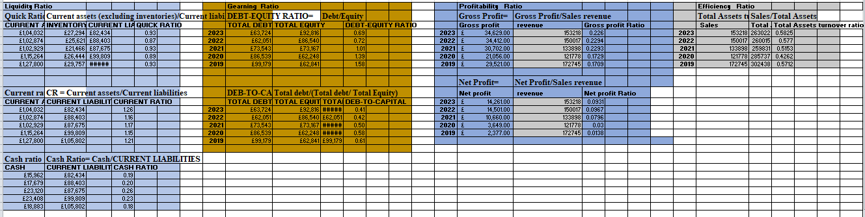
Figure 7: Financial ratio analysis of Mercedes Benz
(Source: Self-created)
The Quick Ratio of Mercedes benz in 2019,2020,2021,2022 and 2023 is .93,.89,.93,.87 and .93 .The Current Ratio in 2019,2020,2021,2022 and 2023 is 1.21,.15,1.17,1.16 and 1.26.The cash Ratio of in 2019,2020,2021,2022 and 2023 is .18,.23,.26,.20 and .19. The Debt to equity Ratio in 2019,2020,2021,2022 and 2023 is 1.58,1.39,1.01,.72 and .69.The debt to capital Ratio 2019,2020,2021,2022 and 2023 is .61,.58.50,.42 and .41.The gross profit ratio of 2019,2020,2021,2022 and 2023 is .17,.7,.22,.22 and .22.The Net profit in 2019,2020,2021,2022 and 2023 is .01,.03,.07,.09 and .09. The Asset turnover Ratio in 2019,2020,2021,2022 and 2023 is .57,.42,.51,.57 and .58.
BMW
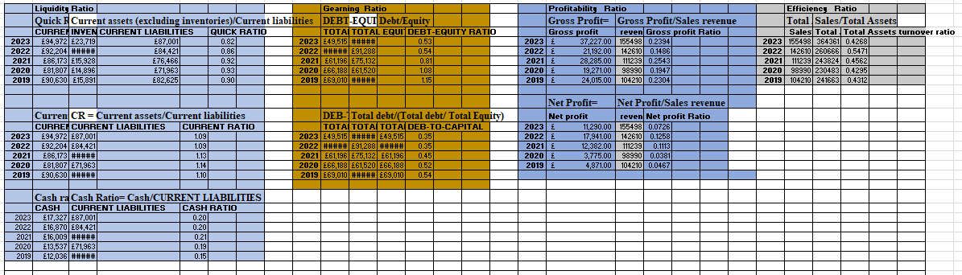
Figure 8: Financial ratio analysis of BMW
(Source: Self-created)
The Quick Ratio of BMW in 2019,2020,2021,2022, and 2023 is. 90 ,.93,.92,.86 and .82.The Current Ratio in 2019,2020,2021,2022 and 2023 is 1.10,1.14,1.13,1.09 and 1.09.The Cash ratio of BMW in 2019,2020,2021,2022 and 2023 is .15,.19,.21,.20 and .20. The Debt to equity of BMW in 2019,2020,2021,2022 and 2023 is 1.15,1.08,.81.54 and .53. The Debt to capital of BMW in 2019,2020,2021,2022 and 2023 is .54,.52,.45,.35 and .35.The Gross profit Ratio in 2019,2020,2021,2022 and 2023 is .23,.19,.25,.14 and .23. The Net profit Ratio in 2019,2020,2021,2022 and 2023 .046.038,.11,.12 and .07.The Asset turnover Ratio 2019,2020,2021,2022 and 2023 is .43,.42,.45,.54 and .42.

2.4 Analysis
The financial performance of Rolls-Royce, Mercedes Benz and BMW from 2019 to 2023 have been assessed with the comparison of several financial ratios, which helped in providing detailed insight regarding the liquidity, profitability, leverage and operating efficiency of the company. The fluctuation in the performance of Rolls Royce reflects the challenges in cost management likely due to the performance-related disruptions .Net profits form the most reliable metric of a business in analysing the financial status of the company (Levi, 2022). The recovery in subsequent years has indicated improved operational efficiency and cost control. Mercedes Benz's strong positioning helps in managing the production expenses related to its revenue. BMW experienced significant volatility in managing costs but generated substantial profitability. The positive turnaround of Rolls Royce is considered a strong indicator of cost control and improved profitability. Mercedes Benz has been able to maintain an upward trend in profitability, and it has demonstrated efficient management and strong profitability.
Rolls Royce has moderate levels of liquidity, which is sufficient for covering short-term obligations. On the other hand, Mercedes Benz possesses robust liquidity and can meet short-term debt obligations. BMW maintains adequate amounts of liquidity to meet the short term obligations. The negative equity of Royal Royce raises significant concern regarding the capital management strategies adopted by the company and its financial structure. Mercedes Benz shows a decreasing trend regarding the reduced reliance on debt and solid equity base.BMW adopts a conservative pricing approach, which is improving its financial stability.
It is found that Mercedes Benz emerged as as a profitable and stable company amongst the three as it poses stranger liquidity, decreased leverage and efficient utilisation of assets.BMW demonstrated strong performance specifically in managing leverages and generating profitability. Rolls Royce faced significant changes in leverage and profitability even though there are signs of recovery and improvement in performance. Fluctuation in specific Ratios implies closer scrutiny in terms of cost management and financial structure

3.0 Recommendations
In the aerospace and automotive sectors, Rolls Royce is a trusted brand worldwide, but it recently is facing challenges seen earlier. The data and calculations above reflect the company’s lesser net profit, decreased cash ratio in its liquidity and increased debt, leading to a more elevated gearing ratio. To address these challenges, Rolls-Royce can focus on cost reduction, debt refinancing, and investing in sustainable technologies. Some recommendations will be discussed here for the concerned company to navigate through these financial issues to maintain its operations with long term sustainability and growth. By diversifying its product portfolio and exploring new markets, the company can eliminate risks and ensure a stable financial future.

Cost Management and Efficiency Improvements
This review should be a comprehensive in-depth dive into the sorts of methods that lay beneath your operational costs where you can then pinpoint how it can improve from here. If implemented correctly, it may help Roll Royce become more efficient and less wasteful in using resources to push innovation-led growth. Other efforts to reduce operational costs may include investing in automation and following lean manufacturing practices. Rolls Royce might also spice up the game with its operational cost. The company can also use this time to pursue collaboration and partnership opportunities, allowing them%age of best practices to be shared along with knowledge whilst increasing the competitiveness in market. Getting rid of its over spends by optimizing the supply chain processes. These can also come with a renegotiation of contracts made by the company with suppliers, additional cost saving technologies and restructuring their organizational set-up for cutting overheads down.

Diversification of Revenue Streams
To eliminate the lesser net profit, Rolls Royce must diversify its products and offerings as well as explore new unaquired markets. The company must also improve its technological sector to come up with newer and more efficient electric propulsion systems to boost its revenue. The concerned company should also enhance its after sales services for more efficient profit generation thereby creating a steadier income flow.
In addition, Rolls Royce can use his brand to enter other segments of higher added value as renewable energy and hybrid systems. Wanting stay ahead of the competition, it is very important for him/her to invest a lot on research and development. Moreover, the business can concentrate on establishing those strategic alliances and collaborations that will enable it to enter new technology areas or markets. This will allow Rolls Royce to develop a more diversified and robust business, less reliant on traditional sectors in ensuring its long term survival. In addition, this will also allow the company to move up on a virtuous development spiral that opens new revenue expanding opportunities and increases market share generating growth and profits.

Strengthening Liquidity Position
Rolls Royce should work on its less company liquidity as a decreased cash ratio might lead the company to future liquidity crunches. The company can optimize its liquidity position through the implementation of optimal working capital management processes. These might include processes like reduced inventory levels and handling the company receivables more efficiently.
In addition, Rolls Royce may also look at asset sales of non-core businesses to create cash generating capacity and deleverage, helping its liquidity situation. Developing a facility cash flow forecasting system will also anticipate and prepare the organization for potential liquidity shortfalls. On top of that, Rolls Royce could look into some alternative funding strategies like Invoice Financing or Supply Chain Financing to improve its liquidity management. By following the above steps, it can account for such risks and also relieve the sudden liquidity crunches in its financial grounds. It will also allow the company to have flexibility in terms of investment into growth opportunities and changing market dynamics.
Debt Restructuring
Since the above data and calculations have shown Rolls Royce’s decreased cash ratio, the company must focus on improving its liquidity. Some of the options like debt restructuring, negotiation with creditors, and equity financing options could be some of the strategies that can be applied to improve the financial stability of the concerned company.

Strategic Partnerships and Collaborations
Collaborative approaches to technological development and joint ventures towards new market entries are some of the ways in which Rolls Royce can enhance its capabilities and market presence. Also, such collaborations and strategic alliances can result in the company’s both improved financial performance as well as achieve more extraordinary expertise in their respective field.

4.0 Part C). Investment appraisal

Result Evaluation
The outcomes of the evaluation of the demonstrate Project 1 and Project 2. Regardless, the viability of the project is shown and compared to the methods based on various funding criteria (Olayinka, 2022). From a mathematical point of view, it can be said that the Payback Period for Project 1 is 2.18 Years.
In comparison, project 2 has shown that the Payback Period is 3 years. From this section, it can be seen that the Payback Period of Project 1 is shorter, in contrast to Project 2. In this sense, Project 1 is very good for Rolls Royce simply because it can lessen the risk of any financial losses that may arise for the organization. It is also possible to allow the organization to rethink and invest the profits booked from withdrawing in the projects provided with capital.

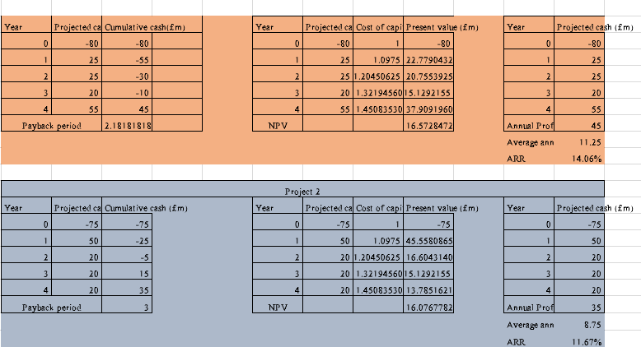
Figure 9: Investment Appraisal for Rolls Royce
(Source: Self Developed)
Moreover, the shorter Payback Period as evaluated in the project 1 clearly outlines that Rolls Royce can improve its financial situation and reduce the risk of loss due to strong market changes (Mohammad et al., 2020). In this aspect, the rapid growth of capital works because of many advantages offered to Rolls Royce. This statement is due to the introduction of short term restrictions on the concerned company’s capital in case of a need for capital distribution. Focusing on Project 1 helps to improve the financial stability of companies because it takes minimal time for the capital worker. This process can also elevate the confidence of investors to invest in the company.

Advantages and disadvantages of Payback Period, ARR and NPV

Payback Period (PBP)
The payback period for a company is calculated when the investment is made to cover cash flow sufficiently thereby covering initial costs for the company (Olaniyi and Prause, 2020). It is a simple and intuitive measurement that can be quickly understood about the capital and the risk associated with its financial project.

Advantages; -
The advantages of the Payback Period are that it is more flexible as well as clarified (Riayatsyah et al., 2022). The Payback Period method is very simple and creates an additional option for Rolls Royce to make its salespeople use it. The requirement of lesser financial expertise makes it easiest for reflective decision making, thereby making it beneficial for better assessment. The Payback Period is very useful for assessing the financial risk of an investment, especially in severely volatile markets. Also, in these markets, a shorter Payback Period is preferable, and it is backed by the reason that it recovers the investment faster while reducing the market risk as well.

Disadvantages; -
Primarily, the disadvantage of having a Payback Period is that it limits to that it does not consider the value of time and capital (Dai et al., 2022), for a brand like Rolls Royce that invests in long term projects and future income. Not knowing the timing of the capital flow can make it wrong to assess the true values of the concerned project. Knowledge is a virtue, which is an important criteria that should be acquired under the correct supervision of stored data related to the same field. Lack of effective knowledge to return on the original investment can also be considered as the next bigger disadvantage.

Average Rate of Return
The accounting return refers to the comparison of the advantages of accounting for the year for British American Tobacco and the initial investment cost (Alayli, 2023). It can be expressed as a percentage and reflects the result of the project from an accounting point of view
- . ROCE can be defined as: ARR
ARR/ROCE$=\frac{\text{average annual accounting profit}}{\text{average investment}}$
- Where average investment is:
$$\text{average investment} =\frac{\text{initial investment + scrap value}}{2}$$
OR

$$ROCE=\frac{\text{average annual accounting profit}}{\text{initial investment}}$$

Advantages; -
The advantages of the Annual Rate of Return are simplicity and understandable, easy to understand and calculated (Akaishi et al., 2022). It is very accessible to managers without advanced financial training, In addition, it was based on accounting information available in Rolls Royce’s financial systems. Another benefit of ARR is that it complies with financial reporting standards and provides a measure of profitability that equates to Rolls Royce’s total ownership costs. This process can help the organization set goals and evaluate the benefits of different programs.
Disadvantages; -
The disadvantages of ARR are shown by not assessing the time and monetary value created for a project (Bagheri Khoulenjani, Talebi, and Karim Zadeh, 2024). This leads to an interpretation of the original economic value of the project, especially for the long term investments of Rolls Royce. However, ARR is dependent on accounting results that can be exposed to non-financial results such as depreciation. Fir Rolls Royce, this process leads to change in the benefit of the project, especially in industries that require more investment.

Net Present Value (NPV)
NPV is a discounted cash flow method that calculates the present value and future cash flows from an investment minus the original investment cost (Shou, 2022). It takes into account the time value of money and provides a comprehensive measure of the effectiveness of the Rolls Royce program.

Advantages; -
Considers the value of time and money and provides an accurate measure of project value over time. This process is essential for Rolls Royce, which often deals with long-term investments in markets with different economic conditions. So, focusing on cash flows, NPV evaluates the actual cash flows generated by a project and provides a realistic view of profitability (Kipkirui and Kimungunyi, 2022). This process is vital for Rolls Royce as it is consistent with the company's focus on cash flow management and financial stability.

Disadvantages; -
NPV is more difficult to calculate and understand than PBP and ARR (Siziba and Hall, 2021). This can make financial analysis more difficult and challenging for managers who are unfamiliar with lack of knowledge because Knowledge is a virtue, which is an important criteria that should be acquired under the correct supervision of stored data related to the same field. with discounted cash flow metrics. In addition, NPV is very sensitive to the discount rate used for Rolls Royce. However, determining the correct NPV discount rate is difficult, especially in uncertain regulatory environments or volatile markets.
Consideration of Non-Financial Factors
When making investment decisions, financial statistics are important for Rolls Royce. In this section, the research shows the non financial aspects of the company, focusing on the impact of the law, the brand name and the goal of sustainability goals.

Regulatory Impacts; -
The regulatory environments for Rolls Royce in both the markets, including the United States and the United Kingdom, affect the manufacturing and distribution of their automotive products, In the UK the traffic laws are based on the laws of the Motor Vehicle Act, 1903. Rolls Royce has already set bits goal to become a carbon-neutral company throughout its operations by the year 2050. The concerned company is focused on the reduction of its operational costs as well as its greenhouse gas emissions while switching to the reduction of dependence on fossil fuels.

Brand Reputation; -
Brand reputation is another important non-financial factor for Rolls Royce. Emphasis is placed on its own market value and its luxuriousness. In this sense, Rolls Royce’s investment in new products, mostly involves next generation products (or NGP) such as electric vehicles, should serve to strengthen the image of the brand as a responsible company as well and looking ahead (Van Buren, 2022). Rolls Royce values ethical behaviour and considers making anough ethical decisions. The company seeks to adoption of the business practices in a circular method, thereby reducing their demands for raw materials and therefore maintaining conserved supply in their inventory chain.
Strategic assessment: Rolls Royce’s commitment to strategic assessment is to reduce carbon emissions and promote sustainable produce. This should be reflected in investment strategies. Though, investors should consider whether or not the proposed investment are consistent with Rolls Royce’s long term sustainability goals. In this respect, projects that promote sustainability contribute to positive social and environmental outcomes and downsize legal risks. They are dedicated to reporting and honest reporting with stakeholders. To the general public, this is a key feature of the concerned company to deliver their best.

5.0 Conclusion
This study includes a ratio analysis and explanation of the general background of Rolls Royce, an automobile manufacturing company. The company is based mainly in the United Kingdom and the United States. Recently, the concerned company has focused on changing the business to the development and delivery of sustainable engineering products. Globally, the company aims to achieve zero carbon emissions by 2050. To reduce this challenge, this study has presented the company's financial management by showing the results of the last five years. After that, the study discussed the methods of investment appraisal to understand their advantages and disadvantages for Rolls-Royce.
The findings of this study gives a brief progress report on the company’s achievements towards its sustainability goal managements. It also highlights the areas for the company to improve itself. Rolls Royce can make informed dicisions which helps it to excel towards its growth, reduce emissions, as well as maintain its position as a leader in the industry it operates. The ratio analysis in this assignment reveals the trends and patterns in the organization’s financial performance. In the section of the invenstment appraisal method, the insight is received on the viability of the future goals of the company. Altogether, This study empowers the contribution of the understanding of how organizations and companies balances their own economic and global objectives, while on the other hand, this provides recommendations which the Rolls Royce to achieve its highly ambitious targets for its sustainability.

Reference List

(UWTSD Moodle, 2024) Course: Financial Management (LCMB7002), Tile: Week 1, session 1 - Welcome and introduction to the module (uwtsd.ac.uk)
Alayli, S., (2023). The impact of capital budgeting practices on the financial performance of Lebanese banks. The EUrASEANs: journal on global socio-economic dynamics, (1 (38)), pp.29- 39. https://euraseans.com/index.php/journal/article/download/401/420
YEC (2024). Council Post: What Is A Good Gross Profit Margin? Forbes. [online] 12 Aug. Available at: https://www.forbes.com/councils/theyec/2022/10/10/what-is-a-good-gross-profit-margin/#:~:text=Gross%20 profit%20 margin%20 indicates%20a [Accessed 20 Aug. 2024].
BMW Group PressClub (2024). Historic sales record completes landmark year for Rolls-Royce Motor Cars, BMW Group PressClub. Available at: https://www.press.rolls-roycemotorcars.com/rolls-royce-motor-cars-pressclub/article/detail/T0407298EN/historic-sales-record-completes-landmark-year-for-rolls-royce-motor-cars (Accessed: 20 August 2024).
Budianto, E.W.H. and Dewi, N.D.T., 2023. Mapping Research Topics on Debt to Equity Ratio (DER) in Sharia and Conventional Banking: VOSviewer Bibliometric Study and Literature Review. https://www.researchgate.net/profile/Eka-Wahyu-Hestya-Budianto/publication/376203838_Mapping_Research_Topics_on_Debt_to_Equity_Ratio_DER_in_Sharia_and_Conventional_Banking_VOSviewer_Bibliometric_Study_and_Literature_Review/links/656e6105a760eb7cc7496ea6/Mapping-Research-Topics-on-Debt-to-Equity-Ratio-DER-in-Sharia-and-Conventional-Banking-VOSviewer-Bibliometric-Study-and-Literature-Review.pdf
Chandi, N. (2024). Council Post: Three Easily Overlooked Cash Gap Issues For Small-Business Owners To Watch. Forbes. [online] 12 Aug. Available at: https://www.forbes.com/councils/forbesfinancecouncil/2023/03/23/three-easily-overlooked-cash-gap-issues-for-small-business-owners-to-watch/ [Accessed 20 Aug. 2024].
Dai, H., Li, N., Wang, Y. and Zhao, X., (2022), March. The analysis of three main investment criteria: NPV IRR and payback period. In 2022 7th International Conference on Financial Innovation and Economic Development (ICFIED 2022) (pp. 185-189). Atlantis Press. https://www.atlantis-press.com/article/125971510.pdf
Glossary, F.F. (2011). Profitability Ratio. [online] Forbes. Available at: https://www.forbes.com/sites/forbesfinancialglossary/2011/07/10/profitability-ratio/[Accessed 20 Aug. 2024].
van Buuren, A., (2022). How Philip Morris manages disruptive regulations and what other industries can learn from them (Doctoral dissertation). https://repositorio.ucp.pt/bitstream/10400.14/41060/1/203133129.pdf

Houston, M. (2023). Understanding The Profit Formula In Your Business. [online] Forbes. Available at: https://www.forbes.com/sites/melissahouston/2023/06/28/understanding-the-profit-formula-in-your-business/#:~:text=Net%20Profit%20Margin&text=This%20formula%20is%20more%20comprehensive [Accessed 20 Aug. 2024].
Kipkirui, L.P. and Kimungunyi, S., (2022). Effect Of Net Present Value Investment Appraisal Practice On Financial Performance Of Cement Manufacturing Firms In Kenya. International Research Journal of Economics and Finance, 4(2). https://www.irjp.org/index.php/IRJEF/article/viewFile/79/99
Levi, A. (2022). Council Post: 7 Critical Business Performance Indicators To Monitor Closely. [online] Forbes. Available at: https://www.forbes.com/sites/forbescommunicationscouncil/2022/07/20/7-critical-business-performance-indicators-to-monitor-closely/ [Accessed 20 Aug. 2024].

Bagheri Khoulenjani, A., Talebi, M. and Karim Zadeh, E., (2024). Feasibility Study for Construction Projects in Uncertainty Environment with Optimization Approach. International journal of sustainable applied science and engineering, 1(1), pp.1-15. https://bgsiran.ir/journal/ojs-3.1.1-4/index.php/IJSASE/article/download/103/84

Shou, T., (2022), July. A literature review on the net present value (NPV) valuation method. In 2022 2nd International Conference on Enterprise Management and Economic Development (ICEMED 2022) (pp. 826-830). Atlantis Press. https://www.atlantis-press.com/article/125975449.pdf

Mohammad, S., Asutay, M., Dixon, R. and Platonova, E., (2020). Liquidity risk exposure and its determinants in the banking sector: A comparative analysis between Islamic, conventional and hybrid banks. Journal of International Financial Markets, Institutions and Money, 66, p.101196. https://durham-repository.worktribe.com/preview/1273092/30597.pdf
Olaniyi, E.O. and Prause, G., (2020). Investment analysis of waste heat recovery system installations on ships’ engines. Journal of Marine Science and Engineering, 8(10), p.811. https://www.mdpi.com/2077-1312/8/10/811/pdf
Olayinka, A.A., (2022). Financial statement analysis as a tool for investment decisions and assessment of companies’ performance. International Journal of Financial, Accounting, and Management, 4(1), pp.49-66. https://goodwoodpub.com/index.php/ijfam/article/download/852/289
Patin, J.C., Rahman, M. and Mustafa, M., 2020. Impact of total asset turnover ratios on equity returns: Dynamic panel data analyses. Journal of Accounting, Business and Management (JAMB), 27(1), pp.19-29. https://journal.stie-mce.ac.id/index.php/jabminternational/article/view/559
Riayatsyah, T.M.I., Geumpana, T.A., Fattah, I.R., Rizal, S. and Mahlia, T.I., (2022). Techno- economic analysis and optimisation of campus grid-connected hybrid renewable energy system using HOMER grid. Sustainability, 14(13), p.7735. https://www.mdpi.com/2071-1050/14/13/7735/pdf
Rolls-Royce (2024). The Rolls-Royce Business Model | Rolls-Royce. Available at: https://www.rolls-royce.com/about/our-strategy/the-rolls-royce-business-model.aspx (Accessed: 20 August 2024).
Rolls-Royce motorcars, 2024 Rolls-Royce Spectre. [online] Available at: https://www.rolls-roycemotorcars.com/en_GB/showroom/spectre.html [Accessed 20 Aug. 2024].
Sari, W.N., Novari, E., Fitri, Y.S. and Nasution, A.I., 2022. Effect of Current Ratio (Cr), Quick Ratio (Qr), Debt To Asset Ratio (Dar) and Debt To Equity Ratio (Der) on Return On Assets (Roa). Journal of Islamic Economics and Business, 2(1), pp.42-58.https://journal.uinsgd.ac.id/index.php/jieb/article/view/20173
Bekker, H. (2024). Henk Bekker, Car Sales Statistics. Available at: https://www.best-selling-cars.com/brands/2023-full-year-global-rolls-royce-worldwide-sales/ (Accessed: 20 August 2024).
Siziba, S. and Hall, J.H., (2021). The evolution of the application of capital budgeting techniques in enterprises. Global finance journal, 47, p.100504. https://repository.up.ac.za/bitstream/handle/2263/74586/Siziba_Evolution_2020.pdf?sequence=1
Vision (2024). Rolls. Available at: https://www.rolls-roycemotorcars.com/en_GB/inspiring-greatness/vision.html (Accessed: 20 August 2024).
West, C. (2024). Council Post: To Drive Business Performance, You Must Understand KPIs. Forbes. [online] 12 Aug. Available at: https://www.forbes.com/councils/forbesbusinesscouncil/2024/07/03/to-drive-business-performance-you-must-understand-kpis/ [Accessed 20 Aug. 2024].

Appendices

Appendix 1: Financial statement of Rolls Royce

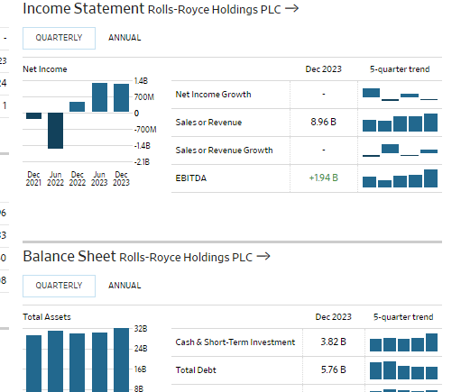
(Source: Wsj, 2024)

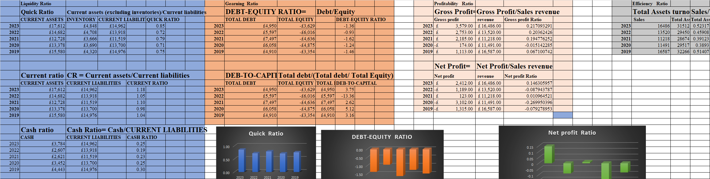
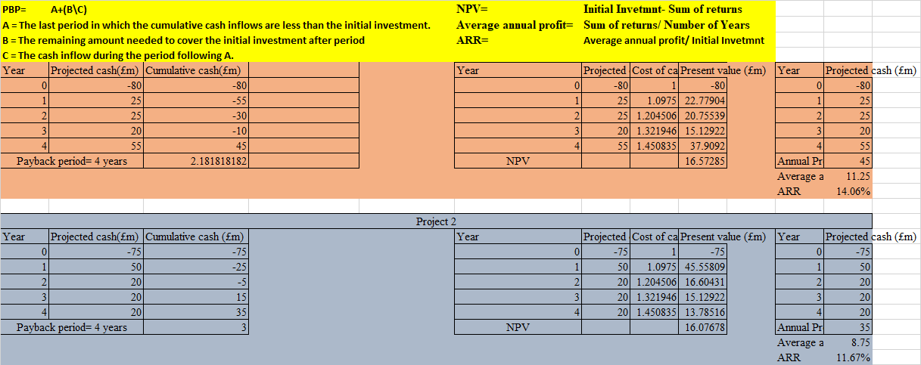

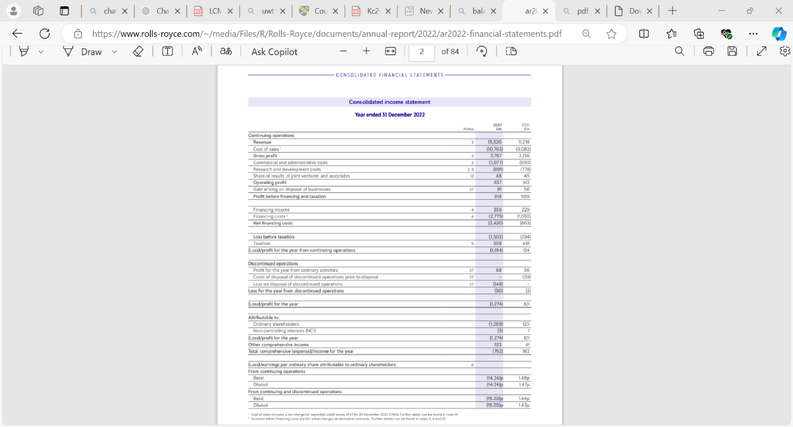

- ROCE can be defined as: ARR
ARR/ROCE$=\frac{\text{average annual accounting profit}}{\text{average investment}}$
Where average investment is:

$$\text{average investment} =\frac{\text{initial investment + scrap value}}{2}$$
OR

ARR/$ROCE=\frac{\text{average annual accounting profit}}{\text{initial investment}}$

