University of Wales Trinity Saint David
Structure and Properties – Assignment 2 (exam replacement)
BEng Material Science

Question 1

- Evaluate the statement “Pressure affects the allotropy of pure iron”

This refers to Le Chateliers Principle. When pressure is increased, α- iron to γ- iron transition temperatures will be lowered. Opposite to this, γ- iron to δ -iron transition temperature is increased. γ- iron has an FFC structure which is close packed and resists pressure better than the other phases of iron. The other phases have a BCC structure which isn’t packed as tight.

- A hypothetical metal has a FCC structure with a density of 8.94g/cm³ and an atomic weight of 63.5g/mol. Calculate the radius of one of its atoms.
$$P=\frac{nA}{VcNA}$$
$$8.94{x10}^{6}=\frac{4*63.5}{a^{3}*6.022{x10}^{23}}$$

Rearrange to get Vc.
$$a^{3}=\frac{4*63.5}{{8.94{x10}^{6}}^{}*6.022{x10}^{23}}$$

$$a^{3}=\frac{254}{5.38{x10}^{30}}$$

$$a^{3}=4.72{x10}^{-29}$$

$$a =\sqrt[3]{4.72{x10}^{-29}}$$

$$a = 3.61{x10}^{-10}$$

FCC structure = $a=\frac{4r}{\sqrt{2}}$

$$r=\frac{\sqrt{2}a}{4}$$

$$r=\frac{\sqrt{2}*3.61{x10}^{-10}}{4}$$

$$r= 1.28{x10}^{-10}$$

- Analyse the difference between crystal structure and atomic structure.

Crystal structure details the alignment of atoms is a crystalline material. A crystal structure is a 3D shape composed of ions, molecules and atoms that occur in a repetitive pattern. Types of crystal structure in metals are body centered cubic, face centered cubic and hexagonal close packed.

Atomic structure is the structure of an atom. This pays reference to the atoms number of protons, neutrons and electrons. Atoms are made of a positively charged nucleus and surrounded by negatively charged electrons.

- In a cubic unit cell one corner atom is located at the origin of the coordinate system (0,0,0). What are the direction indices for a vector that passes from point (½, 1, ½) to point(1, ½, ½)

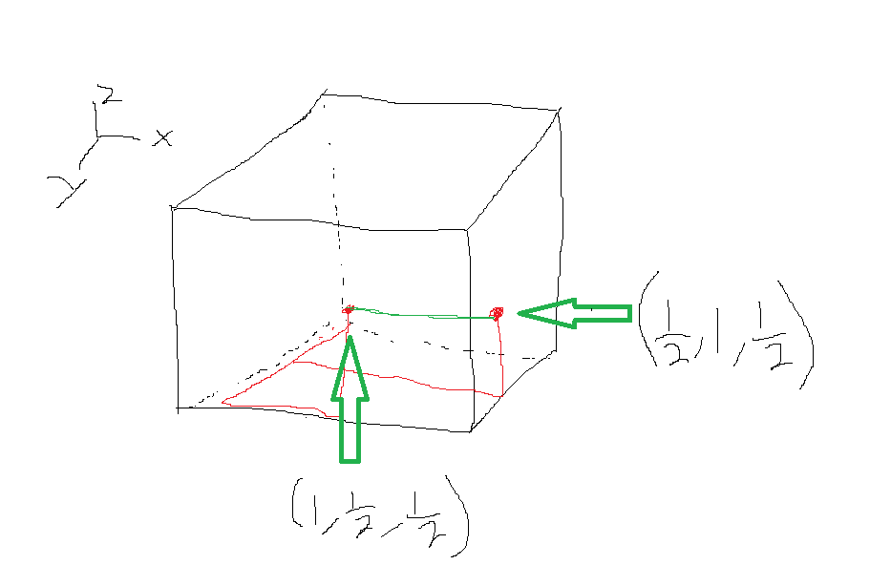
Vector = (1,1/2,1/2) – (1/2, 1, ½)
= (1/2, -1/2, 0)
Reduction = ( 1, -1, 0 )
-
Enclosure = [ 1 1 0]

- Sketch the following planes in a cubic unit cell:
i)(012)
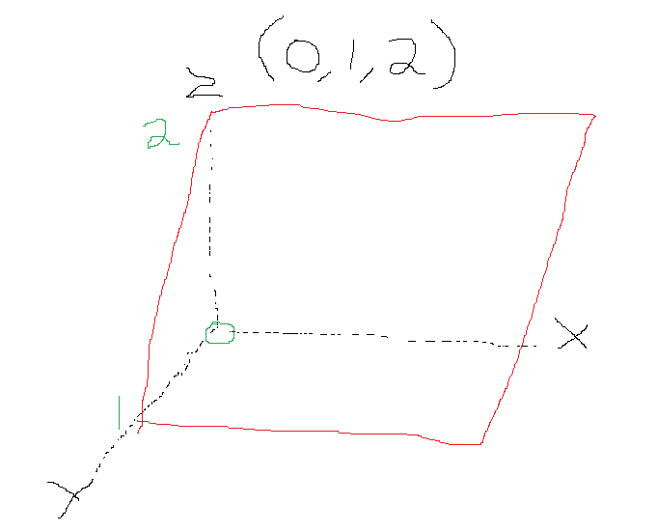 -
ii)(312)
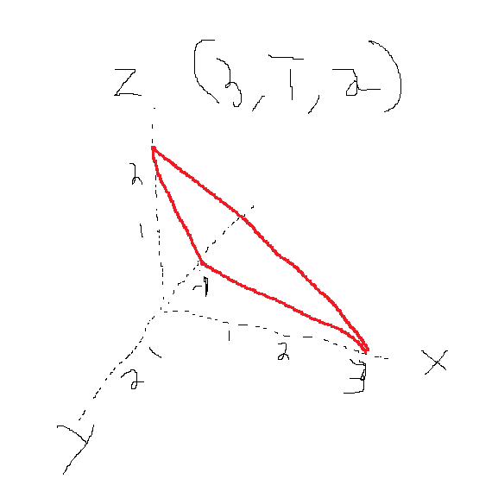

iii) (-1,1,-1)
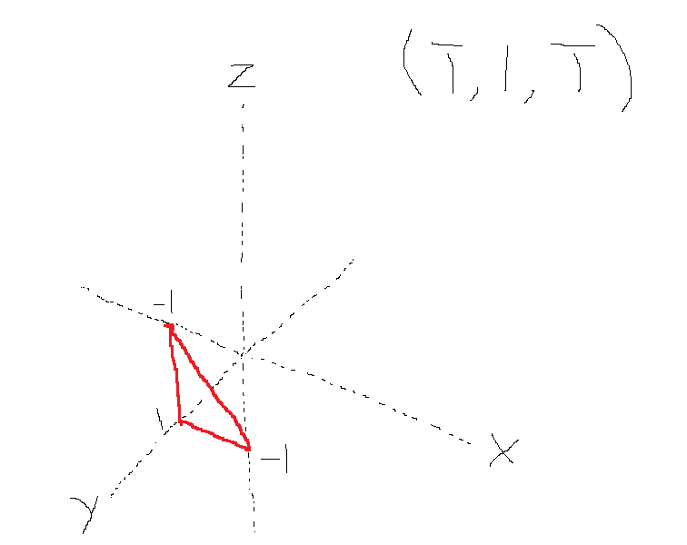

Question 2
- What phases are present in an alloy of composition 40wt% Ag 60wt% Cu at a temperature of 800⁰C?
Alpha and liquid phases are present at 800°C with the wt%’s above.

Calculate the composition in wt% Ag and Cu for both the α and liquid phases at a temperature of 900⁰C and a composition of 30wt%Ag 70wt% Cu.
Ag phases
Alpha = 8wt% Ag and 92wt% Cu at the solidus line

Liquid = 45wt% Ag and 55wt% Cu at the liquidus line

- Calculate the fractional phase amount of both α and ꞵ for an alloy of composition 20wt% Ag 80wt% Cu at a temperature of 400⁰C?

Beta phase =
$$Beta phase=\frac{C-C1}{C2-C1}$$

$$Beta phase=\frac{20-1}{98-1}$$

$$Beta phase=\frac{19}{97}$$

$$Beta phase=20\%$$

Alpha phase
$$Alpha phase=\frac{C2-C}{C2-C1}$$

$$Alpha phase=\frac{98-20}{98-1}$$

$$Alpha phase=\frac{78}{97}$$

$$Alpha phase=80\%$$

Question 3
- Explain the differences between Schottky and Frenkel defects in ceramics. [6 marks]

Schottky defects arise when atoms that are oppositely charged leave their atomic sites and create a set of vacancy defects. Cation and the anion leave their sites at exactly the same time so the crystals electric neutrality is kept. Schottky defects only occur in ionic crystal structures but the size of the cation and the anion must be very similar. Density reduces due to the formation of vacancies with Schottky defects.

Frenkel defects occur when the cation leaves its lattice and takes up an interstitial position in the crystal. Frenkel defects usually occur in inion lattices which is the same and Schottky. Frenkel defects will occur though when then anion is larger than the cation. Frenkel defects only leave one vacancy rather than Schottky’s two.

- For Schottky defects, calculate the number of cation-vacancy/cation-interstitial defect pairs given that the Boltzmann’s constant,
- k=8.62 x 10⁻⁵eV/K
- the temperature, T=500°C
- the energy required for the formation of each Schottky defect, Qs = 2.6eV
- and the number of lattice sites, N= 1.58 x 1028 lattice sites/m3

$$N_{s}=Nexp \left(-{Q \atop 2KT}\right)$$

$$N_{s}={\left(1.58{x10}^{23}\right)}^{3}exp \left(-{2.6 \atop 2*8.62{x10}^{-5}*773}\right)$$

$N_{s}= 5.31{x10}^{19}$ defects/m3

Question 4
- Using your knowledge of material properties, analyse the properties of steel and give 5 bullet points on why you think steel is a suitable material for this use.

Yield Strength – Low carbon steels that will be used in the manufacturing of cars will have low yield strength. This is to ensure that the steel is ductile enough to undergo elastic deformation while in use and not defer from its original shape.

Tensile strength – Steel when compared to other materials has a high tensile strength. This means in can be placed under a lot of stress and not see a failure.

Elongation – Steels that are used for car bodies will have a high elongation. This is to ensure that no cracking or breaks will occur in pressing.

Hardness – Steel has a high resistance to plastic deformation. A hardness result can be created via a Vickers hardness test.

Steel is an alloy of iron, carbon and many other elements. Carbon is used to provide strength and toughness. Carbon gives steel strength by interstitial solid solution strengthening. The carbon atom takes up a position in between the gaps of the iron atoms leading to a strong bond. Steel has good mechanical properties due to the amount of energy needed to break its atomic bonds. Saying that, while steel is strong, it can also be very malleable which make it very good for car bodies. Car bodies are manufactured by a hydraulic pressing machine. The steel needs to be ductile enough to be pressed and not break but also to have enough strength and toughness to keep the persons inside the car safe of impact collisions.

- Mechanical properties – steel is very strong and has high strength to weight ratio. This strength is key to ensuring the user of a car is kept safe.
- Ease of Manufacture – Due to steel being very malleable it can be pressed/ moulded into car chassis very easily.
- Cost – The price of steel is cheap when compared to other materials with the same mechanical properties.
- Availability – With low carbon steels being widely available all over the world, car manufacturers have a plentiful amount of material to create car bodies.
- Weight - Steel is also very lightweight and can make the car very fuel efficient.

- If you had to redesign a car body to make it lighter, predict 5 factors you would need to consider?

The five factors I would consider are below;

- Corrosiveness – Cars are protected usually by a zinc coating which increases the corrosive properties of the material. To make it lighter I would use a thinner coating of zinc but at the same time have enough zinc to ensure the corrosiveness is kept.
- Thinner gauge steel – another way to make my car lighter would be to use a thinner steel which is a dual phase so it keeps its mechanical properties.
- Safety – Safety is a massive consideration of any design. To ensure the safety is kept high strength alloy material would be used to protect from impact collisions.
- Use of composites – the addition of composite springs would be used instead of steel springs as it is lighter and has a high degree of strength.
- Removal of luxury items – Removing any luxury item will help save weight and keep the design as basic as possible.

