
Applied Computing
Wales Institute of Science and Art (WISA)

Digital Forensics (ACCA7031)

Analysis


This Photo by Unknown Author is licensed under CC BY-NC

Lab Activities are based on
TryHackMe, EC Council – CHFI, Digital Forensics Workbook and other Industry Digital Forensic Curriculum

Objectives
In continuation to our lectures, this hands-on Activity helps in providing you an overview of digital forensic analysis.
ETHICAL STATEMENT
As discussed during our lectures, it is very important to adhere to Personal Ethics, Professional Ethics, Computer Ethics and Business Ethics.
We, the participants and stakeholders in the digital forensics laboratory, recognize the significance of ethical conduct when using digital forensics tools and processes for academic purposes. Our commitment to ethical standards is grounded in the principles of integrity, privacy, and responsible handling of digital data.
The tools and techniques you are exposed to’ in this lab is to work only on a virtual machine environment and the purpose is entirely to demonstrate various digital forensic activities. Experimentation with these tools, techniques, and resources is at the discretion of the instructor and institution. If you as a student consider using these tools for educational purposes on an outside environment, you should contact your lecturer prior to any experimentation.
Note: Unauthorized access to data, computer, and network systems is a crime in many jurisdictions and often is accompanied by severe consequences, regardless of the perpetrator’s motivations. It is the learner’s responsibility, as the user of this material, to be cognizant of and compliant with computer use laws.
Based on previous hands on activities, (if you have completed them!!!) you must be clear on the process of identifying digital evidence, and secure them, acquiring data from its original sources ensuring its integrity using various tools and working with acquired images. In this Activity 3, you will be analysing different files to find out more information.
Task 1: Analysing Partitions for anomalies
Task 2: Analysing Meta Data
Task 3: Analysing File Signatures
Task 4: Using The Sleuth Kit to analyse
Task 5: Using Autopsy to analyse raw image

Task 1: Analysing Partitions for anomalies
(Refer to Anexure 1)
Task 2: Analyse Metadata
Required Images:
- HoA3_Files Task 2 Metadata Analysis
The files are available in Shared Folder. Refer to the lecture and complete the activities. You need to analyse the metadata of the given files and extract the below requested information.
For each file given, report the type of application, contents, title, author, last modified details, latest revision details, date and time, any previews and other information.
Cover the details of the tool used, the basic principles behind analysing the metadata as a report with adequate screeshots.
No. of Files given to analyse: 3
Deliverables: Discussion in Class
Task 3: Analysing File Signatures
Required Images:
- HoA3_Files Task 3 Analyse File Types
The files are available in Shared Folder. Refer to the lecture and complete the activities. You need to analyse the signatures of the given files and write a report including all the files – its type and information gathered from the file.
No. of Files given to analyse: 9
Deliverables: Discussion in Class
Task 4: Using The Sleuth Kit to analyse
Filesystem, Metadata and the contents
Required Images:
- HoA3_Files Task 4 hoa3_ddimage.dd

The files are available in Shared Folder.
- Download The Sleuth Kit
- Open The Sleuth Kit and open the hoa3_ddimage.dd file
Type
fsstat -f ntfs "hoa3_ddimage.dd"
make sure the path of the image file is given appropriately
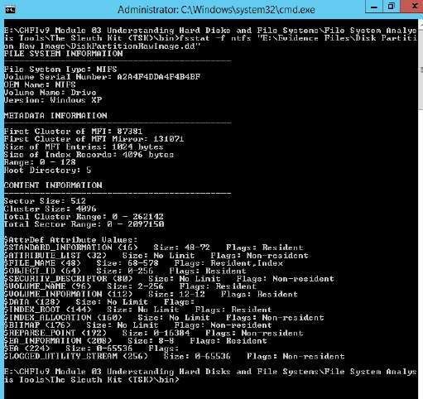
- Use the istat tool of the sleuth kit to view the details of metadata structure.
type
istat -f ntfs “hoa3_ddimage.dd" 0
- Use the following command to view MFTMirr File Overview,
type
istat -f ntfs “hoa3_ddimage.dd" 1
- Use the following command to view the Boot File Overview,
type
istat -f ntfs “hoa3_ddimage.dd" 7
- Use the following command to view the File volume,
type
istat -f ntfs “hoa3_ddimage.dd" 3
- Use the following command to view the AttrDef File Overview,
type
istat -f ntfs “hoa3_ddimage.dd" 4
- Use the following command to view the Bitmap File Overview,
type
istat -f ntfs “hoa3_ddimage.dd" 6
- Use the following command to view the BadClus File Overview
type
istat -f ntfs “hoa3_ddimage.dd" 8
- Use the following command to view the secure File Overview,
type
istat -f ntfs “hoa3_ddimage.dd" 9
- Use the fls command-line tool of TSK to list the files and directory names.
type
fls -f ntfs "hoa3_ddimage.dd"
- Use the following command to see only the deleted entries,
type
fls -d "hoa3_ddimage.dd"
- Use the following command to view the details of the image
type
img_stat “hoa3_ddimage.dd" 6
Report: Document the outcome of the above analysis done. Based on your experience doing Task 1, 2, 3 and 4, so far what is the difference using TSK tool?
No. of Files given to analyse: 1
Deliverables: Discussion in Class
Task 5: Using Autopsy to analyse raw image
Required Images: HoA3_Files Task 4 hoa3_ddimage.dd
- Download Autopsy
- Open Autopsy and open the hoa3_ddimage.dd file (ignore step 1 if you have autopsy installed already)
- Create a new case:
  - Case Number: 031123
  - Description: My Autopsy Analysis before Coursework Task
  - Investigator Name: “Your Name”
- Add the hoa3_ddimage.dd as a new image
- Choose appropriate partition and import method. Before selecting, do a research on the partition and import methods. Justify your selected option.
- Analyse the image. Look for General File System Details.
No. of Files given to analyse: 1

Overall Reflection
Present your reflection to the class. (Note that you will have 10 minutes for presentation during the next lecture session. – Before the presentation, you must submit the documentation in Moodle)
- Understanding on the concepts discussed in the lecture and its relation to the activity done.
- Understanding about various tools used and various frameworks available for DF analysis.
- Rate yourself: Understanding Image Acquisition, Investigation and Analysis
-------------------------------------------End of Activity--------------------------------------------

