Thomas Sellwood (2215661)

Geogrpahical information system:

Methadone usage across wales

Contents
Geogrpahical information system: 0
Methadone usage across wales 0
Task 1 1
Data Types 1
Data Collection and Preparation 1
Task 2 2
Introduction 2
Thematic Mapping Principles 2
HB Spending on Methadone 2
Deprivation of MSOA versus Spend on Methadone 3
Spend Versus Male Life Expectancy 5
Spend Versus Female Life Expectancy 6
Population Versus Spend 7
Methadone Spend Versus Illicit Drug Use Admissions for A+E 8
Conclusion 10
Appendix 1: Data Log 11
Appendix 2: Development Log 12
Appendix 3: Python Code 13

Task 1
This area of the report will focus on the data collection and the creation of the GIS workspace that discusses Methadone spend throughout the health boards in Wales.
This area will focus primarily on the data collection and data preparation of the GIS.

Data Types
Data in GIS systems can be broadly separated into two categories, Spatial Data and Attribute Data. Spatial data contains data around geographic features and their location data, for example in the context of this GIS this could be the health board boundaries and the location of the GP practices. Attribute data covers the descriptive data associated to the spatial data, in relation to this GIS build this would cover attributes such as health board name, GP practice name and address.

Data Collection and Preparation
Excel was a useful tool while preparing the data for use within the GIS particularly as many files were in a csv format. The tabular view of data in Excel presents it in a clear way for validation that data types are appropriate, in the correct format and that the data set is complete.
While excel can be a useful tool, when handling numerous files containing the same data for different months, it is useful to leverage tools to ease the burden of manual data manipulation if data is being processed consistently. For the filtering and amalgamation of the CSV files obtained from NWSSP for the prescribing data set it was preferable to take this approach. Appendix 3 demonstrates the code utilised to filter and amalgamate this data in readiness for use within the GIS workspace. This utilised the Pandas library within the programming language python, this process allowed for accelerated preparation of the main data set.
See appendix 2 for development log of the GIS build.

Task 2

Introduction
Methadone is a synthetic opioid, which is clinically indicated for the treatment of various types of opioid dependence in adults [1][2]. Methadone is prescribed in primary care, and patients can take their prescription to their local chemist where the doses will be dispensed. Usually, patients initiate on methadone therapy will have their initial doses supervised until their dose has been stabilised [2].
This report will analyse the spend of methadone in primary care across the 7 health boards of Wales. The report will look at factors such as life expectancy for males and females, population and illicit drug use admission to A+E. Encompassing these factors should give a rounded view of why methadone spend differs across the regions of Wales.

Thematic Mapping Principles
Thematic mapping is a core technique in GIS that allows users to visualise the spatial distribution of a specific variable, in this case methadone spend, across defined geographical areas [3].
In this project, a range of thematic mapping methods were used to represent data across the seven health boards of Wales and their constituent MSOAs. The most used method was choropleth mapping [3], where areas were shaded based on numerical values such as methadone spend or life expectancy. Colour ramps were chosen carefully to represent data intuitively, for example, darker shades indicated higher spend or higher spend per 1000 people.
To enhance interpretability, maps included clear legends and were designed using a consistent and readable basemap.
Effective data visualisation in GIS relies not only on technical skills to create the visualisations but on design choices that support clarity and insight [3].
By combining spatial data with visual cues, thematic maps in this project helped reveal geographic relationships between drug spend across Wales.

HB Spending on Methadone
The below map demonstrates the spend in GBP on Methadone for each of the health boards. The areas in darker shading represent areas of higher spend of Methadone within a health board. The map was created by combining the health boards of Wales map obtained from Data Map Wales [4] and the NHS prescribing data set which is obtained from NHS Wales Shared Services Partnership (NWSSP) [5]. The data from NWSSP is available only month by month and contains all items prescribed. The data set was filtered and combined into one csv file for use utilising a python script as can be seen in appendix 2, this is also discussed above.
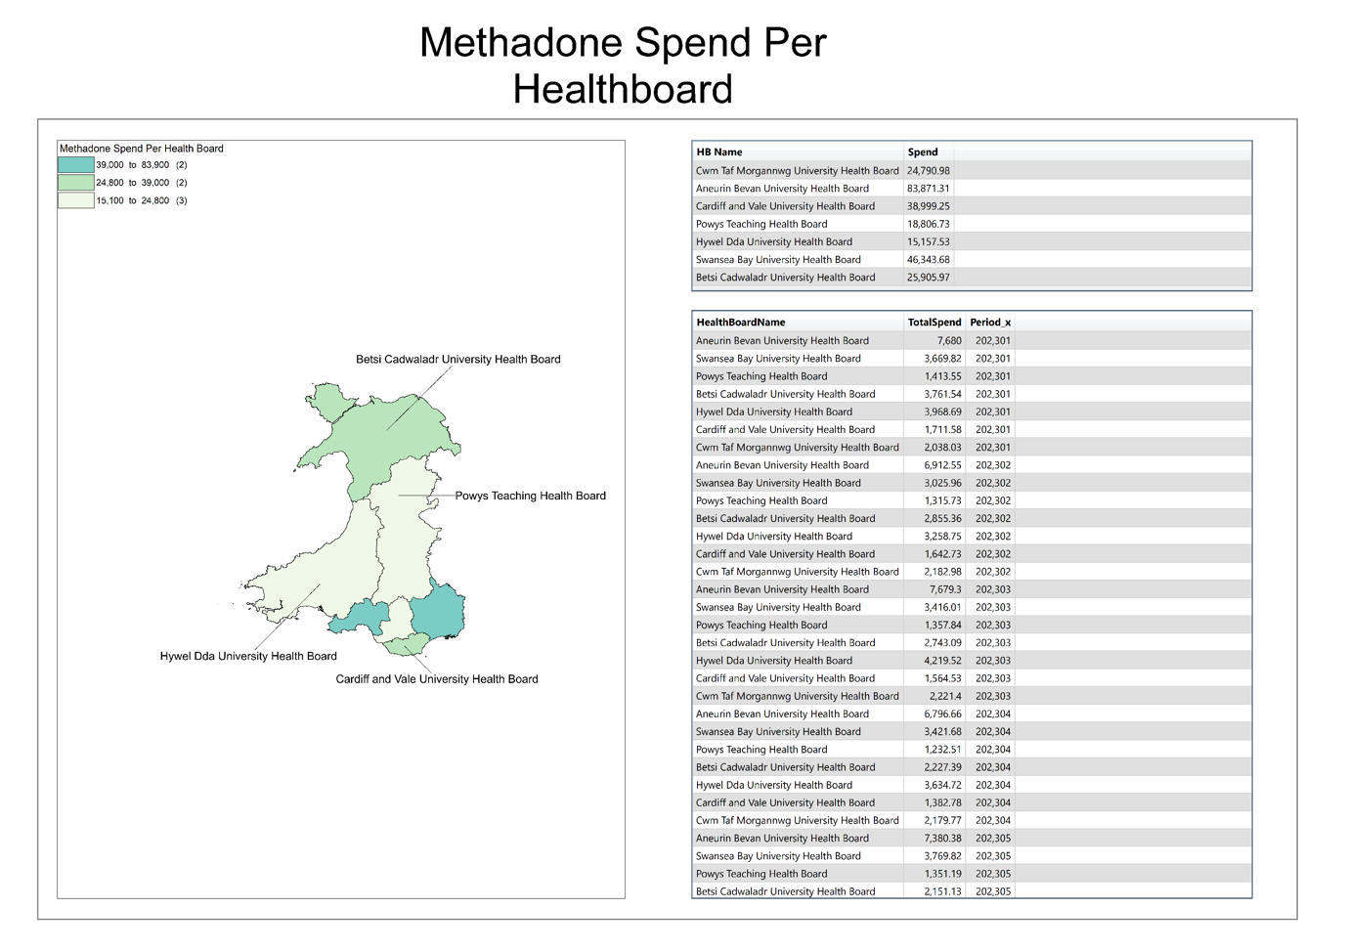
Figure 1: Spend by HB
As can be seen from figure 1, Aneurin Bevan University Health Board holds the highest spend of Methadone in Wales, with a total for calendar year 2023 £83,871.31 [5]. The lowest spend on Methadone is by Hywel Dda University with a spend of £15,157.53 for calendar year 2023 [5].
As can be seen from figure 1 spend is more concentrated to Southern Wales, with spend in Mid and North Wales health boards of Betsi Cadwaladr University Health Board and Powys teaching Health Board not equal to half the spend of Aneurin Bevan University Health Board [5]. Interestingly the two health boards with highest spend Aneurin Bevan University Health Board and Swansea Bay University Health Board bot contain prisons within the health board area.
Using a SQL query within MapInfo, data was able to be aggregated by month and health board. From this data spend throughout the year can be analysed. The data demonstrated that spend is consistent throughout the year for each health board, with some spikes in spend seen from Hywel Dda University Health Board during in the summer months [5].

Deprivation of MSOA versus Spend on Methadone
The below map demonstrates the spend of Methadone obtained from the NWSSP data set [5], versus the Welsh Index of Multiple Deprivation for health data set from Data Maps Wales [6]. This was overlayed with the Middle Super Output Areas map also from Data Maps Wales [7].
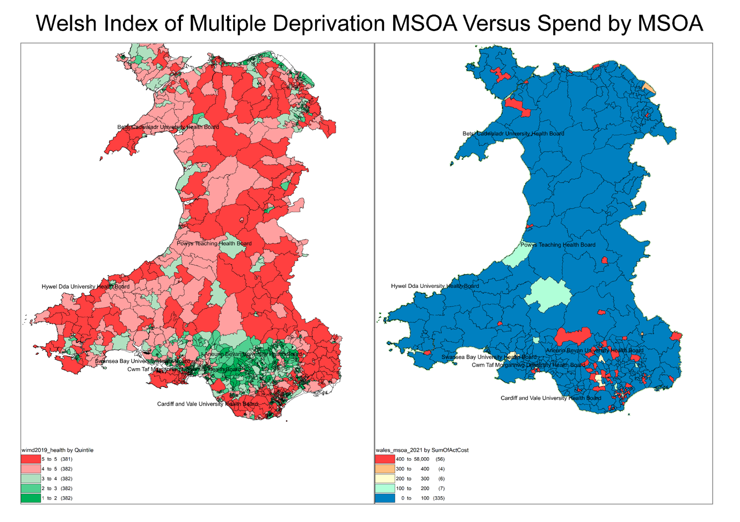
Figure 2: Comparison of spend by MSOA to Deprivation
Figure 2 illustrates a clear spatial relationship between deprivation and methadone spend across Wales. The left map shows deprivation levels using the Welsh Index of Multiple Deprivation (WIMD) [6], with MSOAs shaded from dark red (the areas most deprived) to green (the least deprived areas). The right map displays methadone spend by MSOA [5], with darker blue areas indicating higher expenditure.
A strong geographic overlap is evident. The most deprived areas, particularly across South Wales, such as Swansea, Cardiff, Newport, and the Valleys are also those with the highest levels of methadone spend. Conversely, more affluent and rural regions, such as Powys and parts of North and West Wales, show both lower deprivation and little to no recorded spend. This pattern suggests a strong association between deprivation and opioid treatment needs. Its also important to note as well that particularly in North and West Wales methadone spend is focussed in certain areas suggesting that there are limited services
High levels of methadone expenditure in deprived areas are likely reflective of greater opioid dependence, while this data set is linked specifically to health, other structural factors such as unemployment, poor housing, and long-term health inequalities may link to higher Methadone usage.
Notably, the consistent spatial alignment between red-shaded deprivation zones and high-spend areas supports the view that opioid-related harm is disproportionately concentrated in Wales’s most socioeconomically disadvantaged communities.
In summary, the maps highlight that methadone spend in Wales is not evenly distributed, but closely mirrors patterns of deprivation, reinforcing the public health argument for addressing drug misuse as a symptom of broader social inequality.

Spend Versus Male Life Expectancy
The below map shows the spend of Methadone compared to the male life expectancy for each health board. The data for male life expectancy was obtained from Health Maps Wales [8] and the health board map obtained also from Data Maps Wales [4]. The spend data was obtained from NWSSP [5].
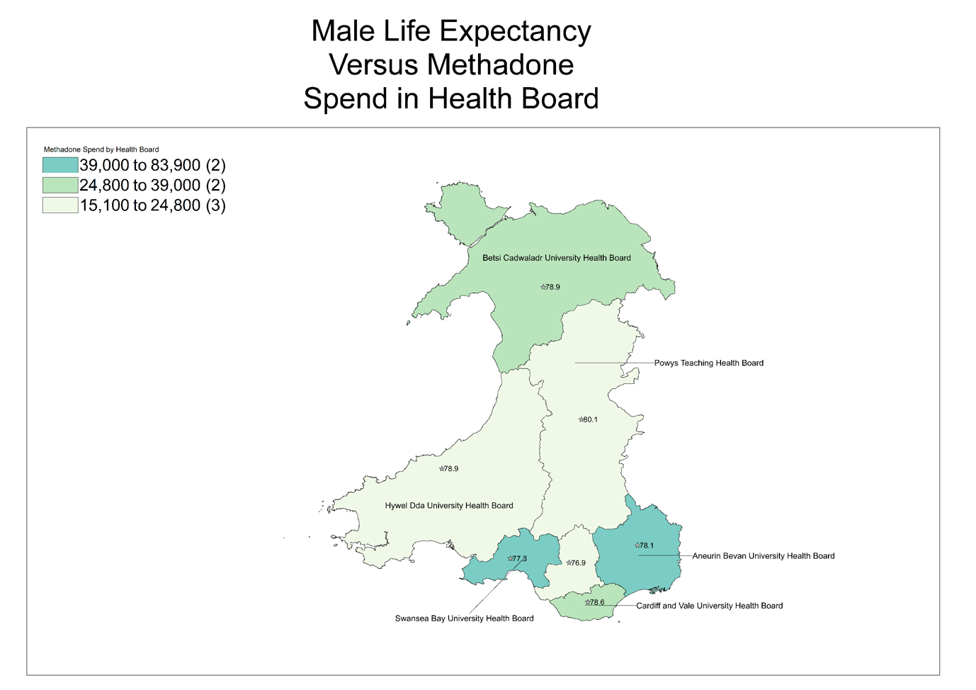
Figure 3: Male Life Expectancy Versus Methadone Spend
Figure 3 demonstrates male life expectancy and the spend of methadone for each health board. Health boards with the highest methadone expenditures—Aneurin Bevan University Health Board and Swansea Bay University Health Board show life expectancy values of 78.1 and 77.3 years respectively [8]. These regions are more urbanised and face higher levels of deprivation, factors typically associated with higher rates of opioid misuse and lower health outcomes [INSERT REFERENCE HERE]. The lowest male life expectancy health board is Cwm Taf Morganwg University Health Board with a life expectancy of 76.9 [8] interestingly this health board is in the lower band of spend on Methadone [5].
Conversely, Powys Teaching Health Board, with the highest male life expectancy at 80.1 years, records one of the lowest methadone spends [8]. This is a predominantly rural area, this correlates with lower rates of drug-related harm. Similarly, Hywel Dda and Betsi Cadwaladr report moderate methadone spend and mid-range life expectancy 78.9 years [8] interestingly these are both rural areas also.
The visualisation shows that higher methadone spend may be indicative of regions with greater drug dependency. However, it is important to take note that higher spend may also reflect better access to treatment services, which can mitigate harm despite underlying socioeconomic challenges.

Spend Versus Female Life Expectancy
The below map shows the spend of Methadone compared to the female life expectancy for each health board. The data for female life expectancy was obtained from Health Maps Wales [9] and the health board map obtained also from Data Maps Wales [4]. The spend data was obtained from the NWSSP prescribing data set [5].
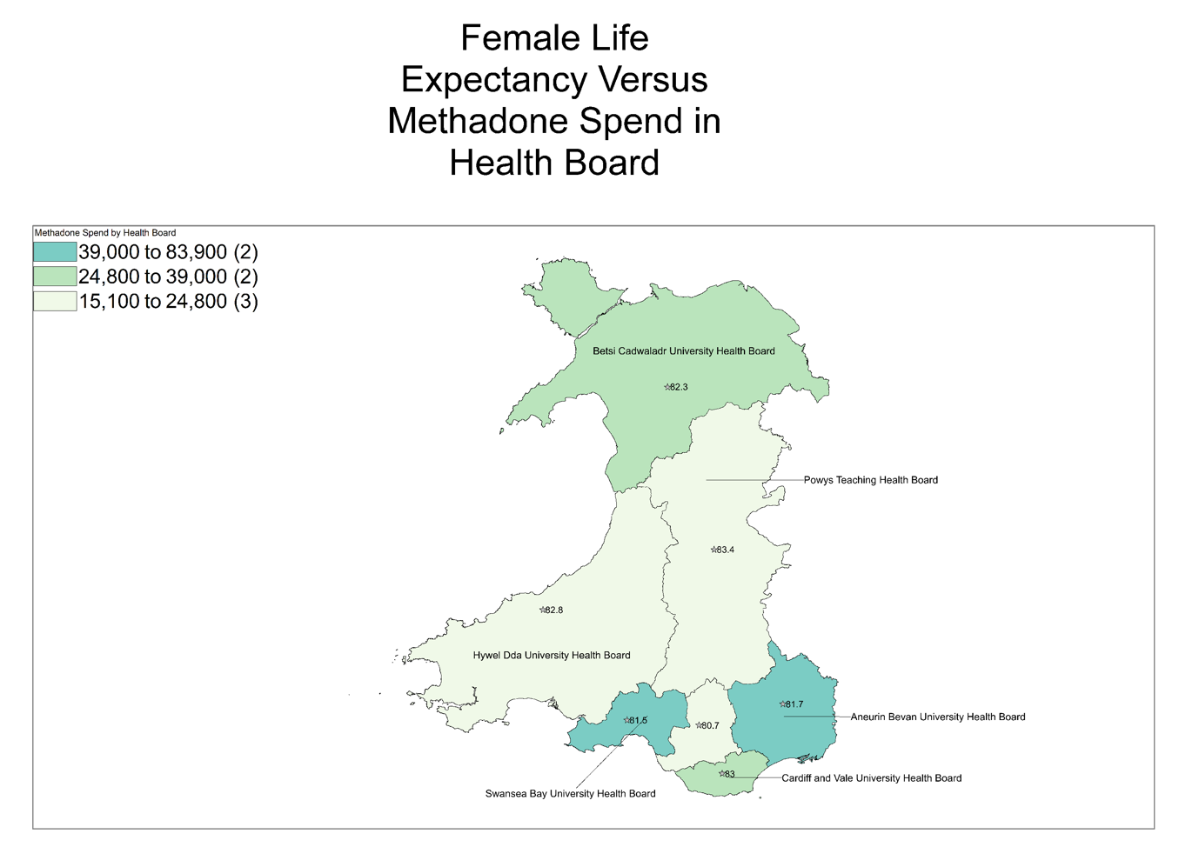
Figure 4: Female Life Expectancy Versus Methadone Spend
Figure 4 enables comparison of life expectancy against the spend of methadone for each health board.
Health boards with higher methadone spend often show lower female life expectancy. Swansea Bay University Health Board and Aneurin Bevan University Health Board fall into the highest methadone spend category (£39,000–£83,900) [9. 5. 9]and report relatively low female life expectancies of 81.5 and 81.7 years [9], respectively.
Cardiff and Vale University Health Board, falls in the middle spend bracket with a life expectancy of 83 years [9], slightly higher than Swansea and Aneurin Bevan. This suggests some regional variation in service demand or potentially prescribing practices.
At the other end of the spectrum, Powys Teaching Health Board reports the highest female life expectancy (83.4 years) [9]and is in the lowest spend bracket (£15,100–£24,800) [5]. Similarly, Hywel Dda and Betsi Cadwaladr show moderate-to-high life expectancies (82.6 and 82.3 years) [9]with lower levels of methadone spending.
Interestingly, Cwm Taf Morgannwg presents a key exception: it has the lowest female life expectancy (80.1 years) yet also falls into the lowest methadone spend category. This discrepancy may indicate under-provision of treatment or unmet need.
Overall, the map supports the idea that higher methadone spend correlates with lower life expectancy, though exceptions like Cwm Taf emphasise the need for a nuanced understanding of health inequality and treatment accessibility.

Population Versus Spend
This visual was created utilising population by health board data from Stats Wales [10], again paired with the spend data provided by NWSSP [5] and the health board map obtained also from Data Maps Wales [4]. Once I had collated this information I was then able to by be using a SQL query obtain the SpendPer1000, this measure normalises the spend per 1000 people within each health board area.
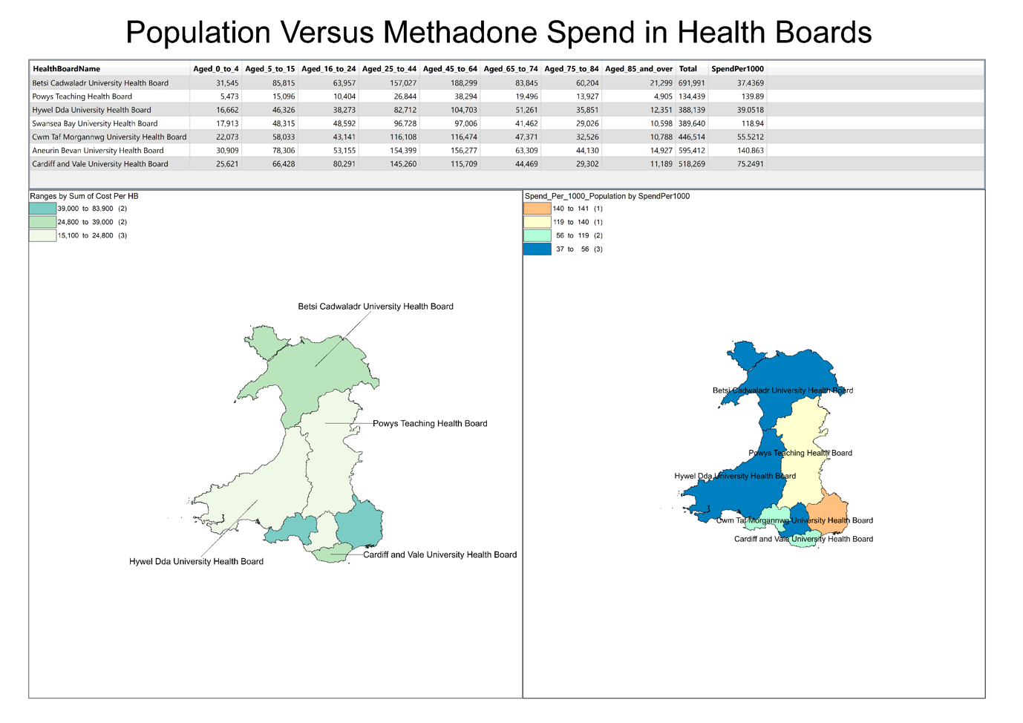
Figure 5: Population Versus Methadone Spend
The table indicates that Betsi Cadwaladr University Health Board serves the largest population (691,991) [10], while Powys Teaching Health Board serves the smallest (134,4399) [10].
However, methadone spend per 1000 people does not correlate linearly with population size. For instance, Betsi Cadwaladr, with a high population (691,991) [10], also has some the lowest spend per 1000 (37.43699), while Powys, despite its small population, reports one of the higher spends per 1,000 (139.89). Aneurin Bevan University Health Board does again top the charts in terms of spend per 1000(140.863).
The right-hand map of figure 5 presents a normalised view spend per 1,000 residents which offers a clearer perspective on methadone usage relative to population.
Here we can see areas such as Powys Teaching Health Board although a spending a small amount overall in comparison to the other neighbouring health boards such as Aneurin Bevan University Health Board, its spend per 1000 people is very similar, indicating a greater requirement for substance misuse services in that area.
This disparity highlights that population size alone is not a sufficient predictor of methadone expenditure. Factors such as socioeconomic deprivation, rurality, service accessibility, and prevalence of opioid dependence likely play significant roles.
To summarise, while population size influences total spend, per capita spend reveals deeper insights into health board-specific spending.

Methadone Spend Versus Illicit Drug Use Admissions for A+E
The below map shows the spend of Methadone obtained from the NWSSP prescribing data set [5], this was then paired with data from Health Maps Wales for illicit drug admission to A+E [11]. This was the layered on top of the health board map to show distribution through out Wales [4].
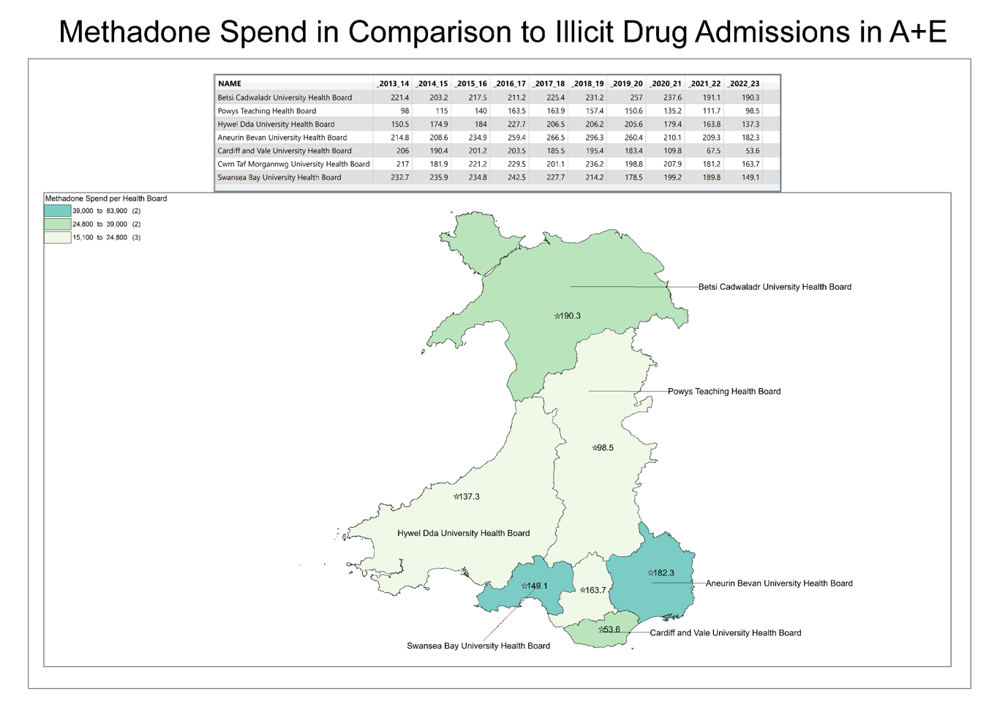Figure 6: Methadone Spend by Illict drug admissions
Figure 6 presents an analysis of the relationship between methadone expenditure and A+E admissions related to illicit drug use across Welsh health boards. The map is supported by a table showing annual admissions from 2015 to 2022 for each board.
From the data in Figure 6, a general trend emerges that health boards with higher methadone spend tend to have higher numbers of A&E admissions related to illicit drugs.
Aneurin Bevan and Cwm Taf Morganwg Health Boards, record the highest total admissions—182.3 and 163.7 [11], respectively.
Swansea Bay, in the high spend range (£39,800–£39,000)[5], follows with 149.3 admissions[11]. These figures suggest that regions experiencing greater acute drug-related harm are also those investing more heavily in methadone treatment, reflecting a likely higher prevalence of opioid dependence.
In contrast, Powys Teaching and Hywel Dda University Health Boards, which report lower methadone spending, also have the lowest total admissions, at 98.5 and 137.3 [11], respectively. Anecdotally due to lack of acute services in Powys this may lead to patients potentially crossing the border to England or to other health boards in Wales, which may skew figures.
Interestingly, Cwm Taf Morgannwg stands out: despite being in the lowest methadone spend category, it has a relatively high number of drug-related A+E admissions. This could potentially indicating a gap between treatment provision and demand in this area.
In summary, the data underscores a clear association between emergency drug-related admissions and methadone investment, while also highlighting inconsistencies like in Cwm Taf that suggest the need to assess not just spend levels, but whether service provision is meeting actual community need.

Conclusion
The analysis has demonstrated that methadone expenditure across Welsh health boards varies significantly by health board and is shaped by a complex factors demographic, geographic, and socioeconomic influences.
Thematic mapping using chloropleth maps has revealed clear spatial patterns, where methadone spend is consistently higher in more deprived, urbanised regions such as Aneurin Bevan and Swansea Bay University Health Boards, where life expectancy is lower and A&E admissions for illicit drug use are more frequent. Conversely, rural health boards like Powys and Hywel Dda exhibit lower overall spend but, when normalised for population, still show notable service need in these areas.
Importantly, there is a strong correlation between high methadone spend and areas with high levels of deprivation, reinforcing the public health perspective that opioid dependency is closely tied to structural inequality. However, within the data there are exceptions such as Cwm Taf Morgannwg University Health Board, where relatively low methadone spend coincides with high A&E admissions and the lowest life expectancy, this suggests possible under-provision or limited access to treatment services.
The use of GIS and thematic mapping throughout this task has been instrumental in identifying regional disparities and supporting evidence-based interpretations. The findings underscore the importance of tailoring substance misuse services to local need, not just based on population size but also on other key influences such as deprivation levels, health outcomes, and demand indicators. Overall, this analysis supports the need for equitable, targeted investment in opioid treatment services as part of a broader strategy to address health inequality and reduce drug-related harm across Wales.
To build on and improve on this work in future, considerations such as distance to health care facilities for patients, could be a key area to explore, and include other measures of deprivation such as the Townsend index.
Other key data such as spend on substance misuse prescribing as whole could be key by drawing in data for other drugs such as buprenorphine could provide a more rounded insight. This data is hard to obtain from the data set as is it stands as buprenorphine is also utilised in pain management.

References
[1] NICE. "Methadone Hydrochloride." NICE BNF. https://bnf.nice.org.uk/drugs/methadone-hydrochloride/ (accessed 21/01).
[2] NHS. "Medicine used to treat heroin dependence." NHS. https://www.nhs.uk/medicines/methadone/ (accessed 21/01).
[3] Ordnance Survey, "Thematic mapping techniques", Ordnance Survey, https://www.ordnancesurvey.co.uk/blog/thematic-mapping-techniques
[4] DataMapWales. "Local Health Boards." DataMapWales. https://datamap.gov.wales/layergroups/geonode:LocalHealthBoards (accessed 17/07).
[5] NHS Wales Shared Services Partnership. "General Practice Prescribing Data Extract." NWSSP. https://nwssp.nhs.wales/ourservices/primary-care-services/general-information/data-and-publications/prescribing-data-extracts/general-practice-prescribing-data-extract/ (accessed 17/07).
[6] DataMapWales. "Welsh Index of Multiple Deprivation (WIMD) 2019." DataMapWales. https://datamap.gov.wales/layergroups/inspire-wg:WelshIndexOfMultipleDeprivationWIMD2019 (accessed 17/07).
[7] DataMapWales. "Middle layer Super Output Areas (MSOAs) - Wales – 2021." https://datamap.gov.wales/layers/geonode:msoa_2021_w_hwm (accessed 17/07).
[8] Digital Health and Care Wales. "Life Expectancy at Birth 3Yr avg, males." Health Maps Wales. https://www.healthmapswales.wales.nhs.uk/data-catalog-explorer/indicator/I1715 (accessed 17/07).
[9] Digital Health and Care Wales. "Life Expectancy at Birth 3Yr avg, Females." Health Maps Wales. https://www.healthmapswales.wales.nhs.uk/data-catalog-explorer/indicator/I1716 (accessed 17/07).
[10] Stats Wales. "Population estimates by local health boards and age." StatsWales. https://statswales.gov.wales/Catalogue/Population-and-Migration/Population/Estimates/Local-Health-Boards/populationestimates-by-lhb-age (accessed 17/07).
[11] Digital Health and Care Wales. "Any Illicit Drug Use, Admission Rates (Age-standardised) per 100k pop, Persons, All Ages." HealthMaps Wales. https://www.healthmapswales.wales.nhs.uk/data-catalog-explorer/indicator/I1330 (accessed 17/07).

Appendix 1: Data Log

Datasets​ | Source​ | File Type​ | Type of Data​ | Applicable​
Wales maps​ | UK data service​ | Shape file​ | Geographic data​ | y​
Health board map​ | UK data service​ | Shape file​ | Geographic data​ | y​
Prescribing data in Wales 2023 ​ | NHS data ​ | CSV file​ | Health Data​ | y​
Addresses for GP surgeries in Wales​ | NHS data ​ | CSV file​ | Geographic data​ | y​
Postcode Data ​ | UK data service ​ | Shape file​ | Geographic Data​ | y​
GP Main sites​ | NHS data​ | Shape file​ | Geographic Data​ | n​
Socioeconomic Data ​ | UK data service​ | CSV​ file | socioeconomic data ​ | y​
Long Term Health Data​ | UK data service​ | CSV​ file | Health Data​ | y​
Life Expectancy data | Data maps Wales | CSV file | Health Data | Y
Population by sex per healthboard | Data maps wales | Csv file | Population data | y

Appendix 2: Development Log
Date | Task | Details | Methodology and Software Utilised
21/06/2025 | Data Collection​ | Identification and collection of data relevant to case study of Methadone Spend | Safari, Excel​, Numbers
26/06/2025 | Data Validation and Preparation | Assess that data is in a usable format for use in GIS. Leverage python to automat data preprocessing | Excel, Numbers,Visual Studio Code, Python – Pandas library,
28/06/2025 | Data Analysis and GIS Build​ | Load data into GIS start to build maps and layers start processing data through the GIS workspace | MapInfo
17/07/2025 | Finalise Data and Visualisations | Finalize maps with data required to accurately represent themes discussed | MapInfo

Appendix 3: Python Code

import pandas as pd

#Read data from CSV into data frame
itemData202301 = pd.read_csv("GPData202301/GPData202301.csv")
itemData202302 = pd.read_csv("GPData202302/GPData202302.csv")
itemData202303 = pd.read_csv("GPData202303/GPData202303.csv")
itemData202304 = pd.read_csv("GPData202304/GPData202304.csv")
itemData202305 = pd.read_csv("GPData202305/GPData202305.csv")
itemData202306 = pd.read_csv("GPData202306/GPData202306.csv")
itemData202307 = pd.read_csv("GPData202307/GPData202307.csv")
itemData202308 = pd.read_csv("GPData202308/GPData202308.csv")
itemData202309 = pd.read_csv("GPData202309/GPData202309.csv")
itemData202310 = pd.read_csv("GPData202310/GPData202310.csv")
itemData202311 = pd.read_csv("GPData202311/GPData202311.csv")
itemData202312 = pd.read_csv("GPData202312/GPData202312.csv")

#Define filter for dataset and then filter original dataframes
filter = 'BNFName.str.contains("Methadone Hcl_Mix")'

#Filter the data in the data frames down to the drugs that we want

filtereditemData202301 = itemData202301.query(filter)
filtereditemData202302 = itemData202302.query(filter)
filtereditemData202303 = itemData202303.query(filter)
filtereditemData202304 = itemData202304.query(filter)
filtereditemData202305 = itemData202305.query(filter)
filtereditemData202306 = itemData202306.query(filter)
filtereditemData202307 = itemData202307.query(filter)
filtereditemData202308 = itemData202308.query(filter)
filtereditemData202309 = itemData202309.query(filter)
filtereditemData202310 = itemData202310.query(filter)
filtereditemData202311 = itemData202311.query(filter)
filtereditemData202312 = itemData202312.query(filter)

#Concatenate the filtered dataframes into one dataframe

frames = (filtereditemData202301,
filtereditemData202302,
filtereditemData202303,
filtereditemData202304,
filtereditemData202305,
filtereditemData202306,
filtereditemData202307,
filtereditemData202308,
filtereditemData202309,
filtereditemData202310,
filtereditemData202311,
filtereditemData202312
)

drugDataFrame = pd. concat(frames)

gpAddressData = pd.read_csv("GPData202312/Address.csv")

#Merge address data to drug data based on practice ID

mergeResult = pd.merge(drugDataFrame, gpAddressData, on='PracticeID', how='inner', validate ='many_to_many')

#Create CSV based off dataframe
mergeResult.to_csv('methadonePrescNum.csv', index=False)

