Roxana Meader
2222009
BMSW4009
An Analysis of own team composition

To understand the composition of my own team it is necessary to address the meaning of the concept. According to Meredith Belbin “a team is not a bunch of people with job titles, but a congregation of individuals, each of whom has a role that is understood by other members” (Belbin,2010). Therefore, the team effectiveness is strongly corelated to a balance in the team’s roles, clear communication, shared goals, complementary skills, and collaboration, all encompassed by core values of trust and respect.
Belbin identified nine team roles, and he categorized those roles into three groups: Action Oriented, People Oriented, and Thought Oriented.

When analysing the team, all members have used Belbin’s team roles questionnaire. The results demonstrate that all the members of our team exhibit Implementer traits, but also Co-ordinator (Alina), Completer Finisher (Alexandra) and Monitor Evaluator (Roxana). It became apparent that our team possesses common and complementary skills and expertise, effective communication and collaboration, shared values and vision, and common goals. The members of the team already knew each other and had a relation based on trust and respect. The weakness of the team was a lack of social interaction and synchronisation due to day-to-day life. Each member agreed to meet weekly via Teams and collaborate online.
According to Tuckman “Teams go through stages of development starting with forming, then storming, norming, performing and finally adjourning” (Tuckman, 1965).

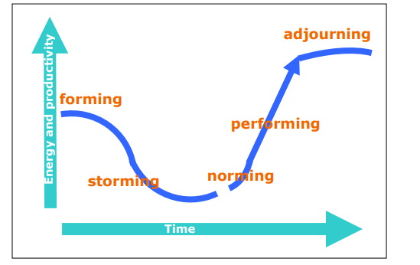

Since our team’s inception, all members were aware of each other’s strengths and weaknesses and had a fair amount of mutual respect and empathy towards each other. Therefore, our team, skipped the forming and storming stage and proceeded directly to norming and performing. The atmosphere was relaxed and informal, the goals were understood, all members participated in the discussion, the team had all the “attributes of a mature group” (Laiken, 1994).
Teams are not static but rather dynamic entities governed by the people involved and their personalities.
Therefore, the cohesion of the group can be influenced by personalities, perspectives, clarity of the information, values, cooperation, and fairness. When those norms do not intertwine or oppose, conflict will appear. Conflict is defined as “a process that begins when one party perceives that another party has negatively affected, or is about to negatively affect, something that the first party cares about.” (S. P. Robbins & T. A. Judge, 2008).
To understand conflict in our group as a work project, I have used Killmann’s conflict resolution model, and each member has completed the questionnaire.

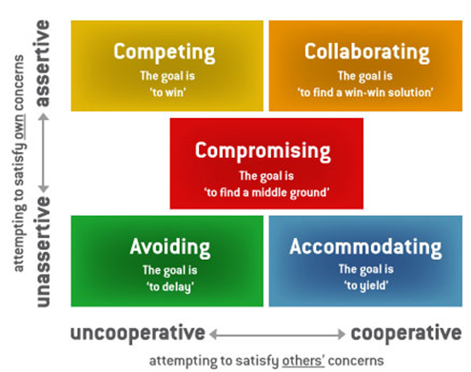
Inevitably, conflict did arise in our team in the norming stage, concerning the times of meetings and the structure of the assessment we had to complete. Two members, appeared to be more assertive, one compromising and one collaborating. The conflict turned out to be beneficial from the structure of the assessment point of view but quite unsettling when it concerned the availability of each member for meetings. Members collaborated well and compromised in finding a suitable date for all.
In conclusion “Synergize is the habit of creative cooperation, it is teamwork, open-mindedness, and the adventure of finding new solutions to old problems” (Convey,1999).

Reference:
Belbin. (2010). Team roles at work (Second edition). Butterworth-Heinemann.
Covey. (1999). The 7 habits of highly effective people: restoring the character ethic. Simon & Schuster.
Laiken. (1994). The anatomy of high performing teams: a leader’s handbook. The Ontario Institute for Studies in Education. https://doi.org/10.3138/9781442680494
S. P. Robbins & T. A. Judge, Essentials of Organizational Behavior, 2008)
Tuckman. (1965). Developmental sequence in small groups. Psychological Bulletin, 63(6), 384–399. https://doi.org/10.1037/h0022100

