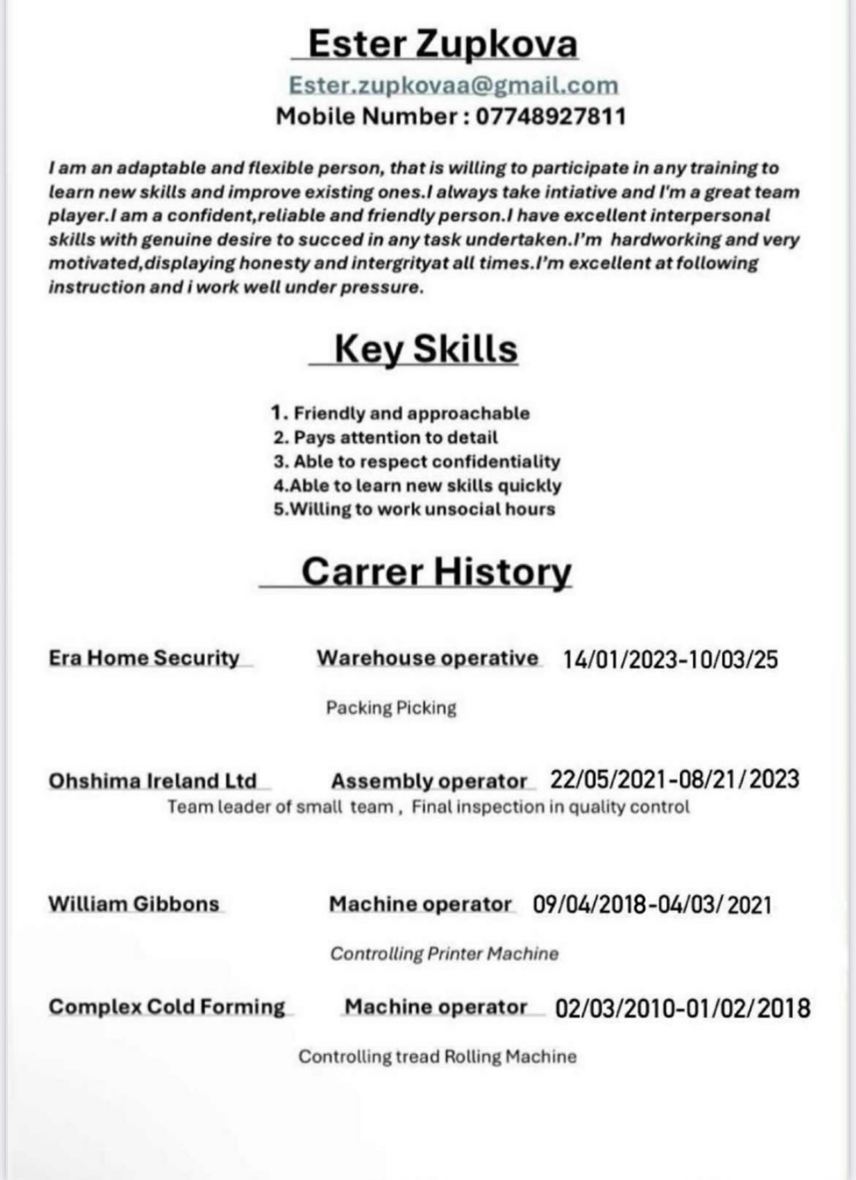

Full job description
Position Machine Shop Operative
Reporting to: - Machine Shop manager / Works Manager
Hours: - 40hrs plus overtime when required
Job Summary To Machine , Mill , Drill and Cut components and sections to drawing specification.
Key Responsibilities
· Studying and interpreting technical documents, such as Drawings, and diagrams required to complete tasks.
· Reading and confirming components & cuttings lists, interpret measurements, verify specifications and sign off on completed works and tasks once completed.
· Starts and observes machine operation to detect malfunctions or out-of-tolerance machining, and adjusts machine controls or control media as required.
· Verifies conformance of finished work-piece to specifications, using measuring and inspection tools as necessary.
· Confers with production personnel, Drawing Office, or others to resolve machining or assembly problems.
· Maintaining a vigilant eye on stocks and consumption of material for jobs and relaying timely information for ordering.
· Diagnosing and troubleshooting equipment malfunctions and performing repairs.
· Performing preventive maintenance and reporting and resolving issues and equipment faults.
· Keeping the workspace area clean.
· Adhering to health and safety requirements of the company and the industry.
· Conserving resources and supplies to facilitate minimum waste
· Performing any other duties that may be deemed necessary to ensure the effective running of the Department and Company.
· Good team worker
Job Type: Full-time
Pay: £12.21-£15.45 per hour
Benefits:
- Company pension
- Free parking
- On-site parking
Work Location: In person

Cover Letter

Dear Hiring Manager,

I am writing to apply for the Machine Shop Operative position at Enviroplast in Willenhall. I am a hard-working and reliable person who enjoys practical work and learning new skills. I believe I would be a good fit for your team.

I have experience working with machines and tools, following drawings, and checking measurements carefully. I always make sure my work is accurate and meets the right specifications. I understand the importance of safety, good communication, and teamwork in a production environment.

I am used to working full-time hours and don’t mind overtime when needed. I take pride in keeping my work area clean and organised and making sure jobs are finished on time.

I would be happy to bring my energy and commitment to Enviroplast and help your company produce quality work. Thank you for considering my application. I look forward to the opportunity to discuss this role further.

