LCHS4008 Introduction to Public Health

Student name: Shakilla Naz
Module: Introduction to health and social care
Module code: LCHS4003
Lecturer: Daniel Haruna
Assignment title: Assessement 2 Report on a Health Issue

Table of Contents
INTRODUCTION 3
MAIN BODY 4
Consequences of bowel cancer on individuals, communities, and the health system 4
Disease Control 5
Factors Influencing the Health and Well-being of People Affected by Bowel Cancer and Those Around Them 7
CONCLUSION 10
REFERENCES 10

Table of Figures
Figure 1: Bowel Cancer 3
Figure 2: Epidemiology, Diagnosis of Colorectal cancer 5
Figure 3: Stages and Types of Prevention 6
Figure 4: Global Data of Colorectal Cancer 8
Figure 5: Significant Rise in Colorectal Cancer Worldwide 9
Figure 6: Bowel cancer Report of U.K 9

INTRODUCTION
Colorectal cancer also known as the bowel cancer may be explained as the uncontrolled proliferation of malignant cells of the colon or rectum. It is a common type of cancer which at an early stage is insidious hence there is need to detect it at the earliest. Common signs and symptoms include persistent changes in bowel habits e.g. diarrhoea or constipation, blood in the stool, unexplainable loss of weight, pains in abdominal cavity and zeal. Bowel cancer is also one of the primary health issues among the population in the global context, and the prevalence of the specified illness is on the rise in both developed nations and the developing areas. Bowel cancer ranks as the fourth most common and one of the leading causes of cancer related deaths within the UK that is considered to be overloaded with approximately 44,000 newly diagnosed incidences in 2012. The survival rate has been better received courtesy of the outcome of early-detection and successful treatment, but the problem of the disease to the overall health facilities in the world is still very high (Axelrad et al., 2020).
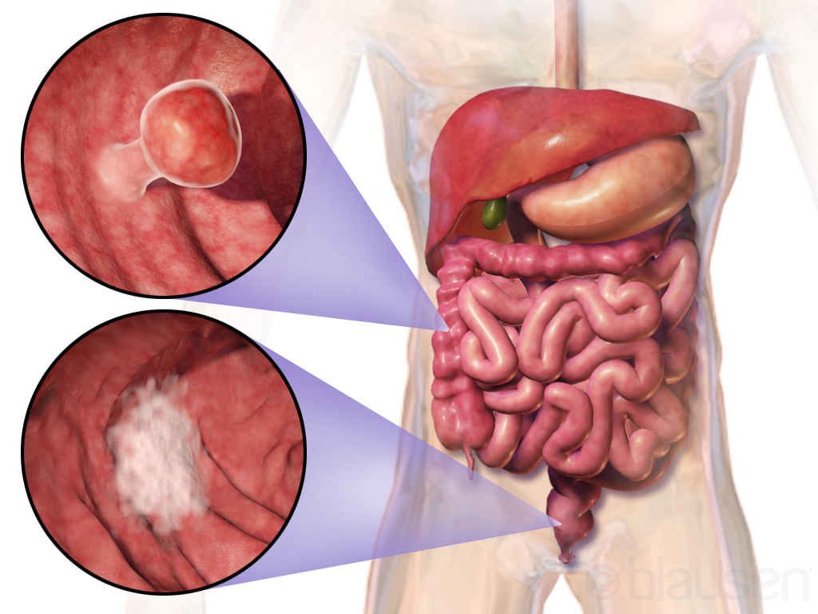
Figure 1: Bowel Cancer
Source: (Google.com, 2025)

MAIN BODY

Consequences of bowel cancer on individuals, communities, and the health system
The bowel cancer has serious effects to the individuals. Physically, invasive procedures, such as surgery, chemotherapy/radiation, can be used on patients with the following resultants i.e. infection, reduced mobility and health-related morbidities such as bowel dysfunction. Psychological effects can be equally important, and the patients are likely to develop sentiment of anxiety, depression and distress and particularly when the cancer was developed in its advanced stage. The disease can alter the body image of an individual especially where the individual must use a stoma and it may affect the quality of life of this individual and emotional service.
On the community level, the diagnosis of bowel cancer could have some implications on the family and the care giver who in most cases takes the responsibility of primary caregiver. It can be ruinous to the extent of being stressful especially to those financially challenged households. It may also result in disruption of work and social roles since bowel cancer patients tend to take long time to recover (Wong, Jones and Halloran, 2024).
Arrangements of health are enormous on the costliness of bowel cancer. The bowel cancer, which consumes its portion of NHS budget, Light in the UK, as well as the initial diagnostic tests and treatment options involved as well as the follow-up, is vast. The growing population age group represents a greater demand on the available medical facilities as bowel cancer is common in age.
The early diagnosis can contribute to the reduction of the total treatment load, and a large proportion of patients still presented at the advanced stages, so the necessity to carry out more complex and expensive procedures. The dilemma or task of healthcare providers is to make sure that such expenses are controlled as their patients acquire quality care that benefits them and on time.
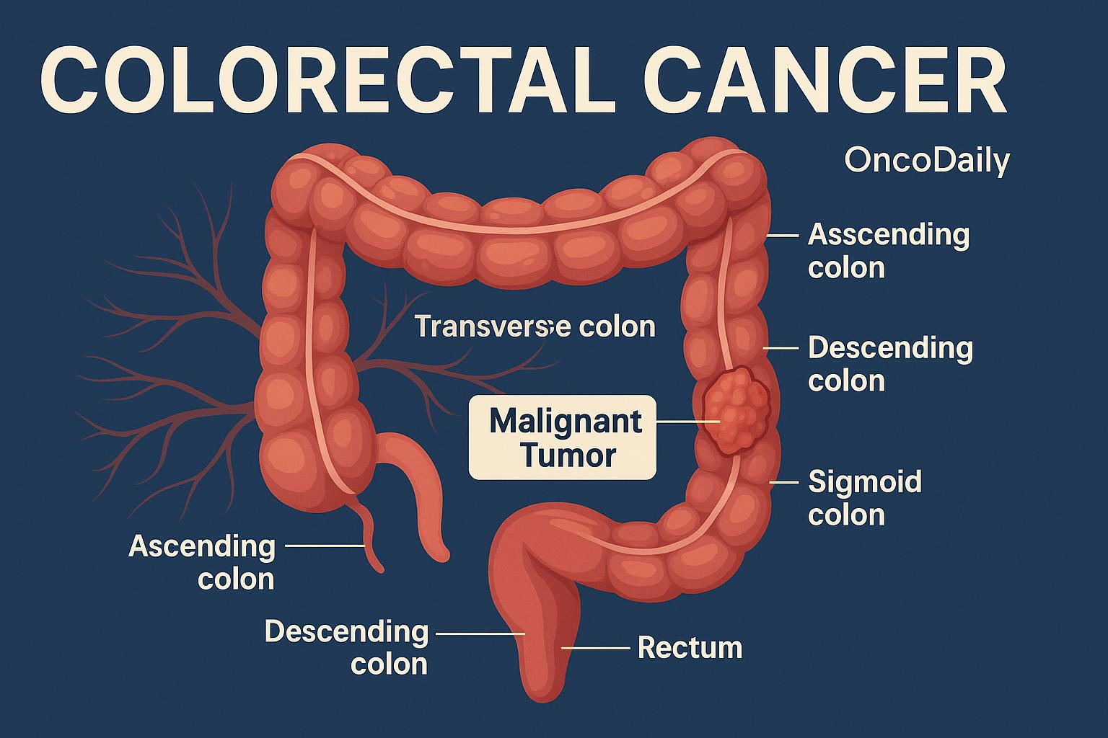
Figure 2: Epidemiology, Diagnosis of Colorectal cancer
Source: (Oncodaily.com, 2025)

Disease Control
Primary and secondary prevention (wrapping (screening)) and tertiary prevention (rational care and follow up) is involved in the management of bowel cancer.
Primary prevention focuses on changes in the way of life with a view of eliminating risks. They are eating a healthy diet rich in fibre, consuming less red and processed meat, doing more physical activities, and reducing the consumption of alcohol. Lifestyle, i.e. quit smoking and proper body weight also helps to avert the threat of bowel cancer. The health campaigns to the population will focus on generating awareness of these modifiable factors of risks which influence individuals to adopt healthy lives.
The second category of prevention is the area of secondary prevention that involves screening programs to detect bowel cancer in an earlier and more curable stage. Bowel cancer screening in the UK offers these screening to individuals aged 50 to 74 years, and this is to carry out regular bowel cancer screening using faecal immuno-chemical test(FIT).
It is directed towards detection of early cancer or precancerous polyps which are removable and they may progress into cancer. It has also been observed that the screening programme in the UK reduces the incidences and deaths of bowel cancer due to its early detection and at the time when it can be treated the best. Tertiary prevention would target at treating the disease and improving the patient outcomes in the long run. Bowel cancer can be treated by surgery, chemotherapy, radiations, and targeted therapies depending on the locality and the stage (Ala, 2021).
The survivors might require follow-up care after treatment to prevent recurrence and treatment to adverse long-term side effects of any treatment. A person has to live with the issues of living with and living free of cancer with the help of psychological counselling, rehabilitation and stoma maintenance. Other than these preventive programs, the policies governing the public health should have also shared the barriers to screening and treatment which involve; the access to healthcare services, health literacy, and socioeconomic status which may dictate the utilization of screening programs.
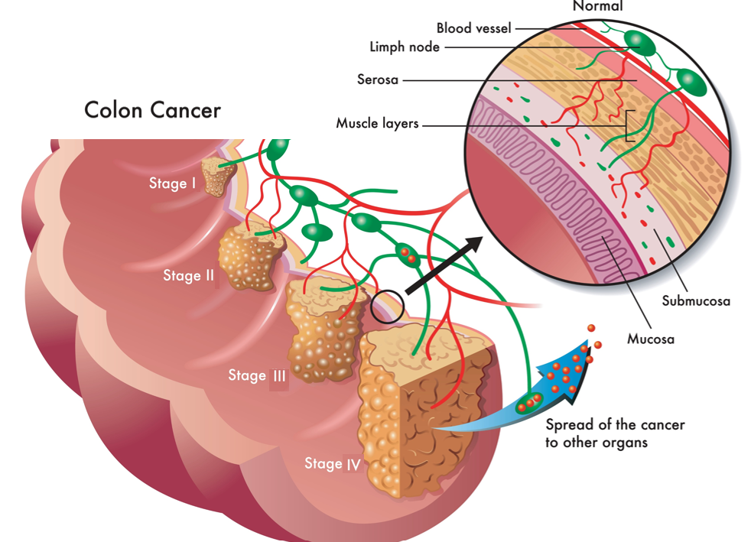
Figure 3: Stages and Types of Prevention
Source: (Southlakegeneralsurgery.com, 2025)

Factors Influencing the Health and Well-being of People Affected by Bowel Cancer and Those Around Them
The health and well-being of bowel cancer patients are considered to be affected by several factors that include genetic orientation and lifestyle practices, socioeconomic conditions and medical service. The factors are significant in the interpretation of the creation of efficient public health intercessions and assistance services.
Non-modifiable risk factors which are important with respect to bowel cancer include and not limited to genetics and family history. The disease is predisposed by people who are chronically affected by bowel cancer or have such genetic abnormalities as Lynch syndrome or family adenomatous polyposis (FAP). The aid of genetic screening can help these patients to be detected and further monitored, including undertaking screening at an earlier and more regular frequency. In addition, persons who possess certain inherited mutations may have the disease at an earlier age, which has its impact on complications in detecting and managing the disease at an early age. Issues surrounding lifestyle can be considered very significant factors contributing to the occurrence of bowel cancer. The inadequacy of the red and processed meat, the low level of the fibre, and high consumption of alcohol are only the points that refer to the risky increasing. On the other hand, intakes of fruits, vegetables and whole grains in form of massive amounts and exercises can reduce the risks of bowel cancer acquisition. The successful campaign programs that lead to healthy diets and exercise are essential in the prevention of the prevalence of such preventive risk factors (Bulkley et al., 2021).
The socioeconomic status of the population is an important factor either to become susceptible to bowel cancer or the diagnosed individuals will be victorious. Individuals at lower social-economic status are likely to have risky lifestyle behaviours, restricted access to healthcare, and are barred early diagnosis, treatment. In addition, there is socio-economic inequity as demonstrated by cancer outcomes with the poor population dying in vast numbers. Lack of access to quality health care helps in augmenting such inequalities in healthcare since such inaccessibility can delay diagnosis and treatment. One of the aims of the public health policy against bowel cancer is the focus made on the decrease of the following inequalities. Healthcare access is another very critical determinant in incidence and prognosis of bowel cancer. There is disparity in the availability of health care that facilitates access to healthcare that plays a significant role in enhancing the survival. Screening or specialist care might not be accessible in the rural locations particularly and this leads to delays in the diagnosis and treatment. Even health literacy has its role to play, as individuals, who lack the knowledge of the symptoms or screening, are less inclined to visit the doctor in a timely manner. Health literacy and health awareness programs on the symptoms of bowel cancer are also necessary in giving the population a chance to seek help at the most suitable stage.
Psycho-social factors are also present. Even the victim and the family in general can experience human aspect of a cancer diagnosis. Patients become nervous, sad, and fear of death that negatively influences their physical state and slows the recovery process. Caregivers and those who are connected to the patient do not get left out since they are usually stressed and emotionally exhausted following a care giving responsibility. The services and support groups provided by counselling can also be invaluable in terms of emotional support and can be helpful in assisting the patients and their caregivers cope with psychological problems that accompany the disease.
Work and social impacts: Bowel cancer as well as its treatments can have a significant negative impact on the employment of individuals with the illness to work and socialize. During the sickness period, exhaustion, as well as the need to visit the hospital, may interfere with the working process, resulting in economic issues to the patient and his/her family. The employers may be mandated to provide flexible work opportunities or leave, and community-based support services may be needed to enable the employers to live their good life during the disease management (Mirza et al., 2024).
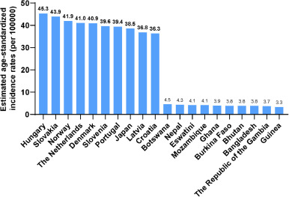
Figure 4: Global Data of Colorectal Cancer
Source: (Xi and Xu, 2021)

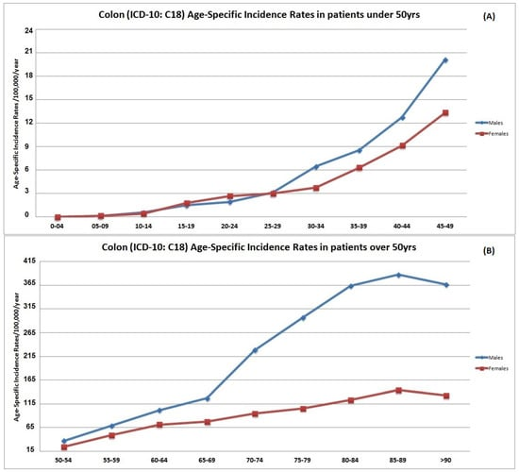
Figure 5: Significant Rise in Colorectal Cancer Worldwide
Source: (Sifaki-Pistolla et al., 2022)

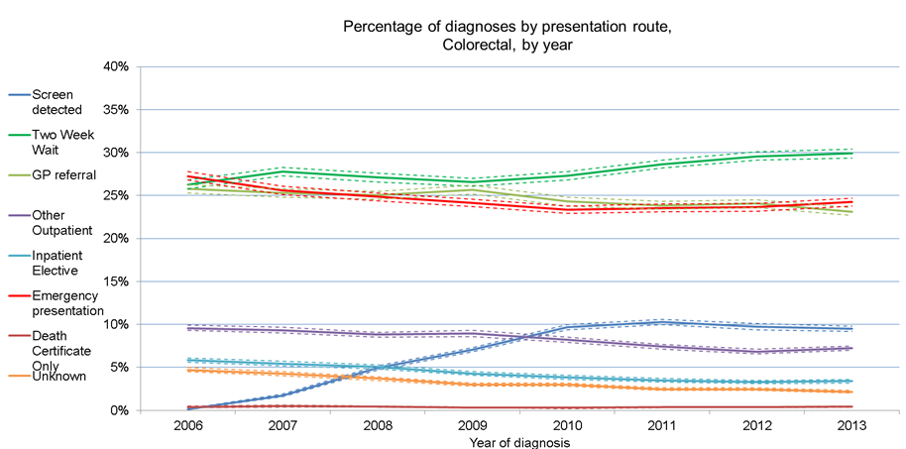
Figure 6: Bowel cancer Report of U.K
Source: (UK Health Security Agency, 2021)

CONCLUSION
Bowel cancer is indeed one of the health issues that constitute a significant issue in the United Kingdom and other related countries and have dismal outcomes to the individuals and their family as well as the health care systems. When early diagnosed, screening and proper management can ensure that mortality is reduced to huge extent, but there is still problem of equity in access to the services. The disease prevention strategies, which include lifestyle change and exposure to increment in the level of screening, are very important in monitoring the disease prevalence. Policies of the public health involving the social and environmental determinants of bowel cancer should be still available to the population and the weak populations should be given the power to control, prevent, and detect the disease. A combined disease policy and supportive services will strengthen

REFERENCES
Books and Journals

Ala, M. (2021). Tryptophan metabolites modulate inflammatory bowel disease and colorectal cancer by affecting immune system. International Reviews of Immunology, pp.1–20. doi:https://doi.org/10.1080/08830185.2021.1954638.
Axelrad, J.E., Olén, O., Sachs, M.C., Erichsen, R., Pedersen, L., Halfvarson, J., Askling, J., Ekbom, A., Sørensen, H.T. and Ludvigsson, J.F. (2020). Inflammatory bowel disease and risk of small bowel cancer: a binational population-based cohort study from Denmark and Sweden. Gut, p.gutjnl-2020-320945. doi:https://doi.org/10.1136/gutjnl-2020-320945.
Bulkley, J.E., McMullen, C.K., Rawlings, A.M., Krouse, R.S., Francisco, M.C., Sterrett, A.T., Burnett-Hartman, A.N., Pawloski, P.A., Corley, D.A., Colwell, J.C. and Feigelson, H.S. (2021). The association of bowel function, participation in life activities, and quality of life in rectal cancer survivors. Quality of Life Research, 31(2), pp.487–495. doi:https://doi.org/10.1007/s11136-021-02930-1.
Google.com. (2025). Redirect Notice. [online] Available at: https://www.google.com/url Oncodaily.com. (2025). Available at: https://oncodaily.com/pub/uploads/2025/05/Colorectal_Cancer_OncoDaily.jpg [Accessed 5 Nov. 2025].
Mirza, R.M., Salim, S., Bell, J.A.H., Esplen, M.J., MacDonald, K.V., Stein, B.D. and Marshall, D.A. (2024). Exploring How Values of Colorectal Cancer Patients and their Caregivers Influence Treatment Decision-Making. The Patient - Patient-Centered Outcomes Research. doi:https://doi.org/10.1007/s40271-024-00716-4.
Sifaki-Pistolla, D., Poimenaki, V., Fotopoulou, I., Saloustros, E., Mavroudis, D., Vamvakas, L. and Lionis, C. (2022). Significant Rise of Colorectal Cancer Incidence in Younger Adults and Strong Determinants: 30 Years Longitudinal Differences between under and over 50s. Cancers, [online] 14(19), p.4799. doi:https://doi.org/10.3390/cancers14194799.
Southlakegeneralsurgery.com. (2025). Available at: https://www.southlakegeneralsurgery.com/wp-content/uploads/2019/12/colon-cancer-stages.jpg .
UK Health Security Agency (2021). UK Health Security Agency. [online] GOV.UK. Available at: https://www.gov.uk/government/organisations/uk-health-security-agency.
Wong, N.A.C.S., Jones, H.E. and Halloran, K.M. (2024). How many polyps need to be histologically assessed when multiple polyps are submitted for the Bowel Cancer Screening Program? Histopathology, 86(2), pp.302–305. doi:https://doi.org/10.1111/his.15337.
Xi, Y. and Xu, P. (2021). Global colorectal cancer burden in 2020 and projections to 2040. Translational Oncology, 14(10), p.101174. doi:https://doi.org/10.1016/j.tranon.2021.101174
Xu, X., Luckett, T., Lovell, M. and Phillips, J.L. (2022). Cultural factors affecting Chinese migrants’ perceptions and responses to cancer pain and its pharmacological management: A convergent mixed-method study. Palliative and Supportive Care, pp.1–9. doi:https://doi.org/10.1017/s1478951522000360.

