
Module Name: Academic Skills in the Digital Era
Module Code: BMSW4013
Assessment 1: E-Portfolio
Student Name: Veronica Gomez
Student Number: 2511807
Lecturer: Scott James
Deadline: Friday 21st November 23:59PM

AI Acknowledgement
I confirm that I have not presented any AI generated text as my own work. I confirm that I have copies of my drafts, notes, and other resources I used before, and after the use of AI tools which I may be asked to provide in evidence.

Contents
Component 1 – Research and Planning Template. 4
Source Exploration. 4
Key Challenge for Students. 4
Key Opportunity for Students. 5
Planning Your Report. 5
Timeline for Component 2 5
Component 2 – Answering the Question. 6
Introduction 6
Challenges Students Face. 6
Opportunities Digital Tools Provide. 6
How Students Can Adapt. 7
Conclusion. 7
Component 3 – Reflective Presentation 8
Slide 1 (Overview) 8
Slide 2 (Introduction) 8
Slide 3 ((Challenges & Opportunities) 9
Slide 4 (Research) 9
Slide 5 (Planning & Writing) 10
Slide 6 (Successes) 10
Slide 7 (Looking Towards) 11
Reference List 12

Component 1 – Research and Planning Template.

Source Exploration.
In this assignment, I chosen a book called "The Study Skills Handbook," 6th edition, written by Stella Cottrell and published in 2024.
The central theme of this work is to demonstrate the advantages, approaches, strategies, techniques, and challenges that students face and how their experience, understanding, and learning about the digital age can be more effective.
This resource was selected because it was developed from practical work with hundreds of students over many years, is written in simple language, is recent, and has the trust of educators. The CRAAP test (see Appendix 1) was used to verify that the resource was current and relevant to learning.
This source will help me answer the main question, as it focuses on the challenges and opportunities as well as the different techniques for adapting to the digital era. In addition, it also offers real-world examples that I can use in my report.

Key Challenge for Students.
One of the biggest challenges for students using digital tools, in my opinion, is digital illiteracy. Some students lack the basic skills needed to use digital tools. This refers not only to not knowing how to use devices like computers and smartphones, but also how to navigate the internet, evaluate information, and communicate through digital platforms.
For example, We need to create a presentation. My university classmate doesn't know how to insert a video, or even how to change the style of each page. He also doesn't know how to work with an Excel spreadsheet, but he can use his social media, upload photos, and videos. So, at this point, I consider it a challenge we face every day. The article I read also mentions that students may be able to use social media, but lack the digital skills to study, research, or work professionally.
This challenge is important because digital tools are increasingly prevalent today, and most of us depend on them. If students cannot use them properly, they will not improve and may feel frustrated.

Key Opportunity for Students.
A major advantage of digital tools for students is access to digital literacy, as it provides support across all areas of life, both daily and academic. It prepares them for a technological world with diverse learning styles. Currently, there are many ways to learn that adapt to each student's needs, allowing them to feel comfortable. Knowing how to identify sources helps students obtain better search results. In past decades, methods were limited; for example, there was only the dictionary, where students had to look up the meaning to verify the information provided by the teacher in class.
This opportunity is valuable because each student learns differently. Some people learn best by watching, others by reading, and others by doing. Digital tools offer us many ways to learn in the way that works best for each individual.

Planning Your Report.
In Component 2, both challenges and opportunities will be addressed, as both are important in the digital era. It is crucial to highlight that while digital tools can be extremely helpful, they also present risks for students.
Digital tools allow students to complete university assignments more efficiently, in a more organized way, and more accessibly. These tools not only help improve academic performance but also foster creativity and collaboration among peers.
This report plans to include tools such as learning management systems (Moodle), time management strategies, digital planners, access to support services, digital skills workshops, online library training, and improved digital literacy.

Timeline for Component 2
Task | Date/ Deadline
Finish research | 17/10/2025
Draft first section | 6/11/2025
Complete first draft | 17/11/2025
Final editing | 20/11/2025

Component 2 – Answering the Question.

Introduction
This article focuses on how university students develop digital skills during their academic training, considering their self-assessment and the factors that influence their digital literacy. It examines digital tools such as applications, platforms, and software used on electronic devices like computers, tablets, and smartphones, designed to optimize easy access to technology in education. The article considers the advantages and disadvantages of their use to avoid difficulties in understanding and learning these tools.

Challenges Students Face.
A major challenge for many students is digital illiteracy. Digital illiteracy is the lack of skills to use information and communication technologies effectively. This includes the inability to navigate the internet, use reliable sources, and know how to use basic computer programs, among other things. For example, when searching for information online, the sheer volume of information found makes it difficult to investigate further and identify reliable sources, leading to stress or a lack of interest.
Another challenge is the constant use of social media. It's a distraction that makes it easy to lose concentration and be unable to pay attention in class because you receive a notification. The article "How Technology Affects Student Learning" by Smith (2022) explains that spending many hours in front of devices can reduce attention spans and decrease the quality of learning. These challenges are significant because they affect students' ability to concentrate and perform well academically.

Opportunities Digital Tools Provide.
Digital tools also offer many opportunities for students. A major advantage is easy access to learning resources and the ability to quickly access information.
For example, when working on an assignment for Academic Skills, I used the university's online library to find books, articles, and sources, which made the process easier and helped me understand the topic better.
According to Smith (2025), students who use digital resources can improve their research skills and gain a deeper understanding of their learning.
Another opportunity is personalized learning. Digital tools adapt to each student's needs. According to Lee (2023), apps and platforms can offer exercises and feedback based on student performance, allowing them to improve at their own pace. These opportunities are valuable because they make learning more flexible and engaging. When used correctly, digital tools can help students better understand their subjects and learn in a way that best suits them.

How Students Can Adapt.
To succeed in the digital era, students need to learn how to use technology wisely. Here are three ways they can adapt:
1. VIRTUAL LEARNING ENVIRONMENT (VLE): MOODLE
Moodle is a popular online learning platform used by many educational institutions. It provides a centralized space for course materials, communication, and interaction between students and instructors.
According to the article, Moodle is recognized not only as a tool for delivering learning content but also as a teaching support partner that contributes to shaping future educational architectures through information and communication technologies.
2. THE POMODORO TECHNIQUE
The Pomodoro Technique is a time management method that involves working in periods of high concentration (working for 25 minutes and then taking a 5-minute break). This can help students focus and avoid distractions. A study by Johnson (2023) demonstrates that using this method improves concentration and productivity. Its benefits include increased productivity and reduced procrastination; its challenges include external distractions and difficulty switching tasks.
3. ACCESS TO SUPPORT SERVICES
Many universities offer workshops or online training to improve digital skills. For example, university offer different types of support (learning support, well-being support). Receiving support helps students feel confident using new tools and solve problems quickly.
By following these suggestions, students can use digital tools effectively and improve their learning experience.

Conclusion.
In summary, today's students face challenges such as digital illiteracy and distraction from social media, where technology is constantly being updated and used in our daily lives. However, it also presents great opportunities, such as easy access to information and personalized learning that adapts to each student's needs.
To adapt and succeed, students must know how to use the tools effectively. Digital planners are very useful for accessing all available resources, practising productivity techniques to organize their time well, and accessing support services. Understanding these points will help them get the most out of digital learning and succeed both in school and in their professional lives.

Component 3 – Reflective Presentation

Slide 1 (Overview)


Slide 2 (Introduction)
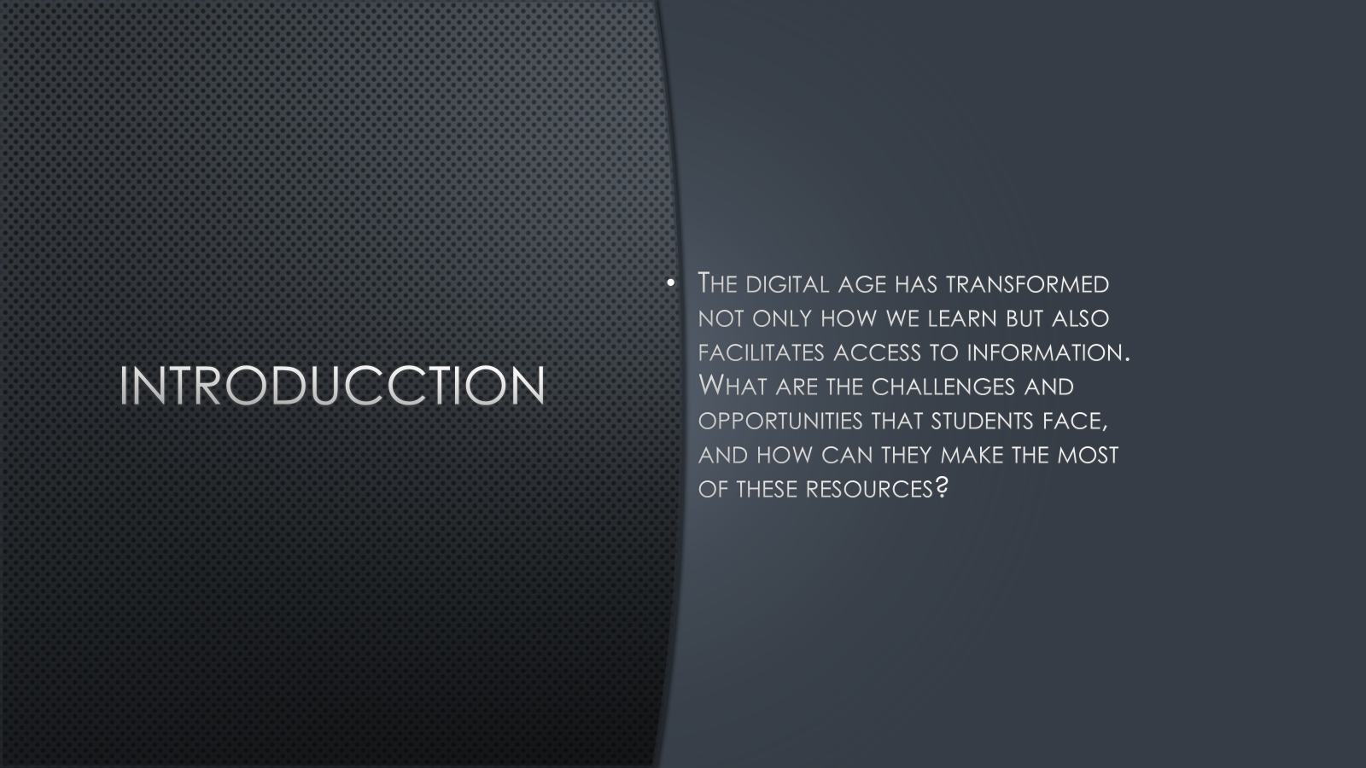

Slide 3 ((Challenges & Opportunities)
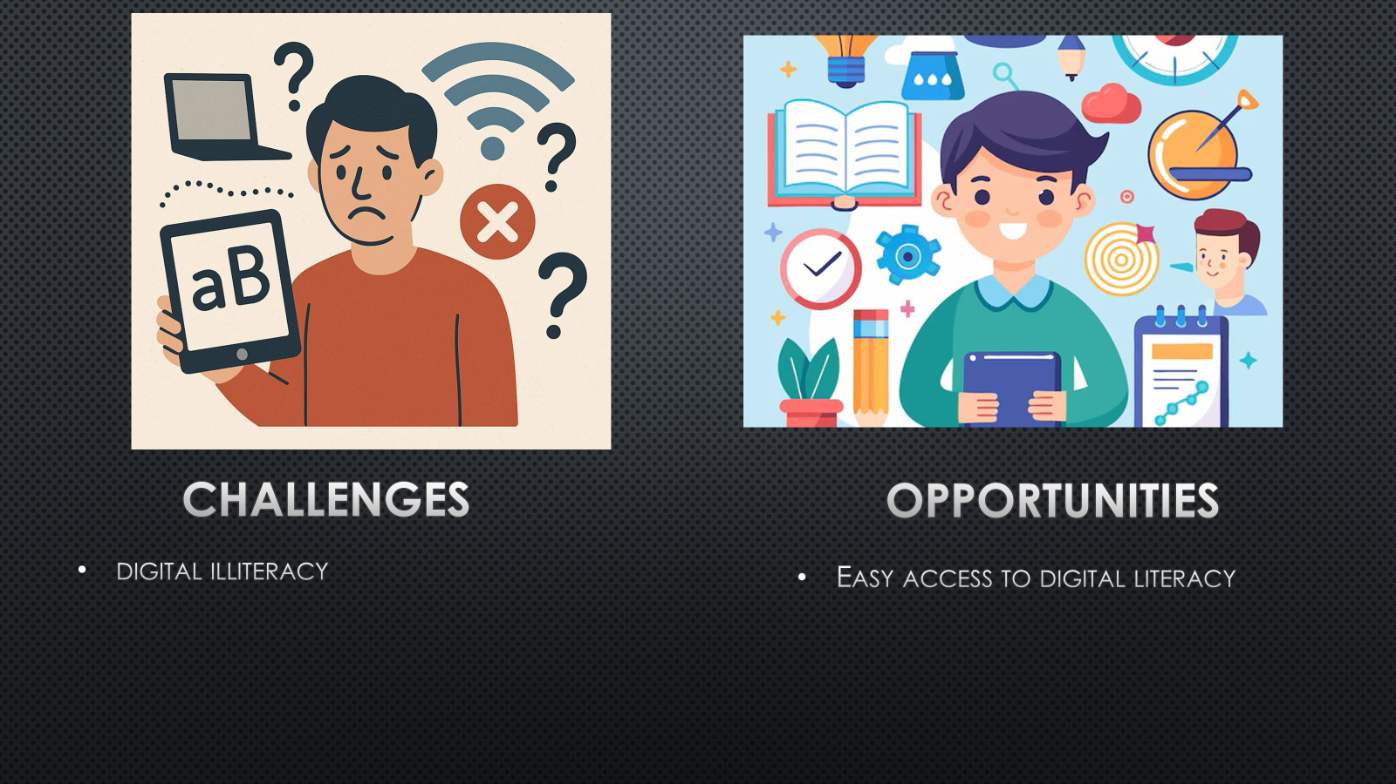

Slide 4 (Research)
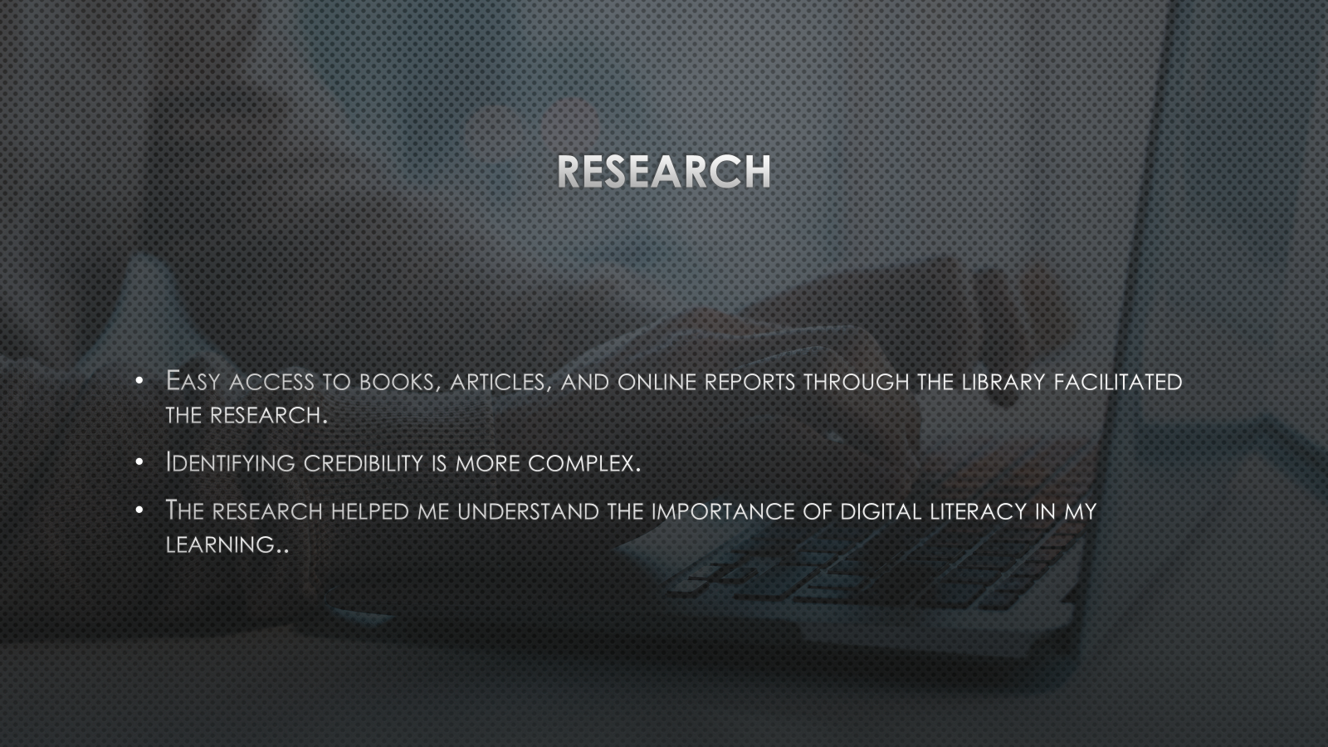

Slide 5 (Planning & Writing)
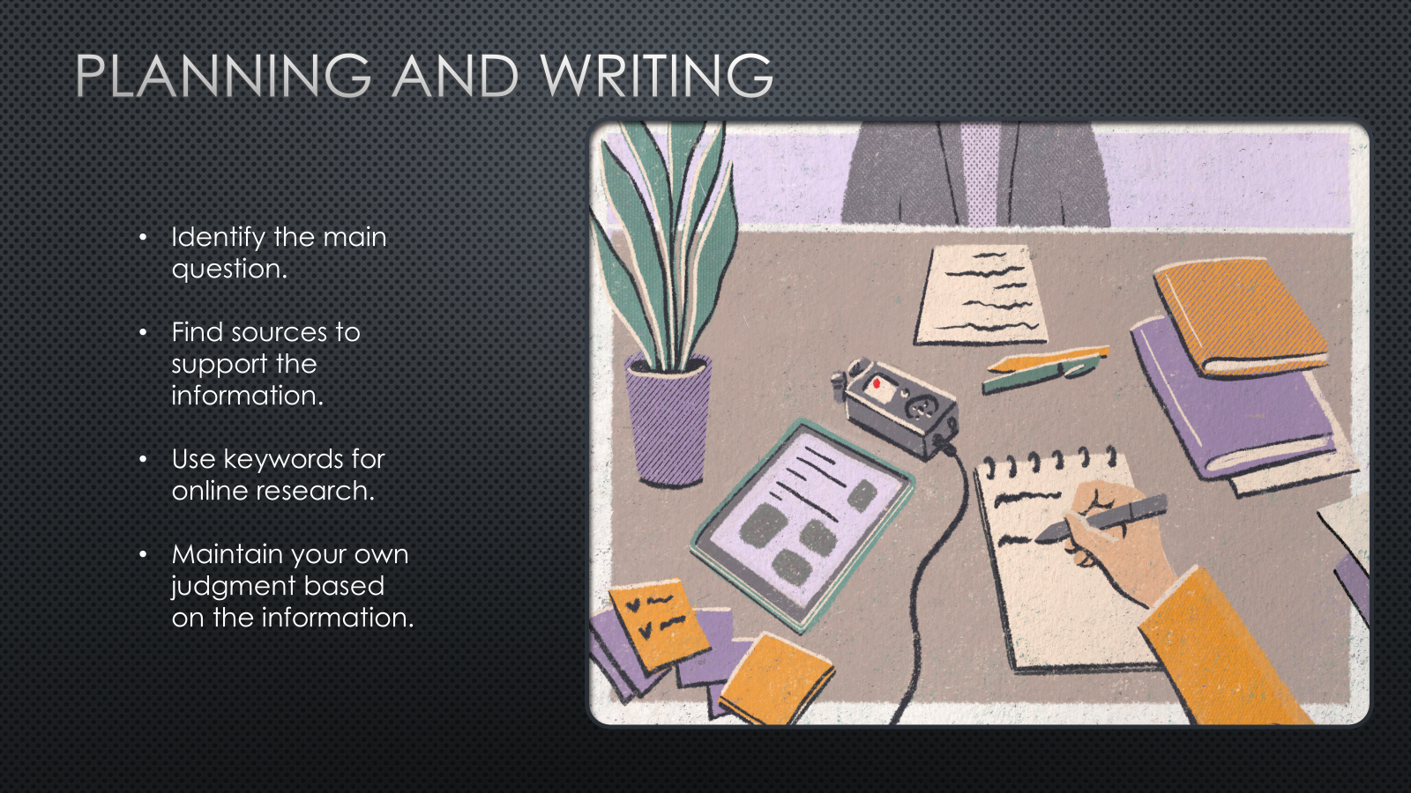

Slide 6 (Successes)
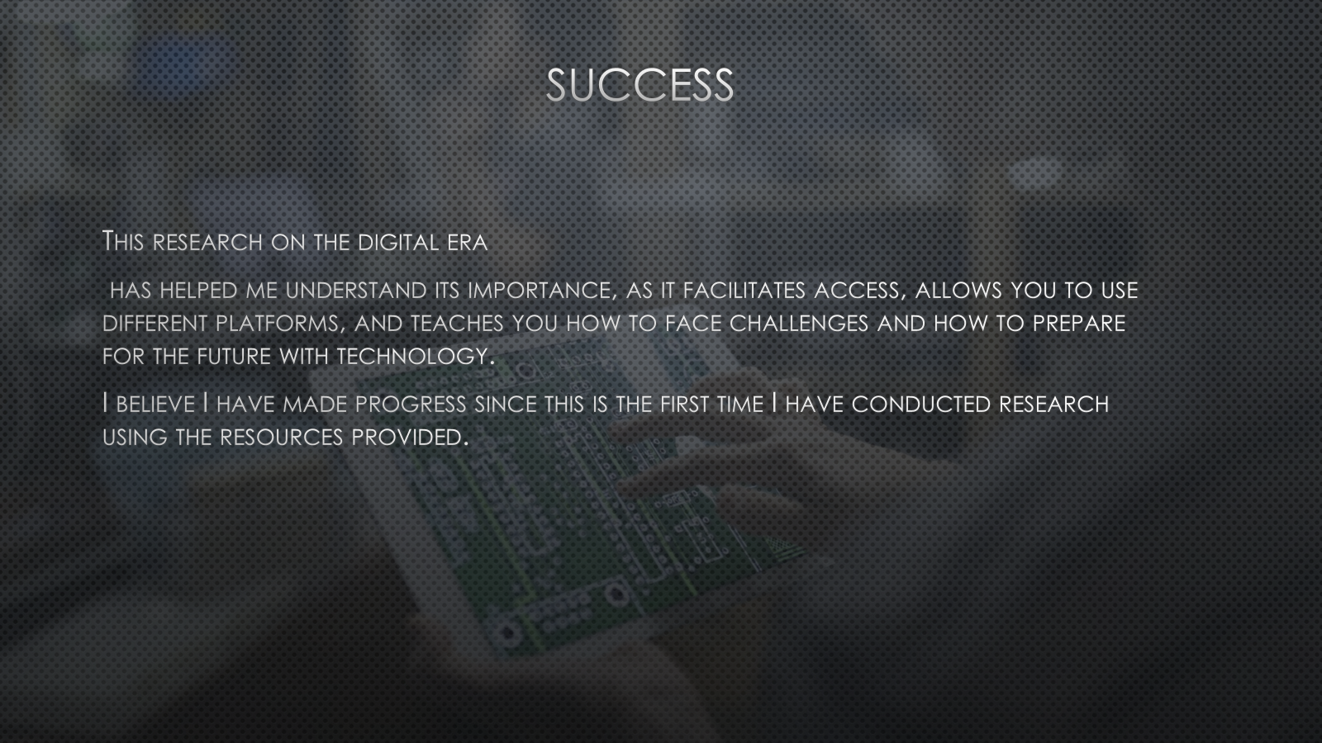

Slide 7 (Looking Towards)
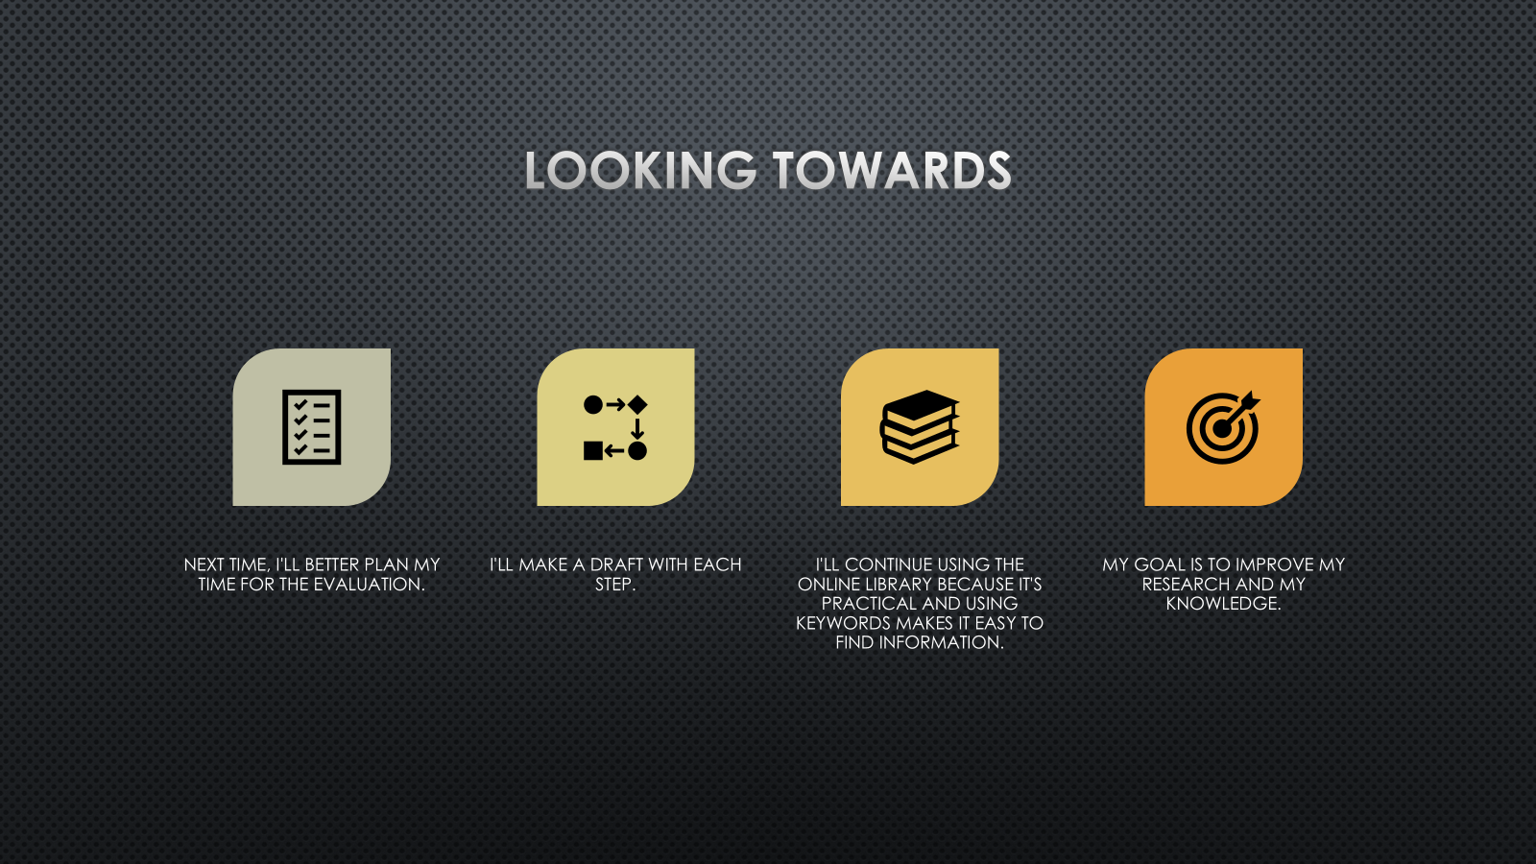

Reference List

Anderson, T. D., Ogruk-Maz, G., & Bell, I. (2025). Enhancing Digital Literacy in Higher Education: A Comprehensive Analysis of Digital Skill Development Among College Students. Journal of Higher Education Theory and Practice, 25(3), 1–22. https://doi.org/10.33423/jhetp.v25i3.7631
Cottrell, S. (2024). The study skills handbook (Sixth edition.). Bloomsbury Academic.
Díaz-León, J. A., Arbelaitz, O., Larrañaga, M., & Arruarte, A. (2025). Combining CS Unplugged and L2T2L to Bridge the Computing Illiteracy Gap of the Elderly Population: A Case Study. Applied Sciences, 15(2), 919. https://doi.org/10.3390/app15020919
Fernando, J.G. & Jain, S.K. (2022) ‘Digital Illiteracy of Teachers and its Impact in Online Learning’, Technoarete Transactions on Application of Information and Communication Technology (ICT) in Education, 1(3), pp. 1–6. doi.org/10.36647/TTAICTE/01.03.A001
Julia Anamaria ȘIȘU. (2023). Digital Leadership Competencies: A Systematic Literature Review. Revista de Management Comparat International, 24(1), 69–77. https://doi.org/10.24818/RMCI.2023.1.69
Lee, S. (2023) ‘Personalised Learning through Digital Tools: Benefits and Challenges’, Educational Review, 28(1), pp. 12-20. Available at: Insert URL or DOI
Perifanou, M., Tzafilkou, K., & Economides, A. A. (2021). The Role of Instagram, Facebook, and YouTube Frequency of Use in University Students’ Digital Skills Components. Education Sciences, 11(12), 766. https://doi.org/10.3390/educsci11120766
Petrişor, R.-M., & Petrişor, S.-M. (2021). Digital Permanences in the Contemporary Educational Space. The Moodle Elearning Platform. Land Forces Academy Review, 26(1), 45–48. https://doi.org/10.2478/raft-2021-0007
Reddy, P., Sharma, B., & Chaudhary, K. (2020). Digital Literacy: A Review of Literature. International Journal of Technoethics, 11(2), 65–94. https://doi.org/10.4018/IJT.20200701.oa1
Reedy, K., & Parker, J. (Eds.). (2018). Digital literacy unpacked. Facet Publishing.
Smith, R. (2022) How Technology Affects Student Learning. Available at: https://www.edtechtoday.com/how-technology-affects-student-learning (Accessed: 8 October 2025)

Appendices

Appendix 1: CRAAP Test
- Currency: The book was published in 2024, so it's quite recent and up-to-date. This is important because technology and digital learning tools change rapidly.
- Relevance: The book covers relevant topics on academic skills. Its approach has been proven based on experience and has helped students succeed and overcome challenges. It uses simple language, which is helpful.
- Authority: Stella Cottrell is recognized for her work as Director of Lifelong Learning at the University of Leeds and Vice-Chancellor for Learning, Teaching, and Student Engagement at the University of East London. She is the author of several guides on study techniques. Her publications have sold over a million copies worldwide, and she has been recognized for her contributions to the education sector. Her experience lends her credibility and makes her book more useful.
- Accuracy: The book provides clear examples and cites research studies to support its arguments. Stella uses simple self-assessment examples and presents different study methods. It is recommended by teachers, which supports its credibility.

- Purpose: The purpose of the book is to support students in developing independent learning and study skills, and to understand the challenges and opportunities of using technology in learning. Designed to empower students, not to sell a product, the information is likely to be unbiased and reliable.

