

MODULE CODE: Digital Skills for Personal Development and Business Growth BMSW4008

ASSESSMENT COMPONENT: PORTFOLIO

STUDENT NAME: MOHAMMED KAMRUZ ZAMAN

STUDENT NUMBER: 2507194

LECTURER: AQSA SHABIR

DATE:12/12/2025
Contents
Task 1 3
Assessment of Digital Skills 3
References 3
Task 2 4
LinkedIn Learning Certificates for Office365 4
Task 3 5
Essay on Relevance of Excel in professional and personal life. 5
References 5
Task 4 6
7 Minute Reflective Presentation 6
References 6

Task 1

Assessment of Digital Skills
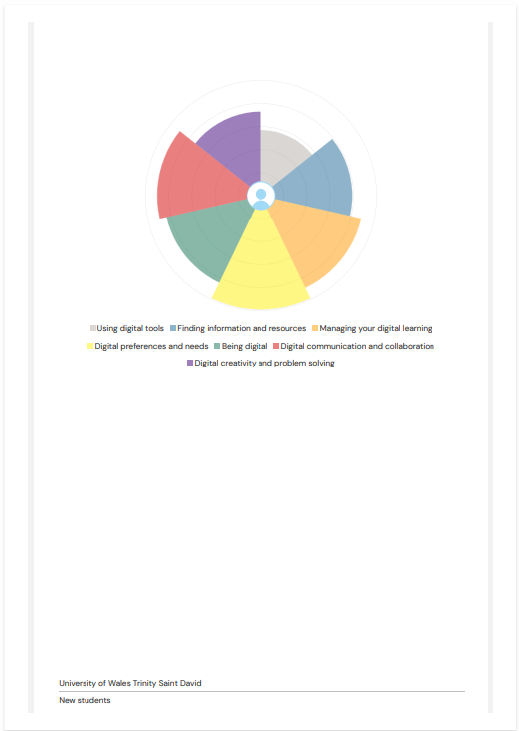

Digital skills are important today because technology keeps changing all the time. It feels like every time you learn one thing, something new comes out. If we don’t keep up, it’s easy to fall behind in school, work, or even normal daily life. To not get left behind, we must keep learning new digital things and try our best to understand how technology works.
Good digital skills make life a lot easier. They help you finish work faster, learn new apps without freaking out, and even give you more job chances in the future since almost every job uses technology now. Even simple things like writing assignments, joining online classes, or talking to people all need digital skills. Like Jisc said in 2018, being good with digital stuff is basically required for students and teachers. It helps everyone learn better and take part in our super-connected world. So, being comfortable with digital things isn’t just “nice to have”—it’s something you really need if you want to function in today’s online world.
When it comes to me, I’ve learned that I have two main strengths in the digital world: “being digital” and “managing my digital learning.” These might not sound huge or special, but they help me a lot in university, work, and everyday life. I’m not a tech genius, and I don’t know everything, but I know enough to get things done, and that makes a big difference for me.
My first strength is “being digital.” This basically means I’m comfortable using technology. I don’t get too stressed when I’m trying something new. I’m okay with clicking around, trying different buttons, and seeing what happens. I learn a lot just by doing. I don’t understand everything right away, but I’m not scared to try. If I need to use a new app or website, I give myself time to play around with it. Even when I mess up, I usually learn something from the mistake. Because of this, I’ve gotten better at using phones, laptops, apps, online platforms, and other digital tools.
Being digital also helps me talk and work with people. I can send emails, join video calls, use messaging apps, and work on shared documents. I’m not an expert, but I can do enough to stay connected and get my work done. Sometimes the internet stops working or something won’t load, but instead of freaking out, I try to fix it or look up a simple answer online. Staying calm helps me handle tech problems without wanting to give up.
My second strength is “managing my digital learning.” Learning online is not always easy. There are so many distractions, like YouTube, TikTok, or just switching tabs for no reason. But I’ve slowly learned how to stay more focused and organized. I use calendars, reminders, to-do lists, and notes on my phone or laptop to help plan my work. These tools remind me what I need to do and help me not forget important things.
I also keep all my digital files organized. I use folders, bookmarks, and note-taking apps so I can find my work quickly. And when I get stuck, I look up videos or tutorials online. A lot of people explain things in simple ways, so it helps me understand better. I don’t feel embarrassed to search for easier explanations because sometimes the first thing I find is too complicated. Learning this way has helped me become more independent and more confident.
Even though I have good strengths, I also have weaknesses. Two of my biggest weaknesses are “digital creativity and problem solving” and “using digital tools.” These things are harder for me, and sometimes they stress me out. But I’m learning that it’s okay to have weaknesses, and it helps me improve when I’m honest about them.
My first weakness is digital creativity and problem solving. When it comes to being creative—like making graphics, editing videos, designing things, or coming up with digital ideas—I get stuck easily. I never know where to start. I’m not someone who can just open a program and instantly know what to do. Sometimes I just stare at the screen because I have no ideas. And when there’s a digital problem, like something not working right, I get confused fast. Instead of thinking of solutions, I freeze or get annoyed. I know solving digital problems takes patience, but I often doubt myself or worry I’m going to mess things up even more.
My second weakness is using digital tools. Even though I can use basic things, some apps or programs confuse me a lot. When people talk about fancy features or shortcuts, I feel lost. Even simple tools can take me longer to figure out because I click the wrong things or can’t find the options I need. Sometimes when I have to use a digital tool for school or work, I get overwhelmed because everything looks so complicated. There are features that could make my life easier, but I don’t know they exist. I also tend to use the same tools over and over instead of trying new ones, which slows my learning.
Even though these weaknesses make things harder sometimes, I’m working on them. I’ve learned that it’s totally okay to not understand everything right away. Watching tutorials, asking for help, and practicing helps me get better little by little. I know I won’t suddenly become super creative or amazing with tech overnight, but at least I’m trying, and that’s what matters the most.
Overall, my strengths and weaknesses show that I’m still learning in the digital world. I’m not perfect with technology, but no one really is. As long as I keep trying to understand new tools and improve my creativity and problem-solving skills, I know I’ll keep getting better over time. Even when I mess up, I learn something, and that helps me move forward.

References

Task 2

LinkedIn Learning Certificates for Office365
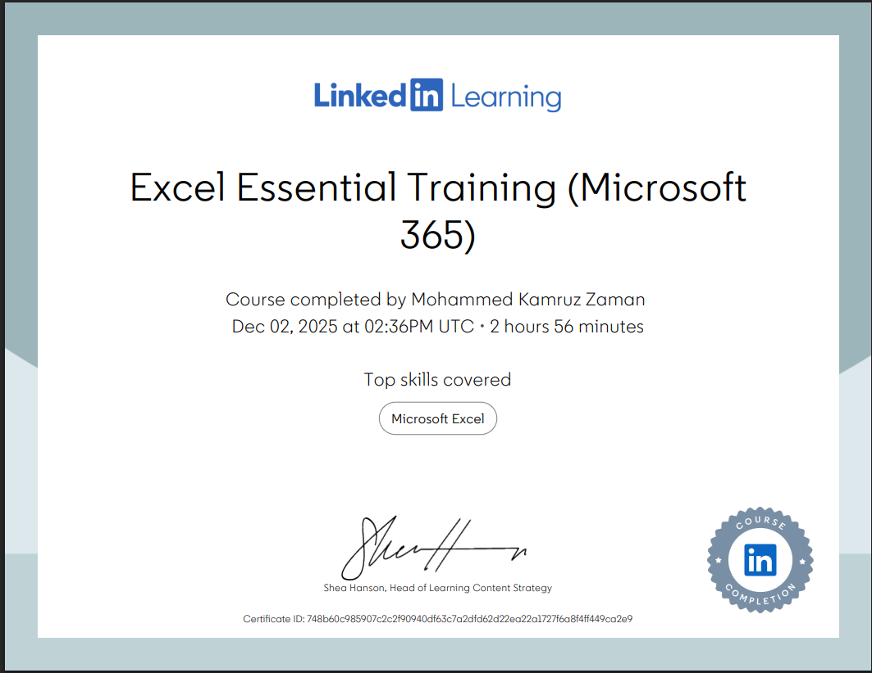

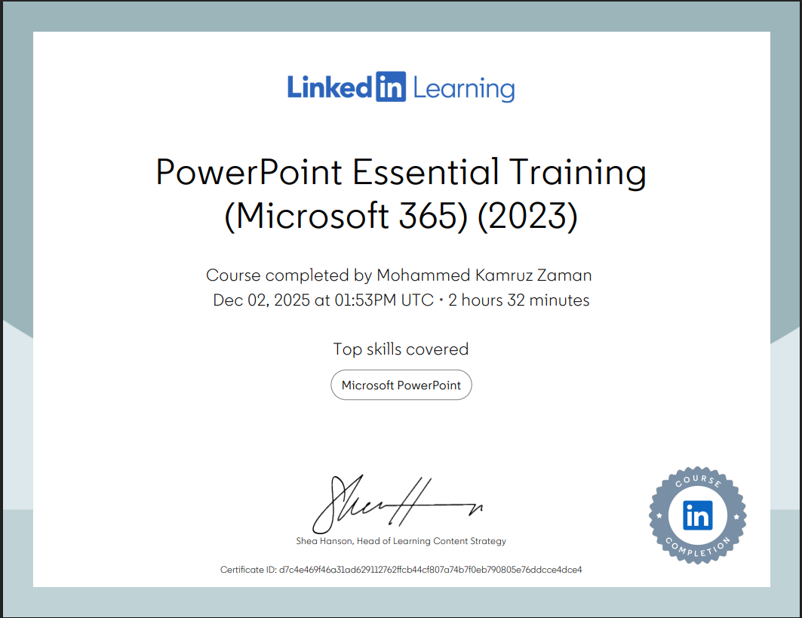
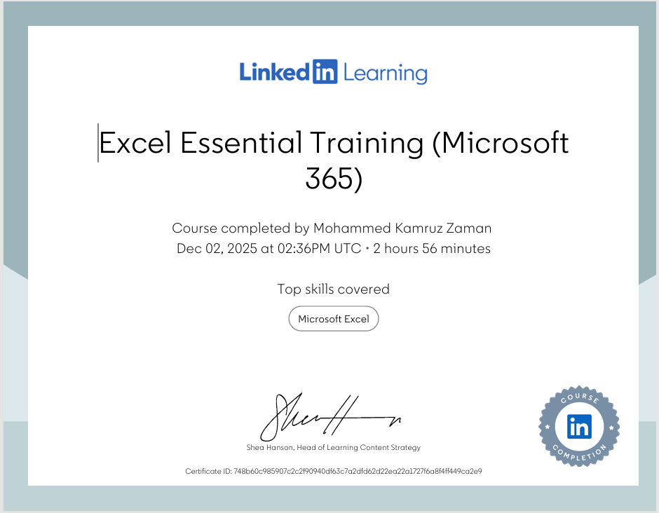

Task 3

Essay on Relevance of Excel in professional and personal life.
In today’s world, everything seems to involve numbers, lists, bills, dates, or planning. Because of that, Microsoft Excel has become one of the handiest tools around. It doesn’t matter if someone works in an office, studies at university, or just runs a household—Excel helps keep life more organised and a lot less stressful. It might look confusing at first, but once you learn the basics, it becomes one of those tools you keep going back to.
One of the main reasons Excel is so important professionally is because almost every job uses some kind of data. Businesses want to know how much money they make, how much they spend, how their staff are doing, and how their products or services perform. Excel makes it easy to put all this information into neat boxes, add it up, compare numbers, and spot problems. Instead of doing maths by hand—which takes forever—Excel formulas can do it in seconds. A simple formula like SUM can add up a whole column of numbers with one click. This saves workers time and makes fewer mistakes.
Many workplaces also use Excel because it helps them stay organised. People create schedules, timetables, stock lists, staff rotas, budgets, charts, and progress trackers. Instead of writing things on paper that gets lost, Excel keeps everything in one place. And because Excel can turn numbers into graphs, it’s easier for workers to explain things during meetings or reports. A boring list of numbers suddenly looks a lot clearer when shown as a chart.
Another reason Excel is helpful in professional life is because it works for almost every type of job. In finance, people use Excel for budgets and accounts. In healthcare, staff use it to track patients and medicine stocks. Teachers use it for grades, attendance, and planning lessons. Engineers use it for measurements and calculations. Even small businesses—like shops or freelancers—use Excel to track income and expenses. Employers also like hiring people who know how to use Excel because it shows they can work with data, stay organised, and solve problems.
Excel isn’t only useful at work. It also helps a lot in personal life. One of the biggest personal uses for Excel is budgeting. A family can track how much money they earn, how much they spend, and how much they should save. Instead of wondering “Where did all my money go?”, Excel shows clearly what is happening. Bills like rent, water, food, fuel, and childcare can be listed each month. Excel can automatically calculate totals, show if you are overspending, and help people make better money choices. It’s especially useful for families trying to save for holidays or handle debt.
Excel also helps with everyday planning. People create shopping lists, meal plans, cleaning schedules, holiday plans, exercise logs, and more. Because Excel is so flexible, you can basically shape it into anything you need. Some people even use it for fun things like tracking TV shows they’ve watched, planning parties, or keeping lists of gifts for birthdays and Christmas.
Another benefit of Excel is how easy it is to access. You can use it on a laptop, phone, or tablet, and you can save files on the cloud so you can open them anywhere. Excel also comes with lots of built-in templates. These templates help beginners create budgets, invoices, calendars, and planners without starting from scratch. This makes Excel useful even for people who don’t feel very confident with technology.
Excel also helps with personal growth. When you use Excel regularly, you naturally get better at problem-solving. You learn how to break big tasks into smaller pieces, notice patterns, and think more logically. Even someone who doesn’t consider themselves “good with numbers” can improve just by using Excel to organise daily life. It also teaches responsibility because you become more aware of your spending, time management, and goals.
A big reason Excel remains important is because it keeps things simple. While there are huge, powerful software programs out there, Excel works for both basic and advanced tasks. Someone can use it just to add numbers, or they can build huge complicated spreadsheets. You get to choose how deep you want to go. And because it has been around for such a long time, almost everyone recognises Excel files. This makes sharing information with others really easy.
In personal and professional life, Excel also helps reduce stress. When things are organised and clear, people feel more in control. Instead of keeping everything in your head or on random bits of paper, Excel keeps your information safe and tidy. With money, especially, Excel helps take away guesswork. You can see exactly what you can afford and what you can’t. This makes it easier to plan ahead, avoid debt, and save toward goals.
In the end, Excel’s relevance comes from how useful, flexible, and simple it is. Whether someone is managing a business, studying at university, raising a family, or just organising their own life, Excel can help. It saves time, reduces stress, improves organisation, and builds skills that are valuable in the modern world. Even though it might look complicated at first, once you learn how it works, it becomes one of the most helpful digital tools available. That is why Excel continues to be important in both professional and personal life.

Task 4

References
Microsoft. (2023). Excel Overview.
JISC. (2018). Digital Capability Framework.
Walkenbach, J. (2015). Excel Bible.
Harvard Business Review. (2021). Data Literacy in the Workplace.
ONS (2022). Household Spending Report.
Robbins, S. (2020). Organisational Behaviour.
Knaflic, C. (2015). Storytelling with Data.
Small Business UK. (2020). Why Excel Still Matters.
• Microsoft Excel official product page – overview of Excel features directly from Microsoft’s site:
🔗 https://www.microsoft.com/en-gb/microsoft-365/excel microsoft.com
• Britannica description of Microsoft Excel – background and information on what Excel is and how it works:
🔗 https://www.britannica.com/technology/Microsoft-Excel Encyclopedia Britannica
• Jisc digital capability framework (individual skills) – explains digital skills and why they matter in learning and work environments:
🔗 https://digitalcapability.jisc.ac.uk/what-is-digital-capability/individual-digital-capabilities/ JISC
• Jisc building digital capability service – describes support and training available for building digital skills:
🔗 https://www.jisc.ac.uk/building-digital-capability Jisc
• Family Food FYE 2024 (UK government stats) – official UK statistics on household food expenditure (useful for realistic data):
🔗 https://www.gov.uk/government/statistics/family-food-fye-2024/family-food-fye-2024 GOV.UK
• ONS Family spending in the UK: April 2023 to March 2024 – official UK household expenditure stats:
🔗 https://www.ons.gov.uk/peoplepopulationandcommunity/personalandhouseholdfinances/expenditure/bulletins/familyspendingintheuk/april2023tomarch2024 Office for National Statistics
• ONS detailed expenditure dataset (example basis for money categories) – downloadable UK expenditure dataset you could reference to support figures:
🔗 https://www.ons.gov.uk/peoplepopulationandcommunity/personalandhouseholdfinances/expenditure/datasets/familyspendingworkbook1detailedexpenditureandtrends Office for National Statistics

