

Digital Forensics Analysis
ACCA7031 Assessment Report
Student Name: Naveed Ullah Shah
Student ID: 2510665
Program: MSc Cybersecurity & Digital Forensics
Submission To: Mohamed Ghanem

Contents
Task:1 3
Cloud Digital Forensics and Incident Response 3
Introduction 4
Current State, Tools and Capabilities 4
Intersection with Cybersecurity 4
Emerging Trends 5
Key Challenges 5
National and International Job Market 5
Conclusion and Recommendations 6
Task 2: Digital Forensic Investigation Report 7
1.Case Background 7
2. Evidence Acquisition 7
2.1 Evidence Acquisition Using Cellebrite UFED 7
3. Evidence Inventory and Chain of Custody 11
3.1 Evidence Item E-001: Emma's Huawei P Smart (Chain of Custody) 11
3.2 Evidence Item E-002: Joe's Samsung Galaxy A13 (Chain of Custody) 12
3.3 Evidence Item E-003: Norman's Nokia Smartphone (Chain of Custody) 14
4. Forensic Methodology 15
5. Digital Evidence Analysis 15
5.1 WhatsApp Communication Analysis (E-001) 15
5.2 Facebook Messenger Communication Analysis (E-001) 19
5.3 Call Log Analysis (E-001) 21
5.4 Multimedia and Geolocation Analysis (E-002) 23
5.5 Instagram QR Code Analysis 26
5.6 Correlated Evidence Timeline 26
5.7 Suspect Profiles and Assessment 28
6. Conclusion 29
7. Recommendations 30
7.1 Recommendations for Law Enforcement 30
7.2 Recommendations for Quantum Tech 30
8. References 31

Task:1

Cloud Digital Forensics and Incident Response
in Hybrid and Multi-Cloud Environments
Current tools, cybersecurity integration, AI-assisted investigation, key challenges, and career opportunities in Pakistan and the global market

Introduction
Cloud digital forensics is the application of established forensic principles - identification, acquisition, preservation, examination, analysis and presentation - to evidence held in cloud environments. Its importance has increased as organizations distribute applications and data across public clouds, private infrastructure and software-as-a-service platforms. Unlike traditional computer forensics, an investigator may not control the physical server or even know the exact country in which evidence is stored. Rapid provisioning, multi-tenancy and global accessibility therefore require new investigation methods [1]. This report argues that cloud forensics is moving from reactive disk imaging towards continuous, log-centred, API-driven and increasingly AI-assisted forensic readiness. This development improves incident response, but provider dependence, volatile workloads, jurisdiction and tool fragmentation continue to limit reliable investigations.

Current State, Tools and Capabilities
A modern cloud investigation commonly examines identity and access records, control-plane activity, virtual-machine snapshots, object-storage histories, application logs, network flows, security alerts and, where possible, volatile memory. The process still follows the traditional stages of collection, preservation, examination, analysis and reporting, but acquisition is usually remote and mediated by provider APIs. NIST's Cloud Computing Forensic Reference Architecture consequently treats forensic readiness as an architectural capability that should be established before an incident [1].
Cloud-native tools provide the first evidence layer. In AWS, Cloud Trail records API activity, Config tracks resource changes, Guard Duty produces threat findings, and Detective assists relationship analysis. Comparable evidence can be obtained from Azure Monitor, Microsoft Sentinel and Defender for Cloud, or from Google Cloud Audit Logs and Google Security Operations. General forensic tools remain important: Volatility 3 examines memory captures; Autopsy and The Sleuth Kit analyse disk images; Velociraptor supports remote endpoint collection; Wireshark examines packet captures; and Plaso with Time sketch reconstructs timelines. Commercial suites such as Magnet AXIOM, Encase and FTK add processing, search and reporting functions.
No single product, however, reconstructs every event across a hybrid or multi-cloud estate. Investigators must correlate provider logs with endpoint, identity, network and application evidence. AWS recommends a separate forensic environment, immediate hashing of acquired artefacts, read-only protection of original evidence and analysis of working copies [2]. These controls make automation useful without sacrificing evidence integrity.

Intersection with Cybersecurity
Cloud forensics and cybersecurity perform different but complementary functions. Security monitoring detects suspicious behavior and seeks rapid containment; forensics determines what occurred, how it occurred, which assets were affected and whether the evidence supports attribution or legal action. A SIEM alert can initiate preservation of logs, snapshots and memory, while forensic findings generate indicators of compromise that improve threat detection. Digital forensics therefore supports SOC operations, incident response, threat hunting, insider-threat investigations, compliance and litigation.
The relationship also creates tension. Immediately terminating a malicious virtual machine may stop an attack but destroy volatile evidence. Effective playbooks must therefore balance containment with acquisition, define decision authority and document every transfer through a chain of custody. Forensic readiness turns this balance into a planned cybersecurity capability instead of an improvised post-incident activity.

Emerging Trends
Automation is the strongest trend. Infrastructure-as-code can create clean investigation accounts, isolate compromised workloads, capture snapshots and preserve logs in immutable storage. Artificial intelligence can triage large datasets, correlate identities and resources, identify anomalies and propose event timelines. In 2025, AWS introduced an investigative agent that gathers and correlates information from services including CloudTrail, IAM and EC2 [3]. Such systems may reduce investigation time, but their conclusions still require human verification because opaque reasoning, false correlations or hallucinated explanations could undermine evidential reliability.
Containers, Kubernetes and serverless computing are another major frontier. Their short-lived components may disappear before manual collection begins, making continuous telemetry essential. Research is also moving towards cross-cloud evidence normalization, privacy-preserving analysis, automated provenance and cryptographically verifiable audit trails. These developments show that the future investigator will need both conventional forensic discipline and cloud-engineering skills.

Key Challenges
The primary technical problem is loss of physical control. Investigators depend on a cloud provider's logging, retention, APIs and cooperation, and responsibility changes across IaaS, PaaS and SaaS. Ephemeral instances may vanish, encryption may block access, timestamps may be inconsistent, and enormous datasets increase processing and storage costs. Multi-tenancy creates the additional risk of collecting another customer's information.
Legal and organizational problems are equally important. Evidence may cross national borders and become subject to conflicting privacy, disclosure and retention rules. Investigators must demonstrate authenticity, completeness, repeatability and an unbroken chain of custody even when the provider performed the original acquisition. Recent reviews identify acquisition, preservation, data integrity, privacy and jurisdiction as persistent open problems [4], [5]. Vendor-specific formats and limited independent validation also make findings difficult to reproduce. AI introduces a further requirement: every automated conclusion should be traceable to original evidence and explainable in a report or court.

National and International Job Market
Pakistan's market is developing through government, banking, telecommunications, law enforcement and managed security services. A 2026 PKCERT procurement aims to create national digital-forensics capabilities supporting incident response, cooperation and professional training [6]. PKCERT has also listed positions including Data Forensic Analyst, Incident Responder, Technology Engineer (Forensic) and Incident Management roles, demonstrating a direct national career pathway [7].
Internationally, relevant titles include DFIR Analyst, Cloud Incident Responder, SOC Analyst, Threat Hunter, Forensic Consultant and Cloud Security Engineer. The ISC2 workforce study reports that employers increasingly prioritize specific skills over headcount; professionals rank AI and cloud security among important skills, while problem-solving, communication and collaboration remain highly valued [8]. Competitive candidates therefore need cloud architecture, IAM, logging, SIEM, scripting, evidence handling and technical report-writing skills alongside practical laboratory experience.

Conclusion and Recommendations
Cloud digital forensics is becoming a strategic component of cyber resilience rather than a specialist activity performed only after a crime. Organizations should centralize and protect logs, synchronize time, define retention policies, maintain least-privilege forensic accounts and test acquisition playbooks through exercises. AI should accelerate triage, not replace accountable human judgement. Pakistan should complement new forensic laboratories with university-industry training based on realistic cloud incidents. These measures would make investigations faster while preserving the integrity, repeatability and legal defensibility of digital evidence.

Task 2: Digital Forensic Investigation Report

1.Case Background

Digital forensics is a scientifically guided procedure for the discovery, recovery, preservation, analysis, interpretation and presentation of digital evidence to aid investigation and provide evidence for use in court proceedings [9].
Semiconductor research firm Quantum Tech has made an announcement regarding the theft of an important commercialization project for its AI chip quantum technology, QT-AI-2025 [10]. By way of initial intelligence, it was established that a senior engineer who had already privileged access to the database, Emma, was the main suspect. According to Emma, she found the patent information and shared it with Director of Research and Development, Vanessa, via Joe. You might also see in the Form 10 earlier this year that an MDS named Norman Smith was also identified as a suspected buyer and coordinator for the exchange of the stolen intellectual property.
After the breach, Quantum Tech made a report to the Police. Three cellphone devices were confiscated and preserved with a written chain of custody: Emma's Huawei smartphone (E-001), Joe's Samsung Galaxy A13 (E-002) and Norman Smith's Nokia smartphone (E-003). Forensic acquisition and examination followed NIST SP 800-86 [11] and ISO/IEC 27037:2012 [12]. The results aid in the inquiry into the matter of Corporate Espionage and the theft of Intellectual Property by the company.

2. Evidence Acquisition

2.1 Evidence Acquisition Using Cellebrite UFED
The evidence collection process has been performed using the Cellebrite UFED v7.76.0.24 application, which is considered one of the most popular tools in mobile forensics [14]. The process of evidence collection in all three smartphones has been described along with the screenshots.

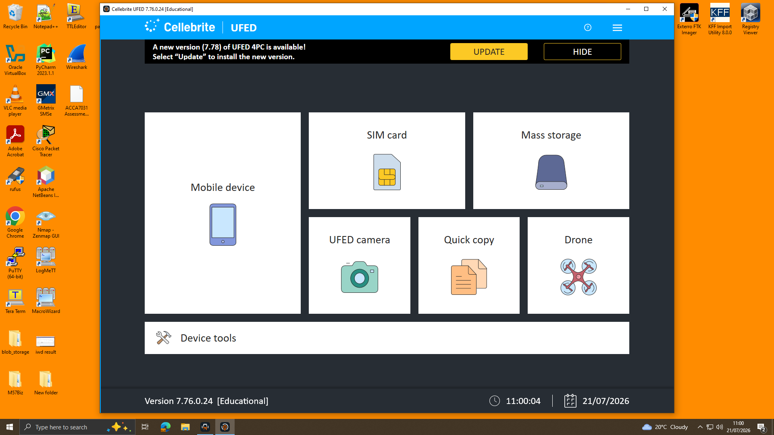
Figure.1 Interface

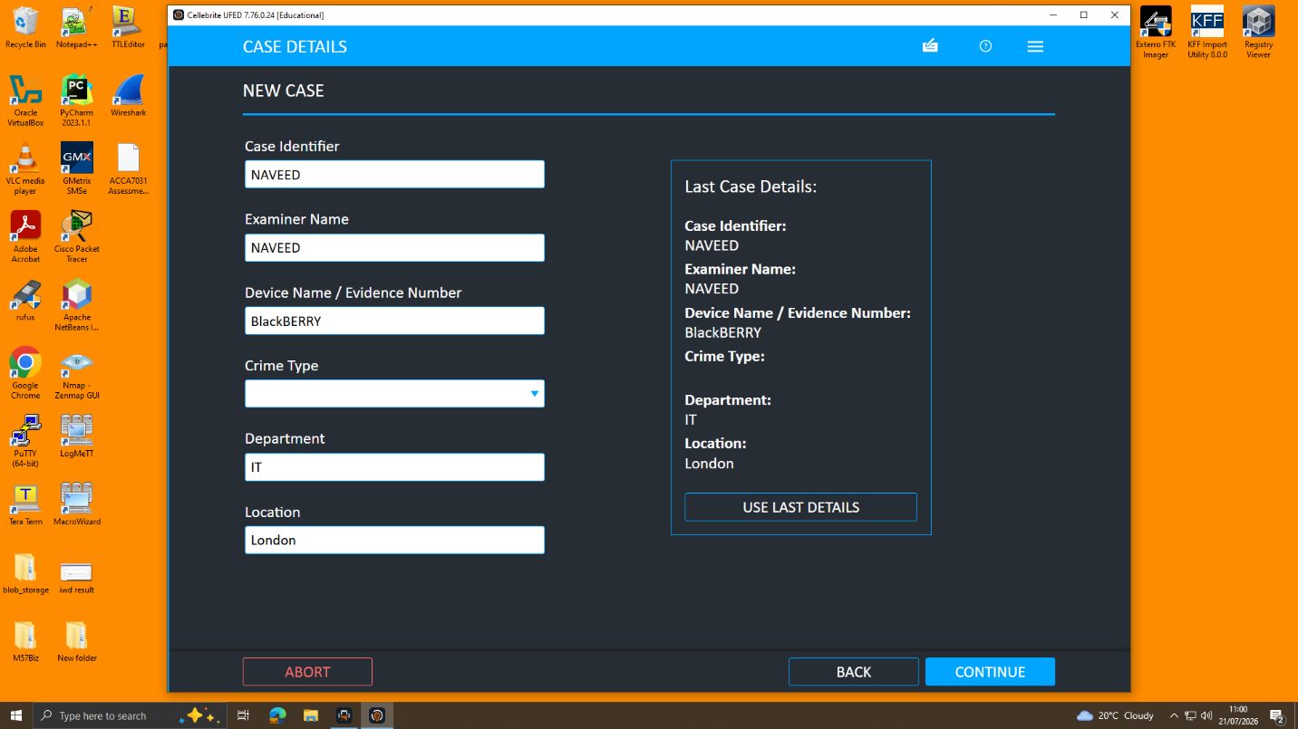
Figure.2 Case Details
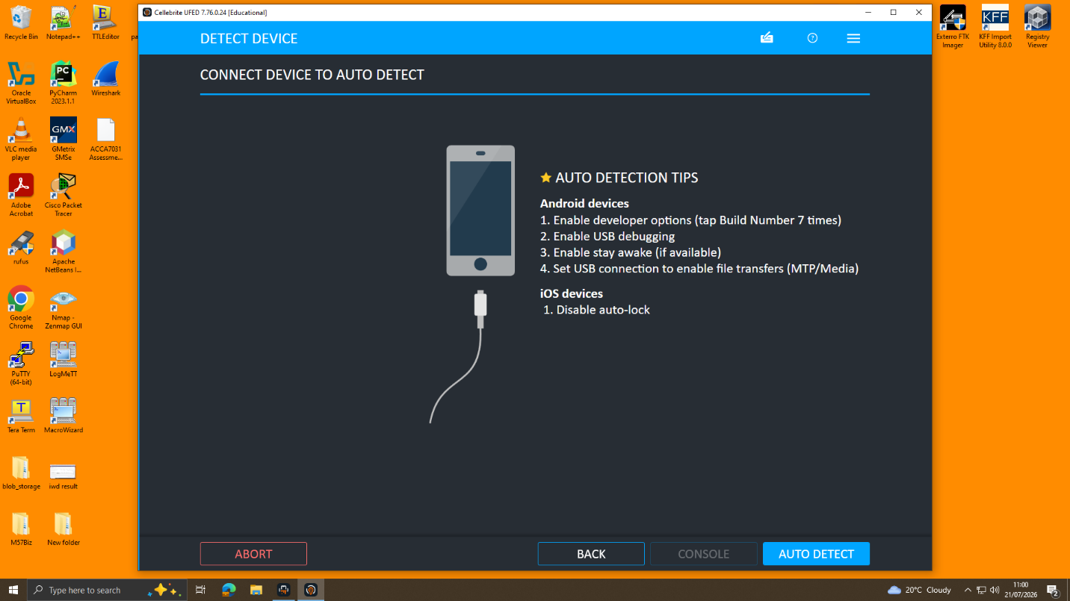
Figure.3 Auto Detect Device
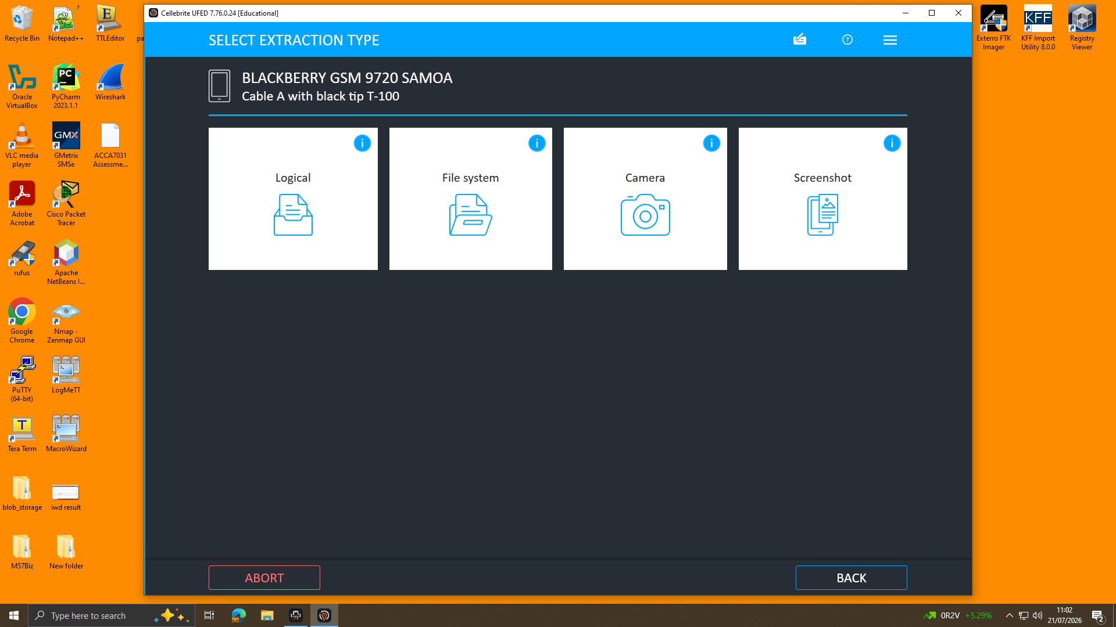
Figure.4 Type of extraction selected Logical
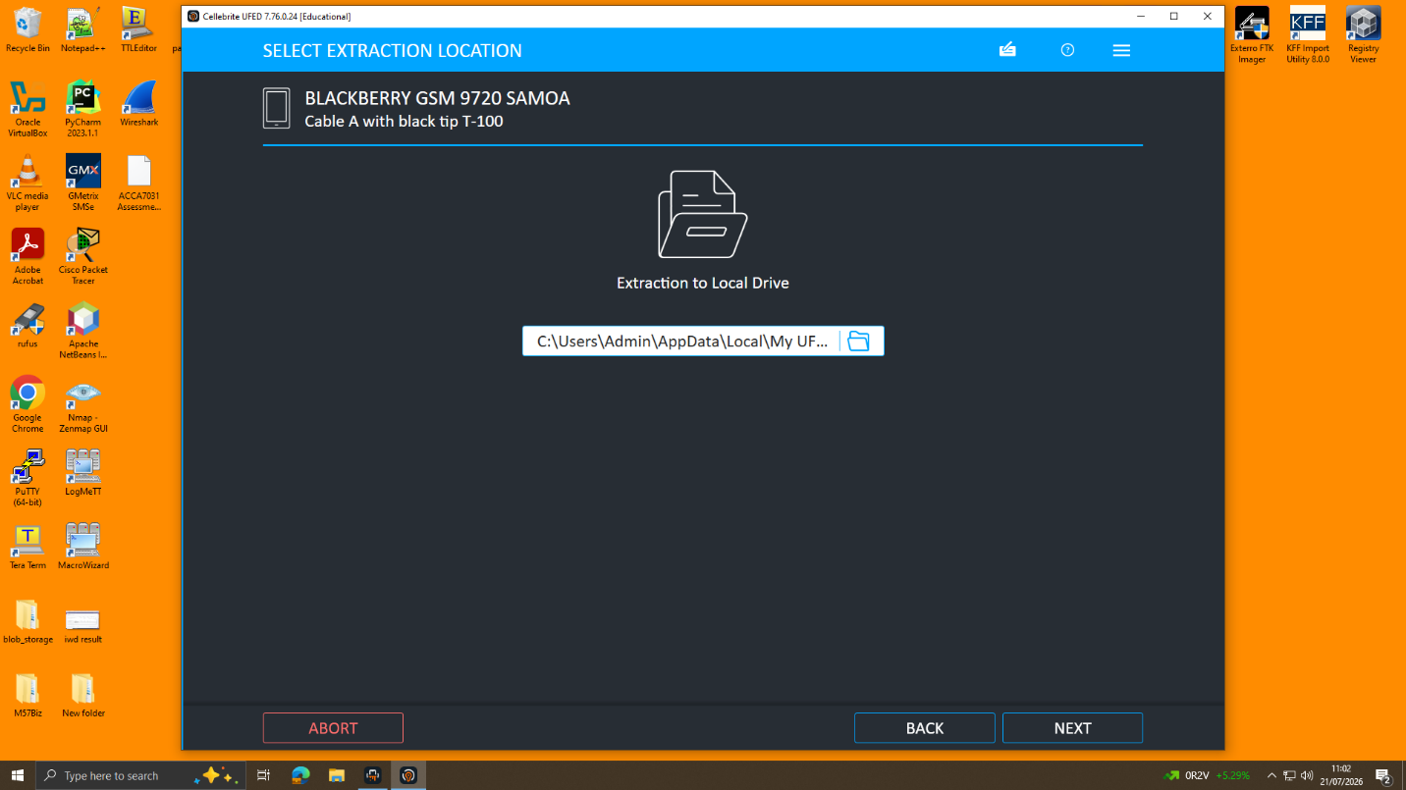
Figure.5 Extraction Location
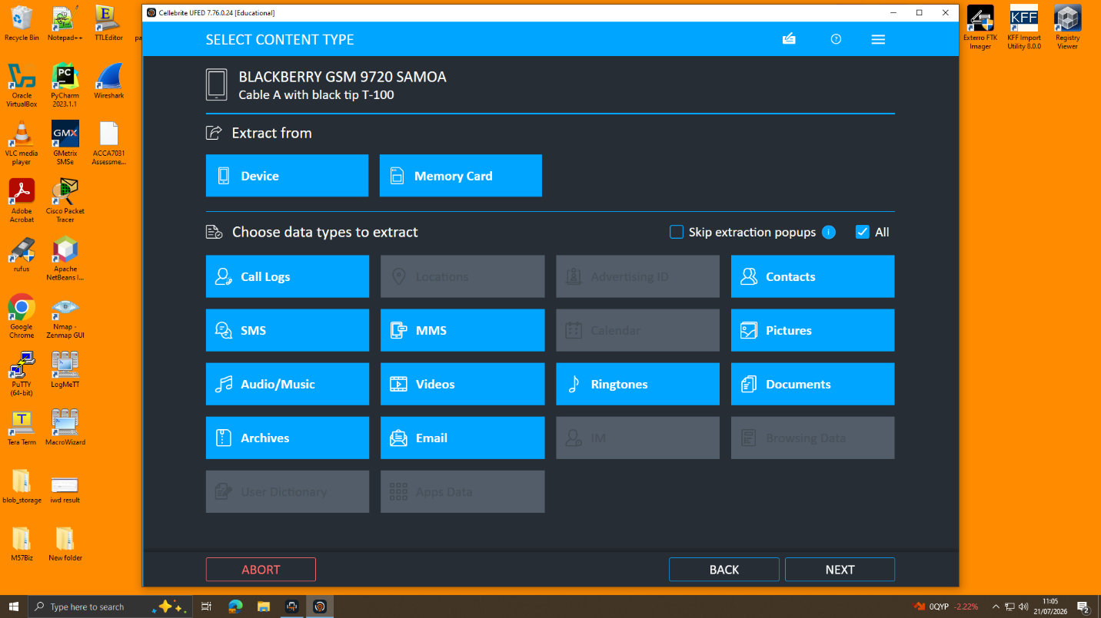
Figure 6. Content Selection Screen Prior to Logical Data Acquisition.
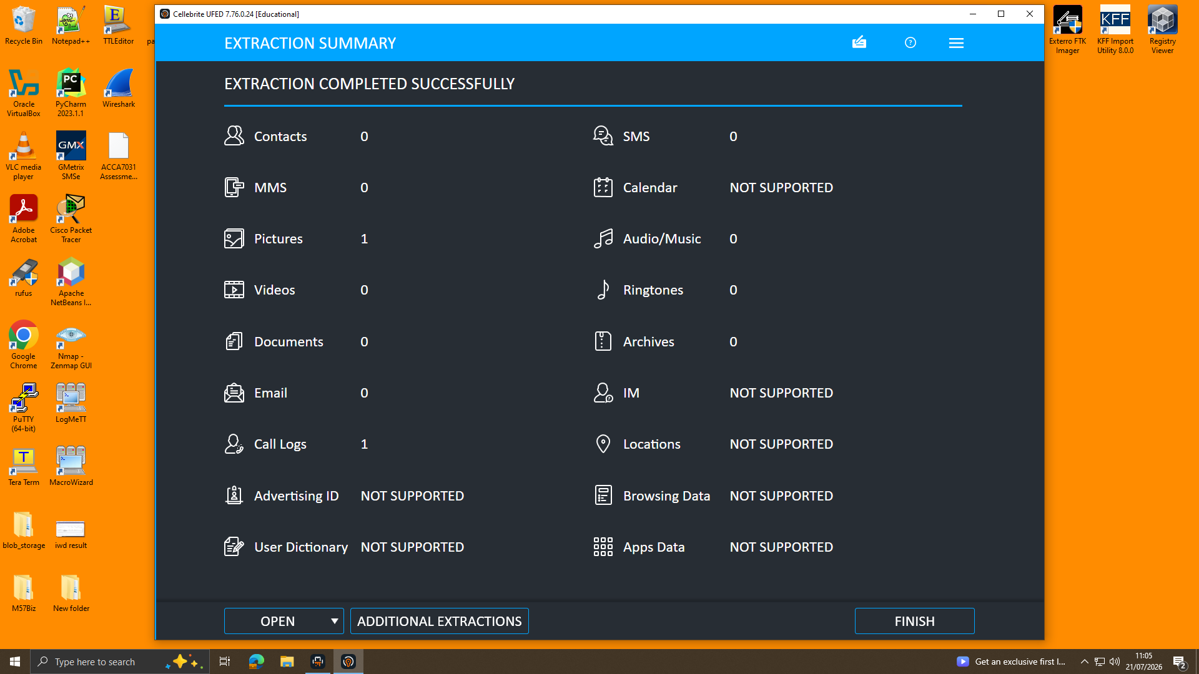
Figure 7. Extraction Summary Following Successful Logical Data Acquisition.
Extraction of digital data presented in Figures 1 to 7 proves compliance with forensic standards [11][13]. Verification through hashing ensured that data was consistent bit by bit and thus retained its authenticity and legality.
3. Evidence Inventory and Chain of Custody
Proper continuity-of-evidence procedures were followed when all digital evidence was received, as required. ISO/IEC 27037:2012 [12].
All items had evidence references, but there were also no original
Communication of evidence was changed at any point. An ACPO Good Practice Guide on digital evidence [13]
Original data should not have been modified; accessors of data should be:
A complete audit trail should be kept of competent.
Reference | Device type | Owner/suspect | Make/Model | Operating System
E001 | Smartphone | Primary Suspect – Emma | Huawei POT-LX1 P Smart | Android
E002 | Smartphone | Intermediary – Joe | Samsung Galaxy A13 (SM-A137F) | Android
E003 | Smartphone | Buyer – Norman Smith | Nokia | Android

3.1 Evidence Item E-001: Emma's Huawei P Smart (Chain of Custody)

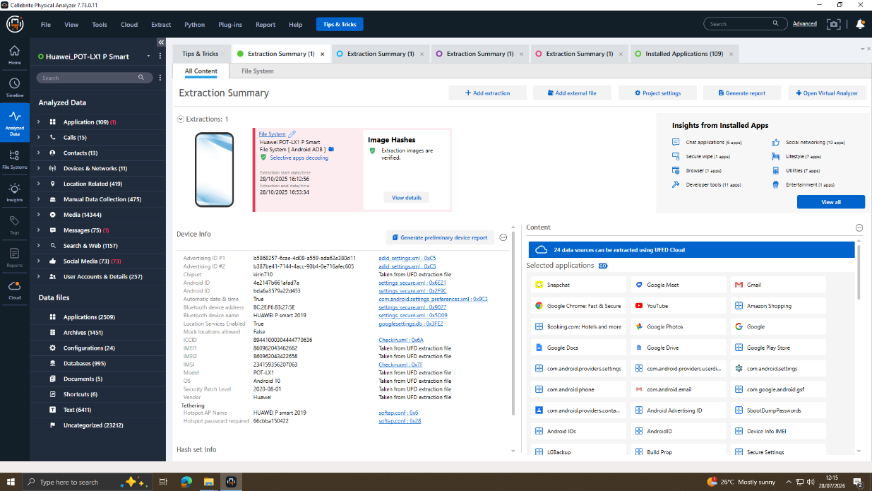

Field | Details
Evidence Reference | E-001
Device | Huawei POT-LX1 P Smart
Acquired By | Examiner: Mohamed Ghanim | Case: Naveed ullah shah
Forensic Tool | Cellebrite Physical Analyser v7.10.8.11 [14]
Data Recovered | Applications: 109 | Call Records: 15 | Media Files: 14,344 | Messages 75| Contacts: 13 |Locations: 419 | Manual Data Collection 475
Platforms | WhatsApp | Snapchat | Facebook | Instagram | Gmail (dovp59@gmail.com)
Acquisition Date | August,2026
Examination Status | Completed Successfully
SHA-1 Hash | d5193dbf8246c09fdde73be8558343985ab24a2e1c142e4d64e16e2b6507e31f
Hash Verified | Integrity SuccessfullyVerified [11]

3.2 Evidence Item E-002: Joe's Samsung Galaxy A13 (Chain of Custody)

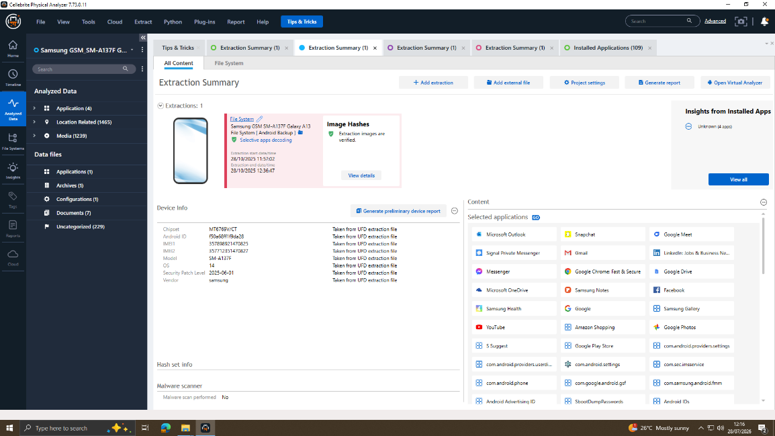

Field | Details
Evidence Reference | E-002
Device | Samsung Galaxy A13 (SM-A137F)
Acquired By | Examiner: Mohamed Ghanim | Case: Naveed ullah shah
Forensic Tool | Cellebrite UFED v7.76.0.24 / Cellebrite Physical Analyser v7.10.8.11 [14]
Platforms | WhatsApp | Instagram DMs | Call Records

Data Recovered | Application: 4 | Media: 1239 | Documents: 7 | Locations: 1465
Acquisition Date | August,2026
Examination Status | Completed Successfully
SHA-1 Hash | 0e585c4fe8160254253be515a16ff94b7fdf88b248b67d45cfdef8753a9a3195
Hash Verified | Integrity SuccessfullyVerified [11]

3.3 Evidence Item E-003: Norman's Nokia Smartphone (Chain of Custody)

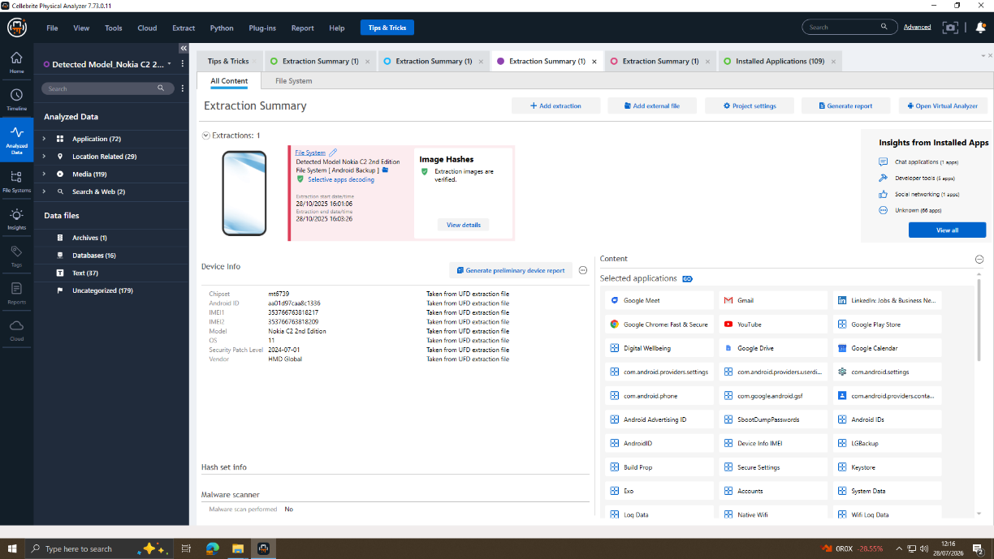
Field | Details
Evidence Reference | E-003
Device | Nokia Smartphone
Acquired By | Examiner: Mohamed Ghanim | Case: Naveed ullah shah
Forensic Tool | Cellebrite UFED v7.76.0.24 / Cellebrite Physical Analyser v7.10.8.11 [14]
Platforms | WhatsApp | Facebook Messenger | Emails | Call Records
Recovered Data | Application: 72 | Media: 119 | Location: 29
Acquisition Date | August, 2026
Examination Status | Completed Successfully
SHA-1 Hash | a693656c260e339069756be8005346e97033d0ccf2f79add56cd69c9eade13ab
Hash Verified | Integrity SuccessfullyVerified [11]

4. Forensic Methodology
The research followed the NIST SP 800-86 methodology for forensics, including collection, examination, analysis, and reporting [11]. ISO/IEC 27037:2012 standard was used to identify, collect, and preserve the evidence, whereas the ACPO guidelines helped in ensuring legal admissibility [12]. The addition of AI-based analysis through the use of the Cellebrite Physical Analyzer improved the process of mobile forensics[9].
Tools | Version | Purpose and Reference
Cellebrite UFED | v7.76.0.24 | Forensic acquisition has been done on all three Android phones using high-level logical acquisition methods.[14]
Cellebrite Physical Analyser | v7.10.8.11 | An analysis of all forms of correspondence, phone calls, multimedia documents, social networking sites, and emails will be conducted thoroughly.[14]
FTK Imager | Latest | MD5 and SHA-1 hashes were used to validate forensic images.[15]
Autopsy | Latest | Analysis of file systems and data artifacts that have been deleted [16].
ExifTool | Latest | File Metadata Extraction, which includes both creation, modification timestamps and authorship.

5. Digital Evidence Analysis

5.1 WhatsApp Communication Analysis (E-001)
The WhatsApp data was obtained from Emma's Huawei P Smart (E-001) phone using Cellebrite Physical Analyzer and particularly from Genie Chats > Genie WhatsApp. The number of WhatsApp messages obtained is 382. The figures 8-12 below show the main conversations relevant to the case of corporate espionage and patent theft.
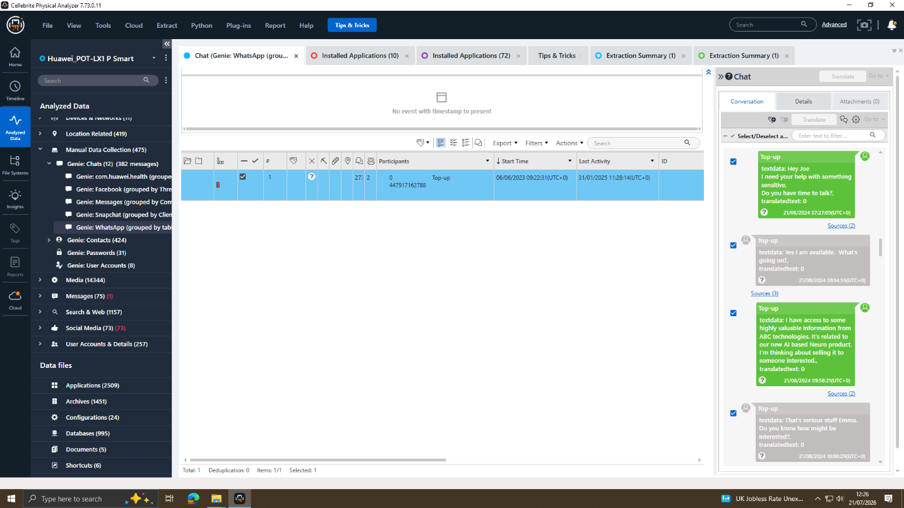
Figure.8 WhatsApp: Conversation Regarding the Initial Proposal to Sell the AI Patent
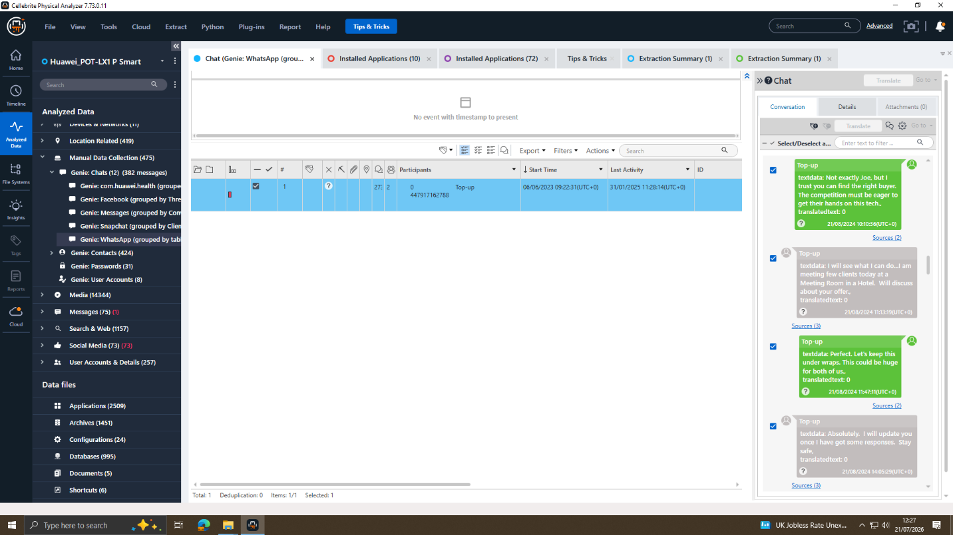
Figure.9 WhatsApp: Communication Confirming Deliberate Concealment
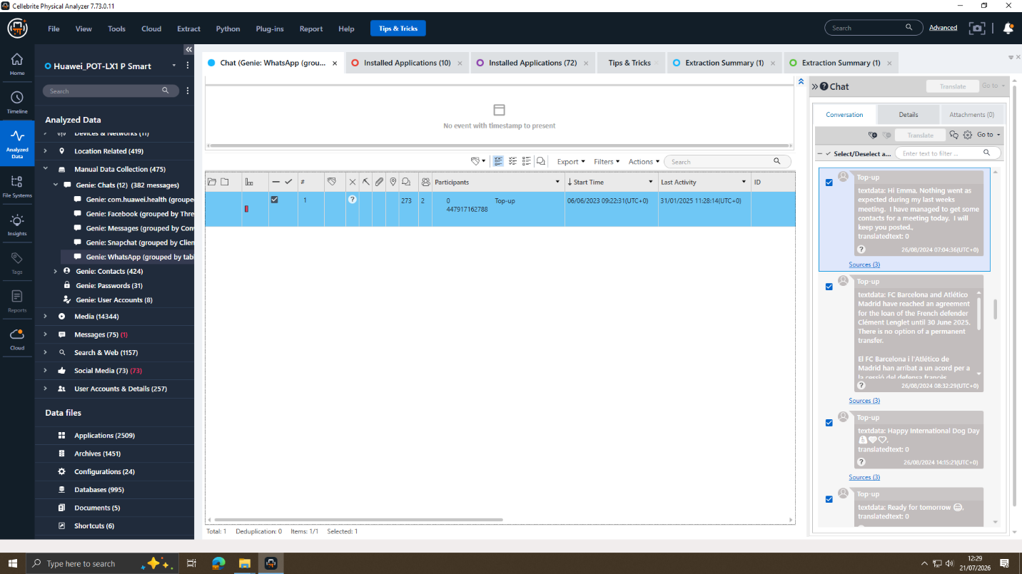
Figure.10 WhatsApp: Communication Coordinating a Meeting in Manchester
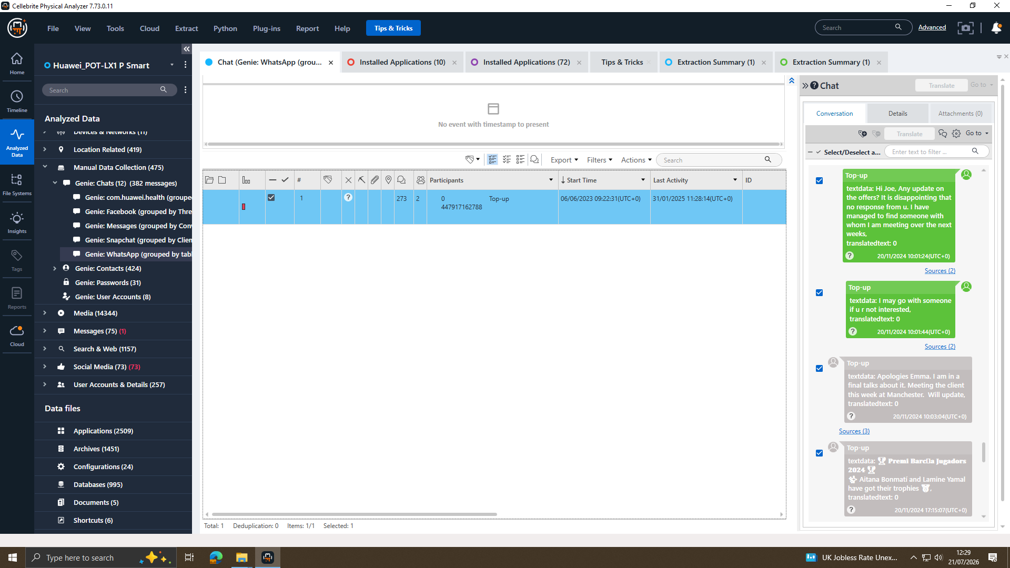
Figure.11 WhatsApp: Conversation Providing Evidence of Pressure and Urgency
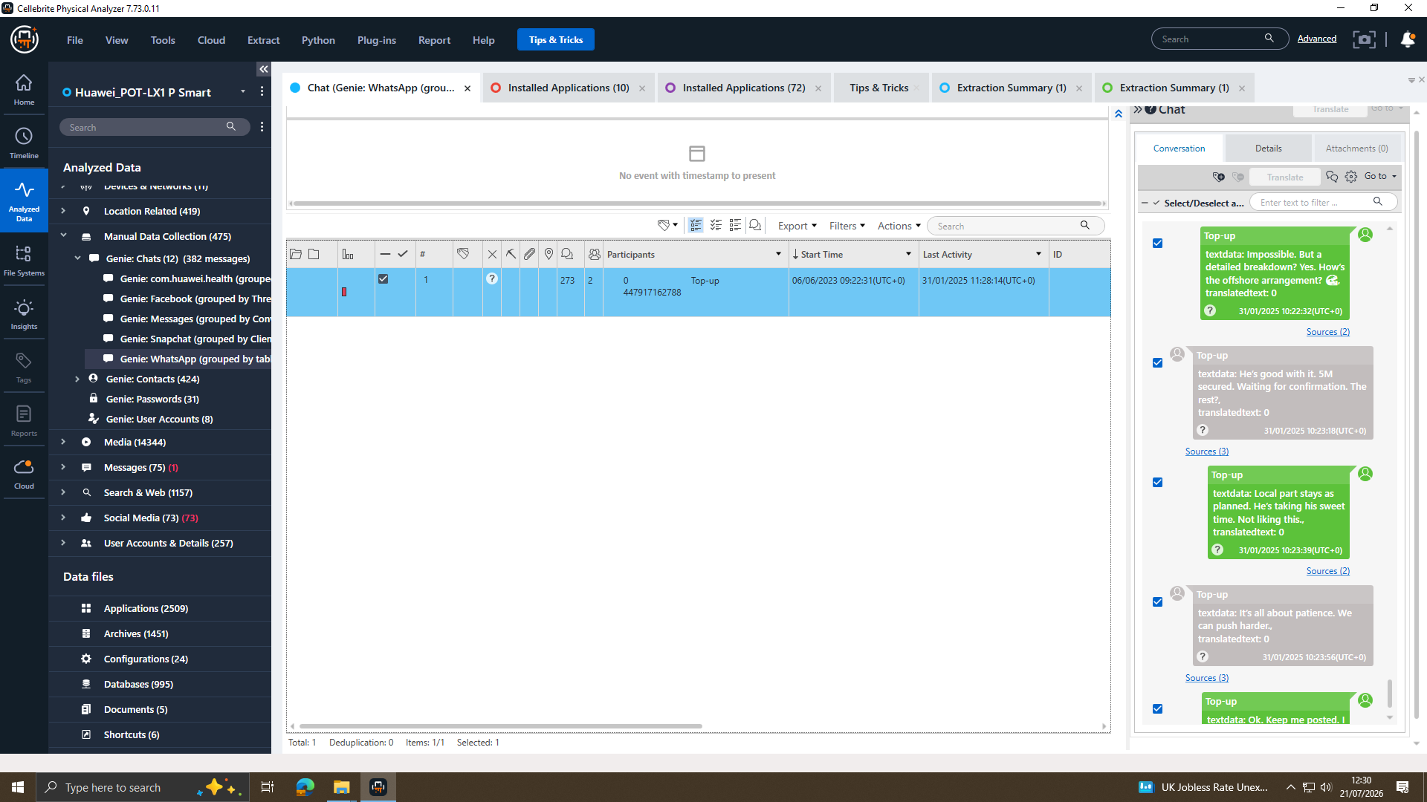
Figure.12 WhatsApp: Conversation Providing Evidence of Offshore Planning and Continued Coordination.
Forensic Significance: WhatsApp communications, which are shown in Figures 8–12, indicate a pattern showing that there is an act of conspiracy involved. An intention to make profits using artificial intelligence data is shown in Figure 8, thus, indicating motive and premeditation. Figure 9 shows conscious efforts to hide something, implying guilty mind. Communications obtained from Emma's Huawei device (E-001) show premeditated insider theft [9][17][21].
S.No | From | To | Timestamp | Platform | Conversation Transcript
1 | Emma | Joe | 21/08/2024  07:27:09 | WhatsApp | Hey Joe I need your help with something sensitive. Do you have time to talk?
2 | Joe | Emma | 21/08/2024  08:14:59 | WhatsApp | Yes, I am available. What’s going on?
3 | Emma | Joe | 21/08/2024 09:58:21 | WhatsApp | I have access to some highly valuable information from ABC technologies. Its related to our new AI based Neuro product. I’m thinking about selling it to someone interested.
4 | Joe | Emma | 21/08/2024  10:06:29 | WhatsApp | That’s serious staff Emma. Do you know how might be interested?
5 | Emma | Joe | 21/08/2024 10:10:36 | WhatsApp | Not exactly Joe, but I trust you can find the right team. The competition must be eager to get their hands on this tech.
6 | Joe | Emma | 21/08/2024 11:13:19 | WhatsApp | I will see what I can do. I am meeting few clients today at a meeting room in a hotel. Will discuss about your offer.
7 | Emma | Joe | 21/08/2024 11:47:11 | WhatsApp | Perfect. Let's keep this under wraps. This could be huge for both of us.
8 | Emma | Joe | 20/11/2024 10:01:24 | WhatsApp | Hi Joe. Any update on the offer? It is a disappointing that no response from you. I have managed to find someone with whom I am meeting over the next weeks.
9 | Emma | Joe | 20/11/2024 10:01:44 | WhatsApp | I may go with someone if not u r interested.
10 | Joe | Emma | 20/11/2024  10:03:04 | WhatsApp | Apologies Emma. I am in a final talks about it. Meeting the client this week at Manchester. Will update.
11 | Emma | Joe | 31/01/2025 10:15:15 | WhatsApp | Any updates? Need to move fast.
12 | Emma | Joe | 31/01/2025  10:17:42 | WhatsApp | Waste of time? should I reach others?
13 | Emma | Joe | 31/01/2025  10:22:32 | WhatsApp | But a detailed breakdown? Yes. How’s the offshore agreement?
14 | Joe | Emma | 31/01/2025  10:23:18 | WhatsApp | He`s good with it. 5M secured. Waiting for confirmation. The rest?

5.2 Facebook Messenger Communication Analysis (E-001)
The extracted data from Facebook messenger of Emma’s device (E-001) was done through Cellebrite Physical Analyzer under Genie Chats>Genie Facebook. Figures 13 & 14 show the conversations of Peter Dover (Emma) and Norman Smith, providing substantial proof of the plan to shift the blueprints of the QT-AI-2025 patent [14].
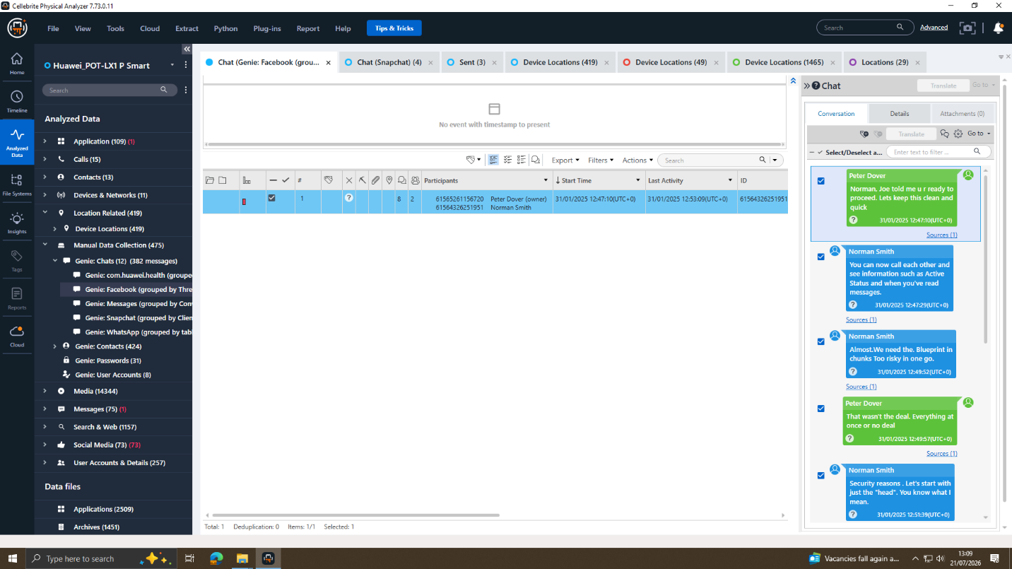
Figure.13 Facebook Messenger Conversation Providing Evidence of Patent Blueprint Transfer Negotiations
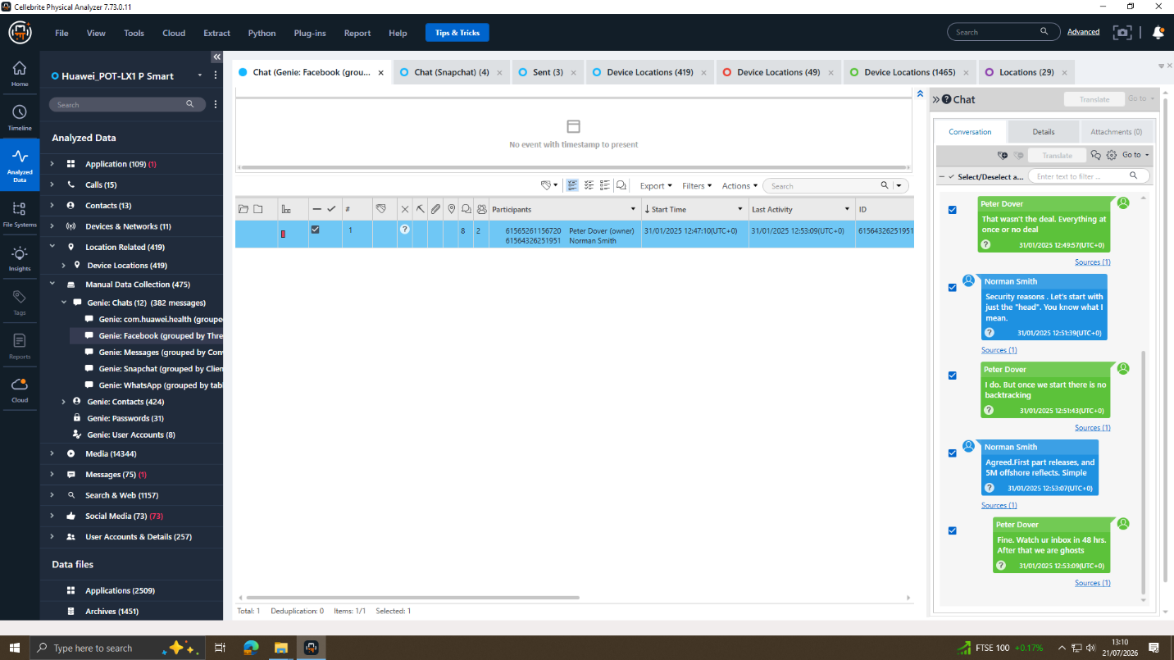
Figure.14 Facebook Messenger Conversation Providing Evidence of Offshore Payment Arrangements and the Planned Transfer of Confidential Data
Significance in Forensic: The Facebook Messenger (Figures 13-14) provides direct evidence of the conspiracy. Those who mention “the Blueprint” in any case have the QT-AI-2025 patent, whereas the offshore payment structure has relevance to money laundering as per the Proceeds of Crime Act 2002 [18]. The term “After that we are ghosting” shows pre-planning for concealing digital evidence, hence committing offenses under the Criminal Justice Act 2003 [19].
S.No | From | To | Timestamp | Plateform | Conversation Transcript
1 | Peter Dover (Emma) | Norman Smith | 31/01/2025 12:47:10 | Facebook | Norman, Joe told me u r ready to proceed. Let’s keep this clean and quick.
2 | Norman Smith | Peter Dover (Emma) | 31/01/2025 12:47:29 | Facebook | You can now call each other and see information such as active status and when you have read messages.
3 | Norman Smith | Peter Dover (Emma) | 31/01/2025 12:49:52 | Facebook | We need the Blueprint in chunks. Too risky in one go
4 | Peter Dover (Emma) | Norman Smith | 31/01/2025 12:49:57 | Facebook | That wasn't the deal. Everything at once or no deal.
5 | Norman Smith | Peter Dover (Emma) | 31/01/2025 12:51:39 | Facebook | Security reasons. Let's start with just the head. You know what I mean.
6 | Peter Dover (Emma) | Norman Smith | 31/01/2025 12:51:43 | Facebook | I do. But once we start there is no backtracking.
7 | Norman Smith | Peter Dover (Emma) | 31/01/2025 12:53:07 | Facebook | Agreed. First part releases, and 5M offshore reflect. Simple.
8 | Peter Dover (Emma) | Norman Smith | 31/01/2025 12:53:09 | Facebook | Fine Watch ur Inbox in 48 hrs. After that we are ghosts.

5.3 Call Log Analysis (E-001)
The forensics examination conducted on Emma's Huawei phone (E-001) revealed a total of 15 call logs. The figure below (Figure 15) presents the call history screen displayed in Cellebrite Physical Analyzer along with the call details panel [14].
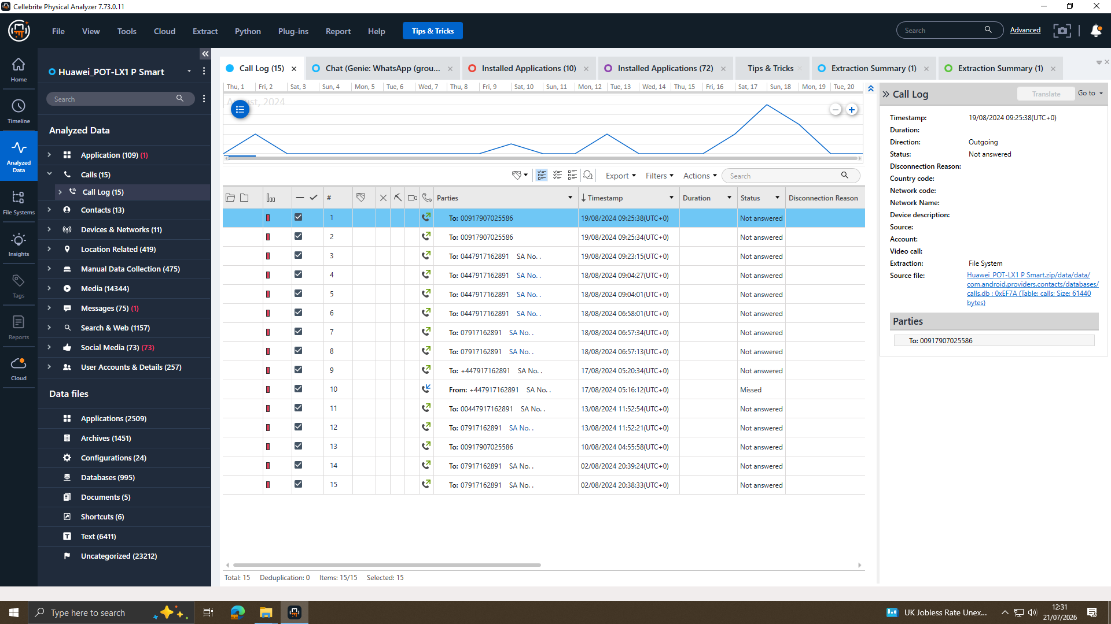
Figure.15 Call Log Artefacts Extracted from Emma's Huawei Smartphone (Evidence Item E-001)
S.No | Device | Called Number | Date & Time | Analysis Remarks
1 | E-001 (Emma Huawei) | 00917907025586 | 19/08/2024 09:25:38 | An unsuccessful call was placed to an international number, with no answer received.
2 | E-001 (Emma Huawei) | 00917907025586 | 19/08/2024 09:25:34 | Again An unsuccessful call was placed to an international number, with no answer received.
3 | E-001 (Emma Huawei) | 07917162891 | 18/08/2024 09:04:27 | Unanswered
4 | E-001 (Emma Huawei) | 07917162891 | 18/08/2024 06:57:34 | Unanswered
5 | E-001 (Emma Huawei) | +447917162891 | 17/08/2024  05:20:34 | Unanswered
6 | E-001 (Emma Huawei) | +447917162891 | 17/08/2024  05:16:12 | Missed Call
7 | E-001 (Emma Huawei) | +447917162891 | 13/08/2024  11:52:54 | Unanswered
8 | E-001 (Emma Huawei) | 00917907025586 | 10/08/2024  04:55:58 | Unanswered
9 | E-001 (Emma Huawei) | +447917162891 | 02/08/2024  20:38:33 | Unanswered
The phone numbers, namely 00917907025586 and 07917162891, appear repeatedly in Emma's phone calls. These two phone numbers, along with their time proximity in relation to WhatsApp messages, signify that there is continuous coordination going on between the accused. Matching of logs of Joe's Samsung device (E-002) and Norman's Nokia device (E-003).

5.4 Multimedia and Geolocation Analysis (E-002)
In total, 1,239 images have been successfully extracted from Joe's Samsung Galaxy A13 (E-002) using Cellebrite Physical Analyzer. Through timeline analysis, two geotagged images Figure (17 &18) taken on 16th December 2024, 14:26:13, and 14:26:15 (UTC+0) have been found in the folder sdcard/DCIM/Camera. The nearness of the timing for the taking of these images, along with the location information provided through GPS, constitutes evidence that is relevant. The relevance of these images can be further established through WhatsApp and Facebook messenger messages.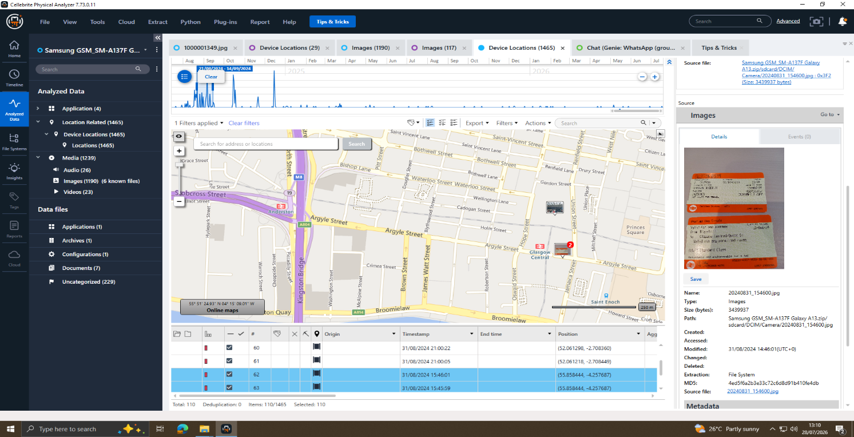
Figure 16: Media Artefacts Recovered from E-002 (Joe's Samsung Galaxy A13)
Here you can see the Cellebrite Physical Analyzer media view for E-002 (Joe's Samsung Galaxy A13) with 1239 images recovered. Joe's travels precede the conspiracy communications as evidenced by his Train Ticket photo. A comprehensive picture library can include additional evidence of the suspects' movements and activity [14].
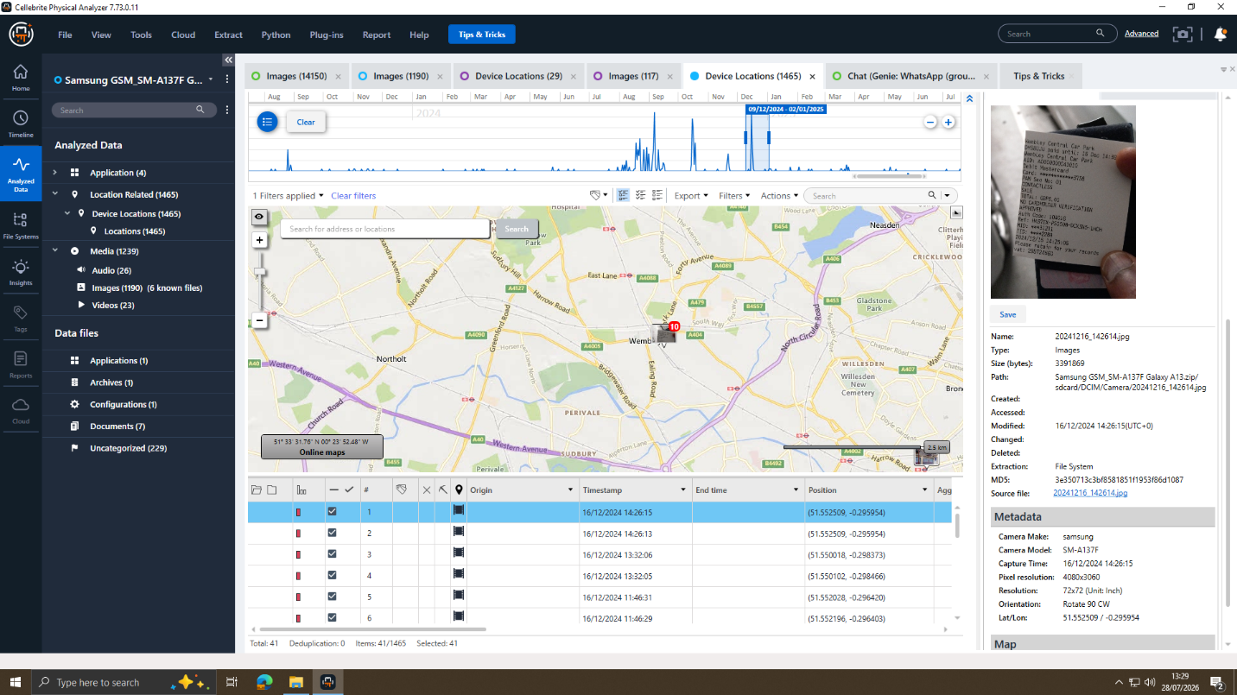
Figure 17: Geotagged Photograph with Embedded GPS Metadata
Embedded GPS EXIF metadata identified this image as being classified under Image: Location. The geotagged photo images Joe's position around a particular date, which in this case is six weeks prior to the patent transfer date communicated through Facebook Messenger - 31/01/2025 [14].
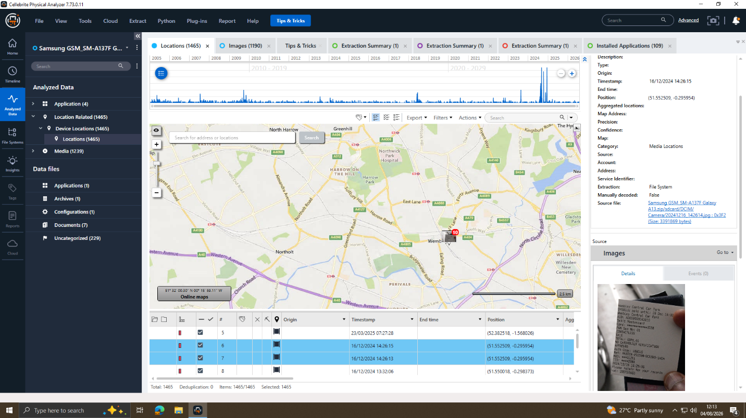
Figure 18: Geotagged Photograph with Embedded GPS Metadata
If two geo-tagged images are found within a 2 second period, it should be considered deliberate documentation. Photographic metadata generated from an ExifTool copy of the file's GPS data can be used to map the location of the photographs more accurately, and correlated with the timeline of the conspiracy, thereby enhancing the evidential value of the photographs [14].

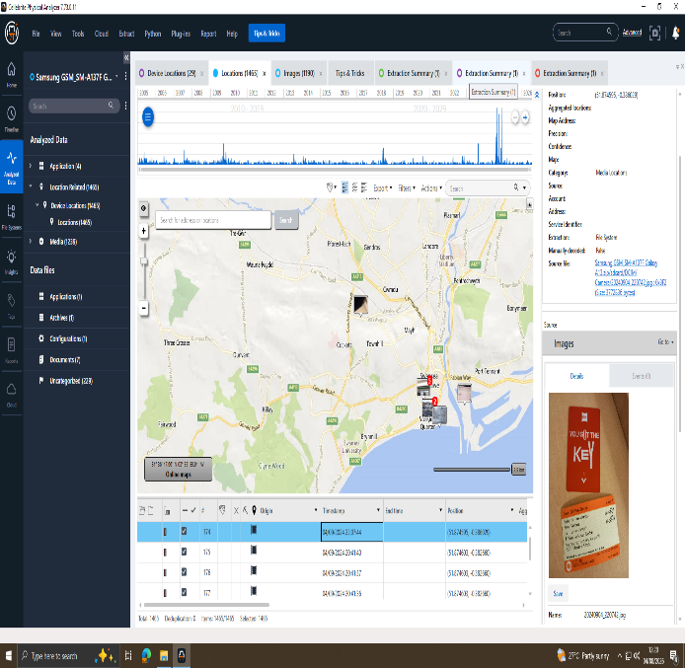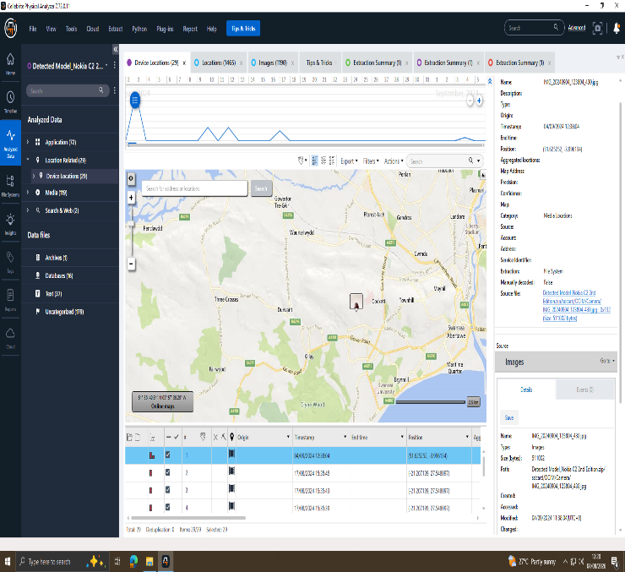
Figure 19: Geotagged Photograph Recovered from Joe's Samsung Galaxy A13 (Evidence Item E-002) Showing GPS Metadata and Capture Location. | Figure 20: Geotagged Photograph Recovered from Norman Smith's Nokia Smartphone (Evidence Item E-003) Showing GPS Metadata and Capture Location.
The rapidly recovered geolocation metadata indicates that both devices were in the Swansea region 04/09/2024. The image timings and location suggest that Joe and Norman Smith occupied the same location around the same time. This is confirmed by WhatsApp and Facebook Messenger communication and the conclusion is that Joe is the facilitator in providing confidential information in the QT-AI-2025 patent.
Forensic Significance: The Joe – Samsung Galaxy A13 (E-002) was retrieved resulting in 1239 images being recovered, some of which included geotagged photos with GPS EXIF. ExifTool retrieved their locations, confirming that Joe visited locations relevant to the conspiracy, and allowing reconstruction of the conspiracy timeline. Both the consistency of the geolocation evidence with WhatsApp and Facebook Messenger communications, and the presence of the geolocation evidence together with the pattern of communication between the patent professionals involved, support the conclusions made in the transfer of the confidential QT-AI-2025 patent information [9][14][17].

5.5 Instagram QR Code Analysis
From Emma's Huawei (E-001), a total of fourteen thousand three hundred and Forty four (14,344) media files were retrieved. A photograph was detected by examining the Device Locations > Locations category in Cellebrite Physical Analyzer that had significant evidentiary importance [14].

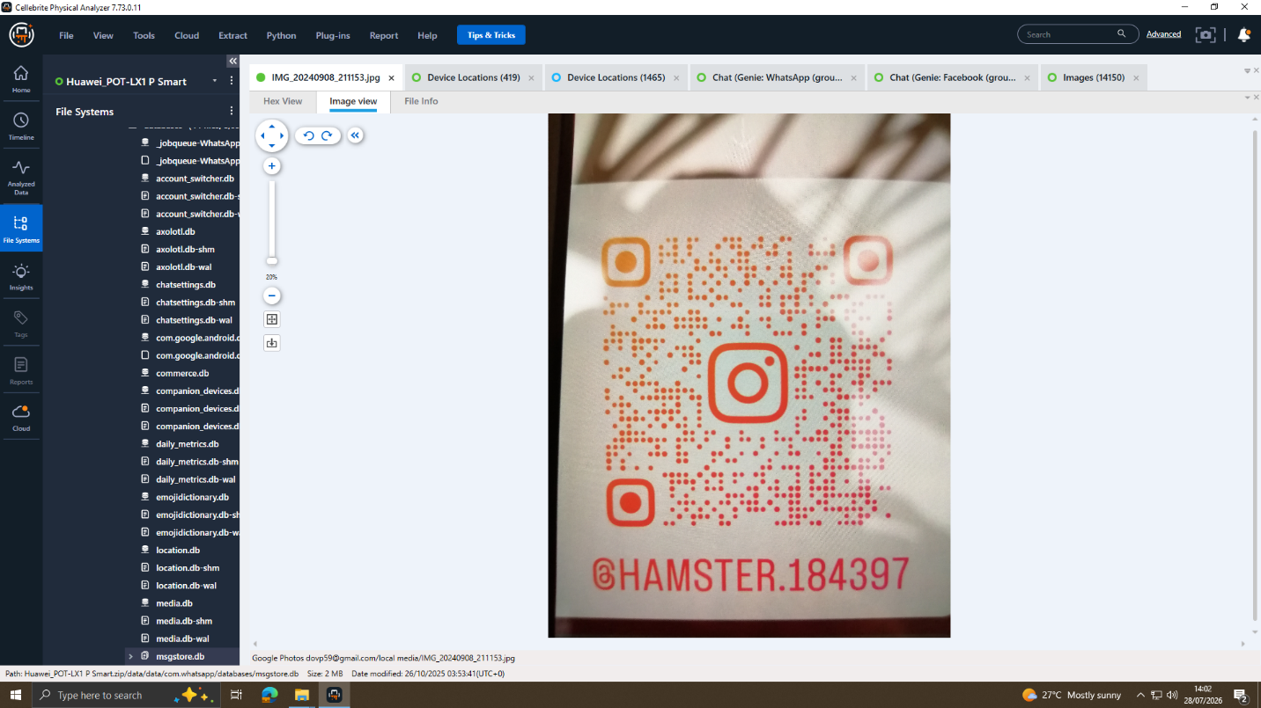
Figure 21: Instagram QR Code Associated with @HAMSTER.184397

The screenshot taken of the Instagram QR code (Figure 21) confirms the WhatsApp evidence showing that @HAMSTER.184397 acted as the alternative means of communication. This suggests that there was deliberate use of various platforms for hiding any kind of coordination among the perpetrators, which is a common trend among organized criminals [20].

5.6 Correlated Evidence Timeline

Date | Time | Platform | Name | Event Description and Evidential Significance
21/08/2024 | 09:58:21 | WhatsApp(E-001) | Emma | CRITICAL: 'I have access to highly valuable information from AI based future product list. I am thinking of selling it.' Initial evidence of conspiratorial activities and criminal intent. Source: Emma's Huawei E-001.
Multiple | Multiple | Phone Calls (E-001) | Emma | There are several outgoing calls to 07917162891 from Emma's Huawei, suggesting that she may have been communicating and coordinating with a co-conspirator.
19/08/2024 | 09:25:34 | Phone Calls (E-001) |  | There are also two outgoing phone calls identified to an international number, 00917907025586, indicating a potentially urgent call.
21/08/2024 | 11:47:11 | WhatsApp(E-001) | Emma | CRITICAL: 'Perfect. Let's keep this under wraps. This could be huge for both of us.' Evidence of deliberate concealment Source: Emma's Huawei E-001.
20/11/2024 | 10:01:24 | WhatsApp(E-001) | Emma | 'I have managed to find someone with whom I am meeting.Buyer identified and meeting scheduled. Source: Emma's Huawei E-001.
31/01/2025 | 12:53:07 | Facebook(E-003) | Norman Smith | CRITICAL: 'Agreed. First part released, and 5M offshore effects. Offshore payment arrangement identified. Source: Norman's Nokia E-003.
31/01/2025 | 12:53:09 | Facebook(E-003) | Peter Dover | CRITICAL: 'Doc. Watch ur Inbox in 48 hrs. After that we are ghosts. Patent document transfer discussed, with references to planned evidence destruction. Source: Norman's Nokia E-003.
31/01/2025 | 12:49:52 | Facebook(E-003) | Norman Smith | “We need the Blueprint in chunks. Too risky in one go”. Request for patent blueprint. Source: Norman's Nokia E-003.
31/01/2025 | 12:47:10 | Facebook(E-003) | Peter Dover | “Norman, Joe told me u r ready to proceed. Lets keep this clean and quick”. Evidence indicating Joe’s intermediary role. Source: Norman's Nokia E-003.
18/11/2024 |  | WhatsApp (E-001) | Emma | “I may go with someone else if not interested”. Evidence of coercive tactics. Source: Emma's Huawei E-001.
19/11/2025 |  | WhatsApp (E-001) | Emma | “Any updates? Need to move fast”. Ongoing communication reflecting urgency and pressure. Source: Emma's Huawei E-001.
August 2026 | Various | Cellebrite | Examiner | All three devices have been acquired successfully using forensic techniques, and verified using hash validation.

5.7 Suspect Profiles and Assessment
Evidence from the digital devices is consistent with the suspects' participation in the conspiracy. The forensic investigation assisted by artificial intelligence has helped to reconstruct the sequence of events and activities of the suspects using evidence of communication [9].
Suspect 1: Emma | Device: Huawei POT-LX1 P Smart (E-001) | Suspected Role: Primary Perpetrator and Insider Threat
Daily Duties: Access the QT-AI-2025 patent database to carry out senior level engineering projects and research. Emma's recovered digital evidence indicates that she played a key role in starting and orchestrating the alleged transfer of proprietary patent information to NexGen Circuits.
Interest: Potential financial benefit in the unauthorised disclosure or sale of the proprietary QT-AI-2025 AI chip design patent to another competing organisation(s) [17].
Key Evidence: A forensic examination of the WhatsApp messages on E-001 showed that it was used to discuss matters relating to the sale of ‘highly valuable information from AI based future product list’ (Figure: 8). Other messages indicate the efforts to keep this secret [Figure: 9] as well as the planning for a meeting in Manchester [Figure: 11] and a reference to the use of a secret Instagram account @HAMSTER.184397 as an extra communication tool [Figure: 21]. There was also 14344 recovered media files and 71 email records relating to(dovp59@gmail.com). that has been left behind in the device that helped to clarify evidential material that could be investigated.
References: [9][11][12][14][17][21]
In terms of potential legal implications, the Computer Misuse Act 1990 [17] and the Trade Secrets (Enforcement, etc.) Regulations 2018 [21], along with the Fraud Act 2006 [22] might apply.

Suspect 2: Joe | Device: Samsung Galaxy A13 (E-002) | Suspected Role: Intermediary
Role:
Digital evidence suggests that Joe was between Emma and Norman Smith. Recovered WhatsApp and Facebook Messenger correspondences (Figures 8–12), call logs (Figure 16), and recovered evidence of geolocation (Figures 16–20), corroborate his participation and involvement in the alleged transfer of the QT-AI-2025 patent information.
Motive:
From the communications that are recovered, it appears that Joe was helping to move things to make money. Norman, Joe told me u r ready to proceed (shown in figure 14) further buttrress his role as the intermediaries.
References: [9][14][17][19][21]
Potential Legal Implications:
Computer Misuse Act 1990 [17]; Fraud Act 2006 [22]; Criminal Justice Act 2003 [19].

Suspect 3: Norman Smith | Device: Nokia Android Smartphone (Evidence Item E-003) Suspected Role: Suspected Buyer and Intended Recipient
Role: Person who is about to buy the product on behalf of NexGen Circuits. Arranges receipt of patent blueprint for QT-AI-2025 and to ensure payment is handled overseas.
Application: To gain the QT-AI-2025 patent to offer a competitive edge in developing the AI chip to NexGen Circuits and cut down on the research and development expenses [20].
Important Evidence: "We need the Blueprint to go" [Fig. 14] "We need the Blueprint in chunks. Too risky in one go" [Fig. 14] "Agreed. First part released, and the offshore effects. Simple" [Fig. 15] “I have others waiting” [Fig. 15]
References: [14][17][18][21][22]
Potential legal implications: Proceeds of Crime Act 2002 (offshore payments/money laundering); Trade Secrets (Enforcement, etc.) Regulations 2018; Fraud Act 2006.

6. Conclusion
Aiding the investigation, there was overwhelming digital evidence that, on the balance of probabilities, showed a coordinated attempt to illegally obtain and transfer Quantum Tech's proprietary QT-AI-2025 AI chip design patent. Reconstructed evidence proves there are three suspects: insider suspect, Huawei E-001; intermediary, Samsung E-002; intended buyer, Nokia E-003.
What we know from WhatsApp messages recovered from Emma's Huawei smartphone (Figures 8-12) is that she was in possession of, and wanted to sell, "highly valuable information from AI based future product list"—a link involving her and the confidential QT-AI-2025 patent, and showing insider involvement. The Facebook Messenger conversations retrieved from Emma phone (E-001) include more corroborating evidence including mentions of "the Blueprint," offshore payment structures, staged transfer topic and the continued conversations of plans for disabled communications after the transfer [18][19].
Multiple communications, such as messaging on WhatsApp, Facebook Messenger and Instagram (i.e., @HAMSTER.184397, Figure 21), suggests a concerted communications strategy designed to minimize the risk of being detected. Call log analysis (Figure 15) revealed frequent calls to two consistent phone numbers, with high correlations to the messaging time series. Taken together with offshore payments issues these results suggest that there was an organised operation [20].
Evidence recovered can relate to offences under the Computer Misuse Act 1990 [17], Trade Secrets (Enforcement, etc.) Regulations 2018 [21], the Fraud Act 2006 [22] the Proceeds of Crime Act 2002 [18] and the Criminal Justice Act 2003 [19]. All forensic activities followed the requirements of NIST SP 800-86 [11] and ISO/IEC 27037:2012 [12] standards.

7. Recommendations

7.1 Recommendations for Law Enforcement
- All three suspects should be prosecuted under the Trade Secrets (Enforcement, etc.) Regulations 2018 [21] and Computer Misuse Act 1990 [17].
- Identify possible offences under the Proceeds of Crime Act 2002 [18] in respect of payment received offshore, as displayed in Figure 15 above.
- Retrieve and preserve and/or analyze the Instagram account @HAMSTER.184397 (Figure 17).
- Cross-reference telephone numbers 00917907025586 and 07917162891 (Figure 16).
- Conduct an interview with Emma about her potential involvement.
- Log assessment of potential offences under the Criminal Justice Act 2003 [19] for the planned concealment or destruction of evidence, by Joe.

7.2 Recommendations for Quantum Tech
- Revoke Emma's system access immediately and review all files accessed during the previous 24 months.
- Implement Data Loss Prevention (DLP) controls to mitigate the insider risks, as mentioned in the IBM Cost of a Data Breach Report 2024 [20].
- Limit the access to the patent database [11] by applying the principle of least privilege to all users accessing the database.
- Roll out User Behaviour Analytics (UBA) more AB, out of hours or large data transfers are detected.
Provide periodic insider threat and trade secret training.
- Think about civil action against NexGen Circuits pursuant to the Trade Secrets (Enforcement, etc.) Regulations 2018 [21].

8. References

- [1] M. Herman, M. Iorga, A. M. Salim, R. Jackson, M. Hurst, R. Leo, A. K. Mishra, N. Landreville, and Y. Wang, “NIST Cloud Computing Forensic Reference Architecture,” National Institute of Standards and Technology, Gaithersburg, MD, USA, NIST Special Publication (SP) 800-201, Jul. 2024, doi: 10.6028/NIST.SP.800-201.
- [2] Amazon Web Services, “Forensic investigation environment strategies in the AWS Cloud,” AWS Security Blog, Oct. 28, 2021. [Online]. Available: https://aws.amazon.com/blogs/security/forensic-investigation-environment-strategies-in-the-aws-cloud/ (accessed Aug. 2026).
- [3] Amazon Web Services, “AWS Security Incident Response now provides agentic AI-powered investigation,” AWS What’s New, Nov. 21, 2025. [Online]. Available: https://aws.amazon.com/about-aws/whats-new/2025/11/aws-security-incident-response-agentic-ai-powered-investigation/ (accessed Aug. 2026).
- [4] M. M. Alshabibi, A. K. Bu Dookhi, and M. M. H. Rahman, “Forensic investigation, challenges, and issues of cloud data: A systematic literature review,” Computers, vol. 13, no. 8, art. no. 213, 2024, doi: 10.3390/computers13080213.
- [5] A. W. Malik, D. S. Bhatti, T.-J. Park, H. U. Ishtiaq, J.-C. Ryou, and K.-I. Kim, “Cloud digital forensics: Beyond tools, techniques, and challenges,” Sensors, vol. 24, no. 2, art. no. 433, 2024, doi: 10.3390/s24020433.
- [6] National Cyber Emergency Response Team of Pakistan (PKCERT), “Procurement of digital forensics and screening hardware,” Tender No. 31, 2026. [Online]. Available: https://pkcert.gov.pk/uploads/2026/04/tender-31-updated.pdf (accessed Aug. 2026).
- [7] National Cyber Emergency Response Team of Pakistan (PKCERT), “Job opportunities.” [Online]. Available: https://pkcert.gov.pk/job-opportunities/ (accessed Aug. 2026).
- [8] ISC2, “2025 ISC2 Cybersecurity Workforce Study,” Dec. 2025. [Online]. Available: https://www.isc2.org/Insights/2025/12/2025-ISC2-Cybersecurity-Workforce-Study (accessed Aug. 2026).
- D. Dunsin, M. C. Ghanem, K. Ouazzane, and V. Vassilev, "A comprehensive analysis of the role of artificial intelligence and machine learning in modern digital forensics and incident response," Forensic Science International: Digital Investigation, vol. 48, Art. no. 301675, 2024. [Online]. Available:https://doi.org/10.1016/j.fsidi.2023.301675
- MarketsandMarkets, "Digital Forensics Market Global Forecast to 2030," 2025.
- K. Kent, S. Chevalier, T. Grance, and H. Dang, Guide to Integrating Forensic Techniques into Incident Response, NIST Special Publication 800-86. Gaithersburg, MD, USA: National Institute of Standards and Technology, 2006. doi: 10.6028/NIST.SP.800-86.
- International Organization for Standardization, ISO/IEC 27037:2012 Guidelines for Identification, Collection, Acquisition and Preservation of Digital Evidence, ISO, Geneva, 2012.
- Association of Chief Police Officers (ACPO), *ACPO Good Practice Guide for Digital Evidence*, Version 5. London, U.K.: ACPO, Mar. 2012. [Online]. Available: link
- .Cellebrite, "Cellebrite UFED and Physical Analyser," Cellebrite DI Ltd., 2024.
- Exterro, "FTK Imager — Forensic Imaging Tool," Exterro Inc., 2024.
- Basis Technology, "Autopsy Digital Forensics Platform," 2025.
- Computer Misuse Act 1990, c. 18. London, U.K.: Her Majesty's Stationery Office (HMSO), 1990. [Online]. Available: Link
- Proceeds of Crime Act 2002, c. 29. London, U.K.: Her Majesty's Stationery Office (HMSO), 2002. [Online]. Available: Link
- Criminal Justice Act 2003, c. 44. London: HMSO.
- IBM Security, "Cost of a Data Breach Report 2024," IBM Corporation, Jul. 2024.
- Trade Secrets (Enforcement, etc.) Regulations 2018, SI 2018/59.
- Fraud Act 2006, c. 35. London: HMSO.

