CertHE Computing Skill for Workplace
Assignment 1: E-Portfolio
Sulvanus Godoga (2537881)
Module: Learning in the Digital Era ACCA4025
Table of Contents
Task 1 – Written summary: 2
Task 2 – Mind Map & Academic poster: 3
Task 3 Automatic Referencing tool: 4
Task 4 E-Portfolio creation and review: 5

1. Click this link to my online e-portfolio.
2. Below is the screenshot of my e-portfolio homepage.
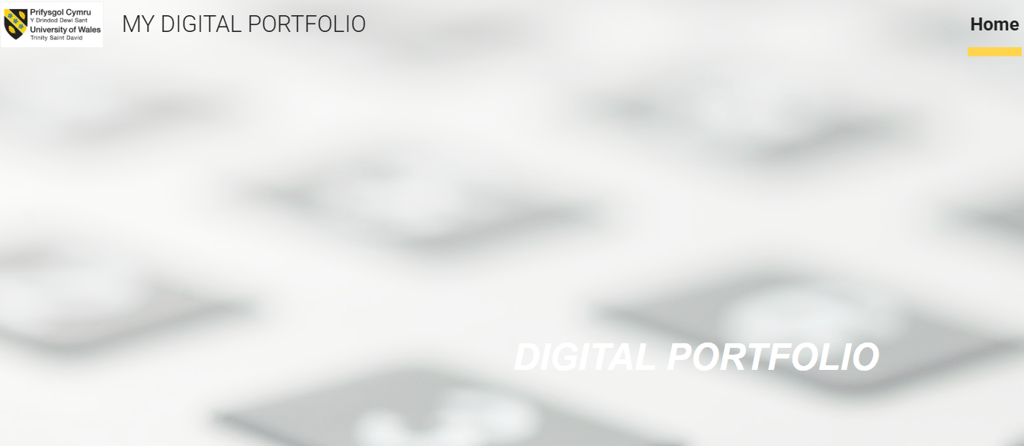
Figure 1 Home page image of my e-portfolio

Task 1 – Written summary:
Below is the screenshot/s of the task 1 answers in the e-portfolio.
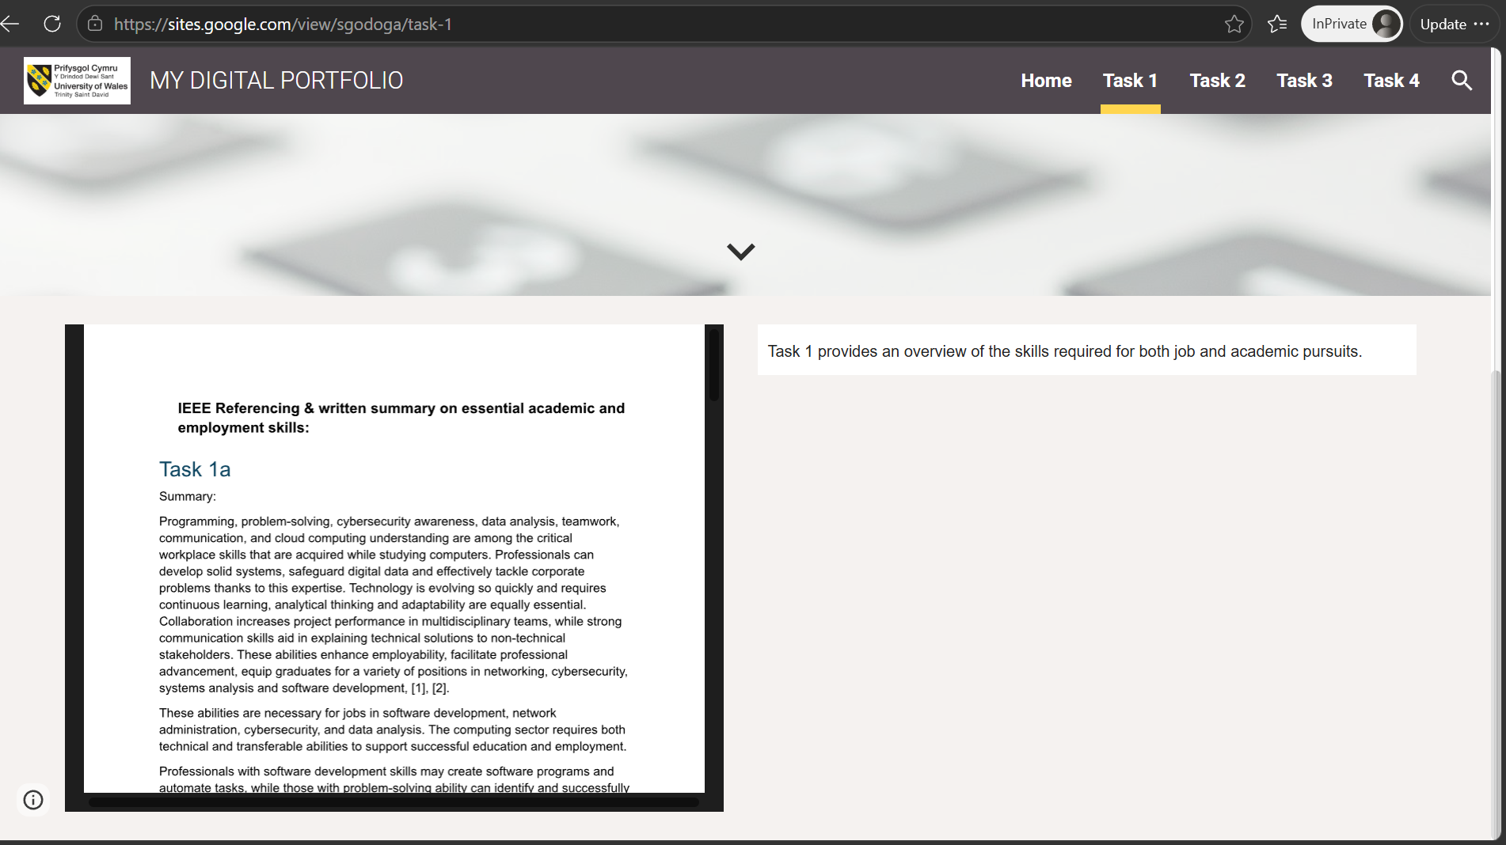
Figure 2 is a description image of Task1

Task 2 – Mind Map & Academic poster:
1. Below is the screenshot of the Mind-map with a link to view it online.
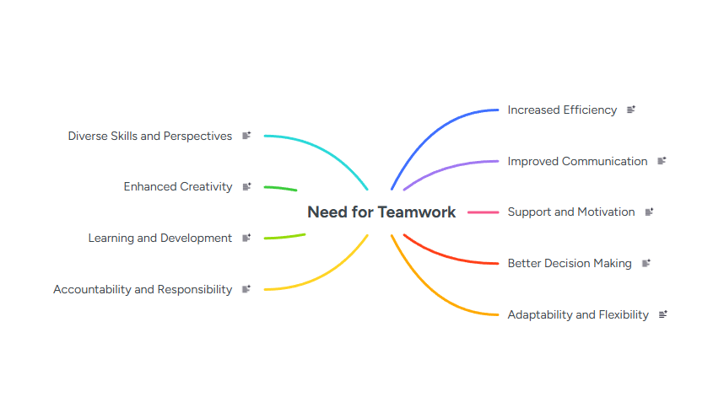
Figure 3 the mind map serves as an example of the necessity of teamwork..

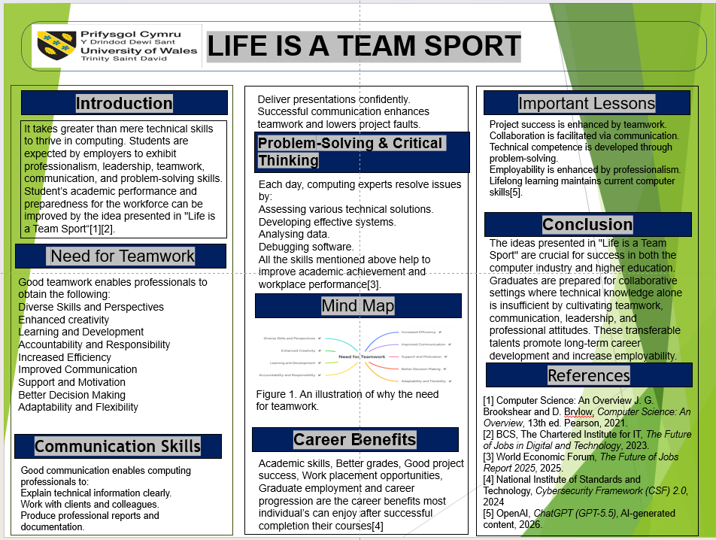
2. The academic poster's screenshot and a link to view or download it from cloud storage are shown below.
Figure 4 An image of Academic Poster.

Task 3 Automatic Referencing tool:
Below is the screenshot of task3 answer in the e-portfolio.
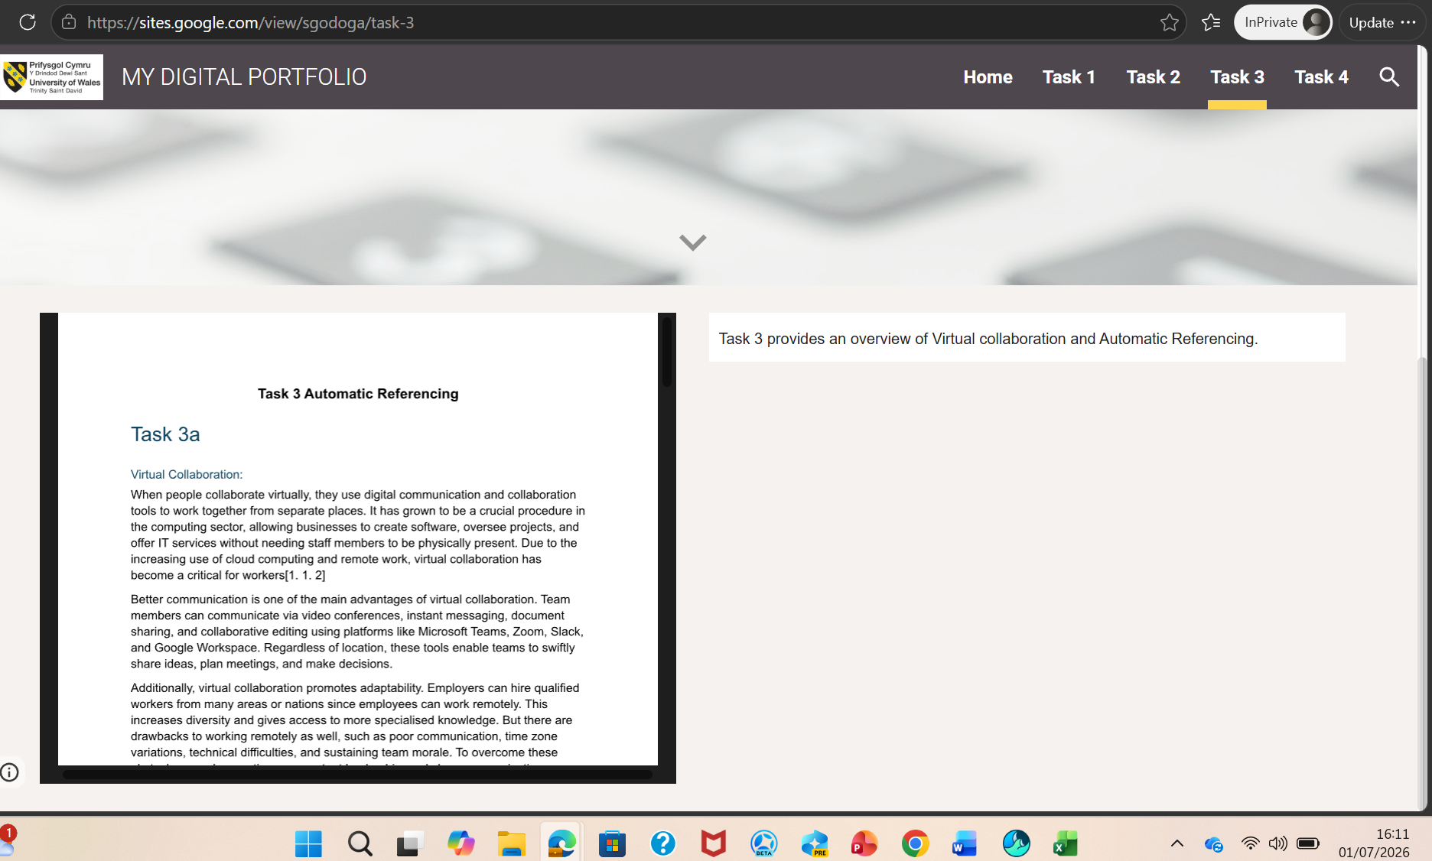
Figure 5 is a description image of Task3.

Task 4 E-Portfolio creation and review:
The pages of each task in my e-portfolio are shown in the screenshots below.
Figure 6 An image of home page of my e-portfolio.

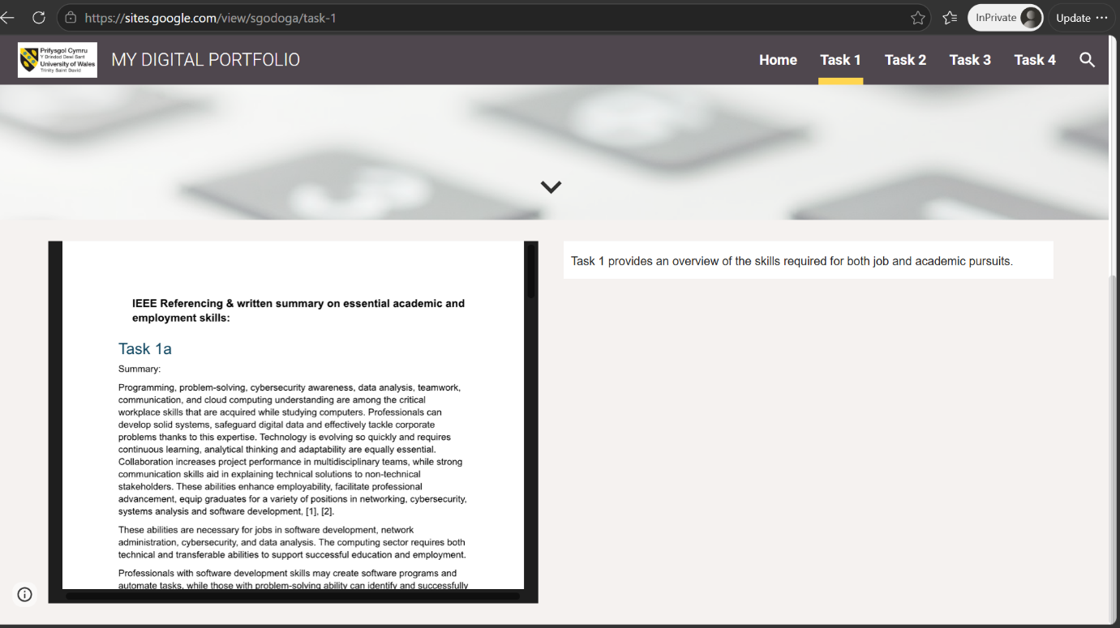
Figure 7 An image of Task 1 page of my e-portfolio.

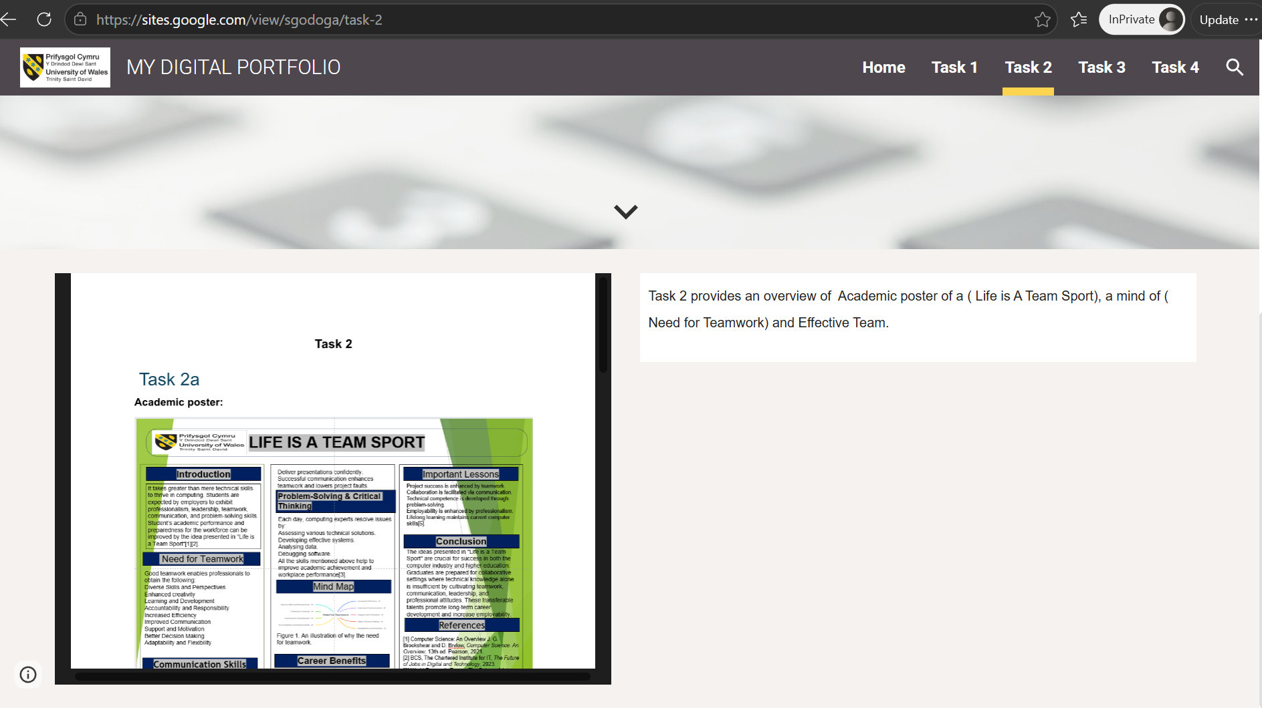
Figure 8 An image of Task 2 page of my e-portfolio.

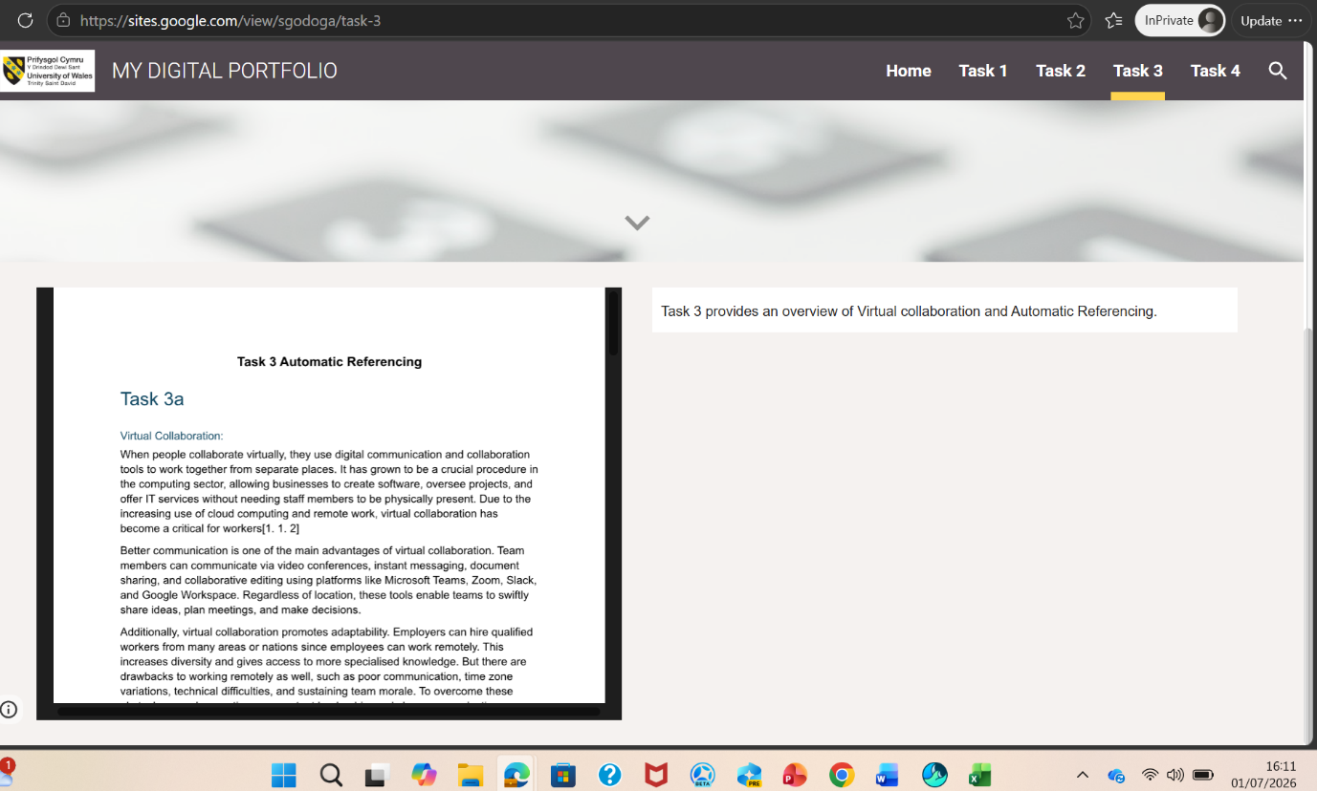
Figure 9 An image of Task 4 page of my e-portfolio.

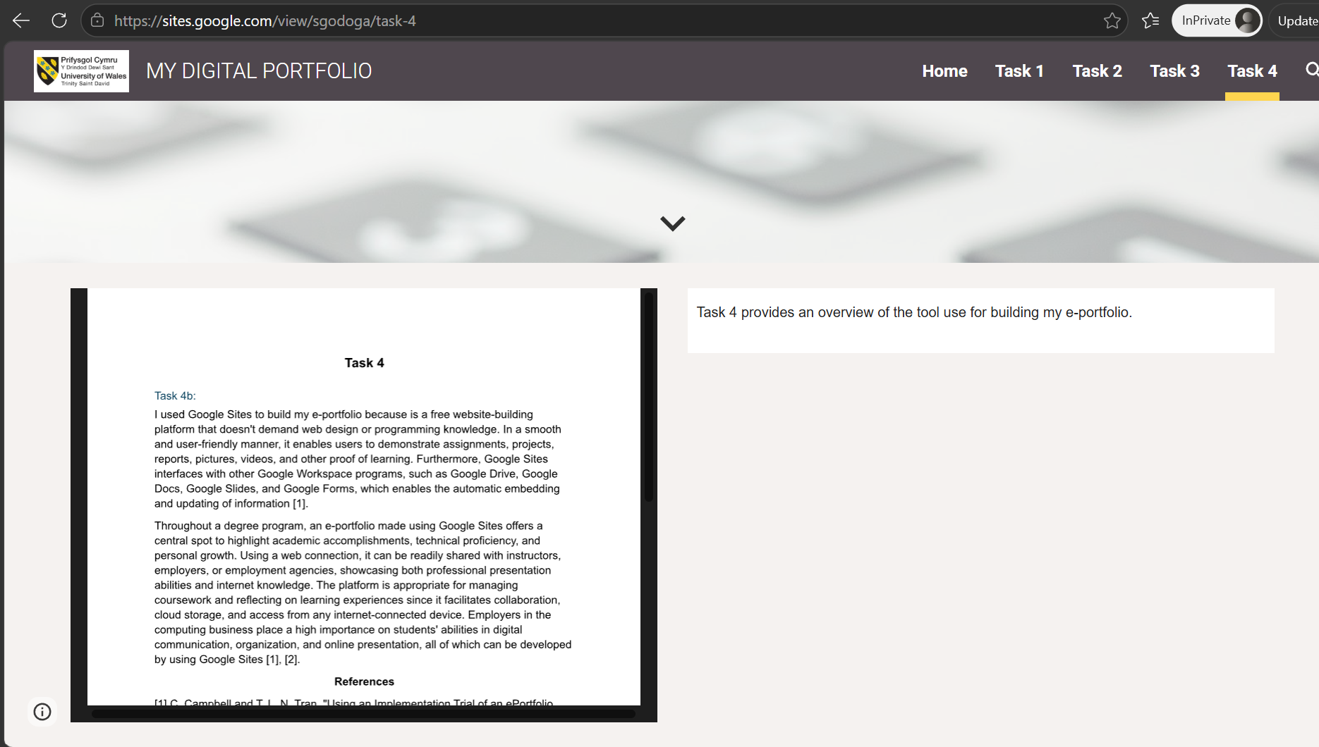
Figure 10 An image of Task 4 page of my e-portfolio.

