
Module: | Academic and employability skills
Modul code: | BMSW4001_BIRM
Student name: | Hristina Bufi
Student ID number: | 2121309
Lecturer: | Doreen Nyaa Amundam

Table of Contents
1.Intruduction 2
2. experience from writing my task 1 (my first report) 4
2.1deskription 4
2.2 filing 4
2.3evaluation and analysis 4
2.4 conclusion 4
2.5action plan 4
3. Experience from working as a group on week 8 activity. 5
2.1deskription 5
2.2 filing 6
2.3evaluation 6
2.4analysis 6
2.5 conclusion 6
2.6action plan 6
4. Analysis 7
4.1GROW 7
4.2 SHOT 8
5 Personal Development Plan 8
5.Conclusion 10
6. Reference list 11

1.Intruduction

This reflective report is intended to analyse my own experience throughout the learning process and how this experience have affected my own confidence and ability to learn, manage, motive and succeed in each individual task. The learning process has been exceptional and the skills I have developed will stay with me in my long-term development and my future. Within this report I will use two different methods to describe my experience and identify areas I need to work to improve my skills, which are Grow and Shot.

For the purpose of this report and identifying various reflective report references, I have researched number of different reports including Driscoll's model, Kolb's experience learning cycle and Bottomley.

-era model

Experience

Action reflection
By Jasper (2013)

- Driscoll’s model- Driscoll (2007) present that model only whit 3 questions WHAT? SO WHAT? NAW WHAT?
- Kolb’s experiential learning cycle- the are four stages which Kolb’s (1984) explain to as:

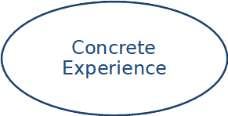
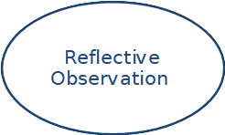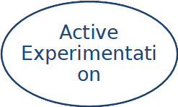
They are described from Bassot (2020).
Having the opportunity to analyse my first report in Task 1 and moving on with the experience and learning process to Task 8, I concluded that I will use the most common method based on Bottomley et al. (2019, p.23)

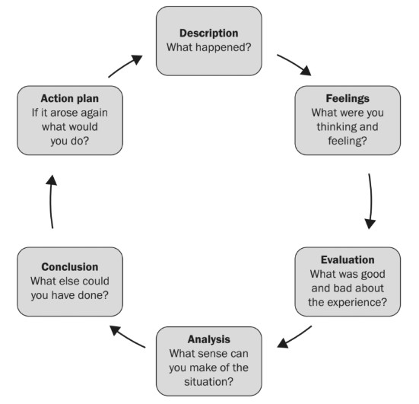
Bottomley et al. (2019, p.23)

2. experience from writing my task 1 (my first report)

2.1deskription
This was the first report on the topic of ‘What is the most effective way to motivate staff?’. I had no idea how to start it, so I started reading and researching everything related to the topic. I referred back to the lectures, watched similar reports, read the books of recommendation given to us by the university. It took long time before I wrote my first draft. Since I wasn't sure, I asked a friend who already had experience. Her recommendation was to add only table of content, everything else was ready and compliant with the requirements. But then a problem arose in front of me: My MS word settings were not fixed, and I could not enter the content. I was looking for another way to do it and decided to open it from another computer where its settings can only enter my content. The second issue I had experienced was that when I opened my initial document on another laptop, it turned out that my report was linked to another user on the tool bar. I felt very anxious, but later realized that this is irrelevant as the MS word will always display the details of the account and not the author of the report.

2.2 filing
After I finished the report, I submitted it, and I was very proud of myself that I finally succeeded. The feedback I received from the lecturer was that I did not comply with the given points and the introduction should be short and precise, there were also a lot of unnecessary information that is not on the topic. I was very upset then, but I still didn't give up

2.3evaluation and analysis
Following the initial feedback, I practiced academically writing and learned how to structure a report. I also learned to make research and write references list. For this element I still need a lot of practice. But just the stress of the unknown is great, it takes a long time to achieve a good result. If people have desired every time, they will find the way to do it. I have desire and I did it.

2.4 conclusion
The is very good expirees of academic reading and writing. For our own good, never give up no matter what the problems are, they can always be solved. There is always a result of our work.

2.5action plan
If I have to do it again, I will follow the same process, but this time I will make sure the feedback is better to do it again, I will do the same, but I will get my feedback and try not to have the same.

3. Experience from working as a group on week 8 activity.

2.1deskription
In week 8 we have activity involving a group of four students. We were asked to do presentation or a poster on the subject ‘‘Design a job advertisement for the job role”. Lecturers make groups in MS team where we can work online. The moment I opened my group in MS team, the discussion was in a language that I did not understand. Whereupon I asked to speak in English but at that moment one of the colleagues disconnected from the meeting. Eventually, I realized that they had already arranged for him to make the presentation. As a result of the conversation, I understood that the other colleagues could not work with PowerPoint. But as I am aware of the program, I suggested that we can work together, and the nominated student to do the presentation should look at it later. Whereupon they agreed, I opened the PowerPoint, made a slide and shared with them, so that we could all work together. Everyone added their opinion to each slide, then we discussed and chose the most appropriate one. I created a group in WhatsApp so we can communicate at any time if anyone has any new idea to share, which we used on the day of the presentation to find out who and when will present and to discuss feedback for other groups. Each group evaluates the other groups, although the evaluations were not very real, each group had to record their feedback. Here is ours:
Group number -2

For each skill listed, award the group  1 – 5 points | Skill/Score | 1 | 2 | 3 | 4 | 5
For each skill listed, award the group  1 – 5 points | Organisation of job advertisement | 5 | 3 | 4 | 4 | 5
For each skill listed, award the group  1 – 5 points | Working as a team | 5 | 3 | 4 | 5 | 5
For each skill listed, award the group  1 – 5 points | Public speaking | 5 | 3 | 5 | 4 | 4
For each skill listed, award the group  1 – 5 points | Professionalism | 5 | 3 | 5 | 5 | 5
Total score =

As per the results, we have achieved the highest grade for ‘Professionalism’. Although this a great result, I feel in a way that the teamwork has not necessarily demonstrated the highest professionalism and there is a field to improve. We also achieved the highest grade for public speaking, but we were all very nervous during the presentation and thought that we could have done it better.
In terms of the actual context of the advert, I believe that including specific benefits to the advert, made it look more favourable by the candidates.

As mentioned above, assessments were not real, but I think our teamwork was very good. Although we were all very worried, we performed at a pretty good level. Our grades were some of the highest. Even the lecturer provided us with great feedback for the presentation. The colleagues from my group provided their feedback of the process of doing the presentation, and they were all really happy how we achieved good results and worked as a team.

2.2 filing
Although I was a little upset by the fact that I was isolated at the beginning, I managed to impose my opinion to work in a group because I like to be a on the front line and organize things.
I was very proud of myself especially after the good grades we received from the lecturer and the groups.

2.3evaluation
The challenges with this activity were that despite all the work we did during the lecture, our colleague who left the group decided that he would rework the whole presentation. But the good thing was that he changed only the design and not the whole idea.

2.4analysis
It is not easy to work in a group, especially when everyone is pretending to know better than the others. Also, when there is more than one holder or when the head of the group does not know what it is about and does not know how to organize things. But in the end, that's why we are a group to help and support each other, and to cover the shortcomings of others.

2.5 conclusion
Everything I could I did to working in a group and offered the best and most attractive job position and many times I imposed my opinion.

2.6action plan
If I need to work again at group, I am hoping that others will respect me more on first instance. If this is not the case, I am sure I can make people respecting me.

4. Analysis
I will show you two types of analysis of my work using the two mentioned analysis in the ‘Introduction’ section of this report to demonstrate my experience.
4.1GROW analysis by Whitmore (2009)

G | OAL  - To learn to express and to write academically  - To improve my communication with people  - To paraphrase an information
R | EALITY  - I need a lot of work to get to the level I want  - I need more reading and writing reports experience  - I need more exercise in the group to improve my report writing skills
O | PTIONS  - To study at university  - to work at group  - to read more books
W | HAT TO DO  - I need to review all my options, do more research and be more talkative

4.2 SHOT analysis by Fleisher and Bensoussan (2015)

Strength’s opportunities
Sociable, quickly understands To find a better job and to develop in education and
and knows how to organize time science

THREATS
I'm afraid I don't have
weaknesses enough time to activity.
Grammar and paraphrasing

5 Personal Development Plan

Personal Target | How will I achieve this? | How will this improve my academic or employability prospects? | How will I know that I have achieved this? | When will I achieve this by?
1. write academically | more reading, writing and practice | To communicate with email | When I get the job I will like | When I get the necessary qualification
2. paraphrase an information | More writing reports | It will help me communicate better | When I start to express myself freely and they understand me more easily | I hope when I finish university
3. past all my assignments | Lots of learning | I will receive an incentive to continue studying | At the end of the school year | When I finish university

5.Conclusion
To analyse my experience from the module "Academic skills and employment skills" after the tasks that were set for me. I would say that I learned to work in a group and listen to my colleagues, which has been very difficult for me so far. I also learned how to write a report, how to do research and how to paraphrase. For me this moody ‘Academic and employability skills’ is very important for my future for my next step in my education. I feel that what I have learned so far will be good starting point for the next level of academic education. But there is still a lot to learn, and I am eager to achieve better results. By continuing with the learning process, I believe with next tasks I will perform better and better.

6. Reference list

Assot, B. (2020) The Reflective Journal, London: Red Globe Press

Bassot, B. (2020) The Reflective Journal, London: Red Globe Press

Bottomley, J., Cartney, P. and Pryjmachuk, S. (2019) Critical Thinking Skills for your Social Work Degree, New York: Critical Publishing.

Driscoll, J (2007) Practising Clinical Supervision: A reflective approach for healthcare professionals, Edinburgh: Balliere Tindall, Elsevier

Fleisher, C. and Bensoussan, B. (2015) Business and competitive analysis: effective application of new and classic methods, New York: FT Press

Gibbs, G. (1988) Learning by Doing: A guide to teaching and learning methods. Further Education Unit, Oxford: Oxford Polytechnic.

John Wiley & Sons, 20 May 2013 - Medical - 256 pages Megan Rosser, Melanie Jasper, Gail Mooney

Kolb, D (1984) Experiential Learning: Experience as the source of Learning and development, Englewood Cliffs, NJ: Prentice Hall.

Whitmore, J. (2009) Coaching for performance: GROWing human potential and purpose: the principles and practice of coaching and leadership. People skills for professionals, 4th ed., Boston: Nicholas Brealey.

