Tensile test
Engineering 1 science & Laboratory skills ACMA4033
BEng (Hons) Mechanical Engineering
BEng (Hons) Mechanical and Manufacturing Engineering
BEng (Hons) Manufacturing Systems Engineering
Lucas Kenny
2517368

Tensile tests
Table of contents
Tensile tests 2
Introduction 3
Experimental procedure 3
Results 5
Analysis 7
Conclusion 8
Evaluation 8
Further work 8
References 9

Introduction
A tensile test plays an important role in the engineering sector; it is used to determine how different materials behave when being pulled apart by a steadily increasing force. It can be used to measure several properties such as tensile strength, yield stress, strain, elongation and where the material begins to yield (yield point) along with many others. Tensile tests are important in engineering to make sure certain materials are fit to carry out the role that is expected of them and to make sure they can withstand certain forces and pressure without breaking, giving out or stretching. The aim of the assignment is to find the materials stiffness (youngs modulus) this can be found using the equation
∑= $\frac{Tensile stress}{Tensile strain}$, and then compare these using the four different materials tested. This is calculated using the gradient of the elastic region of the graph which is the region where the graph is somewhat straight until it starts to bend at the yield point at which point it reaches the plastic region where the material begins to stretch. It can also be calculated using the stress and strain equations which are
$σ=\frac{Force}{Cross sectional area}$ for stress and $ε=\frac{Change in length}{Original length}$ for strain.

Experimental procedure
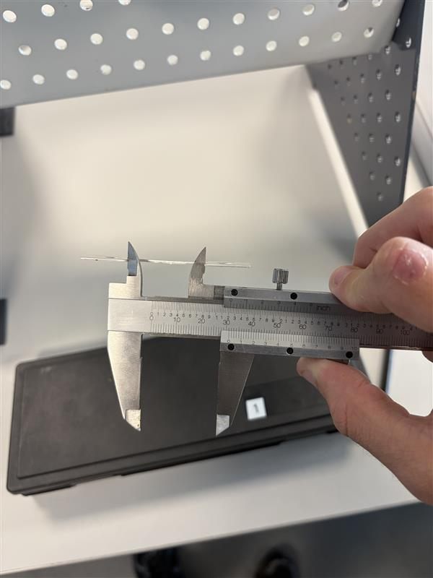
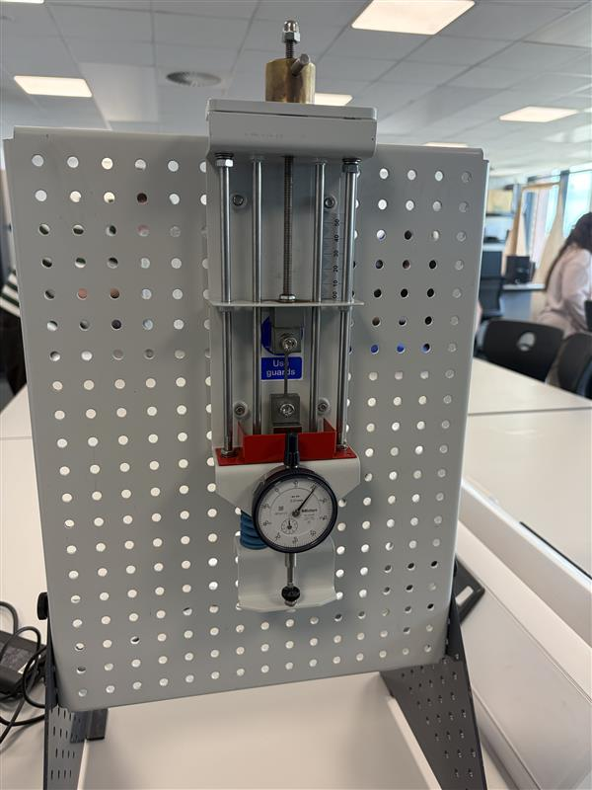
Figure 2: Vernier caliper.
Load nut

Dial indicator

Figure 1: Labelled ES6 Tensile tester complete set up.

To start this experiment firstly you will have to measure the depth and width of each sample using a vernier caliper pictured in figure 2 along with the starting length to find the extension further on. Make sure you have measured them in base units (metres) then using the depth and width of the sample calculate the cross-sectional area of the sample using the equation CSA=$Width ×Depth$. Install the first sample (steel) into the tensile tester using the two bolts and hex key provided, as shown in figure 1. Then zero the dial indicator by twisting the load nut until you see it reach zero.

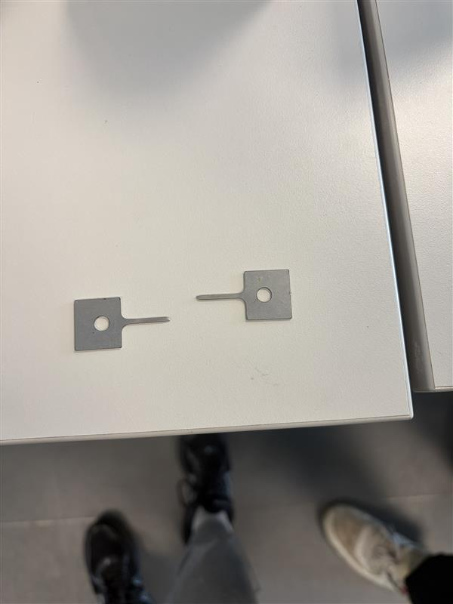
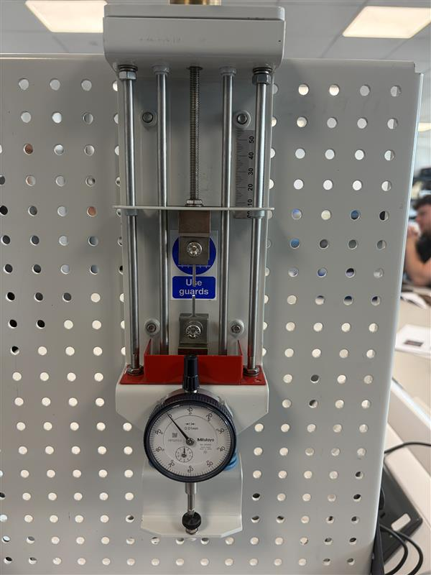

Figure 4: Fractured sample.
Figure 3: Fractured sample in tester.

Next turn the load nut incrementally using the notches each notch is 0.2mm in nut movement and every five notches is one full turn. To start of turn it in 0.2mm increments until you reach 5mm always taking readings from the dial indicator at every point and recording in a table, after you hit 5mm if the sample hasn’t fractured start doing one full turn up until 10mm at which point you will turn ten full rotations until it fractures as shown in figure 3, while taking dial indicator readings at every point measured and forming a complete table. Then take the steel sample out of the holder, put the broken pieces together and measure the final length as shown in figure 4 and take the original length away from this to find the extension of the sample. After that times each dial indicator reading by one hundred to work out the force acting at each point. Using these values, you can work out the stress and strain values at each point using the equations
$σ=\frac{Force}{Cross sectional area}$ for stress and $ε=\frac{Change in length}{Original length}$ for strain. Using your findings plot a stress (Y-axis) against strain (X-axis) graph to find the yield point which is where the graph starts to curve and the gradient of the elastic region (the straight part of the graph) to find youngs modulus (stiffness) of the material. Then repeat this process for the other 3 materials PVC, Duralumin and aluminium as shown in figure 5 below.
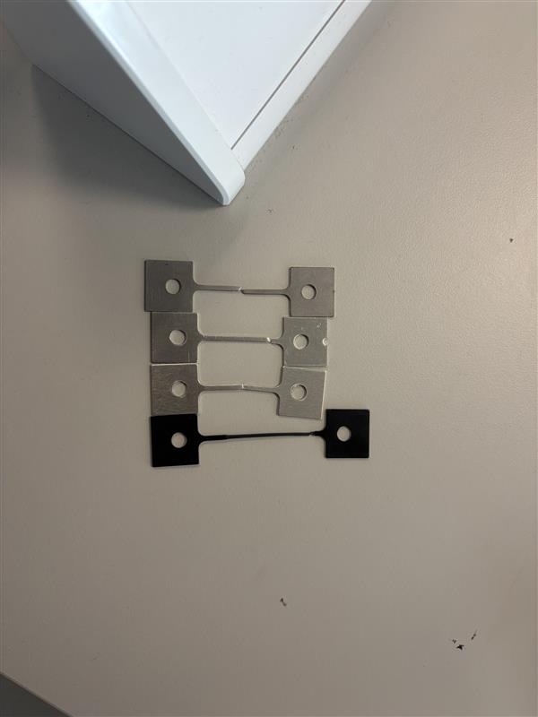
Figure 5: All samples after testing.
PVC
Duralumin
Aluminium
Steel

Results
Figure 6: A graph to show the elastic region of a stress strain graph for steel.
Table 1: A table of results from a tensile test experiment for steel.
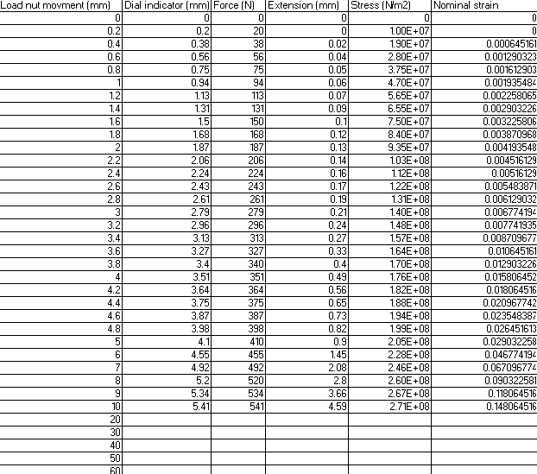

Figure 7: A graph to show youngs modulus of steel.
Plastic region

Tensile strength

Shown above in table 1 and figures 6 and 7 are the results I gathered for steel in a tensile test. The CSA of the sample is 2$×{10}^{-6} m^{2}$ and the original length for steel was 0.031m and it increased to 0.04m giving an extension of 0.009m. The tensile strength is the highest value of stress at 270.5MPa. The yield points as shown by the graph is around 160MPa and finally the gradient of the elastic region or stiffness (youngs modulus) is 18,728MPa.
Figure 8: Stress strain graph for aluminum
Table 2: A table of results from a tensile test experiment for aluminum.
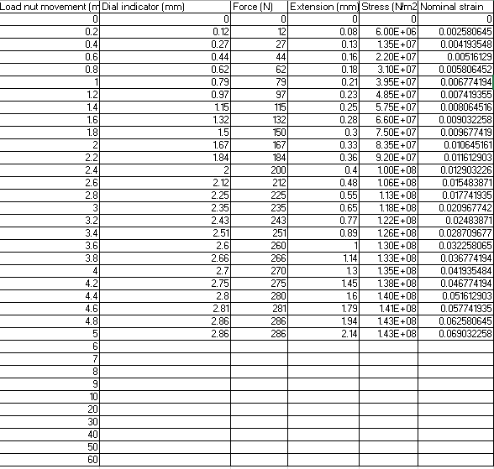
Tensile strength
Figure 9: Elastic region stress strain graph for aluminum (youngs modulus)

Shown in table 2 and figures 8 and 9 are the results for the aluminium tensile tests. The CSA of the sample is 2$×{10}^{-6} m^{2}$ and the original length for aluminium was 0.031m and it increased to 0.034m giving it an extension of 0.003m. The tensile strength is the highest value of stress at 21.143MPa. The yield points as shown by the graph is around 100MPa and finally the gradient of the elastic region or stiffness (youngs modulus) is 8882MPa.
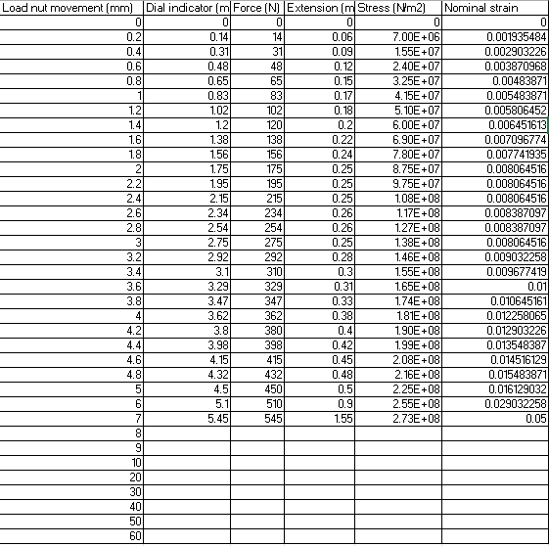
Table 3: A table of results from a tensile test experiment for Duralumin.
Figure 10: A stress strain graph for duralumin labeled.

Yield point
Tensile strength

Figure 11: A stress strain graph for only the elastic region of duralumin. (youngs modulus)

Shown in table 3 and figures 10 and 11 are the results for the duralumin tensile tests. The CSA of the sample is 2$×{10}^{-6} m^{2}$ and the original length for duralumin was 0.031m and it increased to 0.035m giving it an extension of 0.004m. The tensile strength is the highest value of stress at 272.5MPa. The yield points as shown by the graph is around 225MPa and finally the gradient of the elastic region or stiffness (youngs modulus) is 16,682MPa.

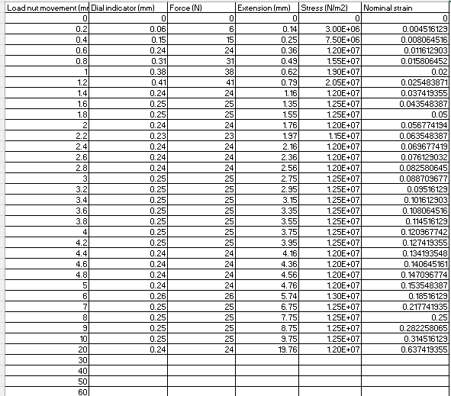
Yield point
Figure 12: A graph to show stress strain for PVC.
Table 4: A table of results from a tensile test experiment for PVC plastic.

Tensile strength
Elastic region

Figure 13: A stress strain graph for the elastic region of PVC. (youngs modulus)

Shown in table 4 and figures 12 and 13 are the results for the PVC tensile tests which are more varied than the others. The CSA of the sample is 2$×{10}^{-6} m^{2}$ and the original length for PVC was 0.031m and it increased to 0.052m giving it an extension of 0.021m. The tensile strength is the highest value of stress at 20.5MPa. The yield points as shown by the graph is around 20.5MPa and finally the gradient of the elastic region or stiffness (youngs modulus) is 871.21MPa.

Analysis
The specimens originally showed elastic behaviour, where the deformation was temporary and proportional to the load, Once the yield point was reached plastic deformation occurred where the material could not return to original shape until eventually it fractured. To find these results, you need to use the equations Force= Dial reading$×100$ and Extension=Load movement – Dial reading as well as the stress strain and youngs modulus equations that have already been mentioned. The strongest material based on tensile strength is duralumin with a tensile strength of 272.5MPa however this is inaccurate as based on a source written in 2021 duralumin should have a tensile strength of around 400MPa whereas steel should have around 700MPa depending on the grade and treatment. The temperature was also 24 degrees Celsius which is slightly warmer and could be the reason for this discrepancy. By far the most ductile material was the PVC plastic as shown in figure 12 it can last the longest after the yield point in the plastic region before its fracture compared to duralumin which could only hold 95N more before it fractured this is accurate based on other people’s findings. The stiffest material as shown in figure 7 is steel, steel has the highest gradient of its elastic region which then translates to youngs modulus of the material, which is 18,728MPa this is inaccurate as the youngs modulus of steel is said to be around 180,000Mpa according to multiple sources. The least stiff material is PVC with a stiffness of 871.21 MPa which is inaccurate as the stiffness at 20 degrees Celsius is 52MPa, however our temperature was 24 degrees Celsius so this could be the reason for the fluctuation in results. Aluminium and duralumin had a similar shaped curve as duralumin is an aluminium alloy however duralumin was much stronger based on tensile strength (272.5MPa) and had almost double the stiffness of aluminium (16,682MPa). Which is accurate in theory, but the numbers are much different as the stiffness of duralumin is 76,000MPa compared to aluminium at 69,000MPa and the tensile strength of duralumin 520MPa compared to 70MPa of aluminium. PVC behaved differently to the metals as it showed greater elongation before failure, PVC continued stretching whereas the metal samples showed more clear elastic and plastic regions.

Conclusion
In this experiment you must find the yield stress, tensile strength and percentage elongation for steel, aluminium, duralumin and PVC plastic the percentage elongations were 29.0323%, 9.6774%, 12.9032% and 67.7419% respectively. The yield stress and tensile strength vary from other published values this could be for a number of reasons for example our temperature was 24 degrees Celsius, but many other tests are taken at 20 this higher temperature could soften the materials and give them lower values for stress and strength which is what I found to be the case. They could have also been a different metal grade from the online values and been treated differently therefore changing the values for stress and tensile strength.

Evaluation
There were many sources of error involves in this experiment as it was completely down to the person taking the experiment these include reading error on the dial which could be common as it moves after turning, misalignment of sample in the tester and inaccurate measurements of the sample as we used a vernier calliper instead of a digital one with a lower resolution. To resolve these errors, we could use a digital calliper for measuring, carefully zero the tester and take repeat readings to find an average and eliminate any outliers.

Further work
To improve the test next time, I would change several things. Firstly, I would control the temperature to make sure its constantly 20 degrees Celsius, to compare the strength and stiffness to the online values and re look at the accuracy of the experiment. I would also take repeat readings of each sample so I could find an average and eliminate any outliers in the test. I would also use a different digital measuring system to make my results more accurate and avoid different people’s interpretation of what they are reading.

References
Chen, Z., Gandhi, U., Lee, J. and Wagoner, R.H. (2016). Variation and consistency of Young’s modulus in steel. Journal of Materials Processing Technology, [online] 227, pp.227–243. doi:https://doi.org/10.1016/j.jmatprotec.2015.08.024.
Cheng, D.C-H. (1986). Yield stress: A time-dependent property and how to measure it. Rheologica Acta, 25(5), pp.542–554. doi:https://doi.org/10.1007/bf01774406.
Gdoutos, E. and Konsta-Gdoutos, M. (2024). Tensile Testing. Solid mechanics and its applications (Print), 275, pp.1–34. doi:https://doi.org/10.1007/978-3-031-45990-0_1.
Helmenstine, A. (2022). Young’s Modulus Formula and Example. [online] Science Notes and Projects. Available at: https://sciencenotes.org/youngs-modulus-formula-and-example/.
Sreenivasa Rao, M., Nayeem, S., Sasi Kiran, N.V.S.G., Gowthami, K. and Krishnaraj, J. (2024). An examination and characterization study of the aluminum alloy Duralumin (AA2014). Journal of Physics: Conference Series, 2837(1), p.012086. doi:https://doi.org/10.1088/1742-6596/2837/1/012086.

