UNIVERSITY OF WALES: TRINITY SAINT DAVID

MARKETING FUNDAMENTALS ANALYSIS AND EVALUATION
LCBB4004

Module Coordinator/Lecturer: Tushara Balendran

Student Name: VALENTINA SIMONA DUROIU
Student ID: 2021942

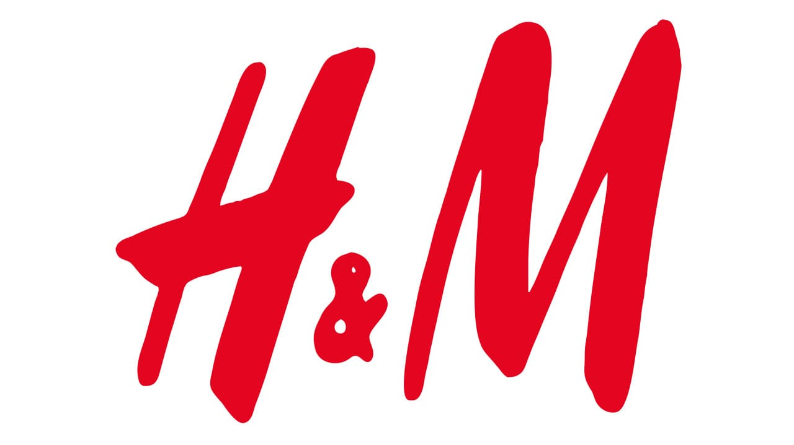

Processes and stages of marketing including the role of the marketing mix
Definition of Marketing
Marketing defines the activity, several institutions and the processes for forming, communicating, exchanging and delivering offerings that possess value for clients, customers, business partners, organizers and society at large (Karayev, 2020). Therefore, marketing includes the process of advertising, selling as well as delivering the products and services to the consumers and drawing the customer's attention in return.
Definition of Marketing Process
The marketing process signifies various steps which offer an organization to identify and assess the customer's problem, explore market opportunities and forming marketing resources to reach the desired consumer (Hope, 2018). In order to conduct a marketing process, the first step is to highlight the vision and mission statement of a company, next, to conduct SWOT, PESTLE analysis, create a marketing strategy and lastly formation of the “marketing mix”.
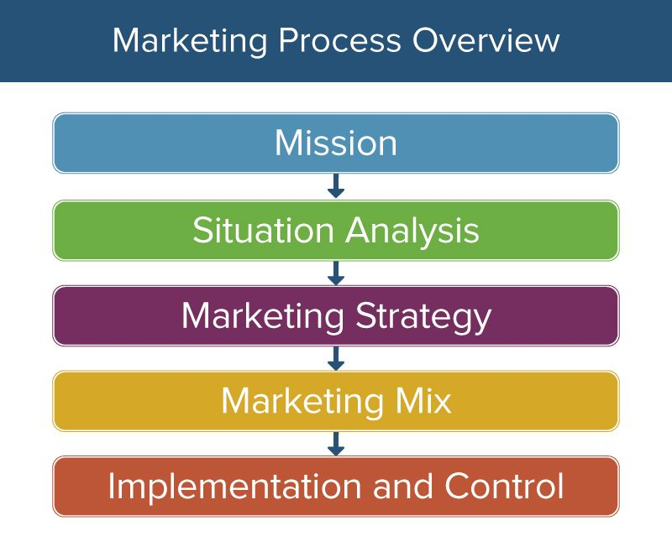
(Source: Hope, 2018)

The mission statement of the company
The mission that is provided by this company to its customers is to provide the best quality of products and goods at the best or reasonable prices. The quality of the products that are provided to the customers by this company has also maintained the effectiveness of the product and sometimes it has exceeded the quality of the product from its best (Hmgroup.com, 2021). On the other hand, in order to meet the expectation of the consumers, H&M implement the strategies in order to provide the customers with more innovative products which improve the living standard and living style of the people.
The situational analysis of the company
H&M includes the factors which impact both the aspect in the macro environment and on the microenvironment. These factors impacts and influences the business in both positive as well as in a negative way (Jiang, 2020). The external factors or the macro environment signifies all the factors like the political background, the economic, social, technological, and legal and environment background. On the other hand, the microenvironment includes the strength, weakness, opportunity and threats of the companies. The microenvironment is the internal factors of the company, based on which the profit and loss of the company depend.
The objectives
The company which it has opted like for the next 30years or within the next 30 years all the brands which are collaborated and are working under the company H&M are implementing the strategies in such a way that they can recycle the products and can increase the sustainability of the product based on the materials those are used for the manufacturization of the goods.
The strategy
It is implemented by this company, is to provide the best products at a reasonable price (Su, 2020). This company always tries to provide the best quality product at a lower price, maintaining the brand value this company always tries to avail this opportunity for the customers or the consumers.


( Source : drapersonline.com)

The implementation and control
The company H&M is that to implement the strategy regarding the marketing so that the profit percentage can be increased (Tsutskiridze and Mammadov, 2017). As well as, to increase the connectivity and networking throughout all the place of the world. The more this company will enhance its business the more the company will increase the profit percentage. Moreover, this company has also collaborated with the other companies which have also good brand values. Hence, collaborating with the other companies helps the customer to choose among the variant product and hence this company can mitigation the expectations of the company.

Pestle Analysis of H&M
ELEMENTS | FACTORS | ANALYSIS
POLITICAL | - De-globalization across the world  - The influence of Brexit in the political scenario  - The worker's demand for fair opportunities and increased wages (Karunakaran, and Raveendran, 2018). | The production cost of goods are being increased  The De-globalization can be turn out to be unfavourable because if the cost of production increases then the prices of the goods and items will be also increased (Xuejie, Chang and GuangHao, 2019). As a result, it can decrease the rate of sales along with the productivity of the company.  The customers can search for an alternative option for reasonable shopping  Due to the impact of Brexit, strict guidelines are imposed on H&M.
ECONOMIC | - Increased rate of disposable income  - Corporate tax policy  - The impact of labor law. | The labour law turns out to be favourable in nature for the company H&M. Due to the low labour rate, the manufacturing setting of H&M is profitable, the increase of disposable income increases the demand for luxurious items, H&M has to abide by the corporate tax policy.
SOCIAL | - Influence of social media  - Strong affinity with a brand image (Jarek, and Mazurek, 2019). | The influences from the social media are favourable for this company. The promotion of products and services through social media helps to address the changing preferences of customers.
TECHNOLOGICAL | - The trend of online shopping  - Developments in logistics. | People order through a mobile application, the changing behaviour and technological development of H&M, collaboration with Hermes, logistic partner with advanced logistics (Karunakaran, and Raveendran, 2018). Hence, the technological influences turn out to be favourable.
LEGAL | - Intellectual Property Rights  - Compliance with regulatory policies  - Collaboration with franchising partners. | The H&M of UK has to collaborate with other franchising partners of Oman, Kuwait and so on. The innovative design of the company should be protected with the Intellectual Property Law, a legal dispute about infringement with a clothing retailer.  As a result, the legal factors are favourable for this company.
ENVIRONMENTAL | - There are certain government norms to reduce pollution  - The company needs to use eco-friendly and renewable resources (Liu, 2017). | Usage of recycled cloth for production, all clothing materials should be generated from the old firm and must be durable.
Table 1: Pestle Analysis
(Source: Created by the researcher)

Porter’s Five Forces Theory
Porter's Five Forces Theory is a strategic analysis through which a company's competitive position is analyzed and this theory helps to determine the underlying power within a company. The five forces of Porter are:
- Supplier’s power.
- Buyer’s power.
- Competitive rivalry.
- The threat of substitution.
- The threat of new entrants.
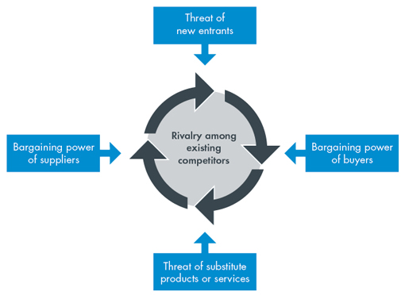
(Source: (Bruijl, 2018)
Porter’s model is also useful to assess and identify the current trends and strategies which will assess its market growth. With this model H&M’s current competition can be assessed:
Supplier’s Power
- Numerous suppliers according to the geographic locations.
- Buying raw materials at a comparatively lower cost (Bruijl, 2018)
- Strengthening of the supply chain management.
- Cost-effective plan.
The power of the suppliers is low in certain as many suppliers are present within a specific location.
Buyer’s Power
- Formulation of unique strategy and quality products, H&M will focus to establish a strong brand image, customer loyalty.
- Creation of better marketing strategies, the customer base is improved.
- With low-cost production as well as lesser selling cost, the company can attract low-income customers (Liu, 2017)
The powers of the buyer are high as they can enhance the productivity as well as the rate of profitability.

(Source: mod-tv.com)

The threat of New Entrants
- Cost-effective business plan of H&M.
- With the unique process of product development and marketing strategy, the company can retain the previous as well as new customers (Nguyen, 2018).
The threats of the new entrants are also high as it can grab the place in the global market with better implementing strategies and growth policies.

Threat of substitution
- Providing quality products at a reasonable price.
- A wide range of products.
As nowadays, the usage of the substitution is increasing day by day result in decreasing the sales and the rate of profit of the specific companies. Hence, the threats are high.
Competitive rivalry
- Development of marketing research and techniques through which the company target a set of new customers.
- Understanding of the marketing situation.
- Prevention of overproduction.
- Good quality services and products at an affordable cost.
The threats competitive nature of market is also high. Therefore, it provide benefit in some certain areas and also pose threat to some extent.

SWOT Analysis of H&M
Strengths  - Universal acknowledgement and strong brand image.  - Enhanced customer satisfaction (Stindtet al., 2017)  - Consistent and stable financial situation.  - Affordable price and quality product and services. | Weaknesses  - The design can be replicated easily.  - Increase in unsold inventory.  - Ineffective response to the customer’s changing preferences.  - Insensitive promotions and failing of mall strategies. | Opportunities  - Increased demand and popularity of online stores.  - Global market value and presence.  - Increased purchase of customers across the world. | Threats  - Transformation in global dynamics.  - Threats from the small and medium-sized competitors.  - The continuous requirement for innovation and uniqueness with the latest market trends.
Table 2: SWOT Analysis of H&M.
(Source: Created by the researcher)

The relation of Porters Five Forces and SWOT Analysis of H&M
Porter's five forces and the SWOT analysis of a company offer a broader view and insight into the organizational faults and strengths. The SWOT analysis can determine the strengths, weaknesses, opportunities and threats of an organization whereas porter’s five forces predict the effect of outward factors on the internal structure and system of a company. From the above SWOT analysis and Porter's five forces theory, the internal as well as outer factors give an insight into the organizational scope as well as shortcomings (Nguyen, 2018). The bargaining power of supplier, buyer, and the threat of new entrants, substitution and competitive rivalry all determine the strategies and measures through which H&M can control its competitor's advantage and the scope of the improvement is assessed. On the other hand, the SWOT analysis decides the internal factors based on which H&M can enhance its advantageous grounds and at the same time can prevent its weaknesses and threats.

Advantages and disadvantages of Porter’s Five Forces
- The company can understand the factors which can affect organizational profitability.
- It can improve the decision-making process (Verdenhofaet al., 2018)
- The model can help to build up business strategies effectively.
Disadvantages
- The model ignores the importance of rivalry among firms in an industrial setting.
- The bargaining power of the supplier indicates the weak market force.
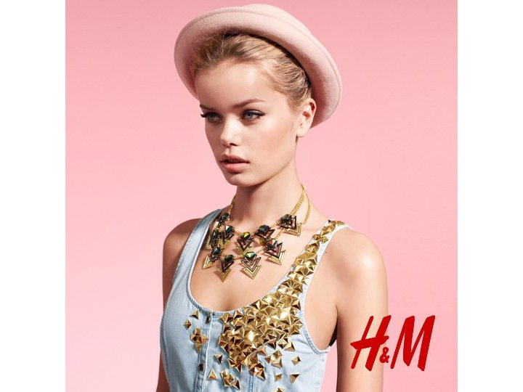
(Source: fashionart.patriciareport.nl)
Segmentation, targeting and positioning strategies of H&M
In case of segmentation used by the company H&M, it is often noticed the taglines used by this company “fast fashion” and “fashion at the best price”. The process of segmentation is mainly used in order to divide the market targeted into smaller sections or pieces. Moreover, the taglines are used by this company in such a way that it can attract the customer focusing with different objective (Javed et al., 2020). The objectives are based on the needs, wants and demands, that they can suit themselves with any of the product that are available in the store.
The company H&M mainly target the woman who belongs from the lower-middle class as well as the working class. On the other hand, it also targets the younger woman. In order to increases the sales and marketing of the products and goods this company mainly targets the younger people. Since, the millennial people get more attached towards new fashion this company is used them for the target market in order increase the sales and promotion of the brand.
Positioning the strategies of H&M
The strategies used by this company are enlisted below-
Beliefs and values – This company maintain a stationary position with the clothing and styling trends of the people that are mostly followed all around the world. As a result, H&M has created a bond of trust and loyalty with the customers.
Attitude of the customers regarding the shopping style or policy – In some cases it is noticed the target market remain constant with the brand. As a result, they do not change or try new things.
The current marketing mix strategies of H&M
Product – This company mainly aims or focus on the brands, goods and items that are trending in the market. On the other hand, the cost of the product is also maintained. Moreover, the goods which are newly launched with pocket-friendly price are also stocked by this company.
Price – In order to maintain the pricing of the goods and product this company keeps a huge amount of stock under offers. Moreover, the strategy that is used by the company is completely different from that of the others. H&M keeps a larger stock under offer in order to increase the sales and productivity, therefore the increase of sales would provide a larger revenue.
Place – The outlet of this company is mostly favourable for the people as they get many items or product within the shop (Arrigo, 2018). Moreover, the price range of the products are minimal as well as pocket-friendly. As a result, customers are more attracted to this brand rather than the others.
Promotion – The advertisement and promotion of the product of the goods and items that are manufactured by the company H&M are often noticed that they focus on the price and on the quality of the product.
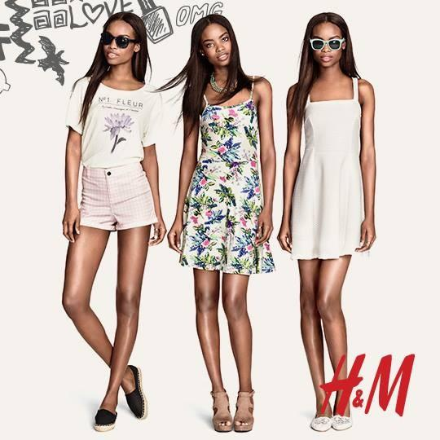
( Source: myfacehunter.com)
Conclusion
The entire report is focus on the analytical implementation considered by the company in order evaluate the threats and challenges prevailed by this company. On the other hand, the impact and the influence of the external environmental factors over the company. On the basis of the external factor the condition is also analysed that can be turn out to be favourable as well as unfavourable.



(Source: fashionfav.com)

Recommendation
As the market competition are increasing day by day the market strategies should be changed and implemented in order to reduce the threat from the competition. On the other hand, the product or the items that are manufactured by this company should be innovative as well as idealistic so that it can not replaced by any other substitute.

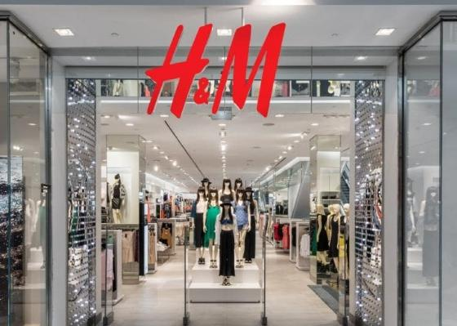
(Source: fashiongonerogue.com)

References
Arrigo, E., 2018. The key role of retail stores in fast fashion companies: The H&M case study. In Contemporary Case Studies on Fashion Production, Marketing and Operations (pp. 121-137). Springer, Singapore.
Hmgroup.com, 2021. Vision and Strategy - H&M Group. [online] H&M Group. Available at: <https://hmgroup.com/sustainability/leading-the-change/vision-and-strategy/> [Accessed 17 April 2021].
Javed, T., Yang, J., Gilal, W.G. and Gilal, N.G., 2020. The sustainability claims' impact on the consumer's green perception and behavioral intention: A case study of H&M. Advances in Management and Applied Economics, 10(2), pp.1-22.
Xuejie, C., Chang, Q. and GuangHao, Z., 2019, August. Research on Innovation supply chain Management in Fast Fashion Industry——A comparative analysis of ZARA and H&M. In 2019 3rd International Conference on Education, Culture and Social Development (ICECSD 2019) (pp. 7-16). Atlantis Press.

