Understanding Culture and Change: Admiral

EXECUTIVE SUMMARY
Admiral is a well known insurance company in the UK. This report has discussed the work culture and behaviour within the organisation. The findings show that Admiral shows a good working culture though their employees say otherwise.

Contents

INTRODUCTION

The paper will be analysing admiral workplace culture using the Cultural Web .

Admiral Group is one of the largest insurance providers in the UK. With business all over in eight countries. It was launched in 1993 Admiral ‘s Aim is to give great value for money to as many people as possible. Admiral’s Slogan is “people who like what they do , do it better”. They are proud to offer an open culture that values equality and most all , they make work enjoyable.
In the recent months, there has been a global crisis which has affected everyone in different ways. The Corona virus also referred to COVID19 has affected a lot of business not only financially but in ways that business have had to consider their working structure and environment.

Using the Pestle model. This report identifies several exeternal factors that has affected the chosen company; Admiral. They are;

The author has identified external factors affecting the company at the moment using the pestle model.

- Due to the economic crisis Admiral has committed over £190million as coronavirus response.
- Due to the new regulations implemented by the government, more customers have recently cancelled their insurances to save money. More people figured it was cheaper for the to cancel their policies since they had nowhere to drive to.
- The government legislation imposed new guidelines on working environment, therefore, the organisation were forced to send their employees to work remotely from home. This of course, caused a strain on Admiral as they were forced to create new resources and come up with quick solutions to work around the COVID19 and ways for their employees to work. For instance, they needed to update and provide technology, invest on protection gear such as masks and sanitizers.
Having less staff in the office to deal with mail urgent matters which has slowed their operations.

The Author has analysed the workplace culture Web . Focusing on the six elements . The stories, Ritual and routines , organisational structure, control system , and power structures. Notably the Author has found the power structures , famous symbol , and Organizational struture has played a pivotal role in the success of the organisation.

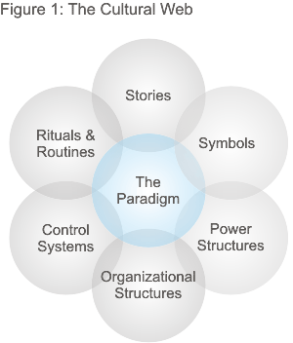

The author has analysed the organisational ethical stance including examples of ethical and unethical behaviour in the organisation. Using research from their websites and independent sources .

The Author has carried an depth analysis of the knowledge skills and behaviour of an employee who is likely to perfom well at the organisation using different models and theories including the Barret Model, Belbin model,
Gaps have been identified in the organisation culture and recommendations offered.

Findings

  - 3.1 External factor affecting Admiral
Admiral has committed £190 million towards covid –19 crisis and the global economic situation. It has managed to keep all its staff fully paid non have gone into government schemes like the furlough .

Customers wanting to cancel their home or car insurance to save money has soured causing the telephone waiting times to be up to one hour .The number of customers visiting the website has increased making the server to break down severally. In response admiral has announced that it will be refunding insurance premiums of the organisation during this period automatically.

Government regulation has meant that social distancing rules are imposed. Some staff had to work from home requiring new technological set up like broadband, headphones and computers. Staff had to adapt to new changes of working from home.

  - 3.2 Analysis of workplace Using the cultural Web.( Define)
The cultural web was developed by Gerry Johnson and Keran Scholes in 1992 they identified six distinct but interrelated elements which contributed to what they called “paradigm” equivalent to the pattern of the work environment or the values of the organisation. They suggested that each could be examined and analysed individually to gain a clearer picture of the wider cultural issue of an organisation. (Johnson and Scholes’ Cultural Web Model . )

- Stories
inspiring . Admiral was launched in January 1993 by Henry Engelhardt in Cardiff as a small start-up with zero customers and 57 members staff to one of the largest car insurance providers in the UK and now the group offers from cars to home and travel insurance with a presence in eight countries. 6.5 million worldwide customers and voted best insurance company in 2019. Additionally, staff say they enjoy working because it is a fun place to work. They state on the review pages that when you join Admiral, you are made to feel welcome. Employees feel that they are treated fairly regardless of their ethnic origins. This gives the idea that, Admiral provides a relaxed and fun work environment. This is illustrated on the awards which have been won in the recent years being named as one of the best employers. Contrary to this some employees find that the opportunity to progress within the company is very limited. Please see image below.Some of the interesting stories of admiral are impressive and
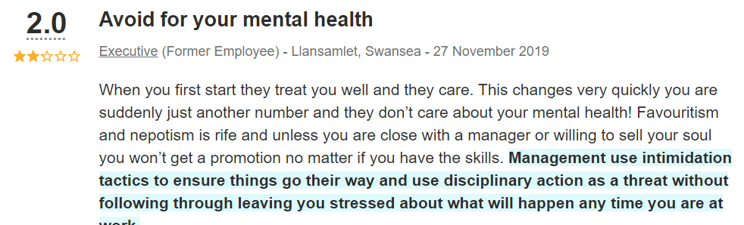

Additionally, a few have mentioned their dissatisfaction with the pay. Despite the environment being relaxed and enjoyable, it is quite clear that individuals would still prefer to have a higher pay and opportunity to progress within the company (Please see image below). The admiral website mentions sharing Shares to their employees, however it seems there much more to the surface that may be hidden. For instance, what it takes to receive the share or how long does it take before you can be considered as a shareholder.

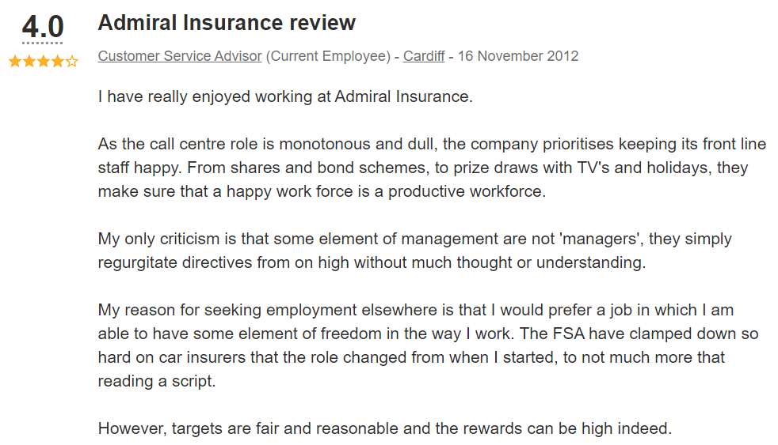

Power and Organizational Structures
structures
Admiral’s power structure is hierarchical and has a board and management team- It consist of chairman, chief executive officer, Chief Financial Officer, and a team of Non-Executive directors. They are managers in different managers and team leaders in different roles. The ultimate power controlled by the board though due to the hierarchical nature small pockets of power exist between other heads of departments managers and team leaders.

Admiral stresses on their website about the provision of a fun and relaxed working environment for their employees. This has been backed up with the reviews given from the employees ho have previously worked with the organisation. In terms of the power structure, it was quite clear that there was some form of abuse of power in the workplace. Additionally, the employees expressed their frustration and disappointment on the management in the workplace (Please see image below)

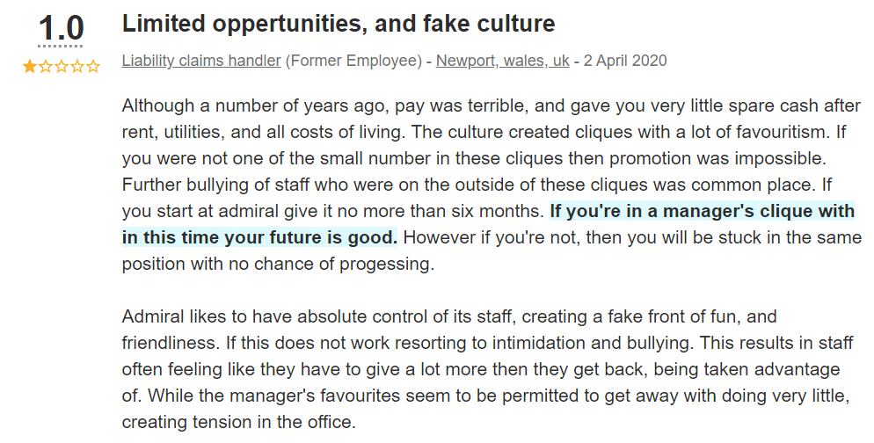

There are several reviews such as the image above, addressing the culture that may not be visible. The idea that one has to be favoured by the management team to advance within the company, demonstrates that this is one area that needs to be looked at vigorously because there is evidence that power is being abused.

Ritual and Routines
Admiral expects to have an independent ombudsman when conflict cannot be resolved in the organisation because it is regulated by the financial conduct Authority. Admiral customers expect to be valued and provided with high quality customer service. The organisation has communicated to customers to warn them of possible delays due to occur due to Covid-19 pandemic. Therefore, the customers should expect delays because the organisation has announced the issue on their website and answering machines. In addition to this, the staff expect circumstance to work in a place where they are treated fairly, and enjoy benefits, progression in their careers in addition to working hard they should be able to communicate efficiently with the management. It should be noted that this rituals and routines reflects core beliefs in Communication, Equality, Reward and recognition value of the customer and staff besides fun.

On the other hand staff expect to have difficulty parking as some of the stories in addition state staff expect to work and play hard.

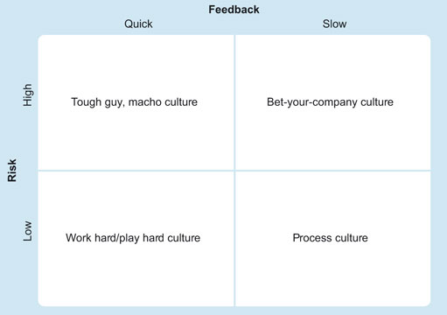

Deal and Kennedy’s model of organisational structure (Source: Deal and Kennedy, 1982, p. 107)

Organisation structure

The organisational structure is hierarchical with the board of directors at the top which consists of the Chairman, chief directors, chief executive officers and several non chief executive directors that form the board. The are also head of departments, managers and Team leaders. Admirals structure is formal is its operations for example their recruitment procedures, risk assessment, quality control and internal operations. Which are bureaucratic with detailed rules about how people and departments interact with each other staff. customers and stakeholder. All policies and procedures are formalised into manuals. This fits in the Role culture model. There is minimal informal lines and only in the lower ranks or department of the organisation. This however makes it very difficult for the organisation to adapt to change because it is very large and every change has to be considered and the impact , weighed and then documented of the other departments and the organisation as a whole. In the contrary the organisation structure has worked well for admiral and the structure contributes to its success.

Control Systems
The Board is ultimately responsible for the Group’s system of risk management and internal control and, through the Audit Committee, has reviewed the effectiveness of this system. The board has an ongoing process of managing groups risks and internal controls. Risks managers have been appointed by the board and have a duty to inform managers the actions to be taken. The control systems used for are reports, annual financial reports, compliance reports, staff progress reports and strategic reports for development of the organisation. Under this we have operational manuals this helps guide staff as they carry out their duties. Staff personal development reports are used to measure productivity, gaps in knowledge and used as a measure for promotions. In addition, internal audits are carried out sporadically. Other controls in place are time management control system where staff log in and out when entering the building using an electronic register. In particular staff are rewarded for meeting targets through a bonus system. So ultimately the tight controls of the system make admiral one of the most successful companies. operations manual are updated, registers ,reports are stored electronically with the latest technology.

Symbols

Admiral staff are known to dress casually to work their famous jargon is” people who like what they do it better”. Admiral has other affiliate groups with different symbols, but symbol of the blue captain is well known and associated with the company. As shown below.

- 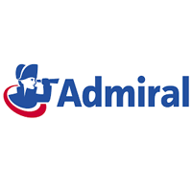

  - 3.3. Organisational Ethical Stance
  - Unethical stance with examples)
Admiral has demonstrated positive ethical stances in the organisation through fairness and reward systems. Firstly,87% staff members have reviewed their experiences at admiral as being treated with fairness within the company. Secondly, the rewards systems such as providing shares to the employees as part of the Merit has been of the success stories that show that those who work hard and use their talents are seen and rewarded for their efforts. This shows that Admiral provide a good ethical stance on merit and reward staff bonuses and for staff who have been more than one year automatically become shareholders and continue to receive two shares a year
Admiral endeavours to give equal opportunities to all. Additionally, Admiral has a culture of Diversity and Inclusion and support both staff and customers from diverse backgrounds as well as this the groups for the areas of age, disability, Black Asian Minority Ethnic (BAME) gender, LGBT+ (Lesbian, Gay, Bisexual, Transgender) and Social Mobility. In the recruitment it avoids mentioning age, race or gender to promote more equality.

Admiral has Wellbeing stance and believe people who do what they like do it better. They have flexible working hours, modern office furniture for workplace, comfortable quiet rest room and prayer rooms and in recent days and in the future are providing options of working from home. Last but not least they have an ethical stance on Handling down and have a strong culture on sustainability and support conservation projects through fund raising activities They engage staff in recycling and energy. a conservation initiative to reduce negative environmental impact on the environment.

While admiral endeavours to have a lot of positive ethical stances reviews from previous staff member reviewed their work experiences at Admiral on the indeed website showed a few unethical stances that occurred in the workplaces. For instance, the employees mentioned feeling welcomed during their first days at Admiral then felt disposable on the rest of their days their. Some went as far as describing the management team as ‘inconsiderate’ and ‘manipulative’. This shows that even though Admiral depicts a fun working environment, the staff members find the workplace quite stressful and mentally draining. Please see example below.
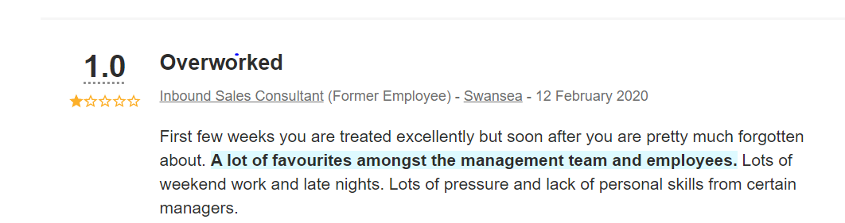

2.4 Skills analysis knowledge and behaviour

The key to success in any organisation in terms of employee and customer satisfaction begins values of the organisation, meaning the deeply held principles, ideals or beliefs that people hold or adhere to when making decisions. Individuals express their values through their personal behaviours, organisations express their value through their cultural behaviours due to the link it is vital to look first into the value of Admirals values which are Communication, Equality, reward recognition and enjoyable.
For an employee to perform well it is important the individual’s values align with those of the organisation according to Barret. Research suggests a link between financial performance and the alignment of an organisation’s cultural values with employees personal values, who an employee is and what they stand for is becoming just as important as the quality of products and services they provide. Therefore, it is important that employee to be aware of their personal values, this can be done by the employee taking a test and analysing results using the Barret Model to understand their core values. The Barret model was initially inspired by Maslow’s Hierarchy of needs and has previously been tested throughout the decade. Barret’s model provides a useful map in understanding the values of employees, leaders and stakeholders within an organisation. Even though this may be an old tool to use today, several researches have argued that it is useful in creating a more supportive and productive relationships between the employees. Below is an image demonstrating the seven values that a company such as Admiral could use to build a supportive relationship with their employees. This will not only benefit the employees, but it will help build a more reputable work area around the countries in which Admiral has set their offices.
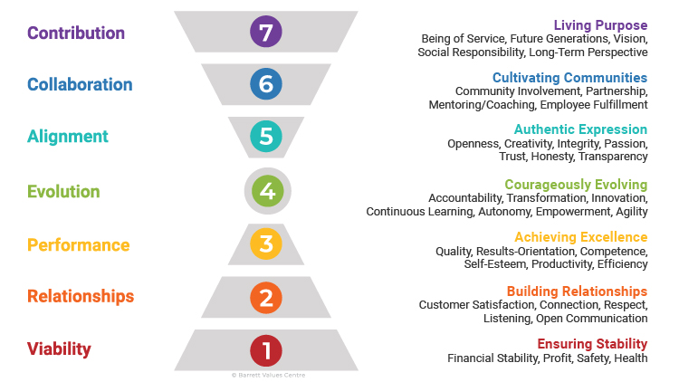
The idea of providing motivational support to employees has also been proven to show that it generates creativity, commitment and even generates a sense of community (Barrett, 2003). Therefore, It would be important for Admiral to consider using a model such as Barrett’s to improve the employee’s behaviour, motivation and generally have a successful business.

Additionally, identifying behavioural and leadership styles can be done using Belbin model. The main focus usually lies on employees understanding their key strengths and how to articulate how they prefer to work as it also helps with efficient work allocation. However, the management teams and leaders in the company should also be considered especially how they use their skills, for example how they strategies the work, or work with others to complete a project. When hiring an individual to work in Admiral, the organisation could use the Belbin’s (2002) model to find the right person to work in the organisation. Belbin (2002) suggests that challenging the employee the right way, nurtured and taught carefully, the employee may grow more loyalty towards the company.
In view Admirals values the skills, knowledge of employee is importantly Outgoing, enthusiastic hard worker, communicative, and Have personal values that align or do not clash with admiral values. As well as that according generic model of cultural categorisation Lewis . Linear active person will be also an ideal person to work in admiral . Linear active people will be task oriented, highly organised, prefer doing one thing at a time and adhere to logic ,have faith in rules and honour written contracts. In a target oriented environment this character will thrive well.

CONCLUSION and Recommendations
A good work culture encourages employees to work harder and provide a satisfactory service to the customers. In return, the customers feel appreciated and well looked after which may lead to the organisation having good reputation. As discussed in the report, the work culture at Admiral is portrayed as relaxed an a fun place to work on the website. However as previously mentioned, it seems as though there are hidden agendas that may not be seen by ‘outsiders. The reviews may not apply to every Admiral workstation, however, majority seem to state that the environment is stressful depending with the management team. Therefore, models such as Belbin and Barrets could be one of the useful tools that Admiral could use to train their management teams and implement new leadership skills and techniques.

RECOMMENDATIONS

Following the complaints from few staff in Admiral a recommendation for Admiral to integrate and promote a culture of personal accountability where individuals have a make it happen mindset instead of spending time blaming any obstacles that come in the way of performance. Employees should believe that success and failure comes from them and not external sources . Management can redirect blame culture by asking questions :what more can we do ? This can be achieved in appraisals, team meetings , one to one meeting or questionnaires. (, Business model and strategy)
Secondly, incorporation of Integrity and Ethical values will help resolve the issue of power abuse by managers biases when making decisions as identified in complaints that managers favour some colleagues. Integrity is the foundation of trust between people and companies. Ethics, can be broadly defined as the moral standards guide decisions and behaviour according to article on strategic finance (M A Anne )
The IMA® Statement of Ethical Professional Practice identifies four overarching ethical principles: honesty, fairness, objectivity, and responsibility. These are essential values for any organisation and would benefit Admiral. For successful implementation of change leaders should use lewin”s change
management Model three stages. (Lewin's Change Management Model: Understanding the Three Stages of Change, 2020)
because change does not come quickly and if not done right will fall

REFERENCE LISTS

Admiral Group plc. (2020) Available at: https://admiralgroup.co.uk/our-culture (Accessed: 7 june 2020).

Admiral Group plc. (2018) Annual Report 2018. Available at: https://admiralgroup.co.uk/sites/default/files_public/annual-report/2019/03/2018-full-year-results-annual-report.pdf (Accessed 7 June 2020).
Barrett, R., 2003. Measuring Spirituality in the Workplace by Mapping Values. Handbook of workplace spirituality and organizational performance, p.345.
https://www.indeed.co.uk/cmp/Admiral/reviews?fcountry=GB&ftopic=mgmt
Copyright . Barrett Value Centre
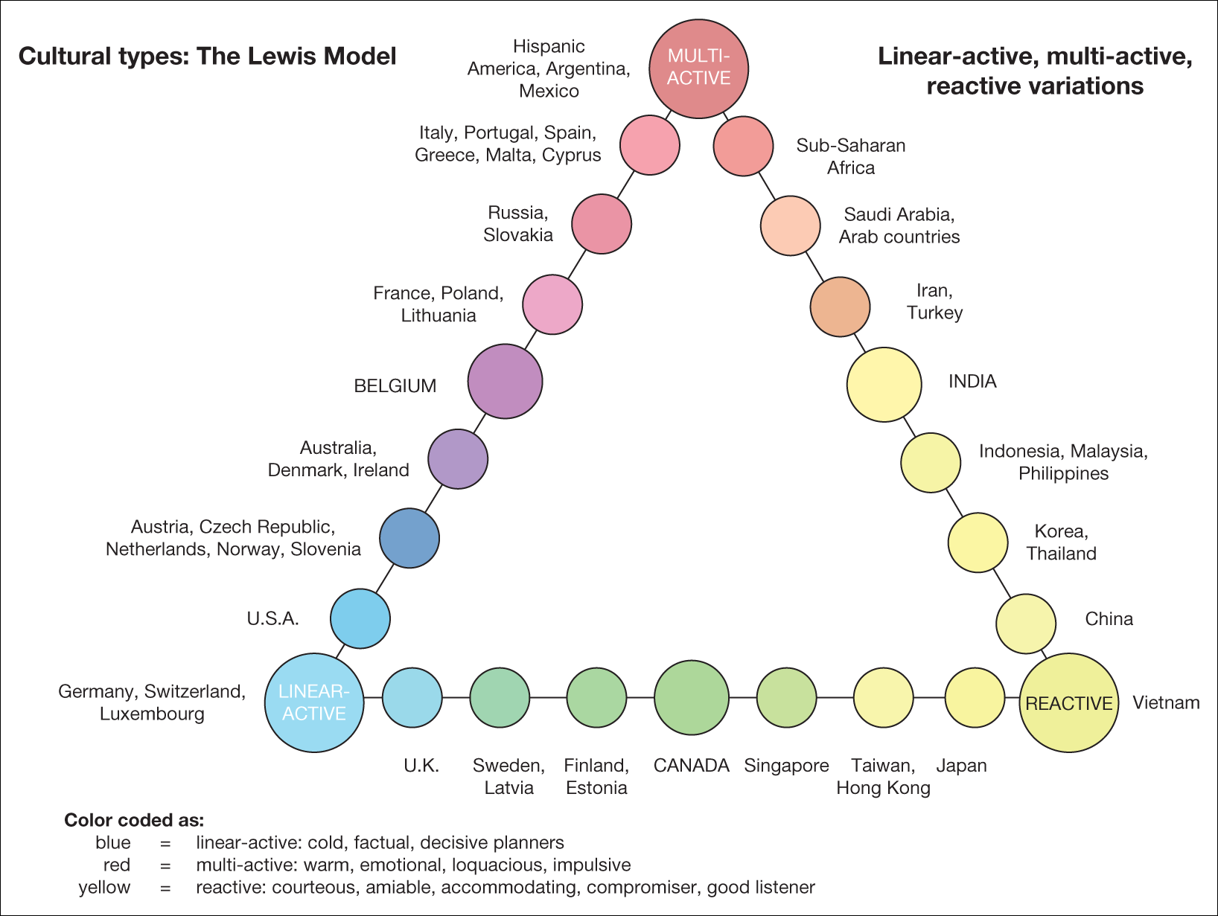
Mindtools.com. 2020. Lewin's Change Management Model: Understanding The Three Stages Of Change. [online] Available at: <https://www.mindtools.com/pages/article/newPPM_94.htm> [Accessed 19 June 2020].
Figure 15.4 Cultural categorisation
Source: Lewis, R.D. The Cultural Imperative: Global Trends in the 21st Century, © 2003 Richard Lewis. Reproduced by permission of Nicholas Brealey Publishing.
, Business model and strategy. Available: https://admiraljobs.co.uk/ [14/06/, 2020].
Johnson and Scholes’ Cultural Web Model .
M A ANNE, success through strong culture.

