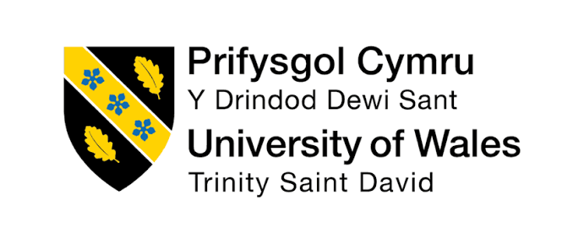
STUDENT NAME : | MABEL TABITA A/P MATHIALAGU
STUDENT ID & PROGRAMME: | 2527782  BACHELOR OF BUSINESS ADMINISTRATION IN FINANCE
MODULE NAME : | MWBA4000 Contemporary Challenges : Making a Difference

TABLE OF CONTENT
NO | TOPIC | PAGE
1 | Setting up the Problem —- Fatihah  1.0 Introduction  1.1 Complex and Wicked Problems  1.2 The Problem Across Malaysian Companies  1.3 A Second Dimension: Technology and Connectivity Barriers  2.0 Design Thinking
2 | The Group in Motion — Amisha  3.0 Decision-making  4.0 Leadership challenges
3 | Responding & Evaluating the Process — Ardini  5.0 Skills used  6.0 Interdisciplinary/collective decision-making
4 | Culture, Ethics & Closing — Mabel  7.0 Individual differences / cultural evidence  8.0 Ethics  9.0 Conclusion
5 | References

Presentation video link :
https://drive.google.com/file/d/1tbHlNv3Fr9-b5PvWNw4ie835IM3EmEIv/view?usp=drivesdk

Title: Language and Communication Barriers in High-Stakes Decision-Making within Global Teams

SECTION 2:

The combination of the group presentation comprised the four students A, B, C, D, and it was presented according to the sequence. The topic presented was about Language and Communication Barriers in High-Stakes Decision-Making within Global Teams. Overall the presentation focussed on why communication barriers in modern organisations constitute a wicked problem when it's absolutely necessary to make a quick decision across countries, cultures and professions – with accuracy. The presentation delved into the nature of the problem, the decision-making process, interpersonal skills needed to handle communication issues and cultural and ethical factors that play a role in the issue. The group determined that language is not a sufficient issue to resolve communication challenges. Rather, successful and high stakes decision making depends on the quality of leadership, working together, cultural sensitivity, ethical accountability and inclusive communication.

The presentation started with an introduction to the concepts of complex and wicked problems by person A. The selected issue was considered as a wicked problem due to the absence of any one solution and its continuous evolution as organisations are working in a more global context. Malaysian businesses were cited as examples such as Perodua and Petronas to show how communication impediments can impact on significant business decisions and partnerships at the international level. Person A also illustrated the Design Thinking process: Empathise, Define, Ideate, Prototype and Test, and how it can be used to learn more about and take action on communication challenges. This section gave the theoretical background for all the presentations and set the tone for the importance of the
problem not being merely a technical problem but a flexible and people-centred problem.

After this introduction, Person B covered decision making and leadership in international teams. The presentation discussed how groups make decisions and several leadership issues that can occur if there are communication issues present. Some of the challenges were intra team dynamics, language barriers and a lack of participation from some members who may not be comfortable expressing themselves. Person B raised the significance of leadership in the context of 'providing a climate in which every member can be an effective participant'. This section has shown that lack of communication can not only cause problems in passing on information, but can also be important in affecting participation, trust and confidence within a team. The impact of poor leadership on risk of miscommunication during high stress situations was also noted.

Then, person C explored interpersonal skills for effectively managing these challenges. Summarizing the discussion, negotiation, influence, diplomacy and emotional intelligence were highlighted. The skills were deemed essential as global teams are composed of people who may approach communication, the process, and the outcomes differently. Emotional intelligence, as a key aspect of understanding others' feelings and concerns, and diplomacy and negotiating as approaches to resolving disagreements, were discussed. The advantages and disadvantages of person C's exploration of interdisciplinary and collective decision making were also explored. Teams can be diverse to bring greater perspectives and fresh ideas, however, they can also take longer to manage differences and agree. This section emphasized the importance of having good interpersonal and collaborative communication skills in order to overcome communication barriers.

Person D, as the last presenter, took on individual differences, cultural aspects differences, ethics and the overall conclusion of the presentation. The five-minute presentation focused on communication barriers impacting not only language, but also with cultural differences and individual communication preferences. The topics spoken about included a cultural comparison, to illustrate that communication, authority and decision-making might differ between cultures. Others might be okay disagreeing openly, others may disagree in another way. Such disparities can lead to misunderstandings even if they have the same working language. Communication barriers should not be considered as a language problem alone, but also a problem of human behaviour and culture.

However, as the last, I generally added to the group's findings by stressing that, in order to be successful in communicating with another group of people in a global team, one does not necessarily have to have a solution to the problem or know the language. Individual differences were emphasised and the need for respecting various viewpoints and standards for ethical decision-making processes were also reinforced. Person D integrated in the discussion the cultural elements of the problem and the moral responsibilities to include them in the discussions, and thereby strengthened the group's general conclusion of the importance of inclusive communication, good collaboration and knowledge of human factors which affect organizational interaction in effective high stakes situations.

SECTION 3 : Critique
The presentation gave a general overview of the language and communication issues that occur in high stakes decision-making , allowing for a critical evaluation of some of the ideas presented. An important aspect of critique is that communication barriers do not necessarily have to be interpreted as a language issue. Despite communication being in the same language, misunderstandings can still happen because of the varied communication styles, cultural expectations, personal experiences and confidence of the members of the global team. Thus, to improve language proficiency is not enough to solve the problem completely.

In my opinion, I think the individual differences have to be taken into consideration more heavily when addressing communication barriers. In the same culture, the people communicate differently due to their personality and previous work experience. The assumption that one will communicate in the same way due to that individual can lead to additional misunderstandings.

Hall (1976) also developed another perspective that there are also high-context and low-context people, so that the meaning of a message could not just be determined by the words contained in the message but also by the context. Hampden-Turner and Trompenaars (2012) also pointed out differences in individuals' response to relationship, rules and social contexts.
In the group assignment, critical thinking was used as the students questioned themselves if there was another way language is affecting communication? Depending on the issue, varied perspectives were shared prior to making decisions and there was some negotiation when members disagreed on the content of the presentation. Disagreements were settled by discussions and compromising one another, not by giving in to one person’s views. Another thought that had to be included was cultural and ethical considerations and how this relates to other group members’ ideas. This enabled me to understand more about high stakes decision-making beyond just communicating well, being respectful and mindful of differences are essential.

Overall, it was found that there are a number of overlapping factors which affect communication barriers. In discussing alternative viewpoints, I gained more insight into various limitations of those centered on language usage and reaffirmed the significance of cultural awareness, ethical decision making and effective working in global teams.

Section 4: Reflection

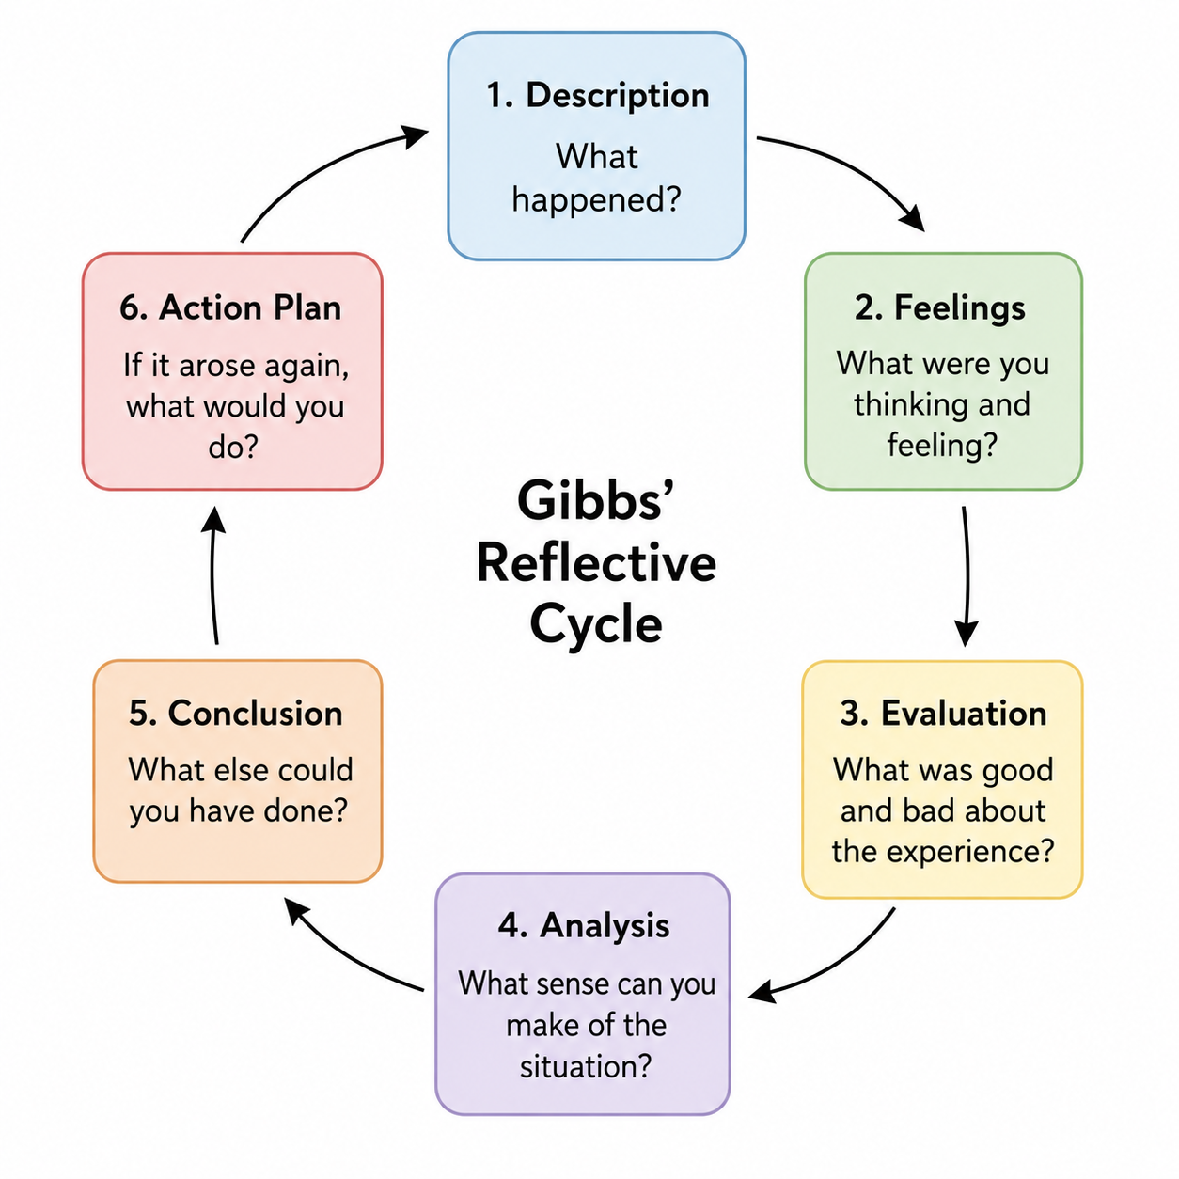

Gibbs' Reflective Cycle is a helpful structure to use for reflecting on the completed group presentation. The model has 6 stages which are Description, Feelings, Evaluation, Analysis, Conclusion and Action plan (Gibbs, 1988). It enables one to look back at the experience systemically by reflecting on what went well, what didn't go well, what should have gone better, and what can be learnt from this experience for situations that could occur in the future.

Description

The group presentation was to be done with 4 students each taking on a different responsibility for a different part of the presentation. Person A presented the wicked problem, Design Thinking, Person B presented decision making and leadership issues, Person C presented on negotiation, influence, emotional intelligence and diplomacy, and I was the final presenter on individual differences, cultural considerations and ethics, then the conclusion. The group was cohesive and collaborative, with each member taking on specific roles and responsibilities, and brainstorming and discussing the ways in which each part could contribute to the larger project.

Feelings

I was a bit nervous when I started because I was the last presenter and had to tie-in what I had written to what the others had written. I also felt that I had a duty to assure that the conclusion was clear and made the main points. This was slowly increasing my confidence but as the group kept on communicating and helping each other, it got better. It was also more organised when each member finished their section.

Evaluation

There was one good thing about the experience, the group worked together. Members shared their progress, ideas and thought over each other's. The group gained the communication, listening, negotiation and emotional intelligence skills of Unit 2 to help them handle a variety of perspectives and decide as a group. One difficulty was, however, getting various parts organized and making sure no information was duplicated. It took a few meetings for the group to work through the transitions between each of the group's contributions.

Analysis

This experience showed that it is not enough to just follow a rule of distributing work between the team members, but the availability of effective teamwork needs other things. Communication, cooperation, respect and disagreement management skills are required. In instances of differing preferences, the group used active listening to gain an understanding of various opinions, as well as negotiation and diplomacy to find compromises. Another factor that aided me in becoming the final presenter was having an understanding of the other people's ideas, so as to relate my writing of individual differences and ethics to the rest of the presentation. This allowed me to understand the influence on communication and decision making within a team of cultural and ethical factors.

Conclusion

The group task helped me develop a better understanding of collaborative working, and the need to respect other views. I found that the impact of group members participation is enhanced when it is used in line within the group's purpose. Moreover, I developed a greater confidence in expressing myself clearly in group discussions and being a listener to other group members when making a decision.

Action Plan

If I would have to do another similar assignment, I would start working on my section sooner and liaise more with my group members on how my section will connect with their section. Would also feel more comfortable with suggesting ideas and requesting clarification as needed. Communication, negotiation, active listening and emotional intelligence are some skills that get introduced in Unit 2 while performing the task; these skills can be more specifically utilized in future group projects.

REFERENCES

- Gibbs, G. (1988). Learning by doing: A guide to teaching and learning methods. Further Education Unit, Oxford Polytechnic. Retrieved August 24, 2026
https://books.google.com/books?q=%22Learning+by+Doing%22+Gibbs+1988

- Hall, E. T. (1976). Beyond culture. Anchor Press. Retrieved August 24, 2026

https://books.google.com/books/about/Beyond_Culture.html?id=GrPZAAAAMAAJ

- Hofstede, G., Hofstede, G. J., & Minkov, M. (2010). Cultures and organizations: Software of the mind (3rd ed.). McGraw-Hill. Retrieved August 24, 2026

https://www.mheducation.com/highered/mhp/product/cultures-organizations-software-mind-third-edition.html?viewOption=student&

- Rittel, H. W. J., & Webber, M. M. (1973). Dilemmas in a general theory of planning. Policy Sciences, 4(2), 155–169. Retrieved August 24, 2026

https://doi.org/10.1007/bf01405730

- Trompenaars, F., & Hampden-Turner, C. (2012). Riding the waves of culture: Understanding diversity in global business (3rd ed.). Nicholas Brealey.
Retrieved August 24, 2026

https://research.vu.nl/en/publications/riding-the-waves-of-culture-understanding-cultural-diversity-in-b

