Certificate in Higher Education Skills for the Workplace

Course Module: BMSW4006

Student Names:
Amanda Persephone Griffin 2017950
Kristiyan Grudev 2018996
Marian Daniel 2017869
Gabriel Gheorghe 2021690
Andrei Vilceanu 2021009
Krystal Lewis 2016755

Lecturer: Olu Adegbite
Appurcar Group Business Plan

Table of Contents
Introduction 2
Business Overview 2
Products and Services 4
Market Audit 5
PESTEL Analysis 6
Target market 6
Marketing Plan 7
Team Management 8
Financial Plan 9
Start-up Cost 9
Start-up expenses 9
Start-up budget 10
Income Statement/Cashflow Forecast 11
Conclusion 12
Reference List: 13
Appendices 14

Introduction

This report details the concept idea of our company Appurcar, we aim to hire vehicles that are not in use to subscribing members of the public for monetary gain. At present, there are six people involved in running the business: Krystal, Mariam, Daniel, Gabriel, Kristian, and Amanda.



Business Overview

Appurcar Mission
At Appurcar, we drive members. The aim is to empower and encourage collective thinking, while innovating and collaborating with our members. We believe Appurcar should act as a community and use technology to communicate quickly and efficiently to assisting one another.
Appurcar is an LLP company, it is multiple ownership.
There are six people involved in running the business: Krystal, Mariam, Daniel, Gabriel, Kristian, and Amanda.
Appurcar is a new service that utilizes peoples’ cars within the community allowing them the opportunity to make money from their vehicle which is not in use.
Appurcar is built on the concept that there are too many vehicles on the roads. According to car magazine Motorparc (2019). A survey by the industry body the Society of Motor Manufacturers and Traders (SMMT) “Most of the vehicles registered are indeed cars: more than 35 million of them “.
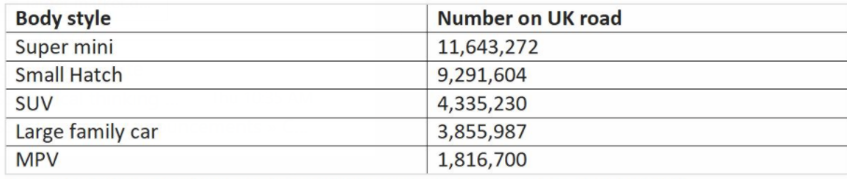

Survey by industry body the society of Motor manufacturers and Traders (SMMT)
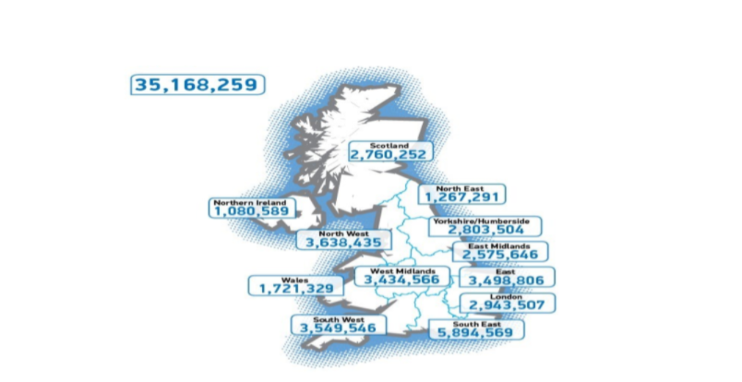
By UK Motor parc cars (2019).
That thought in mind is where the idea for Appurcar was formed. We did not want a car share service, as it meant that our members would have to be dropped off precisely to a destination, leaving them waiting for a lift back. Not only this but current social distancing guidelines set out by the UK government would make this difficult. On the other hand, there would be a vehicle sitting unoccupied, on the road or in a car park, when it could be in use, by a someone who needs it.
Our Aim is to provide a service for the local community. A vehicle hiring partnership that facilitates local commuting to recreational travel.
“It is a hypothesis about things that are in constant flux—society, markets, customers, technology. And so, built into the theory of the business must be the ability to change itself.” The Theory of Business Peter F. Drucker the Magazine (September–October 1994).
Appurcar is a membership network. We offer members the opportunity to hire their vehicle for a fee. Our members lease their vehicle to other members.
All vehicles are inspected by our trained technical engineer and will require a valid mot certificate prior to being uploaded onto the App sharing site.
“As important enablers of CE business models, they allow firms to share data within their supply chains and identify and track products and materials, which improve their ability to retain value.” (De Sousa Jabbour et al., 2019).
The vehicles will be readily available by using our App, with the intention of keeping monitoring and improving the service we provide
Our aim is to Help the environment with emissions- carbon footprint. Instead of more vehicles being on the road, we use the ones which are road ready.
Appurcar is targeted at an age range of:
25 years and upward
Income £18,000 upwards
Any Occupation
Any Area
As a member only facility, we aim to ensure that members' cars are properly taken care of by other members, that is why we will be introducing a video telematic device.
A vehicle hiring company which caters to all for whatever reason. Appurcar’s focus is not just within the community but further afield if it is required on commercial rentals. It comes at an Affordable cost. With the use of our app, we intend to be the quickest, most reliable way for people to commute in and around their cities. While supporting the economy and allowing vacant cars make money for their owners.

Products and Services

Subscribing members have access to APPURCAR, which provides the cars on short notice and for extended periods of time. We partner with the DVLA to verify that all our members have valid driver's licences. Customers will be charged a fee to use the vehicles. They can also earn incentives by recommending friends to the programme.
Appurcar is convenient and simple for members'; our physical product is the use of our members' cars; it is up to the persons to decide how much they want to charge for the rental of their cars to other customers.
Our app is the digital product, and it is designed to make car reservations faster, verify drivers' licence credentials, and utilize facial recognition technology to ensure the safety of clients' vehicles throughout the rental process. All cars provided by Appurcar are comprehensively insured and have adequate roadside breakdown coverage for all eventualities.
The customer can access the Appurcar website by scanning our QR code, which allows them to choose the start and end dates for their rental period. They must then choose the type of car that would best meet their needs.
The service we offer is a key collection scheme in which members send their spare car keys to an Appurcar representative, who will then install a telematic device in the vehicle for the owner's peace of mind and to ensure that once the vehicle has been rented out, it is treated with due care and attention. The representative will go on to conduct a thorough vehicle examination to ensure that the car is returned in the same condition.

According to Omnisci, (2021). Vehicle telematics is a combination of GPS systems that monitor onboard diagnostics within an automobile. This is done via black box technology plugged directly into the vehicles OBD port. The data is recorded and transmitted back to a receiver where the vehicles speed can be averaged, as well as the location and driving style of the end user. The driver’s performance is then ranked in terms of being good or bad because the data can be used in real time analysis to investigate driver behaviour.
As an incentive, APPURCAR offers customers the opportunity to rate the hire process of the cars from start to finish out of 5 starts earning points on a reward system, which can be used to collect vouchers and discount codes from their preferred retailers as and when they wish.

Market Audit
Kuratko (2011, p.9) has brought discussion about “the emergence of the entrepreneurial economy” whereas he reasoned that the natural business has been transformed fast innovation and technology, highly threatening and increasingly global environment which has required organisations reviewing their purposes and required more flexible in their approaching to serve multi stakeholders (Morris et al., 2008). Therefore, companies have chance to reform structure, operation, modify the model business This changing is not only a challenging but there is also a new opportunity to entrepreneurial in 21st century.
Moreover, competitive game has been kept changing which helps organisations realising that sustainable advantage competition is moving rapidly in which the technological and innovative development becomes driving the engage process of entrepreneurs with newest source of competitive advance (Kuratko, 2009). According to Minniti and Bygrave (2004) and Autio (2007), entrepreneurs drive economic to growth in two different ways: first way, by entering and expanding exist market to increase competitive and ineffective economic. Second way, creating entirely new market by offering innovation products which presents profit opportunity to others. As the result of research, Appurcar applies both ways. By combining technological advance and exist market but less competitors, therefore this market is still new and changeling but that is potential expanding. Further, Appurcar has been using market audit tools such as SWOT and PESTEL to analyse market and business opportunity.
SWOT Analysis
Strengths · Business is new phenomenon. · Attractive and interesting technology. · Customers and partners are flexible time and schedule. · Customer a part of business. · Not too many competitors | Weaknesses · It takes time to get people in part of business. · High risk because need to be safe for customers and the car of partners
Opportunities  · New opportunities  · New trend in business | Threats · It takes time to build up the trust with partners who want to give their cars for renting. · Comprehensive work to check clean license of customer.

By applying the SWOT tool to understand to identify the market for business, Appurcar is confident in this new trend of business which is suitable with entrepreneurs in 21st with applying innovation and technology on the services, furthermore, it is very flexible operations in business which brings biggest benefit to customers and partners. Comparing strengths, opportunities and weaknesses, threats, Appurcar is strong idea to enter the existing market and the team can expand the business rapidly, although it will take time to build up customer relationship.

PESTEL Analysis
PESTLE analysis: According to Zalengera al et, (2014), SWOT focuses on analyzing general the factors surround business while PESTLE analyses widely and in more detail about factors which affect business:
· Political: Appurcar encourages everyone being able becoming partner of business which operate under guideline of government to cover pandemic.
· Economic: in the situation of global economy when pandemic hits badly economy and cause financial individual problems, Appurcar could help everyone who want to earn extra money with their cars while they are not using them.
· Social: This business will contribute to build up society with communicating and wealth by gathering much as possible between individual to be a partner in business.
· Technology: Take maximum advance of technology because business operates via aps and online communication between partners and customers.
· Legal: Reduce worker work and renting space.
· Environmental: When the cars are on the road, it will effect on environment by emission. However, all cars will be checked to meet the requirement of quality of emission volumes in their different locations.
It could not deny that entrepreneurs play essential roles in market business by leading innovation which lead to technology changing and productive growth to pursue successful economic (Kuratko, 2011). Appurcar recognizes new trends and applies energy, passion forward to create and implement the new idea, and create solutions. “Seeking opportunities, taking risk beyond security, and having the tenacity to push an idea through to reality combine into a special perspective that permeates entrepreneurs (Kuratko, 2011, p.9).

Target market
· Profitability
Despite concerns for the UK and worldwide economy in 2020/21, the National Lottery Company UK announced 1.5 million £25,000 start-up grants. And being picked as one of those entrepreneurs is an honor. Our Business first funding comes from the Lottery Company. According to (Stanley, 2007) Target Market is concerned with the activities necessary to provide greater customer value in the firm's target markets.
Our key benefits include covered fuel expenses, reasonable pay fees, and vouchers for a range of retailers for those who maintain their automobiles in good shape and have a 5-star rating.
We intend to collaborate with electric automobiles in the future, cutting the cost of fuel and enabling individuals to earn more. Using our service is still cheaper and more convenient than taking a taxi, waiting for public transit, or driving other people's automobiles.
Our company concept has a strong potential for recurring sales since we address people's issues. Publicity via paid social media, in-store displays, and press/media.
Email marketing, social networking, cold calling, and marketing groups are presently used to enhance and manage customer feedback. Set up a solid feedback system that asks how the client wants to be contacted in the future. This works for current customers, and new customers may explore other techniques.
Before beginning our organization, we assembled a team of skilled marketers who examined the location, income, lifestyle, age range, and competitors. Appurcar creates ads, promos, websites, and videos to entice clients to utilize his services. Appurcar’s marketing team studied competition and consumers to better serve clients. We want our customers to submit feedback on our services, helping us to better understand their requirements and goals.

Marketing Plan
PRODUCT/SERVICE
The product and services of our company are based on helping people who need a car for a short period. The reasons for which a vehicle can be rented can be different, but not this is what interests us. One of our goals is to help our customers arrive at the established destination. And we will be able to do this, thanks to our trusted APPURCAR LLP company. Therefore, in exchange for a small subscription fee, people who wish to make their car available can become members of the APPURCAR LLP company. Then, the member's car will immediately become available on both our app and website page to be rented by people who need one.
The best marketing strategy ever: CARE. (Sevelyn, 2020)
Alongside our principal service, rewards will be implemented because of our customer matter. In fact, APPURCAR plans to issue vouchers to our members to be spent everywhere. These vouchers will be issued after the fifth time our member’s car has been rented to thank him for his contribution. After that, the vouchers will keep being issued periodically based on reviews and renting performance.

PRICE
As well as our customers who have access to our service are significant, we have decided to put into practice a price strategy that allows everyone to take advantage of our services at affordable prices. The pricing strategy that will be put into practice is the variable pricing strategy. This strategy is to optimize profit by offering different prices for various products as the vehicles registered with our company will be categorized following specific criteria.
The categories in which our company is based are:
Small 3.70£/Miles
Medium 5.00£/Miles
Large £6.00 Per Mile
Luxury £9.00 Per Mile
SUV’s £7.00 Per Mile
Vans £10.00 Per Hour
All prices per mile are subject to a standard price, for more information, visit the price list. Vehicles that exceed 10 miles will be charged at a lower price per mile.
PLACE
APPURCAR LLP is in Birmingham, United Kingdom. Our Head Office's location allows the company's faster evolution thanks to direct contact with a higher number of populations. In addition, we conduct our business online, via telephone, website chat, email, and app chat from our offices for more assistance.
PROMOTION
Give them quality. That is the best kind of advertising. (Entrepreneur, 2008)
Promoting our business is one of the most important goals. Reaching many people helps our company realize the reason APPURCAR was created. For more profitable management, our team will take care of the promotion activity, which will take place through posters, radio, email, and social media.

Team Management

The members of our management team are Gabriel Gheorge Cybersecurity/Business analysist, IT/Customer service Krystal Yasmine Lewis, HR/Legal policies Amanda Persephone Griffin, Finance/Accounting Kristiyan Krasimirov Grudev, General/Marketing Manager Andrei Vilceanu, and Product/People Marian Daniel Stefan APPURCAR LLP would be unable to function without the contributions of each one of these people. This slide will break down and describe each of these guys' jobs in our management team; they are all professionals, and they are all capable of using a broad variety of helpful skills in the workplace. Below the report providing our organization chart.

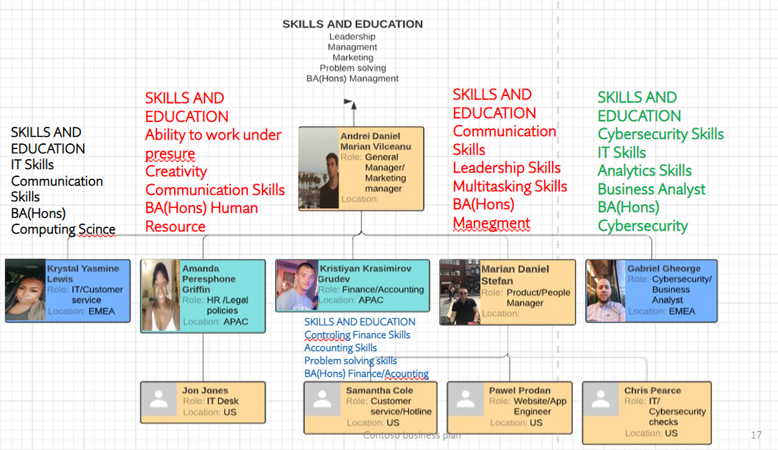

Financial Plan
This financial plan will provide information on the financial health of APPURCAR LPP organization, and it comprises two financial statements: an income statement, and a statement of cash flows, among other things. According to our Financial Expert reports will be written and communicated in a timely way, and they will be accurate and understandable to our audience. Although generating a financial report may seem to be a daunting task, the accounting that is necessary is not incredibly challenging.
Before we start, it is significant to consider how long our financial report will be. Most financial reports are generated quarterly or yearly, while others are done weekly. In APPURCAR we decide to do our financial projections annually from the period of January 2021 till December 2021.

Start-up Cost
Starting costs are the total of two types of expenses. Both may be estimated in two lists.

Start-up expenses
Ahead to the plan's start, or the first month of operations. Before launching an APPURCAR LPP, the startup pays rent for a month or longer. Also, our staff is paid before the business opens; such payments represent starting costs.

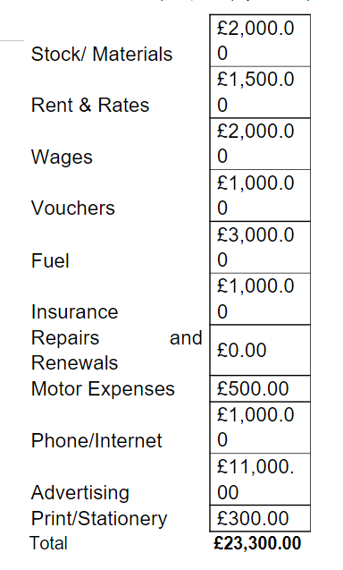
Start-up budget
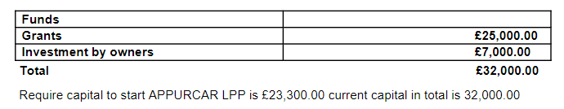
Cash (the money in the bank when the firm begins), business or plant equipment, office furnishings, automobiles, and initial goods for stores or manufacturing are common startup assets.

Income Statement/Cashflow Forecast
According to (Helen, 2002) the Income Statement is a key financial statement that displays an APPURCAR profit and loss over time. Revenues from both operational and non-operating operations are subtracted to calculate profit or loss. The income statement is one of three financial statements used in both corporate finance and accounting. A logical and consistent presentation of our company's sales, expenditures and income, taxes paid and net profit.
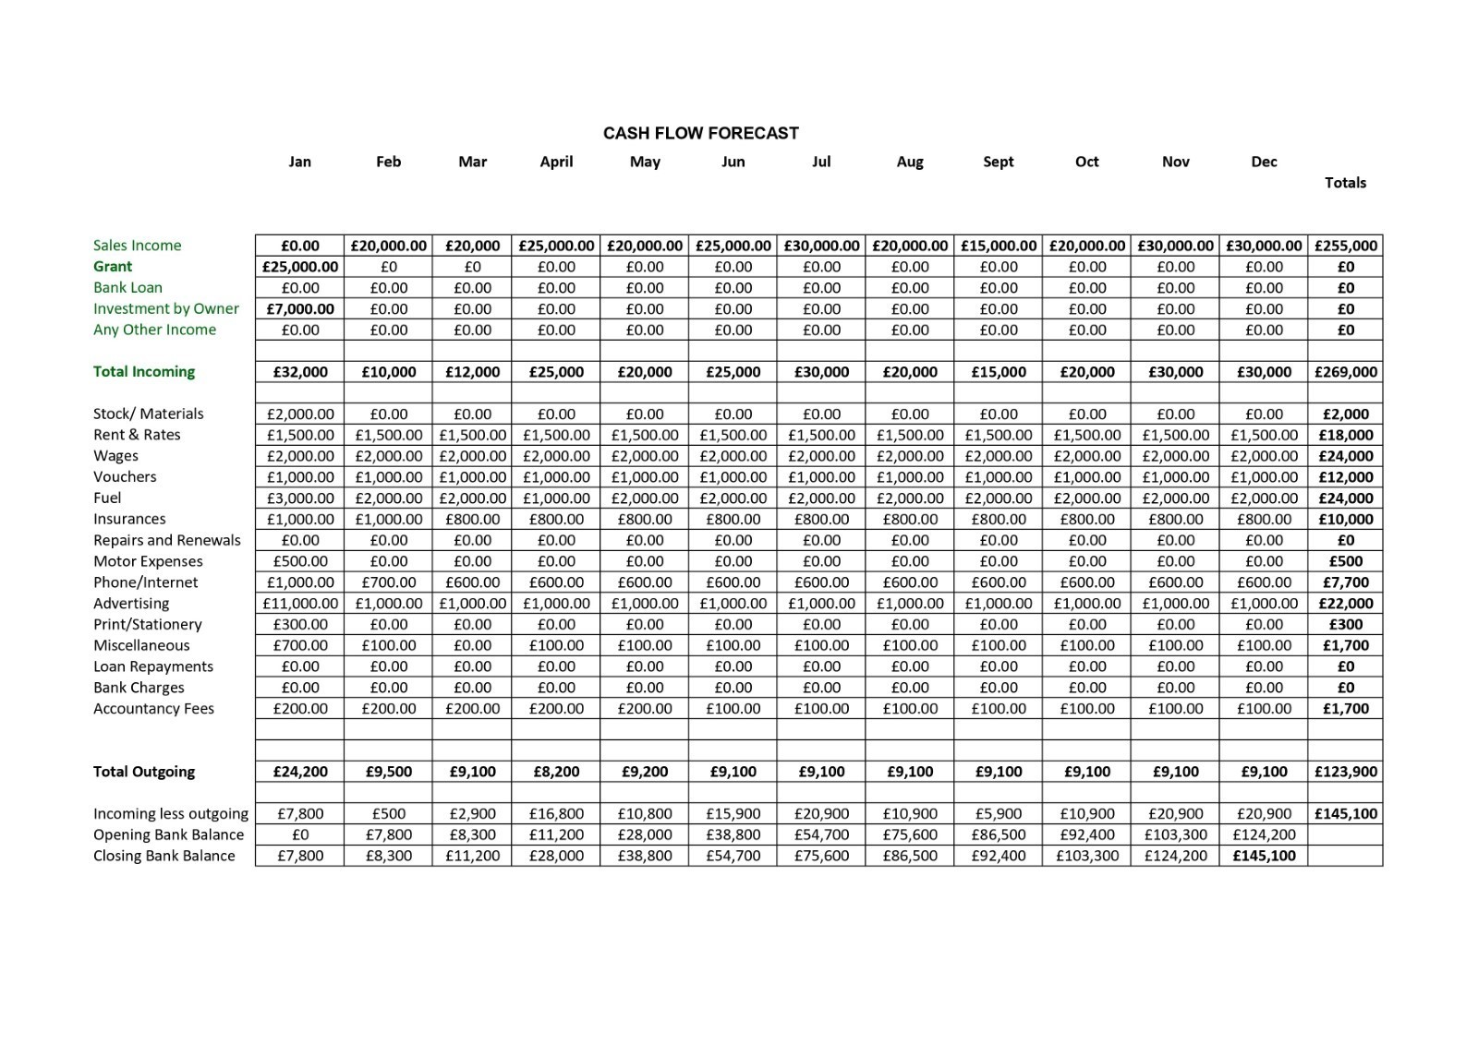Profit and Loss Forecast
According to (Winston, 1992) like the cash flow statement, the P&L indicates changes in accounts over time. The balance sheet, on the other hand, is a snapshot of our company's assets and liabilities. The accrual method of accounting allows APPURCAR to record revenues and costs before cash is exchanged. This paper has a generic format as shown below. It starts with revenue (the top line) and subtracts operational expenditures, tax charges, and interest expenses. The difference is net income, often known as profit or earnings.

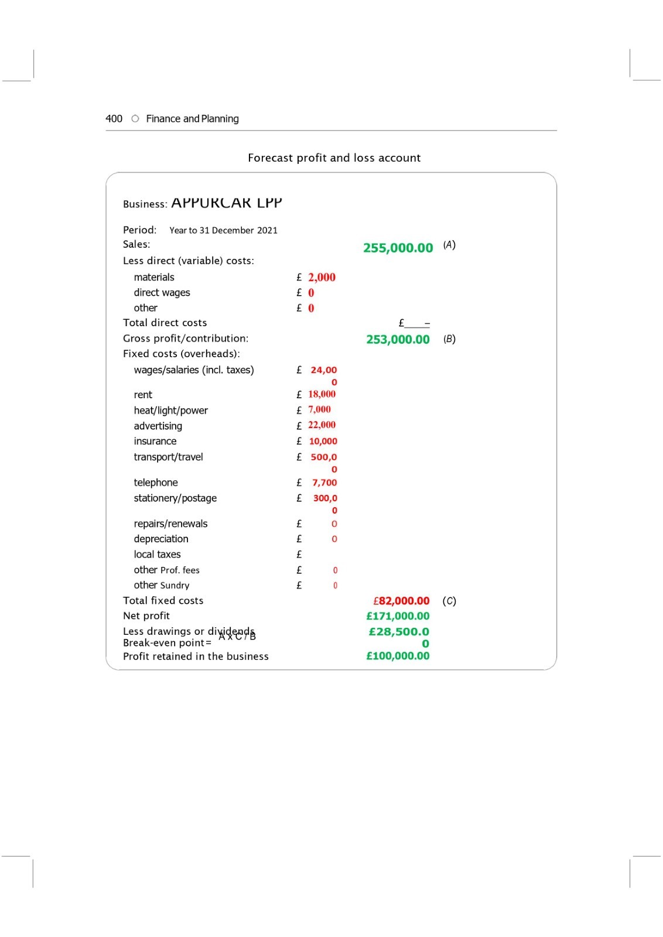

Conclusion

We at Appurcar believe our business idea will be a very successful venture that has the capability of benefiting our local economy and community in numerous ways. The team at Appurcar would like to thank the Lottery Company UK for the opportunity to pitch this new concept of generating positive change for the future of the automotive hire industry.

Reference List:
Autio, E. (2007) Global Report on High Growth Entrepreneurship, Babson College and London, London Business School, Wellesley MA, UK.
Kuratko, D.F. (2009a) Entrepreneurship: Theory, Process, Practice, Cengage/South-Western Publishers, Mason, OH
Kuratko, D.F., 2011. Entrepreneurship theory, process, and practice in the 21st century. International Journal of Entrepreneurship and Small Business, 13(1), pp.8-17.
Minniti, M. and Bygrave, W.D. (2004) Global Entrepreneurship Monitor, Kauffman Center for Entrepreneurial Leadership.
Morris, M.H., Kuratko, D.F. and Covin, J.G. (2008) Corporate Entrepreneurship & Innovation, Cengage/South-Western College Publishers, Mason, OH.
Zalengera, C., Blanchard, R.E., Eames, P.C., Juma, A.M., Chitawo, M.L. and Gondwe, K.T., 2014. Overview of the Malawi energy situation and A PESTLE analysis for sustainable development of renewable energy. Renewable and Sustainable Energy Reviews, 38, pp.335-347.
Slater, S.F., Hult, G.T.M. and Olson, E.M., 2007. On the importance of matching strategic behavior and target market selection to business strategy in high-tech markets. Journal of the Academy of Marketing Science, 35(1), pp.5-17.
Omnisci.com. 2021. What is Vehicle Telematics? Definition and FAQs | OmniSci. [online] Available at: <https://www.omnisci.com/technical-glossary/vehicle-telematics> [Accessed 1 December 2021].
(De Sousa Jabbour et al., 2019). Digital technologies catalysing business model innovation for circular economy—Multiple case study - ScienceDirect (Accessed 10th November 2021) https://hbr.org/1994/09/the-theory-of-the-business (Accessed 30th November 2021) https://www.carmagazine.co.uk/car-news/motoring-issues/2020/how-many-cars-are-there-in-the-uk/
Society of Motor Manufacturers and Traders (Accessed 26th November 2021)
Sevelyn, W. (2020) The Best Marketing Strategy Ever: CARE [online] Available at: http://www.articlesfactory.com/articles/marketing/the-best-marketing-strategy-ever-care.html (Accessed 30 November 2021)
Entrepreneur, (2008) Milton S. Hershey [online] Available at: https://www.entrepreneur.com/article/197530#:~:text=%22%20Give%20them%20quality.%20That%27s%20the%20best%20kind,S.%20Hershey%20followed%20a%20different%20path%20to%20success. (Accessed 01 December 2021)
Kwok, H., 2002. The effect of cash flow statement format on lenders' decisions. The International Journal of Accounting, 37(3), pp.347-362.
Lin, W.T., 1992. Analysis and forecasting of income statement account balances the dynamic interdependency and ARIMA approaches. Journal of Forecasting, 11(4), pp.283-307. 13

Appendices
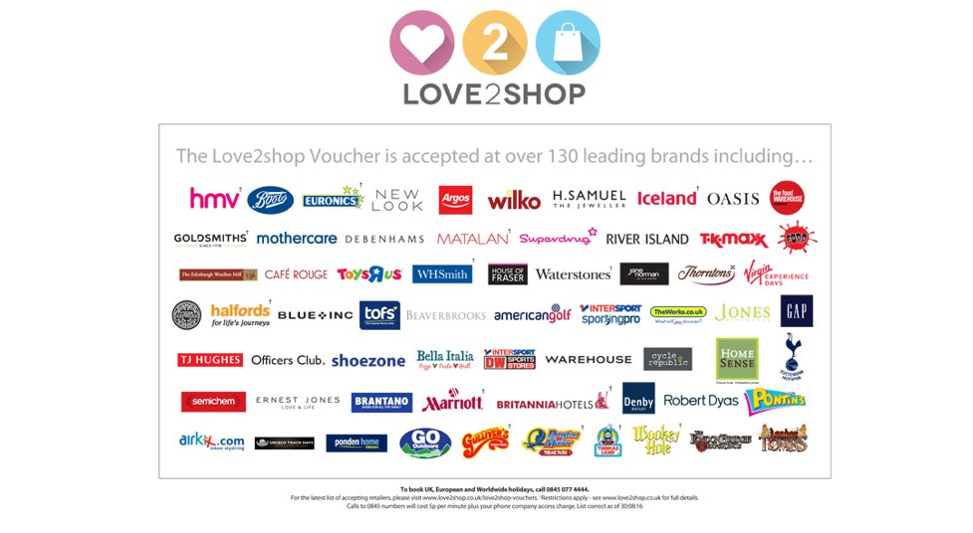
Vouchers for keeping cars in good condition & receiving 5-star reviews:

Mobile app services: 14
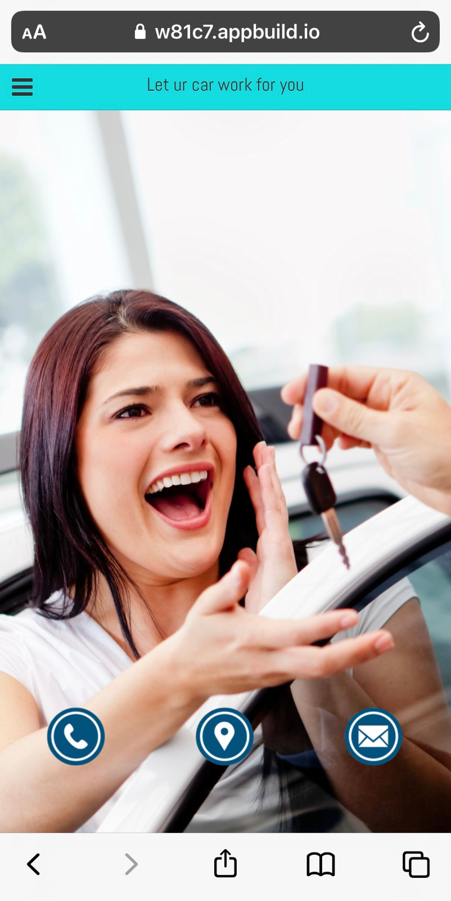

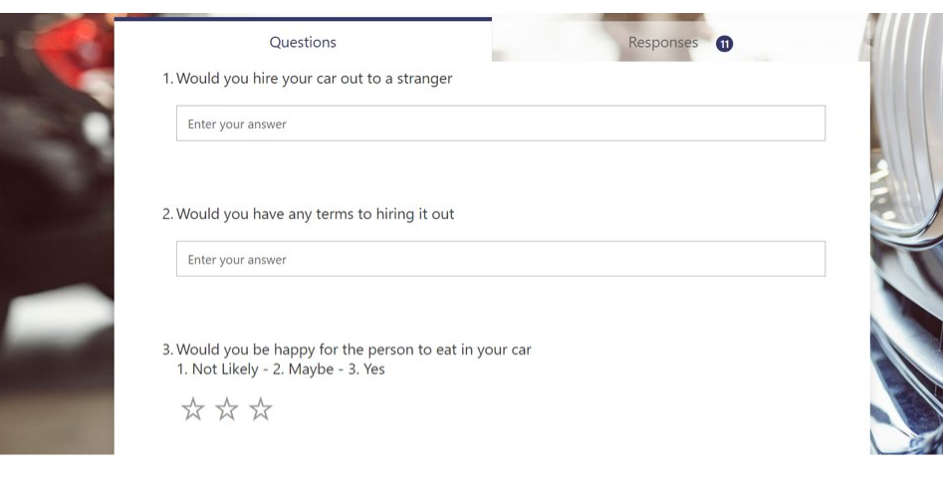
Customer survey:
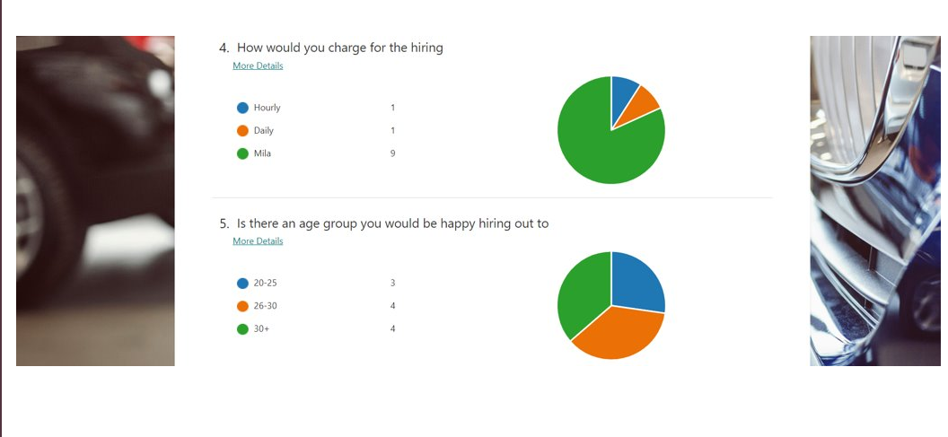

16

