
Postgraduate/Distance Learning
Assignment coversheet & feedback form

THIS SHEET MUST BE THE FIRST PAGE OF THE ASSIGNMENT YOU ARE SUBMITTING (DO NOT SEND AS A SEPARATE FILE)

For completion by the student:
Student Name: Niema Bohrayba

Student University Email: 1707539@student.uwtsd.ac.uk
Module code: AHAN7043  Module title: Skyscapes, Cosmology and Archaeology | Student ID number:  1707539 |  |  | Educational support needs: No
Assignment title: Using at least two examples from scholarly literature, consider the cultural consequences of astronomical cycles.

Assignment due date: 30.07.2018
This assignment is for the 1st 2nd 3rd 4th 5th 6th module of the degree
I confirm that this is my original work and that I have adhered to the University policy on plagiarism.
Signed …Niema Bohrayba…………………………………………………………
Email submission:if you are submitting this form via email, please tick this box □
(as a substitute for your signature) to confirm that you agree to the above declaration.
Assignment Mark
1st Marker’s Provisional mark
2nd Marker’s/Moderator’s provisional mark
External Examiner’s mark (if relevant)
Final Mark

NB. All marks are provisional until confirmed by the Final Examination Board.

For completion by Marker 1 :
Comments:

Marker’s signature: |  |  | Date:
For completion by Marker 2/Moderator:

Comments:

Marker’s Signature: |  | Date:
External Examiner’s comments (if relevant)

External Examiner’s Signature: |  | Date:

What is the direction of orientation of Exeter mosque? And to what extent is this orientation in accordance with Islamic guidance?
Word Count: 3538
This project seeks to measure the orientation of Exeter mosque and determine to what extent this orientation is in alignment with Islamic guidance. The reason this study is being undertaken is due to mosque orientation being subject to much debate amongst scholars, and is an important topic since the orientation of the person towards the Qibla is a key component of Islamic prayer. The methodology used in this study is to measure the orientation of Exeter mosque through one traditional method (The Direct Sun Method), and compare results from this measurement with modern apps and a compass.

Literature Review:
Background and context of Exeter Mosque:
Exeter mosque is the only purpose built mosque and Islamic centre in the South West of England. The mosque as it currently stands was initially founded in 1976 where the then small Exeter Muslim community made up of approximately 80 people raised funds to purchase a property which could serve as prayer hall to conduct Friday prayers in the first instance. The initial mosque was comprised of 2 neighbouring properties (numbers 14 and 15 York Road, Exeter). Due to the expansion of the community, the mosque board further fund-raised so that they could purchase a piece of land from the neighbouring school, and expand the building to include a purpose built prayer hall which was completed in 2011.
Exeter mosque serves as both a place of worship and as a community centre and as such fits with the what would be expected of a mosque which serves as a community hub.
Basic design elements of Exeter mosque:
To understand the design elements of Exeter mosque, it is compared to the first mosque built in Islam known as the Prophet’s mosque located in the city of Madinah in modern day Saudi Arabia, which at the time of its original construction c. 622 AD, still serves as a model for all subsequent mosques throughout the Islamic world today.
Similar to the Madinah mosque, Exeter mosque comprises of a simple rectangular prayer hall, which houses the Mihrab or prayer niche. The Mihrab is located on what is known as the Qibla wall. The mosque boasts both a dome and a minaret, both of which were absent from the original construction of the Prophet’s mosque, and thus serve no theological purpose, and are considered to be architectural features and are not a focus of this project. A floor plan of the mosque is outlined in (figure 1).
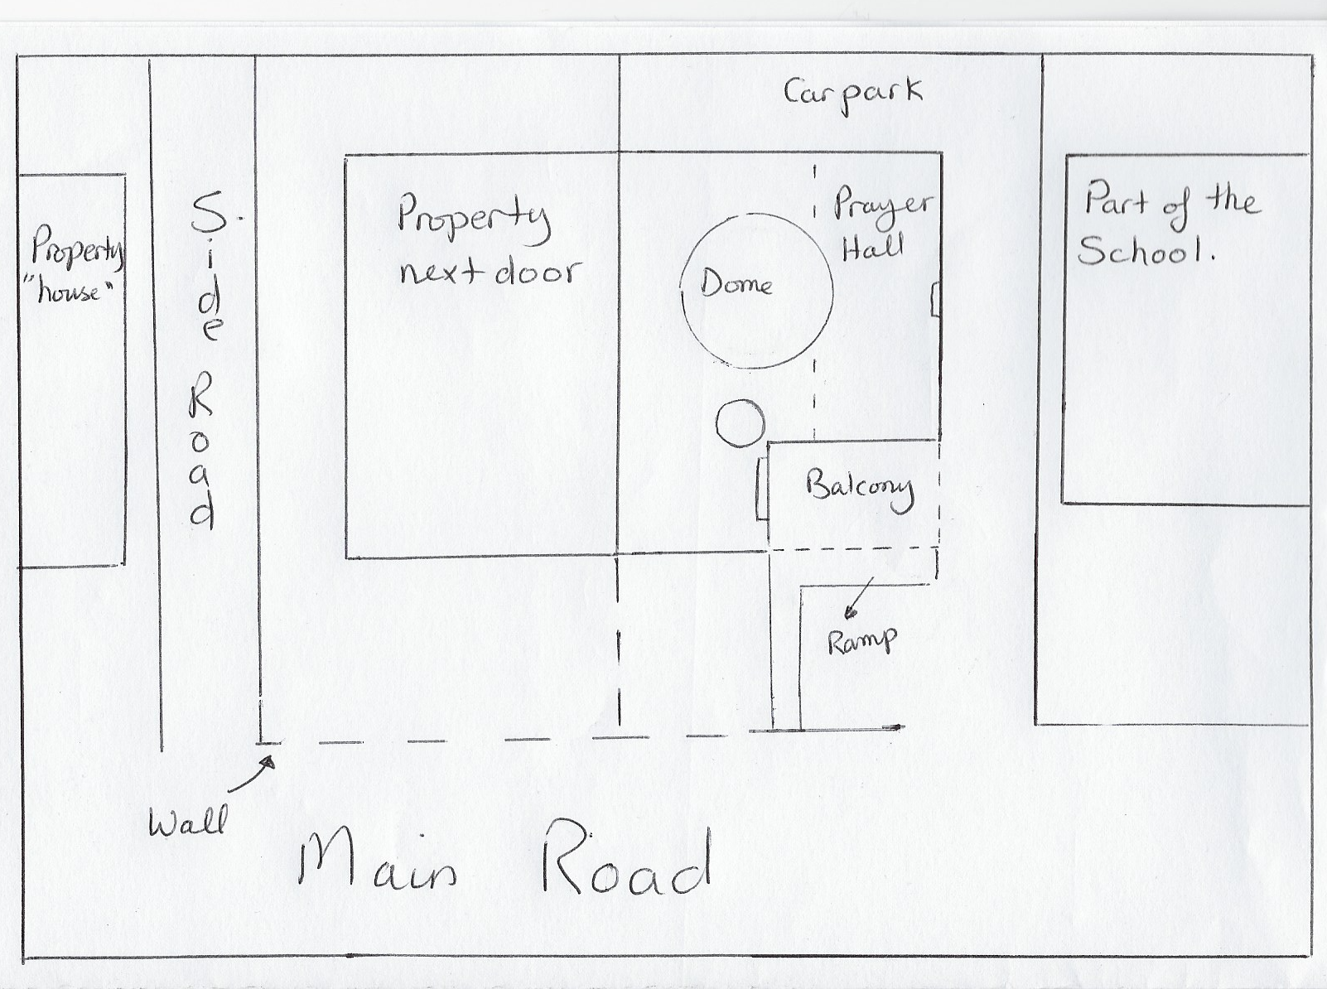
Figure 1 Lay out of Exeter Mosque, Exeter. UK. The Blue arrow is pointing to the Mihrab and the Red arrow is pointing to the Minaret.

The relevance of praying in a mosque:
The word mosque is an English translation of the Arabic word masjid which in turn is derived from the Aramaic word msjd and according to Cooke means to ‘prostrate oneself’, which is a core component of the act of Islamic prayer.
The word masjid is mentioned multiple times in both the Holy Quran and the Sunnah (both main primary sources for Islamic doctrine several times) with the act of prayer mandated five times daily in a prescribed and regulated way. Whilst prayers can be performed either individually or in congregation led by an Imam, the latter is considered more desirable unless there is a valid excuse as highlighted in the authentic hadith narrated by Al-Bukhari:
“Prayer in congregation is superior to a prayer performed individually by twenty-seven degrees”
Prayers both individually or in congregation are not restricted to being performed in a mosque since they can be performed in any location, as described by the Prophet Muhammed :
“And whenever the time comes for prayer, pray in your location (pray there), for everywhere is your masjid”.
In accordance with this teaching, the formality of praying in a certain building is not obligatory providing that other conditions of prayer are met. However, since the establishment of the first mosque in Islam, it is customary for Muslims to pray in congregation within a mosque setting.
Facing the Qibla as a key prayer condition:
Whilst the location of prayer is flexible in Islamic doctrine, some elements of prayers are none negotiable. Prayers are governed by several religious rulings, however the scope of this project focuses on one none negotiable ruling in particular and that is the requirement to face the Qibla whilst praying. Facing the Qibla which is defined according to Al-Khattabi as the ‘direction such that when an observer faces it, it is as if he is looking at the diameter of the earth passing through the Kaaba’.
According to King, in a mosque setting, the direction of the Qibla is symbolized by the Mihrab or prayer-niche which is located on what is known as the Qibla wall, and it is due to this that a mosque is said to be Qibla orientated.
Yilmaz as part of his research into the orientation of historical mosques in Turkey affirms Kings’ definition of orientation in the context of mosques, where the orientation of a mosque is ‘indicated by a niche in the focal point of the Qibla wall aligned with the Qibla wherever mosques were built on earth’.
In contrast with this definition of mosque orientation is also discussed in the the work of Pantazis and Lambrou, where their focus was on investigating the orientation of mosques in Greece. The aim of their study was to verify whether and how accurately the mosques had been constructed in accordance with Islamic traditions. They identified that for the mosque to be correctly orientated towards the Qibla, the mosque building in its entirety needs to be orientated towards the Qibla. In their study they found that all of the mosques in the scope of the study reflected this feature.
If the definition of Qibla orientation is not universal as outlined by the scholarship of King, Yilmaz, Pantazis and Lambrou, then this could explain why some reports indicate that for some modern and ancient mosques there is an error in their Qibla orientation. King in his work on medieval mosque orientation has identified that several scholars through their lack of understanding of what constitutes a Qibla orientated mosque have arrived at conclusions that a mosque is not orientated. In addition to this scholarly work, reports in the telegraph and Al-Hayat newspapers (2009) highlighted that several mosques in Saudi Arabia were incorrectly orientated. A further example of this was the need to re-orientate the Jamea masjid in Lancashire England. This was discovered as a result of the mosque’s efforts to expand and in doing the initial design ground work, it emerged that the original structure was not correctly orientated towards the Qibla.
In addition another reason that could have contributed to the inconsistency in mosque orientation is due to the variation in the methods used to calculate mosque orientation. Although this can be understandable in the context of ancient mosques, it is less clear why this would happen in modern mosques due to the availability of widely accessible Qibla apps and compasses. There is no scope to appraise the range of methods available to both ancient and modern mosque architects in this study, however in considering the methods available to use, one method appeared to be more suitable than other methods due to the timing and context of the study. This method is the direct solar method which is an ancient method used for calculating the Qibla direction, made more accessible through the use of modern technology.
The Direct Solar Observation Method:
This method can be used when the sun is vertically above Mecca which occurs twice every year. This method is described by Al-Tusi as taking place when:
‘The sun transits the zenith of Mecca when it is in 8º of Gemini and 23º of Cancer at noon time there”
He specifies the two days as May the 28th at 12:18 (Local Daylight Saving Time) and July the 16th at 12:27 (Local Daylight Saving Time) through the sun’s position on the ecliptic. Al-Tulsi further outlines how to calculate the observation time from any location from the longitudinal difference between Mecca and the place where the sun is being observed. This method is more accessible today due to time differences being readily available using modern technologies such as the internet.
Therefore through using this method, the direction of the Qibla can be determined on both the afore mentioned days and times by observing the position of the sun and the shadow it casts without the requirement to know the latitude or longitude of both Mecca or the location of the observer, or the need for complex mathematical equations. The findings of this method could be validated through the use of modern tools such as Qibla apps and a compass.
It is important to note that there is a degree of flexibility in calculating the direction of the Qibla, and an error of up to ±0.50º would be tolerated.
The Direct Sun Observation method has been selected as the main method to measure the orientation of Exeter mosque due to:
- Both days when the method could be used fell within the time frame of the project.
- The ability to conduct measurements on two days using the same method allows for the accommodation to any unanticipated last minute changes to schedule.
- Since the mosque is a functional building, the measurements could be taken with minimum disruption to the function of the worshippers using the mosque, since the timings when this method would be effective was in-between the Fajr prayer at 02:52 and the Dhuhr prayer at 13:18 (The timings fluctuate slightly from day to day, and these figures are approximate).
A factor that might limit this method is rainy or cloudy weather.

Methodology:
Contact was initially made with the administrator at Exeter mosque in mid-April 2018 to ensure that the mosque board would allow for the research to carried out. Once approval for the commencement of the project was obtained from the mosque board, there were two issues that needed to be navigated:
- The Direct Solar Observation method utilised in this research is time and date restricted; and
- According to the website of the Muslim Council of Britain, the Islamic holy month of Ramadan was take place between Thursday the 17th of May 2018 and Thursday the 14th of June 2018. This would be followed by the three days of the Eid el Fitr celebrations. The administrator had highlighted that Ramadan constituted the busiest time of the year for the mosque and as a result, opportunities to gain access to the prayer hall might be restricted especially for a female researcher, and the period of Eid el Fitr was notable as a time when most Muslim people took leave from work including the mosque staff so this would mean fewer opportunities for accessing the prayer hall in-between prayers. The second did coincide with Ramadan and this was discussed with the mosque administrator and since it fell outside of prayer times, and the nature of the visit meant that the observation would take place outside of the mosque, this was felt to be achievable and wouldn’t interfere with any activities taking place in the mosque on that particular day.

In addition to the above, special considerations were given to appropriate attire when being present on mosque premises. This was advised by the mosque administrator and included wearing shoes that could be easily removed when entering the mosque building, and for a female researcher suitably modest clothing and a head scarf.

Measurements:
The purpose of the measurements was to ascertain if Exeter mosque was Qibla orientated.
The mosque was visited a total of three times through the course of this project. Depending on the presence of worshippers or not, photographs were taken where appropriate. A description of the activity that took place on each of these visits is outlined below:
Visit one:
The first visit took place on the 15th of May 2018, and involved a guided tour of the building by the mosque administrator, and identifying the Qibla wall of the mosque (Figure 2). This is characterised by the presence of the Mihrab, and is situated in the prayer hall.
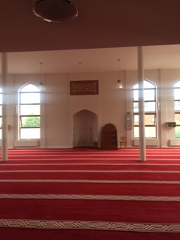
Figure 2 The Qibla Wall in Exeter Mosque, Exeter, UK. Blue arrow points to the Mihrab. Photo: Niema Bohrayba

When praying in a mosque, muslims face the Mihrab which in a correctly orientated mosque should be the direction of the Qibla. Facing the Mihrab, two apps were used to calculate the direction of the Qibla and comparing this with the orientation of the Mihrab of Exeter mosque. The rationale for using two apps was to compare and contrast the results from each app. The apps were installed on an iPhone 5 phone.
- Muslim Assistant: This app calculates both the Qibla direction and prayer times depending on the user’s location. The location of the mosque was manually inputted into the app through selecting the Exeter, UK option prior to use. The phone was laid flat on the palm of the hand and calibrated, the compass view was then selected. The phone was moved from side to side until the app’s compass needle turned from red to green (Figure 3) indicating that the Qibla direction is in the direction of the needle.

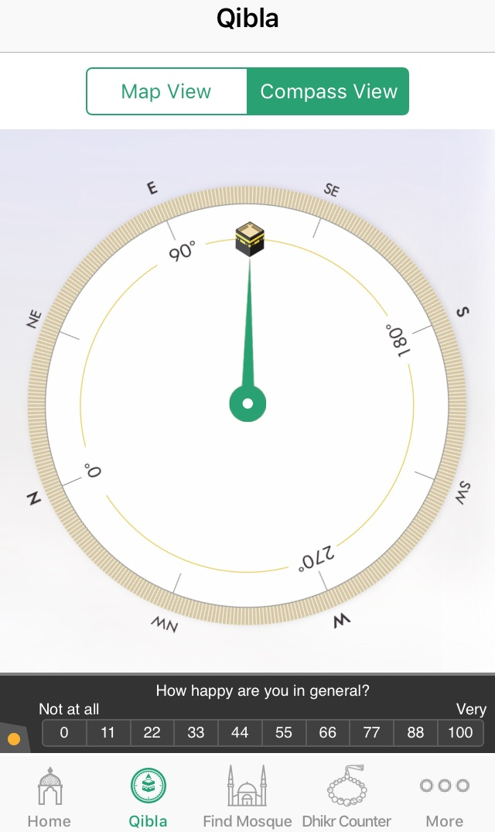
Figure 3 Screen Shot of Muslim Assistant App Compass View indicating the direction of the Qibla in Exeter mosque. Exeter, UK
- Qibla Compass: This app calculates the direction of the Qibla in accordance with the user’s location. The location of the mosque was manually inputted into the app through selecting the Exeter, UK option prior to use. The phone was laid flat on the palm of the hand and calibrated. The phone was then moved from side to side until the yellow arrow was aligned with the mini image of the Qibla app the app, and the background turned brown as shown in Figure 4 indicating that the direction of the Qibla is in the direction where the yellow arrow on the app is pointing.
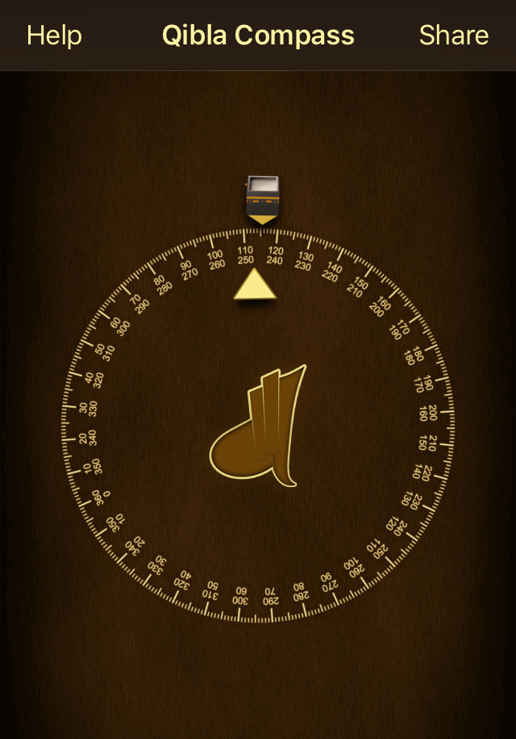
Figure4 Screen Shot of Qibla Compass indicating the direction of the Qibla in Exeter mosque, Exeter, UK

The readings obtained from both apps was then compared to the Qibla direction from Exeter using the Qibla Way calculator which identifies the direction of the Qibla from Exeter at 114.6º.
Visit two:
The second visit was conducted on the 28th of May 2018. During this visit, the direction of the Qibla was calculated using the direct sun method. This calculation was done by standing outside but within the grounds of the mosque parallel to the Qibla wall, and observing the position of the sun at exactly 10:18 am British Summer Time. The position of the sun and its shadow was compared to the alignment of the mosque’s Qibla wall.
Visit three:
The third visit was conducted on the 16th of July 2018. This was a second day when the direct sun method to calculate the Qibla direction could be used. This calculation was done be repeating the process undertaken during the second visit, however this time observing of the sun took place at 10:27 am British Summer Time. The positon of the sun and its shadow was again compared to the alignment of the mosque’s Qibla wall.
Findings and discussion:
On first experiencing the mosque on the first visit, the immediate impression of the mosque is how well it fits with the remainder of the street. With the exception of the signage identifying the building as Exeter mosque along with the visible dome and minaret, there are no obvious ways of concluding that the building was built in any way other than to fit with the layout of the street.
This immediately prompted a revisit of the definition of orientation proposed by King and Yilmaz which focuses on the orientation of the Mihrab and by default the Qibla wall towards the Qibla as opposed to the definition of orientation proposed by Pantazis and Lambrou which focuses on defining a mosque as Qibla orientated if the entirety of the building was orientated towards the Qibla.
In light of the first impression of the mosque, the latter definition seems vague. This view is further supported through the act of prayer itself. The orientation towards the Qibla is only required for the prayer aspect of the mosque’s function as outlined by Islamic doctrine, it is not required for any other activity the mosque may carry out.
This observation supports the definition of the orientation of the mosque being based on the orientation of the Qibla wall towards the Qibla and not the remainder of the building or indeed the building in its entirety. This is because there is no occupational need for the entirety of the mosque building to be orientated towards the Qibla because the rest of the building may be taken up with community based activities.
The measurements taken during the first visit involved finding the alignment of the Qibla using 2 apps (Muslim assistant and Qibla Compass) and indicated that the direction of the Qibla was located between (112º and 116º), this carries an error of ± 2º because the Qibla direction from Exeter as calculated by the Qibla Wall website and confirmed by a compass is 114.6º. Therefore the range between (112º and 116º), is well within the ± 50º tolerated error.
These measurements were then compared with the orientation of the Mihrab which was found to be at 115.0º. This means that the error is ±0.4 which again is within the tolerated error of ± 50º error.
This means that based on the measurements ascertained through the use of both Qibla measuring apps, the use of a compass and the calculation Qibla Way website, all confirm that the Qibla wall of Exeter mosque is Qibla orientated.
Measurements taken using the Direct Sun Method on both the 28th of May and the 16th of July 2018 were complimentary of one another in so much that both the sun’s position and the bearing of the sun’s shadow were orientated in a similar direction visually appearing to be in the direction between East and South East when compared with a compass.
This direction was then compared to the orientation of the Qibla wall of Exeter mosque which on both days was shown to be in alignment with the direction which had been identified from the previous visit as 115.0º with an error of ±0.4, from the calculated Qibla direction of 114.6º which is within the tolerated error of ± 50º.
This result is aligned with the results found using the Qibla apps, compass and the Qibla way website. Based on these results, the Direct Sun Method is shown to be a reliable method to calculate the Qibla direction. Despite its accuracy, it’s extremely limited in its use due to the fact that it can only be used twice a year, and the weather would have to be accommodating for it to be carried out successfully. Whilst the weather was described as a potentially limiting factor, on both the 28th of May and the 16th of July 2018, the weather posed no problem for the calculations.
Conclusion:
The Qibla orientation of Exeter mosque was measured using the Direct Sun Method and validated using two Qibla calculation apps (Muslim Assistant and Qibla Compass), an iPhone compass, and the Qibla Way calculation website. The results from the measurements show that the Qibla Wall of Exeter mosque is orientated towards the Qibla, and since this is the part of the mosque that is used by worshipers to determine the direction prayer, it is this part of the mosque that needs to be orientated towards the Qibla, when other parts of the mosque don’t have to be. The results of this study whilst small scale echoes the definition of mosque orientation proposed by King and Yilmaz, by considering not only the orientation of a mosque but the reason why the orientation must be in a certain way which is to accommodate prayer.
Niema Bohrayba

References:

Abdali, S. Kamal, Prayer Schedules for North America, (Indianapolis: American Trust Publications, 1978).
Al-Bukhari, The Book of Mosques and Places of Prayer (Sahih Bukhari, Chapter 13, hadith number 122)

Al-Khattabi, Muhammed al-Arabi: Ilm al-mawaqit: usuluhu wa manahijuhu (1986).
Al-Tusi, Nasir al-Din, Nasir al-Din al-Tusi’s Memoir on Astronomy (al-Tadhkira fi ilm al-hay’a), translated by F.J. Ragep (New York: Springer-Verlag, 1993).
David A. King, The historical mosques of Saudi Arabia (UK: Longman Group Ltd, 1986)

David A. King, The orientation of medieval Islamic Religious Architecture and Cities, (1995).

Exeter Mosque and Community Centre Website
www.exetermosque.org.uk
[Accessed 25th March 2018]

George, A. Cooke, A text-book of north-Semetic inscriptions, (Oxford: Clarendon Press, 1903). p. 238

George Pantazis and Evangelina Lambrou, Investigating the orientation of eleven mosques in Greece, (Athens: National Technical University of Athens, 2009).

Hammudah Abd el-Ati, Islam in focus, (Amana Publications, 2002).

Islamic Finder: www.islamicfinder.org/exeter
[Accessed 28th May 2018]
Jamea Masjid
www.jameamasjid.co.uk/ construction-project
[Accessed 25th March 2018]

Mohamed Nabeel Tarabishy, Orientation Specifications for Mosques. (2014)
www.icoproject.org/pdf/tarabishy_2014.pdf
[Accessed 29th April 2018]

Mustafa Yilmaz, Historical mosque orientation in Turkey: central-Western Anatolia Region, 1150-1590 (Turkey: Afyon Kocatepe University, 2012)

Nasir al-Din Al Tusi (1201-1274 AD) was a Persian polymath, architect, philosopher, physician and theologian. His works are described in his memoir. al-Tadhkira fi ilm al-hay’a.

Robert Hillenbrand, Islamic architecture: Form, Function and Meaning (UK: Edinburgh University Press, 1994).Muslim ‘Sahih Muslim: The book of Mosques and Places of Prayer.
The Muslim Council for Britain, ‘Ramadan 2018’. http://www.mcb.org.uk/ramadan
[Accessed May 1, 2018]
The telegraph ‘More than 200 Mecca mosques face the wrong direction’ April, 2009
https://www.telegraph.co.uk/news/worldnews/middleeast/saudiarabia/5110754/More-than-200-Mecca-mosques-face-wrong-direction.html
[Accessed 2 April, 2018]

Exetermosque.org.uk
Robert Hillenbrand, Islamic architecture: Form, Function and Meaning (UK: Edinburgh University Press, 1994). p. 28
David A. King, The historical mosques of Saudi Arabia (UK: Longman Group Ltd, 1986)
George, A. Cooke, A text-book of north-Semetic inscriptions, (Oxford: Clarendon Press, 1903). p. 238
Hammudah Abd el-Ati, Islam in focus, (Amana Publications, 2002).
Al-Bukhari, The Book of Mosques and Places of Prayer (Sahih Bukhari, Chapter 13, hadith number 122)
Muslim: The book of Mosques and Places of Prayer
Al-Khattabi, Muhammed al-Arabi: Ilm al-mawaqit: usuluhu wa manahijuhu (1986). p. 11
David A. King, The orientation of medieval Islamic Religious Architecture and Cities, (1995).
Mustafa Yilmaz, Historical mosque orientation in Turkey: central-Western Anatolia Region, 1150-1590 (Turkey: Afyon Kocatepe University, 2012)
George Pantazis and Evangelina Lambrou, Investigating the orientation of eleven mosques in Greece, (Athens: National Technical University of Athens, 2009).
Jameamasjid.co.uk/ construction-project
Nasir al-Din Al Tusi (1201-1274 AD) was a Persian polymath, architect, philosopher, physician and theologian. His works are described in his memoir. al-Tadhkira fi ilm al-hay’a. p 306
Mohamed Nabeel Tarabishy, Orientation Specifications for Mosques.
Islamicfinder.org/exeter
Qiblaway.com

