Digital Skills and Research Methods

Mohammed Shafi Mohammed Yar
2010170
University of Wales Trinity Saint David

Table of Contents
Introduction: 3
Rationale 3
Objectives 4
Literature review 4
Historical background on the use and development of VLEs 4
Positive Impacts of VLE 4
Negative Impacts of VLE 6
Role of VLE in during global pandemic 7
Primary Research and Research Findings analysis 8
Impact of Virtual Learning Environment on Students' Satisfaction, Engagement, Recall, and Retention 20
Conclusion and Recommendation 20
References 22

Introduction:
Digital study skills could embody economical literature looking, knowledge management, communication and collaboration skills, and having the ability to find out and replicate exploitation digital tools.
A virtual learning environment (VLE) is a web-based platform for the digital aspects. Its also known as an online platform all activities is about courses of study, usually within educational institute. The present resources, activities and interactions according to course structure and also provide different level of assessment with students. VLE is replicate and replacement of physical classroom environment for distance learners. VLE refers to a system that offer students digitally-based solutions for education. VLE helps faculties to create, store and disseminate content. Courses and lessons are also planned in this system. VLE can foster communication between students and professor. Higher education institutes often use VLE for wider learning management system. There have many positive and negative impact of virtual learning environment (Suwardy, 2003).
Because of COVID-19 situation most of the educational institutes operating their educational activities through online. 95% of UK universities has VLE. University of Wales Trinity Saint David London Campus also proceeding its activities virtually. This report is developed on the impact of virtual learning environment (SW Chou,2005).

Rationale
One of the criticisms that VLE often levelled is the obvious prevalence of instructor-centered pedagogies which represent the classroom or lecture theatre. However, learning is now become barrier less because VLE widely acknowledged to be socially situated (GM McKhann,2000). VLE informed by the ideas that learning is a process of constructing knowledge rather than acquiring this, another one is learning is a process that involves supporting construction rather than communicating knowledge.
Effective use of VLE could have positive impact on students on the other hand misuse of technology can be dangerous for students. So, this depends on user whether they can use this process effectively or not (Uzunboylu,2011).

Objectives
Main objective of VLE is to make learning material and knowledge available in vast population. This project focused on design and implement a new and innovative teaching technology. Which is cost-effective, flexible and high-quality learning system for students. This system enhances the quality of education (R Ahmad, 1998).

Literature review
This literature review outlines the background and development of VLE. How VLE support the teaching and learning system. It starts with positive and negative impacts of VLE use. And the specific impacts of VLE on individual learning and motivation (Montalbo, 2014).

Historical background on the use and development of VLEs
It is not clear when exactly and how long VLE have been in use. The UK’s Open University have been utilizing the computer learning since the 1970. By 2010 over 3700 educational institutions in more than 60 countries started use the blackboard software. The most popular VLE was introduced in 2001. By 2011, 212 countries with 49635 active sites were constructed (Cornips, 2013).

Positive Impacts of VLE
VLE has impact on both teacher and students. Benefits of virtual learning environments for teacher and students. For students VLE allow them to self-paced learning opportunity and learn new skills without having to travel. Students can learn anything at any place, any time. Virtual learning is one of the gifts of time. By the use of E-learning students can learn at their own time and phase. E- Learning also helps students who live distance place (Barker, 2013). If professor is from UK and student is from Germany still, they can connect with each other on virtual platform. This system also enhances collaboration a communication between teacher and students. By the help of VLE time management become effective and efficient. This system gives student and teacher a worldwide exposure. This is a best combination of structure and freedom, and student can get immediate feedback on tests. Virtual learning also saves money for teacher, students and organization as well.
Time- Saving:
There are lots of advantages of VLE. Among them time saving is most convenience one. By the help of this both student and teacher can save their multiple precious hours and ton of money. As students do not need to step out of the house to go to the School\ College to learn. Moreover, educational institutions also can skip many operational activities and save money. Also, student can study at specific time and manage all the other chores of home without any trouble (Cultura, 2017).
Increased Convenience
Virtual learning is flexible for students. Most of the time there are no restrictions for students on getting late to class. Even if students miss any classes, they can get the lecture record. It also helps them in absorbing class content efficiently. Students and educator also can decide assignments, exam and tests at the time which suits best (TJ McGill, 2008).
Sharpen Digital Skills
While students are increasing the knowledge and skills in the area of study, the will also able to learn or expertise in digital skills by using of online learning technology (Suwardy, 2003).
Super Affordable
Virtual learning saves money for both the students and the institutions. The cost of set up a physical classroom is not concern when teaching goes online. Similarly, student also can save money as they do not need to go to the organization (SW Chou,2005).
Immediate Test & Exam Results
Instant feedback is another significant advantage of the web-based learning system. The time student give exam they can receive feedback instantly. In traditional learning process students need to wait some curtain period to get the result after evaluate. But in virtual learning they can reduce the time (GM McKhann,2000).

Negative Impacts of VLE
Every possible thing has advantage and disadvantages. Though there are many positive impacts of VLE, there have also some disadvantages of e-learning.
Infrastructural Challenges
Firstly, there need lot of expenditure to set up the virtual classes. Infrastructure needs to upgrade to support the new tech. students also need to have upgraded devices. In many cases, lacking of infrastructure forms an obstacle in virtual classes (Uzunboylu,2011).
Extra Training
When people use new tech for the first time it is important to know about the process. There are only few students and professor who are expert with new technology. So there has to be a training process so that everyone can utilize the technology. There is always need to have IT support for any troubleshoot. Some cases teacher fine difficulties to prepare soft copies of lecture/notes (R Ahmad, 1998).
Lack of Social & Emotional Skills
Since the classes take place over the online platform, so there isn’t much face-to-face or physical interaction among the students. Which needs to loss of social and emotional skills in the child.
Physical Activity Is Compromised
When all the classes conducted in virtual platform students do not get the change to go to schools/colleges. Usually when students are at schools the move around, run, play and do all kind of physical activities which keep them fit physically. The PT classes, sports, dance etc. helps them to active physically. Because of online classes their activities often neglected. Moreover, they need to just sit and stare at screen on desktop or laptop what they have signed up for (Montalbo, 2014).

Effects of Excess Screen Time on Students
The blue light of screens can damage human body in large extent.as they need to constantly staring at the screen which can be reason for eyes damage and may lead to many other problems in future. Regular breaks are advised when we use laptop/phone screens (Cornips, 2013).
Reduced Personal Interaction between Teacher & Students
Because of VLE the interaction between teachers and students are decreasing. There is no physical approach and Q&A session between them.

Role of VLE in during global pandemic
COVID-19 is the global pandemic that entire world facing right now. Because of this pandemic over 1.2 billion children in 186 countries are out of class. COVID-19 resulted school/collage shut across the world. Education system has changed dramatically (Barker, 2013). Education system is undertaken by digital platforms. VLE has played a vital role in education during this pandemic period. As VLE has impact on both teacher and students. Benefits of virtual learning environments for teacher and students. For students VLE allow them to self-paced learning opportunity and learn new skills without having to travel. Students can learn anything at any place, any time. Virtual learning is one of the gifts of time. By the use of E-learning students can learn at their own time and phase. E- Learning also helps students who live distance place. If professor is from UK and student is from Germany still, they can connect with each other on virtual platform. This system also enhances collaboration a communication between teacher and students. By the help of VLE time management become effective and efficient. This system gives student and teacher a worldwide exposure. This is a best combination of structure and freedom, and student can get immediate feedback on tests. Virtual learning also saves money for teacher, students and organization as well (Cultura, 2017).
Before COVID-19, VLE already had a high growth and adoption in technology. In response of significant demand, many online platforms are offering free courses and services.

Primary Research and Research Findings analysis

For conducting a primary quantitative research, the survey method is chosen. For conducting the survey among the randomly chosen 50 VLE students, the survey questionnaire is designed based on five-point Likert scale. The survey is conducted through online sur vey method (Costley, 2010). So, for the quantitative research, the primary data is collected by utilizing the following survey questionnaire about this research on the impacts of VLE. The survey questionnaire is presented in below:
 | Questions | Strongly Disagreed | Disagreed | Neutral | Agreed | Strongly Agreed
Q.1 | Virtual Learning Environment (VLE) is a crucial learning approach.
Q.2 | VLE approach can improve the involvement of the students.
Q.3 | The VLE approach has benefitted the students and teachers through saving lots of time and developing their digital skills.
Q.4 | VLE has become one of the most important learning methods in this pandemic situation of Covid-19.
Q.5 | Because of the affordability, VLE can be accessed by different students from social and cultural background.
Q.6 | The fast procedures of exam and result has improved the motivation of students.
Q.7 | The VLE has vital influence to the improvement of the students recall.
Q.8 | VLE has positive influence to the development of the satisfaction of students.
Q.9 | Regarding the retention of students, VLE has very effective and positive impacts.
Q.10 | Overall, the VLE has significant role in improving the learning approach of students in the Covid-19 Pandemic.

Primary Data Analysis and Research Findings
The collected primary data through the survey method is analyzed and presented in a data excel data table in below. From the collected primary data analysis and data table evaluation, the research findings are illustrated in the following excel graphical charts.

- Q.1 Virtual Learning Environment (VLE) is a crucial learning approach.
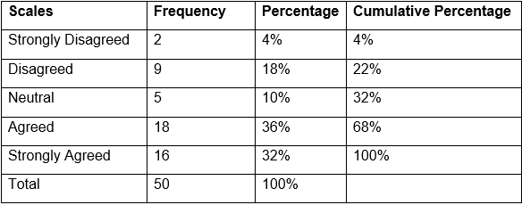
It can be identified that most of the survey participants (about 36%) are agreed that Virtual Learning Environment (VLE) is a crucial learning approach.
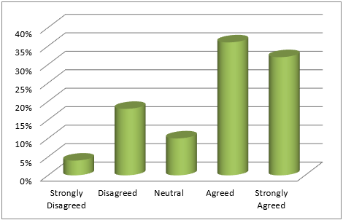

- Q.2 VLE approach can improve the involvement of the students.
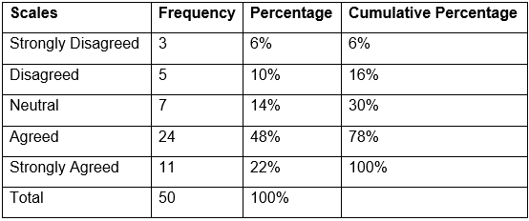
Based on the primary data analysis table and following graph chart, it can be found that most of the survey respondents (about 48%) are agreed with the question. So, it can be concluded that VLE approach can improve the involvement of the students.
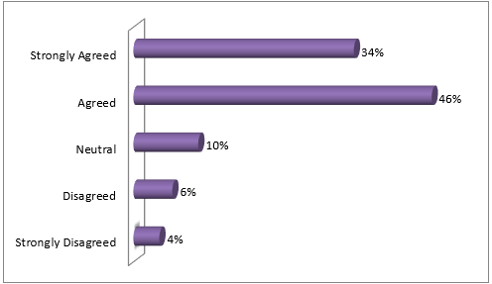

- Q.3 The VLE approach has benefitted the students and teachers through saving lots of time and developing their digital skills.
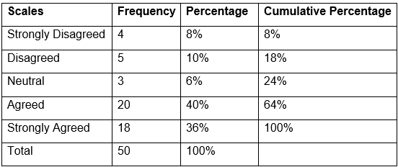
In this survey responses analysis, it can be identified that most of the survey participants (about 40%%) are agreed that the VLE approach has benefitted the students and teachers through saving lots of time and developing their digital skills.

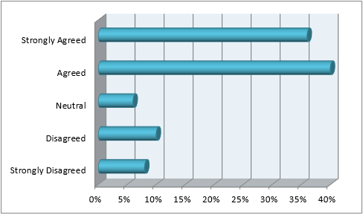

- Q.4 VLE has become one of the most important learning methods in this pandemic situation of Covid-19.
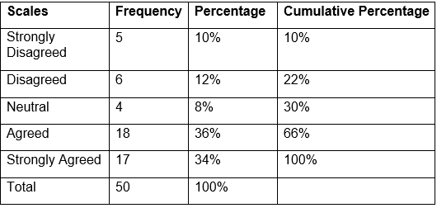
Based on the primary data analysis table and following graph chart, it can be found that most of the survey respondents (about 36) are agreed with the question. So, it can be concluded that VLE has become one of the most important learning methods in this pandemic situation of Covid-19.
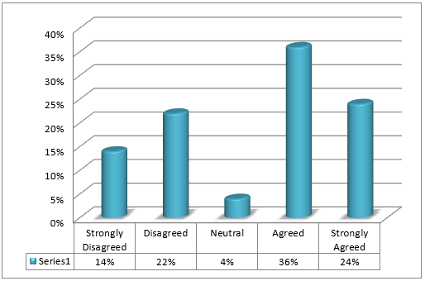

- Q.5 Because of the affordability, VLE can be accessed by different students from social and cultural background.
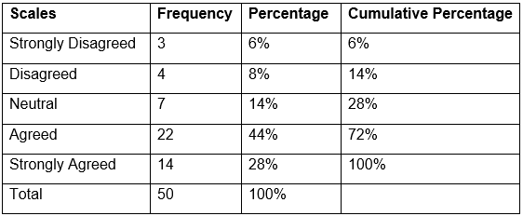
In this survey responses analysis, it can be identified that most of the survey participants (about 44%) are agreed that because of the affordability, VLE can be accessed by different students from social and cultural background.

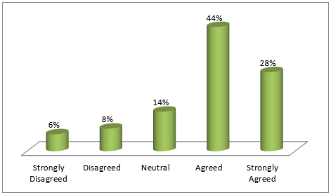

- Q.6 The fast procedures of exam and result has improved the motivation of students.
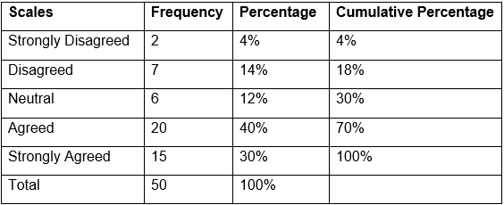
Based on the primary data analysis table and following graph chart, it can be found that most of the survey respondents (about 40%) are agreed with the question. So, it can be concluded that the fast procedures of exam and result has improved the motivation of students.

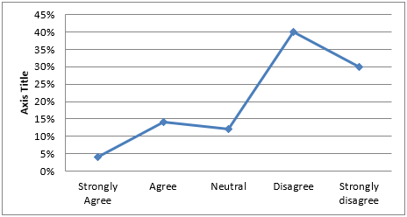

- Q.7 The VLE has vital influence to the improvement of the students recall.
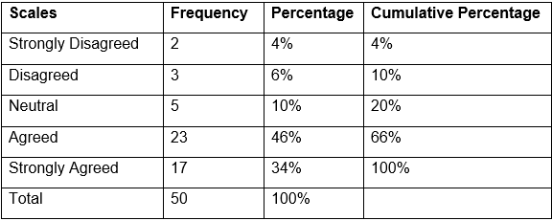
In this survey responses analysis, it can be identified that most of the survey participants (about 46%) are agreed that the VLE has vital influence to the improvement of the students recall.

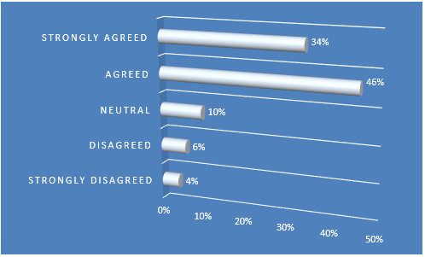

- Q.8 VLE has positive influence to the development of the satisfaction of students.
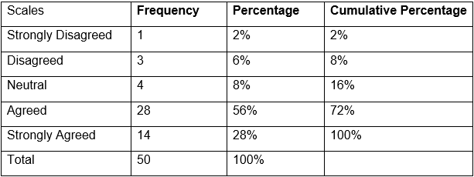
Based on the primary data analysis table and following graph chart, it can be found that most of the survey respondents (about 56%) are agreed with the question. So, it can be concluded that VLE has positive influence to the development of the satisfaction of students.

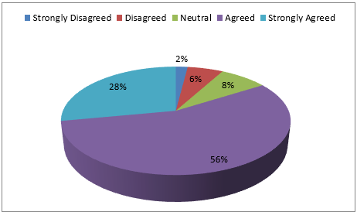

- Q.9 Regarding the retention of students, VLE has very effective and positive impacts.
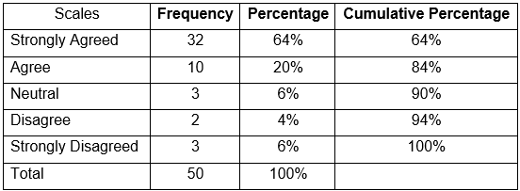
In this survey responses analysis, it can be identified that most of the survey participants (about 64%) are strongly agreed that regarding the retention of students, VLE has very effective and positive impacts.

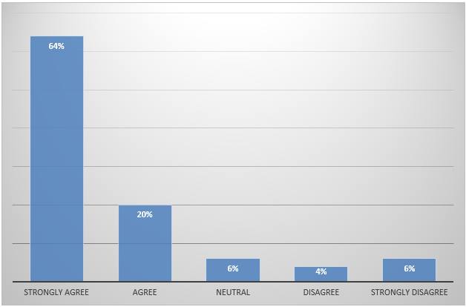

- Q.10 Overall, the VLE has significant role in improving the learning approach of students in the Covid-19 Pandemic.
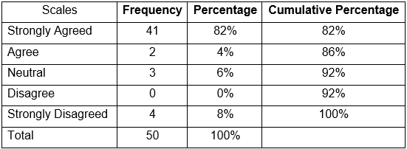
Based on the primary data analysis table and following graph chart, it can be found that most of the survey respondents (about 82%) are strongly agreed with the question. So, it can be concluded that overall, the VLE has significant role in improving the learning approach of students in the Covid-19 Pandemic.

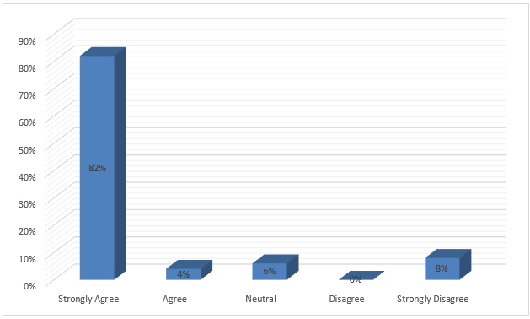

Impact of Virtual Learning Environment on Students' Satisfaction, Engagement, Recall, and Retention
An irregular management trial was conducted with students haphazardly attending one in all 2 teaching sessions concerning radiation. Each session was identical except a VLE was utilized in the second speak with the primary being entirely instructive. Anonymous questionnaires were distributed. Period when the talks, participants were needed to finish identical data form to work out retention. Mann-Whitney, means, commonplace deviations, and chi-squared tests were used in step with information characteristics. Qualitative information (open-ended questions) was analyzed thematically (TJ McGill, 2008).
Result:
Virtual learning appeared to considerably improve students' satisfaction/engagement and recall. a complete of forty students attended the teaching sessions (Suwardy, 2003). The coed cluster tutored exploitation the VLE had higher mean scores for retention than the instructive group; but this wasn't statistically important. Use of VLEs was related to larger satisfaction/engagement than instructive info Students' learning designs appeared to don't have any impact on their satisfaction/engagement and simple learning. 3 key themes emerged from the qualitative data: (1) the visuals were good/helpful, (2) the speak was informative, and (3) additional details/visuals were needed.

Conclusion and Recommendation
VLE refers to a system that offer students digitally-based solutions for education. VLE helps faculties to create, store and disseminate content. Courses and lessons are also planned in this system. VLE can foster communication between students and professor. Higher education institutes often use VLE for wider learning management system. There have many positive and negative impact of virtual learning environment (SW Chou,2005). Virtual learning is one of the gifts of time. By the use of E-learning students can learn at their own time and phase. E- Learning also helps students who live distance place. If professor is from UK and student is from Germany still, they can connect with each other on virtual platform. This system also enhances collaboration a communication between teacher and students. By the help of VLE time management become effective and efficient. This system gives student and teacher a worldwide exposure. Virtual learning appeared to considerably improve students' satisfaction/engagement and recall. a complete of forty students attended the teaching sessions. The coed cluster tutored exploitation the VLE had higher mean scores for retention than the instructive group; but this wasn't statistically important. Though there are many positive impacts of VLE, there have also some disadvantages of e-learning (GM McKhann,2000).
Some recommendation for virtually learning environment are:
- Educational institutions should aware about online safety and cyber wellness.
- Professors should monitor students’ progress efficiently.
- Need to motivated and engaged students about learning.
- Establish an accessory learning culture. Every member of the training community ought to have the sensation of connectedness (Uzunboylu,2011).

References

P De Lange, T Suwardy, F Mavondo - Accounting Education, 2003 - Taylor & Francis
SW Chou, CH Liu - Journal of computer assisted learning, 2005 - Wiley Online Library
HR Goldberg, GM McKhann - Advances in physiology, 2000 - journals.physiology.org
H Uzunboylu, H Bicen, N Cavus - Computers & Education, 2011 – Elsevier
R Ahmad, G Piccoli, B Ives - ICIS 1998 Proceedings, 1998 - aisel.aisnet.org
C Chua, J Montalbo - Information and Knowledge Management, 2014 - academia.edu
EMJ Cornips, K Rijkers, JSH Vles - European Journal of, 2013 – Elsevier
J Barker, P Gossman - Teacher Education Advancement, 2013 - insight.cumbria.ac.uk
LH Mosquera - Íkala: Revista de Lenguaje y Cultura, 2017 - search.ebscohost.com
TJ McGill, VJ Hobbs - Journal of Computer Assisted Learning, 2008 - Wiley Online Library
Costley, C., Elliot, G. and Gibbs, P. - Doing Work Based Research: Approaches to Enquiry for Insider-researchers, 2010 - London: SAGE.
Gray, D. - Doing Research in the Real World, 2009 - 2nd Ed. London: SAGE.

