Manufacturing, Design and Technology
ACMA5002

Design, Development and Manufacturing – 3-Jaw Co-bot End-effector
Bryony Stanfield
2008682

Contents
List of figures 3
Introduction 4
Concept design appraisal 5
Manufacturing Process Proposal 9
Design and Development work undertaken 13
Manufacturing Process Design 20
Conclusion 23
References 24

List of figures

Figure 1 Market requirements 6
Figure 2 Life in service requirements 6
Figure 3 Production requirements 6
Figure 4 Conformance requirements 7
Figure 5 Design specification 7
Figure 6 Quality function deployment 8
Figure 7 Gripper design 9
Figure 8 Housing design 10
Figure 9 Drive plate design 11
Figure 10 Lucas method table 14
Figure 11 Measuring improvements percentages 15
Figure 12 FMEA 19
Figure 13 Investment casting manufacturing process 21
Figure 14 Injection moulding manufacturing process 21
Figure 15 Assembly process for Co-Bot Gripper 22
Figure 16 Shopfloor process layout 22

Introduction

The Aim of this report was to take a concept design and turn it into a manufacturable solution. I also had to take into consideration the types of materials being chosen, the process to make it and using off the shelf products so that there were standardised components. The Product which I will be looking at enhancing is a 3 Jaw End effector which will be used on co-bot systems, this gripper must be able to pick and place parts during its operation.
This report will detail my design activity along with my final design of the 3 jaw gripper end effector. Currently there are 7 individual parts of this component that’s excluding fixtures or fasteners to ensure the part stays together. Undertaking the redesign of the gripper I need to take into consideration that when going into manufacturing between 1000 to 2000 units will be being produced per week.
This Report will cover processes and techniques showing and proving the redesign of the gripper, giving reasons why my solution to the redesign would be best for the job.
(R.Morgan, Gripper, CAD 2021)

Concept design appraisal

Customer Needs
The customer has come with the initial design of the 3 jaw Gripper, I have looked at this and have made some key feature changes to help improve the manufacturability and also to ensure that the product does not get damaged during the pick and place procedure.
The customer has pointed out that the product that will be getting picked up needs to have little to no marks left on the materials surface after the pick and place operation has taken place, but it also has to make sure that it has enough pressure to ensure that the part is held safely during its manoeuvre. There was also a possibility that for future growth the gripper could potentially get used in another processes picking up other parts/shapes which could potentially be smaller or larger in size. There were a few key features that the design had to meet for the customer, these were things such as
- Needs to be low cost
- Strong
- Lightweight
- Integration to the rig to be easy
- Good Gripper pressure
- No damage to part picked up by gripper
- Good surface finish
- Non corroding
- Long lasting material
- Work in humidity level (45-75%)

End user needs
The concept design which has been provided by the customer had specific end user needs attached to it. The concept design not only had to be changed to become manufacturable, it also had to comply with the user needs. There were a few key features that the design had to meet, these were things such as
- Hold a cylindrical component.
- Must not over apply pressure.
- Must be able to hold 1.3kg (Metal cylinder containing volatile material)
- Must cope with Humid conditions (55-60%)

To follow on from this there are also specifications and requirements that need to be met to ensure that the product meets the customer and end user needs. To do so I compiled specifications under various categories, to help develop/refine the product from the concept design.

  - Design Specification
Market requirements
Requirements | Specification
Target Price | Selling Cost | The cost for the end effector must not exceed £1150
Target Price | Maintenance Costs | The maintenance costs would vary between £100-300 dependant on fault/failure & man hours
Product Performance | Retract Speed | <15mm/s
Product Performance | Gripping Force | Up to 35Nm
Product Performance | Product Weight | >1300g
Product Performance | Max. Recommended Payload | >10kg
Product Performance | Repeatability/Tolerance | 0.075mm
Product Performance | Gripper Opening Width | 50mm
Appearance | Colour choice | Natural Metal Finish with Anti-Static coating
Appearance | Material Choice | No Burr’s, Smooth Edges
Figure 1 Market requirements
Life in service requirements
Requirement | specification
Target life in service | 10 Years (If maintained)
Operating environment | Humid environment
Disposal requirement | Recycled materials / Serviced components
Maintainability/Accessibility | Minimal Maintenance lubrication tasks
Easy Assemble/Re-Assemble | Minimal components to strip down
Interchangeability | Must conform with customers Co-bot systems
Replacement units/components | COTS components
Installation | When following manual, using all steps required, installed in <10 minutes
Figure 2 Life in service requirements
Production requirements
Target manufacturing costs | Should not cost more than £550.00 per unit (NVA not included)
Quantities | 1000 – 2000 units per week. This will be subject to customer demand, in order to reduce the amount of inventory on site.
Materials | Aluminium
Manufacturing processes | Casting and Milling processes
Assemble methods | Hand Assembled
Product size | L - 655mm D - 100mm
Product weight | Less than 6kg
Off the shelf components to standardise | Fasteners, motor etc
Figure 3 Production requirements

Conformance Requirements
Industry standard | HSAWA 1974, ANSI/RIA R15.06, HSG43
Company standards | Must be IP66 rated for environment intended
Product compatibility requirements | Compatible with customers already in service co-bot system
Testing requirements | Repeatability testing, Maximum Lifting, Max grip pressure, Stress testing
Statutory Requirements | CE Marking
Safety Requirements | HSAWA 1974, Electrical equipment safety, ISO 10218-1
Property Rights | GD patented item
Figure 4 Conformance requirements
3 Jaw Gripper Design Specification
Performance Req | Design Req | Design Spec
Must be Manufacturable | Must use effective processes | Most cost effective and minimum waste processes
Must be affordable | Must be low cost | <£1150 (complete unit price)
Must be strong | Must be ridged and durable | Withstand 30 Nm
Must hold components | Must have good gripper pressure | Must have variable pressure between 5 – 20 Nm
Must be easy to assemble | Must be light weight | Must be less than 6kg
Must not damage products | Must have non marking jaws (soft jaws) | Non marring material
Athletically pleasing | Must have smooth/Good surface finish | Material which is easy to apply finishing processes to
Withstand Humidity | Must not corrode | Non corroding material
Must be Durable | Tough material | Material must be strong and ductile
Figure 5 Design specification
Public Perception
In order to engage with the public perception for the benefit of the customer, It would be valuable to the customer (in order to offer an understanding of what the company are able to offer with this technology) to explain to their end user that by investing in this technology, how it will benefit the customer, thus garnering support for the product and increasing positive perception and generating sales revenue. As observed by the range document on public perception of engineering, this showed that there is an overwhelming lack of understanding as to what engineering is or does for society. The general consensus is that “engineers fix things” but other than that there appears to be a gap in knowledge for various disciplines or even parts of the process with regards to product development and improvement. It is observed that the bulk of the knowledge with regards to what engineering is or can be, resides in older generations or in higher social/education circles. As mentioned above, our customer would benefit from explaining to its end user their reason for developing & choosing to use this new technology, how they came to the decision and how it will improve their product and what positive effects it has for the end user.
(Public perception, RAE-ETB cover and text)
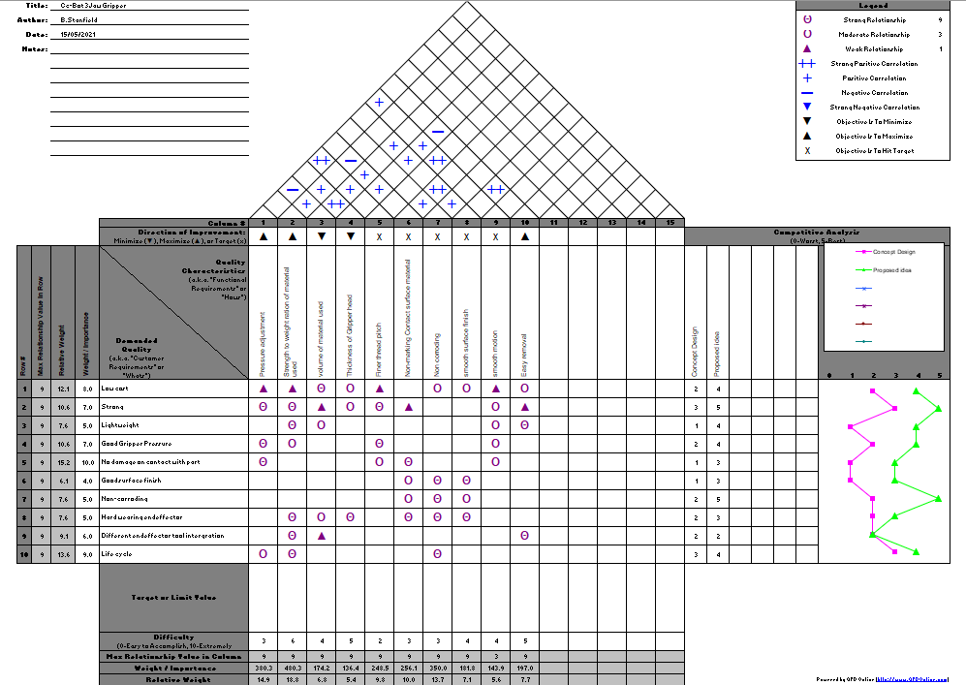
Quality function deployment
Figure 6 Quality function deployment
(What Is Quality Function Deployment (QFD) and Why Do We Use It?, n.d.)

Manufacturing Process Proposal

Business and Company Needs –
Having been tasked with easing the manufacturability of the end effector to suit the customer, I felt that it would be important not to be led down the path of attempting to re-invent the design already given by the customer. Instead, I will be making subtle adjustments that I feel will positively improve the design and make it the most suitable solution for our customer.
In order to remain competitive, I will reduce costs in areas where I believe it safe and sensible to do so, and invest in other areas which will make the product unique, i.e. The more tailored part of the End Effector. Notably, I will be focussing my attention on the actuation process of the Effector and the profile of the Jaws. I believe that focusing on these two parameters will focus my goal and hopefully yield a product that is the most effective for its purpose.
Justification for manufacturing processes –
Grippers
I have decided that the most cost-effective production method for the Jaws of the end effector would be to injection moulding them from plastic materials. Certain plastics are high strength and come in a variety of types to suit the strength/weight ratios for different uses.
When selecting an injection method, I thought about several factors but came to a decision based on the suitability for my product.
Injection Moulding process
The process of injection moulding involves injecting the molten plastics into the pre-lubricated multi-use mould at a high pressure. This pressure is maintained throughout the cooling process until the piece has completely set. Injection moulds have a higher initial cost due to the machining requirements, but are perfectly suited to high-production runs, if the design has been made to correctly input the parameter to help speed to process up. Which is why I have selected it as the manufacturing process, as we are looking to produce in high volume and to within a greater degree of accuracy than what a single-use mould can provide.
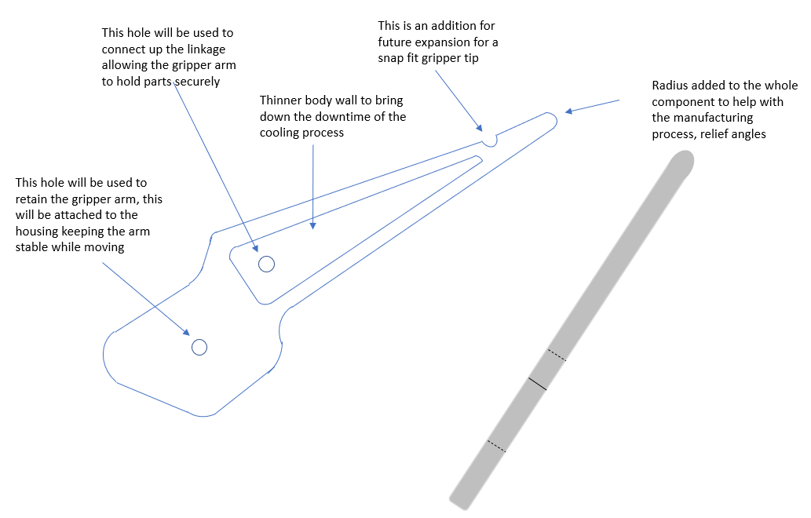Figure 7 Gripper design
Housing
Due to the complex nature of the Housing shape, I feel that it would be most cost effective to invest in an investment casting process. Investment casts are particularly favourable for parts that require more precision and are of an awkward shape. By choosing an investment cast, we would only need to mill off small amounts of material if needed to form the finished cast. This would be quicker and less wasteful than turning from a full block and then putting it through another process.

Investment casting process
The housing will be constructed from Aluminium, this will help to reduce the weight of the finished product. I will also increase the wall thickness on the housing as there is an unnecessary overhang from the mounts into the body of the housing, creating a difficult solution for machining/creating the part.
I considered using only Lathes and Milling machines to create the housing, however, in order to replicate these parts on such a large scale in line with the customer requirements, it would be more cost effective to batch cast with investment casting, than to either add time using few lathes, or over-investing in more lathes in order to cope with production volume.
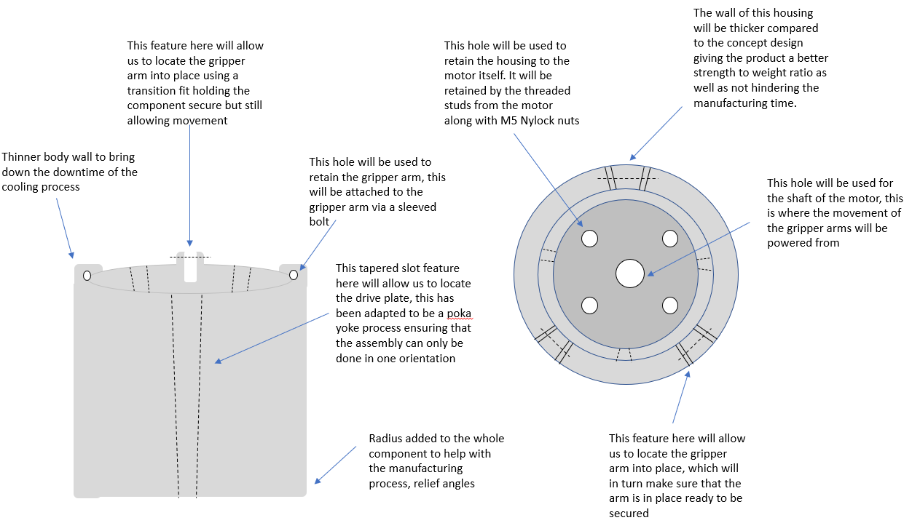
Figure 8 Housing design

Drive plate
Due to the complex nature of the Drive plate shape, I feel that it would be most cost effective to invest in an investment casting process for the plate. Investment casts are particularly favourable for parts that require more precision. By choosing an investment cast, we would only need to insert a tap into the finished cast. This would be quicker and less wasteful than milling a full block and then putting it through another process.
Investment casting
The drive plate will be made using an investment casting process. The plate will be constructed from Steel, this will help to product a quality finished product. I will also decrease the thickness of the drive plate as there was unnecessary amount of excess materials being used. As for the mounts into the body of the drive plate and the holes these will be created in the same process.
Lathe/Bench work
Dependant on the number of components being ordered by the customer this process will act as a JIT process. The tap will be run down the internal hole of the drive plate creating a thread for the plate to be driven up and down the threaded shaft giving the movement to the grippers.

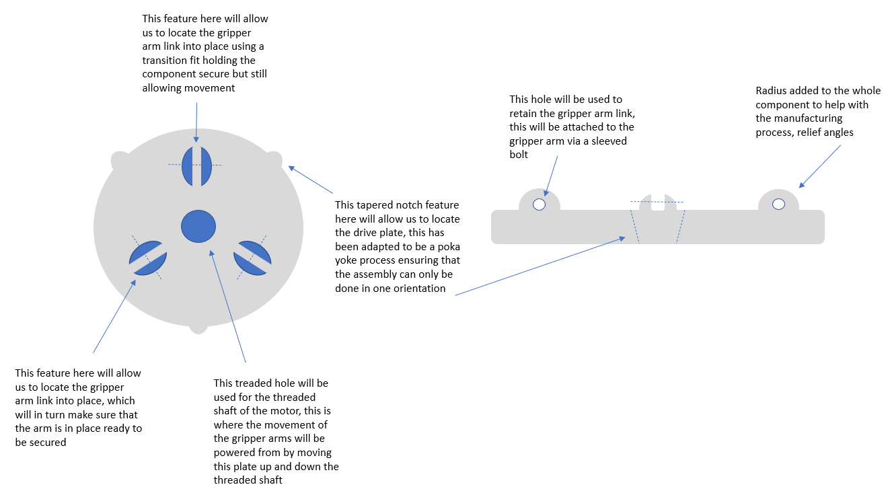
Figure 9 Drive plate design

Fastenings
In order to reduce costs, I will be utilising off the shelf fixtures and fastenings for securing the jaws of the end effector and the chuck arrangement. Any Bolts, Grub-Screws or threaded bar will be stainless-steel, but will be bought in bulk.

Drive shaft and Worm
The worm will be connected to the shaft (drive) via an interference fit. I have decided upon interference fit as a solution to cut down on unnecessary manufacturing steps when working on individual pieces. I considered an opposite thread fitment from shaft to worm, with a locking grub screw, but decided it was over-working the piece.
I will also increase the wall thickness on the housing as there is an unnecessary overhang from the mounts into the body of the housing, creating a difficult solution for machining/creating the part. Any holes or cut-outs that cannot be fabricated on the lathe, will be moved to a milling stage for the piece.

Future expansion - Gripper snap fit cap
For future expansion and an ‘excitement’ for the customer I ensured that when the gripper arm was being designed I added additional features to make room for improvements. The improvement to the part was make it compatible with a snap fit feature for the use when different component are being produced on the pick and place line, the snap fit cap would take into consideration the shape it was picking up to allow safe transportation.

Design and Development work undertaken

Design for manufacturing (DFM)
Standardising components
The use of standardised components helps with regards to the buying products in from suppliers and being able to fit them to the product with no alterations being made, making them a easily sources part as well as them being a non-essential part according to the Lucas method.
The standardised components that will be used in my design are this such as the fasteners. Each fastener on the product will be exactly the same as this reduces the risk of the incorrect fastener being used for the incorrect components fitting. The fasteners I will be using will all be M5 bolt and sleeved thread. Using the sleeved thread will also protect the material of the components from wear, acting as another barrier.

Tolerances
I applied tolerance to all of the component but where the tolerances were more critical this is where I applied more in depth detail to ensure that the components integrated with each other and would not cause failure on behalf of the tolerance of the tool.

Injection moulding
The reason I have chosen injection moulding is because of the time, precision and cost effectiveness of the part being made. With regards to the time of the components being made the gripper Arms have been designed with draft angles for ease of ejections and the wall thickness of the component being made thinner decreasing the cooling time. With regards to cost this is a very cost effective way of producing batch components and every component being calculated for the correct amount of shot to be used.

Investment casting
The reason I have chosen Investment casting is because of the relative complexity of the housing shape. If I were to turn the housing, as well as mill the housing, this would be very time consuming and not particularly economical. With investment casting, you can ensure quality, create more complex shapes, cast in large batches, and will only need to mill out/around finishing touches. This will speed up the otherwise very time-consuming process for this particular part.

Design for assembly (DFA) –
Lucas Method
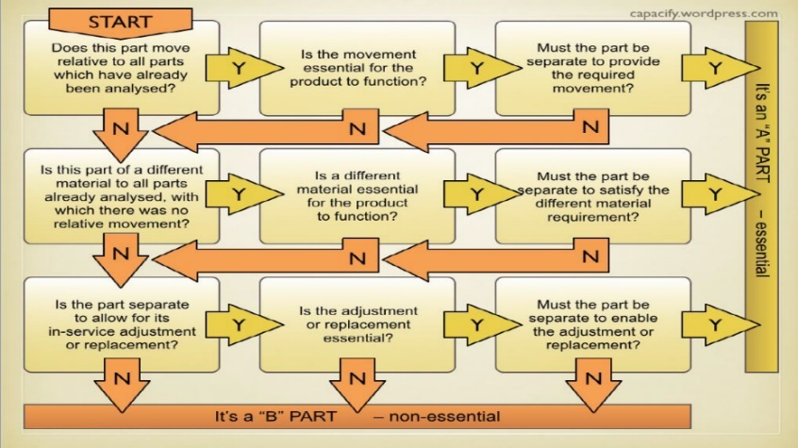
The Lucas methodology is a method which is used to try and establish which parts are essential and which are non-essential. Below I have composed a table with the parts all identified by following the flow chart.

(Farr and Farr, 2021)

Parts | Essential (A) | Non-essential (B)
Gripper | x
Housing | x
Drive plate | x
Worm | x
Shaft | x
Motor | x
Linkage | x
Sleeved nut and bolt |  | x

Figure 10 Lucas method table
All non-essential parts should be evaluated and if possible be designed out, in some cases this is not always possible. In this case I was unable to design the sleeved nut and bolt out of the design due to the characteristics of the maintainability and serviceability of the complete product. I must allow for the components to be taken apart to allow for the customer ease of maintaining the product as stated in the FMEA. The design for efficiency of this product is 87.5%. I arrived at this percentage by using (A / A + B) x 100.

Measuring Improvements
 | Concept | Re-design | Improvement
Assembly time (hrs) | 1.25 | 0.75 | 40%
Number of parts | 7 | 6 | 15%
Number of operations | 9 | 6 | 30%
Fabrication time (hrs) | 10 | 7.25 | 28%
Downtime/waiting on parts (hrs) | 25 | 10 | 60%
Design for efficiency

Figure 11 Measuring improvements percentages
Simplify design and reduce the number of parts
I have kept the number of components the same as the concept design as If I were to integrate two components together with would add a more complex part to manufacture as well as increase the potential cost due to more steps in the processing and more time designing the movement of the part. Also I kept the number of parts the same as if there was to be any wear on one individual component it would cost less to replace the one component rather than a specialised part. The number of parts altogether are 7 individual components, 3 of these components being manufactured in house and the other 4 components being purchased from suppliers, this excluded the fixtures and fittings.
Standardise and the use of common parts
Fixtures and fastening
I would like to keep all fixtures and fastenings the same M5, to ensure that the correct parts are used. This will eliminate the risk of incorrect fastenings being used. For example, cross threading different pitched bolts or nuts. It will also speed up the assembly process. With fewer combinations of different types of fastenings, operators will only have to choose from a small selection of different bolts and fastenings, this will save time and again, help to eliminate mistakes.

Components
Links
The three link arms will all be bought in from an outside supplier allowing us to focus our interest on the main components. All three links will all be identical components with the same size hole this will ensure that the part, no matter what way it is inserted will work regardless of the orientation it has been fitted.
Shaft and worm
Both the Shaft and worm will be bought in from an outside supplier these will be fitted together prior to the assembly for the overall component and will be using an interference fit to ensure that they stay together through their production life.
Motor
The Motor will be sourced from a reasonable well known source ensuring that the life of the product will be easy to maintain with easy access to servicing and replacement components.

Mistake-proof product design and assembly
With regards to mistake proofing the product I had added some key design features to ensure that the product will only go together one way. This is to ensure that on assemble or reassembly after servicing/maintenance task that the product goes back together with ease and correctly. To do so I have added tapered tabs to the drive plate, these tabs will then located into the tapered slots of the housing.
For future growth and expansion, I have also included a snap fit feature which will allow different material jaws to be used for example a soft jaw this would be classed as an excitement in regards to the ‘Kano model of quality’
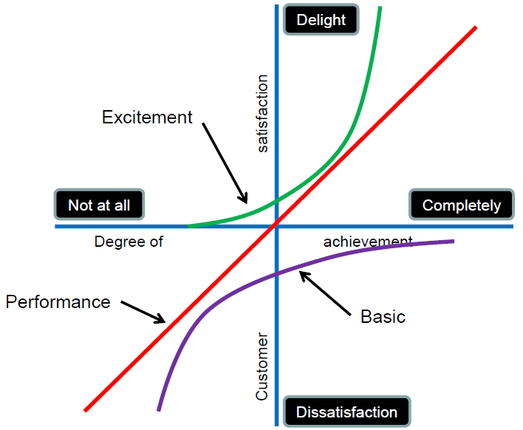

(Kano, N. Quality Function Deployment, (1992))

Design for environment
Design for environmental processing and manufacturing
The processes chosen for the manufacturing of these components have all taken into consideration the amount of time and amount of materials to be used. Cutting down on time and material helps cut down the consumption of both energy used to process the part and also cuts down on excess waste materials.

Design for disposal or reuse
All metal components will be able to be melted back down in the raw material to be either reformed or moulded for other purposes, making this product much more environmentally friendly. The motor will be serviceable by the manufacturer of the product and kept maintained by the customer.

Environmental/product life cycle factors considerations
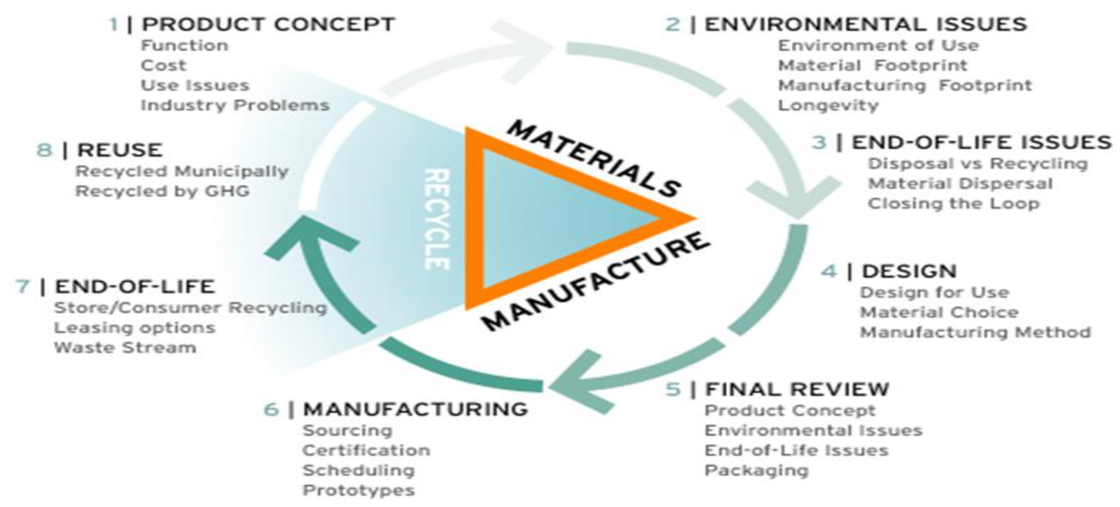
(GreenHeart Global | What We Do, n.d.)
In order to establish the life cycle of the product, I would first need to know the environment in which it is to be used. These factors can/will affect the longevity of the Gripper. If it were to be used in a damp, extreme environment, not only would there need to be better sealing on all components and the correct treatment for parts, but also, as the gripper will be being used as a ‘pick and place’ unit, then we would have to assume that the items or parts that are being picked up will be damp/wet/slippery. This in turn would affect what type of pressure maximum I would need to be able to apply to the jaws. However, I know that the chosen environment for this product will be inside a dry factory. This means that no extra cost will need to be invested into gaining higher IP Rated sealing for any components, considering temperature as a factor that will affect the wear/tolerances of the End Effector. I have shown below a graphical representation of the average temperature in the UK.

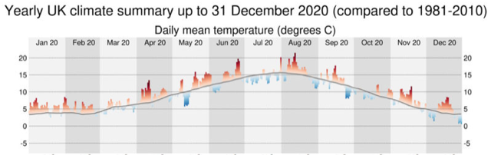
(Met Office: A review of the UK’s climate in 2020 | Carbon Brief, 2020)

This shows the yearly average and from this data I can see that despite falling close to 0°C over a period of days throughout the year, we rarely go into prolonged periods of extreme cold. The same can be said for extreme heat. Therefore, it would be safe to assume that there will be no extreme or rapid changes in temperature that would cause componentry to freeze up or expand to a point where it will not be useable. This means that I will not have to make allowances for tolerance or expansion beyond what is reasonably practicable. However, I will also consider that going to extremely tight tolerances will be less cost effective. Based on the customer’s requirements, they are not going to be ‘picking and placing’ objects that vary greatly in dimensions, so I will be able to allow for general machine tolerance when designing and considering the manufacturing of the components. This will help to reduce costs but also should give the product a considerable lifespan with regards to day-to-day wear on moving parts.

FMEA
This FMEA highlightS the aspects that could potentially go wrong with the product, how likely they are to go wrong with the product and also the possible reasons why the part potentially failed
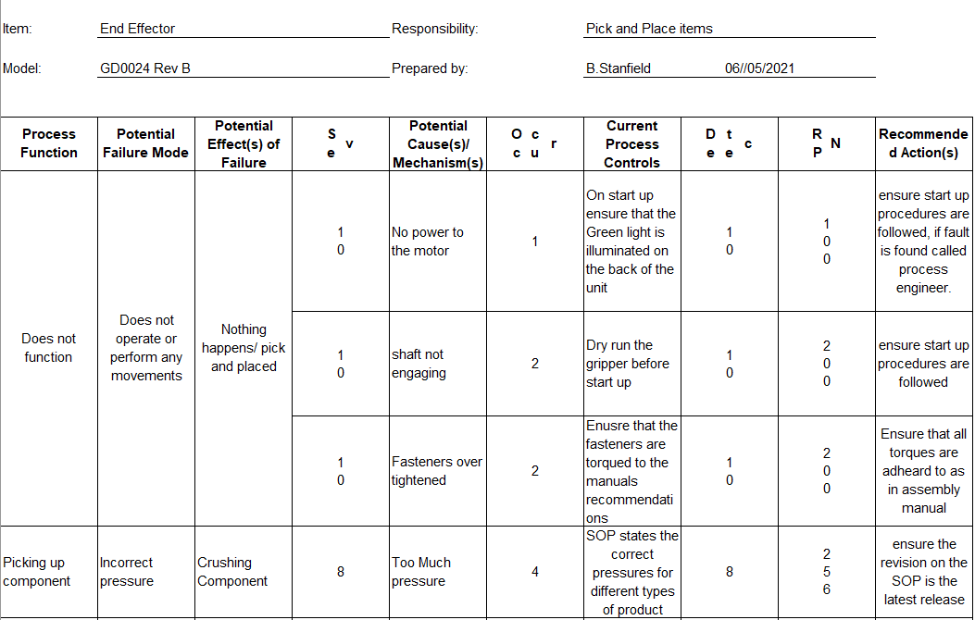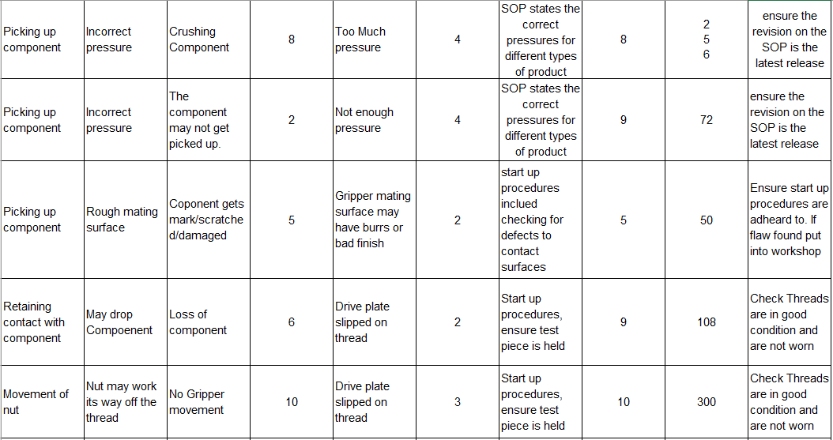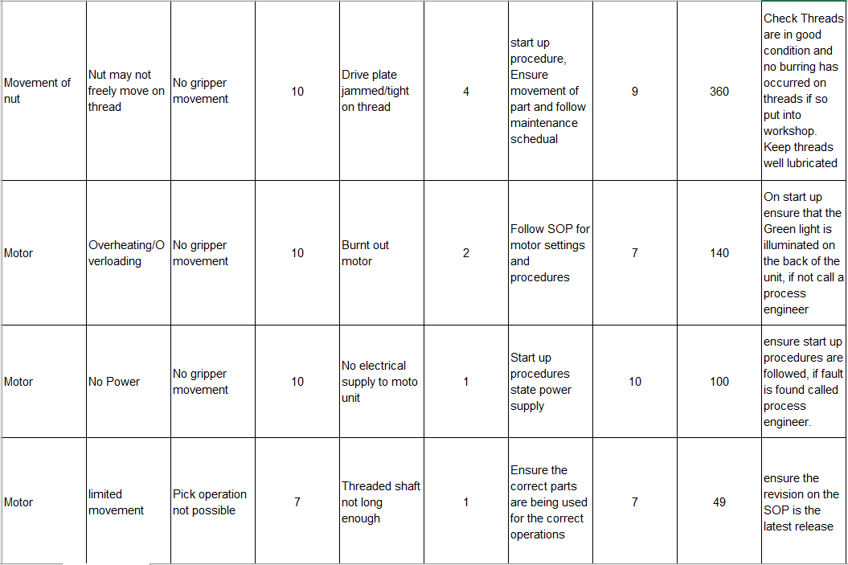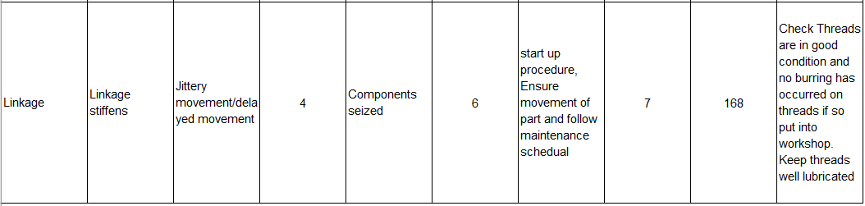 Figure 12 FMEA

Manufacturing Process Design

5 principles of lean manufacturing
- Define the Value
- Value stream mapping
- Process flow
- Establish the pull (Inventory)
- Refine the process
The manufacturing of the relevant components will all be made in one building allowing us to keep the costs down on the overheads of the production, It will also allow us to manufacture the parts in the same environmental parameters (Temperature, humidity). Keeping it within one building will also cut down on unnecessary transportation of parts and enable the process to run with little inventory. Running with little stock allows us to cut down on cost and allows us to use ‘just in time’ this means we are able to call on the parts when the demand ramps up, this applies more to the Supplied parts.
(What is Lean Manufacturing?, Skills and Management, n.d.)

Investment casting manufacturing process

Defect found stop product, revisit step 3

Figure 13 Investment casting manufacturing process
Injection moulding manufacturing process
Defect found stop product, revisit step 3

Figure 14 Injection moulding manufacturing process
Assembly process for Co-Bot Gripper

Figure 15 Assembly process for Co-Bot Gripper
Shopfloor process layout
This is the shopfloor showing a very lean layout. Having a layout such as this will help ensure that each step is value added. This is also know as a value stream focused layout.
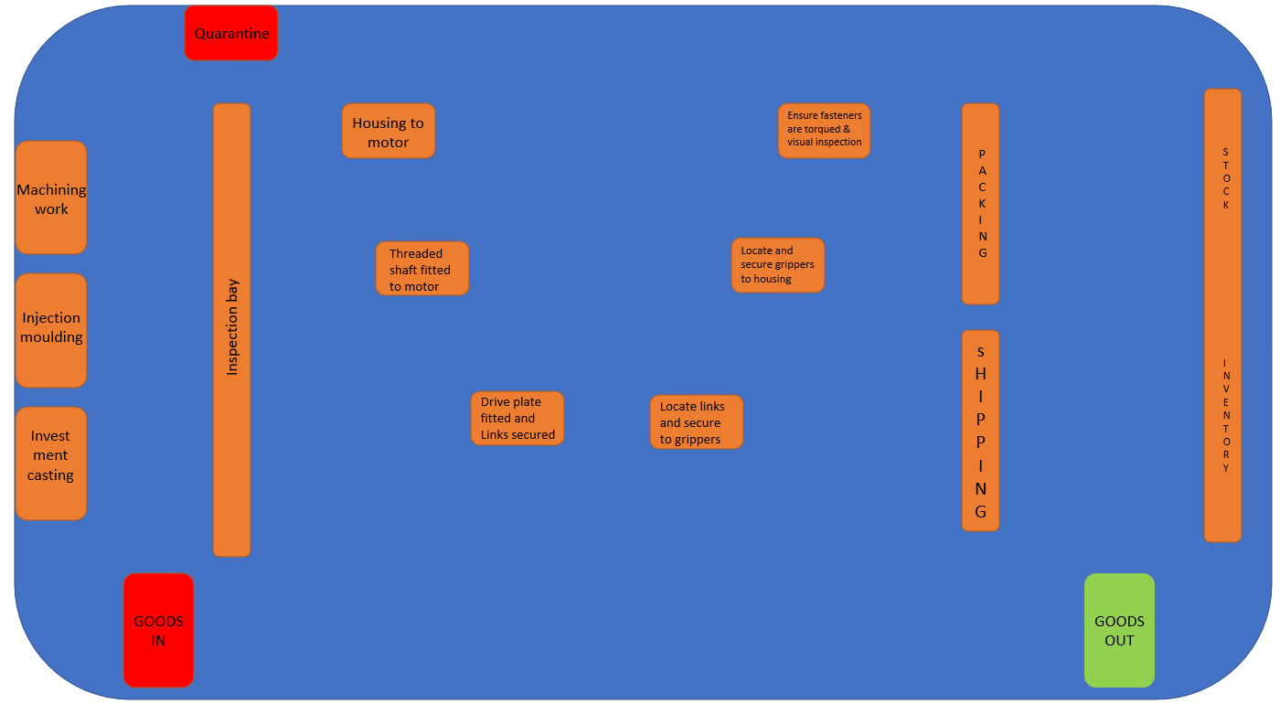
Figure 16 Shopfloor process layout

Conclusion

To conclude, I believe that I have taken my previous experience and applied it effectively to the brief and successfully produced a workable product using a methodical approach.
I believe that the adaptations and alterations that I made to the concept design not only improve it from the original, but also make it perfectly capable of excelling in its designated environment.
I adapted my changes to the concept design whilst also bearing in mind cost factors and material waste and ensuring that the product was manufacturable. I decided to keep changes minimal as I knew that the small changes that I could make would be more effective rather than waste time and resources making changes to all components and over working unnecessarily.
It was interesting working within the limits of the Robotic Arm, where changes couldn’t be drastic without greatly effecting performance or incurring unnecessary cost. Despite these parameters however, I feel that I have adhered to the brief and produced a successful product and document that has outlined the design, manufacturing and production processes involved with creating this unit.

References

Kano, N. Quality Function Deployment: Practitioner Manual, American Supplier Institute, Dearbourn, (1992), Michigan pp 5-6
(Farr and Farr, 2021)
Farr, R. and Farr, R., 2021. Capacify. [online] Capacify.

(Public perception, RAE-ETB cover and text)
Raeng.org.uk. 2021. [online]

(What Is Quality Function Deployment (QFD) and Why Do We Use It?, n.d.)
Master of Project Academy Blog. n.d. What Is Quality Function Deployment (QFD) and Why Do We Use
It?. [online]

(Post, n.d.)
Post, J., n.d. The Basic Plastic Injection Molding Process - Injection Molding Texas. [online] Injection
Molding Texas.

(Investment Casting - an overview | ScienceDirect Topics, 2015)
Sciencedirect.com. 2015. Investment Casting - an overview | ScienceDirect Topics. [online]

(DFA the Lucas Method - [PDF Document], 2005)
vdocuments.site. 2005. DFA the Lucas Method - [PDF Document]. [online]

(GreenHeart Global | What We Do, n.d.)
Greenheartglobal.com. n.d. GreenHeart Global | What We Do. [online]

(Met Office: A review of the UK’s climate in 2020 | Carbon Brief, 2020)
Carbon Brief. 2020. Met Office: A review of the UK’s climate in 2020 | Carbon Brief. [online]

(What is Lean Manufacturing?, Skills and Management, n.d.)
Skills, T. and Management, O., n.d. What is Lean Manufacturing? | CIPS. [online] The Chartered
Institute of Procurement and Supply.

(R.Morgan, Gripper, CAD 2021)
Design, Development and Manufacturing – 3-Jaw Cobot End-effector, ACMA5002

(7 Flows to Consider with your Factory Layout - TXM Lean Solutions, n.d.)
TXM Lean Solutions. n.d. 7 Flows to Consider with your Factory Layout - TXM Lean Solutions. [online]

