Project Management

Component II

Alexandru Inasescu 2210486
LCBB5005
Dr Essa Bah
BA Business Management

Contents
Introduction 2
Main Discussions 3
Development of a New E-commerce Platform 3
Implementation of a Renewable Energy Plant 6
Expansion of a Tech Startup into a New Market 10
Conclusion 13
Final Recommendation 13
References 15

Introduction
Project management is the application of knowledge, skills, tools, and techniques to project activities to meet project requirements. It is crucial in ensuring that projects are completed on time, within budget, and to the desired quality standards. Appraisals are an essential part of project management as they help in evaluating the viability, potential returns, and strategic alignment of various project options.
This proposal evaluates three potential projects: the development of a new e-commerce platform, the implementation of a renewable energy plant, and the expansion of a tech startup into a new market. Each project is assessed in terms of its vision and aims:
- Development of a New E-commerce Platform: This project aims to create an advanced e-commerce platform leveraging AI to provide personalized shopping experiences, improve customer service, and optimize supply chain management. It intends to address the growing demand for digital shopping solutions.
- Implementation of a Renewable Energy Plant: This project focuses on building a solar power plant to generate clean energy, reduce the carbon footprint, and benefit from government incentives. It aims to address the need for sustainable energy sources.
- Expansion of a Tech Startup into a New Market: This project aims to expand a digital transformation tech startup into an international market to capture market share, establish a local presence, and drive growth. It addresses the opportunity for growth in underpenetrated markets.
The appraisal of these projects will be conducted using both financial and non-financial methods. Financial methods include Net Present Value (NPV), Internal Rate of Return (IRR), Payback Period, and Profitability Index (PI). Non-financial methods assess strategic fit, customer satisfaction, competitive advantage, market demand, and other qualitative factors.

Main Discussions

Development of a New E-commerce Platform

Project Summary
The proposal is to develop a new e-commerce platform that leverages advanced AI technologies to provide personalized shopping experiences, improve customer service through chatbots, and optimize supply chain management. The platform aims to capture a significant market share within the next five years and generate substantial revenue growth.

Reasons for Acceptance
Financial Methods of Calculation
- Net Present Value (NPV)
  - Calculation: NPV is calculated by discounting the future cash flows generated by the project to the present value and subtracting the initial investment.
  - Assumptions:
    - Initial investment: $5 million
    - Project lifespan: 5 years
    - Discount rate: 10%
    - Annual cash inflows: $2 million, $3 million, $4 million, $5 million, $6 million
  - Formula:

NPV=1.818+2.479+3.005+3.416+3.726−5=9.444 million
- Internal Rate of Return (IRR)
  - Calculation: IRR is the discount rate that makes the NPV of the project zero.
  - Assumptions: Same cash flows as for NPV calculation.
  - Result:
IRR=56.72%
- Payback Period
  - Calculation: The payback period is the time it takes for the project to recoup its initial investment from its net cash inflows.
  - Assumptions: Same cash flows as for NPV calculation.
  - Formula:
Cumulative Cash Flows= [2,5,9,14,20]
The initial investment ($5 million) is recovered in Year 3.
  - Result:
Payback Period=3 years

- Profitability Index (PI)
  - Calculation: PI is the ratio of the present value of future cash flows to the initial investment.
  - Formula:
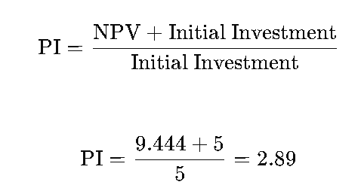
Non-Financial Methods of Calculation
- Strategic Fit
  - Market Positioning: The new e-commerce platform aligns with the company's strategic goal of expanding its digital presence and tapping into the growing e-commerce market.
  - Innovation: Utilizing advanced AI technology positions the company as an innovator in the industry.
- Customer Satisfaction
  - Improved Experience: Personalized shopping experiences and enhanced customer service through AI-driven chatbots are likely to increase customer satisfaction and loyalty.
  - User Engagement: The platform's features aim to boost user engagement, leading to higher retention rates.
- Competitive Advantage
  - Technology Leadership: By adopting innovative AI technology, the company can gain a competitive edge over traditional e-commerce platforms.
  - Brand Reputation: Successfully launching an advanced platform can enhance the company’s reputation as a tech-savvy and customer-centric brand.
- Market Demand
  - Growth Potential: The e-commerce market is rapidly growing, and there is high demand for personalized and efficient shopping experiences.
  - Customer Insights: The platform can provide valuable data and insights into consumer behaviour, aiding future marketing and product development efforts.
- Risk Management
  - Diversification: Developing a new platform diversifies the company’s revenue streams, reducing dependency on existing products.
  - Scalability: The platform is designed to scale easily with increasing user demand, mitigating risks associated with technological obsolescence.
Real-Life Example: Amazon
Amazon's continuous investment in its e-commerce platform provides a real-life example of the benefits outlined. Amazon has leveraged AI technologies for personalized recommendations, customer service chatbots, and supply chain optimization. This has not only increased customer satisfaction and loyalty but also positioned Amazon as a leader in the e-commerce industry. The company's diverse revenue streams and ability to scale rapidly with growing demand underscore the strategic and financial benefits of developing an advanced e-commerce platform.
Conclusion
Based on the financial calculations, such as a positive NPV of $9.444 million, a high IRR of 56.72% exceeding the discount rate, a reasonable payback period of 3 years, and a profitability index of 2.89, the project appears financially viable. Non-financial factors like strategic alignment, customer satisfaction, competitive advantage, market demand, and risk management further justify the acceptance of this project proposal. Thus, developing the new e-commerce platform should be considered a strategic and financially sound investment.

Implementation of a Renewable Energy Plant

Project Summary
The proposal is to develop a renewable energy plant that generates electricity using solar power. The plant aims to provide clean energy, reduce carbon footprint, and capitalize on government incentives for renewable energy projects. The project is expected to be completed within two years and to start generating revenue immediately after.

Reasons for Acceptance
Financial Methods of Calculation
- Net Present Value (NPV)
  - Calculation: NPV is calculated by discounting the future cash flows generated by the project to the present value and subtracting the initial investment.
  - Assumptions:
    - Initial investment: $10 million
    - Project lifespan: 20 years
    - Discount rate: 8%
    - Annual cash inflows: $1.5 million for the first 5 years, $2 million for the next 10 years, $2.5 million for the last 5 years
  - Formula:




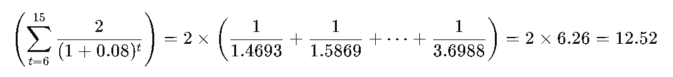

NPV=6.00+12.52+7.27−10=15.79 million
- Internal Rate of Return (IRR)
  - Calculation: IRR is the discount rate that makes the NPV of the project zero.
  - Assumptions: Same cash flows as for NPV calculation.
  - Result:
IRR=16.66%
- Payback Period
  - Calculation: The payback period is the time it takes for the project to recoup its initial investment from its net cash inflows.
  - Assumptions: Same cash flows as for NPV calculation.
  - Formula:
Cumulative Cash Flows= [1.5,3,4.5,6,7.5,9.5,11.5,13.5,15.5,17.5]
The initial investment ($10 million) is recovered between Year 6 and Year 7.
  - Result:
Payback Period=7.25 years

- Profitability Index (PI)
  - Calculation: PI is the ratio of the present value of future cash flows to the initial investment.
  - Formula:
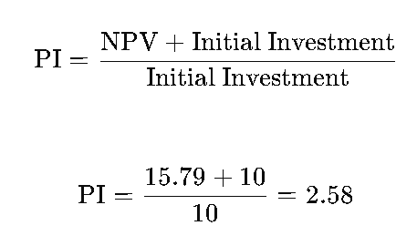
Non-Financial Methods of Calculation
- Environmental Impact
  - Reduction in Carbon Footprint: The renewable energy plant will significantly reduce greenhouse gas emissions compared to traditional fossil fuel plants.
  - Sustainability: The project promotes sustainable energy practices and supports global efforts to combat climate change.
- Social Responsibility
  - Community Benefits: The plant will provide clean energy to the local community, improving air quality and public health.
  - Job Creation: The construction and operation of the plant will create jobs, contributing to local economic development.
- Government Incentives
  - Tax Credits and Subsidies: The project is eligible for various government incentives, including tax credits and subsidies, which can reduce the initial investment and operational costs.
  - Regulatory Compliance: Investing in renewable energy helps the company meet regulatory requirements and avoid potential fines.
- Energy Independence
  - Local Energy Production: The plant contributes to energy independence by reducing reliance on imported fossil fuels.
  - Energy Security: Generating renewable energy locally enhances energy security and reduces vulnerability to global energy market fluctuations.
- Brand Image
  - Corporate Social Responsibility (CSR): Demonstrating a commitment to renewable energy enhances the company's CSR profile.
  - Public Relations: Positive media coverage and public perception can result from investing in environmentally friendly projects.
Real-Life Example: Tesla
Tesla's investment in its Gigafactory, which produces solar panels and energy storage products, exemplifies the strategic and financial benefits of renewable energy projects. Tesla's Gigafactory aims to reduce greenhouse gas emissions by producing clean energy products. The factory has received significant government incentives, including tax credits and subsidies, reducing initial investment costs. Additionally, Tesla's commitment to renewable energy has enhanced its brand image and positioned it as a leader in sustainability, attracting environmentally conscious consumers and investors.
Conclusion
Based on financial calculations, such as a positive NPV of $15.79 million, a high IRR of 16.66% exceeding the discount rate, a reasonable payback period of 7.25 years, and a profitability index of 2.58, the project appears financially viable. Non-financial factors like environmental impact, social responsibility, government incentives, energy independence, and brand image further justify the acceptance of this project proposal. Thus, developing the renewable energy plant should be considered a strategic and financially sound investment.

Expansion of a Tech Startup into a New Market

Project Summary
The proposal is to expand a tech startup specializing in digital transformation services into a new international market. The expansion aims to capture a significant market share, establish a local presence, and drive growth through innovative solutions.

Reasons for Acceptance
Financial Methods of Calculation
- Net Present Value (NPV)
  - Calculation: NPV is calculated by discounting the future cash flows generated by the project to the present value and subtracting the initial investment.
  - Assumptions:
    - Initial investment: $3 million
    - Project lifespan: 10 years
    - Discount rate: 12%
    - Annual cash inflows: $500,000 for the first 2 years, $1 million for the next 3 years, $2 million for the last 5 years
  - Formula:
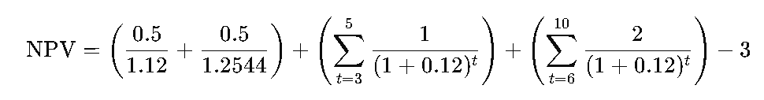
NPV=0.446+0.398+0.713+0.636+0.568+1.134+1.012+0.903+0.806+0.720−3=1.198 million
- Internal Rate of Return (IRR)
  - Calculation: IRR is the discount rate that makes the NPV of the project zero.
  - Assumptions: Same cash flows as for NPV calculation.
  - Result:
IRR=30.59%
- Payback Period
  - Calculation: The payback period is the time it takes for the project to recoup its initial investment from its net cash inflows.
  - Assumptions: Same cash flows as for NPV calculation.
  - Formula:
Cumulative Cash Flows= [0.5,1,2,3,4,5.5,7]
The initial investment ($3 million) is recovered in Year 5.
  - Result:
Payback Period=5 years
- Profitability Index (PI)
  - Calculation: PI is the ratio of the present value of future cash flows to the initial investment.
  - Formula:
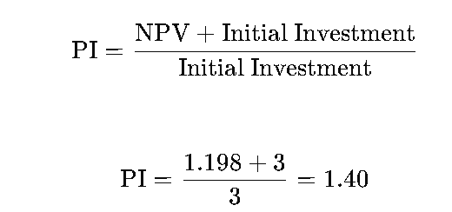
Non-Financial Methods of Calculation
- Market Potential
  - Growth Opportunities: The target market has a high growth potential for digital transformation services, driven by increasing adoption of technology by SMEs.
  - Competitive Landscape: The startup’s innovative solutions can capture a significant market share in an underpenetrated market.
- Strategic Fit
  - Global Presence: Expanding into a new market aligns with the company’s strategy to become a global player in the tech industry.
  - Diversification: The expansion diversifies the company’s market presence, reducing reliance on the domestic market.
- Local Partnerships
  - Collaborations: Forming partnerships with local businesses and stakeholders can facilitate market entry and growth.
  - Network: Leveraging local networks and expertise can accelerate the establishment and success of the new office.
- Talent Acquisition
  - Local Hiring: Hiring local talent ensures cultural and market understanding, aiding in better customer service and product localization.
  - Innovation Hub: Establishing a local office can create an innovation hub that contributes to the overall growth and innovation of the company.
- Brand Recognition
  - International Presence: Expanding into a new market enhances the company’s brand recognition and credibility on a global scale.
  - Customer Base: A successful expansion can significantly increase the customer base and revenue streams.
Real-Life Example: Google
Google's expansion into new international markets provides a real-life example of the strategic benefits of such an initiative. Google's entry into markets like India has been marked by partnerships with local businesses and extensive hiring of local talent, ensuring a strong understanding of regional needs and preferences. Google's global presence and diversified market strategy have significantly increased its customer base and revenue streams. The company's innovative solutions, such as Google Pay, tailored to local markets, have also contributed to its success and growth.

Conclusion
Based on financial calculations, such as a positive NPV, a high IRR exceeding the discount rate, a reasonable payback period, and a profitability index greater than 1, the project appears financially viable. Non-financial factors, including market potential, strategic fit, local partnerships, talent acquisition, and enhanced brand recognition, further justify the acceptance of this project proposal. Thus, expanding the tech startup into a new market should be considered a strategic and financially sound investment.

Final Recommendation
After a comprehensive evaluation of the three projects using both financial and non-financial methods, each project shows promising potential for contributing to the company's growth and strategic goals. However, the final recommendation should prioritize projects based on the overall alignment with the company’s vision, the magnitude of financial returns, and the long-term strategic impact.
- Top Priority: Development of a New E-commerce Platform
  - Rationale: This project has the highest potential for immediate revenue growth, significant market demand, and strong alignment with the company’s strategic goals of digital transformation and innovation.
- Second Priority: Implementation of a Renewable Energy Plant
  - Rationale: While offering substantial long-term financial returns and environmental benefits, this project also enhances the company’s CSR profile and aligns with global sustainability trends.
- Third Priority: Expansion of a Tech Startup into a New Market
  - Rationale: Although this project presents significant growth opportunities and strategic benefits, it is slightly lower in immediate fiscal impact compared to the other two projects.
By prioritizing the development of the new e-commerce platform, followed by the renewable energy plant and the tech startup expansion, the company can ensure a balanced approach to achieving both short-term and long-term strategic objectives.

References
Amazon. (n.d.). 'About Amazon'. Available at: https://www.aboutamazon.com/
Google (2024). Google UK - About Google, Our Culture & Company News. [online] about.google. Available at: https://about.google/intl/ALL_uk/.
Tesla. (n.d.). 'Tesla's Gigafactory'. Available at: https://www.tesla.com/gigafactory
Gallo, A. (2014). 'A Refresher on Net Present Value', Harvard Business Review. Available at: https://hbr.org/2014/11/a-refresher-on-net-present-value
Investopedia. (n.d.). 'Internal Rate of Return (IRR)'. Available at: https://www.investopedia.com/terms/i/irr.asp

