 | Cybersecurity Strategy Report for Vigilant Trust & Asset Management  Mariia Golovko  IT Security Manager

Table of Contents
INTRODUCTION AND CONTEXT 2
MODERN THREAT LANDSCAPE 3
ZERO TRUST AND GOVERNANCE FRAMEWORK 4
SECURITY POLICIES ALIGNED TO ZERO TRUST 5
TECHNICAL AND ADMINISTRATIVE CONTROLS 6
PROACTIVE MONITORING AND INCIDENT RESPONSE 7
CONTINUOUS TRAINING AND SECURITY CULTURE 8
IMPLEMENTATION ROADMAP AND METRICS 9
CONCLUSION 10
References 12
Appendix: 14
Certificate for Getting started with Cisco Packet Tracer: 14
PowerPoint presentation screenshots: 14

ZERO TRUST SECURITY FRAMEWORK FOR VIGILANT TRUST & ASSET MANAGEMENT
Prepared by: IT Security Manager Mariia Golovko

INTRODUCTION AND CONTEXT
Vigilant Trust & Asset Management operates within a highly regulated financial services environment where confidentiality, integrity, and availability of data are critical to business viability and customer trust [1]. Recent security incidents, which includes a sophisticated phishing activity that bypassed legacy email controls and an trying ransomware infection, demonstrate that traditional perimeter-based security controls are no longer sufficient.
The Board has mandated the development of a modern security framework. This report presents a comprehensive security strategy aligned with internationally recognised standards, including the NIST Cybersecurity Framework (CSF), NIST Special Publication 800-207 (Zero Trust Architecture), and guidance from the Cybersecurity and Infrastructure Security Agency (CISA), including its Known Exploited Vulnerabilities (KEV) catalog [2],[3],[4].
The purpose of this report is to identify modern threats, define appropriate security policies, propose technical and administrative controls, outline a proactive monitoring and incident response capability, and establish a continuous security awareness programme. The overall objective is to reduce cyber risk, improve resilience, and provide assurance to executive leadership and regulators.

MODERN THREAT LANDSCAPE
The cyber threat environment facing financial institutions has evolved significantly in recent years. Attackers are increasingly professional, well-resourced, and adaptive, often operating as organised criminal groups or nation-state actors. Threats must be considered from both external and internal perspectives [2].
Externally, ransomware has become one of the most significant risks. The emergence of Ransomware-as-a-Service has reduced technical barriers, allowing attackers with limited expertise to carry out highly effective campaigns by leveraging ready-made malware, payment systems, and extortion frameworks. Modern ransomware attacks rarely focus solely on encryption; instead, they frequently involve data exfiltration and threats of public disclosure, which is particularly damaging for financial institutions [4],[5].
Social engineering has also evolved. Phishing attacks are no longer generic emails with obvious grammatical errors. Attackers now use artificial intelligence to generate highly personalised messages that reference real business relationships, current projects, and organisational structures. Voice phishing, or vishing, has become more prevalent due to the availability of AI-driven voice cloning, allowing attackers to impersonate senior executives or trusted third parties with alarming realism [5].
Supply chain attacks represent another major concern. Financial organisations rely on a complex ecosystem of software vendors, managed service providers, and cloud platforms. A compromise within a trusted third party can provide attackers with indirect access to internal systems, often bypassing traditional security controls [3].
Cloud adoption and hybrid working models have further expanded the attack surface. Misconfigured cloud resources, overly permissive identity roles, exposed APIs, and unmanaged remote devices all introduce new avenues for exploitation. In parallel, internal threats must not be overlooked. Employees, contractors, and partners may unintentionally introduce risk through poor security practices, while compromised credentials can allow attackers to operate as legitimate users for extended periods [3].
These threats align closely with those documented by NIST and CISA and underline the need for a security model that assumes breach, continuously verifies trust, and limits the impact of any single compromise[4],[6].

ZERO TRUST AND GOVERNANCE FRAMEWORK
Zero Trust is not a single technology but a strategic approach to cybersecurity, originally articulated as a model that assumes no implicit trust within or outside the network perimeter [6]. As defined in NIST SP 800-207, Zero Trust is based on the principle that no user, device, or system should be trusted by default, regardless of whether it is located inside or outside the traditional network perimeter [3], [7].
Under a Zero Trust model, access decisions are made dynamically based on identity, device posture, location, behaviour, and risk. Trust is continuously evaluated rather than implicitly granted.
To ensure effective governance, this Zero Trust strategy is mapped to the NIST Cybersecurity Framework. The NIST CSF provides a structured approach to managing cyber risk across five core functions: Identify, Protect, Detect, Respond, and Recover. Each security control and policy proposed in this report supports one or more of these functions, ensuring traceability, auditability, and alignment with regulatory expectations [3],[8].
CISA guidance, particularly the Known Exploited Vulnerabilities catalog, is used to prioritise operational risk. The KEV catalog provides an authoritative list of vulnerabilities that are actively exploited in the wild, allowing organisations to focus remediation efforts where they will have the greatest impact [9].

SECURITY POLICIES ALIGNED TO ZERO TRUST
A modern security framework must be underpinned by clear, enforceable policies [8]. These policies translate strategic intent into operational rules and provide a basis for accountability.
The Identity and Access Management policy is central to Zero Trust. All access to systems and data must be authenticated using strong, phishing-resistant multi-factor authentication. Access rights are granted based on role and business need, following the principle of least privilege. Privileged access is tightly controlled, time-limited, and monitored using dedicated Privileged Access Management solutions [3].
A Device Security policy ensures that only trusted and compliant devices can access corporate resources. Device posture, including patch level, endpoint protection status, and encryption, is assessed continuously. Devices that do not meet security requirements are restricted or denied access [1],[2],.
Network and application access policies eliminate implicit trust based on network location. Internal networks are segmented, and access to applications is granted on a per-session basis using Zero Trust Network Access mechanisms. This approach significantly reduces lateral movement opportunities for attackers [6],[7].
Vulnerability and patch management policies explicitly reference the CISA KEV catalog. Vulnerabilities listed in the KEV catalog are treated as highest priority, with defined remediation timelines approved by executive management [4],[9]. This ensures alignment with national cyber defence priorities and regulatory expectations.
Data protection policies mandate encryption of sensitive data at rest and in transit, classification of information assets, and controls to prevent unauthorised data exfiltration. Logging and monitoring policies require comprehensive collection and retention of security-relevant events to support detection, investigation, and compliance [3].

TECHNICAL AND ADMINISTRATIVE CONTROLS
To operationalise these policies, Vigilant Trust must deploy a combination of technical and administrative controls [8].
At the identity layer, phishing-resistant multi-factor authentication and modern identity governance tools reduce the risk of credential theft. Conditional access policies evaluate risk signals in real time, such as anomalous login behaviour or access from unmanaged devices [7],[10].
At the endpoint layer, advanced Endpoint Detection and Response tools provide continuous monitoring, behavioural analysis, and rapid containment capabilities. These tools are essential for detecting ransomware, credential theft malware, and lateral movement techniques[11].
Network security is enforced through microsegmentation and Zero Trust Network Access solutions. Rather than exposing entire networks, users connect only to the specific applications they are authorised to use. This limits the blast radius of any compromise [7].
In cloud environments, Cloud Security Posture Management tools continuously assess configurations against best practices and regulatory requirements. Misconfigurations are detected early and, where possible, automatically remediated. Identity entitlements in the cloud are reviewed regularly to prevent privilege creep [12].
Centralised logging through a Security Information and Event Management platform provides visibility across identity systems, endpoints, networks, and cloud services. This is complemented by Security Orchestration, Automation, and Response capabilities, which allow routine incident response actions to be executed quickly and consistently [13].
Administratively, clear procedures, segregation of duties, vendor risk assessments, and formal change management processes ensure that technology controls are supported by strong operational discipline [8].

PROACTIVE MONITORING AND INCIDENT RESPONSE
Continuous monitoring is essential in a Zero Trust environment. Vigilant Trust must assume that some attacks will bypass preventive controls and focus on rapid detection and response.
A 24/7 monitoring capability, delivered either through an internal Security Operations Centre or a managed detection and response provider, is required. This function monitors alerts generated by SIEM, EDR, and cloud security tools, correlates events, and identifies suspicious behaviour[2],[11].
Incident response follows a structured lifecycle aligned with NIST guidance. Events are triaged to determine severity and scope. Confirmed incidents trigger containment actions, such as isolating affected devices, disabling compromised accounts, or blocking malicious network traffic. Forensic analysis is conducted to understand root cause and impact. Recovery activities restore systems from secure backups and validate their integrity before returning them to production [3].
Post-incident reviews are conducted for all significant incidents. Lessons learned are used to improve controls, update detection logic, and refine training programmes. This continuous improvement cycle is essential to maintaining resilience in a rapidly evolving threat landscape [7],[8].

CONTINUOUS TRAINING AND SECURITY CULTURE
Technology alone cannot address the risks posed by modern social engineering and insider threats. A strong security culture is critical [8].
Security awareness training at Vigilant Trust must be continuous, engaging, and relevant. Rather than relying on annual compliance-driven training, employees should participate in regular, short sessions focused on real-world scenarios. Simulated phishing and vishing exercises are used to reinforce learning and measure effectiveness [14].
Training is tailored by role. Executives receive guidance on targeted attacks such as whaling and impersonation. Finance teams are trained to recognise payment diversion fraud. Technical staff receive advanced training on secure configuration and incident response [15].
Importantly, the organisation promotes a culture where reporting suspicious activity is encouraged and rewarded. Employees are treated as a vital layer of defence rather than a weakness to be managed.

IMPLEMENTATION ROADMAP AND METRICS
Implementation of this framework should be phased to manage risk and cost. Immediate priorities include enforcing multi-factor authentication, addressing vulnerabilities listed in the CISA KEV catalog, and deploying endpoint detection capabilities [9].
Medium-term initiatives focus on Zero Trust Network Access, cloud security posture management, and SIEM and SOAR integration. Longer-term efforts mature automation, analytics, and continuous improvement processes [7],[12].
These changes can be made using Microsoft Zero Trust architecture for Vigilant Trust&Asset Management:
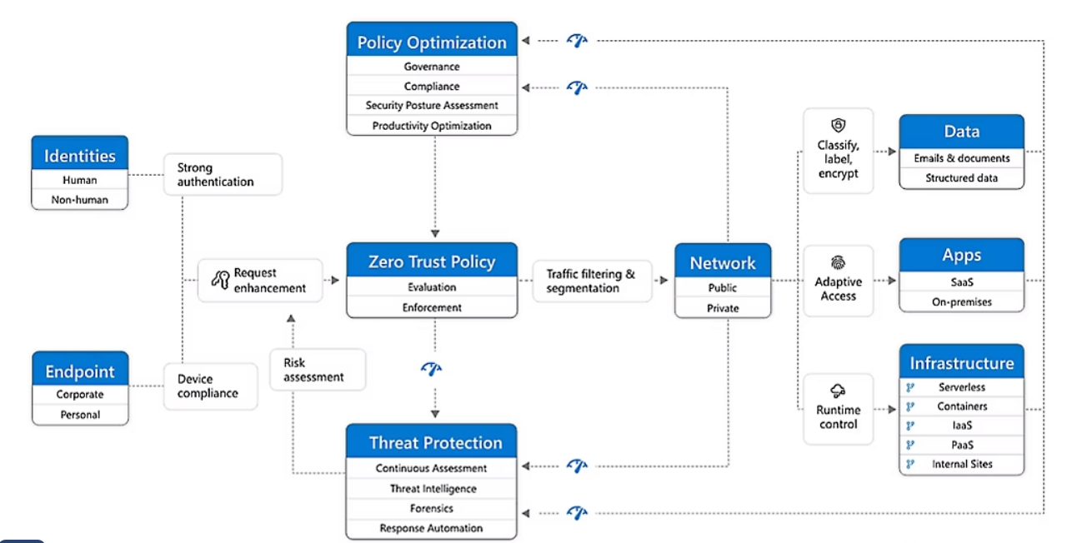[16]
Progress is measured using clear metrics aligned with the NIST CSF. These include time to detect and respond to incidents, patching timelines for KEV vulnerabilities, reduction in successful phishing attempts, and backup recovery success rates. These metrics are reported regularly to executive leadership and the Board [3],[9].
Medium-term 9-12 months roadmap:
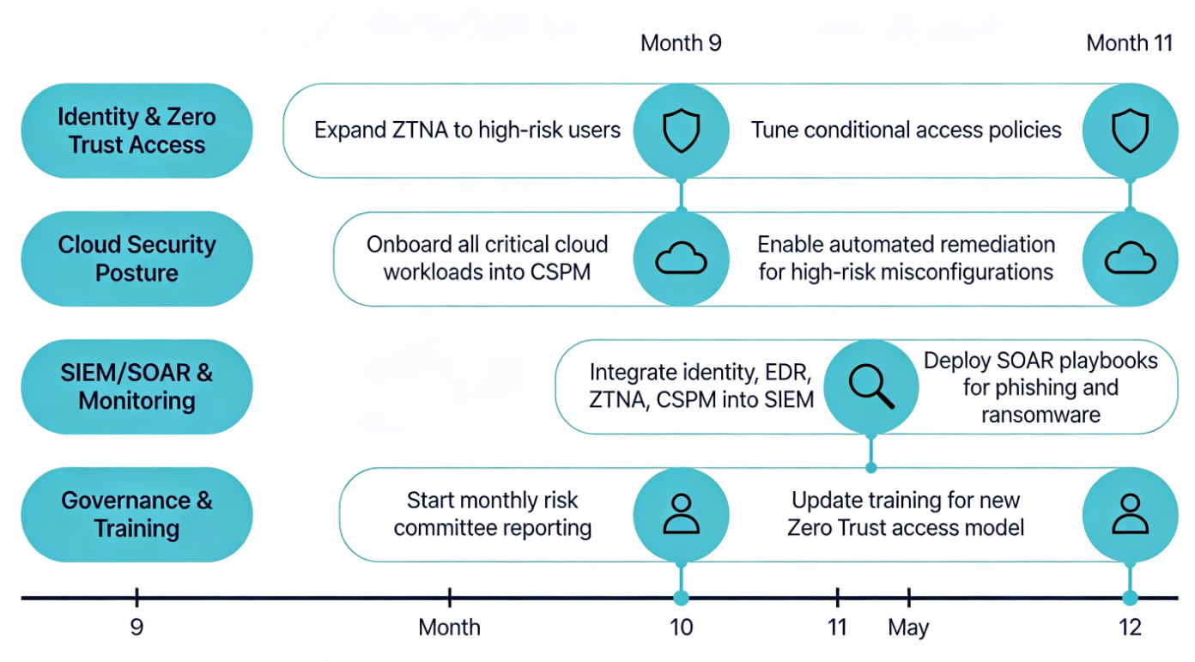
During months 9–12, Vigilant Trust should move from initial deployment to integration, hardening, and operational maturity for Zero Trust, cloud, and monitoring capabilities.

CONCLUSION
The threat environment facing Vigilant Trust & Asset Management demands a fundamental shift from perimeter-based security to a Zero Trust model. By aligning strategy, policy, technology, and culture with NIST and CISA guidance, the organisation can significantly reduce cyber risk while supporting business agility and regulatory compliance.
This framework does not eliminate risk entirely, but it ensures that attacks are harder to execute, easier to detect, and less damaging when they occur. With sustained executive support and disciplined execution, Vigilant Trust will be well positioned to defend its assets, protect its clients, and maintain trust in an increasingly hostile digital environment.

References
[1] J. M. Borky and T. H. Bradley, "Protecting information with cybersecurity," in Effective model-based systems engineering, Springer, 2018, pp. 345–404.
[2] N. P. A. Plan, "National Institute of Standards and Technology (NIST),"
[3] "NIST." [Online]. Available: https://www.nist.gov/cyberframework
[4] U.S. Department of Homeland Security. "CISA." [Online]. Available: https://www.cisa.gov/
[5] European Union Agency for Cybersecurity (ENISA). "ENISA Threat Landscape 2023." [Online]. Available: https://www.enisa.europa.eu/sites/default/files/publications/ENISA%20Threat%20Landscape%202023.pdf
[6] J. Kindervag, "Build security into your network’s dna: The zero trust network architecture," vol. 27, pp.1–16, 2010,
[7] V. Stafford, "Zero trust architecture," vol. 800, no. 207, pp.800–207, 2020,
[8] M. Malatji, "Management of enterprise cyber security: A review of ISO/IEC 27001: 2022", 2023 International conference on cyber management and engineering (CyMaEn), pp. 117–122.
[9] CISA. "Known Exploited Vulnerabilities Catalog." [Online]. Available: https://www.cisa.gov/known-exploited-vulnerabilities-catalog
[10] D. Temoshok, et al., "Digital Identity Guidelines," 2022,
[11] M. ATT&CK, "Mitre att&ck framework," vol. 24, pp.2024, 2024,
[12] S. Ahmadi, "Systematic literature review on cloud computing security: Threats and mitigation strategies," vol. 15, pp.148–167, 2024,
[13] K. Kent and M. P. Souppaya, "Sp 800-92. guide to computer security log management," 2006,
[14] J. D. Christopher, "Sans 2024 state of ICS/OT cybersecurity," vol. 1, no. 7.1, pp.7.2, 2024,
[15] M. Wilson and J. Hash, "Building an information technology security awareness and training program," vol. 800, no. 50, pp.1–39, 2003.
[16] Microsoft. (n.d.). Zero Trust model. https://www.microsoft.com/en-gb/security/business/zero-trust

Appendix:

Certificate for Getting started with Cisco Packet Tracer:
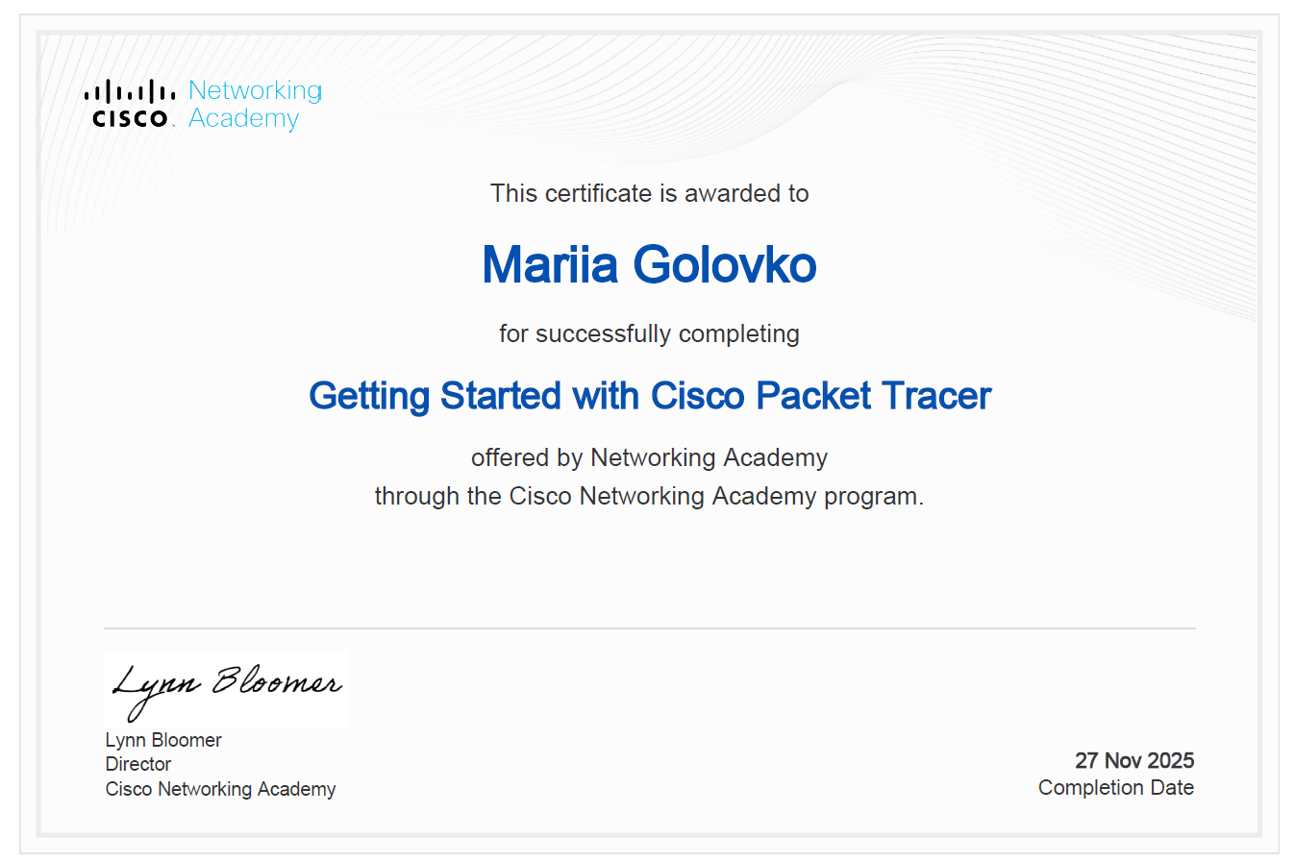

PowerPoint presentation screenshots:


