BMIH5007, BMIH5002
Financial Management for the Hotel Industry
LEVEL 5
Student name: Simona-Elena Mezo
Student Id: 2030170
Lecturer: Dale Clarke

Executive Summary
Financial management basically assists organisations in obtaining, managing, and allocating the overall capital. The below-mentioned segment has elaborated on all the essential aspects of financial management within the hospitality industry. The whole context has focused on depicting a specific comparison between all the accounting aspects of Hilton Hotel as well as Marriott International. Both of the hotels are multinational and famous hospitality companies. The comparison is basically based on the factors like current profit margin, commitment to CSR, growth potentiality, and position in the market.

Table of Contents
Introduction 4
Establishing the comparison among two hotel industries like Marriot International and Hilton 5
Discussion about Marriott International 5
Discussion about Hilton 8
Suggesting certain recommendations to the above-mentioned hospitality companies 11
Recommendation for Marriott International 11
Recommendation for Hilton Hotel 11
Conclusion 13
Reference 14

Introduction
The following report has been prepared on comparing two hospitality organisations by some of their financial aspects. Marriott International and Hilton are two popular hotel chains that will be discussed in the following. The total revenue of both hotel businesses will be highlighted. The market position of the hotels will be discussed. The growth of the business is necessary for achieving better results in future. The growth potential of both the hotel businesses and their financial commitment to CSR will also be mentioned below. Some recommendations like growth opportunities and potential outsourcing for both businesses will also be highlighted there.

Establishing the comparison among two hotel industries like Marriot International and Hilton

Discussion about Marriott International
1. Total earnings of the Marriot International
This respective hotel business is the one top-notch hotel chain business entity worldwide that offers its hotel services to the entire world. This business entity offers room services in different places of the world with the assistance of 120000 workers who are conducting the daily activity of the business in a precise manner (Harrison et al., 2012). On the basis of the given information, the total earnings of Marriot international in the year 2022 was £19.29 Billion. In the time of 2021, it was just about £13.85 Billion, this highlights the total interchange in the sum of income in 2022 around a 39.25% increase from the preceding time. During the unexpected layout of the novel virus, the business faced a lot of issues while accomplishing the task in a precise manner. The industry was affected the most as most during the issues of lockdown. Due to the problem of business, the level of earnings in the time of 2020 was about £10.57 Billion. It suffered a huge disgrace of -49.59% in the accounting year of 2019 due to the unpredicted spread of the pandemic condition (Hayes and Miller, 2012).
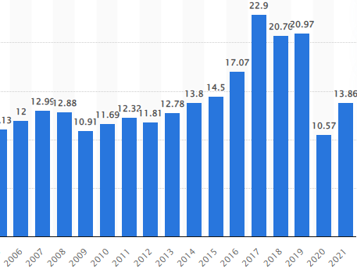
Source: (marriott, 2022)
2. Evaluating the Market position of the Marriot International
The market position of a business entity indicates the position of this in the market relating to attracting consumers over time. This is a brand which offers premium tourism services to its premium consumers that have the potential to consume these services at a high value. The sum volume of the market share of Marriot International is about 17.95% of the total market and has a separate level of goodwill rather than other competitors (marriott, 2022). This has a unique position in the total market of the UK from the other business rivals Hyatt Hotels Crop. Apart from that, the sum value of the capitalised market is around 44.51 billion pounds during accounting periods. The positioning of the respective business is to offer a quality service to the consumer over time with the assistance of premium pricing (Seal, et al., 2008).
3. Identifying the growth potential of Marriot International
The growth potential of the business reflects the chance of development in the daily function of the respective hotel industry over time (Jagels, 2007). The probability of future development by offering this quality service is very high rather to other business entities. On the basis of the analysis in the period of 2023, the assistance of 156 new branches help to grow the overall level of business by 2.2% over a period (Bahadori-Jahromi et al., 2020). The higher authority needs to focus on operational activity monitoring, and regular training of the employees helps to generate more returns over time. This also plays an important part in accomplishing the task in an efficient way and also acquiring relevant resources to meet the objectives of itself in the allotted time (Bhimani, 2006).
4. Financial commitment to CSR for Marriot International
Marriot is one of the biggest business companies in the hospitality industry. They have a lot of responsibilities towards the environment and society which they fulfil. The specific company properly maintain their sustainability towards the environment and take initiatives to clean the environment (Sanvitale., 2020). Other than this, the respective hotels also promote the education of awareness regarding human trafficking and also forced labour on the walls of the hotels. In addition to this, all these aspects would definitely need investment. These investments are mainly handled by the finance department of the respective company (Boğan., 2021).

Discussion about Hilton
1. Total earnings of the Hilton
The Hilton hotel is a quality full hotel service provider that offers services to the potential business. This is the main competitor of Marriot International and took place in the second position on the basis of the consumer base. On the basis of the reports, the overall earning of this is around £8.16 Billion over time. It has the capacity to enhance the total volume of income by 41.07% from the preceding time for the year 2021 (hilton, 2023). In the period 2020, the earnings from owned hotels were about 0.42 and the level of income was around 2.71 over time. Apart from that, in the time of 2021, owned and leasehold income was around 0.6 and the income from the other properties was around 3.34 over the point of time (Atrill and McLaney, 2015).
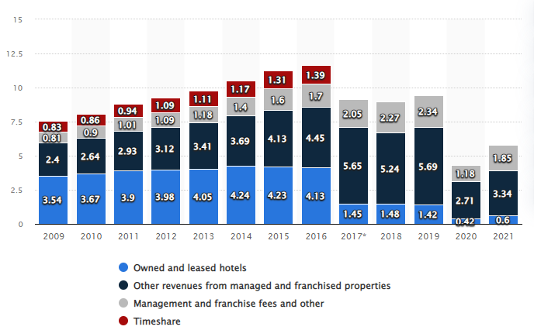
Source: (hilton, 2023)
2. Evaluating the Market position of the Hilton
The commercial object is been stated as a well-arranged hotel in the hospitality segment over the point of time. The mentioned business entity is considered the strongest business rival in the entire market. In a survey of the top hotel firms internationally by revenue, it had the option to grab the position of 2nd during the accounting period (Leeds University, 2016). On the other hand, the total market exposure of the Hilton business has been reflected as 7.78% respectively. After the position of Marriot International, Hilton has the option to offer a premium service to its potential consumers. Other than this, the goal marketplace of the stated business entity is been acknowledged as a demographic subdivision correspondingly (Guilding, 2013).
3. Reflecting the chance of growth for the operation of Hilton
On the basis of a recent analysis, the respective business of Hilton Hotels unfastened 414 branches and added more than 67,100 accommodations to its arrangement, establishing the greatest year for expansion activities (Garbutt, 1992). With a remaining unit upsurge of 5.6%, the secure decided 2021 with the assistance of more than 6,800 boarding house meals across 18 brands and six landforms. Furthermore, having a strong monetary model, Hilton doesn't have to make reserves in the building of new branches to offer the services to the potential consumer over time. This authority f the business always keeps focusing on the usage of the franchise method for expansion (hiltonmanchesterdeansgate, 2022). The individual business entity may start accusing franchise and administration fees once designers have enclosed the first expenses. The stated business entity brands use the 7Ps of the advertising system to its growth for intensifying the operations of the business. Hence, on the basis of the data that is been accessible in the upstairs part, these demonstrations that the professional has the possibility to increase and transport better development occasions in the future correspondingly (Drury, 2015).
4. The financial commitment for Hilton
The CSR aspects of Hilton are also one of the main parts of the whole business. They take multiple initiatives for society. They usually support the local communities quite often by implementing non-profit organisations and thousands of volunteers. Other than this, the specific business hotel provided 2 million courses and more than 5 million hours of learning in the year 2015. Here, all these kinds of responsibilities need investment which is usually handled by the financial department of the respective business (Barauskaite et al., 2021).

Suggesting certain recommendations to the above-mentioned hospitality companies

Recommendation for Marriott International
As the revenue margin of this multinational hotel company is very high, it can focus on grabbing any possible opportunities for the purpose of growth. As multiple millennials are entering the market of consumers, Marriott International can acquire the opportunities to strengthen its overall customer base by representing itself as a better and more youthful brand. Also, the requirement for hospitality services in all developing nations is constantly escalating and bestows lucrative and essential opportunities for all the hotel chains, such as Marriott International (Fredericks, 2020). Marriott can have a better opportunity to open more hotel chains in order to serve various elite-class tourists. The hotel also can focus on satisfying the customers with the help of technology because it is difficult to fulfill the demands of the customers in this digital age. This hotel business is connected with a broad range of tourism sectors, catering as well as real estate. Marriott International can render housing for the core business, such as Airbnb (Touryalai, 2019).

Recommendation for Hilton Hotel
This specific hotel chain can focus on elevating its revenue margin by adopting the business practice of outsourcing. This particular business practice can aid the Hilton Hotel chain in leveraging its knowledge and abilities as well as the overall supply chain. Outsourcing helps in enhancing the agility, flexibility, and ability to adapt to multiple market trends of the company. This will also help this hospitality company to face the issues while rendering cost savings and also service level developments. This hotel can utilise this business practice for cutting labor costs, involving salaries for its overall management, employees, and expense for technology and equipment. After using the outsourcing practice, Hilton can enlist the aid of other hotel companies not affiliated with this company in order to fulfill particular tasks. This hotel can also improve its focus on all the integral business activities. This practice can free up the business of Hilton Hotel to focus on the overall strengths, and also motivate the employees to concentrate on daily tasks as well as future strategies (Tranter, 2013).

Conclusion
The report has been reflecting on some different financial approaches. Hilton and Marriott International are both popular hotel chains that are serving people worldwide. A good amount of revenue is being generated by the hotels. The total revenue of both the hotels and their position in the market has been mentioned. The total earnings of Marriott International have been recorded at £19.29 billion in the year 2022. On the other hand, the revenue of Hilton is £8.16 billion in a period. Marriott holds near about 17.96% of the total market share in the hospitality industry whereas, Hilton grabs almost 7.78% of the share. The growth potential and financial commitment to CSR have also been highlighted to measure the financial position of the business. Growth opportunities for the business have been recommended for Marriott International. By implementing this strategy, the hotel chain can increase its customer base and do a good amount of business. Possible outsourcing has also been recommended to the Hilton to make their business sustainable in the market. This outsourcing can help the business in strengthening its business by advancing its ability and acquiring a good quality supply chain.

Reference
Atrill P, McLaney E (2015) Management Accounting for Decision Makers, FT Prentice Hall.
Barauskaite, G. and Streimikiene, D., (2021). Corporate social responsibility and financial performance of companies: The puzzle of concepts, definitions and assessment methods. Corporate Social Responsibility and Environmental Management, 28(1), pp.278-287.
Bhimani A, (Ed) (2006) Contemporary Issues in Management Accounting , Oxford.
Boğan, E., (2021). A review of prominent theories in perceived CSR-employee outcomes link in hospitality literature. Journal of multidisciplinary academic tourism, 6(2), pp.99-105.
Drury C (2015) (9 th Ed) Management and Cost Accounting, London, Prentice Hall.
Fredericks, L., (2020). The Ultimate Hotel SWOT Analysis in 7 Simple Steps. [Online] Available at: https://www.cvent.com/en/blog/hospitality/hotel-swot-analysis [Accessed 30 January 2023].
Garbutt Prof. D (1992) Making Budgets Work, London: CIMA.
Guilding,C.(2013) Accounting Essentials for Hospitality Managers, London, Taylor and Francis.
Harrison, M, Jakeman, V &amp; Paterson, K (2012) Improve your Grammar, Hampshire: Palgrave Macmillan
Hayes,M. & Miller, A. (2012) Revenue Management for theHospitality Industry, London, Wiley.
hilton, (2023). Get the most from your stay. [Online] Available at: https://www.hilton.com/en/ [Accessed 24 January 2023].
hiltonmanchesterdeansgate, (2022). Hilton Manchester Deansgate. [Online] Available at: https://hiltonmanchesterdeansgate.h-rez.com/?lbl=ggl-uk-rsp&gclid=CjwKCAiAleOeBhBdEiwAfgmXf73EXLChUmbLFuwiKt-V2DJI0o48d2lKKVEhOgElpCiaKTiJApqjbxoCYAQQAvD_BwE [Accessed 26 January 2023].
Jagels,M. (2007) Hospitality Management Accounting, London, Wiley.
Leeds University (2016) Referencing [Online] https://library.leeds.ac.uk, Accessed 17 th November 2016
marriott, (2022). We Are Marriott International. [Online] Available at: https://www.marriott.com/marriott/aboutmarriott.mi [Accessed 26 Janauary 2023].
Salem, R., Bahadori-Jahromi, A., Mylona, A., Godfrey, P. and Cook, D., (2020). Energy performance and cost analysis for the nZEB retrofit of a typical UK hotel. Journal of Building Engineering, 31, p.101403.
Sanvitale, A.L., (2020). Corporate Social Responsibility in the Hotel Industry: A Study of Marriott International and Odyssey Hotel Group.
Seal W, Garrison RH, Noreen E (2008) Management Accounting, McGraw Hill.
Touryalai, H., (2019). World's Largest Hotels 2019: Marriott Leads Again, Hyatt & Accor Rise. [Online] Available at: https://www.forbes.com/sites/halahtouryalai/2019/05/15/worlds-largest-hotels-2019/?sh=68acb85f796d [Accessed 30 January 2023].
Tranter,K. Stuart-Hill,T. Parker,J. (2013) Introduction to Revenue Management for the Hospitality Industry, London, Pearson.

