Dummy Report for Academic Skills Assignment 2 2018 –Reflective Report



MARCH 2018

MODULE NAME: Academic Skills (M4X01434)
Project Name: unity lgbt
Name: sophie suzanne morgan
Student Number: 1701822

Table of Contents

1. eXECUTIVE sUMMARY 1
2. Introduction 2
2.1 report remit 2
2.2 Background of the organisation .2
2.3 models of reflection .3
2.4 masterclass sessions 6
2.5 infulence of the masterclass on my project………………………………………………………7
2.6 influence of masterclass on personal development…………………………………………….8
2.7 Conclusion 10
3. References 11

List of Figures
FIGURE 2-1 - Gibbs reflective cycle (1988) 5
FIGURE 2-2 - Bortons 3 stage model (1970) …………….........................................5

APPENDICES

Apendacie 1 – Skills_Audit.docx

eXECUTIVE sUMMARY
The purpose of conducting this report is to reflect on the skills and knowledge that we have learnt individually and as a team through the means of attending masterclass and academic skill sessions. This report is an outlet for reflection purposes and allows you to compare what stage you were at when first starting the project and the end of it and along the way identifying key skills and knowledge that you have picked up on and adapted to your personal and academic life along the way.
The unity LGBT centre is a charity for the LGBT community and asylum seekers in Swansea and the surrounding areas and has been the continuous theme throughout the project as our task was to raise awareness for the charity by marketing strategies and holding an actual fundraising event. Throughout this report you will be able to see how working with the unity LGBT centre has impacted on our personal skills and helped develop the ability to work in a team to achieve a common goal.

The findings of the report are that the masterclass sessions had a direct impact on the implementation of the project and the development on our personal skills. Some of the key themes from the masterclass sessions from Stifyn Parri and Kate Gower Cottage brownies is the importance of communication, marketing, perseverance and structure. Major ways that the masterclasses directly impacted the running of our project was the ability to communicate effectively as a team and how to appropriately market our fundraising event to engage with our targeted audience. Regarding my own personal development, the masterclasses allowed me to gain confidence with public speaking and showed me all the suitable ingredients to give an effective presentation in the most comfortable manner, also that perseverance played a vital role in my own personal learning and how I was able to apply it to the project.

The conclusion of this report summaries every skill that was taken from the masterclass sessions and how I will be able to benefit from all the skills and advice given in my later life in the job market and casual day to day scenarios.

Introduction

Report Remit
During the first semester of study at University of wales trinity St David, we were tasked to work in groups of five individuals, and we were given a charity organisation based in Swansea whom we were to work closely with over the semester raising awareness and funds for their cause. Our group had chosen to work with the Unity LGBT centre whose mission was to help aid support to the homeless LGBT community in Swansea and surrounding areas and the asylum seekers. This project was to be carried out through the entire semester, and alongside the project we would attend weekly masterclasses and academic skills lectures to help mature our personal and theoretical skills. The theme of this report is to reflect on these masterclass sessions to see how their content has impacted the development of our group project. In addition to this, this report sets out to identify how these masterclass and academic skill classes have impacted on my knowledge and growth and how I have been able to apply what I’ve learnt to my project effectively. This entire report will be a reflective process and will touch upon what went well throughout the project but also how I would approach a similar project in the future and what I would do to expand my skills further to be as adequate as possible. It is important to undertake a reflective report such as this as reflection is a human action where individuals can recall their experiences, take time to understand them and evaluate it. It is these reflective experiences that help assist learning (David Boud, 2013).

Brief background on your project
The organisation that our group have worked with over the first semester was the Unity LGBT centre based in Swansea. The unity LGBT centre was set up in 2001 with the intent to improve the lives and future of the people of the LGBT community in Swansea but also around the country (Unity Group Wales, 2001). The organisation's main focus is on the homeless community and asylum seekers and aims to provide various services including counselling, events, social meetings and advocacy for the community. A few of the unity LGBT centres missions is to provide services to the older people in the LGBT community to help enable them to stay independent and live at home. In addition to this, they aim to support the local communities with the hope to create opportunities for the youth of the LGBT community. The organisation is run by a dedicated team of individuals whose commitment to helping people of those in need is undeniable and commendable and relies on funding and volunteers to help make a difference to the LGBT communities.

Models of reflection

Critical reflection is a crucial concept to undertake; it is a complex process which allows individuals to use scepticism constructively so that you can pick apart and analyse your findings. Using critical reflection also allows for better informed and productive decisions and is always working towards how decisions can be better ably made (Cottrell, 2011).
One of the models I have chosen to follow to demonstrate the experiences throughout the project is the Gibbs (1988), the Reflective model. This model encourages you to think analytically about all of the stages of experience and encourages you to make use of all the titles to help add construction to your reflection (Reflective writing: About Gibbs reflective cycle, n.d.). Students commonly use this model as a framework for projects that involve reflective writing, that’s why I found it appropriate to adapt this model to my own experiences with the project. The model is made up of 6 different headings to be applied to a certain activity. The first heading is the Description, where in my case I was working for my group alongside a charity organisation with the intent to hold a fundraising event to raise awareness for the unity LGBT centre. The second part of the model is the feelings, where for example at the start of the project I had feelings of enthusiasm and determination to do extremely well in the project and to ensure as a team we were able to support the organisation profoundly. The next part of the model is evaluation and speaking from personal experience the project did not go exactly as the group had anticipated, as there was a failure of communication between the organisation that affected us greatly and us. The next step is the analysis of what caused the things to happen the way they did, and for our group, we found it increasingly difficult to get in contact with the organisation, many attempts to contact them failed which contributed to our fundraising event not achieving its full potential. The conclude part of the model sums up what we have learnt from the experience, and what I have learnt about myself from this experience that I can make situations work to my advantage instead of losing morale to complete the task given. Lastly, is the action plan which indicates what you would do differently in the future, and for our project, I would make all efforts to ensure effective communication is received on both parts of the parties involved to make sure everyone can accomplish what is required of them. The Gibbs model of reflection is a good tool for having distinctive stages to help when reflecting on experience or event. However, it is important to consider that it does not have the complexity to probe questions as other reflective models (Student, 2015).
In addition to this Reflective model, I have decided that it would be suitable also to use Bortons (1970) three staged model due to its simplistic nature and being easy to apply to a reflective framework. Borton's model is arguably the simplest of all the reflective models and consists of three key questions, what? So, what? Now what? (M, 2003). The first question is what? And this stage involves the description and all the questions being with what, for example, what was I trying to achieve? To answer that as a group we tried to raise awareness for the unity LGBT centre as a group by putting on a fundraising event. Also, what was good or bad about the experience, what went wrong with the experience as mentioned previously was the lack of communication from the organisation, however despite not being able to be in contact the centre communication and effort within the team allowed us to complete our project successfully.
The second question is so what? This is the level where we analyse the experience in more depth, where what I have learnt from this experience is that you cannot be heavily reliant on external influences to aid your success and that it is always important to have a plan b in hand. Where for example during our project the place we wanted to hold our fundraising event was too expensive as we had no budget in place, so we went with our plan B to hold the fundraising event in the university’s student union which had no cost. The last question of the model is, what now? Which encourages us to debate alternative routes and decide on our next course of action. As the project has finished, there is nothing further we need to do as a team. However, there are certain courses of action to consider for future projects to avoid the misjudgement that happened through the unity LGBT project (reflections, 2016).

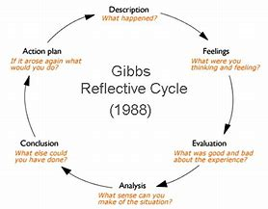
Figure 2-1. Gibbs reflective cycle (1988)

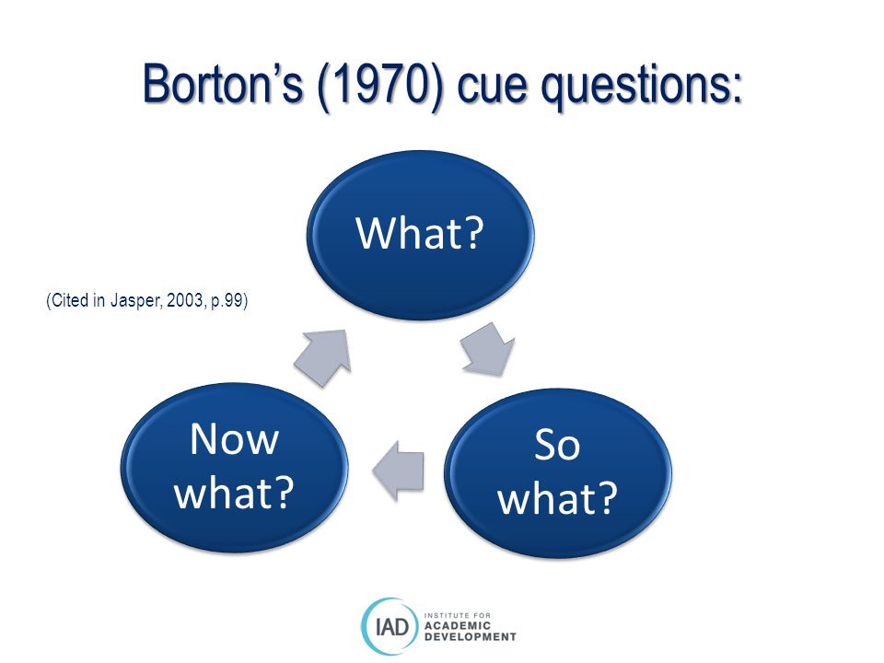
Figure 2-2 Bortons three staged model (1970)

2.3 MASTERCLASS SESSIONS

Throughout the first semester, we had to attend weekly masterclass sessions, over the many that I attended a few sessions resonated with me where I have since applied what I have learnt in my academic and personal development. One of the masterclass sessions was with entrepreneur Stifyn Parri otherwise known as the managing director of Mr. Producer. The company offers a selection of creative services including media training and creative consultancy (Perry, 2016). Throughout his masterclass session, the key primary themes that were highlighted was the important of communication and being prepared. Stifyn Parri spoke about how it is crucial that you communicate with your audience on an equal status but also match the status to those of your audience. It is blatant that effective communication is a clear indicator to success and the success of our project as being able to communicate effectively has allowed us to build an element of trust with our target audience and in effect increases the moral levels within our team (Page, 2016).
Stifyn further touched upon how important it is to be prepared and have a structure to your project where he urged us to become familiar with our project. From this I have learnt that it is important to be prepared for the expected, which can be minor details such as deadlines for assignments with our project of event dates and also the unexpected which involve unknown circumstances you may be faced with, for example when our group were not able to hold our fundraising event at the desired venue we had to source another venue in very little time (Edgar, 2016).
Another masterclass session that had an impact on my project and personal learning is Kate, the founder of Gower Cottage brownies. Kates success story was certainly impressive where she started making her brownies from her house and distributing them locally in 2007 to be a multi award winning brand which is now being sold in thousands of shops around the UK (Brownies, 2016). The themes that I picked up on throughout Kate’s masterclass session is the importance of Marketing and Perseverance. Kate spoke about how she was able to market her business and herself to create a trustworthy brand and how it has contributed to the success of her brownie business. I was already aware how important marketing is to a business and how it would affect the success of our project because marketing allows you to build a sense of brand awareness and allows you to grow your business or whatever you are trying sell to engage with more customers (Gross, 2016).

Influence of Masterclasses on the Project
The Masterclasses had a direct impact on the running and structure of our project, as touched upon previously Stifyn Parri reiterated the importance of communication and how you engage with your target audience. Before attending his masterclass how we communicated as a group with our target audience was not a priority factor however, once attending his masterclass we realised as group that because we were targeting a young adult target audience for both the LGBT community we realised that it was important that our audience would be able to relate to us. Following this, we decided to reach out on social media channels to our target audience and connect with them on an informal level to build a relationship on trust and relatability. For our project, connecting with our audience was crucial, however not in the sense of running after our target audience but to run with them and to understand the role that we as a group can do to help achieve what our target audience expects from us, this is the ultimate concept of connecting with your consumers. Understanding what we need from them and in turn what they expect from us (Robert Edwin Wayland, 1997).
The importance of Marketing was a key concept in Kate Gower cottage brownies masterclass, and as a group, for our project, we have been able to apply what we acquired from her class and used it effectively. Marketing played a continuous role throughout our project and used it predominately to raise awareness for the unity LGBT and the fundraising event we were hosting. Through the means of social media, leaflets, blogs and talking one on one of our target audience we were able to contribute these efforts to the success of our project. The marketing strategy was a recurring theme throughout our project and following the connect of the marketing mix enabled us as a group to achieve our overall objectives and goals in our target market (Stanley F, 2010).
In the future, I would have made various changes to improve the project, especially with communication. Even though the communication between my team and our target audience was positive, despite countless attempts to connect with the unity LGBT centre, we received no input from them towards our project and raising awareness for the centre. The lack of communication from the unity LGBT centre left the group feeling uncertain on what the correct course of action would be to raise awareness for the centre, and without their contribution, the team had to go off our initiative to find the most appropriate way to increase awareness for the centre (Kokemuller, 2017).
To further this, if I were able to do the project over again, I would ensure that the team would always have a plan B in motion in case things did not go according to plan. In more technical terms, I feel as it would have been beneficial to have a contingency plan in place to prepare for the worst scenarios that could have happened during the completion of our project. If we the team had a contingency plan in place allows you to identify risks and minimise the impact if they were to occur. Many businesses have a contingency plan in place identifying things that could potentially go wrong (Kearns, 2017) and I believe that if we had one in place for when we were not able to hold our fundraising event where we had hoped, we would not have been stuck with limited time to find an alternative venue, and thus our event being more successful and would have reached more people.

Influence of the masterclasses on personal learning & development
From attending the masterclasses, I have learnt various techniques that I have adapted and used towards my learning and development. One of the key things I have improved is the ability to communicate effectively and listen to others. While working in a team, it is crucial to communicate and listen to everyone’s ideas and values to achieve overall success. While occupied in a team I have cultured that each member of our team has their unique learning style, and instead of clashing due to the different approaches I’ve learnt that you can take something from each member of your team and use it to improve your self-learning and knowledge (Llopis, 2013).
From attending Kates Gower Cottage Brownies masterclass and her advice on perseverance and to not give up is something I have taken personally and adapted it to my personal life and academic life. Our project was conducted over several months, and as a group, we faced many downfalls along the way, that’s why from attending Kates masterclass and committing to the perseverance of the project has allowed the group to achieve our overall goals. From a personal point of view, Perseverance was something I have had to learn, and from this project I have learnt that failures lead to success, and despite the setbacks we had during our project I had to keep a positive morale and keep making continuous efforts to achieve the goal of the project even if it did not always run effortlessly to get there (Lemind, 2012). The biggest lesson for my learning from this is that you can learn from your mistakes, and it’s important to turn a negative into a positive.
throughout the project and attending the masterclasses my academic skills have developed profusely, especially from listening to Stifyn Parri and how explained that you should always rehearse your script whether it is with public speaking or giving a presentation and be familiar with your surroundings. This advice I have taken literally when it comes to public speaking and giving presentations during the project, Stifyn Parri gave the advice of always have your notes typed out in bold so that you can read them clearly and also put your notes in to bullet points rather than paragraphs, something that I would previously not of thought of. From this masterclass, I have more confidence when it comes to public speaking something I was not previously comfortable with. Having improved academic skills from communication and public speaking, for example, is vital, especially when leaving university to go into the job market which is more and more competitive. Attending these masterclasses gives me access to personal skills for life, and I will be more desirable to an employer if I can conduct an impressive presentation and communicate effectively (Schulz, 2008).
For the future, I am continuously going to be improving the skills I have learnt from the masterclass sessions especially with practicing public speaking to get as professional and comfortable in giving presentations as it will be required of me in the working environment. Also I am always eager to Improve my communication skills particularly with listening, there are various ways to improve your listening skills, for example, to communicate effectively I have to work towards listening to people first before I speak, and then provide an answer when I have taken their ideas into consideration even if I might not agree, I must respect other people’s approaches (Patel, 2017).
Regarding working on my strengths, I consider myself to be very realistic, which has proven useful throughout the project when some members of the team produce ideas that are simply unachievable and to farfetched to be completed with the time frame we had and no budget. I believe it is important to be optimistic but also have realistic traits in your personality, as being too optimistic can show a delusion of the success you will be able to achieve (Jao, 2013) and some members within the team overestimated our ability to execute the desired fundraising event.

Conclusion

To conclude this report, the masterclass session has had a vast impact on the project and the personal skills I have been able to develop along the way which I am now able to use for the rest of my life. The skills and models of reflections used have reflected the running and ability to achieve the overall goals of the project successfully. I hope to be able to effectively use these skills and replicate them to enhance my unremitting personal learning.

References

Brownies, G. C. (2016). Retrieved from Gower Cottage BROWNIES: http://www.gowercottagebrownies.co.uk/

Cottrell, S. (2011). Critical Thinking Skills: Developing Effective Analysis and Argument (Palgrave Study Skills). Palgrave Macmillan; 2nd edition edition.

David Boud, R. K. (2013). Reflection: Turning Experience into Learning. Oxfordshire: Routledge.

Edgar, M. (2016, October 1st). On Being Prepared. Retrieved from Matthew EDGAR: https://www.matthewedgar.net/on-being-prepared/

Gross, J. (2016, November 4th). Why marketing is SO important. Retrieved from Moving Targets: https://movingtargets.com/blog/business/why-marketing-is-so-important/

Jao, J. (2013, December 4th). Optimism vs. Realism: Which Breeds More Entrepreneurial Success? Retrieved from Forbes: https://www.forbes.com/sites/jerryjao/2013/12/04/optimism-vs-realism-which-breeds-more-entrepreneurial-success/#6536ed0d5126

Kearns, S. (2017). What Is a Contingency Plan and Why Does Your Business Need One? Retrieved from QuickBooks Resource Center: https://quickbooks.intuit.com/r/business-planning/what-is-a-contingency-plan-and-why-does-your-business-need-one/

Kokemuller, N. (2017, September 27th). How Does Poor Communication Affect an Organization? Retrieved from Bizfluent: https://bizfluent.com/info-8380825-poor-communication-affect-organization.html

Lemind, A. (2012, Febuary 16th). Perseverance in achieving success. Retrieved from Learning mind: https://www.learning-mind.com/perseverance-in-achieving-success/

Llopis, G. (2013, May 20th). 6 Ways Effective Listening Can Make You A Better Leader. Retrieved from Forbes: https://www.forbes.com/sites/glennllopis/2013/05/20/6-effective-ways-listening-can-make-you-a-better-leader/#6fcbde7c1756

M, J. (2003, Febuary). Bortons’ (1970) framework. Retrieved from Reflection on the tin: https://reflectiononthetin.files.wordpress.com/2013/02/bortonsmodelofreflection.pdf

Page, M. (2016, December 8th). The importance of good communication. Retrieved from Micheal Page: https://www.michaelpage.co.uk/advice/management-advice/development-and-retention/importance-good-communication

Patel, D. (2017, September 20th). 14 Proven Ways to Improve Your Communication SKILLS. Retrieved from ENTREPENUER: https://www.entrepreneur.com/article/300466

Perry, S. (2016). Mr Producer Stifyn Perry. Retrieved from Mr PRODUCER: https://mrproducer.co.uk/homepage/

reflections, D. (2016, Febuary 2nd). Choosing a reflective model and looking at the components. Retrieved from Digital Dilemas Solved: http://digitaldilemmas.cymru/choosing-a-reflective-model/

Reflective writing: About Gibbs reflective cycle. (n.d.). Retrieved from Oxford Brookes UNIVERSITY: https://www.brookes.ac.uk/students/upgrade/study-skills/reflective-writing-gibbs/

Robert Edwin Wayland, P. M. (1997). Customer Connections: New Strategies for Growth. MA: Harvard Business Press.

Schulz, B. (2008). The Importance of Soft Skills: Education beyond academic knowledge. Journal of Language and Communication, 150.

Stanley F, S. T. (2010). Factors inﬂuencing the relative importance of marketing strategy creativity and marketing strategy implementation effectivenes. Industrial Marketing Management, 552.

Student, M. (2015, May 2nd). Guide to models of reflection – when & why should you use different ones? Retrieved from Lifelong Learning with OT: https://lifelonglearningwithot.wordpress.com/2016/05/02/different-models-of-reflection-using-them-to-help-me-reflect/

Unity Group Wales. (2001). Retrieved from UnityGroup: https://www.unitygroup.wales/

