Appendices

Appendix 1: Ethics Form

APPLICATION FOR ETHICAL APPROVAL

In order for research to result in benefit and minimise risk of harm, it must be conducted ethically. A researcher may not be covered by the University’s insurance if ethical approval has not been obtained prior to commencement.

The University follows the OECD Frascati manual definition of research activity: “creative work undertaken on a systematic basis in order to increase the stock of knowledge, including knowledge of man, culture and society, and the use of this stock of knowledge to devise new applications”. As such this covers activities undertaken by members of staff, postgraduate research students, and both taught postgraduate and undergraduate students working on dissertations/projects.

The individual undertaking the research activity is known as the “principal researcher”.

Ethical approval is not required for routine audits, performance reviews, quality assurance studies, testing within normal educational requirements, and literary or artistic criticism.

SECTION A: About You (Principal Researcher)
Full Name: |  | Abigail Susan Fellows
Tick all boxes which apply: |  | Member of staff: | ☐ | Honorary research fellow: | ☐
Undergraduate Student | ☒ | Taught Postgraduate Student | ☐ | Postgraduate Research Student | ☐

Faculty/School/Centre: | ITE: Yr Athrofa, UWTSD
Campus: | Carmarthen
E-mail address: | 1708219@student.uwtsd.ac.uk
Contact Telephone Number: | 07415487966
For students:
Student Number: | 1708219
Programme of Study: | BA Primary Education (QTS)
Director of Studies/Supervisor: | Dr Sioned V Hughes

SECTION B: Approval for Research Activity
Has the research activity received approval in principle?  (please check the Guidance Notes as to the appropriate approval process for different levels of research by different categories of individual) |  | YES | ☒ | NO | ☐
 |  |  |  | Date
If Yes, please indicate source of approval (and date where known): Approval in principle must be obtained from the relevant source prior to seeking ethical approval | Research Degrees Committee |  | ☐
 | Faculty Research Committee |  | ☐
 | Other (write in) Module Lead |  | ☒ | 6.02.2020

SECTION C: Internal and External Ethical Guidance Materials
Please list the core ethical guidance documents that have been referred to during the completion of this form (including any discipline-specific codes of research ethics, and also any specific ethical guidance relating to the proposed methodology). Please tick to confirm that your research proposal adheres to these codes and guidelines.
UWTSD Research Ethics & Integrity Code of Practice | ☒
UWTSD Research Data Management Policy | ☒
BERA (British Educational Research Association) guidelines -Ethical Guidelines for Educational Research, (2018) | ☒
The research is within the bounds of the normal classroom and in accordance with the ATHROFA guidelines for parental consent as per ATHROFA letter. | ☒
Education Workforce Council (EWC) Research and Ethics Guidelines (2019) | ☒

SECTION D: External Collaborative Research Activity
Does the research activity involve collaborators outside of the University? |  | YES | ☐ | NO | ☒
If Yes, please provide the name of the external organisation and name and contact details for the main contact person and confirmation this person has consented to their personal data being shared.as part of this collaboration.
Institution
Contact person name
Contact person e-mail address

Has this individual consented to sharing their details on this form? |  | YES | ☐ | NO |  |  | ☒
Are you in receipt of a KESS scholarship? |  | YES | ☐ | NO |  |  | ☒
Is your research externally funded |  | YES | ☐ | NO |  |  | ☒
Are you specifically employed to undertake this research in either a paid or voluntary capacity? | Voluntary | YES | ☐ | NO |  | ☒
 | Employed | YES | ☐ | NO |  | ☒
Is the research being undertaken within an existing UWTSD Athrofa Professional Learning Partnership (APLP) | If YES then the permission question below does not need to be answered. | YES | ☒ | NO |  |  | ☐
Permission to undertake the research has been provided by the partner organisation | (If YES attach copy)  If NO the application cannot continue | YES | ☐ | NO |  |  | ☐

Where research activity is carried out in collaboration with an external organisation
Does this organisation have its own ethics approval system? | YES | ☐ | NO | ☒
If Yes, please attach a copy of any final approval (or interim approval) from the organisation

SECTION E: Details of Research Activity
Indicative title: | Identifying the teacher’s role in supporting student mental health and emotional wellbeing and the importance of promoting positive mental health and wellbeing in the primary school context.
Proposed start date: | 10.02.2020 | Proposed end date: | 01.07.2020
Introduction to the Research (maximum 300 words)

Ensure that you write for a Non-Specialist Audience when outlining your response to the three points below:
- Purpose of Research Activity
- Proposed Research Question
- Aims of Research Activity
- Objectives of Research Activity
Demonstrate, briefly, how Existing Research has informed the proposed activity and explain
- What the research activity will add to the body of knowledge
- How it addresses an area of importance.
Purpose of Research Activity

- To explore teaching staff’s role in promoting positive mental health and wellbeing in primary schools.
- To explore the importance of promoting mental health and wellbeing in education.
- To further develop professional knowledge and understanding for future practice.
- To gain a better understanding to support pupils in education.

(this box should expand as you type)
Research Question
Identifying the teacher’s role in supporting student mental health and emotional wellbeing and the importance of promoting positive mental health and wellbeing in the primary school context.

(this box should expand as you type)
Aims of Research Activity
The research aims to capture the views of our current generation of practitioners and students as they contribute to an informed dissertation regarding mental health and wellbeing. Existing research such as DeSocio and Hootman (2014) suggest that a lack of support regarding health and wellbeing impacts individual educational attainment and potential. But according to McGourty (2017) only a small number of teachers have received necessary training to support pupils with their mental health problems. The primary research that I wish to undertake will provide an insight into how important existing mental health and wellbeing support is and distinguishing the role of teaching staff and the effectiveness of their role.

(this box should expand as you type)
Objectives of Research Activity
- To interview students to gain their understanding of the importance of wellbeing.
- To use a questionnaire to capture their views on the importance of supporting mental health and wellbeing.
- To interview teaching staff to gain an understanding of their role in regard to supporting mental health and wellbeing within the school.
- To gain an understanding of the existing support strategies to support pupils.
- To critically reflect on findings and consider how I can use this to improve and transform my professional practice.
(this box should expand as you type)
Proposed methods (maximum 600 words)
Provide a brief summary of all the methods that may be used in the research activity, making it clear what specific techniques may be used. If methods other than those listed in this section are deemed appropriate later, additional ethical approval for those methods will be needed.
A group of children from key stage two classes will be involved in a semi-structured interview where they will be asked key questions regarding health and wellbeing support/interventions at the school. The children will be in an informal setting and I will make notes of their responses or with their permission, make an audio recording of the interview. EXIT: The children will not be forced into participating or responding to questions; the notion that responses to questions are voluntary will be expressed at the start of the interview. All children will be asked if they wish to take part in the interview and before the interview, the children will be informed that they can withdraw from the interview or not respond at any time without notice. During the interview I will check they remain comfortable throughout. At the time that the interviews data is utilised in my written response, no names shall be mentioned. I may use pseudonyms to assist the discussion.
Additionally, I will interview members of staff. However, with members of staff, questions of a professional nature will be posed. EXIT: Staff participation will be voluntary, and this notion will be expressed to participants from the outset. The staff will be informed that they can withdraw from the interview or not respond to a question at any time without providing notice.

Video or audio taping will be used during group or individual interviews (with the interviewees prior permission) and later utilised to contribute towards my discussion and synthesis. I will engage with the class teacher to enquire whether all children in the situation can be videoed. Recording interviews with teaching staff may also be gathered to contribute towards the research project. Prior to recording any research participant, I will gain their permission initially and act in an ethical manner throughout.

Depending on the participants responses throughout the research period I may create and administer a questionnaire to assist me to gather quality data. Throughout the creation of the questionnaire, I will adhere to and follow the training provided by the university. The questionnaire may focus on qualitative or quantitative data or both, depending on its focus. Furthermore, the questionnaire may be administered to learners, staff or both. If a questionnaire is necessary, then participants will not be required to list their name or personal information.
I will create a cover letter to accompany the questionnaire which will explain to the participant the reason for and nature of the research questionnaire. The questionnaire will be distributed via physical means only. Once participants have completed their questionnaire, their response will be gathered and placed within the response pool for analysis. EXIT: Before the participant submits their questionnaire, they have the right to retain their response. However, once I receive the participants response and it is added to the pool there will be no fair means of identifying their response in order to return it to them. This will be explained in the cover letter.

To support my research, I may conduct a learning walk through the school to observe displays and discuss certain aspects of provision with members of staff or pupils. These learning walks may be self-directed or facilitated by a learner, group of learners or member of staff. EXIT: Prior to conducting the learning walk I will obtain consent from a member of staff. Prior to evidencing the walk (by means of written, photographic or audio methods) I will ask the participant who hosted the walk for their consent to use the information they provide in my research.

At no times will children’s and adults’ names be recorded.

(this box should expand as you type)

Location of research activity
Identify all locations where research activity will take place.
The proposed research activity will be conducted in a Primary school within the Athrofa.

(this box should expand as you type)
Research activity outside of the UK
If research activity will take place overseas, you are responsible for ensuring that local ethical considerations are complied with and that the relevant permissions are sought. Specify any local guidelines (e.g. from local professional associations/learned societies/universities) that exist and whether these involve any ethical stipulations beyond those usual in the UK (provide details of any licenses or permissions required). Also specify whether there are any specific ethical issues raised by the local context in which the research activity is taking place, for example, particular cultural and/or legal sensitivities or vulnerabilities of participants.
N/A
(this box should expand as you type)
Use of documentation not in the public domain: Are any documents NOT publicly available? | NO | ☒
 | YES | ☐
If Yes, please provide details here of how you will gain access to specific documentation that is not in the public domain and that this is in accordance with prevailing data protection law of the country in question and England and Wales.

(this box should expand as you type)

SECTION F: Scope of Research Activity
Will the research activity include: | YES | NO
Use of a questionnaire or similar research instrument? | ☒ | ☐
Use of interviews? | ☒ | ☐
Use of diaries? | ☐ | ☒
Participant observation with their knowledge? | ☐ | ☒
Participant observation without their knowledge? | ☐ | ☒
Use of video or audio recording? (Interview) | ☒ | ☐
Access to personal or confidential information without the participants’ specific consent? | ☐ | ☒
Administration of any questions, test stimuli, presentation that may be experienced as physically, mentally or emotionally harmful / offensive? | ☐ | ☒
Performance of any acts which may cause embarrassment or affect self-esteem? | ☐ | ☒
Investigation of participants involved in illegal activities? | ☐ | ☒
Use of procedures that involve deception? | ☐ | ☒
Administration of any substance, agent or placebo? | ☐ | ☒
Working with live vertebrate animals? | ☐ | ☒
Other primary data collection methods, please explain in this box  For example, ‘focus groups’. Please indicate the type of data collection method(s) in this box and tick the accompany box. | ☐ | ☐
Details of any other primary data collection method:  (this box should expand as you type) | ☐ | ☐
If NO to every question, then the research activity is (ethically) low risk and may be exempt from some of the following sections (please refer to Guidance Notes).

If YES to any question, then no research activity should be undertaken until full ethical approval has been obtained.

SECTION G: Intended Participants
Who are the intended participants: | YES | NO
Students or staff at the University? | ☐ | ☒
Adults (over the age of 18 and competent to give consent)? | ☒ | ☐
Vulnerable adults? | ☐ | ☒
Children and Young People under the age of 8? (Consent from Parent, Carer or Guardian will be required) | ☒ | ☐
Prisoners? | ☐ | ☒
Young offenders? | ☐ | ☒
Those who could be considered to have a particularly dependent relationship with the investigator or a gatekeeper? | ☐ | ☒
People engaged in illegal activities? | ☐ | ☒
Others (please identify specifically any group who may be unable to give consent) please indicate here and tick the appropriate box. | ☐ | ☒
Other – please indicate here:  (this box should expand as you type) | ☐ | ☒

Participant numbers and source
Provide an estimate of the expected number of participants. How will you identify participants and how will they be recruited?
How many participants are expected? | About 50 participants in school.  (this box should expand as you type)
Who will the participants be? | Headteacher  Majority of the teaching staff.  Around 30 students from Key Stage 2.  (this box should expand as you type)
How will you identify the participants? | Prior to conducting the research, I will discuss and seek advice from the headteacher or senior mentor in the school setting.  (this box should expand as you type)

Information for participants: | YES | NO | N/A
Will you describe the main research procedures to participants in advance, so that they are informed about what to expect? | ☒ | ☐ | ☐
Will you tell participants that their participation is voluntary? | ☒ | ☐ | ☐
Will you obtain written consent for participation? | ☒ | ☐ | ☐
Will you explain to participants that refusal to participate in the research will not affect their treatment or education (if relevant)? | ☒ | ☐ | ☐
If the research is observational, will you ask participants for their consent to being observed? | ☒ | ☐ | ☐
Will you tell participants that they may withdraw from the research at any time and for any reason? | ☒ | ☐ | ☐
With questionnaires, will you give participants the option of omitting questions they do not want to answer? | ☒ | ☐ | ☐
Will you tell participants that their data will be treated with full confidentiality and that, if published, it will not be identifiable as theirs? | ☒ | ☐ | ☐
Will you debrief participants at the end of their participation, in a way appropriate to the type of research undertaken? | ☒ | ☐ | ☐
If NO to any of above questions, please give an explanation
(this box should expand as you type)

Information for participants: | YES | NO | N/A
Will participants be paid? | ☐ | ☒ | ☐
Is specialist electrical or other equipment to be used with participants? | ☐ | ☒ | ☐
Are there any financial or other interests to the investigator or University arising from this study? | ☐ | ☒ | ☐
Will the research activity involve deliberately misleading participants in any way, or the partial or full concealment of the specific study aims? | ☐ | ☒ | ☐
If YES to any question, please provide full details
(this box should expand as you type)

SECTION H: Anticipated Risks

Outline any anticipated risks that may adversely affect any of the participants, the researchers and/or the University, and the steps that will be taken to address them.

If you have completed a full risk assessment (for example as required by a laboratory, or external research collaborator) you may append that to this form.
Full risk assessment completed and appended? |  | Yes | ☐
 |  | No | ☒
Risks to participants
For example: emotional distress, financial disclosure, physical harm, transfer of personal data, sensitive organisational information
Risk to Participant:  May affect self-esteem through not being chosen as participant in the research.  Teaching staff and pupils could feel under pressure to give the correct answer to the questions  Safeguarding issues could arise during research  Anonymity | How will you mitigate the Risk to Participant  All potential pupils will give in consent forms. Pupils will be told that there will be a selection of children chosen at random.  I will make it clear that I want open and honest answers. Pupils will be told there are no consequence for anything that they say. We will make it clear that the answers they give will affect their education in no way and there will be no repercussions for their actions and answers in regard to the research.  If anyway safeguarding issues arise, I will inform the safeguarding officer at the school immediately.  Participants will be made aware that all data will be anonymised and will remain confidential. They will be aware that no pupil will be able to be identified by the research.
If research activity may include sensitive, embarrassing or upsetting topics (e.g. sexual activity, drug use) or issues likely to disclose information requiring further action (e.g. criminal activity), give details of the procedures to deal with these issues, including any support/advice (e.g. helpline numbers) to be offered to participants. Note that where applicable, consent procedures should make it clear that if something potentially or actually illegal is discovered in the course of a project, it may need to be disclosed to the proper authorities
N/A
(this box should expand as you type)
Risks to investigator
For example: personal safety, physical harm, emotional distress, risk of accusation of harm/impropriety, conflict of interest
Risk to Investigator:  Allegations from pupils in the classroom whilst completing the research.  Possibility of being accused of favouritism by pupils who are not part of the focus group.  Accusation of fabrication or falsification of the data.  Possible power imbalance with myself as a teacher researcher.  (this box should expand as you type) | How will you mitigate the Risk to Investigator:  During the interview, there will be another researcher in the room.  All potential participants will give in consent forms. Pupils will be told that there will be a selection of children chosen at random.  I will ensure that I follow the UWTSD and BERA ethical guidelines when conducting this research.  Pupils will be made aware that participation is voluntary, they have the right to withdraw at any time, without consequence, Consent will be obtained from parents and carers.  (this box should expand as you type)
University/institutional risks
For example: adverse publicity, financial loss, data protection
Risk to University:  The need to uphold the good name of the university.  Not falsifying any data which could impact the representation and standards of the university.  Not behaving in a way that could impact the relationship between school and university.  (this box should expand as you type) | How will you mitigate the Risk to University:  I will make sure I follow the UWTSD and BERA ethical guidelines when conducting this research. I will always behave in a professional manner.  (this box should expand as you type)

Disclosure and Barring Service
If the research activity involves children or vulnerable adults, a Disclosure and Barring Service (DBS) certificate must be obtained before any contact with such participants. | YES | NO | N/A
Does your research require you to hold a current DBS Certificate? | ☒ | ☐ | ☐

SECTION I: Feedback, Consent and Confidentiality
Feedback
What de-briefing and feedback will be provided to participants, how will this be done and when?
I will not be providing feedback to the participants as it is not relevant to the research. If the participants request feedback from the response then I, as the author, will provide a summary of the data.

(this box should expand as you type)
Informed consent
Describe the arrangements to inform potential participants, before providing consent, of what is involved in participating. Describe the arrangements for participants to provide full consent before data collection begins. If gaining consent in this way is inappropriate, explain how consent will be obtained and recorded in accordance with prevailing data protection legislation.
Participation consent- children
I will converse with my class teacher and senior mentor and inform them of the research I will be undertaking, providing reason and rationale behind the research. However, I will verbally ask children identified to participate whether they wish to participate, they will be offered to use traffic light cards. If they show the green face, then I know they are happy to take part. If they show the red face, then I know they are not willing. This will be an individual exercise so that children are encouraged to respond honestly with their interest and wellbeing in mind. Children will also be informed that they can approach me at any time to discuss their contribution to the research project and explain whether they wish to participate.

Participation consent- adults
For the teaching staff, I will ask them to sign a document if they agree to take part in the research. If they are not willing to sign the document, then I shall not use them in my research. The consent from will include a box for a participant to tick if they agree with the statements, e.g. I confirm that I have read and understand the information sheet dated __/___/_____for the above student. I have had the opportunity to consider the information, ask questions and had these answered satisfactorily. I understand that my participation is voluntary, and I am free to withdraw at any time, without giving any reason. I understand that any information given by me may be used in future report, articles or presentations by the research team. I understand that my name will not appear in any report, articles or presentations. I agree to participate in the above study.

(this box should expand as you type)
Confidentiality / Anonymity
Set out how anonymity of participants and confidentiality will be ensured in any outputs. If anonymity is not being offered, explain why this is the case.
I will ensure that no individual data are made available to schools/ parents. Only non-identifiable summary/aggregate data can be provided this way.

I will also place a statement of the consent form indicating that ‘if you decide to remain anonymous, maintaining your anonymity will be a priority and every practical precaution will be taken to disguise your identity/if you prefer anonymity, there will not be any identifying information on audiotapes and transcripts without your prior consent. All materials generated from this or any interview will remain confidential.’

(this box should expand as you type)

SECTION J: Data Protection and Storage
In completing this section refer to the University’s Research Data Management Policy and the extensive resources on the University’s Research Data Management web pages (http://uwtsd.ac.uk/library/research-data-management/).
Does the research activity involve personal data (as defined by the General Data Protection Regulation 2016 “GDPR” and the Data Protection Act 2018 “DPA”)? | YES | NO
“Personal data” means any information relating to an identified or identifiable natural person (‘data subject’). An identifiable natural person is one who can be identified, directly or indirectly, in particular by reference to an identifier such as a name, an identification number, location data, an online identifier or to one or more factors specific to the physical, physiological, genetic, mental, economic, cultural or social identity of that natural person. | ☐ | ☒
If YES, provide a description of the data and explain why this data needs to be collected:
(this box should expand as you type)
Does it involve special category data (as defined by the GDPR)? | YES | NO
“Special category data” means sensitive personal data consisting of information as to the data subjects’ –  (a) racial or ethnic origin,  (b) political opinions,  (c ) religious beliefs or other beliefs of a similar nature,  (d) membership of a trade union (within the meaning of the Trade Union and Labour Relations (Consolidation) Act 1992),  (e) physical or mental health or condition,  (f) sexual life,  (g) genetics,  (h) biometric data (as used for ID purposes), | ☐ | ☒
If YES, provide a description of the special category data and explain why this data needs to be collected:
(this box should expand as you type)
Will the research activity involve storing personal data and/or special category data on one of the following: | YES | NO
Manual files (i.e. in paper form)? | ☒ | ☐
University computers? | ☐ | ☒
Private company computers? | ☐ | ☒
Home or other personal computers? | ☐ | ☒
Laptop computers/ CDs/ Portable disk-drives/ memory sticks? | ☒ | ☐
“Cloud” storage or websites? | ☒ | ☐
Other – specify: | ☐ | ☒
For all stored data, explain the measures in place to ensure the security of the data collected, data confidentiality, including details of password protection, encryption, anonymisation and pseudonymisation:
Confidentiality will be upheld by not requesting participant names on any piece of data collected. Data will be stored in a file that will be stored in a locked cupboard and password protected computer. Any correspondence between my tutor and myself will be through a password protected email account.

(this box should expand as you type)
All Data Storage
Will the research activity involve any of the following activities: | YES | NO
Electronic transfer of data in any form? | ☐ | ☒
Sharing of data with others at the University? | ☒ | ☐
Sharing of data with other organisations? | ☐ | ☒
Export of data outside the European Union or importing of data from outside the UK? | ☐ | ☒
Use of personal addresses, postcodes, faxes, emails or telephone numbers? | ☐ | ☒
Publication of data that might allow identification of individuals? | ☐ | ☒
Use of data management system? | ☐ | ☒
Data archiving? | ☐ | ☒
If YES to any question, please provide full details, explaining how this will be conducted in accordance with the GDPR and DPA (and/or any international equivalent):
Raw data will be available to the university module lead and external examiner, on request. All data will be stored until the relevant research assignment goes through the university exam board. After this point, the data will be destroyed. All data will be archived on the university one drive and password protected in line with the UWTSD data management guidelines.

(this box should expand as you type)
List all who will have access to the data generated by the research activity:
Research Abigail Fellows, Tom Cox, marker

(this box should expand as you type)
List who will have control of, and act as custodian(s) for, data generated by the research activity:
Researcher Abigail Fellows

(this box should expand as you type)
Give details of data storage arrangements, including security measures in place to protect the data, where data will be stored, how long for, and in what form. Will data be archived – if so how and if not why not.
Any electronic data will be held on a password protected USB stick. Only I will have access to the USB stick. Any hard copies of work will be held in a locked drawer. Only I will have access to the key. All data will be stored until the relevant research assignment goes through the university exam board. After this point, the data will be destroyed. All data will be archived on the university one drive and password protected in line with the UWTSD data management guidelines.

(this box should expand as you type)
Please indicate if your data will be stored in the UWTSD Research Data Repository (see https://researchdata.uwtsd.ac.uk/ ). If so please explain. (Most relevant to academic staff)
N/A

(this box should expand as you type)
Confirm that you have read the UWTSD guidance on data management (see https://www.uwtsd.ac.uk/library/research-data-management/) | YES | ☒
 | NO | ☐
Confirm that you are aware that you need to keep all data until after your research has completed or the end of your funding | YES | ☒
 | NO | ☐

SECTION K: Declaration
The information which I have provided is correct and complete to the best of my knowledge. I have attempted to identify any risks and issues related to the research activity and acknowledge my obligations and the rights of the participants.

In submitting this application I hereby confirm that I undertake to ensure that the above named research activity will meet the University’s Research Ethics and Integrity Code of Practice
Signature of applicant: |  | Date:  6.02.20

For STUDENT Submissions:
Director of Studies/Supervisor: | Dr Sioned V Hughes | Date:  07.02.20
Signature: | S.V.Hughes | Date:  07.02.20

For STAFF Submissions:
Head of School/Assistant Dean: |  | Date:
Signature: |  | Date:

Checklist: Please complete the checklist below to ensure that you have completed the form according to the guidelines and attached any required documentation:
☒ | I have read the guidance notes supplied before completing the form.
☒ | I have completed ALL RELEVANT sections of the form in full.
☒ | I confirm that the research activity has received approval in principle
☐ | I have attached a copy of final/interim approval from external organisation (where appropriate)
☐ | I have attached a full risk assessment (and have NOT completed Section H of this form) (where appropriate) ONLY TICK IF YOU HAVE ATTACHED A FULL RISK ASSESSMENT
☒ | I understand that it is my responsibility to ensure that the above named research activity will meet the University’s Research Ethics and Integrity Code of Practice.
☒ | I understand that before commencing data collection all documents aimed at respondents (including information sheets, consent forms, questionnaires, interview schedules etc.) must be confirmed by the DoS/Supervisor, module tutor or Head of School.
☒ | I have deleted the guidance notes before submitting the PG2 for consideration

Appendix 2: Pupil Questionnaire


Research Question- An exploration into the teachers and teaching assistant’s role in promoting positive mental health and wellbeing in primary school.
- I am
Male

Female

- There is someone in school to help me when I am worried
Yes Name:

No

Don’t know
- There is someone in school to help me when I feel anxious
Yes Name:

No

Don’t know

- There is someone in school to help me when I am upset
Yes Name:

No

Don’t know

- How important are the following in helping you when you feel like you can’t cope on a scale of one to 10? (with 10 being very important and 1 being not at all important)
The school in general
Class teacher
Another teacher
Teaching assistant
Other

- How do teachers/ teaching assistants make sure you feel happy in school?

- What support would you like in school when you are feeling distressed/unhappy?

Appendix 3: Teacher Questionnaire

Research Question- An exploration into the teachers and teaching assistant’s role in promoting positive mental health and wellbeing in primary school.

- What is your role within the school?

Headteacher

Class Teacher

Teaching Assistant

- What training or guidance have you received on student emotional well-being and mental health, either through your initial teacher training or continuing Professional Development?

- To what extent do you agree or disagree with the following statement? (1 meaning strongly disagree, 10 meaning strongly agree)
"The training or guidance I have received has helped me to support my students with their emotional well-being and mental health."

- What are the specific strategies you have used to support pupils?

- Could you expand in the ways you have used these strategies?

- On a scale of 1-10, how confident do you feel at supporting pupils with ill mental health? (1 being unconfident and 10 being extremely confident)

- On a scale of 1-10, In your opinion, how effective are the strategies that you have used to support learners with mental health issues or poor wellbeing. (1 being ineffective and 10 being extremely effective)

- Educators and policymakers recognize that good mental health is essential to achieving success in life, but schools are not primarily organized to facilitate the provision of mental health services (Cunningham & Cunningham, 2001; Adelman & Taylor, 1998). On a scale from one to 10 what extent do you agree with this statement. (1 meaning strongly disagree, 10 meaning strongly agree)

- To what extent do you agree or disagree with the following statement? (1 meaning strongly disagree, 10 meaning strongly agree)
"The current school curriculum provides opportunities for students to learn about emotional well-being and mental health."

- To what extent do you agree or disagree with the following statement? (1 meaning strongly disagree, 10 meaning strongly agree)
"The new curriculum will improve opportunities for students to learn about emotional well-being and mental health."

11A). Should promoting good mental health be taught as part of the school curriculum?

11B) What areas/topics would you focus on if this was the case?

National Assembly for Wales, Children, Young People and Education Committee (2017) Emotional well-being and mental health in schools and colleges survey summary - education professionals. [Online].
Available from:http://senedd.assembly.wales/documents/s69007/CYPE5-33-17%20-%20Paper%201b%20-%20Summary%20of%20survey%20results%20- %20education%20professionals.pdf (Accessed: 8th February 2020)

Appendix 4: Participant 1 Interview

- What does positive mental health and good wellbeing mean to you?

- Happy place- from their own point of view and my own personal point of voice
- Being content with their life
- Mental state/ mind being in a good place

- What do you consider the biggest challenges for Ynysfach primary school regarding mental health issues/wellbeing?
- Being able to get at all children that need the support- not all children have the relevant support that they need
- Time constraints- Limited time- timetable for 1 day a week
- Lots of children need to access the support
- Mental health in primary school is so severe
- Many different complex needs
- Funding

- Does your school have a mental health policy?
- Probably
- Healthcare policy is available on website and in office

- ALNco would speak to staff if needed about mental health support

- Does your school have a counsellor or dedicated support for the emotional well-being and mental health of its students?
TA- Nurture, relationship play, talk-about
Can access intervention TA if they need to. However, they are usually working 1:1 with a child but if children need support and they are able to leave the classroom they will.
- Do you think there is a link between positive mental health and students’ academic performance and behaviour?
Definitely, if a child has something on their mind or has low self-esteem or family issues that we do not know about, it will impact their work. They won’t be able to learn and have the ability to sit and learn because their mind is elsewhere.

- How would you raise awareness on the topic positive mental health to pupils?

Display board- Stress thermometers- If you’re at this level this is what you can do etc- looking at how stress/anger can come in different forms and levels and there are many different strategies they can use to calm themselves
Nurture – Discuss mental health boards
Mindfulness activities – Skittles Yoga
- What strategies/interventions are you familiar with to support mental health and/or wellbeing?
Nurture, talkabout, relationship-based play, ‘worry monster’ (anonymously getting rid of their feelings or worries)-can usually work out who’s said what and activities can be put in place to support learners without them knowing we know about their problems. ELSA support website, support group Facebook group- collaborate with other TA’s, access to the ALNco, class teacher
- Which strategy would you consider to be the most effective for supporting pupils and why?

Building a relationship with learners so they open up to you.
No pressure- sitting and listening to them, colouring, playing a board game- simple things because that’s when they open up.
If a child has issues but not prepared to speak, you’re fighting a losing battle
Then interventions can be put in place depending on the learners needs.

- Do you think your school is meeting the emotional well-being and mental health needs of its students?
Upmost to
Cannot do more at the moment
Someone should doing it (interventions) more often, but it is not feasible
We are getting to the children that they are aware of
Funding affects this
Something needs to be down within education in the UK – mental health issues are increasing
- Are there whole-school procedures that help staff recognise and respond to emotional well-being and mental health issues?
Yes – Class teacher
Discussions between class teacher and headteacher- may need to share
During ADDS or inset days – issues are shared with members of staff so they are all aware of difficulties learners have and in ways they can support them
Referral forms to access interventions
- Could you define the role of the teacher in supporting positive mental health and wellbeing?

Teachers main role is to teach but they cannot get away from it
Teachers role is everything- tying shoelaces, toilet training, emotional wellbeing
Teachers can only do so much
More should be done with the parents
If there are 5/6 students in a class with poor mental health- should teachers focus on them or focus on the other 15/20 students, then leave the 5 children who are struggling
It is a balancing act – ensure they are ready to learn because you may be fighting a losing battle.
We have got to get the children educated but you cannot educate if their mental health is poor.
But only certain amount of time can be put into mental health issues because teachers have so many responsibilities.

- Could you define the role of teaching assistants in supporting positive mental health and wellbeing?

Give children the tools they need to help themselves
Access to nurture, relationship play, talk about
Display for learners to support themselves.
TA available for extra support, time out of class etc.

- In what ways is your school working with parents and the wider community to promote student emotional well-being and mental health?
Children who need access to nurture is because home life is so busy.
The emotional wellbeing of parent is as important as the child- so many other things to focus on.
Through parents evening
Parents need to give consent for their children to engage with interventions.
Letters go home to parents on any news.
Interventions- movement breaks, time out breaks- have to be shared with parents
Home school books with students behavioural/attachment issues
Parents and teacher communication if need through books or emails- ‘Yes, he has had a good night tonight’ etc.
- Do you have anything else you would like to say about the support/training available for teachers/ teaching assistants to support mental health and wellbeing in school?
All teachers/ TAs should be ELSA trained but it is very expensive. Our ELSA is on long term sick
There should be more understanding of mental health issues- in depth training- TAs rather than teachers trained- because they can take them out of class to do 1:1 with them and IEPs etc.
Inset days for nurture training, relationship-based play- Safeguarding team come in
All teaching staff have the understanding
- Does training impact your confidence at supporting learners?
Without question
Difficult to talk about mental health if you do not know them that well or know much about mental health
Been doing it a while now so I am more confident with it
It is hard to have difficult conversations – certain things you can and can’t say
Without question training supports this.

Appendix 5: Participant 2 Interview

- What does positive mental health and good wellbeing mean to you?

Feeling happy, positive, feeling safe in their environment- school and home

- What do you consider the biggest challenges for Ynysfach primary school regarding mental health issues/wellbeing?

Need for interventions in these areas
Not a lot of funding

- Does your school have a mental health policy?

I believe so

- Does your school have a counsellor or dedicated support for the emotional well-being and mental health of its students?
Don’t think so – Elise the SENco lead person
Different TAs support wellbeing – Lisa- nurture, Kelly- relationship based play and time to talk
- Do you think there is a link between positive mental health and students’ academic performance and behaviour?
Yes, there is a big link
- How would you raise awareness on the topic positive mental health to pupils?
More so now- mindfulness, growth mindset,
- What strategies/interventions are you familiar with to support mental health and/or wellbeing?
Nurture, relationship-based play time to talk, talk about, wellbeing Wednesday – teacher’s pet website – e.g what are you proud about, worry box.
- Which strategy would you consider to be the most effective for supporting pupils and why?
Relationship based play – 1:1 intervention
Relationships with the class teacher- negative teacher creates a negative atmosphere
- Do you think your school is meeting the emotional well-being and mental health needs of its students?
Not for the lack of trying

- Are there whole-school procedures that help staff recognise and respond to emotional well-being and mental health issues?
Safeguarding – yellow and red forms
Back ground of child, listening to them, talking to them
- Could you define the role of the teacher in supporting positive mental health and wellbeing?
You still got to look at the stuff
Massive workload go to focus on
Important for teacher to deal with
- Could you define the role of teaching assistants in supporting positive mental health and wellbeing?
Assisting that
Children will open up more to TA
TA implement the interventions
- In what ways is your school working with parents and the wider community to promote student emotional well-being and mental health?
Open communication with parents- open door policy
Approachable to parents
- Do you have anything else you would like to say about the support/training available for teachers/ teaching assistants to support mental health and wellbeing in school?
Probably out there
Would like to have more opportunities for training

Appendix 6: Participant 3 Interview
- What does positive mental health and good wellbeing mean to you?

- Happy to come to school, happy in school, happy at home
- Children who enjoy school, engaged in school and their learning
- Good opinion of themselves and others

- What do you consider the biggest challenges for Ynysfach primary school regarding mental health issues/wellbeing?
Very little control of what happen in the home environment, this is brought into school and this affects their learning.
Mental health issues are something we see a lot more of, didn’t hear of its years ago, now every class has child or children with issues.
It is becoming more forefront in education.
Also, there are more children on child protection register.
CAHMS is overstretched
Funding
Quicker route to support learners with mental health – remove waiting lists.
- Does your school have a mental health policy?
Yes
- Does your school have a counsellor or dedicated support for the emotional well-being and mental health of its students?
Foundation phase- TAs carry out time to talk, relationship-based play
Juniors- dedicated emotional support worker- not ELSA trained- most experienced
- Do you think there is a link between positive mental health and students’ academic performance and behaviour?
Yes definitely
Positive thoughts – growth mindset
Encourage children to work hard and think positively
- How would you raise awareness on the topic positive mental health to pupils?
One of the school targets
Pupils voice- what they want to learn, if they are enjoying it, ownership, positive attitude
School is good to supporting, but society does not have the same ethos e.g parents- they can’t do this etc
- What strategies/interventions are you familiar with to support mental health and/or wellbeing?
Time to talk – Ginger- not all children use it, only some who need the intervention
In class- growth mindset, we can’t do it YET
- Which strategy would you consider to be the most effective for supporting pupils and why?

Positive teaching-
Negative teacher, negative atmosphere, never tell a child they cant do something
Nurturing atmosphere in the classroom
- Do you think your school is meeting the emotional well-being and mental health needs of its students?
I don’t think we could every meet it fully. We can always improve and keep learning, of course it can always be better, but we are trying our best.
- Are there whole-school procedures that help staff recognise and respond to emotional well-being and mental health issues?

All had ADDS training on it
No secrets- all teaching staff know about issues- all staff are aware on issues they need to know about to support learners.

- Could you define the role of the teacher in supporting positive mental health and wellbeing?
- Positive atmosphere
- Children feel happy and safe
- Children can share things with you- are not scared of you
- Approachable, welcoming and helpful
- Fun, bright classroom
- Active effort to know the children, to understand them better
- More and more things are brought into school from the home- toothbrushes- We have got to do it because who else is?

- Could you define the role of teaching assistants in supporting positive mental health and wellbeing?
- Same attitude as teacher
- Same page as teacher- as they follow their leads
- On board and supportive
- Willing to try any strategies to support learners
- Positive mental attitude in regard to teaching
- Nurturing

- In what ways is your school working with parents and the wider community to promote student emotional well-being and mental health?
Open door policy, any queries or policies
Letters – encouraging parents to come in
TAFF- team around the family – extra support for parents
- Do you have anything else you would like to say about the support/training available for teachers/ teaching assistants to support mental health and wellbeing in school?
Undertrained in a way as we can never have too much training. If there was any more training available as a teacher, I would welcome it.
Appendix 7: Participant 4 interview
- What does positive mental health and good wellbeing mean to you?
- To feel happy
- Feel good about yourself
Confident in situations
- Feel well in any environment you’re in

- What do you consider the biggest challenges for Ynysfach primary school regarding mental health issues/wellbeing?
- Significantly increased over the past few years. More and more children are suffering with poor mental wellbeing.
- It is coming from the home.
- Highlighted the difficulty for teachers to find the correct resources and support for learners
- We are trying to address as many pupils as we can
- Staff are trained, but more children need support and interventions
- Budgets are decreasing- but mental health issues are increasing

- Does your school have a mental health policy?
Yes
- Does your school have a counsellor or dedicated support for the emotional well-being and mental health of its students?
TAs go on trained courses- ELSA training, talk about programmes, nurture programmes
Nursery/reception teacher- implements all interventions to support many nursery children
TAs will assess learners and put them into appropriate interventions or groups
- Do you think there is a link between positive mental health and students’ academic performance and behaviour?
If you’re not feeling positive, happy, confident with yourself you’re not going to be motivated to do the best as you can do.
Children may have off days and the decrease in motivation, they can’t focus on a task, they feel unvalued, they don’t think they are good at something. If they have negative feelings inside them, they are not going to perform to the best of their ability.
- How would you raise awareness on the topic positive mental health to pupils?
- Whole school strategy- growth mindset- You can’t do it YET- Positive language to encourage positive understanding
- Certain days- e.g rights respecting days
- Questionnaires for learners to see areas that schools should address
- Policies
- Involve children in school life

- What strategies/interventions are you familiar with to support mental health and/or wellbeing?
Nurture, relationship play, talk about
- Which strategy would you consider to be the most effective for supporting pupils and why?

1:1 nurture- area of attachment issues- they need that time where they have the 1:1 time, where they can relax and be open with a trained adult- particularly in my class- to focus on mental wellbeing- some learners need that nurture and reassurance
More effective due to feedback from TA- that has been a good session
Counselling- 1:1 just for year 6s -
Talkabout- with peers- restraint on how open they are- better for social skills, communicating with peers- no not usually
Basic – cooking, making a card, talking with them, playing a game- basic needs they are missing out on- children come back to class beaming- they look forward to that time
- Do you think your school is meeting the emotional well-being and mental health needs of its students?
Yes- moved really far along the track
Looking to the past- no support- wasn’t a need- realising the importance of wellbeing and mental health
Thinking about introducing the daily mile- link between exercise and wellbeing
Implement Nurture, ELSA support.
But also looking at whole school- looking at the way they interact with the children, the children’s vocabulary- cannot do it YET- address the increasing needs of the children
- Are there whole-school procedures that help staff recognise and respond to emotional well-being and mental health issues?
Discuss questionnaires completed by pupils and teacher
Marking policy – utilising the growth mindset- more positive comments- encouraging them- rather than focusing on the negative
Stickers, postcards to parents- positive wellbeing of students- including the parents
- Could you define the role of the teacher in supporting positive mental health and wellbeing?
- Encourage the whole school policies are- growth mindset
Visitors in, trips- wellbeing
- Sport is in the planning
Ensuring marking policy is correct
- Pupil voice
- Talking to the pupils- each individual child -making use of the opportunities available – ELSA-
- ALN- discussing with them- who can support them- supporting parents= team around the family- communicate with family
- Whole school policies- but be aware of individuals in the class

- Could you define the role of teaching assistants in supporting positive mental health and wellbeing?
- Aware of policies
growth mindset policies
- Carry out intervention programmes
Record keeping – e.g intervention – teacher needs this feedback – to have the professional conversation to further support that child
Must share with the teacher
- In what ways is your school working with parents and the wider community to promote student emotional well-being and mental health?
Refer team around the family – work with family outside school- discuss with teacher but it is an outside agency
Access to outside agencies to guide parents to the right support
To support the whole child, many agencies need to be involved- CAHMS
Postcards, communicate with parents- open door policies
Need to have the knowledge to support Parents- discussed- strategies- what I suggest- create a plan together – I think you need to do this etc.- guidance- regular meetings- teachers understand the whole picture to fully understand the situation
- Do you have anything else you would like to say about the support/training available for teachers/ teaching assistants to support mental health and wellbeing in school?
- With decrease in budget- increase in what we need for children
- Resources- they are there but costs
- Waiting lists
- Money and opportunities

Appendix 8: Headteacher Interview

- What do you consider the biggest challenges for Ynysfach primary school regarding mental health issues/wellbeing?
We are finding that children are coming in with more issues than ever before whether that’s parenting or social media.
Counselling services- won’t do counselling before the age of 6
Buy into it- don’t have the funding
Finding the right mental health support- then accessing it
Use scatican support- doctors, CAHMs
Coming in younger with more complex issues.
Police notices through- few days too late
- How would you raise awareness on the topic positive mental health to pupils?
Individual schools
Local health visitors
Positive days
Growth mindset
Talk about
nurture
relationship-based play
Come have a glass of squash and biscuits
Use Spock forms- social services- not the best but we are trying
Be kind, be nice- notes in bags, high-five hugs before class.

- Do you think your school is meeting the emotional well-being and mental health needs of its students?
I’d like to think so. We put a lot in place, lots of different opportunites for learners. Some children do not enjoy school get people in, get children out
Teachers plan for 8 weeks rather than 12
Pupil voice- Epic Fridays – link to school topic – can do whatever they do
Creative week, book of the week, ethically informed citizen week -Cheers them up and spurs them on
- Could you define the role of the teacher in supporting positive mental health and wellbeing?
Teacher has the harder job in regard to mental health
Teacher knows about everyone
Information comes from teacher and teaching do the focused part
Important teacher knows the class individually
Hard job – go above and beyond for children
Headteacher is present in the school – not seeing teachers as these ‘ogres’ having a positive relationship with everyone
Knowing what’s best for each child as they gave gotten to know each child individually
Stopping triggers – knowing what’s best for the child – making sure they are happy in school
Teaching has changed within 20years- not just teaching, a lot of social work
Write reports for social service meetings
Try every strategy suggested by professionals
Teachers wellbeing is worry for headteacher- so many pressures, cut down on planning,
- Could you define the role of teaching assistants in supporting positive mental health and wellbeing?
Better relationship with children as working 1:1
TA’s is more focused
- Are there whole-school procedures that help staff recognise and respond to emotional well-being and mental health issues?
First port of call is headteacher
Niggle forms – yellow e.g I didn’t sleep until 5 cause my mum was up and red forms –e.g child has been hit-
Always note it and keep evidence
Spock form- send to spock team- multi agency- team round the family, social services- discuss in meetings if they need to progress it
Headteacher – rings different agencies to get them involved- Cluster meetings in comprehensive school Cahms counselling service wellbeing team educational psychologist – every team
Headteacher does a lot behind the scene

Appendix 9: Potential Topics for Health and Wellbeing Area of Learning and Experience

- Neuroscience- understanding why our bodies feel the way they do for example, recognising anxiety.
- Providing child initiated/independent strategies for learners to respond to negative emotions and feelings.
- Talking about their feelings.
- Mindfulness
- Understanding emotions and how to control them e.g cognitive therapy.
- It should be part of the whole ethos and it should be seen through all areas of the curriculum.

Appendix 10: Most effective strategies that support pupils (pupils’ perspective)
Year 3
They talk to me to make school work fun. They help me.
They use growth mindset to encourage me
They talk to me and make the work fun
Help me with my work and talk to me when I am sad.

Year 4

They look after me when I am not feeling well. They help me if I am stuck on work. They help me learn.
Help me with my school work.
They ask us what is wrong, and they try their best to try and sort it out.
By being kind and helping me
They make me feel happy when they are kind

Year 5
Encourage me
Do a jigsaw
Ask me how I feel and check I am okay
Because they support me through the school day and check I am okay
They help me with my work
They fix the issue that made me sad

Year 6
The reassure me
Nurture with the TA, focusing on my targets with class teacher
Golden time where they have free choice e.g draw or play with cards
Teachers are not always serious and try to make us laugh
Talk to me and they try their best to support me and make sure I’m happy
By starting by day off right by doing a handshake or a smile and a wink and giving me a hug at the end of the day

Appendix 11: Further support from teachers (Pupils Perspective)

Year 3
Make me laugh
Nothing
Talk to me
Help me more with my work
More calm time with music

Year 4
Unsure
To cheer me up when I am upset
To have time to play with my friends when I am upset
To have more help from my teacher
To be helped by my teachers and friends

Year 5
To have more fun in school for example more jokes
More opportunities for calm time
Teachers mediate situations to resolve problems
To have more fun and try to make me laugh
To let me colour or draw more often
Allow me to have some chillout time

Year 6
Extra time to support me
More time spent 1:1 with teaching assistant/ TA
Opportunities to use the sensory room.
Opportunities to see their person of trust e.g another teacher
To have more opportunities to have a 1:1 chat with a teacher/teaching assistant
Time out of class to talk to the teacher

Appendix 12: Effective Strategies- Pupils and Teachers Perspective

Effective Strategies to support wellbeing and mental health
Pupils | Teaching Staff
They make me feel happy when they are kind | 1:1 Interventions
Talk to me and they try their best to support me and make sure I’m happy | Nurture
By starting by day off right by doing a handshake or a smile and a wink and giving me a hug at the end of the day | Relationship Based Play
They talk to me to make school work fun. They help me. | Growth Mindset

Appendix 13: Electives Register

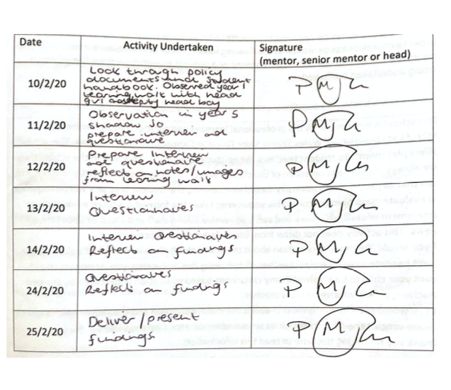

Appendix 14: Consent Form

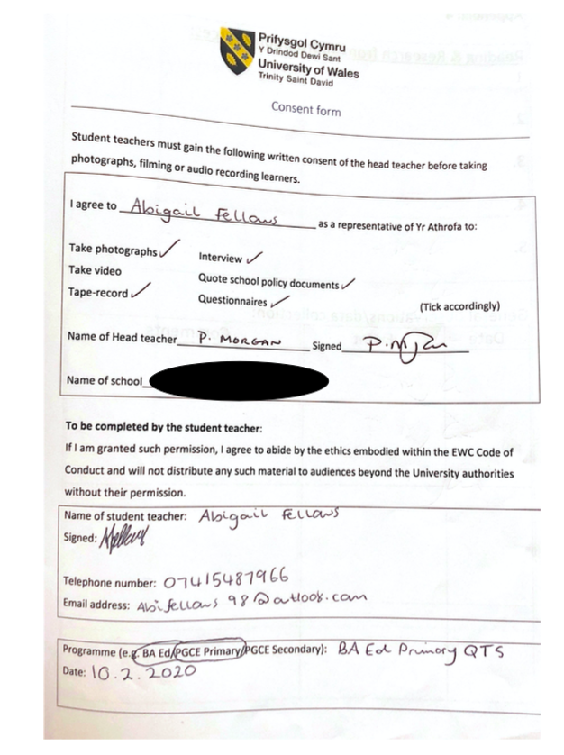

Appendix 15: School Report


Research Title - An exploration into the teachers and teaching assistant’s role in promoting positive mental health and wellbeing in primary school.

University Tutor- Tom Cox

Elective Experience Placement- Ynysfach Primary School

Introduction

Bore da, good morning. Thank you very much for providing me with the opportunity to share my electives experience with you today. I wish to start my presentation by thanking the members of staff who helped with my research, it is very much appreciated.

About Ynysfach Primary School
Ynysfach Primary is situated in the Neath Valley and is a rural school with a warm, friendly, caring ethos. Their school motto is Achieving Our Best Together. In 2014 the school catered for 130 pupils aged three to 11 years. There were four single-age and two mixed-age classes and six full-time teachers.
Around 18% of the pupils were entitled to free school meals, which is below the national average. Very few pupils came from ethnic minority backgrounds. No pupils came from homes where Welsh is the first language. Around 19% of pupils had additional learning needs, which is about average for Wales, and very few pupils have a statement of special educational needs. Very few pupils were looked after by the local authority.
Purpose of this research
The main purpose of the experience is to explore teaching staff’s role in promoting positive mental health and wellbeing in primary schools. But also exploring the importance of promoting mental health and wellbeing in education, gaining better understanding to support pupils and finally developing professional knowledge and understanding for future practice.
Aims of the research activity
The research aims to capture the views of our current generation of practitioners and students as they contribute to an informed dissertation regarding mental health and wellbeing. Existing research such as DeSocio and Hootman (2014) suggest that a lack of support regarding health and wellbeing impacts individual educational attainment and potential. But according to McGourty (2017) only a small number of teachers have received necessary training to support pupils with their mental health problems. The primary research that I wish to undertake will provide an insight into how important existing mental health and wellbeing support is and distinguishing the role of teaching staff and the effectiveness of their role.

Findings

To explore the chosen topic, various research methods were used such as interviews with teaching staff, a questionnaire for learners and teaching staff, a learning walk guided by head boy and head girl to observe and discuss certain aspects of provision with the pupils. Also linking the primary research with secondary research to provide a critical analysis of the data. Using a combination of both primary and secondary research should provide sufficient findings in order to answer the research question.

It is important to note that I have received 22 responses from the children’s questionnaire and 4 responses from the staff questionnaire. I have interviewed 5 teaching staff.
Learning Walk

The head boy and head girl were aware of what a ‘Rights Respecting School’ is and what their rights of a child are. The school Mascot, Richard the Rights Respecting Fish, was displayed around the school. The articles were displayed around the school using child friendly vocabulary and there is also a right of the month which is focused upon in assembly. This strongly links to ‘ethical, informed citizens’ purpose of the new curriculum (Donaldson, 2015). There are many displays in the computer room and sensory room dedicated to support learner’s health and wellbeing such as the calm corner and an ‘Inside Out’ feelings display.

Interviews with teaching staff

Challenges identified in supporting mental health and wellbeing are funding, many different complex needs, CAHMHs are overstretched, schools cannot control what is happening and home and these problems are brought to school and the decreasing budget but rise in mental health issues.

The most effective strategies used are growth mindset, encouraging positive talk, I can’t do it YET, 1:1 nurture, 1:1 counselling, Talkabout and relationship-based play.

The teacher’s role in supporting mental health and wellbeing was identified as all staff explained they have an important part to play in supporting learners. However, it was highlighted that the teacher’s main role is to teach.

The teaching assistant’s role identified was implementing interventions such as nurture and relationship-based play, Talkabout etc. As teaching assistants often spend more 1:1 time with students, they are more likely to open up was highlighted by staff.

Questionnaires with teaching staff
All staff stated that they would rate the strategies they use to support mental health and wellbeing as 8+/10 on effectiveness.

Areas/ topics that teaching staff would like to focus on in the Health and Wellbeing area of learning and experience include:
- Neuroscience- understanding why our bodies feel the way they do for example, recognising anxiety.
- Providing child initiated/independent strategies for learners to respond to negative emotions and feelings
- Talking about their feelings
- Mindfulness
- Understanding emotions and how to control them e.g cognitive therapy
- It should be part of the whole ethos and it should be seen through all areas of the curriculum

Questionnaires with pupils

All students could identify a member of staff to support them when they felt worried, anxious or upset. This was either their class teacher, their previous teacher, the headteacher or a teaching assistant.

All learners were able to identify ways teaching staff support them which include, ‘checking if I am okay’, ‘they fix the issue that has made me sad’, ‘they do a jigsaw with me’, ‘they talk to me about my problems’.

But learners were also able to identify ways they could be supported in regard to their mental health and well-being such as having more fun in school such as the teachers making jokes, more opportunities for designated calm time, allow for ‘chill-out’ time or time for students to colour or draw, to be allowed in the sensory room and to have more time to talk to my class teacher.

Summary and conclusion

I would like to thank all members of staff for their help, advice and support throughout my electives experience. I have successfully gathered data that will inform my research project at UWTSD. It is clear that Ynysfach prioritises well-being in all aspects of the school and are all aware of the important role they have at supporting positive mental health and well-being in school. This will enable learners to become ‘healthy, confident individuals’ which are one of the four purpose of the curriculum (Donaldson, 2015).

Appendix 16: Elective Experience Presentation

 | 
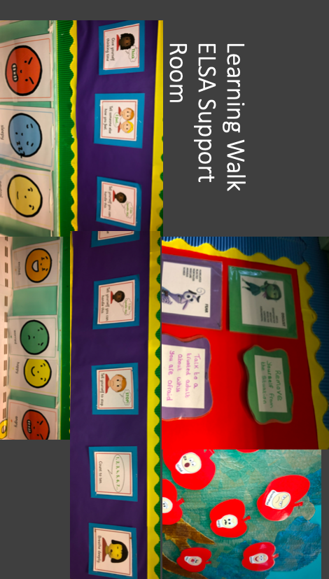 | 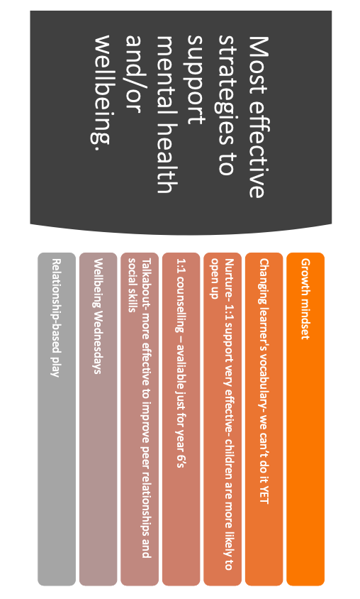
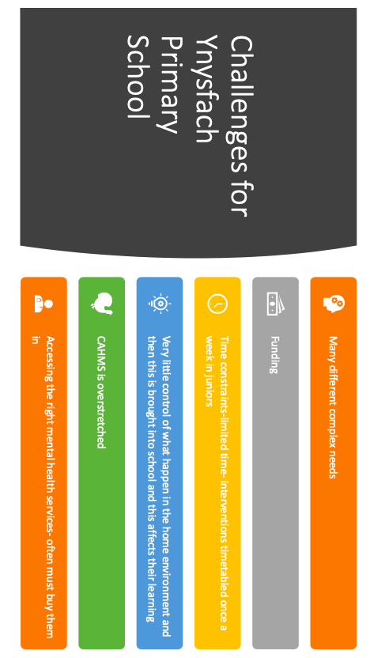 | 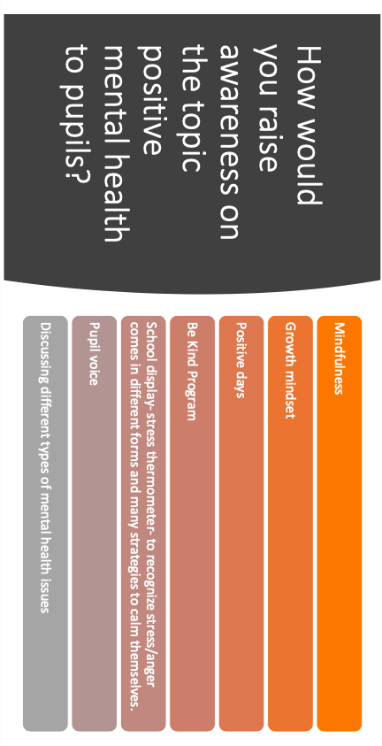
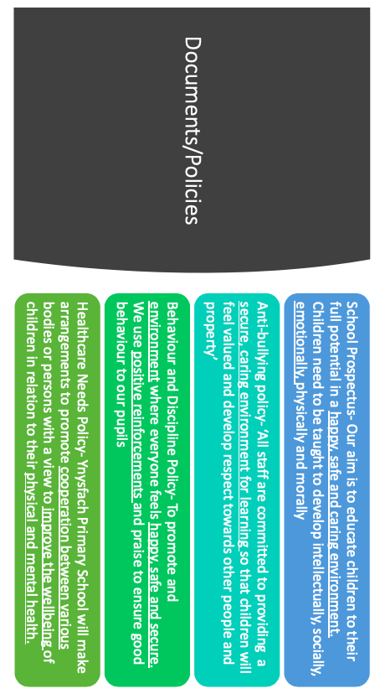 | 

