Stuart Sumner Smith

1919831

BSc/HND Computing

ACCA4023

21/04/2021

Table of Contents
- Cover Page
- Table of contents
- Abstract
- Requirements
- – 7. Implementation
8. – 10. Validation
11. Usability
12. – 13. SEO
14- 16. Accessibility
17. References

Abstract
This report examines in some detail the construction of the website. Including its relevance, its requirements and implementation of the site. It also considers the standard procedures for HTML and checks the code with various online checking tools. The report also examines search engine optimization and asks what the fundamentals of this practice are. Providing an answer to this in the design of the site. Finally, the report examines the accessibility of the site and considers the four principles of accessibility as laid out by the WCAG 2.1. These are: Perceivable, Operable, Understandable and Robust.

Requirements
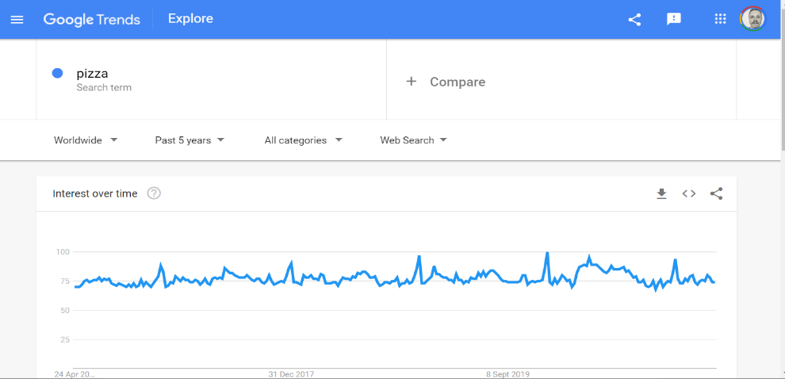
The website is called The History of Pizza and its purpose is to advertise, promote and sell a book with the same name: The History of Pizza, subtitled “The Entire History of Pizza in One Book.” This website is aimed at people who are passionate about pizza. Adults and young people aged from 24 – 50 years old, who like Pizza and are interested in its history as well as recipes to try at home in the group. Generation X and generation Z as coined by the Pew Research Centre. A book that would look good on a coffee table as well as on a Kindle or other mobile reading device. The website would be part of a larger social media marketing campaign for the book with the website being the primary tool to capture sales and avoid the higher commission charges on online markets such as Amazon. In retrospect, the site should include extracts from the book including high-definition images and samples of the books actual content. This would be shown in a full page “hero image” carousel and relying on the wow factor and visual impact of the images. Pizza is one of the most popular foods across the world and each country having their own versions of the classic dish. The search trends for Pizza have been consistently high over the past 5 years.

Implementation
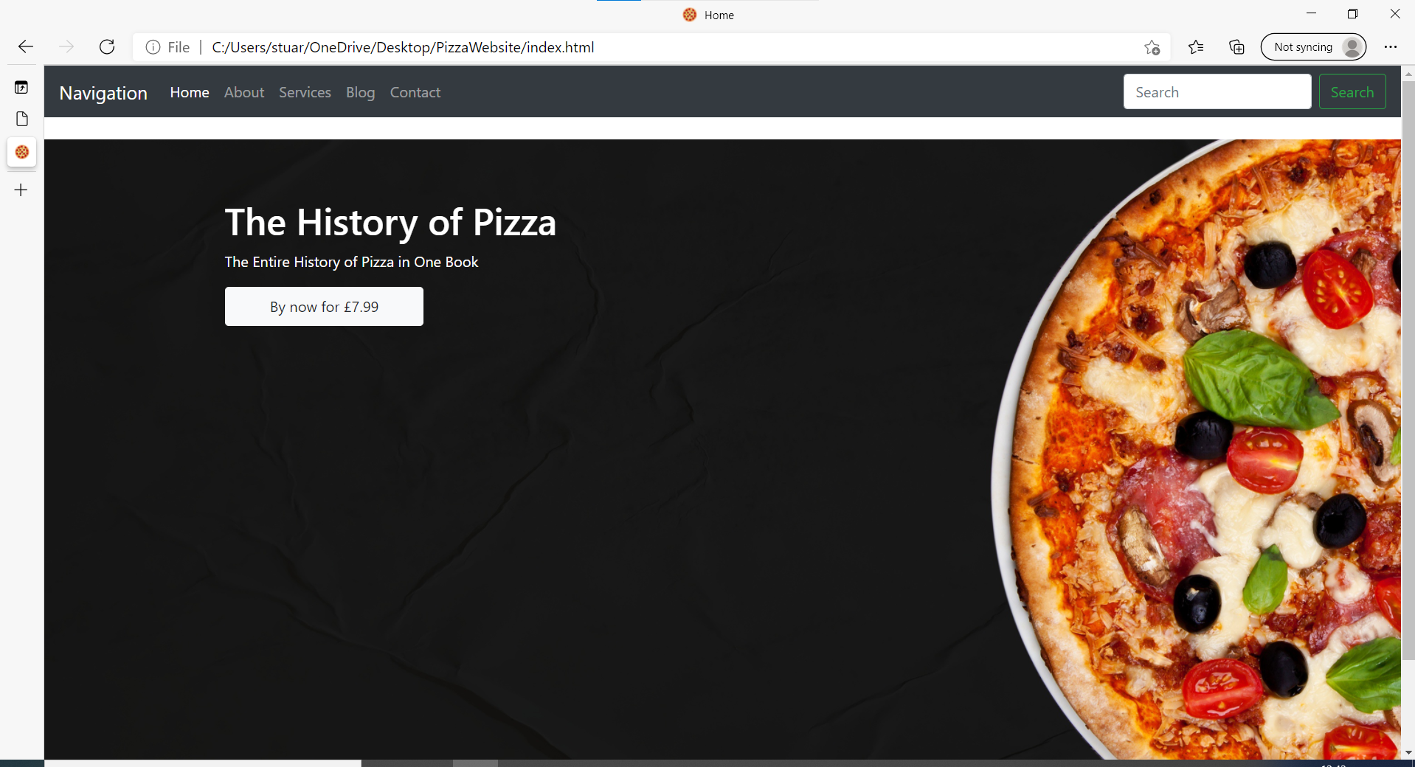
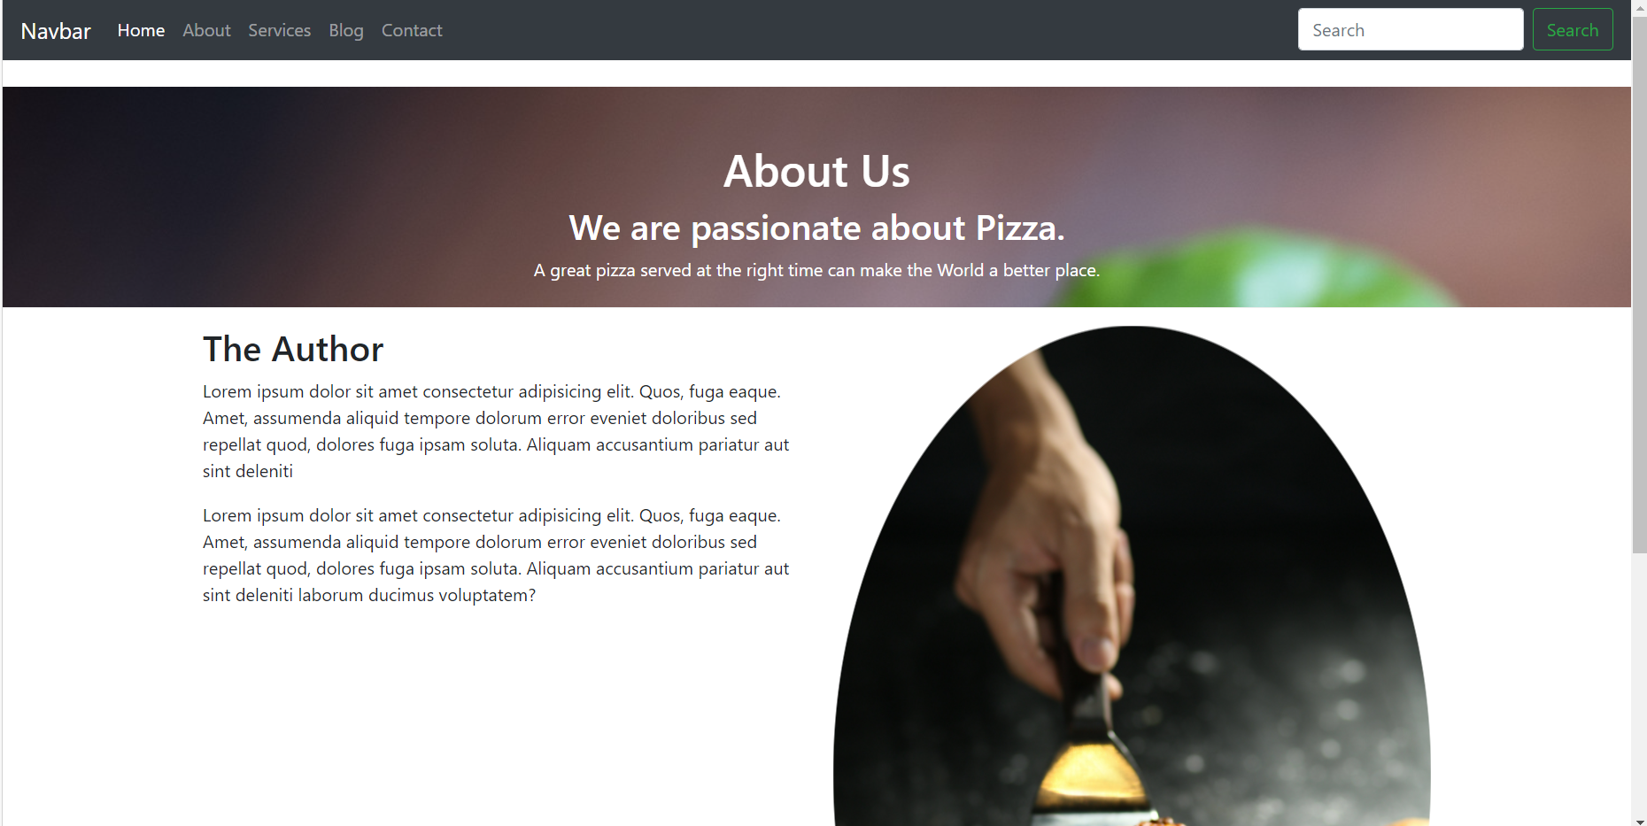
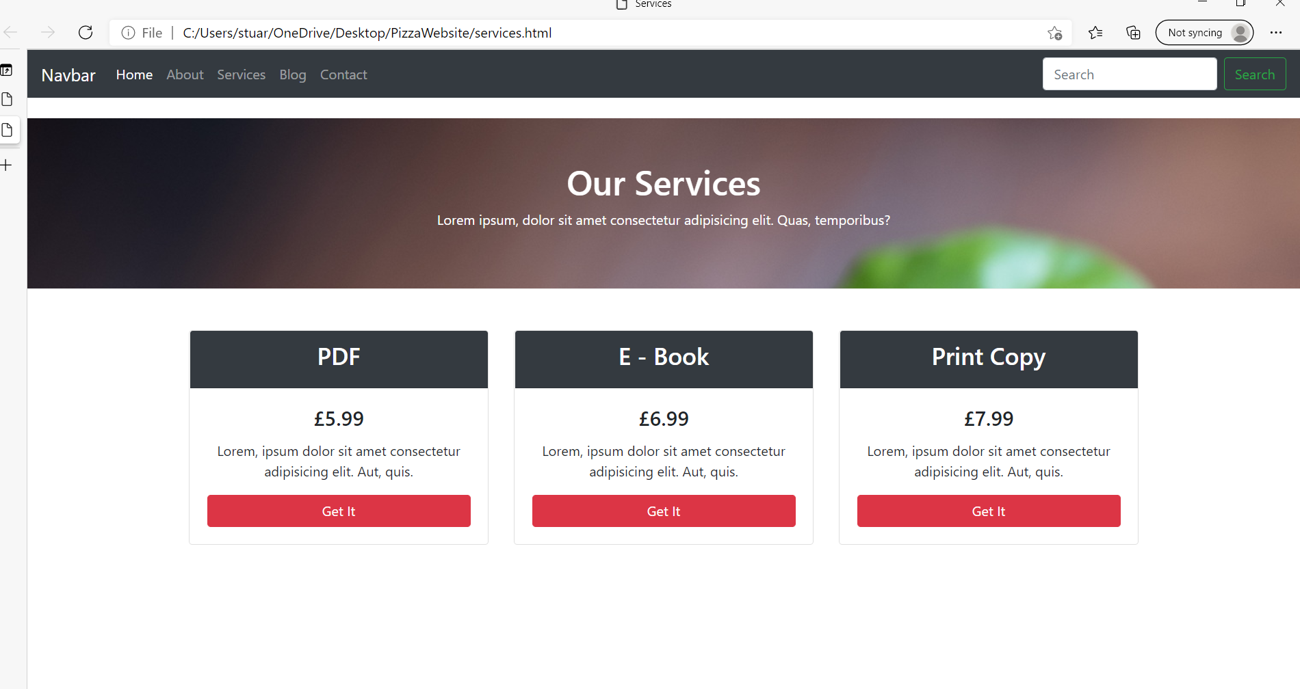
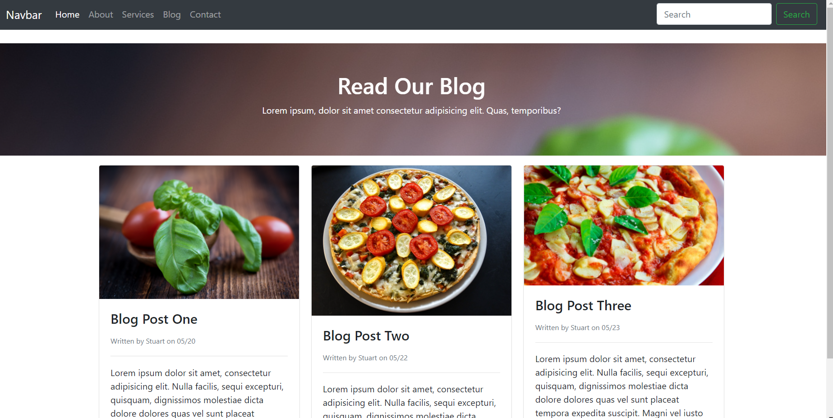
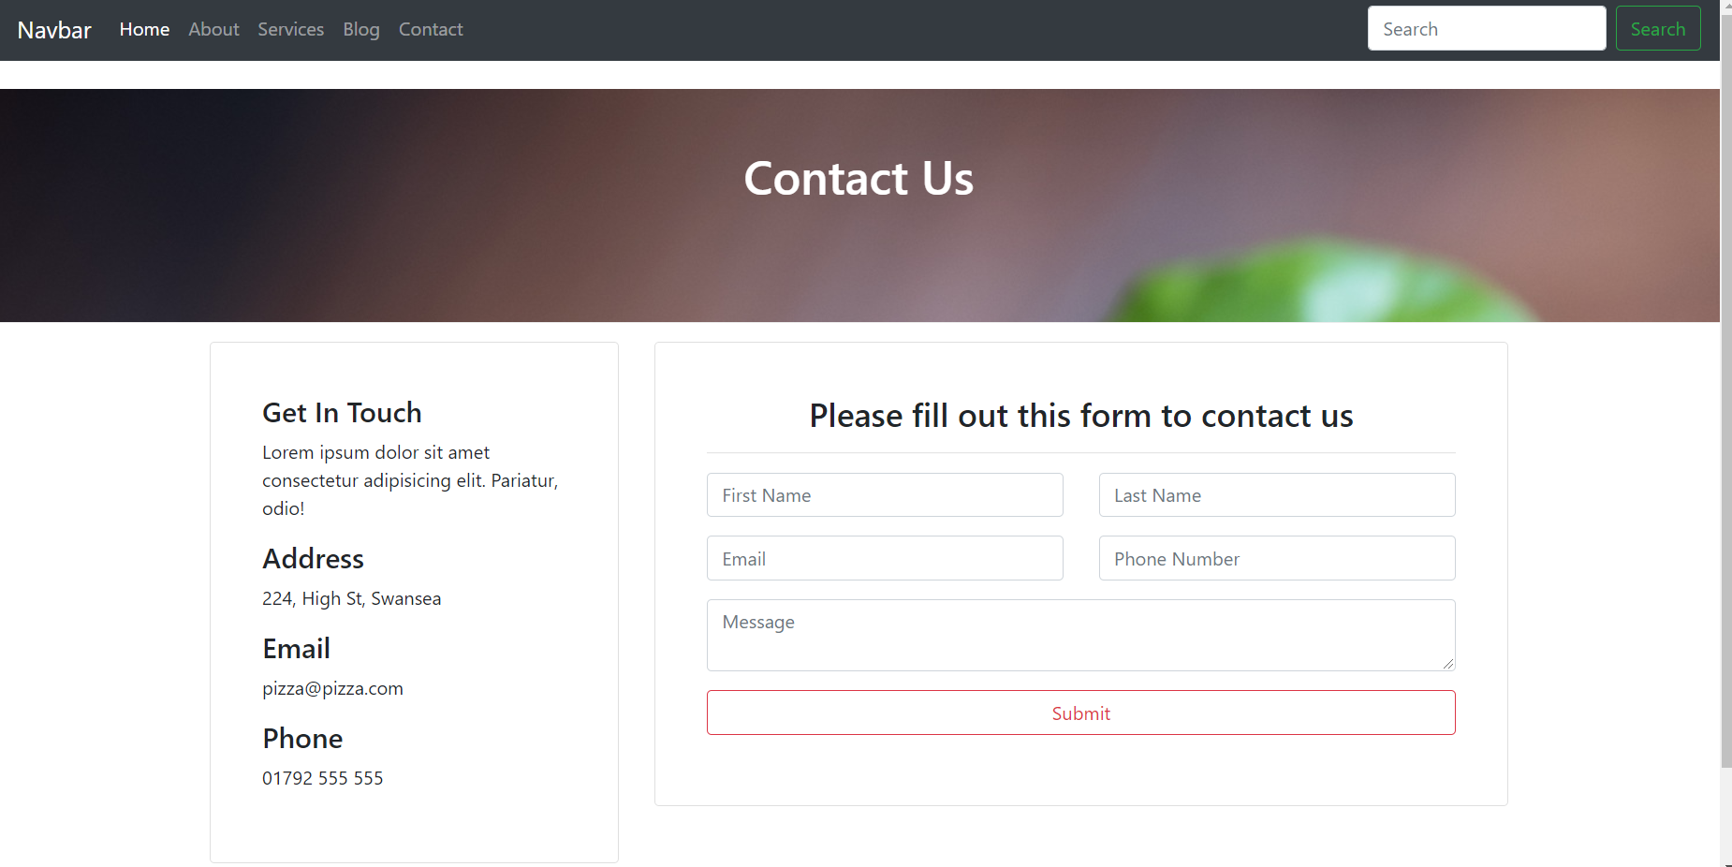

Validation [1]
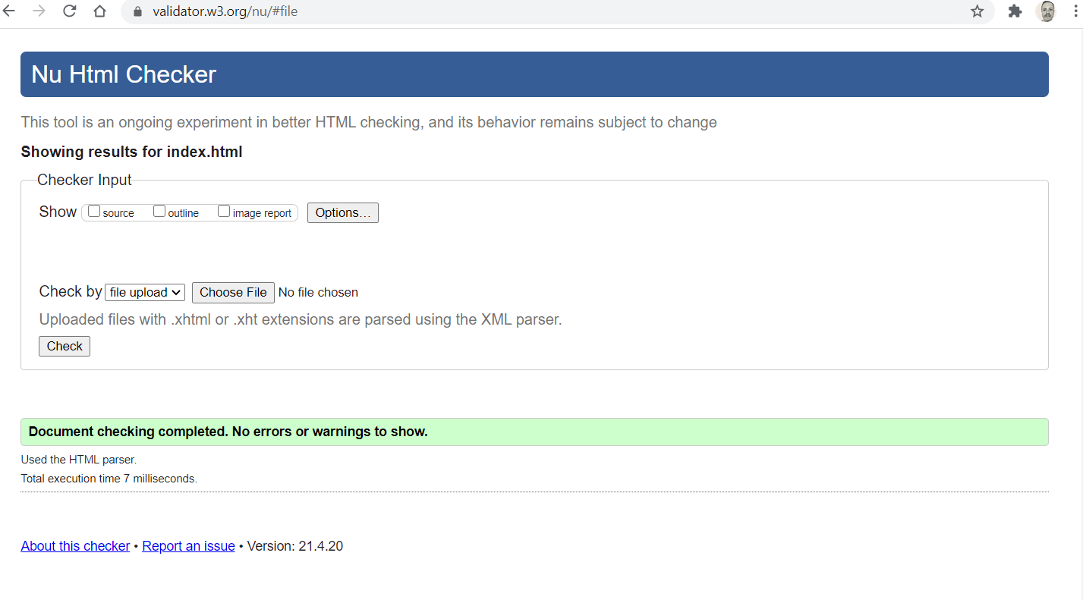

CSS Validation
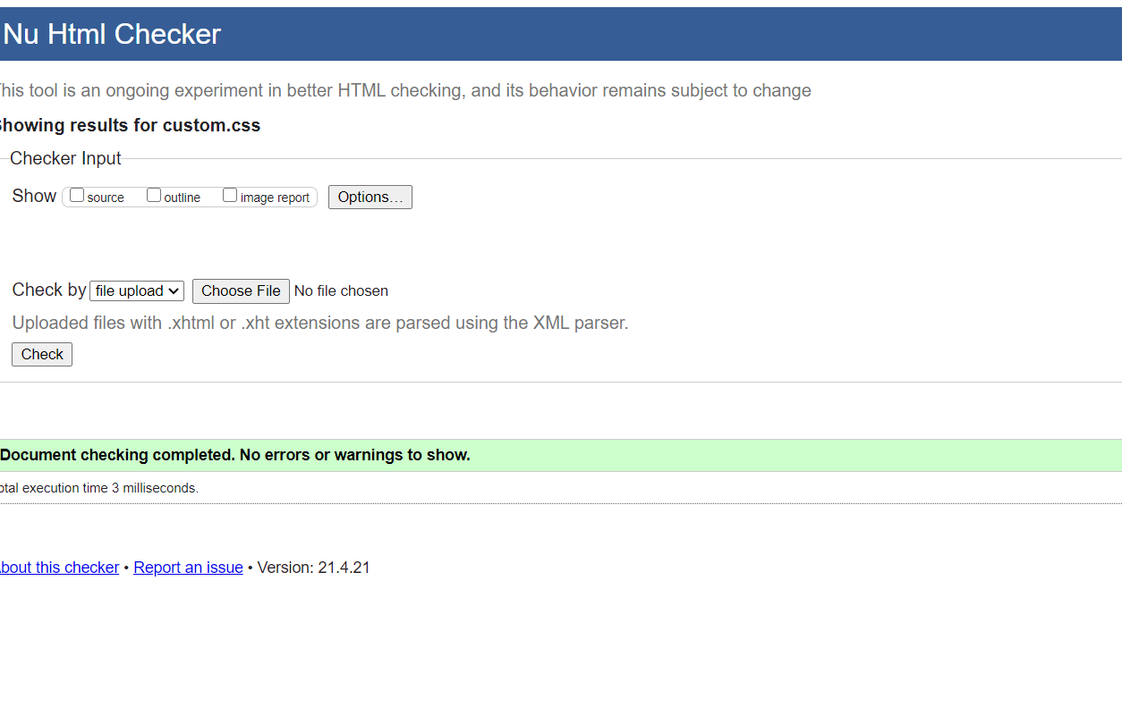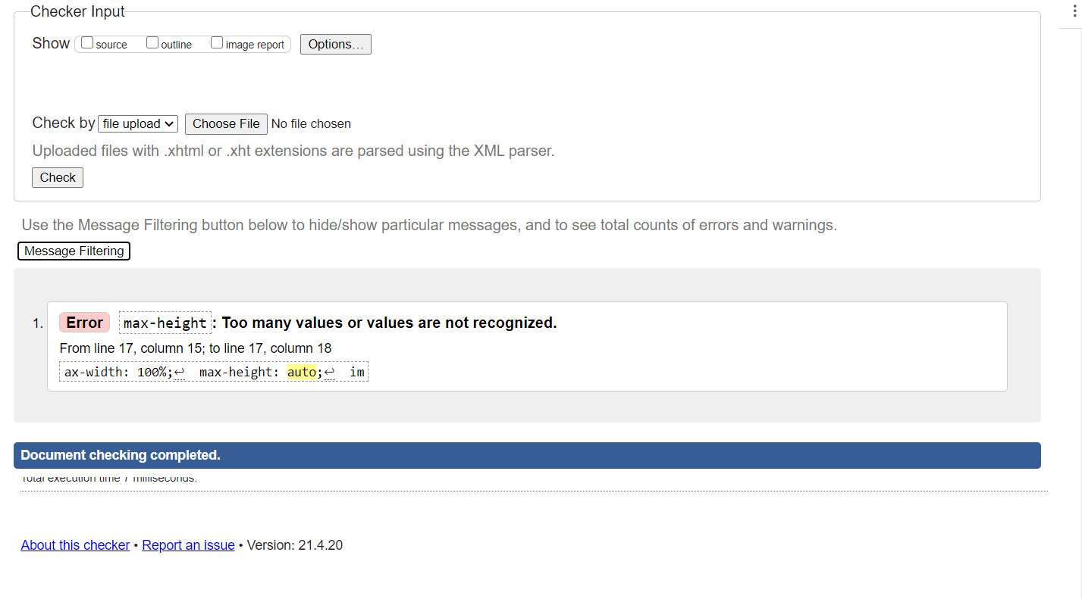

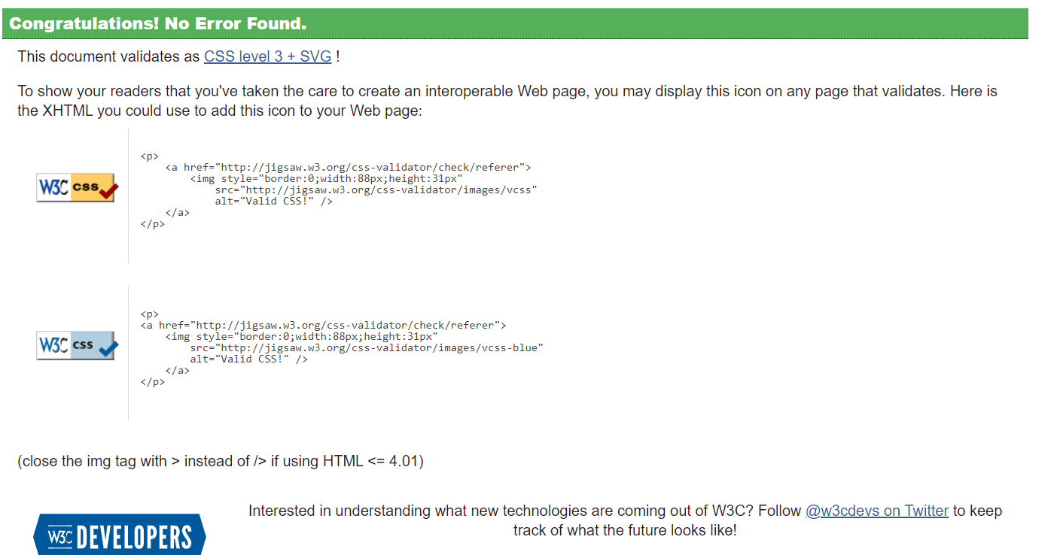

Resolved CSS error by removing unrecognized term(auto) in CSS code.
Usability
The world wide web consortium W3 define usability as “Usability is about designing products to be effective, efficient, and satisfying. Usability includes user experience design. “[2]
Taking this point of view as a measure of usability. The History of Pizza website is effective as it provides the user with an easy to negotiate, clear and easy to understand website from the first page. It is clear what the website is there to do.
On page 1 we see instantly what the website is for “The History of Pizza.”
The Entire History of Pizza in One Book” This straightforward delivery is carried on throughout the site. There are no confusing adverts or mentions of other content. This is also mirrored by the architecture of the site. It uses a basic navigation system that remains in the same place throughout the site. Making it very easy for the user to return to a pervious page. The pages have no large files attached or links to other sites making the pages fast loading even for low internet speeds below 12Mbps. From another point of view however, considering todays use of media rich websites it might be seen as slightly boring to some users as the site does not contain media rich elements often found on many of today’s websites. Elements such as video, animation, ultra-high-definition images, all perhaps make a more interesting website but might not necessarily improve usability.

Search Engine Optimisation (SEO):
A list of the on-page SEO techniques applied to the website with examples of where and how these have been applied.
A simple website structure that’s easy for search engines to index. There are no confusing links on the site to other sites and the pages follow a logical order. Site links are ordered and there are not broken links on the site. This structure optimises the whole sites SEO. This is further strengthened, by being compatible on all major browsers and responsive to different screen sizes.
Although not installed to this current version of the site. When the site is hosted online, I would create an XLM site map to add to the website which would allow search engines to crawl and index my site faster boosting SEO ratings.
Each page would be optimised by using has an individual title in the H1 Title Tag, and H2 for a section subtitle of the HTML code.
The sites index page has a defined favicon icon which will show up in search results and further define the page and site in search rankings. Individual images would have Alt attributes completed and descriptions for each image.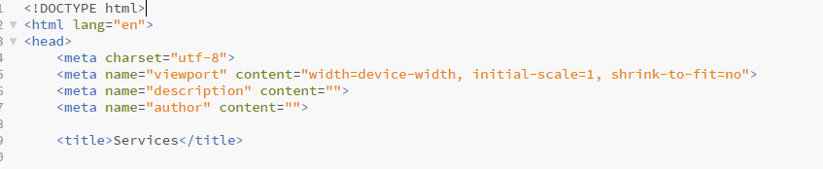
Keywords in the site’s menu and content link together. For example, “Blog” on the navigation menu, leads directly to the blog page which shows blogs about pizza. This when combined with standard structured data such as HTML code “head” “body” “footer” help to present the site in a logical way to the search engine developing a positive SEO.
In comparison a site without standard structured data could look malicious to a search engine and therefore develop negative associations between the search engine and the website.

Accessibility
The four main principles of the WCAG 2.1 accessibility guidelines are: Perceivable, Understandable, Operable and Robust.
Perceivable
The essence of this guideline is that all parts of the site should be able to be perceived by the user’s senses either assisted or non-assisted, this mainly covers sound and visual parts of the site.
Text alternatives are provided by using Alt tags properly when displaying an image. Demonstrated by this code on the Blog page of the site:
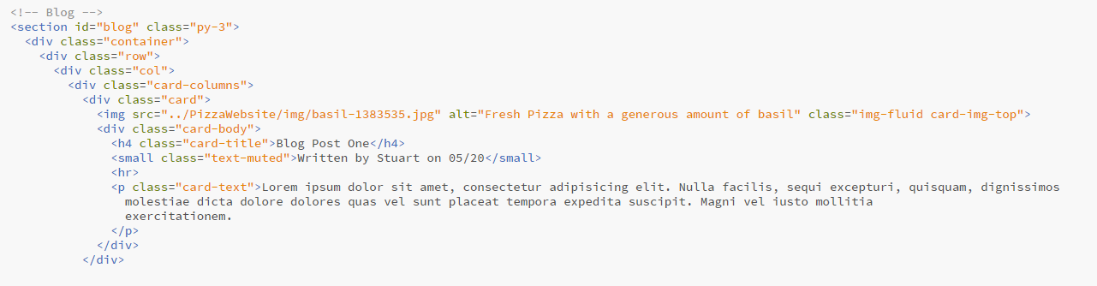

Dynamic resizable text
All the text on the History of Pizza site is dynamic and resizable:
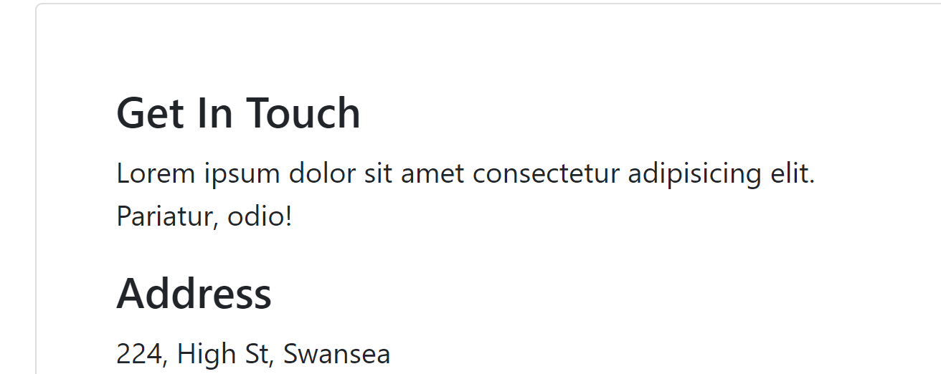
High contrast pages
The majority over 90% of the site uses high contract pages to assist people with contrast sensitivity. However, the navigation menu could be improved somewhat, in this respect. I could not fix this error in the allotted time [3]: 
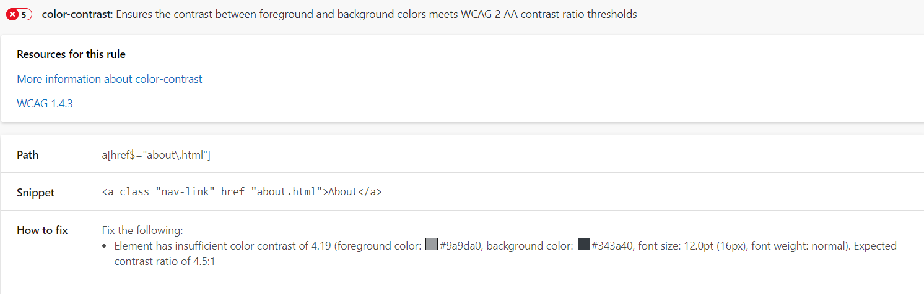

The website also works with the Google colour change extension [4] as shown to further improve accessibility:
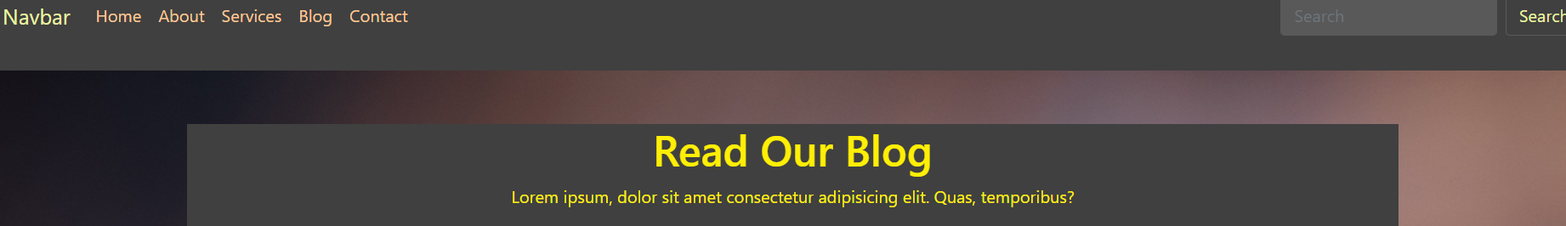

Understandable
The essence of this guideline checks to see if there are any unusual words confusing abbreviations. I have self-checked the site for this and have found no indicators matching these issues.
Operable
This guideline checks if the website can operate to improve accessibility. I have checked the History of Pizza website and it works with a screen reader. Furthermore, it is operable just using a keyboard to navigate the site. It has easy navigation as compared to a complex navigation with a navigation bar with links that are “dead” and too many drop down items. The navigation on the site is logical and consistent this is reflected on the contact of the pages which are consistent in the amount of information on each page.

Robust
The final accessibility guideline is the website being Robust. The fundamentals of this guideline means the website build in a way in terms of architecture and make up language that does not cause confusion and problems while using the site with accessibility tools.
When examining the History of Pizza Site in this respect. Firstly, the architecture of the markup language used is consistent and robust. It the whole site has been tested using https://validator.w3.org/ proving validity and consistency in coding and site architecture. Furthermore, to in increase the robustness of the site pages and elements have unique IDs nothing is duplicated and there are no nesting of tables, which confuses the sequence of content. The site has dynamic sixing and can be viewed equally well on mobile devices as well as desktop computers.

Reference
[1] https://validator.w3.org/ Version: 21.4.2, Validator W3, W3.org, 21/04/2017,
[2] S Lawton, S Abou-Zahra, K White, Accessibility, Usability, and Inclusion, W3C, Updated 6 May 2016. First published March 2010, https://www.w3.org/WAI/fundamentals/accessibility-usability-inclusion, (24/04/2021).
[3] Accessibility Insights for Web, Version 2.25.0, A-11-Insights, 21/04/2021
[4] Change content color, version 1.2, Jeff T, 10/01/2017
[5] https://getbootstrap.com/
[6] https://www.w3schools.com/bootstrap4/

