Strategic Analysis

of English National Opera



Strategic Management Module SBMA7103D Assignment

Lecturer: Gareth Hughes

Master of Business Administration (MBA)

University of Wales Trinity Saint David

Mark Stone

Student Number: 1601851

25th July 2018

STRATEGIC ANALYSIS OF ENGLISH NATIONAL OPERA

CONTENTS

1 Executive Summary …………………… 3

2 Introduction …………………… 5

3 The macro-environment …………………… 6

3.1 STEEPLE analysis …………………… 6
4 The industry …………………… 8
4.1 Porter’s five forces …………………… 8
5 The company …………………… 11
5.1 VRIO framework …………………… 11
5.2 Value chain …………………… 12
5.3 SWOT analysis …………………… 13
5.4 TOWS matrix …………………… 15
5.5 SOAR framework …………………… 16
6 Stakeholders …………………… 18
6.1 Arts Council England …………………… 18
6.2 Government …………………… 18
6.3 Political groups …………………… 19
6.4 Grant-making trusts …………………… 19
6.5 Corporate sponsors …………………… 19
6.6 Private donors …………………… 19
6.7 Audience members …………………… 20
6.8 Operatic community …………………… 20
6.9 London theatre community …………………… 20
6.10 Management …………………… 21
6.11 Employees …………………… 21
6.12 Unions …………………… 21
6.13 Competitors …………………… 22
6.14 Artists …………………… 22
6.15 Mendelow’s matrix …………………… 22
6.16 Cultural web …………………… 22

7 Corporate-level strategies to date …………………… 25
7.1 Post-war period …………………… 25
7.2 Powerhouse era …………………… 26
7.3 Post-powerhouse survival …………………… 26
7.4 International engagement …………………… 27
7.5 Reduction of public subsidy …………………… 28
8 Implications of strategies followed …………………… 30
8.1 Three levels of strategy …………………… 30
8.2 Change management …………………… 30

9 Recommendations …………………… 32

9.1 Create a vision …………………… 32

9.2 Avoid ROH’s domain …………………… 32

9.3 Align business strategy …………………… 33

10 References …………………… 34
1 EXECUTIVE SUMMARY

This report analyses the strategic management of English National Opera (ENO).

It considers the macro-environment, concluding that although there are national and international trends that present challenges to ENO’s position, there are steps which the company could take to take exploit these situations, such as dispelling the myths of elitism in opera and broadening the company’s scope outside of London.

The industry analysis also produced some positives, with threats from new entrants unlikely and buyers and suppliers being within ENO’s sphere of control. Competition from the Royal Opera House (ROH) is significant, as is the threat of stay-at-home entertainment.

VRIO and value chain analysis showed the resources and processes of the company that provide competitive advantage (chiefly the orchestra and chorus).

Considering stakeholders, using Mendelow’s matrix, indicates not only the vast array of people who have an interest in the strategy of ENO, but also the key groups that ENO should focus on, namely Arts Council England, grant-making trusts, private donors, management and employees.

The company’s historical strategies are analysed in practical and theoretical terms, and Ansoff’s matrix is used to show how this has changed at different periods and the impact it has had throughout the organisation.
Based on the analysis, the following recommendations are made for the future strategic management of the company:
- Create a clear vision for the company, reflecting the needs of all stakeholders and the founding ideals of the organisation;
- Find a defendable competitive position which is clear from competition, specifically ROH; and
- Develop a business strategy aligned to this vision and competitive position.

2 INTRODUCTION

This report investigates the corporate strategies employed by English National Opera (ENO) throughout its history. In recent years, the company has been the subject of much scrutiny in the press and the artistic community as a result of the different approaches undertaken by senior management and the effects these have had inside and outside the company.

The strategic position is considered by looking at the macro-environment, the industry, the company and its stakeholders. This environmental analysis provides an understanding of the setting within which the company’s strategy is formed and the parties it affects. The different corporate strategies that have been undertaken are explored, providing reasons for their implementation and their effects.

Based on these findings, recommendations are made for the approach to formulating corporate strategy in the future.

3 THE MACRO-ENVIRONMENT

ENO presents opera in English at the London Coliseum. It was founded in 1931 by Lilian Baylis (ENO, n.d.a) with the aim to provide artistic enlightenment at accessible prices (ENO, n.d.b). The company is still referred to as “the people’s opera” (Wigglesworth, 2016), a comparison with foreign domestic houses, such as the Volksoper Wien (cf. Wiener Staatsoper), and the original idea of “accessibility in seat prices” (Jonas et al., 1992).

3.1 STEEPLE analysis
Like the Volksoper in Vienna, ENO faces competition from the nearby international opera company, the Royal Opera House (ROH). However, the macro-environment is multifaceted, and STEEPLE analysis (Cameron, 2011) considers seven areas (Figure 1).
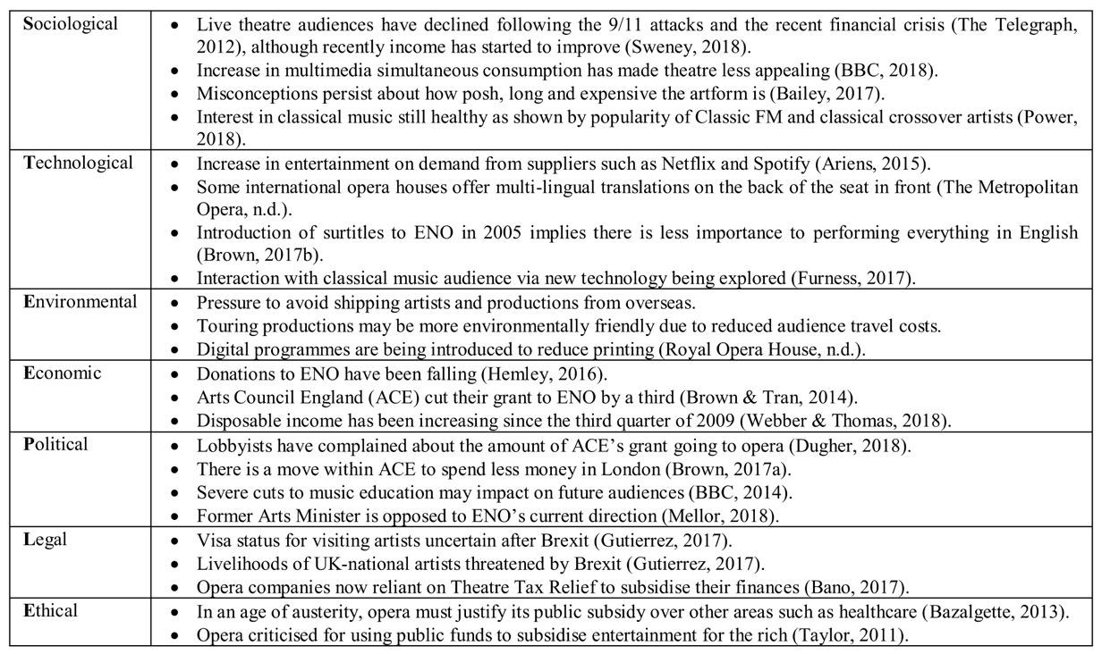
Figure 1: STEEPLE analysis of ENO’s macro-environment
There are national and international trends that present challenges to ENO’s position. Theatre-going in general is reduced, and there is a misconception that opera is expensive and elitist, fuelling political will to question the level of subsidy to opera in general and specifically in London. This gives some direction as to where to focus effort. Broadening the company’s scope outside of London would be advantageous, and engaging in activities to dispel image problems is essential for increasing audience diversity.

4 THE INDUSTRY

4.1 Porter’s five forces
Michael Porter proposed the five forces that drive competition within an industry (Figure 2).
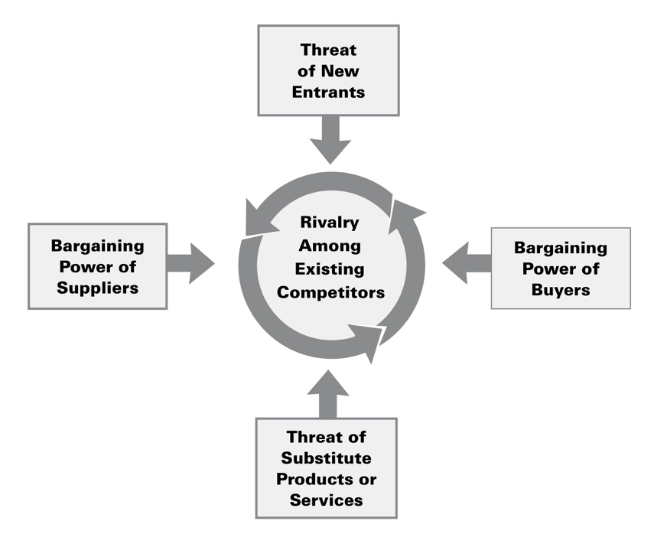
Figure 2: Forces Driving Industry Competition (Porter, 1980, p. 4)
By considering each of these areas in the opera industry, it is possible to understand the forces that affect ENO’s competitiveness (Figure 3).

There is good news for ENO in this analysis. Key is the fact that it takes time and capital to produce an enterprise the size and importance of ENO, and a new entry is unlikely to be able to achieve this quickly. Buyer power may be used as a factor to differentiate ENO, as tickets can be priced to make ENO more accessible. Supplier power can be combatted by making the standard of work at ENO important and therefore desirable for artists.

Rivalry among existing participants is strong, and ROH is a key competitor. The country house opera market is vibrant but differentiated from ENO, and the company should seek to distinguish its product from that of ROH. The main substitute that threatens all live performance is the amount of staying-in entertainment being consumed.
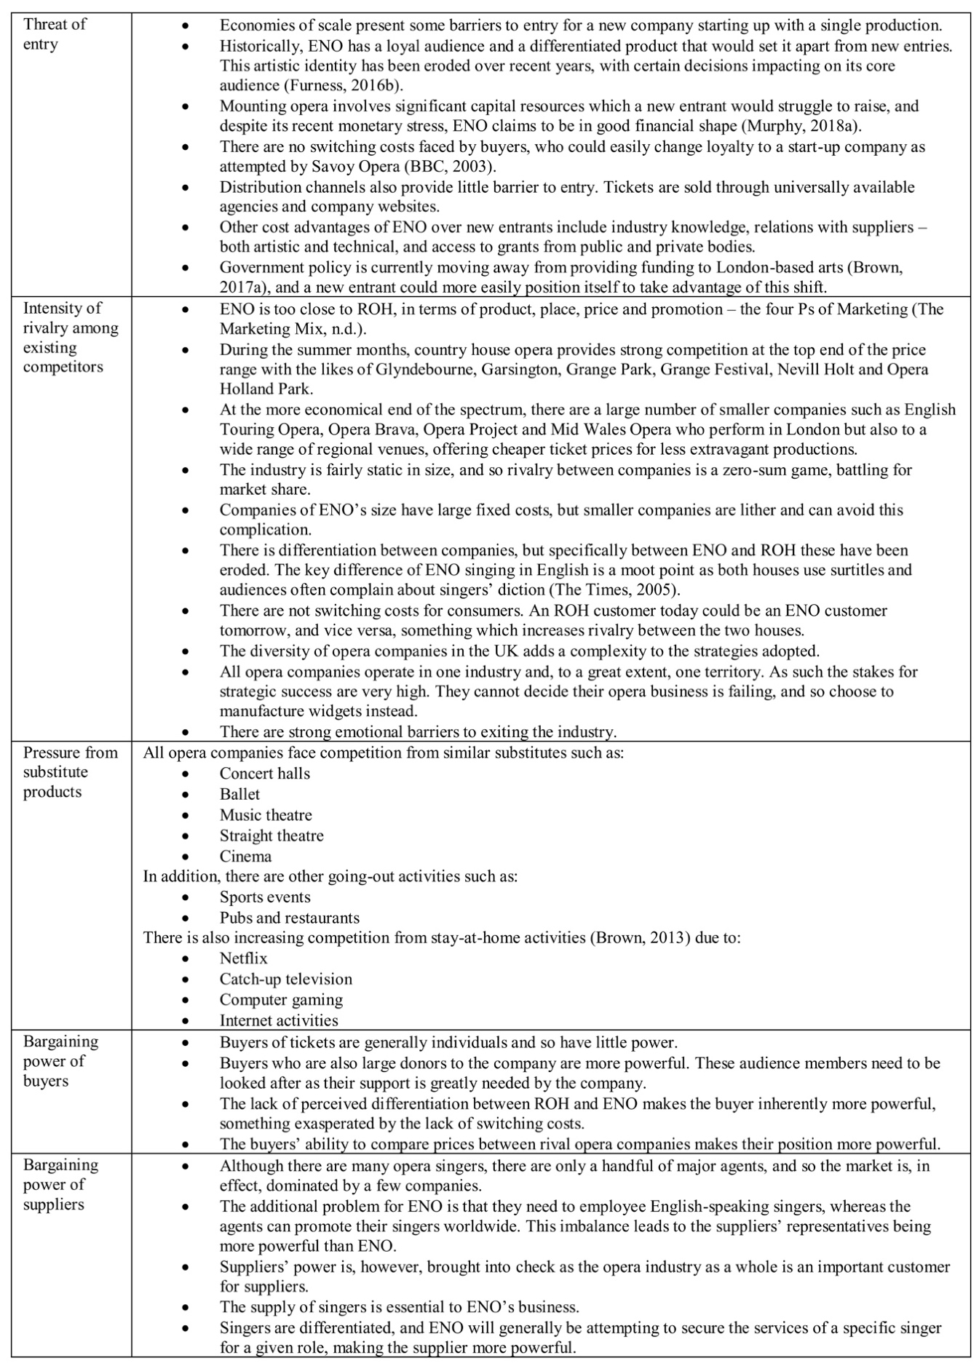
Figure 3: Porter’s five forces in the opera industry
5 THE COMPANY

5.1 VRIO framework
The VRIO framework (Jurevicius, 2013 and Johnson et al., 2017) can be used to focus on which resources and capabilities provide the company with a competitive advantage by asking if they are Valued by customers, Rare amongst competitors, Inimitable by competition, and Organised to capture value (Figure 4).
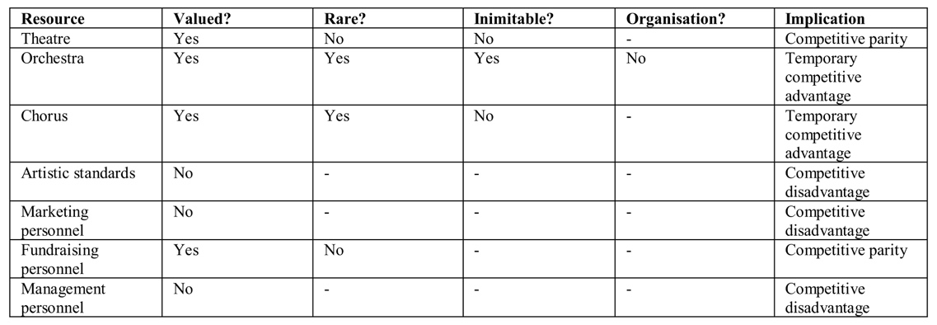
Figure 4: VRIO analysis of ENO’s resources
This shows that the chorus and orchestra are the key current resources and capabilities within the organisation that are providing a competitive advantage. The theatre is valuable, although not rare in London. What is clear is that competencies need to be improved in marketing, fundraising and management in order to move out of a position of competitive disadvantage, and overall organisation needs to be strengthened in order to get the most out of all resources.

Although this is indicative of the areas where ENO holds an advantage, the VRIO designation is somewhat subjective, and “it may be challenging to establish the exact competitive implication” (Johnson et al., 2017, p. 7). However, it can help to ascertain which resources are dynamically aligned with opportunities (Bhagat et al., 2012).

5.2 Value chain
In order to create a competitive advantage, it is important for an organisation to understand which activities are important in creating value and which are not (Johnson et al., 2017). Michael Porter produced a general example of the value chain for an organisation (Figure 5).
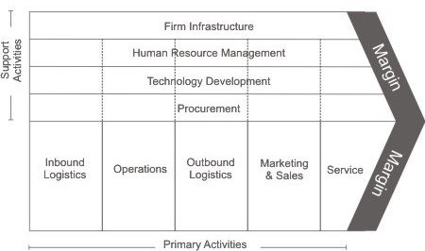
Figure 5: The value chain of an organisation (Porter, 1985, p. 37)
Considering this breakdown for ENO, we can analyse where value is added at each step. Inbound logistics, in the case of an opera company would relate to the hiring of the best casts, directors, designers, conductors and other creatives at the best price, and occasionally buying in a production from another house. Operations not only relates to ensuring that the shows are produced to the highest quality within an appropriate budget, but also the provision of educational work and renting out productions. Outbound logistics is the management of the ticketing system via the company’s own website and other agencies, as well as the logistics with sending rented out productions abroad. Marketing and sales is concerned not only with selling the shows on the mainstage, but also educational projects, production rentals and, most importantly, effective fundraising. Service at ENO is about optimising the customer experience, whether that is an audience member, a school child on an educational project, a house receiving an ENO production or a donor who has given funds to the company. Throughout all the primary activities run the secondary activities of purchasing, IT, HR and infrastructure.

Although there are problems with employing Porter’s Value Chain method to non-standard industries (Bhadwal, 2015), and social media impacts on all distribution channels (Merchant, 2012), splitting ENO’s business into these areas gives an idea of the value that each part of the process adds to the company. In this way it is possible to identify value activities, assess their relative importance internally (comparing cost to significance), assess relative importance externally (comparing costs to competitors), and identify where costs can be reduced.

5.3 SWOT analysis
SWOT analysis can extend the environmental analysis of STEEPLE to include internal strengths and weaknesses (Figure 6).
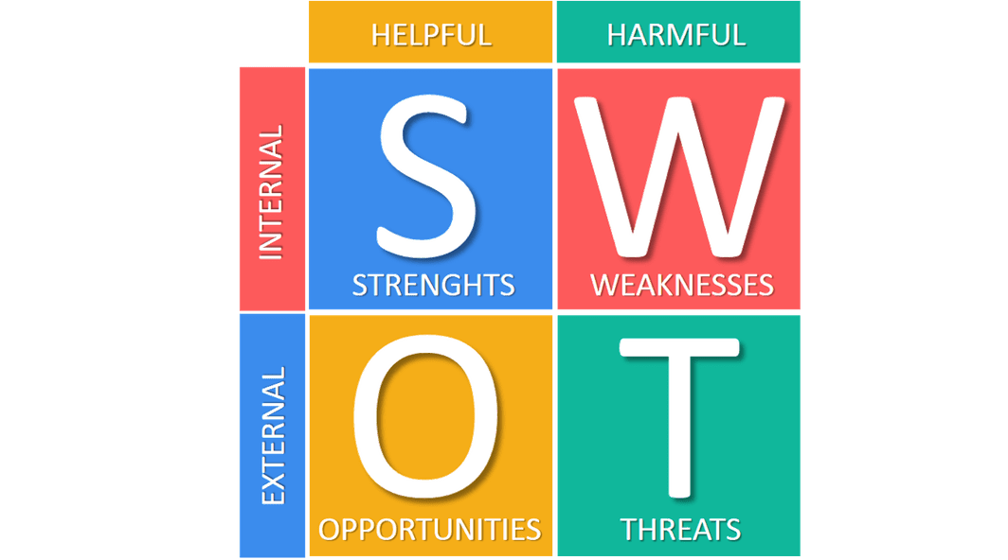
Figure 6: SWOT analysis (Business To You, 2017)
Internally at ENO (Figure 7) we see that the assets of the excellent chorus, orchestra and theatre together with a loyal audience are offset by the decline in artistic standards and the erosion of industry expertise in senior management. The external situation, transferred from the STEEPLE analysis, indicates opportunities for ENO to exploit its environment. The threats relate to competition from ROH, political uncertainty and changes in consumption.
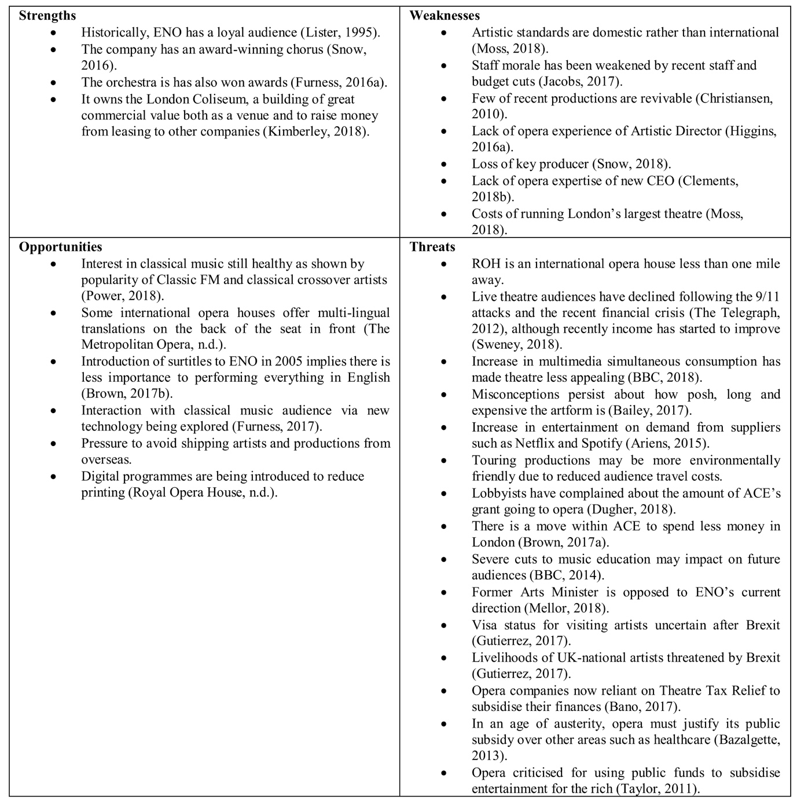
Figure 7: SWOT analysis of ENO

5.4 TOWS matrix
A development to SWOT analysis is the TOWS matrix (Weihrich, 1982) which considers responses based on combinations of SWOT (Figure 8). This analysis provides potential policies based on contingencies within the SWOT matrix. It enables the company to develop broad strategies for anticipated scenarios with high probability (Hooley et al., 2004), while still being prepared for low probability high impact situations (Shankar, 2014).

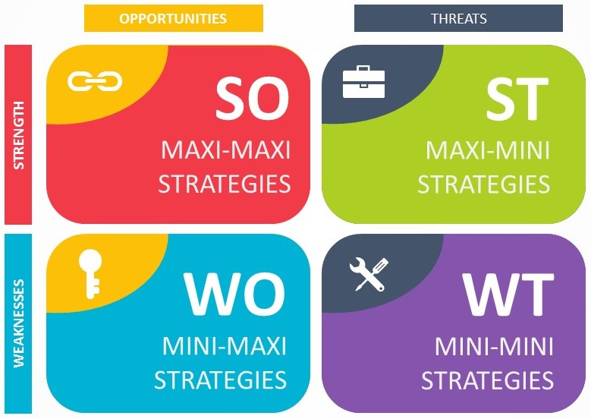
Figure 8: TOWS matrix (Pslides, n.d.)
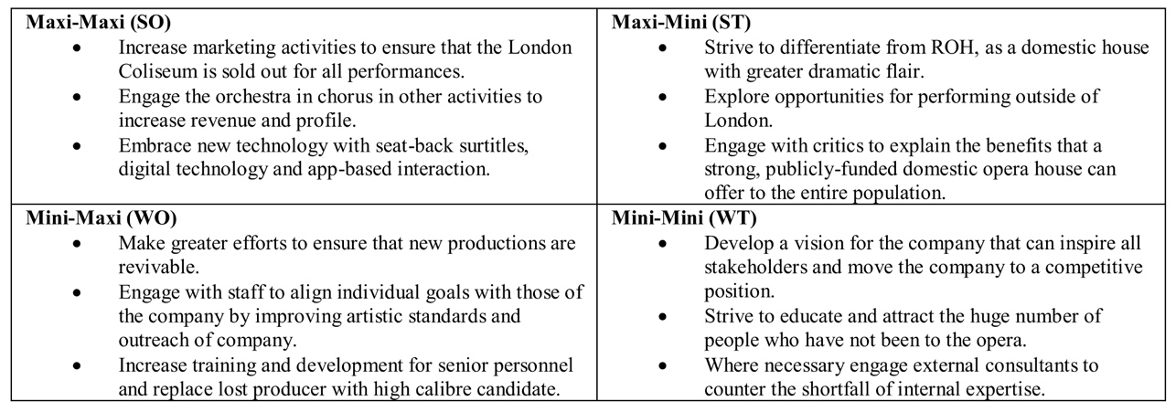
Figure 9: TOWS matrix for ENO
In its application to ENO (Figure 9), TOWS highlights some important strategies for consideration, such as differentiation from ROH and stakeholder engagement, which should be considered in terms of their likelihood and effect on the company.

5.5 SOAR framework
A more positive method of considering an environment, based on the process of Inquire, Imagine, Innovate and Implement, is the SOAR framework (Stavros & Cole, 2013). The SOAR framework differs from SWOT in that it is not a top-down analysis of an environment but a strength-based approach strategy (Figure 10).
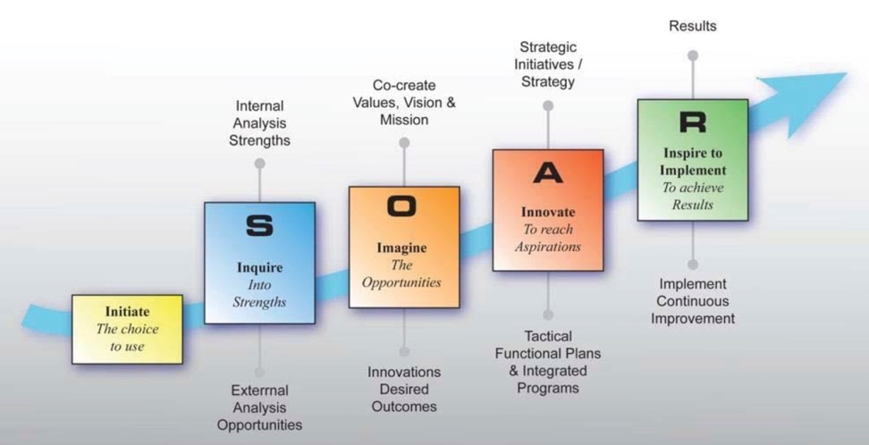
Figure 10: SOAR framework (Stavros & Cole, 2013)
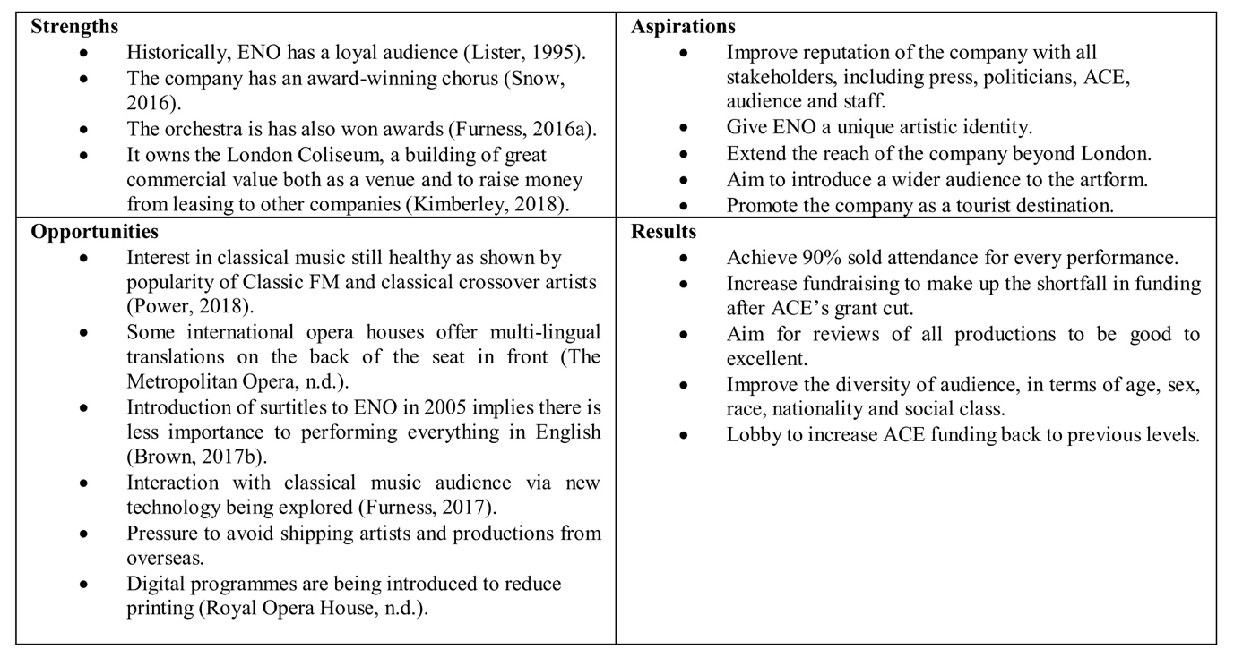
Figure 11: SOAR framework for ENO
Considering SOAR for ENO (Figure 11), we are presented with positive aspirations of how to engage with the challenges of the environment (e.g. extending beyond London and improving artistic identity) and results by which these actions can be measured (e.g. 90% attendance rate and improved audience diversity).
6 STAKEHOLDERS

ENO is a company limited by guarantee and a registered charity; it has no shareholders and its board are its trustees. However, “stakeholders, inside and outside the firm, now have the power of choice” (Nordström, & Ridderstråle, 2001, p. 131), and ENO must consider them when devising strategy.

6.1 Arts Council England
One of the key stakeholders from both a commercial and an existential point of view is ACE, a public body sponsored by the Department for Digital, Culture, Media and Sport. Recently ACE expressed its concern with ENO’s governance and business model by cutting its grant by a third (Henley, 2016) and saying they “expect them to improve or they could face the removal of [ACE’s] funding” (Brown, 2015). Before the cut, ENO received £19.1m from ACE representing 48% of its income (ENO, 2014). ACE’s decision to cut this by a third was significant, leading to reductions in its artistic output.

6.2 Government
ACE is funded by the National Lottery and government. Although it operates independently, if will inevitably feel the pressures of political mood. In effect, the government is a secondary stakeholder of ENO; it is the key stakeholder of ACE, which in turn is the key stakeholder of ENO.

6.3 Political groups
Within and around government, there are various groups, such as political parties and lobbyists, that will influence the thinking of government. For example, bodies that seek to improve the standard of musical education in UK schools may shape policies on arts funding to ensure that major arts organisations give proper emphasis to outreach work.

6.4 Grant-making trusts
In addition to ACE, there are also trusts that make philanthropic gifts to ENO. These are important to ENO, as strong relationships can produce significant income. Trusts are likely to have specific agendas that they will want to see adopted by the company. For example, the Peter Moores Foundation was particularly interested in producing opera in English and sponsoring young singers (Green, 2013).

6.5 Corporate sponsors
Corporate sponsors can also provide significant income. Here the return for the sponsor is more likely to be based on a level of service rather than specific artistic requirements.

6.6 Private donors
ENO’s private sponsorship receipts vary in amount from modest levels (such as membership of the Friends of ENO) to gifts of several thousand pounds. The level of access a sponsor receives, and the degree of influence they can exert, depends on the amount of money given. Sponsors are typically stratified, with higher levels of donation being rewarded with access to rehearsals and senior management. At other opera companies, particularly in America, large donors are given places on the board.

6.7 Audience members
Ticket sales represent a significant proportion of the company’s turnover – for the sixteen months ended 31 July 2017, box office income was £8.7m, 18% of turnover (ENO, 2018). Whilst this figure is less than at other UK opera house – ROH achieves 32% (ROH, 2017) – it is important to remember that much sponsorship comes from audience members, so there is considerable overlap between these groups.

6.8 Operatic community
With the company’s season having been cut after the reduction in the company’s ACE grant, the company is more reliant on other forms of income. One of these is rentals, where productions that originate at ENO are rented to other opera houses. In the sixteen months to 31 July 2018, this was £7.1m (ENO, 2018), almost as much as box office.

6.9 London theatre community
The reduction in the company’s season also increases the dark time for the London Coliseum. As London’s largest theatre, this is valuable real estate, and renting the theatre to visiting companies raised £4.5m in the sixteen months to 31 July 2018. Understanding London promotors and touring companies has become an important part of the company’s business.

6.10 Management
At a time when new managerial appointments at the company have reduced the amount of industry expertise, the company must seek to nurture and keep its human resources, rather than allowing them to be tempted away, as has recently happened (Alberge, 2018 and Brown & Tilden, 2016).

6.11 Employees
Staff morale at ENO has been low for some time, not helped by recent disputes between employees and senior management concerning cuts to jobs (Jacobs, 2017). In order to get the best out of the company’s human resources, the company should seek to align the ambitions of these individuals with those of the organisation and make strides to incorporate their needs within company strategy.

6.12 Unions
Both Equity and BECTU were involved in disputes in the aftermath of the ACE cuts. In this “hard” model of Human Resource Management, where HR policy “is driven by overall corporate strategy” (Henderson, 2011, p. 13), a pluralist atmosphere is created where employees do not consider themselves to be stakeholders of the company and are merely compliant rather than committed (Armstrong & Taylor, 2014). Softening the company’s HR policy will improve relations with these key groups.

6.13 Competitors
The UK and international opera industry is small, where key players are known across the globe. Ensuring good relationships with competition is helpful for co-productions and cooperation (e.g. when sickness leads ENO having to request other companies’ artists to jump into their shows).

6.14 Artists
Although generally freelance, artists are key to the success of the company, and ensuring that they are fully committed to the organisation’s work is key to the success of business.

6.15 Mendelow’s matrix
Stakeholders can be mapped by placing them in Mendelow’s matrix (Figure 12).
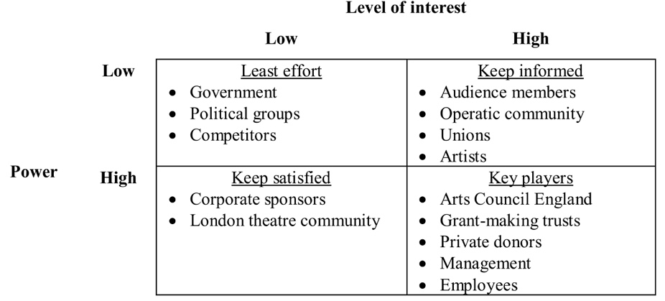
Figure 12: Mendelow’s Matrix of ENO stakeholders (Kaplan, n.d.)
This allows ENO to establish the appropriate strategy for each group. With the greatest interest being given to ACE, grant-making trusts, private donors, management and employees.

6.16 Cultural web
The manifestation of how these stakeholders interact, both internally and externally, produces the organisation’s culture (Figure 13).
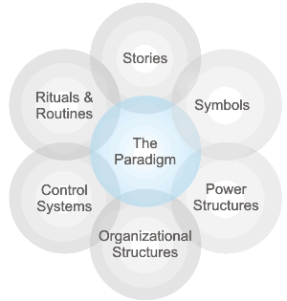
Figure 13: Cultural Web (Johnson et al., 2017)
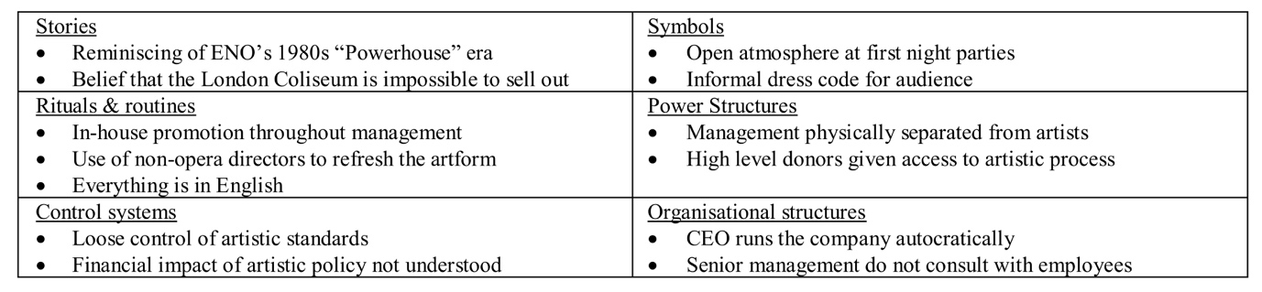
Figure 14: Cultural Web at ENO
These headings outline the ways in which ENO behaves, consciously and subconsciously (Figure 14). They indicate a paradigm that is fractured and pessimistic but retains some essence of its core objectives. The dominant culture is one of mistrust on the part of a number of key stakeholder groups, something that will take time to change due to how long it has persisted. The paradigm is re-enforced throughout the web, with, inter alia, the pluralistic organisational structure providing a power structure that breeds contempt due to the nature of power senior management possess (French & Raven, 1959). They have Reward and Coercive power, making decisions for pay and conditions, and although there is some Legitimate power – most employees accept that management have their role – there is little Referent power due to their isolation. Crucially there is no Expert power – most employees consider the expertise of senior management to be severely lacking (Clements, 2018b).

7 CORPORATE-LEVEL STRATEGIES TO DATE

7.1 Post-war period
After being evacuated from London during the war, the company returned to Sadlers Wells for the première of Britten’s Peter Grimes (ENO, n.d.b). This event revived the company and disrupted the English operatic industry.
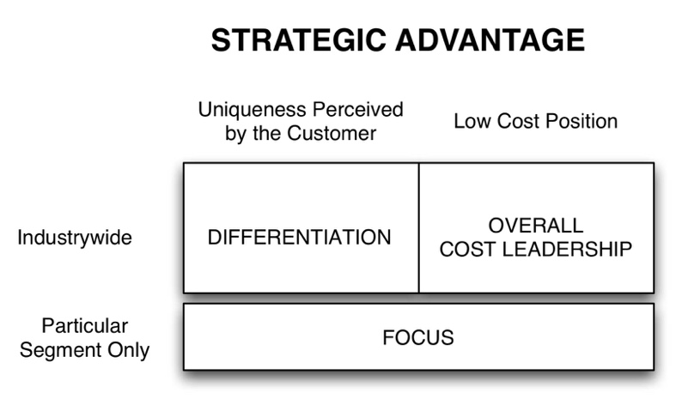
Figure 15: Three Generic Strategies (Porter, 1980 and Kryscynski, 2012)
Porter’s three generic strategies for competitive advantage are differentiation, cost leadership and focus (Figure 15). With accessible pricing being one of the founding tenets of the company, cost leadership was the company’s strategy for achieving a competitive advantage. Compared to ROH, it strove for this competitive position – one of the five Ps of strategy (Mintzberg, 1987 and Mintzberg et al., 2009).

7.2 Powerhouse era
From 1979 to 1985 three key appointments were made: Mark Elder (Music Director); David Pountney (Director of Productions); and Peter Jonas (General Manager). This triumvirate became known as the Powerhouse and “brought the company increasingly to the forefront of public debate about opera in Britain” (Jonas et al., 1992) thanks to increased musicals standards and provocative stagings.

Throughout the Powerhouse era, cheaper opera companies such as English Touring Opera and Opera Factory emerged, meaning the company’s cost leadership position was no longer viable. Instead it moved to a policy of differentiation, producing distinctive productions that would continue to attract an audience.

7.3 Post-powerhouse survival
ENO’s Powerhouse era pursued an artistic agenda at all costs – in fact, the cost amounted to a deficit of £2.2m by 1993 (The Telegraph, 2015). Dennis Marks took over as General Director at this time and was immediately faced with financial problems and uncertainties over funding, attempting and failing to move the company to a smaller theatre (The Telegraph, 2015). After five years of Marks’ austerity, Nicholas Payne took over as General Director in 1998 and set about plans to renovate the London Coliseum – now that the company was definitely staying – and reinvigorate artistic standards. The former was achieved with Lottery funding and Arts Council grants; the latter was less successful, and when Payne was encouraged to resign in 2002 his reign became the first of several to be unfavourably compared to the Powerhouse years.

This post-Powerhouse time can be examined on using Ansoff’s matrix (Figure 16) which considers strategy along the axes of product and market development. Moving left and down on this matrix increases risk, and at a time of financial vulnerability both Marks and Payne sought to avoid this. This period stayed firmly in the top left box of Market Penetration Strategy.
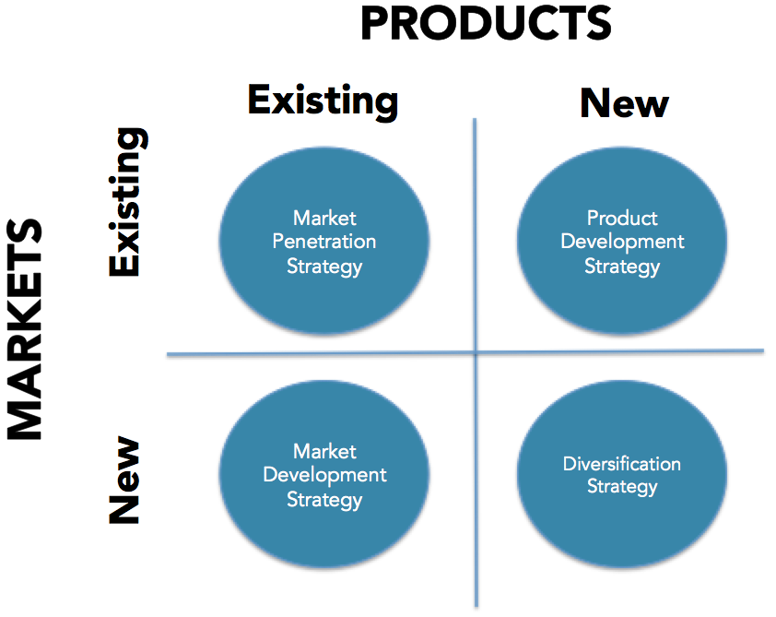
Figure 16: Ansoff’s Matrix (Johnson et al., 2017, p. 245)

7.4 International engagement
After Payne, Sean Doran held the reins at ENO for a couple of years before John Berry was internally promoted to be Artistic Director (Barnes, 2006). Berry’s ten years at the head of the company saw international reach extend, both in terms of artists hired and co-productions (Christiansen, 2015).

In terms of Ansoff’s matrix, it sought to increase its product range by introducing Musicals – something that subsequently worked well in Berlin (Schliess, 2017) – and its market, by attempting to collaborate with overseas companies. Simultaneously pursuing strategies of Market Penetration, Product Development and Market Development was a risk for the company. Some of its core audience were upset by the style of musicals introduced (Furness, 2016b), and the multitude of co-productions diluted the house style to the extent that it was hard to understand ENO’s artistic identity (Higgins, 2016b).

The risks ultimately did not pay off, and Berry’s approach placed ENO in direct competition with the much-better-funded ROH a mile down the road, enraging ACE, who saw the company’s falling attendance and rising prices as a betrayal of its public subsidy.

7.5 Reduction of public subsidy
When ACE decided to express their displeasure by cutting ENO’s grant by a third, John Berry’s days were numbered, and in July 2015 he resigned (The Times, 2015). He had previously engaged McKinsey & Co. to provide a new business model for the company in the light of their reduced means, and the Board decided to parachute in a member of consultancy team, Cressida Pollock, as CEO to implement their plans, and cut the company according to its cloth (Jacobs, 2017). Her reign was extremely unpopular, but left the company financially secure, if artistically wounded. The necessary changes having been undertaken, she chose to leave after three years, perhaps due to the animosity she was feeling from all sides (Masso, 2018), and Stuart Murphy, a media director with no opera experience was brought in as her replacement (Murphy, 2018b).

Surviving on a more commercial footing has led ENO to cut its season but maintain the breadth of product introduced in Berry’s time. It is focused on the top two segments of the Ansoff matrix: following a Market Penetration Strategy and Product Development Strategy, the latter of which includes gaining significant rental from hiring out the London Coliseum when the company is not producing its own work.

8 IMPLICATIONS OF STRATEGIES FOLLOWED

8.1 Three levels of strategy
Strategy is viewed at three levels: corporate, business and functional (Knowledgequity, 2016). Decisions that are made at the strategy level (which markets to aim for) will have implications at the business (how to achieve competitive position) and functional (methods of delivery) levels. At smaller companies, such as ENO, the corporate and business levels of strategy are often combined (ibid.).

As strategy flows through the organisation, conflict may occur when the practicalities of implementing a policy requires specific actions for certain departments. At ENO, this was observed following the ACE cuts. The company was compelled to choose a corporate strategy of operating on a more commercial basis, and the business strategy to deliver this was to reduce the season by a third and rent out the theatre when the company wasn’t performing. This caused conflict at the senior management level, with the Musical Director resigning (Brown & Tilden, 2016). Management claimed that without these changes the company was “at grave risk of bankruptcy” (BBC, 2016). However, the functional impact of this strategy was redundancies and pay cuts, and the chorus took industrial action.

8.2 Change management
The method of implementing change impacts the effect of strategy throughout the organisation depending on the key factors of the policy – Time, Scope, Preservation, Diversity, Capability, Capacity, Readiness and Power (Open Tuition, 2017 and Balogun & Hailey, 2014). Kotter outlines a method of effecting a new strategy within an organisation (Figure 17).
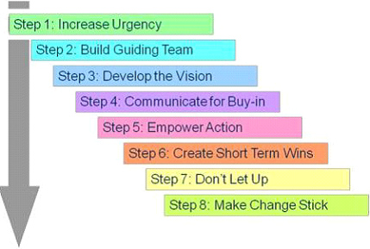
Figure 17: Kotter’s eight-step change management model (Madsen, 2016 and Hayes, 2010)
At ENO, there was resistance to change from a large number of stakeholders of varying degrees of influence and importance. Cressida Pollock, the CEO, took John Kotter’s advice to intransigent resistance, removing and ignoring it in order not to undermine the change process (Kotter, 2011). The result of this was that the change process occurred, but her position became untenable (Masso, 2018).

Her successor, Stuart Murphy, has an easier task, being untainted by the cuts. In fact, he has an opportunity to move from Change Management to Change Leadership (Kotter International, 2015) and move the company forward by articulating a corporate vision.

9 RECOMMENDATIONS

ENO has undergone a process of upheaval and change over the last few years which has left staff morale bruised and the market wary of what will happen to the organisation. Notwithstanding the precariousness of the situation, this is a time of great opportunity to move forward and create a new direction for the company.

9.1 Create a vision
ENO has articulated its mission (ENO, n.d.c), but it is unclear and not reflected in the functional reality of its operations. The core values, mission, vision and objectives of the company should be reconsidered, articulated and communicated to ensure that all strategy flows from ideals commonly held amongst stakeholders. Great faith is placed in the original tenets of the organisation, and, much as Disney achieved success by revisiting the founder’s original corporate recipe (Zenger, 2013), so ENO may rediscover the reason for the company’s existence.

9.2 Avoid ROH’s domain
ENO has for too long sought to compete head-on with the more powerful ROH. It is time to understand that this is not a fight worth engaging in, nor one it is likely to win – lessons can be learn from the parallel situation in New York which led to the demise of New York City Opera (Gagliardi, 2014). By seeking out blue waters where ROH is not actively engaged, ENO could re-establish a defendable competitive position (Kim & Mauborgne, 2014). The starting point for this should be an understanding of the ENO brand by plotting it alongside the competition on a Centrality-Distinctiveness map (Diwar & Bagga, 2015) and ascertaining where ENO can operate effectively. In essence, ENO must realise that it is a domestic house rather than an international house. This does not mean it is less important, but rather that it should have a different focus: discovering, nurturing and presenting UK-based talent, and performing in the vernacular at accessible prices. In this way, it can not only survive but thrive, as Berlin’s Komische Oper has in competition with the Deutsche Oper and Staatsoper (Smale, 2015).

9.3 Align business strategy
Based on the corporate strategy outlined in the vision and positioning of ENO, the company should devise a business strategy that reflects these factors. Placed as it is, towards the high end of the London opera market, but not the top, Porter’s three generic strategies (Figure 15) indicate that differentiation is key to the company’s success. More appropriate to ENO’s specific situation is the Faulkner and Bowman’s Strategy Clock (Figure 18) which allows for Hybrid Strategies between low-price and differentiation.
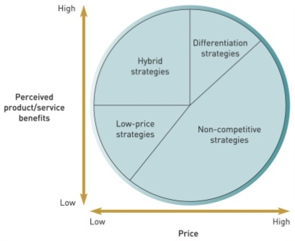
Figure 18: Strategy clock (Johnson et al., 2017, p. 220)
Much as IKEA has sustained a hybrid of low-cost and differentiated design over a long period, it should be possible for ENO to offer accessible pricing and exciting productions – along the lines of Lilian Baylis’ founding ideals for the organisation.

[4,159 words]
10 REFERENCES

ALBERGE, D (2018) Fresh crisis at English National Opera as key figure quits, The Guardian. Available at https://www.theguardian.com/music/2018/jun/19/crisis-english-national-opera-eno-key-figure-terri-jayne-griffin-quits [accessed 2 July 2018].
ARIENS, C. (2015) Infographic: the Rise of Entertainment on Demand, Adweek. Available at https://www.adweek.com/tv-video/infographic-rise-entertainment-demand-164529/ [accessed 6 July 2018].
ARMSTRONG, M. & TAYLOR S. (2014) Armstrong’s Handbook of Human Resource Management Practice, 13th edition. KoganPage: London, UK.
BAILEY, G. (2017) Millions of Brits never attend opera because it's 'too posh', 'too long' and 'too expensive', survey finds, Independent. Available at https://www.independent.co.uk/arts-entertainment/classical/news/opera-attendance-public-deterred-posh-long-expensive-etiquette-elitist-classic-fm-survey-a8090356.html [accessed 6 July 2018].
BALOGUN, J. & HAILEY, V. H. (2014) Landing transformational change, CIPD. Available at https://www.cipd.co.uk/Images/landing-transformational-change_2014_tcm18-16180.pdf [accessed 24 June 2018].
BANO, T. (2017) Theatre tax relief brings savings to nearly 2,000 shows, The Stage. Available at https://www.thestage.co.uk/news/2017/theatre-tax-relief-brings-savings-nearly-2000-shows/ [accessed 8 July 2018].
BARNES, A. (2016) Ousted ENO director attacks 'backstabbers', Independent. Available at https://www.independent.co.uk/news/uk/this-britain/ousted-eno-director-attacks-backstabbers-6231620.html [accessed 23 July 2018].
BAZALGETTE, P. (2013) The value of arts in a time of austerity, Financial Times. Available at https://www.ft.com/content/7d10a60a-b406-11e2-b5a5-00144feabdc0 [accessed 8 July 2018].
BBC (2018) Stage actors rage at audience members watching World Cup on phones, BBC website. Available at https://www.bbc.co.uk/news/entertainment-arts-44722812 [accessed 6 July 2018].
BBC (2003) Impresario plans 'accessible' opera, BBC website. Available at http://news.bbc.co.uk/1/hi/entertainment/3223329.stm [accessed 11 July 2018].
BBC (2016) ENO ‘faces bankruptcy’ over chorus pay dispute, BBC website. Available at https://www.bbc.co.uk/news/entertainment-arts-35783006 [accessed 26 June 2018].
BENNETT, N. & LEMOINE, G. J. (2014) What VUCA Really Means for You, Harvard Business Review. Available at https://hbr.org/2014/01/what-vuca-really-means-for-you [accessed 11 July 2018].
BHADWAL, R. (2015) Porter’s Value Chain - Does it serve the service industry?, LinkedIn. Available at https://www.linkedin.com/pulse/porters-value-chain-does-serve-service-industry-rajesh-bhadwal [accessed 29 May 2018].
BHAGAT, C., HIRT, M., HUYETT, B., KEHOE, C. & MATSON, E. (2012) Twelve questions every new director should ask, McKinsey & Company. Available at https://www.mckinsey.com/business-functions/strategy-and-corporate-finance/our-insights/twelve-questions-every-new-director-should-ask [accessed 22 June 2018].
BROWN, J. (2013) Stay-at-home drinking and socialising on the rise as Britons avoid paying premium of being served food or drink in pubs and bars, Independent. Available at https://www.independent.co.uk/news/uk/home-news/stay-at-home-drinking-and-socialising-on-the-rise-as-britons-avoid-paying-premium-of-being-served-9001375.html [accessed 11 July 2018].
BROWN, M. (2015) English National Opera told to improve or face funding axe, The Guardian. Available at https://www.theguardian.com/music/2015/feb/12/english-national-opera-funding-arts-council-england-special-measures [accessed 22 July 2018].
BROWN, M. & TILDEN, I. (2016) ENO music director Mark Wigglesworth quits, The Guardian. Available at https://www.theguardian.com/music/2016/mar/22/eno-music-director-mark-wigglesworth-quits [accessed 26 June 2018].
BROWN, M. (2017a) Arts Council England to spend £170m more outside London, The Guardian. Available at https://www.theguardian.com/culture/2017/jun/27/arts-council-england-to-spend-170m-more-outside-london-plymouth-tees-valley-bradford [accessed 8 July 2018].
BROWN, M. (2017b) Loud and clear: English National Opera dedicated to diction as it looks to future, The Guardian. Available at https://www.theguardian.com/music/2017/apr/27/english-national-opera-2017-2018-season-diction-coaches [accessed 8 July 2018].
BROWN, M. & TRAN, M. (2014) English National Opera tightens reins as 58 groups lose Arts Council funding, The Guardian. Available at https://www.theguardian.com/culture/2014/jul/01/arts-council-funding-english-national-opera [accessed 8 July 2018].
BURNS, J. (2014) 'Crazy funding cuts put music education at risk', BBC website. Available at https://www.bbc.co.uk/news/education-27663696 [accessed 8 July 2018].
BUSINESS TO YOU (2017) SWOT Analysis: Bringing Internal and External Factors Together, Business To You website. Available at https://www.business-to-you.com/swot-analysis/ [accessed 11 July 2018].
CAMERON, S. (2011) The MBA Handbook, 7th edition. Pearson Education Limited: Harlow, UK
CHRISTIANSEN, R. (2010) English National Opera: We’re all fans of ENO now, The Telegraph. Available at https://www.telegraph.co.uk/culture/music/opera/7987710/English-National-Opera-Were-all-fans-of-ENO-now.html [accessed 8 July 2018].
CHRISTIANSEN, R. (2015) ENO’s John Berry: surly but talented, The Telegraph. Available at https://www.telegraph.co.uk/culture/music/opera/11731103/ENOs-John-Berry-stubborn-and-surly-but-talented.html [accessed 23 July 2018].
CLEMENTS, A. (2018b) Why isn’t a practical knowledge of opera a ’must-have’ for ENO’s chief executive?, The Guardian. Available at https://www.theguardian.com/music/2018/mar/09/why-isnt-a-working-knowledge-of-opera-a-must-have-for-eno-chief-executive-stuart-murphy [accessed 25 June 2018].
DIWAR, N. & BAGGA, C. K. (2015) A Better Way To Map Brand Strategy, Harvard Business Review. Available at https://hbr.org/2015/06/a-better-way-to-map-brand-strategy [accessed 13 June 2018].
DUGHER, M. (2018) Arts Council funding to opera is unfair – pop needs support too, The Guardian. Available at https://www.theguardian.com/music/2018/apr/12/arts-council-music-funding-unfair-opera-pop [accessed 8 July 2018].
ENGLISH NATIONAL OPERA (n.d.a) Opera in London, ENO website. Available at https://www.eno.org/discover-opera/opera-in-london/ [accessed 23 July 2018].
ENGLISH NATIONAL OPERA (n.d.b) History of ENO, ENO website. Available at https://www.eno.org/about/history-of-eno/ [accessed 23 July 2018].
ENGLISH NATIONAL OPERA (n.d.c) ENO’s mission, ENO website. Available at https://www.eno.org/about/enos-mission/ [accessed 24 July 2018].
ENGLISH NATIONAL OPERA (2014) Report and Financial Statements Year Ended 31 March 2014, Companies House. Available at https://beta.companieshouse.gov.uk/company/00426792/filing-history [accessed 22 July 2018].
ENGLISH NATIONAL OPERA (2018) Report and Financial Statements Year Ended 31 July 2017, Companies House. Available at https://beta.companieshouse.gov.uk/company/00426792/filing-history [accessed 22 July 2018].
FRENCH, J. R. P. JR. & RAVEN, B. (1959) The Bases of Social Power, Power and Influence in Groups, pp. 259-269. Available at http://www.communicationcache.com/uploads/1/0/8/8/10887248/the_bases_of_social_power_-_chapter_20_-_1959.pdf [accessed 6 June 2018].
FURNESS, H. (2016a) Judi Dench crowned queen of Oliviers with record eighth award The Telegraph. Available at https://www.telegraph.co.uk/news/2016/04/03/judi-dench-crowned-queen-of-oliviers/ [accessed 11 July 2018].
FURNESS, H. (2016b) Opera world fury as ENO casts Katherine Jenkins and Alfie Boe in musical to attract new fans, The Telegraph. Available at https://www.telegraph.co.uk/news/2016/11/25/opera-world-fury-eno-casts-katherine-jenkins-alfie-boe-musical/ [accessed 9 May 2018].
FURNESS, H. (2017) Classical music app to send programme notes to your phone as orchestra plays, The Telegraph. Available at https://www.telegraph.co.uk/news/2017/06/26/classical-music-app-send-programme-notes-phone-orchestra-plays/ [accessed 8 July 2018].
GAGLIARDI, T. (2014) The Sad Demise of the New York City Opera, International Musician. Available at https://internationalmusician.org/the-sad-demise-of-the-new-york-city-opera/ [accessed 21 June 2018].
GREEN, A. (2013) Last hurrah: the Peter Moores foundation goes out with a bang, Rhinehold Publishing. Available at https://www.rhinegold.co.uk/classical_music/last-hurrah-peter-moores-foundation-goes-bang/ [accessed 22 July 2018].
GUTIERREZ, I. (2017) Musicians’ Union: Brexit threatens the cultural fabric of our great nation, Labour List. Available at https://labourlist.org/2017/10/musicians-union-brexit-threatens-the-cultural-fabric-of-our-great-nation/ [accessed 8 July 2018].
JUREVICIUS, O. (2013) VRIO Framework, Strategic Management Insight. Available at https://www.strategicmanagementinsight.com/tools/vrio.html [accessed 11 July 2018].
HAYES, J. (2010) The Theory and Practice of Change Management, 3rd edition. Palgrave McMillan: New York, USA.
HEMLEY, M. (2016) ENO box office takings rocket by 32% but donations fall, The Stage. Available at https://www.thestage.co.uk/news/2016/eno-box-office-takings-rocket-by-32-but-donations-fall/ [accessed 8 July 2018].
HENDERSON, I. (2011) Human Resource Management for MBA Students. Chartered Institute of Personnel and Development: London.
HENLEY, D. (2016) Every opera company must adapt or die: the ENO is no exception, The Guardian. Available at https://www.theguardian.com/commentisfree/2016/feb/16/english-national-opera-eno-cultural-treasure-value-for-money [accessed 9 May 2018].
HIGGINS, C. (2002) Charlotte Higgins says ENO was wrong to let Nicholas Payne walk away, The Guardian. Available at https://www.theguardian.com/culture/2002/jul/15/artsfeatures [accessed 23 July 2018].
HIGGINS, C. (2016a) ENO artistic director Daniel Kramer: ‘I’ve never run an opera house. Isn’t that exciting?’, The Guardian. Available at https://www.theguardian.com/music/2016/jun/04/english-national-opera-eno-artistic-director-daniel-kramer-interview [accessed 8 July 2018].
HIGGINS, C. (2016b) ENO: The situation looks bleak, but it need not be terminal, The Guardian. Available at https://www.theguardian.com/music/2016/mar/23/eno-english-national-opera-situation-bleak-not-terminal-embrace-change [accessed 23 July 2018].
HILL, T. & WESTBROOK, R. (1997) SWOT Analysis: It’s Time for a Product Recall, Long Term Planning, Vol. 30, No. 1, pp. 46-52, 1997. Available at https://pdfs.semanticscholar.org/2391/d179adcfa511bf2ff57f1b89a837ffcf4f92.pdf [accessed 25 February 2018].
HOOLEY, G., SAUNDERS, J. & PIERCY, N. (2004) Marketing Strategy and Competitive Positioning, 3rd edition. Pearson Education Limited: Harlow, UK.
JACOBS, E. (2017) Cressida Pollock on saving the English National Opera, Financial Times. Available at https://www.ft.com/content/b0d915f4-1937-11e7-9c35-0dd2cb31823a [accessed 23 July 2018].
JONAS, P., ELDER, M., POUNTNEY, D. & JOHN, N. (1992) Powerhouse – The English National Opera Experience. Lime Tree: London, UK.
JOHNSON, G., WHITTINGTON, R., SCHOLES, K., ANGWIN, D. & REGNÉR, P. (2017) Exploring Strategy, 11th edition. Pearson: Harlow, UK.
KAPLAN (n. d.) Mendelow’s Matrix, Kaplan Financial Knowledge Bank website. Available at http://kfknowledgebank.kaplan.co.uk/KFKB/Wiki%20Pages/Mendelow%27s%20matrix.aspx [accessed 5 May 2018].
KIM, W. C. & MAUBORGNE, R. (2014) Blue Ocean Strategy Tools and Frameworks, Blue Ocean Strategy. Available at https://content.curatr3.com/resources/353/blue-ocean-strategy-tools-frameworks_1492423012.pdf?Expires=1532426430&Signature=oHPER~F-N8S0QFuhyuBbW53IRsYrbmNKj8pPxW~l3qx7rB3xbT0hPRKbFpMXolwq31QAaQj6TaOFUvksBzYRFGn5fQcNd3HP5rafZ4z0dlvHXG6TTbw4jurBbjioYuINUkeJh1OLkNhLYHKaz1XtbEKEDFJFCZQ6dpEQR5bvGaj1cJoMdxV65QyFgU~PPRdQmiKYJ145czywqnMY02Qk2ATRkv1X-MqX4SwqdjXFSjw2kkQvCClfhExv~E4wIe8hyE4JkJHTcCEnM3OKp3NkPubuEaA-bS6th-9~hc9vE0OgN~1N7494TbNtTcWOXrl7pKJWH5s9KkF~2-dsCyeKAg__&Key-Pair-Id=APKAJCEGL7JDG6GKNT6A [accessed 24 July 2018].
KIMBERLEY, N. (2018) Acis and Galatea, ENO Studio Live review: Handel goes tech with phones and beer, Evening Standard. Available at https://www.standard.co.uk/go/london/arts/acis-and-galatea-eno-studio-live-review-handel-goes-tech-with-phones-and-beer-a3860776.html [accessed 11 July 2018].
KNOWLEDGEQUITY (2016) Three levels of strategy, YouTube. Available at https://www.youtube.com/watch?v=xcJf_UCjIg0 [accessed 11 May 2018].
KOTTER INTERNATIONAL (2015) Change Management versus Change Leadership: What’s the Difference?, YouTube. Available at https://www.youtube.com/watch?time_continue=8&v=yseq-v9DFqg [accessed 25 June 2018].
KOTTER, J. (2011) Resistance to change, YouTube. Available at https://www.youtube.com/watch?v=Wdroj6F3VlQ [accessed 26 June 2018].
KRYSCYNSKI, D. (2012) Generic Strategies Mini-Lecture, YouTube. Available at https://www.youtube.com/watch?v=V14kuqYEsxE [accessed 29 May 2018].
LISTER, D. (1995) English National Opera: something had to give, Independent. Available at https://www.independent.co.uk/arts-entertainment/books/english-national-opera-something-had-to-give-1581300.html [8 July 2018].
MADSEN, S. (2016) Kotter’s 8 Step Change Management Model, YouTube. Available at https://www.youtube.com/watch?v=7qlJ_Y8w5Yk [accessed 26 June 2018].
MALVERN, J. (2015) Embattled ENO chief John Berry resigns, The Times. Available at https://www.thetimes.co.uk/article/embattled-eno-chief-john-berry-resigns-zz56dw5cpsd [accessed 23 July 2018].
MARKETING MIX, THE (n.d.) 4 Ps in Marketing, The Marketing Mix. Available at http://marketingmix.co.uk/4ps-in-marketing/ [accessed 11 July 2018].
MASSO, G. (2018) Cressida Pollock: ‘I was publicly trashed following my appointment at ENO’, The Stage. Available at https://www.thestage.co.uk/news/2018/cressida-pollock-publicly-trashed-following-appointment-eno/ [accessed 25 June 2018].
MELLOR, D. (2018) Falstaff in the ‘back garden’? Blooming good! Garsington Opera’s first-class production of the Verdi classic proves that country house opera is thriving, Daily Mail. Available at http://www.dailymail.co.uk/home/event/article-5869083/Garsington-Operas-class-production-Falstaff-proves-country-house-opera-thriving.html [accessed 26 June 2018].
MERCHANT, N. (2012) Why Porter’s Model No Longer Works, Harvard Business Review. Available at https://hbr.org/2012/02/why-porters-model-no-longer-wo [accessed 29 May 2018].
METROPOLITAN OPERA, THE (n.d.) Met Titles, The Metropolitan Opera website. Available at https://www.metopera.org/About/FAQ/met-titles/ [accessed 6 July 2018].
MINTZBERG, H. (1987) The Strategy Concept I: Five Ps For Strategy, California Management Review, Fall 1987. Available at http://www3.uma.pt/filipejmsousa/ge/Mintzberg,%201987.pdf [accessed 9 May 2018].
MINTZBERG, H., AHLSTRAND, B. & LAMPEL, J. (2009) Strategy Safari: Your complete guide through the wilds of strategic management, 2nd edition. FT Prentice Hall: Harlow, UK.
MOSS, S. (2018) ENO was the Quentin Tarantino of opera powerhouses. What happened?, The Guardian. Available at https://www.theguardian.com/commentisfree/2018/jun/29/eno-quentin-tarantino-powerhouse-opera-financial-crisis [accessed 8 July 2018].
MURPHY, S. (2018a) Glad to report to #DavidMellor that @E_N_O is in rude health with recent sold out perfs of Iolanthe, Figaro, Satyagraha & Acis; critical acclaim for Gate Thtre, @grangeparkopera & West Hamp prods; financially stable for several years now & artistically planned for the next three [Online], Twitter. 24 June 2018. Available at https://twitter.com/stuartmurphy100 [accessed 11 July 2018].
MURPHY, S. (2018b) English National Opera’s new boss lays out his plans to broaden the appeal of what many still see as a niche artform, The Guardian. Available at https://www.theguardian.com/commentisfree/2018/mar/11/opera-must-take-more-risks-new-eno-chief-exec-stuart-murphy [accessed 25 June 2018].
NORDSTRÖM, K. A. & RIDDERSTRÅLE, J. (2001) Funky Business, 3rd printing. Bookhouse Publishing AB: Stockholm, Sweden.
OPEN TUITION (2017) ACCA P3 Chapter 20 Change Management, YouTube. Available at https://www.youtube.com/watch?v=h3aE-qx1xQ4 [accessed 24 June 2018].
PESTLE ANALYSIS (2016) Potential Limitations to the PEST Analysis and How to Address Them, Pestle Analysis website. Available at http://pestleanalysis.com/limitations-of-the-pest-analysis/ [accessed 11 July 2018].
PORTER, M. E. (1980) Competitive Strategy. Free Press: New York, USA.
PORTER, M. E. (1985) Competitive Advantage. Free Press: New York, USA.
POWER, V. (2018) A touch of Klass: The Classic BRIT Awards are back and Myleene Klass is co-hosting, Sunday Express. Available at https://www.express.co.uk/life-style/life/970882/the-brit-awards-myleene-klass-hosting-classic-FM [accessed 8 July 2018].
PSLIDES (n.d.) Free TOWS Matrix for Powerpoint, Pslides website. Available at https://pslides.com/templates/tows-matrix-powerpoint/ [accessed 24 February 2018].
ROH (n.d.) All publications, ROH website. Available at https://www.roh.org.uk/publications/all [accessed 8 July 2018].
ROH (2017) The Annual Report 2015/16, ROH. Available at https://s3-eu-west-1.amazonaws.com/static.roh.org.uk/about/annual-review/pdfs/annual_review_1516.pdf [accessed 25 July 2018].
SCHLIESS, G. (2017) Berlin 24/7: Komische Oper continues to reinvent the musical after 70 years, DW. Available at http://www.dw.com/en/berlin-24-7-komische-oper-continues-to-reinvent-the-musical-after-70-years/a-41717335 [accessed 21 June 2018].
SMALE, A. (2015) Australian Director Barrie Kosky Carries on Innovative Operatic Tradition in Berlin, New York Times. Available at https://www.nytimes.com/2015/04/22/arts/international/australian-director-barrie-koskie-carries-on-innovative-operatic-tradition-in-berlin.html [accessed 25 July 2018].
SNOW, G. (2016) ENO chorus wins at International Opera Awards, The Stage. Available at https://www.thestage.co.uk/news/2016/439925/ [accessed 11 July 2018].
SNOW, G. (2018) English National Opera producing director Terri-Jayne Griffin to leave after 19 years, The Stage. Available at https://www.thestage.co.uk/news/2018/english-national-opera-producing-director-terri-jayne-griffin-leave-19-years/ [accessed 8 July 2018].
SHANKAR, V. (2014) Take risk to manage uncertainty, YouTube. Available at https://www.youtube.com/watch?time_continue=479&v=gRdiIzqrUNw [accessed 25 May 2018].
STAVROS, J. M. & COLE, M. L. (2013) SOARing Towards Positive Transformation and Change”, The ABAC ODI Visions.Action.Outcome., 1(1), 10-34. Available at http://www.mcole-psy.com/mcole/Cole-publications/StavrosCole2013_SOARing_Towards_Positive_Change.pdf [accessed 3 June 2018].
SWENEY, M. (2018) UK's live entertainment industry hits new highs, The Guardian. Available at https://www.theguardian.com/media/2018/jan/19/uks-live-entertainment-industry-hits-new-highs [accessed 6 July 2018].
TAYLOR (2011) Opera’s now for rich only, Sunday Express. Available at https://www.express.co.uk/comment/expresscomment/231437/Opera-s-now-for-rich-only [accessed 8 July 2018].
TELEGRAPH, THE (2012) Theatre losing its appeal, The Telegraph. Available at https://www.telegraph.co.uk/culture/theatre/9025373/Theatre-losing-its-appeal.html [accessed 6 July 2018].
TELEGRAPH, THE (2015) Dennis Marks, BBC head of music – obituary, The Telegraph. Available at https://www.telegraph.co.uk/news/obituaries/11514346/Dennis-Marks-BBC-head-of-music-obituary.html [accessed 23 July 2018].
TIMES, THE (2005) Should English opera use surtitles?, The Times. Available at https://www.thetimes.co.uk/article/should-english-opera-use-surtitles-jh0wpbxj7js [accessed 11 July 2018].
WEBBER, D. & THOMAS, N. (2018) Household disposable income and inequality in the UK: financial year ending 2017, Office for National Statistics. Available at https://www.ons.gov.uk/peoplepopulationandcommunity/personalandhouseholdfinances/incomeandwealth/bulletins/householddisposableincomeandinequality/financialyearending2017 [accessed 8 July 2018].
WEIHRICH, H. (1982) The TOWS Matrix – A Tool for Situational Analysis, Long Range Planning, Vol.15, No. 2, pp. 54-66, 1982. Available at https://s3.amazonaws.com/academia.edu.documents/54127095/weihrich1982.pdf?AWSAccessKeyId=AKIAIWOWYYGZ2Y53UL3A&Expires=1531309889&Signature=AfuUdPF%2Fns08OM5hn5%2FeSqXLIN4%3D&response-content-disposition=inline%3B%20filename%3DThe_TOWS_Matrix_A_Tool_for_Situational_A.pdf [accessed 11 July 2018].
WIGGLESWORTH, M. (2016) Mark Wigglesworth: save the people's opera, The Guardian. Available at https://www.theguardian.com/music/2016/feb/11/mark-wigglesworth-eno-needs-to-innovate-to-survive-not-reduce [accessed 6 July 2018].
ZENGER, T. (2013) The Disney Recipe, Harvard Business Review. Available at https://hbr.org/2013/05/what-makes-a-good-corporate-st [accessed 21 June 2018].

