Name Paula Smith
Student Number 1903588

Human Evolution and the Origins of Modern Human Behaviour

Practical exercise 2023

Please indicate your response clearly

Looking at faces 1
Look at the following images and then compare them to the list below. Indicate clearly (circle or highlight) the name of the early hominin skull you believe this to be.
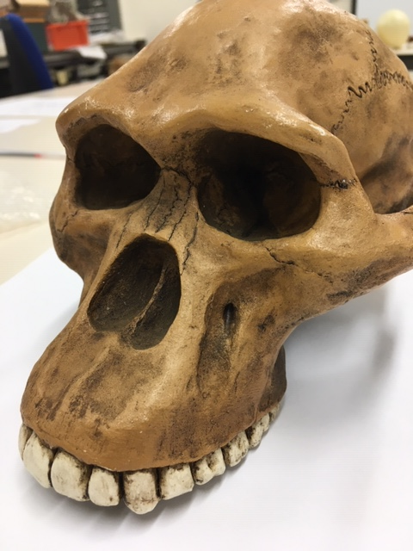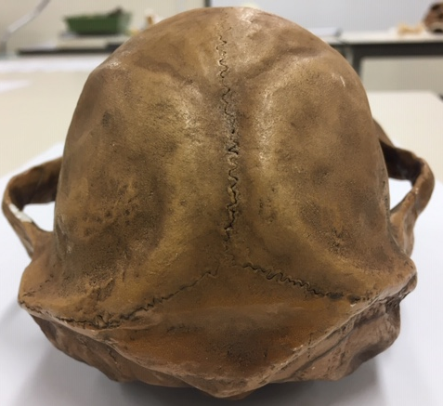

Chimpanzee

Australopithecus afarensis

Australopithecusafricanus

Australopithecus robustus

Homo habilis
Looking at faces 2
Look at the following images and then compare them to the list below. Indicate clearly (circle or highlight) the name of the early hominin skull you believe this to be.
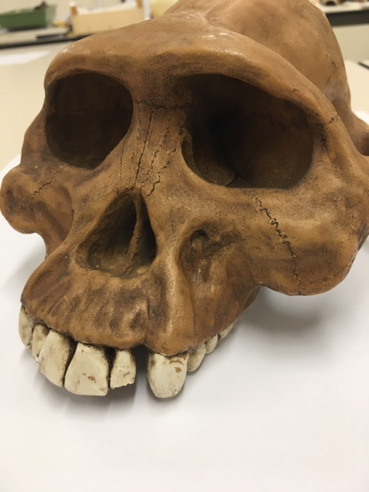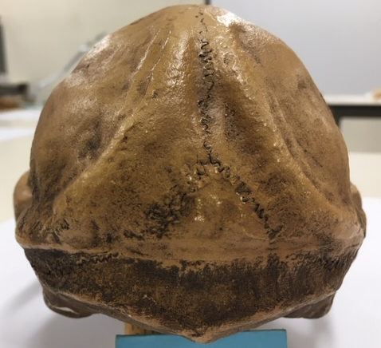

Chimpanzee

Australopithecus afarensis

Australopithecusafricanus

Australopithecus robustus

Homo habilis

Looking at faces 3
Look at the following images and then compare them to the list below. Indicate clearly (circle or highlight) the name of the early hominin skull you believe this to be.
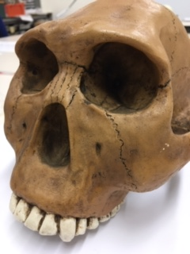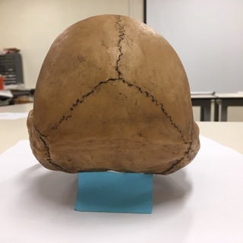

Chimpanzee

Australopithecus afarensis

Australopithecusafricanus

Australopithecus robustus

Homo habilis
Maxilla (upper jaw): Identify the species these belong to
A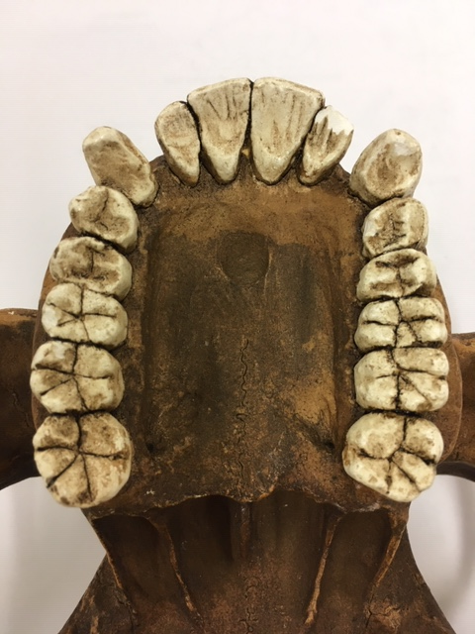B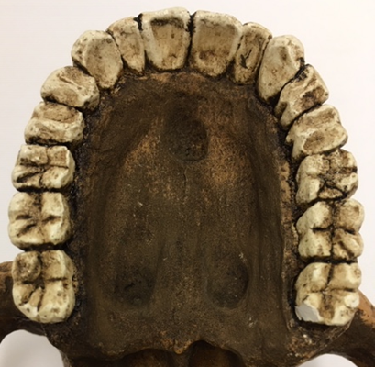
A Australopitheccus afarensis B Modern human
Top row left Chimpanzee, Middle Australopithecus afarensis, Right modern human
Lower row Left Australopithecus africanus, Right Australopithecus robustus
Indentify the skull to genus and species level
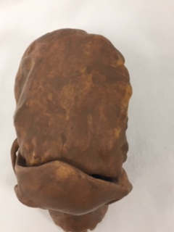
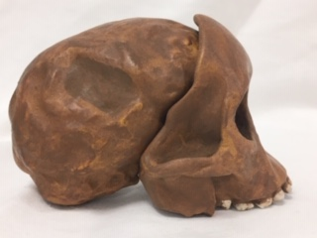
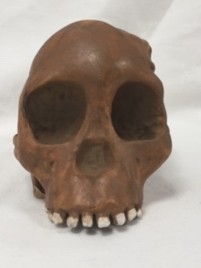
Answer Australopithicus africanus
Indentify the skull to genus and species level
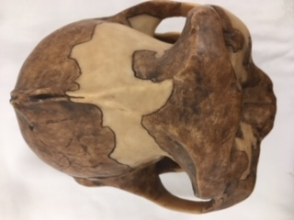
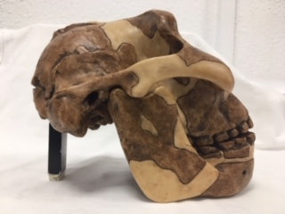
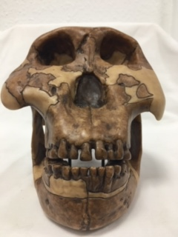
Answer Paranthropus boisei
Identify the hominin skull to genus and species level
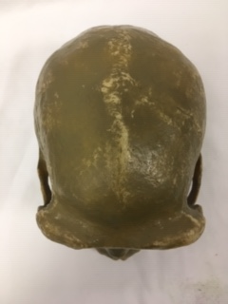

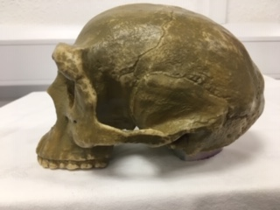

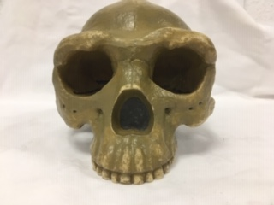
Answer Homo erectus
Indentify the skull to genus and species level
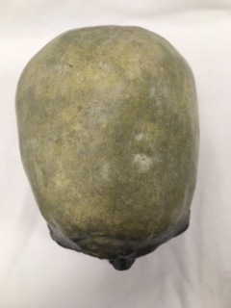
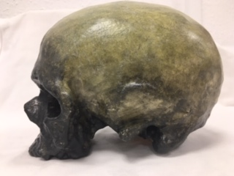
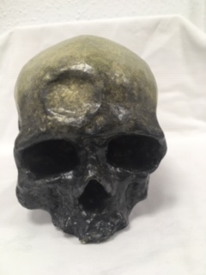
Answer Homo spaiens
Identify, compare and contrast these two mandibles. Use the illustration below to help if you need to.
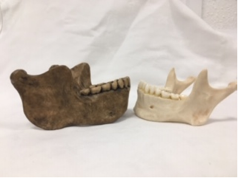
1st mandible= A 2nd mandible= B
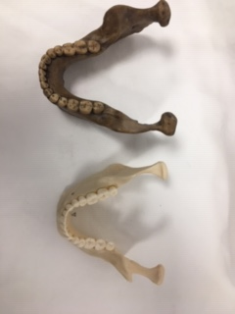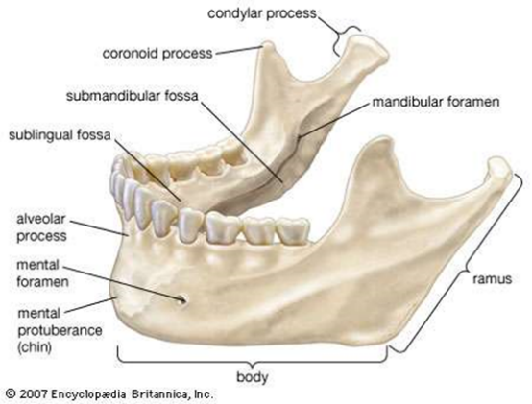
Answer.
Neither A or B have a diastema. A is bigger generally with a wider body and a larger ramus. The coronoid process and condylar process are more pronounced on B. The dental plate is more flared on B. The mental protruberance and alveolar process is more pronounced on B. The teeth are larger on A and the mental foramen is lower.

Stone tools and tool technology: How to tell a stone is worked.
What features suggest this stone has been worked (knapped)?
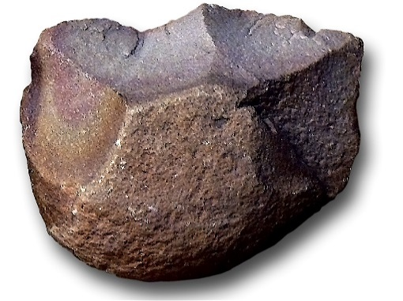
Answer: This stone looks to have Mode 1 or Oldowan knapping. It has had cortex removed from a large area and been flaked from more than one angle, possibly with 2 sided flaking. This is unlikely to have been caused by a natural process. It appears to be a useable size and has a round side to fit into a hand and a sharper edge suitable for crushing and cutting.
Features of stone tool flaking: identify features 1-5
1.Platform
2.Point of percussion
3.Bulb of percussion with bulbar scar
4.Fissures
5.Ripples

Stone tools and tool technology: Stone tools not to scale
Below left: Oldowan Below Right: Acheulean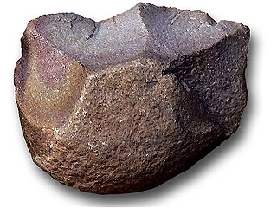 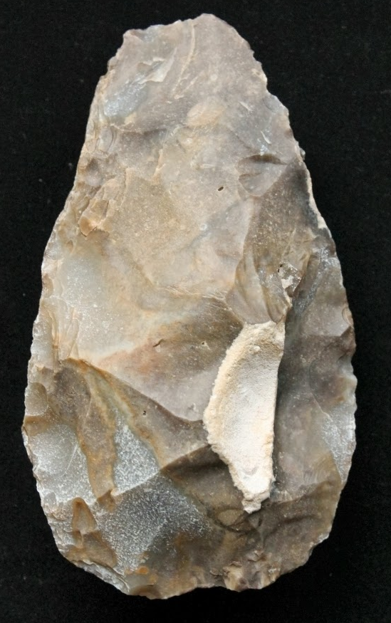
Images taken from https://images.search.yahoo.com

Task: Compare and contrast these two stone tools
Mode 1/Oldowan is made from a basalt cobble, Mode 2/ Acheulean from flint. Both have had cortex removed, Mode 2 leaving very little. Mode 1 is a rough stone fashioned with 4 blows visible, Mode 2 has been flaked many times with secondary knapping to make a pear shaped, symmetrical, bifacial tool. Mode 1 is suitable for heavy chopping and Mode 2 for lighter duty scraping. Mode 1 has 1 or 2 cutting edges whereas Mode 2 has 2 long cutting edges and a tip- which may have been broken and reworked. Mode 2 has cross shape thinning whereas Mode 1 has no alteration to the thickness of the cobble. Mode 1 would be rapidly fashioned and possibly discarded, Mode 2 requires spatial awareness and future thinking in it’s production and would be more valued.

Fig 1 Fig2
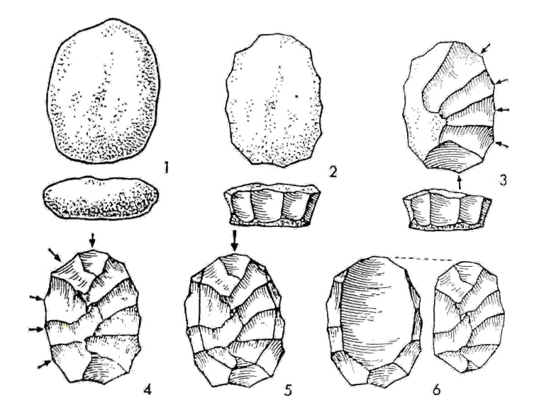
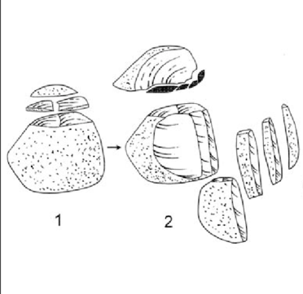
Above left: Levallois Technique and above right: Upper Palaeolithic blade technology

Task: Imagine you are a mobile Hunter-Gather-Forager, briefly outline why these (Middle and Upper Palaeolithic) technologies would be seen as an advantage above the Oldowan and Achulean
Levallious technique requires a knowledge of stone types and skill to produce the flakes, but once acquired, this gives a very portable resource that can be worked as needed. Preparing the core in this specific way (Fig 1) shows an ability to imagine a future rather than be confined to the ‘here and now’, and this ability coupled with the new tools produced, gave rise to an expansion of digital dexterity and brain capacity. In producing regular, predictable flakes with parallel sides, this technique produced blades that could be simple or complex- combining them or manufacturing other tools. Prismatic blades so produced (Fig 2) had a fine point or ‘chisel’ end and sharp cutting edges, but also a thickened ‘spine’ that gave strength. Tools that could make other tools and the accompanying innovation broadened the horizon of possibilities for these early humans- having a multi-tool such as this would make the exploration and exploitation of new environments possible, and therefore make it possible for these early humans to adapt and thrive in ever widening territories.

