RESEARCH PROPOSAL
ASSIGNMENT 1
BY MICHAEL HOWELLS
UNIVERSITY OF WALES TRINITY SAINT DAVID
RESEARCH METHODS – ACDA5012

  - SUBJECT SPECIALIST: STEPHEN MOSEY

CONTENTS
1 ABSTRACT 2
2 INTRODUCTION 2
2.1 LITERATURE REVIEW 2
2.2 Relevance 4
2.3 Aims 5
3 PROJECT DESIGN 6
3.1 Overview 6
3.2 Data Collection 6
3.3 Development Method 6
3.4 Risks 7
3.5 Evaluation Plan 7
4 RESOURCES AND PLANNING 8
4.1 Resource Requirements 8
4.1.1 Further Research 8
4.1.2 Electrical Design 8
4.1.3 Software Design 8
4.1.4 3D Design and printing 8
4.2 Gantt Chart 9
5 REFERENCES 12

ABSTRACT
This document is a proposal for a project that will be developed in the major project module of the electrical and electronic engineering degree course. The project idea is an efficient plant watering system. The research carried out will explore different existing designs philosophies and ways to make it more efficient as well as methods for measuring moisture in soil.
The project design section is an explanation of the chosen project and defines what a successful project would be and how it would be evaluated.
The proposal includes a planning section that identifies the resources that would be required to complete the project and a Gantt chart to show the projects timescale.

INTRODUCTION
The initial idea for this project is to develop an automatic plant watering system.
The aim of the research in this section is to evaluate some existing designs and to identify and understand ways in which to improve the efficiency of the device. Efficiencies could be achieved by limiting wastes in water usage and electrical usage for example.

LITERATURE REVIEW
Water is a critical part to plant growth as it required during photosynthesis. Photosynthesis is the process in which a plant generates sugars that are required for development using a combination of light, water, and carbon dioxide [1]. During photosynthesis, carbon dioxide is taken into the plant using pores called stomata; these pores open for this to work, however, water is lost when they are open and so the more carbon dioxide the plant takes in, the more water is lost. On average, for each carbon dioxide molecule gained, 400 water molecules are lost during photosynthesis [2]. Water is absorbed into plants through the roots, which are in the soil; it is critical that the soil has a sufficient water content so that the plants needs are met to ensure it can photosynthesize correctly and grow effectively.
Water in plant soil can be defined in three ways. Firstly, there is hygroscopic water which is bound to particles within the soil and in not available for plants to use. Secondly, there is gravitational water that drains out of the soil after it rains. If this is retained within the soil due to poor drainage it can interrupt the growth of the plant. The final type is capillary water. This is the water that is held within the soil and is not drained. This is the type that plants are mainly dependent upon for survival. The total water that remains in the soil after the gravitational water have been removed is called the field capacity. When there is not enough water in the soil and the plant cannot absorb enough water for its requirements, then the soil can be defined as at a permanent wilting point. The available water to a plant is defined as water within the soil between the field capacity and the permanent wilting point [3]. For this project, it is critical to ensure that the moisture level of the soil remains above the permanent wilting point to ensure the plant growth if not stinted.
There are many ways to measure the moisture level in soil. They often determine the permittivity of the soil which is related to the water content within it.
One of the most common methods is time domain reflectometry [4]. This method involved inserting dual probe electrode into the soil and injecting a voltage pulse into it [5]. The waveform is measured, and velocity of the reflected pulse is used to calculate the permittivity of the dielectric material, which is the soil. The largest factor that determines the permittivity of soil is its water content and that is why this method is so useful for this application.
Another common method for determining the water content of soil is using a capacitance/ frequency domain type measurement. In this method, the probes of the device form a capacitor using the soil as the dielectric. The capacitance is proportional to the water within the soil [6].
Time domain transmissometry (TDT) is similar to TDR as a voltage pulse is injected into the electrode, however the time is measured across a looped probe [7]. This method is considered to be more accurate as a single ended probe like the one used in TDR can cause multiple reflections when the pulse travels back through the probe. The time delay through the probe in the TDT is not affected by these multiple reflections; this is an advantage TDT has over TDR measurements [8].
For larger scale moisture level measurements, cosmic ray measurements can be used. This method involved measuring the amount of fast-moving neutrons in and around the soil. A low number of neutrons indicate wet soil because it would contain more hydrogen to absorb energy from these particles. The neutrons are generated from cosmic rays in space that are broken down by nitrogen and oxygen in the air. The breakdown of these cosmic rays generates subatomic particles such as protons and neutrons; the neutrons are measured with this method [9]. One benefit of this method is its noninvasive nature and ability to be used over large areas with relative ease.
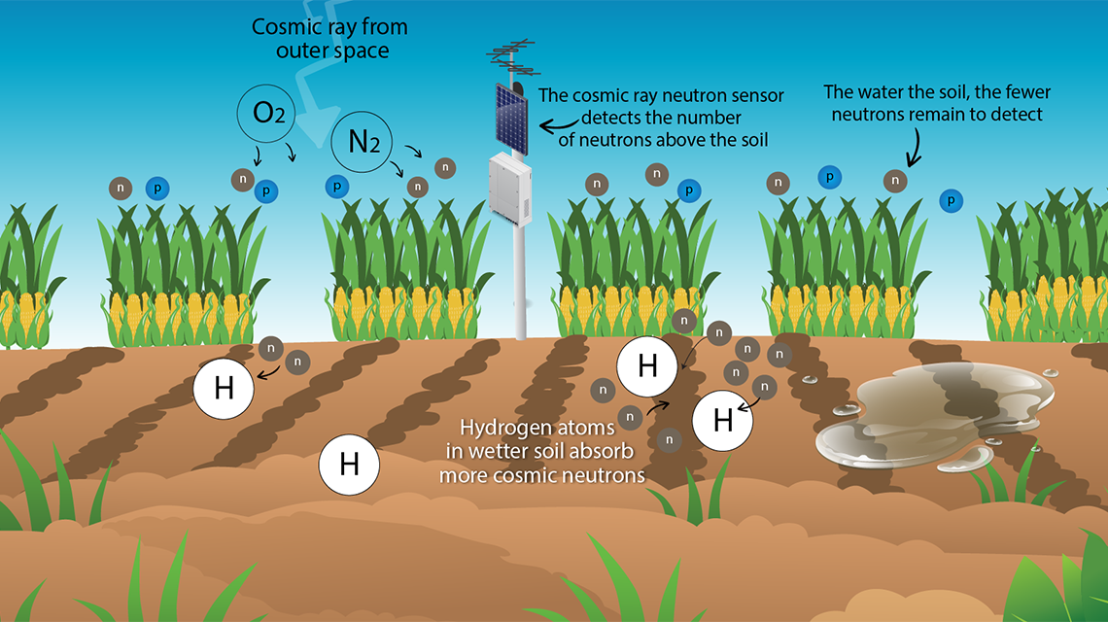
Figure 1 - Illustration of cosmic ray neutron sensors process [10]

Studies have been carried out to determine optimum methods for scheduling the irrigation of plants. One such study hypothesized that a combination of meteorological data and soil water data could be used to schedule the irrigation of plants more effectively by reducing water usage.
An experiment was carried out to show the differences between plant growth using two different watering methods. One used a timer to control the watering schedule and the second method was to control the watering schedule using a tensiometer. A tensiometer is a device that is used to measure the water availability to plant roots, such as the SKTM 600 which was used in this experiment [11].
The results of this investigation showed that irrigation strategies-based measurements of the soil significantly improved plant growth while using less water [12]. This is a key idea that will be explored and implemented in this project.
A study was carried out in 2016 to create an automatic irrigation system using an Arduino microcontroller as the controller of the device. The aim of the study was to show an application of this concept. The system comprised of the following components:
- Battery and battery charge system
- Soil Humidity detector
- Pump
- Control System
It was designed to be implemented in locations that do not have access to mains electricity. This is the reason it uses a solar power as its source of energy. This idea could be implemented into the design in this project proposal as a way to improve the systems sustainability. This system contained a raspberry pi that was used to take pictures and send them to relevant people before and after irrigation. This idea is interesting because it could allow for remote control of the irrigation system over large distances (as the raspberry pi requires internet to send emails), however this would have the potential risk of irrigation systems getting hacked remotely. The control method for this system was relatively simple and could possibly be developed to further improve efficiency [13].
For example, a similar study was carried out and the control system was shown to use a PD controller. This is just another method of controlling the system based on its inputs [14].

Relevance
Electrical and electronic engineering would be fundamental to this project. Problems such as powering the system and managing the sensors outputs would be covered under electronics engineering. The scope for electrical and electronic engineering within this project is limited by the imagination. PCBs could be designed to contain circuits for example.
Another element of the project that would need to be explored and designed is the programming aspect. This would be required to develop a smart way to manage the water distribution based on the inputs. Programming is a skill that is closely linked with electronics.
A study such as this could be used to develop new ways of watering plants to improve efficiency by saving water while sustaining or improving plant growth.

Aims
The aim of this project is to design and develop a working prototype irrigation system that can automatically water a plant to maintain successful growth using a microcontroller. Sustainability will be a key factor to be considered while developing the project. This would include not wasting water and efficient power usage within the system.
At the end of the project, a detailed report of the process that was followed to design the system will be delivered. This will include design documents and explanations of the systems developed. A study of any data gathered would also be carried out to attempt to identify potentially useful trends.

PROJECT DESIGN

Overview
The overall aim of this project is to design and create an automatic irrigation system prototype that effectively monitors water levels and sustains plant life. The main parts of the system will be a microcontroller to control the functions of the device; a moisture sensor that will be used to detect the moisture levels of the soil and feed the information back to the microcontroller; a pump system that has access to a reservoir of water. These are the most basic parts of the system; however other parts could be developed further to improve efficiencies.

Data Collection
The system will also be gathering a data log for analysis. This would include values such as water consumption, soil moisture levels and the time of waterings. A method of transferring the data to a location where it can be used will need to be developed. The prototype will need to be tested before use. This would include making sure that water is dispensed when the moisture sensor is too dry and that it stops dispensing when the soil has an optimum level of water. The systems program will need to be tested in order to ensure that the threshold soil water levels required for turning on and off the pump are set to reasonable levels.

Development Method
To develop the project, part of the waterfall design methodology will be used. This is due to the clear stages of development process, shown in figure 2. This process is commonly used for software developments, however the stages are still relevant to general project developments.
The first stage will be where I define the design requirements. This will include defining what the device will be capable of doing and its features. The time scale of the project is also be defined at this stage.
The design stage comprises of figuring out an initial high-level design that specifies the block components of the device. Then the blocks will be broken down into more specific solutions.
Next is the testing phase. This is key for this project as it will show if all the design requirements have been met and it is also where the system is fine tuned.
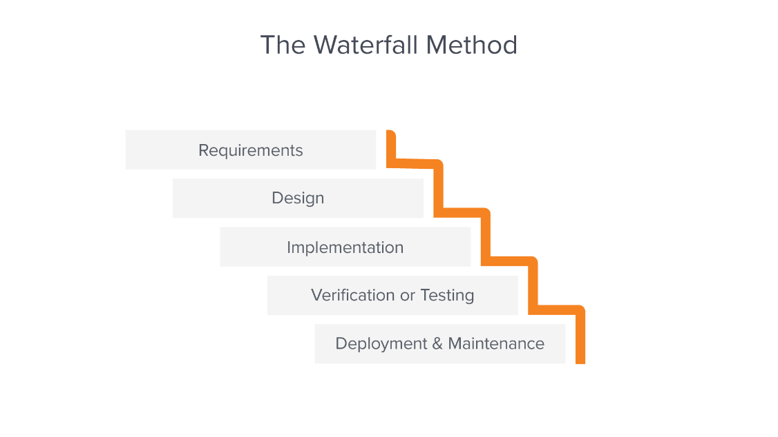
The deployment may be limited however as the project to developed is a prototype and not something for mass production [15].
Figure 2 - Waterfall Design Methodology [16]
There are limitations to the waterfall method such how it does not cope with change well, however studies have shown that the effects are worse on large scale projects. As the scope of this project is quite focused the limitations should have a small effect on the project results [17].

Risks
The ethical and legal risks of this project must be considered but will be limited. No animals or people will be involved in this project.
A full ethics approval form will be completed before any part of the project is started to ensure that there will be no ethical violations.

Evaluation Plan
The main evaluation of the project will take place during the testing phase. This will be the stage that will prove the desired functionality of the project. The main testing will involve confirming that the program written for the microcontroller will effectively turn on the watering pump when the soil is dry.
Further evaluation of the project can be carried out by monitoring values specified previously such as water usage, soil water level and power consumption to infer expected operation.
The testing of the watering system could be further expanded, to trial different watering methods over a longer period of time by monitoring the growth of plants with different setups, however this is beyond the desired scope of the project.

RESOURCES AND PLANNING

Resource Requirements
The resources required to complete this project are specific in this section.

Further Research
Further research and study will be required in the initial stages of the project. This will include research into suitable microcontrollers, pumps, sensor etc. In order to effectively do this, library access will be required. This is so relevant published documents such as journals and books can be reviewed. Internet access and a computer will be an essential resource in order to access and compile any useful information.

Electrical Design
The electrical design will be a key component of this project as it is the most relevant section to the area of study. It will be beneficial to have some electrical design software that is capable of creating schematics. This will ensure designs are easily legible and of a high quality. Proteus would be a good choice for this as is it available through the university. Proteus is also capable of PCB design which would be a good option to pursue for this project as it can make designs easier to replicate in the future.
Altium designer is another software package that could be used for schematic and PCB design. A license would need to be obtained through the workplace or a student license could be used.

Software Design
The software design for this project will depend on the control method. The programming languages Python and C are two examples that could be used for this project.

3D Design and printing
A 3D CAD software package would be required in order to design mechanical parts. There are many options available such as Design Spark, Free CAD and Autodesk. Some of these option will require licenses in order to be used.

Gantt Chart
A Gantt chart for this project with estimated timings was created in Microsoft Project. Screenshots of the document are shown in figures 3-5. A link to the full PDF can be found at the end of this section.
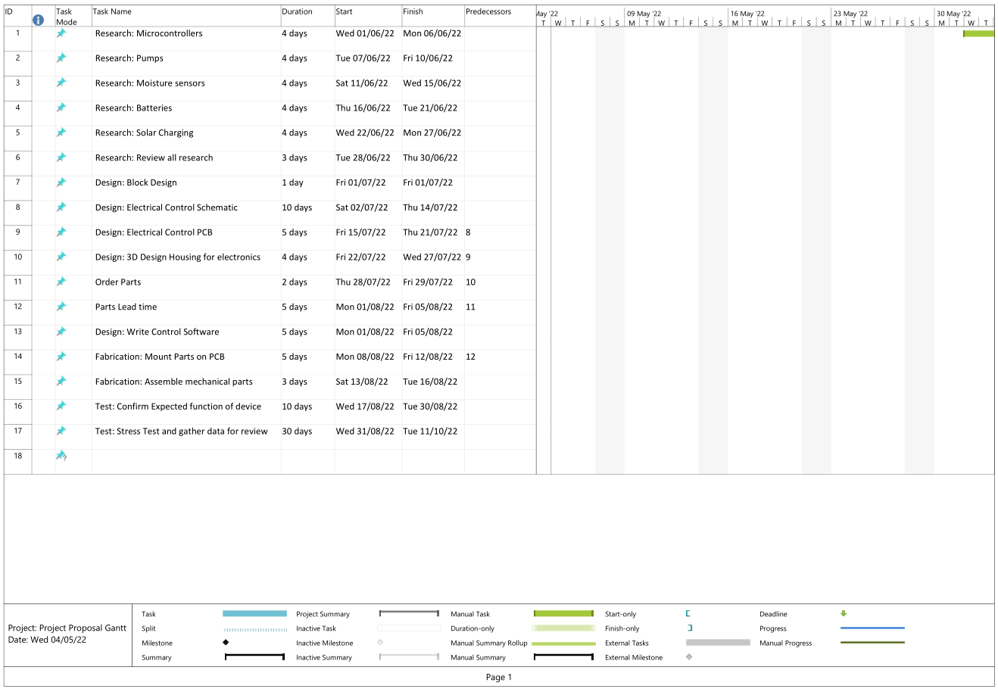
Figure 3 - Project Gantt Chart Page 1
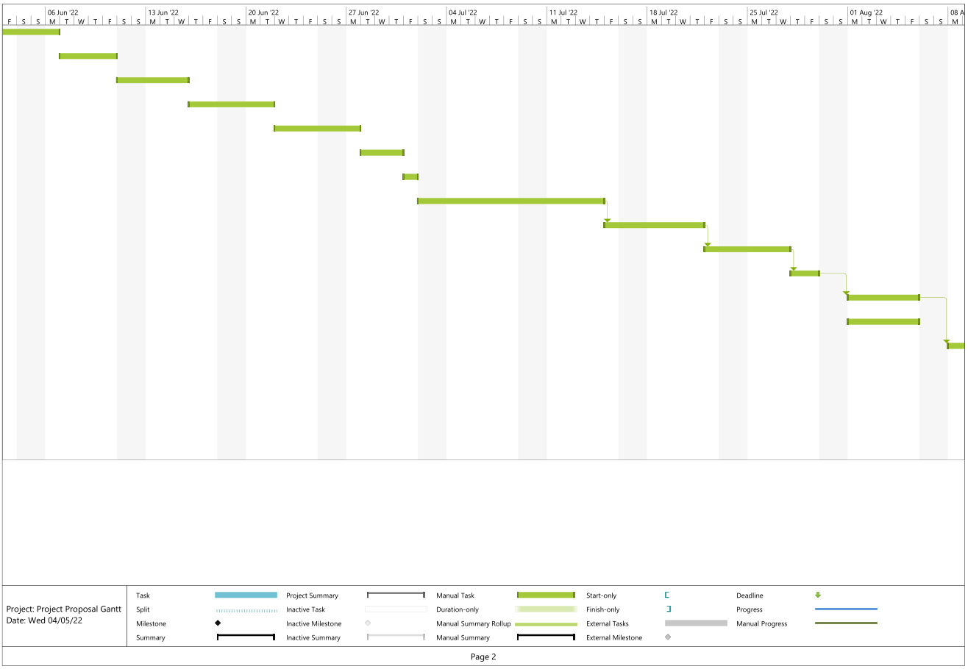
Figure 4 - Project Gantt Chart Page 2
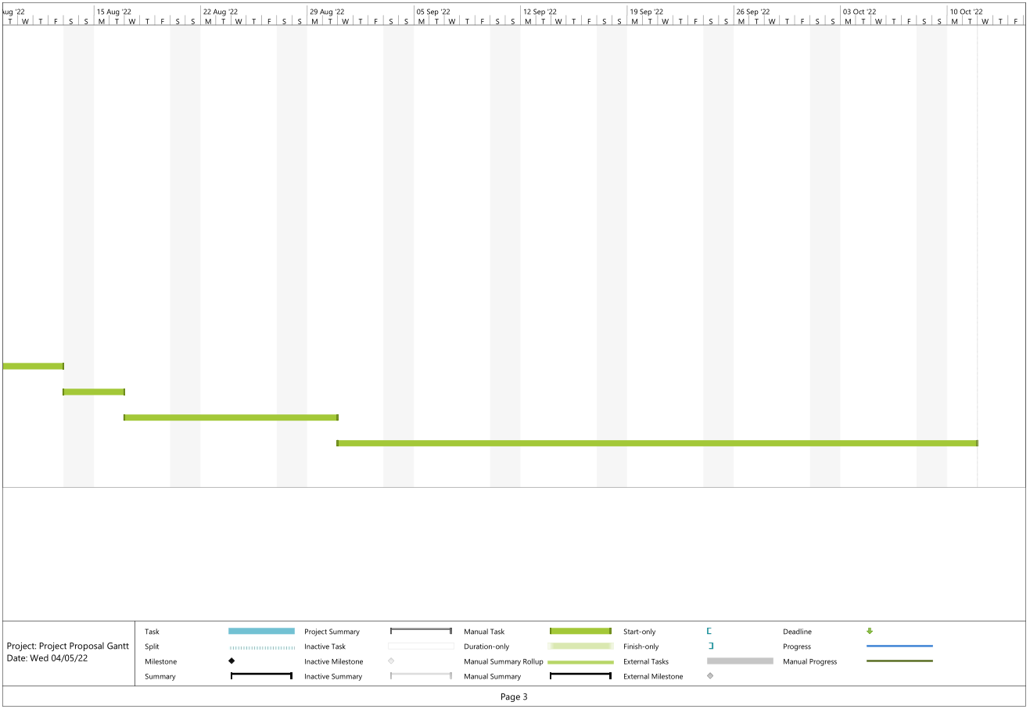
Figure 5 - Project Gantt Chart Page 3

REFERENCES

[1] | J. E. Bidlack and S. H. Jansky, "The Essence of Photosynthesis," in Stern’s Introductory Plany Biology, Fourteenth Edition, McGraw-Hill, 2017, p. 167.
[2] | A. J. McElrone, B. Choat, G. A. Gambetta and C. R. Brodersen, "Water Uptake and Transport in Vascular Plants," Nature Education Knowledge, 2013. [Online]. Available: https://www.nature.com/scitable/knowledge/library/water-uptake-and-transport-in-vascular-plants-103016037/. [Accessed 28 04 2022].
[3] | J. E. Bidlack and S. H. Jansky, "Water in the Soil," in Stern’s Introductory Plany Biology, Fourteenth Edition, McGraw-Hill, 2017, p. 82.
[4] | Edaphic Scientific, "What is time domain reflectometry?," Edaphic Scientific, [Online]. Available: https://edaphic.com.au/soil-water-compendium/time-domain-reflectometry-tdr/. [Accessed 01 05 2022].
[5] | S. R. Evett, "Soil Water Measurement by Time Domain Reflectometry," 2003. [Online]. Available: https://web.archive.org/web/20130418081955/http://www.cprl.ars.usda.gov/pdfs/DekkerEvettTDR.pdf. [Accessed 01 05 2022].
[6] | G. C. Topp, "State of the art of measuring soil water content," 15 6 2003. [Online]. Available: https://www.oieau.org/eaudoc/system/files/documents/38/191119/191119_doc.pdf. [Accessed 01 05 2022].
[7] | Edaphic Scientific, "What is time domain transmissometry (TDT)?," Edaphic Scientific, [Online]. Available: https://edaphic.com.au/soil-water-compendium/time-domain-transmissometry-tdt/. [Accessed 01 05 2022].
[8] | B. Will and I. Rolfes, "Comparative Study of Moisture Measurements by Time Domain Transmissometry," 2013. [Online]. Available: https://ieeexplore-ieee-org.ezproxy.uwtsd.ac.uk/stamp/stamp.jsp?tp=&arnumber=6688529. [Accessed 01 05 2022].
[9] | B. Benzinger and N. Jawerth, "Using Cosmic Rays to Measure Moisture Levels in Soil," International Atomic Energy Agency, 31 10 2018. [Online]. Available: https://www.iaea.org/newscenter/news/using-cosmic-rays-to-measure-moisture-levels-in-soil. [Accessed 01 05 2022].
[10] | International Atomic Energy Agency, "cosmic-ray-neutron-sensor-1140x640.png," [Online]. Available: https://www.iaea.org/sites/default/files/images/2018/10/cosmic-ray-neutron-sensor-1140x640.png. [Accessed 01 05 2022].
[11] | Skye Instruments Ltd, "minitensiometer-dts-v1b-DRAFT.cdr," [Online]. Available: https://www.skyeinstruments.info/index_htm_files/minitensiometer-dts-v1b.pdf. [Accessed 01 05 2022].
[12] | L. Bacci, P. Battista and B. Rapi, "An integrated method for irrigation scheduling of potted plants," Scientia Horticulturae, vol. 116, no. 1, pp. 89-97, 2008.
[13] | Ç. Ersin, R. Gürbüz and A. K. Yakut, "Application of an Automatic Plant Irrigation System Based Arduino," Solid State Phenomena, vol. 251, pp. 237-241, 2016.
[14] | Z. Ge, R. Zhang, Y. Yu and W. Wu, "An Automatic Plant Irrigation System Based on Fuzzy Control," Applied Mechanics and Materials, Vols. 303-306, pp. 1162-1166, 2013.
[15] | Adobe, "Waterfall Methodology - A Complete Guide | Adobe Workfront," Adobe, [Online]. Available: https://www.workfront.com/en-gb/project-management/methodologies/waterfall#:~:text=The%20Waterfall%20methodology%E2%80%94also%20known,before%20the%20next%20phase%20begins.. [Accessed 03 05 2022].
[16] | Adobe , "waterfall-method-process.png," [Online]. Available: https://www.workfront.com/sites/default/files/inline-images/waterfall-method-process.png. [Accessed 03 05 2022].
[17] | K. Petersen, C. Wohlin and D. Baca, The Waterfall Model in Large-Scale Development, 2009, pp. 386-400.

