An Ethical Assessment of Management Theories
—— Business Report on Amazon Management Practices and Employee Monitoring Complaints
JIAYING HE
2208747

Executive Summary
The report examined Amazon's employee monitoring practices in response to the growing complaints, and the potential impacts on organizational culture and human resource management. The company's monitoring systems, especially in warehouses, have raised concerns about over-monitoring, excessive stress and health problems, leading to complaints and legal fines.
Ethical issues are explored based on the 4V model of ethical leadership, which reveals that Amazon's monitoring practices conflict with the core values of employee well-being and organizational trust. In addition, the company's leadership lacks empathy and transparency, creating a toxic work environment and potentially causing long-term damage to employee engagement and retention.
A theoretical analysis of Amazon's practices from a mainstream and critical management perspective highlights significant ethical and management deficiencies. While mainstream theories such as Taylorism and the Fayol principle emphasize efficiency, they ignore the emotional and privacy needs of employees. Critical management theory, on the other hand, promotes employee empowerment and collaboration, which ought to be incorporated into managerial guidelines to support HR changes in the modern business environment.
Therefore, the report recommends Amazon implement some key changes, including reducing intrusive monitoring, shifting to an employee-centric management style, improving communication and transparency, and establishing feedback mechanisms. The goal of these modifications is to improve organizational performance and employee happiness by establishing a more sustainable and encouraging work environment. By reflectively viewing and reforming management styles with ethical considerations, Amazon can enhance its reputation, attract and retain talent, and achieve long-term success in the competitive business market.

Table of Contents
Executive Summary 1
1. Introduction 4
2. Main Findings 5
2.1 Key Complaints 5
2.2 Ethical Investigation 6
2.2.1 Value 7
2.2.2 Virtue 7
2.2.3 Voice 7
2.2.4 Vision 8
2.3 Evaluation of Management Theories 8
2.3.1 Mainstream Management 8
2.3.2 Critical Management Theories 10
2.3.3 A Hybrid Model 11
3. Conclusion 13
4. Recommendations 14
4.1 Reform Monitoring Practices 14
4.2 Adopt Employee-Centric Management Styles 14
Reference 16

- Introduction
With the gradual recovery of business in the post-epidemic era, companies are striving to seize market opportunities. As a global leader in e-commerce, Amazon is constantly evolving. From relentless innovation to a hard-won mission-driven culture, it has revolutionized the online shopping experience (Interbrand, 2024). However, during a recent Performance Review Meeting, the CEO was alerted to complaints about management practices, especially in the Human Resource Department. As the market environment is becoming increasingly volatile and competitive, these issues may adversely affect the company's management and performance, requiring swift and strategic reforms.
For preparing for the next Review Meeting, key complaints need to be identified and analyzed in details. As reported, Amazon was accused of “excessive” monitoring of employees at its warehouses in France and the UK. The scanner for counting goods monitors employee productivity on a second-by-second basis and records breaks to urge employees continuing to work (Warburton, 2024). This report will evaluate these practices within Amazon and their relationship with ethical considerations, highlighting their impact on organizational culture and performance. Among these, both Mainstream and Critical Theories of Management will be included to explore the potential influences on corporate management and development (Spicer and Alvesson, 2024). Based on this framework, feasible and standardized recommendations will be proposed, aiming to provide helpful takeaways for the future improvement.

- Main Findings
  - Key Complaints
According to the report, at our Amazon headquarters in France, there are recent complaints from employees and warnings from relevant authorities in terms of human resource management. Amazon France Logistique, who manages warehouses, has a managerial system of recording data captured by workers' handheld scanners (EDPB,2024). However, some employees said that Amazon tracks employee activity so precisely that everyone has to justify their every break during scanning the cargo. Thus, they feel that they are over-monitored, leading to overwork, extreme stress and anxiety, as well as health problems such as joint hurts (Dawood, 2023).
Moreover, this problem was also raised in the UK Amazon warehouses before. Brian Palmer, Amazon's head of European policy, told a parliamentary select committee in Nov. 2022 that if an employee had three productivity warnings on the system, they would be fired (Gruet, 2024). Amazon's surveillance practices were proved to leading to distrust and micromanagement against its workers according to the report published by the Business, Energy and Industrial Strategy Committee of UK Parliament (2023). Micromanagement, characterized by excessive control and a lack of trust in employees, will weaken workplace morale and productivity. This leadership style focuses excessively on details and limits employees' autonomy, which will reduce employee engagement and satisfaction, leaving workers feeling demotivated and creating a toxic work environment driven by fear and resentment (Majka, 2024).
Additionally, these monitoring practices are judged as intrusive due to insufficient communication about their purpose and scope. Thus, the French Supervisory Authority (CNIL) has imposed an administrative fine of €32 million on Amazon for failing to comply with its information and transparency obligations under Articles 12 and 13 of the GDPR, including not giving a privacy policy before the data collection and lacking adequate notice of surveillance (Laéna Bouafy, 2024).
All the above complaints and penalties have explained the problems existing in Amazon's human resource management, so further analysis and solutions are needed.
  - Ethical Investigation
Ethical considerations are essential when addressing management issues, as business ethics play a crucial role in modern organizational development (Jaganjac et al., 2024). Business ethics are summarized by Melé (2024) as basic principles applied in human economic relations to evaluate the morality of controversial business issues. Applying these principles, this section analyzes Amazon’s over-monitoring practices using the 4V Model of Ethical Leadership (Mulder, 2024).
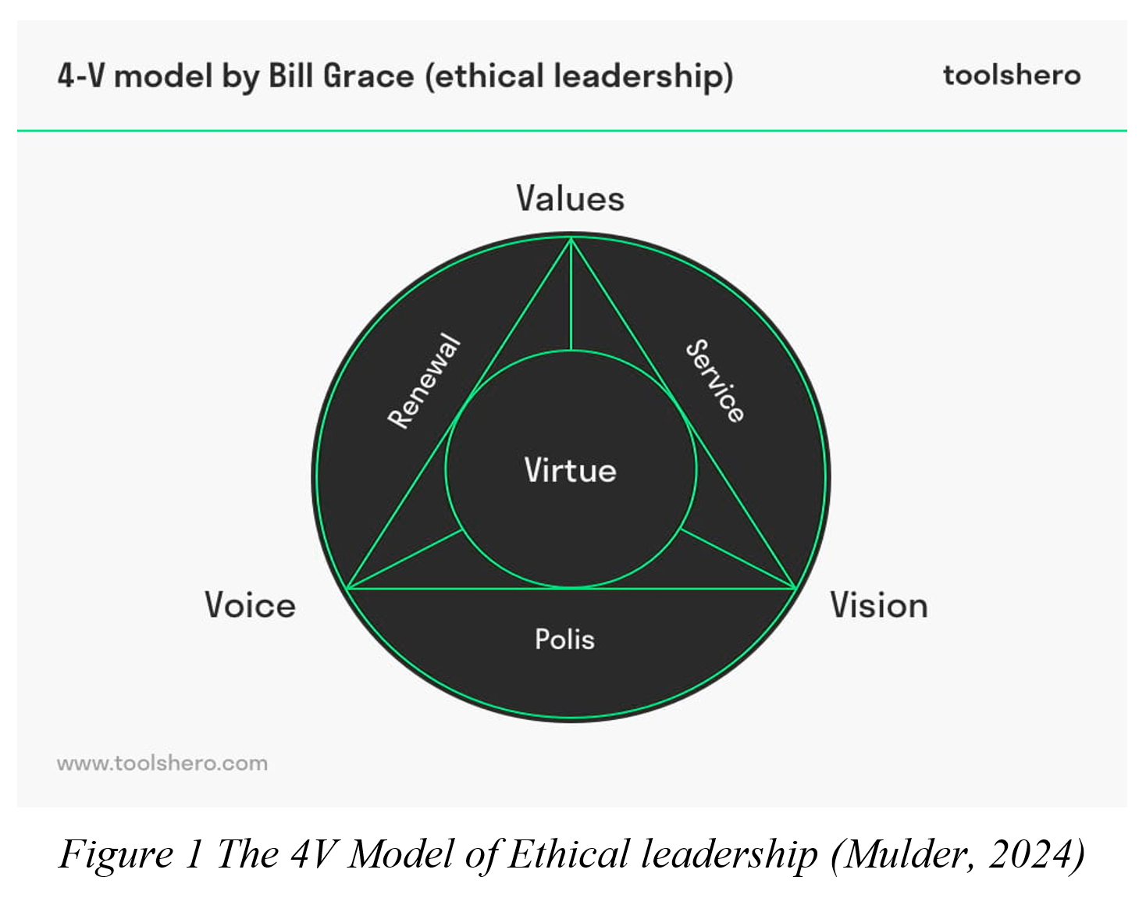
    - Value
Amazon has four guiding principles, which are customer first, passion for invention, operational excellence, and long-term thinking (Amazon, 2024). However, there is no emphasis on the value of employee welfare. Its excessive monitoring practices appear to prioritize operational metrics over employee well-being and trust, revealing potential conflicts with broader ethical responsibilities. Respect for privacy and integrity are workplace imperatives (Jha, 2024), but complaints from UK Amazon warehouses indicate employees fear taking breaks to meet strict productivity standards (Bao et al., 2022). By excessively tracking productivity and breaks, Amazon has compromised these values, which will undermine employee trust and morale.
    - Virtue
Leaders are expected to demonstrate moral integrity, fairness, and empathy (Futuresmart, 2024). In this case, the management’s conduct on intrusive surveillance suggests a lack of ethical leadership (Katanich, 2024), as they have prioritized micromanagement over fostering a supportive and empowering workplace culture. Amazon's failure in ethical use of labour resources highlights its inadequacies in virtue-based decision-making.
    - Voice
Ethical organizations value employee voice by involving them in decisions that affect their work environment. In our case, workers were not properly informed of the video surveillance systems, which means their voices are not included in the whole managerial process. Additionally, a warning will appear when a worker scans an item more than 1.25 seconds after the last one (Mohamed et al., 2024). It was found that such precise monitoring based on seconds exceeds the reasonable expectations of workers, which is seen as ignoring the voice of employees.
    - Vision
Amazon’s short-term focus on operational efficiency obviously violates its long-term vision of creating a sustainable enterprise. Excessive monitoring will damage the organization’s reputation, making it hard to attract and retain talented employees (Zemke, 2024). An ethical-based vision should include commitments to employee well-being (Mayne, 2024), which requires rethinking the surveillance practices to ensure they are consistent with the organization’s moral aspirations.
In short, the contradictory values, lack of virtue, ignored voice, and short-sighted vision are the most prominent problems in terms of this issue from an ethical perspective. While monitoring can aid workflow management and decision-making (Morgan and Nolan, 2023), its excessive and intrusive practices exceed reasonable boundaries, as confirmed by the French Data Protection Authority (CNIL, 2024).
  - Evaluation of Management Theories
    - Mainstream Management
The origins of mainstream management theory date back to the late 19th and early 20th centuries, when early managers developed principles to optimize efficiency and benefits in business environments (Lumen Learning, 2024). Scientific Management, or Taylorism, emphasizes maximizing economic efficiency (Indeed, 2024). Frederick Taylor advocated for ensuring the prosperity of both employers and employees by optimizing individual effectiveness through supervision, and retraining when better methods were identified (Peek, 2024). Moreover, Henri Fayol’s 14 Principles of Management emerged during the Industrial Revolution, providing a top-down approach to streamline operations and enhance employee performance. Relevance to Amazon’s case is Fayol’s principle of discipline, emphasizing effective supervision and fair judgment in enforcing organizational rules (Agrawal, 2024). Similarly, Weber’s Bureaucratic Management Theory underscores procedures and hierarchy (Guragain et al., 2024). Its emphasis on selection and promotion of employees based on merit and qualifications aligns with Amazon’s monitoring practices in UK warehouses.
These classical theories profoundly influenced modern management by increasing efficiency, standardizing workflows, and ensuring predictability and consistency. Amazon's monitoring system reflects these principles through its use of streamlined processes and performance metrics to maintain high levels of productivity, contributing to a fair and transparent work environment (Alateeg and Alhammadi, 2024).
However, this critique of classical management theories is particularly evident in Amazon's case for disregarding the emotional well-being of employees. The automated tracking systems were described as stressful and dehumanizing by employees, which mirrors the limitations of classical management as focusing on standardization and efficiency at the expense of individual needs (Pappas, 2024). Additionally, in dynamic environments like e-commerce, Amazon stifled employees' creativity to explore their own work styles by rigorously limiting their working patterns. Employees may feel undervalued and lack the motivation to innovate or respond to changing circumstances (DailyBot, 2024). Thus, Amazon's case highlights the importance of balancing efficiency with employee well-being and adaptability, challenging the modern organization's total reliance on classic principles (Ahmad, 2024).
    - Critical Management Theories
Upon Mainstream Theories, Critical Management Theories challenge traditional approaches, offering a range of alternatives focusing on the human and social aspects of organizations (Adler et al., 2007). They emphasize employee well-being, power dynamics, and trust as central to sustainable organizational performance and culture.
Human Relations Theory as the key one highlights the importance of employee satisfaction and trust as key drivers of productivity (Anas, 2024). In Douglas McGregor’s Theory X and Y, Theory X assumes employees are inherently lazy and require strict control, while Theory Y views employees as self-motivated and capable of innovation given support and trust (Yeung, 2024). Amazon’s current reliance on productivity monitoring is consistent with Theory X. However, transitioning to Theory Y by fostering trust and empowering employees could improve motivation and performance. Additionally, according to Maslow’s Hierarchy of Needs (Figure 2), Amazon has the responsibility to address employees’ basic needs of going to the toilets and moving to higher needs like belonging and esteem (McLeod, 2024), ensuring employees feel valued and motivated.
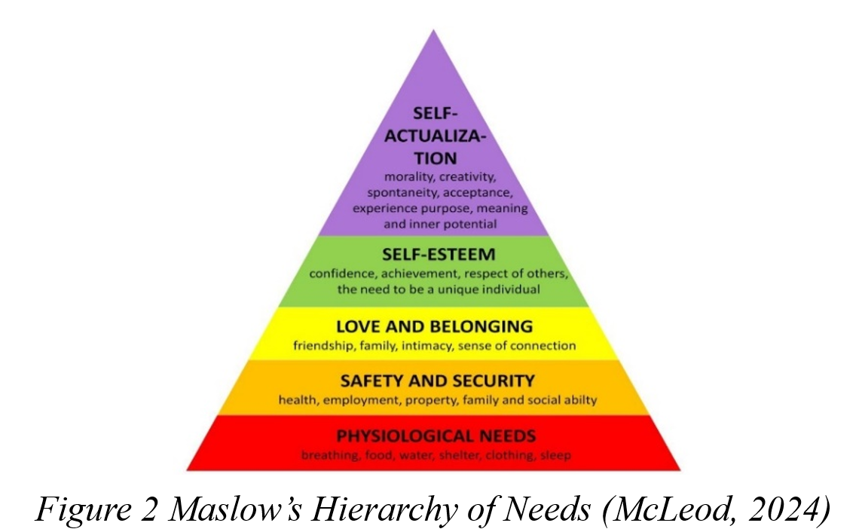
Furthermore, more critical management studies involving power and control are also emerging. For example, the research from Mastio and Dovey (2019) shows that conflicting power results in organizational dysfunction; Ibarra and Martinez (2024) explored power dynamics and revealed the negative impact of power imbalance in labour relations on workplace equality. In our case, the monitoring system reflecting Amazon’s top-down power dynamics centralizes power with management. This mode puts employees at the bottom of the corporate power structure and suppresses their voice. The imbalance will eventually lead to dissatisfaction and decreased efficiency.
    - A Hybrid Model
As the business environment becomes more competitive, management theory research continues to evolve. Emerging management models, such as flat structure management, reflect a shift toward power decentralization and collaboration (Schooley, 2024). This approach emphasizes fewer managers to empower employees and encourage flexible collaboration. However, in oversized organizations such as Amazon warehouses, fully flat management may face significant risks in integrating decisions, so too radical a change is undesirable. Thus, by incorporating elements of human relations theory and forming a Hybrid Model based on mainstream management, Amazon should strike a balance between efficiency and employee satisfaction.
For example, the implementation of Amoeba Management in warehouses is an effective Hybrid Model. It means dividing an organization into small units called “amoebas”, where Amazon can divide units based on the types of goods that workers are responsible for. This mode encourages each unit to control its own performance with management awareness to achieve “Management by All” (CHOWDHURY and KHONDAKER, 2024). By decentralizing the power, more employees are empowered and valued by organizations, promoting equality and solidarity.
In short, reconciling the efficiency-oriented values of traditional management with the employee-centred values of human relations theory provides a pathway to sustainable organizational success by creating a culture that values employees while achieving long-term performance goals (Khan, 2024).

- Conclusion
In conclusion, while Amazon's monitoring practices aim to enhance efficiency and operational performance, they expose significant ethical and managerial shortcomings. Complaints of excessive oversight and micromanagement highlight the urgent need for reform to prioritize employee well-being and trust.
Through the 4V model analysis, Amazon violated ethical principles, indicating that its current practices are harmful to the organizational culture and reputation. From a theoretical perspective, mainstream management principles such as Taylorism and Fayol’s 14 Principles provide a framework for efficiency but ignore employee’s emotional needs. In contrast, critical management theories, emphasizing collaboration and empowerment, offer a more sustainable approach. Models like Theory Y and Maslow's Hierarchy of Needs suggest that applying human-relation approach can significantly boost productivity and engagement.
Looking forward, Amazon should embrace a balanced approach that integrates the structured efficiency of mainstream theories with the human-centric insights of critical management (Schiuma et al., 2024). Thus, relevant recommendations are proposed in the following section to help create a healthy and sustainable organizational culture in an increasingly competitive and dynamic business landscape.

- Recommendations
In order to improve the quality and satisfaction of the human resource management function at Amazon, the following recommendations can be considered:
  - Reform Monitoring Practices
- Avoid excessive monitoring: Instead of monitoring every action of employees, Amazon should focus on measuring their results and contributions to organizational goals. Metrics such as completed projects or team objectives can ensure accountability while reducing stress and anxiety (Schmellenkamp, 2024).
- Introduce less invasive tools: Overall progress reports can be introduced to replace real-time surveillance to emphasize task accomplishment. Such methods will protect employee privacy and ensure compliance with global privacy laws, such as the GDPR (Wallbank and Malak, 2024).
- Enhance communication and transparency: Clearly outline the purpose and scope of monitoring systems in employee handbooks and policy documents (Campbell, 2024), because transparency can mitigate feelings of distrust and demonstrate the efficiency requirement rather than control.
  - Adopt Employee-Centric Management Styles
- Involve employees in decision-making: Employees should be involved in decisions to promote empowerment and autonomy, such as forums to voice opinions in labour management (Ganesh, 2024), making employees feel valued while allowing the common decision to address concerns proactively.
- Implement flexible performance metrics: By applying a Hybrid Model incorporating Human Relations principles (Mulumba, 2020), Amazon can apply an Amoeba model selectively that assigns each unit a clearer division of labour and promotes overall collaboration to achieve final results.
As the company continues to innovate and grow, embracing these human-centric recommendations will ensure long-term success, driving both business excellence and positive employee experiences.

Reference
Adler, P. S., Forbes, L. C., and Willmott, H. (2007). 3 Critical management studies. Academy of management annals, 1(1), pp. 119-179.
Agrawal, V. (2024) Henri Fayol’s 14 Principles of Management explained, Simplilearn.com. Available at: https://www.simplilearn.com/principles-of-management-by-henri-fayol-article (Accessed: 22 November 2024).
Ahmad, J. (2024). Strategic Planning: Navigating Uncertainty in Business Management. Journal of Management and Social Science, 1(02), pp. 33-46.
Alateeg, S. and Alhammadi, A. (2024). The impact of organizational culture on organizational innovation with the mediation role of strategic leadership in Saudi Arabia. Journal of Statistics Applications and Probability, 13(2), pp. 843-858.
Amazon (2024) Who we are: About Amazon, Who we are | About Amazon. Available at: https://www.aboutamazon.com/about-us (Accessed: 21 November 2024).
Anas, M. (2024) Human relations theory: Enhancing organizational performance, Next Gates. Available at: https://nextgates.com/human-relations-theory-enhancing-organizational-performance/ (Accessed: 22 November 2024).
Bao, Y., Li, W., Ye, Y., and Zhang, Q. (2022). Ethical Disputes of AI Surveillance: Case Study of Amazon. In 2022 7th International Conference on Financial Innovation and Economic Development (ICFIED 2022) (pp. 1339-1343). Atlantis Press.
Campbell, M. (2024) What lessons can hr learn from Amazon’s €32 million employee monitoring fine?, HR Magazine. Available at: https://www.hrmagazine.co.uk/content/comment/what-lessons-can-hr-learn-from-amazons-32-million-employee-monitoring-fine/ (Accessed: 23 November 2024).
CHOWDHURY, M. A., and KHONDAKER, R. M. (2024). Amoeba Management System in Japanese Companies: With Special Focus on Inamori Model at Kyocera Corporation. Nanshan Management Research Institute, 39(1-2), pp. 1-26.
CNIL (2024) Employee monitoring: CNIL fined Amazon France Logistique €32 million, CNIL. Available at: https://www.cnil.fr/en/employee-monitoring-cnil-fined-amazon-france-logistique-eu32-million (Accessed: 26 November 2024).
DailyBot (2024) How micromanagement stifles creativity and growth, How Micromanagement Stifles Creativity and Growth | DailyBot Insights. Available at: https://www.dailybot.com/insights/micromanagement-stifles-creativity-growth (Accessed: 26 November 2024).
Dawood, S. (2023) Amazon’s worker surveillance ‘leads to extreme stress and anxiety’, New Statesman. Available at: https://www.newstatesman.com/spotlight/tech-regulation/cybersecurity/2023/02/amazon-workers-staff-surveillance-extreme-stress-anxiety (Accessed: 21 November 2024).
EDPB (2024) Employee monitoring: French SA fined Amazon France Logistique €32 million, European Data Protection Board. Available at: https://www.edpb.europa.eu/news/national-news/2024/employee-monitoring-french-sa-fined-amazon-france-logistique-eu32-million_en (Accessed: 21 November 2024).
Futuresmart (2024) The importance of ethical leadership in the workplace: Insights from Kate McKenzie, Futuresmart. Available at: https://futuresmart.uk/the-importance-of-ethical-leadership-in-the-workplace-insights-from-kate-mckenzie/ (Accessed: 21 November 2024).
Ganesh, K. (2024) What is employee empowerment: How it transforms your workforce for the better?, CultureMonkey. Available at: https://www.culturemonkey.io/employee-engagement/what-is-employee-empowerment/ (Accessed: 23 November 2024).
Gruet, S. (2024) Amazon fined for ‘excessive’ surveillance of workers, BBC News. Available at: https://www.bbc.co.uk/news/business-68067022 (Accessed: 21 November 2024).
Guragain, G. P. et al. (2024). Navigating Bureaucracy: Principles, Practices and Strategies for Effective Engagement. Social Science and Humanities Journal (SSHJ), 8(09), pp. 4806-4818.
Ibarra, P. I. R., and Martínez, A. M. (2024). Unveiling Power Dynamics: Diversity Interpretations, Management Practices, and Inclusion Perceptions in the Workplace. Nova scientia, 16(32), pp. 1-18.
Indeed (2024) What are Taylor’s principles of Scientific Management? | indeed.com UK, Indeed. Available at: https://uk.indeed.com/career-advice/career-development/principles-of-scientific-management (Accessed: 21 November 2024).
Interbrand (2024) Amazon: Leading global E-commerce with relentless innovation, commitment to culture , Interbrand. Available at: https://interbrand.com/thinking/amazon-leading-global-ecommerce-relentless-innovation-commitment-culture/ (Accessed: 21 November 2024).
Jaganjac, B. et al. (2024). Is it time to reclaim the ‘ethics’ in business ethics education?. Journal of Business Ethics, 190(1), pp. 1-22.
Jha, N. (2024) Legal and ethical considerations in HR practices, Avado. Available at: https://www.avadolearning.com/blog/legal-ethical-considerations-hr/ (Accessed: 21 November 2024).
Katanich, D. (2024) Amazon fined for ‘excessively intrusive’ surveillance of its workers in France | euronews, Euro News. Available at: https://www.euronews.com/business/2024/01/23/amazon-fined-for-excessively-intrusive-surveillance-of-its-workers-in-france (Accessed: 21 November 2024).
Khan, D. S. (2024). Organizational Behaviour insights: Examining dynamics of Workplace Culture and Employee Interaction in Modern Organizations. International Journal for Multidimensional Research Perspectives, 2(5), pp. 37-53.
Laéna Bouafy, J.P. (2024) What Amazon’s fine for ‘excessively intrusive’ employee monitoring tells us about workforce GDPR rights, Passle. Available at: https://technologyquotient.freshfields.com/post/102izs0/what-amazons-fine-for-excessively-intrusive-employee-monitoring-tells-us-about (Accessed: 21 November 2024).
Lumen Learning (2024) Principles of Management, Scientific Management | Principles of Management. Available at: https://courses.lumenlearning.com/suny-principlesmanagement/chapter/scientific-management/ (Accessed: 22 November 2024).
Majka, M. (2024) How leadership missteps create toxic work environments, LinkedIn. Available at: https://www.linkedin.com/pulse/how-leadership-missteps-create-toxic-work-marcin-majka-lzagf/ (Accessed: 21 November 2024).
Mastio, E., and Dovey, K. (2019). Power dynamics in organizational change: an Australian case. International Journal of Sociology and Social Policy, 39(9/10), pp. 796-811.
Mayne, M. (2024) Amazon fined €32m for ‘excessive’ employee monitoring: What are the rights and wrongs of checking up on staff?, Home. Available at: https://www.peoplemanagement.co.uk/article/1859274/amazon-fined-%E2%82%AC32m-excessive-employee-monitoring-rights-wrongs-checking-staff (Accessed: 21 November 2024).
McLeod, S. (2024) Maslow’s hierarchy of needs, Simply Psychology. Available at: https://www.simplypsychology.org/maslow.html (Accessed: 22 November 2024).
Melé, D. (2024). Ethical theories in business ethics: A critical review. Journal of Human Values, 30(1), pp. 15-25.
Mohamed, J.et al.(2024) Lessons for global employers: Amazon France Logistique fined €32 million for ‘excessively intrusive’ employee monitoring | Fieldfisher, Fieldfisher. Available at: https://www.fieldfisher.com/en/insights/lessons-for-global-employers-amazon-france-logistique-fined-%E2%82%AC32-million-for-excessively-intrusive-employee-monitoring (Accessed: 21 November 2024).
Morgan, K. and Nolan, D. (2023) How worker surveillance is backfiring, BBC News. Available at: https://www.bbc.com/worklife/article/20230127-how-worker-surveillance-is-backfiring-on-employers (Accessed: 21 November 2024).
Mulder, P. (2024) Ethical leadership theory plus 4V model, Toolshero. Available at: https://www.toolshero.com/leadership/ethical-leadership/ (Accessed: 21 November 2024).
Mulumba, B. K. (2020). The Influence of Classical and Human Relations Approaches in Today’s Management: Evaluation through Real-Life Examples. The International Journal of Business & Management, 8(8). https://doi.org/10.24940/theijbm/2020/v8/i8/BM2005-062
Pappas, C. (2024) Classical management theory: How does it work?, eLearning Industry. Available at: https://elearningindustry.com/classical-management-theory-how-does-it-work (Accessed: 26 November 2024).
Peek, S. (2024) How to apply Frederick Taylor’s management theory, business.com. Available at: https://www.business.com/articles/management-theory-of-frederick-taylor/ (Accessed: 22 November 2024).
Schiuma, G. et al. (2024) ‘Transformative leadership competencies for Organizational Digital Transformation’, Business Horizons, 67(4), pp. 425–437. doi:10.1016/j.bushor.2024.04.004.
Schmellenkamp, D. (2024) Creating a culture of accountability and excellence, OKRI. Available at: https://okrinstitute.org/creating-a-culture-of-accountability-and-excellence/ (Accessed: 23 November 2024).
Schooley, S. (2024) Flat organizations: Advantages of eliminating managers, business.com. Available at: https://www.business.com/articles/flat-organization/ (Accessed: 22 November 2024).
Spicer, A., and Alvesson, M. (2024). Critical Management Studies: A Critical Review. Journal of Management Studies. https://doi.org/10.1111/joms.13047.
UK Parliament, House of Commons. (2023) Post-pandemic economic growth: UK labour markets, UK Parliament. Available at: https://committees.parliament.uk/work/6729/postpandemic-economic-growth-uk-labour-markets/publications (Accessed: 21 November 2024).
Wallbank, A. and Malak, S. (2024) Employee monitoring costs Amazon €32M, Shoosmiths. Available at: https://www.shoosmiths.com/insights/articles/employee-monitoring-costs-amazon-32m (Accessed: 23 November 2024).
Warburton, N. (2024) Amazon France Logistique fined €32m over ‘excessively intrusive’ system for monitoring employees, IOSH magazine. Available at: https://www.ioshmagazine.com/2024/02/13/amazon-france-logistique-fined-eu32m-over-excessively-intrusive-system-monitoring (Accessed: 21 November 2024).
Yeung, S. Y. (2024). Towards A Holistic Management Framework For Social Enterprises In Hong Kong (Doctoral dissertation, University of Wales Trinity Saint David).
Zemke, A. (2024) Strong organizational cultures attract and retain top talent, Beehive. Available at: https://beehivepr.biz/strong-organizational-cultures/ (Accessed: 21 November 2024).

