

University of Wales Trinity Saint David
Digital Signal Processing and Communications
Simulation of Digital Modulation Techniques

Author: Oliver Kucyj
Student number: 1910808
Course: B.Eng Electrical and Electronic Engineering
Module Code: ACDA5008
Lecturer: Dr Steve Mosey
Date: 31st March 2022

Table of Contents
Abstract 3
Introduction 4
Background information 5
Analysing transmitted signals using constellation diagrams 5
Key Variables 6
The Circuit Design 7
What Determines System failure? 7
Simulation Models 8
ASK circuit 8
PSK Circuit 9
QPSK circuit 10
QAM circuit 11
Results 13
Discussion 14
Conclusion 15
References 16

Abstract
During this assignment four different digital modulation/demodulation systems were built and simulated under a range of different Signal-to-Noise-Ratio conditions. The results were then compared and analysed to highlight the advantages/disadvantages of each method and to develop a better understanding of how they work.

The results show that the QPSK and 16-QAM circuits are the most viable options for a DSP system, and that the specific application would need to be considered to choose between the two of them.

Introduction
The objective of this assignment is to design four different modulation/demodulation techniques using Simulink. These are ASK (Amplitude Shift Keying), PSK (Phase Shift Keying), QPSK (Quadrature Phase Shift Keying) and 16-QAM (Quadrature Amplitude Modulation). The circuits will need to be simulated under a range of different SNR (Signal to Noise Ratio) levels. The BER (Bit Error Rate) from each simulation will be recorded. Once all simulations are complete, the results will be used to create a graph comparing the relationship between SNR and BER on all four models. The circuits will have two random elements applied due to the binary input and random noise generator. Due to these uncontrollable factors, the test must be made fair. Each circuit will be simulated 10 times under each selected SNR level and will run for 30 seconds to minimise the risk of an inaccurate BER caused by the random elements in the circuit.

Each of these DSP methods transmits the signals slightly differently. ASK involves shifting the amplitude of the carrier signal. It is cheap to implement when compared to other systems but it is susceptible to noise and is not very power efficient. It is well suited to fibre optics as it can simply switch the LEDs on/off to transmit the data.

PSK involves shifting the phase of the carrier signal. It is less susceptible to noise than ASK making it preferable for wireless transmission, however it is a more complex design which requires higher system costs.

QPSK uses the same theory as PSK, however it uses four different phases to represent four symbols, rather than the two used in PSK. This allows two bits of data to be sent with each symbol. Its applications are like PSK however it is more commonly used since it is more resilient to noise and has a lower bandwidth. The downside is the increased complexity of the system.

QAM is a combination of ASK and PSK. It involves shifting both the phase and the amplitude to allow multiple symbols to be transmitted at once. Types of QAM which are used in modern DSP systems range from 8-QAM, all the way up to 4096-QAM. The number represents the number of symbols which can be sent per signal. QAM is used where large amounts of data must be sent with as small a bandwidth as possible. It is commonly used in wireless applications like LTE (a type of 4G technology). There are downsides to high level QAM modulation systems. They are extremely complex and costly [2]. They also require a higher SNR as more symbols are added. To combat this, many modern systems can switch between different levels of QAM to maintain a set BER. This is known as adaptive modulation [3].

Background information

Analysing transmitted signals using constellation diagrams

The transmitted signal of each modulation method is different and can be analysed using constellation diagrams. In constellation diagrams, the horizontal axis is referred to as I (the In-phase plane) and the vertical axis is referred to as Q (the Quadrature Plane). The dots (constellation points) highlight where the symbol is represented in the signal. The phase angle is plotted anti-clockwise. The amplitude is plotted as the distance of the constellation point from the centre of the graph. Figures 1-3 show the constellation diagrams for ASK, PSK, QPSK, 16PSK and 16QAM.

The closer the constellation points are to each other, the more susceptible they are to noise since there are more nearby symbols they could be confused with. Figure 3 demonstrates why QAM is preferred to PSK when using more symbols. The dots are more equally spread out, providing more room for error created by noise. This also shows that as more symbols are added, the distance between symbols are reduced, so whilst the systems will be more efficient in terms of bandwidth, they may be more prone to noise which could potentially bring the BER too high.

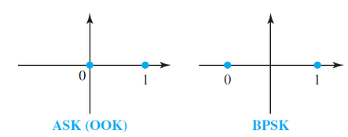
Figure 1 – ASK and BPSK constellation diagrams [3]

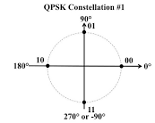
Figure 2 – QPSK constellation diagram [4]

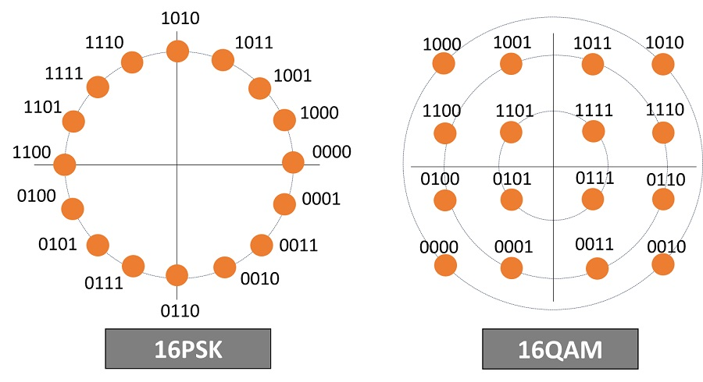
Figure 3 – 16PSK and 16QAM constellation diagrams [5]

Key Variables

Signal to noise ratio - SNR is the ratio between the strength of the signal and the strength of the external noise. The relationship between this and the BER will be analysed in this experiment.

Data rate - The data rate is the rate at which data is sent, measured in bps (Bits Per Second).

Bandwidth - The bandwidth is the frequency range which is required to transmit the data. A smaller frequency range means there is less risk of interference with noise and other signals [6]. Since the bandwidth is twice the Baud rate (Symbols per Second), increasing the number of bits per symbol allows more data to be sent on the same bandwidth.

Carrier Frequency - A higher carrier frequency to symbol rate ratio will help keep the BER lower. The disadvantage to a higher carrier frequency is that a higher order filter will be required, increasing the circuit complexity.

The Circuit Design

Each circuit will use the same parameters to ensure the results are fair. These parameters are listed below:

Bit rate: 10Hz
Carrier frequency: 500Hz
Sample time: 10KHz

The bit rate and carrier frequency were decided upon as a compromise due to the performance of the computer being used. As the bit rate and carrier frequency were increased, the time to complete simulations increased drastically. Considering the number of simulations required, these values for the bit rate and carrier frequency were chosen. Increasing these values would provide a more realistic circuit, however these values are going to be consistent throughout testing so it will still be a fair reflection of the different modulation methods performance. There are also many regulations which must be complied with in wireless communication systems which will not be considered in this experiment.

The Nyquist sample time must only be at least twice the Nyquist frequency (highest frequency component) however sampling too slowly can lead to aliasing, causing inaccurate readings. To maximise the circuits efficiency, the sampling rate should be at least 10 times the highest frequency component in the circuit [7]. This is known as oversampling.

The digital LPF will vary slightly with the more advanced modulations due to variances in the symbol rate, however it will be an FIR (Finite impulse response) filter using the equiripple method throughout all four models. The FIR filters are simpler then IIR (Infinite Impulse Response) and offer a linier phase response. This means the delay is the same across all frequencies, making the rest of the system simpler. The advantage of IIR filters is that they generally require smaller order filters [8]

What Determines System failure?

System failure is determined by the BER. A general industry standard for minimum BER is 10e-9, as stated on Viavi Solutions website [9]. It is unlikely values this low will be seen in these simulations due to the parameters being used. An article posted on cloud RF [10] states that a BER of 0.1 is considered a bad connection. This is a more realistic value for this experiment and will provide a reference point by which to judge the results.

Simulation Models

ASK circuit

Figure 4 shows the ASK circuit. The binary input is multiplied by the carrier wave. This results in binary ‘1’ transmitting the carrier wave, and binary ‘0’ transmitting nothing. To demodulate the signal, it is multiplied by the original carrier wave to remove the negative half of the wave. A switch is then used to convert the filtered signal back into binary.

The LPF parameters are shown in figure 5. The value for Fpass is half of the bit rate, 5Hz. This is the time it would take for one full cycle. All signals 5Hz and under will pass through the filter. The Fstop value is the absolute maximum frequency which will pass through the filter. A low Fstop value requires a high order filter causing a long delay, however more unwanted noise will be blocked out. Trial and error found an Fstop value of 20Hz to be a suitable compromise.
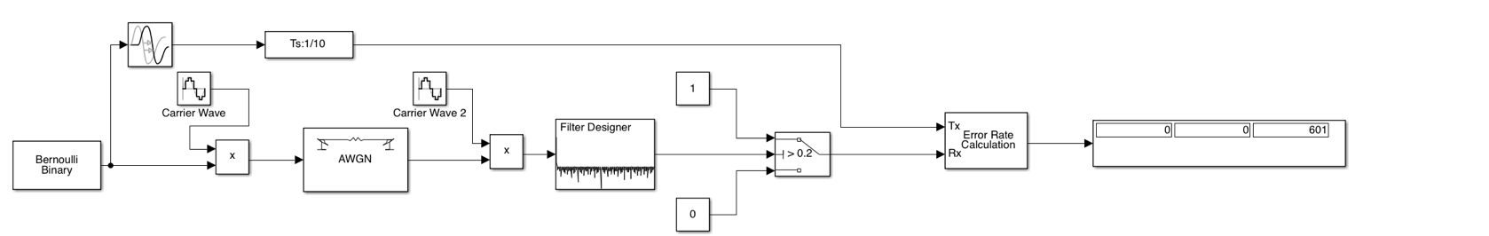Figure 4 – ASK circuit design

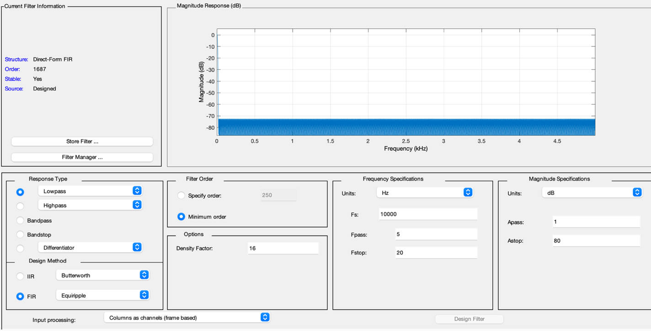
Figure 5 – LPF parameters

PSK Circuit

The PSK circuit is shown in figure 6. The switch determines whether the in-phase wave is transmitted or the 180° out of phase quadrature wave is transmitted. The Quadrature wave represents binary ‘0’ and the in-phase wave represents binary ‘1’. To demodulate, the transmitted signal is multiplied by the original in-phase carrier wave. As a result, the in-phase signals become positive, and the quadrature signals becomes negative as demonstrated in figure 7. A LPF and a switch are then used to convert the signal to binary. The LPF for this demodulator is identical to ASK.
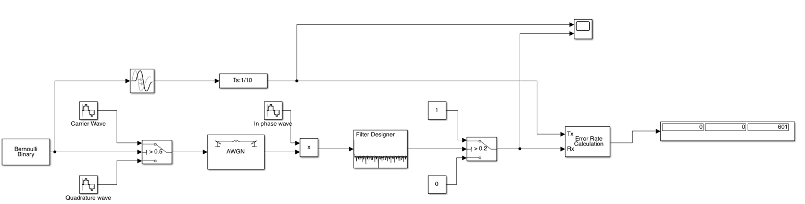
Figure 6 – PSK circuit

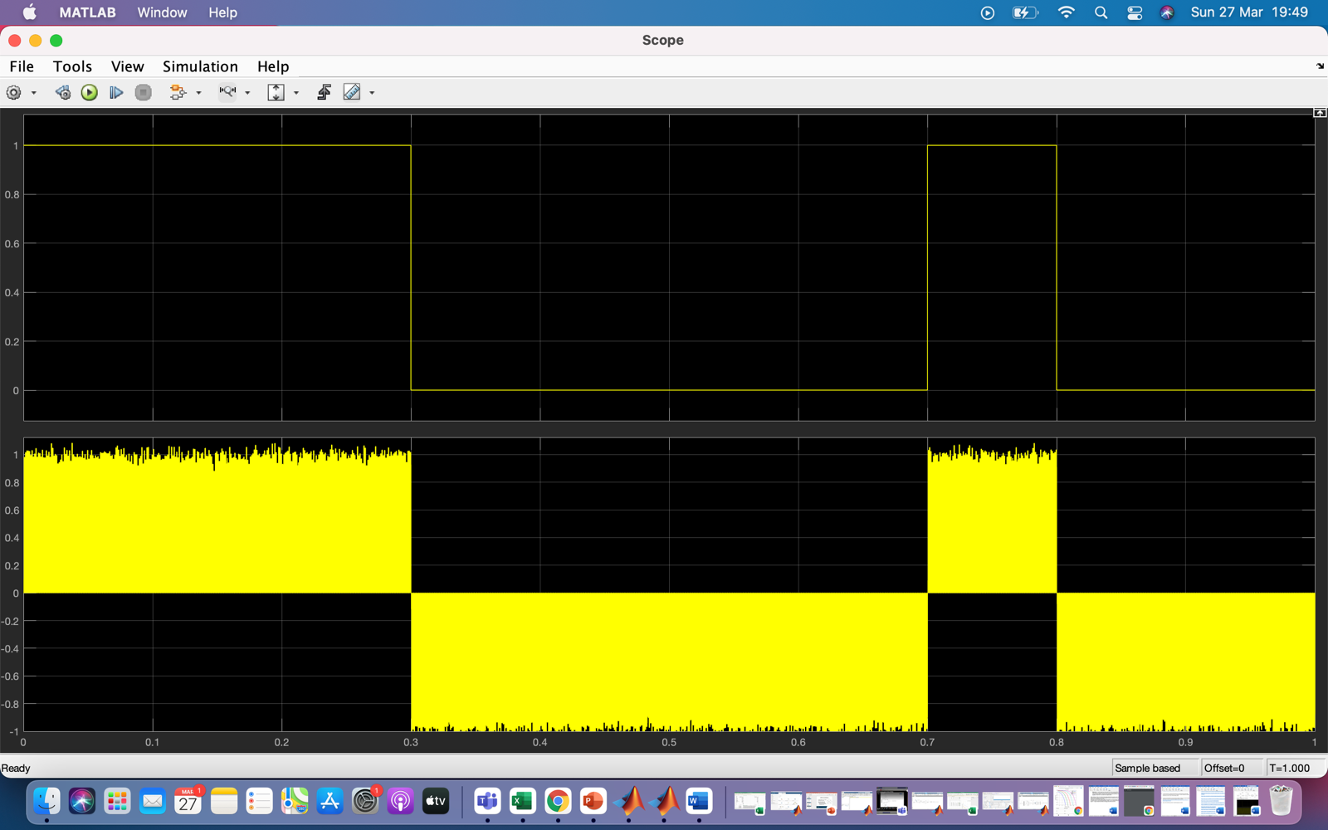
Figure 7 – PSK binary input compared to unfiltered demodulated signal

QPSK circuit

The QPSK circuit, shown in figure 8, works with 2-bit binary packets. A serial to parallel converter splits the 2-bit binary packet into two parallel bits which are sent to separate channels. Both channels enter an NRZ filter (Non-Return-to-Zero). This converts binary ‘0’ to -1, and binary ‘1’ to +1. One channel is then multiplied by an in-phase carrier wave (I-plane) and one by 90° out of phase carrier wave (Q-plane). If the input number was a 1, the output signal is the carrier wave. if the input number was a -1, the output signal is shifted 180°. This provides the outputs 0° and 180° from the I-plane and 90° and 270° from the Q-plane. These two signals are then summed and transmitted. The demodulation is the same as PSK however there are two channels instead of one. The LPF parameters are shown in figure 9.
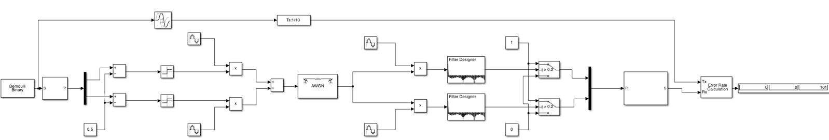
Figure 8 – QPSK circuit

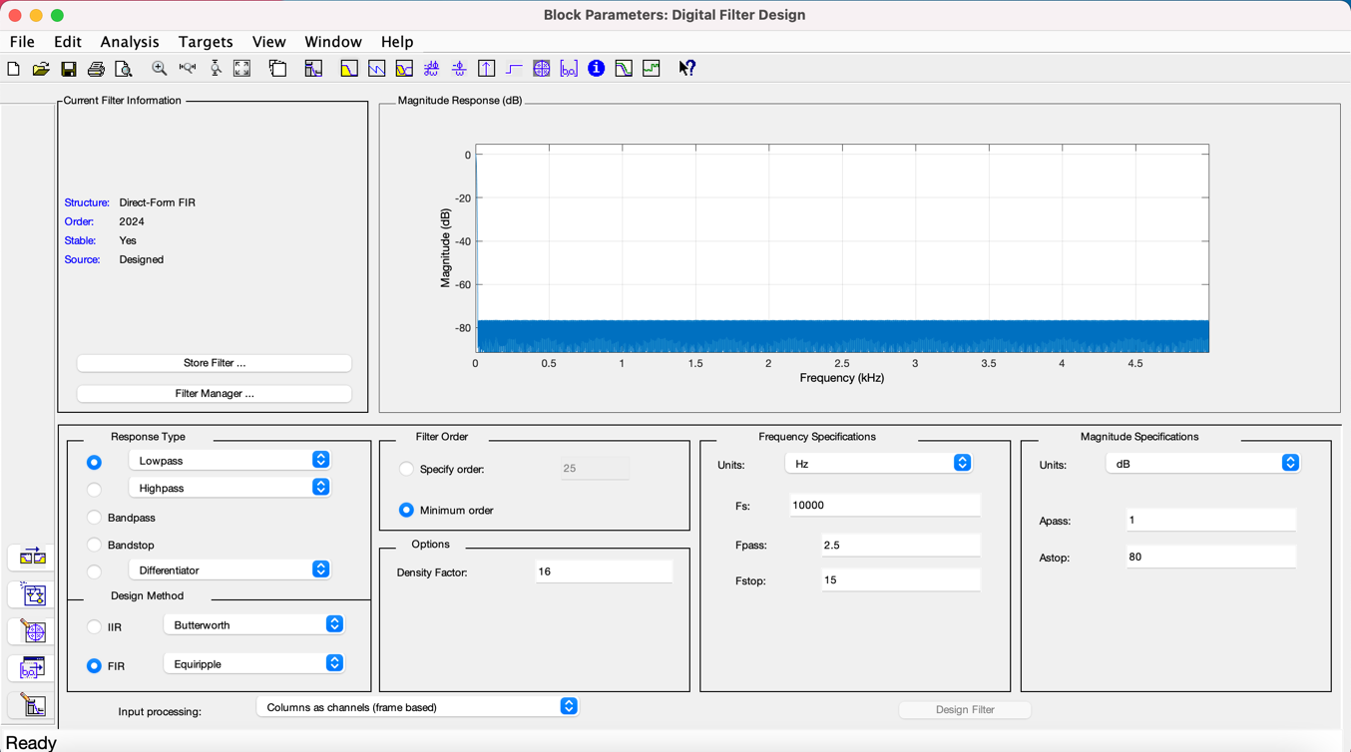
Figure 9 – LPF parameters for QPSK circuit

QAM circuit

16 QAM works by transmitting 4-bit binary packets and has 16 possible symbols which can be transmitted. These 16 symbols are represented by an arrangement of 12 different phases and 3 different amplitude levels. The amplitude shifting enables more phases to be used. When the amplitude level of one carrier signal is amplified and the other is not amplified, the phase shift is pulled further towards the amplified signal. For example, if the I-plane phase is 0° and amplified by 3 and the Q-plane phase is 90° and not amplified, then the transmitted phase angle is going to be roughly 15°. Figure 10 shows a list of the phase/voltage level for each binary input combination.

The circuit is shown in figure 11. The binary input is split into 4 parallel bits. These bits can be represented as I, I’, Q and Q’. The I and Q bits function the same as the two bits in the QPSK circuit shown previously. The I’ and Q’ bits change the amplitude of the wave. When these bits are 0, the wave amplitude remains the same. When one or more of these bits is 1, the amplitude is changed.

On the demodulation side, the signal is split back into two planes and is multiplied by the original carrier waves. This splits the signal into one channel which carries the I and I’ signals and one which carries the Q and Q’ signals. Once filtered, the Q and I bits can be identified using the same method as QPSK demodulator. The amplitude shifting bits, I’ and Q’ require an extra step. Multiplying this signal by itself will convert the negative values to positive, meaning a switch can be used to set the low amplitude signals to 0 and the high amplitude signals to 1. The low pass filter parameters are shown on figure 12.

The bits on this circuit must be mapped so that on the constellation diagram, there is only 1 bit in between nearby symbols. This means that if there is an error, only 1 bit is incorrect. This is known as Gray coding. The bit mapping used on this circuit will result in the constellation diagram shown in figure 13.

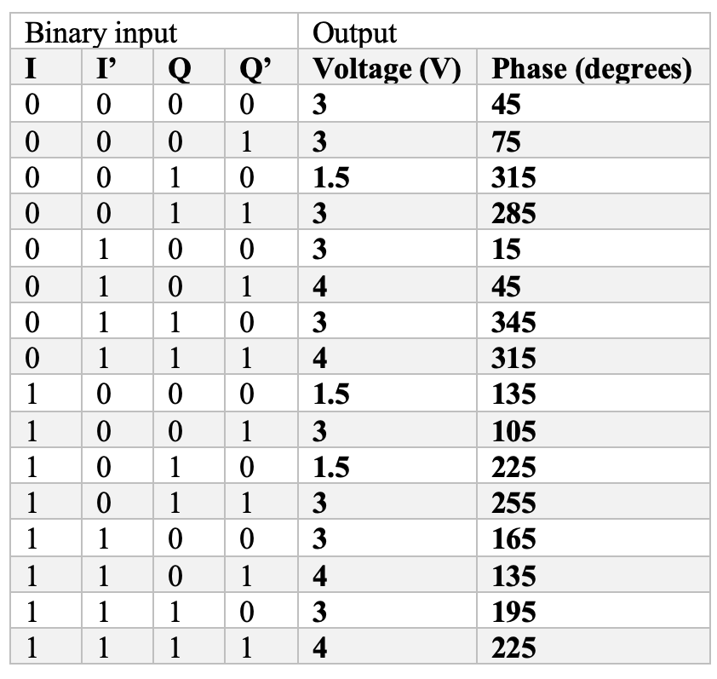
Figure 10 – 16-QAM phase and voltage output

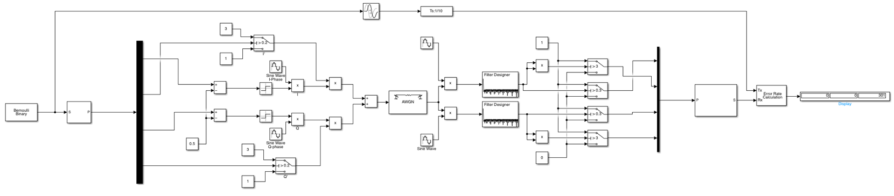
Figure 11 – 16-QAM circuit

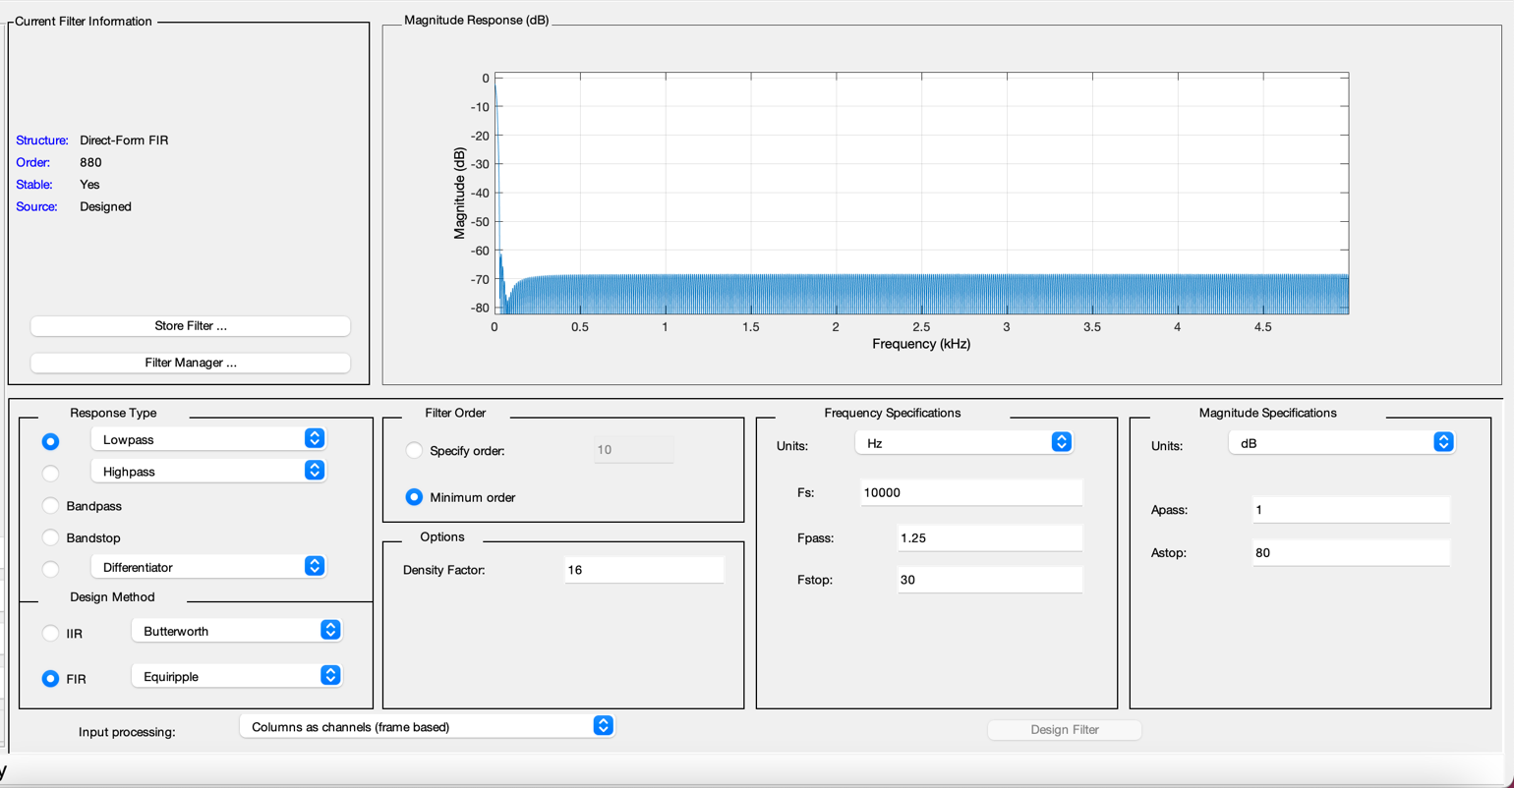
Figure 12 – LPF parameters

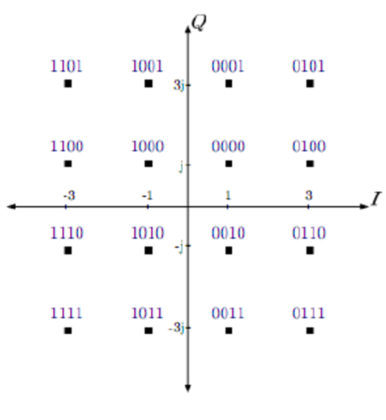
Figure 13 – 16-QAM constellation diagram [11]

Results
The graph shown in figure 16 shows the results from the simulations carried out. Overall, the expected trend is clear, as the SNR is increased, the BER also increases. The graph shows QPSK to be the most resilient to noise and ASK to be the least resilient.
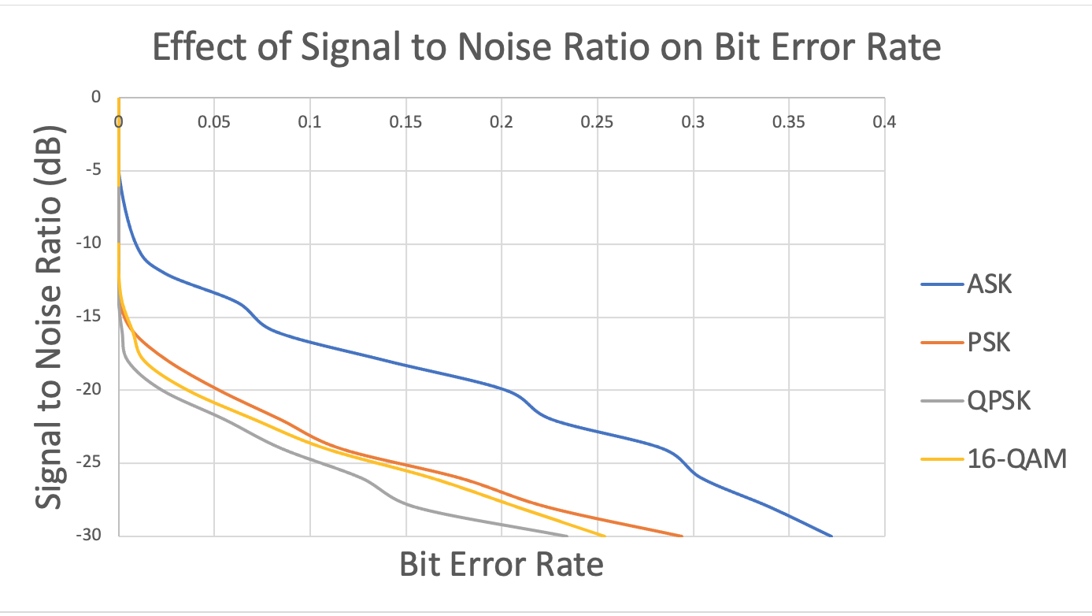
Figure 16 – Graph showing the simulation results from all four circuits

Discussion
As mentioned in the results section it is clear that ASK has the worst resistance to noise. This was expected. The constellation diagrams viewed previously show that the two ASK symbols are much closer together than the symbols in PSK and QPSK. This increases the chance of misinterpretation of the symbol since there is less ‘room for error’. As the SNR increases, this smaller distance becomes more of an issue. Based on this theory alone, 16-QAM should be the most prone to SNR related issues, however, the results show that this is not the case. This is because 4 bits are sent at once, causing the baud-rate to be reduced by a ratio of four. This increases the carrier frequency to baud-rate ratio, which increases the reliability of the circuit. This is the same reason that QPSK performed better than PSK. This comparison highlights the advantage of sending multiple symbols at once, however based on the results, the QPSK circuit is the most resilient to noise. This is because it combines the advantages of sending multiple bits of data at once without the compromise of reducing the distance between symbols.

Conclusion
The results of this experiment show that QPSK/QAM are superior digital modulation methods to ASK and PSK. QPSK is the same as 4-QAM, meaning overall QAM is the more efficient modulation method. It can maintain a lower BER in noisy conditions whilst also working on a smaller bandwidth. ASK may still be used in fibre optics transmission and PSK may still be used where bandwidth is not important, and the system is on a budget.

Overall, there are many variables which need to be considered when choosing a modulation method. These are the application type, budget, bandwidth, expected transmission range and the noise levels in the environment.

References
[1] R. T. Kamurthi, S. R. Chopra and A. Gupta, "Higher Order QAM Schemes in 5G UFMC system," 2020 International Conference on Emerging Smart Computing and Informatics (ESCI), 2020, pp. 198-202, doi: 10.1109/ESCI48226.2020.9167619 [Accessed Mar. 21, 2022].

[2] A. Svensson, "An Introduction to Adaptive QAM Modulation Schemes for Known and Predicted Channels," in Proceedings of the IEEE, vol. 95, no. 12, pp. 2322-2336, Dec. 2007, doi: 10.1109/JPROC.2007.904442 [Accessed Mar. 21, 2022]

[3] S. Mehta, “Digital Modulation,” Engineers Community, 2018. [Online] Available: https://engineerscommunity.com/t/digital-modulation/5621 [Accessed Mar. 22, 2022].

[4] United States Naval Academy, “Lesson 21: Digital Modulation,” USNA. [Online] Available: https://www.usna.edu/ECE/ec312/Lessons/wireless/EC312_Lesson_21_Digital_Modulation_Course_Notes.pdf [Accessed Mar. 22, 2022].

[5] E. Hsu, “Modulation Schemes for satellite Communications,” Keysite, 2020. [Online] Available: https://blogs.keysight.com/content/usergenerated/asi/cloud/content/keysight-blog/en/blogs/tech/rfmw/jcr:content/root/responsivegrid/keysight_layout_cont_526586764/colcntrl-1/column-1/journal/modulation_schemesf-6MpZ.social.0.7.html [Accessed Mar. 22, 2022].

[6] M. Parker, Digital signal processing 101 : everything you need to know to get started, Second edition. Oxford, United Kingdom ;: Newnes, 2017.

[7] Siemens, “Digital Signal Processing: Sampling Rates, Bandwidth, Spectral Lines, and more,” Siemens, 2020. [Online] Available: https://community.sw.siemens.com/s/article/digital-signal-processing-sampling-rates-bandwidth-spectral-lines-and-more [Accessed Mar. 24, 2022].

[8] B. Sklar, F. Harris, and F. (Fredric J. . Harris, Digital communications : fundamentals and applications, Third edition. Boston: Pearson Education, 2021.

[9] Viavi Solutions, “Bit Error Rate Test (BERT),” Viavi Solutions. [Online] Available: https://www.viavisolutions.com/en-uk/products/bit-error-rate-test-bert [Accessed Mar. 24, 2022].

[10] Cloud RF, “Modelling the Bit Error Rate (BER),” Cloud RF, 2020. [Online] Available: https://cloudrf.com/modelling-the-bit-error-rate-ber/ [Accessed Mar. 24, 2022].

[11] A. Agarwal, S. Mehta, “Combined effect of Block Interleaving and FEC on BER Performance of OFDM based WiMAX (IEEE 802.16d) System,” American Journal of Electrical and Electronic Engineering, 2015, DOI:10.12691/ajeee-3-1-2 [Accessed Mar. 24, 2022].

