

MODULE CODE: Digital Skills for Personal Development and Business Growth BMSW4008

ASSESSMENT COMPONENT: PORTFOLIO

STUDENT NAME: Louise Hunt

STUDENT NUMBER: 2524729

LECTURER: Philipa Fitzgerald

DATE: 14/03/2026
Contents
AI Use Statement 3
Task 1: Assessment of Digital Skills 4
Reference List: 6
Badges from Info Skills: 8
Task 2: Certificates from Linkedin Learning 9
10
Task 3 – The Relevance of excel in professional and personal life. 10
References 13
Task 4 14
Slides for my 5-minute PowerPoint presentation. 14

AI Use Statement
This assignment was written by me using my own research, understanding, and interpretation of the topic.
I used AI tools to support my learning by helping to explain some concepts in simpler terms, assist with organising ideas, and improve the clarity of wording. As someone with ADHD, I sometimes experience difficulties with attention and structuring written work, so using AI in this way helped me stay focused and organise my thoughts more effectively.
All final content, arguments, and conclusions are my own, and I reviewed and edited the work to ensure it reflects my own understanding of the subject.

Task 1: Assessment of Digital Skills
After taking the JISC capability test I was quite pleasantly surprised by the results. Before completing the assessment, I assumed my digital skills would probably be quite average most likely, as there are always new software and technology moving quickly. However, the results showed that in several areas my confidence with digital technology is stronger than I thought. The assessment (JISC, 2022) highlighted my strength in digital innovation and digital problem solving, while my weaknesses and areas I can improve on are information literacy and data literacy
One of my strongest areas identified in my JISC results was digital innovation, which is basically about being willing to dive into new tech, have a play with it and work out how you can use it in a creative or practical way (Redecker, 2017). I feel this reflects how I tend to approach technology in general. I am often curious about new tools and platforms such as Canva to design visual content and presentations. I have also explored AI tools and other online systems that support creativity, organisation and productivity. New tech never intimidates me. It excites me and I am hugely curious, which may explain why this area is a strength in my results.
Another strong area that was highlighted was problem solving in digital environments. The results here are basically saying that I can stay calm when technology plays up, think through the issue and find a way around it or fix the problem. (European commission, 2019).
Although I was pleased with my strengths, the results also highlighted weaknesses, areas where my digital skills could be improved or developed. One of these areas is information literacy, which involves being able to locate reliable sources of information and evaluate their credibility (CILIP, 2018).
This is particularly important at university level as academic work requires citing and referencing using quality sources rather than general internet searches. I am currently improving this area by learning how to use the library search tool on the UWTSD hwb and Google Scholar as well as academic databases. Developing stronger research skills will ensure information used in my assignments is reliable and academically correct. Another area for improvement was data literacy, which means understanding and interpreting data. This includes using tools such as spreadsheets, analysing information and presenting data clearly (UNESCO, 2018) Through this course I have already started to develop these skills, particularly when using Microsoft Excel. Creating spreadsheets, organising data and producing visual representations such as charts has helped me understand how digital tools can be used to interpret information more effectively.
As I am hoping to move into areas such as data science and femtech, developing stronger data literacy skills will be particularly important for me. These fields rely heavily on the ability to collect, interpret and communicate data accurately to identify patterns, trends and insights. Improving my confidence with tools such as Excel and other data analysis platforms will therefore be an important step in supporting both my academic progress and my future career goals.
Developing my digital skills
To address the areas identified for improvement, I have started developing a plan to strengthen my digital skills further. One of my main goals is to improve my information literacy by using the university library search tools more regularly instead of relying on general internet searches. I plan to practise locating academic journal articles through Google Scholar and the UWTSD library databases when completing assignments. This will help ensure that the information I use is reliable and academically appropriate (CILIP, 2018).

In terms of data literacy, I intend to continue developing my confidence using Microsoft Excel and other data analysis tools. Over the next term I plan to practise creating spreadsheets, using formulas and interpreting data sets through coursework tasks and homework. Improving these skills will help me better understand how data can be used to support decision making and problem solving (UNESCO, 2018).
So, in conclusion, completing the JISC digital assessment really opened my eyes to both my strengths and my weaknesses. While I was pleased to have high scores in the digital innovation and problem solving, It was actually great to have confirmation on the areas I need to work on , which I kind of knew as they were the areas I struggle in but also I’m excited I know where to concentrate my efforts as I feel I’m in the exact place I need to be to move forward I’m learning the exact tools I needed to learn at this point in my career pivot, I feel very positive.

Reference List:
CILIP (2018) Information Literacy Definition.
Available at: https://www.cilip.org.uk/page/informationliteracy

European Commission (2019) The Digital Competence Framework for Citizens (DigComp).
Available at: https://joint-research-centre.ec.europa.eu/digcomp_en

JISC (2022) Building Digital Capabilities: The Framework.
Available at: https://digitalcapability.jisc.ac.uk
Redecker, C. (2017) European Framework for the Digital Competence of Educators: DigCompEdu. Luxembourg: Publications Office of the European Union.
Available at: https://publications.jrc.ec.europa.eu/repository/handle/JRC107466
UNESCO (2018) A Global Framework of Reference on Digital Literacy Skills. Paris: UNESCO.
Available at: https://unesdoc.unesco.org/ark:/48223/pf0000265403
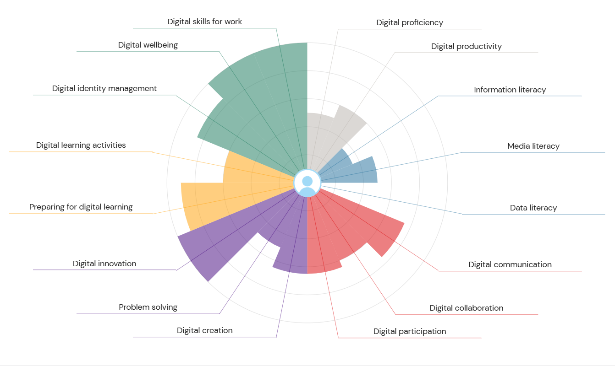

Badges from Info Skills:
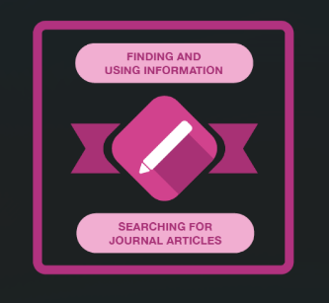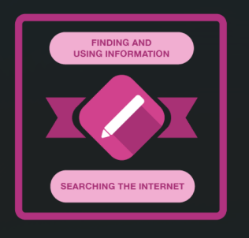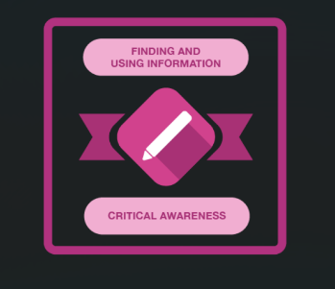
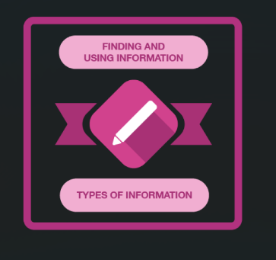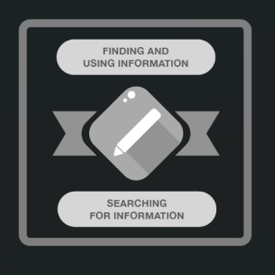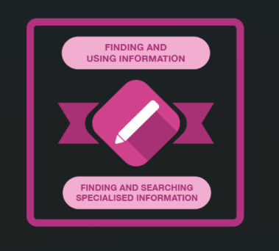
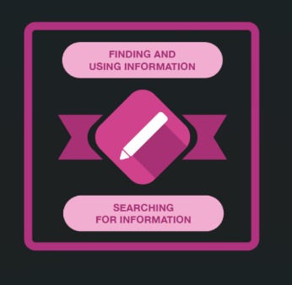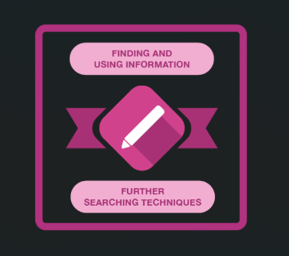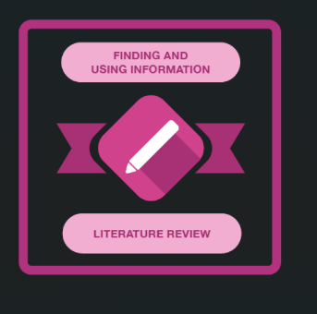
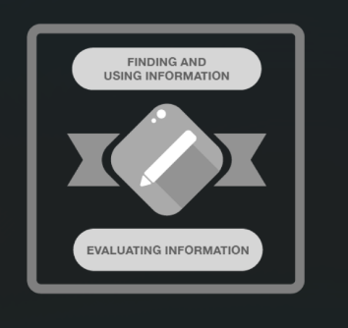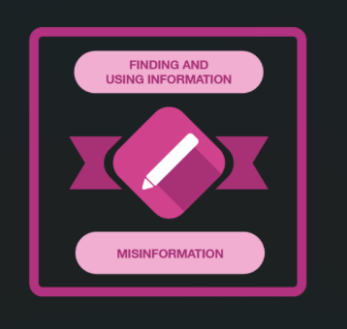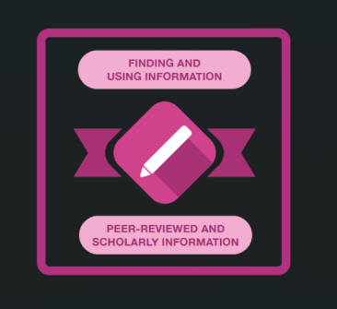
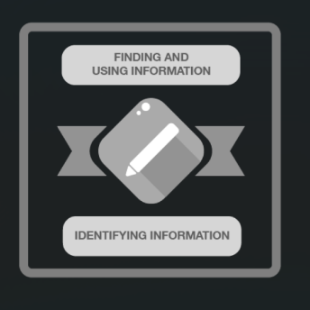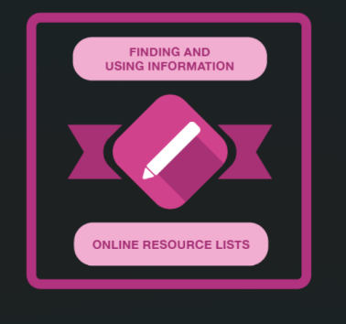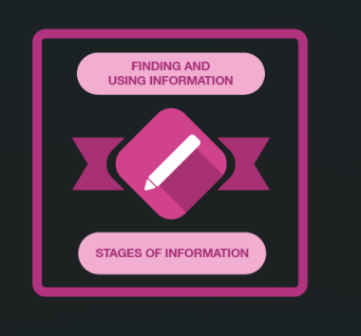

Task 2: Certificates from Linkedin Learning
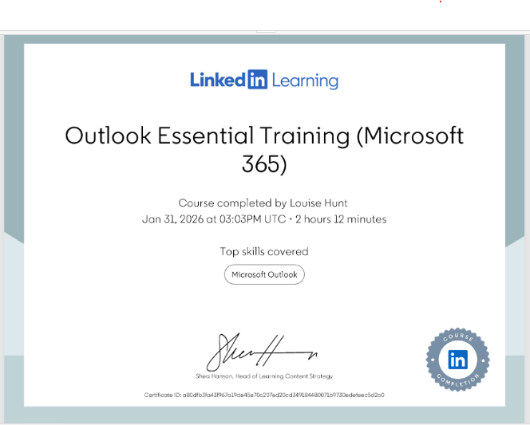
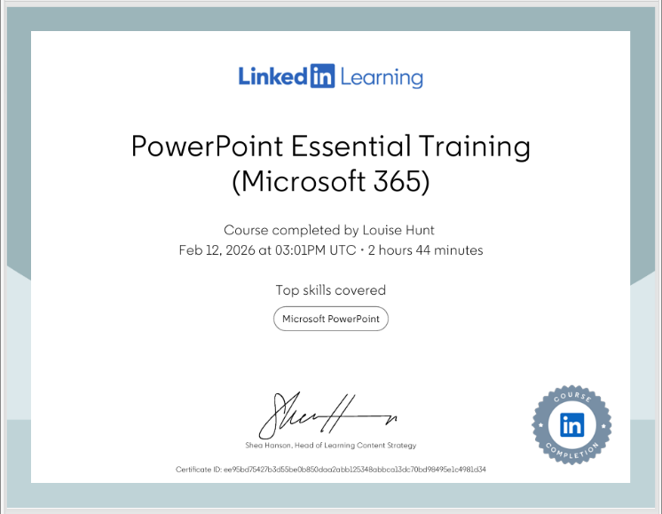
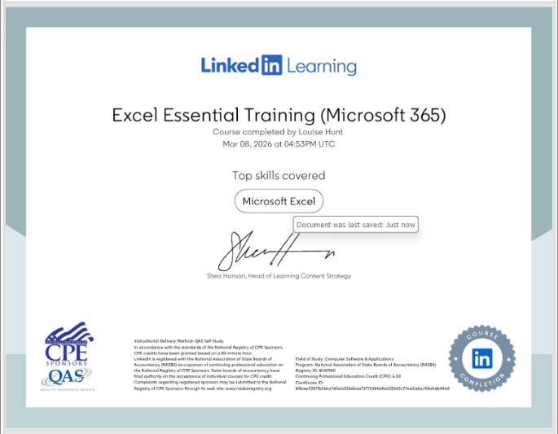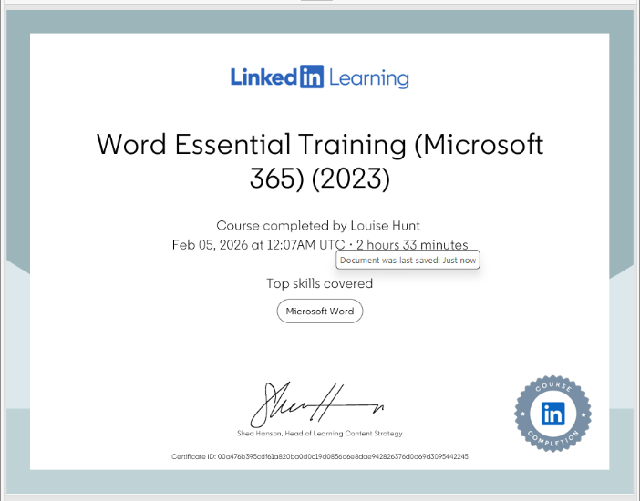

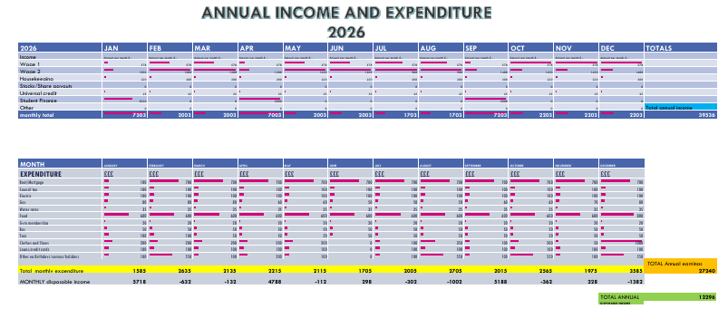

Task 3 – The Relevance of excel in professional and personal life.

Microsoft Excel is one of the most popular and commonly used digital tools for organising, analysing and presenting data. Before completing this module, I had only used Excel in a very basic way high school basically and did not fully understand how powerful it can be. Through the digital skills course I have developed a much better understanding of how spreadsheets work and how they can be used to manage information. Learning how to create spreadsheets, use formulas and produce charts has helped me realise how useful Excel can be for both academic work and everyday tasks.

One of the first things I learned when working with Excel was how easily data can be organised clearly in rows and columns. Even though I had learned this in high school I had not retained anything pretty much as I’ve never had the use for it, so I guess I forgot. In my spreadsheet task I created a table showing household income and expenditure. This included different sources of income such as Universal Credit, as well as multiple wages and student loan and the expenses like rent, electricity, travel and groceries among others that varied throughout the year as a family would, uniforms in sept birthdays throughout the year, low income at summer etc. By placing all this information into a spreadsheet, it becomes much easier to see where money is coming from and where it is being spent. According to Alexander and Kusleika (2019), spreadsheets are useful because they allow large amounts of data to be organised in a structured format that makes information easier to analyse. For instance, u can see that having a low income 1 month isn’t so bad if you look at things from the bigger picture and look at the earnings over a 6 month or 12-month period.
Another key feature of Excel is the use of formulas. Formulas allow you to automatically insert calculations, which saves time and reduces the chance errors. In my spreadsheet I used formulas such as SUM to calculate total income and total expenditure. This allowed the spreadsheet to instantly calculate totals based on the values entered the cells. If any of the numbers change, Excel automatically updates the totals. Walkenbach (2015) explains that formulas and functions are central to the purpose of Excel because they allow users to analyse numerical data quickly and efficiently.
Excel also has tools that help you analyse and sort data more effectively. For example, pivot tables allow data to be reorganised and read from different angles. This makes it easier to identify patterns or trends within a dataset. For example, you can monitor where you are spending the most in your outgoings and if it’s necessary. McFedries (2018) suggests that pivot tables are one of the most powerful features of Excel because they allow users to quickly summarise and analyse large sets of information.
More useful features of Excel are charts and graphs. Charts make it easier to understand patterns or comparisons. Instead of reading through rows of numbers, you can quickly see the information visually. Knaflic (2015) explains that presenting data visually can improve communication and help people interpret information more effectively.
Learning to use Excel has also helped me understand the importance of data literacy. Data literacy is the ability to read, understand and use data to make informed decisions. In modern workplaces, many decisions are based on analysing data, so being able to work confidently with spreadsheets is a skill I want to work on. Powell and Baker (2017) highlight that spreadsheet software is widely used in business and management because it allows users to model and analyse data in practical ways.
The spreadsheet exercise also helped me understand how Excel can support personal organisation and financial planning. By creating a household income and expenditure spreadsheet I was able to clearly see how much money comes in each month and where it is spent. This type of spreadsheet could easily be expanded to track spending over time or identify areas where costs could be reduced. Excel therefore has practical value not just for work and academic reasons but for home life too. O'Day (2016) explains that spreadsheets are commonly used for budgeting, forecasting and financial planning.
Another advantage of Excel is that it increases productivity by automating tasks that would otherwise take a long time to complete manually and asa neuro divergent learner and self-employed person this is huge. Functions, formulas and autofill tools allow you to perform calculations quickly and consistently. This reduces the risk of mistakes when working with data. Knight (2020) states that spreadsheet tools are essential for improving digital productivity because they help you manage and understand complex information with confidence. Overall, completing the Excel task helped me develop a stronger understanding of how spreadsheets can be used to organise and analyse information. Before this course I had limited experience using Excel, but now I feel much more confident working with spreadsheets, formulas and charts. These skills will be useful both academically and professionally, as well as at home, particularly in a world where digital tools and data analysis are increasingly important. Even shopping for and tracking our just food takes digital masterclass with apps and membership account promising discounts for online usage even the smallest areas of commerce and home life are digitised and therefore monitored in some way either for informative reasons or monetary among others. Everything is tracked or digitised calorie intakes and, sleep, home-fuel, steps, public transport, even love and relationships, clothes , cosmetics even surgery and therapy – they all work with some sort of data set more often than not, for multiple reasons. Developing stronger spreadsheet skills will support my future studies and help prepare me for workplaces and indeed a world that relies heavily on digital data and information management.

References
Alexander, M. and Kusleika, R. (2019) Excel 2019 Bible. Indianapolis: Wiley.
Knaflic, C. (2015) Storytelling with Data: A Data Visualization Guide for Business Professionals. Hoboken: Wiley.
Knight, G. (2020) Using Microsoft Excel for Business and Data Analysis. London: Routledge.
McFedries, P. (2018) Excel Data Analysis for Dummies. Hoboken: Wiley.
O'Day, D. (2016) Learn Excel Essential Skills. Birmingham: Packt Publishing.
Powell, S. and Baker, K. (2017) Management Science: The Art of Modeling with Spreadsheets. Hoboken: Wiley.
Walkenbach, J. (2015) Microsoft Excel Bible. Indianapolis: Wiley.

Task 4

Slides for my 5-minute PowerPoint presentation.


