Introduction 3
Key Functions of General Operating Systems 4
Use of Windows OS CLI Commands 5
Use of Linux OS CLI Commands 6
Use of Windows OS Scripts 9
Use of Linux OS Scripts 10
Conclusion 12
Appendix 13

Introduction

This report introduces the fundamental roles of general-purpose operating systems, such as Windows or Linux, to manage hardware resources and provide a user interface, particularly through the command line Interface (CLI) and scripting for system administration. It demonstrates the essential tools and commands of the CLI interface, along with other scripting for everyday system administration. Among other things, this report aims to reveal the basics of the ecosystem that we rely on in our computing lives, whether working professionally or domestically. By showing a user the most important tools to manage their own systems, it provides a roadmap for others to explore more advanced topics in system administration.

Key Functions of General Operating Systems

General-purpose operating systems (OS) are integral to managing computer hardware and software resources, offering a range of functionalities crucial for both system performance and user convenience. These systems are designed to act as a bridge between the hardware of a computer and the user applications, managing several key aspects:

Process Management: Every application running on a system operates through processes, and managing these processes is a fundamental function of an OS. This includes allocating CPU time to various processes, managing their state, and handling their execution from start to completion. Processes can be viewed and managed using tools like the Task Manager in Windows (taskmgr.exe) or the top command in Linux.
Memory Management: The OS is responsible for managing the system’s memory such as RAM, which includes allocating memory when a process needs it and deallocating it when the process is done. This function ensures that applications have sufficient and isolated memory for their execution. Memory usage can be monitored via the free command in Linux or the Memory tab in Windows Task Manager.
File Management: File management is another crucial function, involving the storage, retrieval, creation, and deletion of files. An OS provides a file system which users interact with to access their data stored in various storage devices. This can be observed through file explorer systems like Windows Explorer or the ls and cd commands in Unix/Linux systems.
Device Management: An OS manages device communication via respective drivers and APIs. This includes handling the inputs and outputs from attached hardware devices such as keyboards, mice, printers, and storage devices. Device management can typically be accessed through the Device Manager in Windows or lshw and lsusb commands in Linux.
Security and Access Control: Operating systems ensure the security of the data stored in the system through access controls, encryption methods, and account permissions, protecting sensitive data from unauthorised access and cyber threats. Security settings can be configured and viewed through the Control Panel in Windows or security commands like chmod and chown in Linux.
User Interface (UI): The UI provides a visual or textual interface through which users interact with the computer. Most general-purpose OS offer graphical user interfaces (GUIs), such as Windows, macOS, and Linux distributions like Ubuntu, which are more intuitive and user-friendly than command-line interfaces (CLI), although both are extensively used.
These functionalities collectively ensure the smooth operation of your computer, providing a stable, efficient, and user-friendly environment. They allow the OS to manage software applications, user commands, and hardware resources, making them accessible and efficient for everyday tasks.

References:

Silberschatz, A., Galvin, P. B., & Gagne, G. (2018). Operating System Concepts. Wiley.
Tanenbaum, A. S., & Bos, H. (2014). Modern Operating Systems. Pearson.

Use of Windows OS CLI Commands

Windows operating systems provide powerful command-line tools through Command Prompt and PowerShell, which help in system management and task automation. Here we document some useful commands:

dir - This Command Prompt command lists all files and directories within the current directory. Example usage: dir.
cd - Changes the current directory to another within the file system. Example usage: cd \path\to\directory.
copy - Copies files from one location to another. Example usage: copy source.txt destination.txt.
del - Deletes one or more files. Example usage: del filename.txt.
move - Moves files from one directory to another or renames them. Example usage: move oldname.txt newname.txt.
mkdir - Creates a new directory. Example usage: mkdir newdirectory.
PowerShell Get-Process - Displays information about all running processes. Example usage: Get-Process.
PowerShell Get-Service - Retrieves the status of Windows services. Example usage: Get-Service.
PowerShell Set-ExecutionPolicy - Sets the user execution policy for PowerShell scripts, which is essential for running scripts safely. Example usage: Set-ExecutionPolicy Restricted.
PowerShell New-Item - Creates a new item, like a file or a folder. Example usage: New-Item -Path 'C:\example\newfile.txt' -ItemType File.

These commands are fundamental for system administration, allowing for efficient file management, system monitoring, and automating repetitive tasks.

References:

Stanek, W. R. (2010). Windows Command-Line Administrator's Pocket Consultant, 2nd Edition. Microsoft Press.
Holmes, L. (2016). Windows PowerShell Pocket Reference. O'Reilly Media.

Use of Linux OS CLI Commands

Linux systems are renowned for their powerful command-line interface. Below, we document some fundamental Bash commands that are essential for system management:

ls - Lists the contents of a directory. Useful for quickly viewing the files and directories within the current working directory. Example usage: ls to list files.
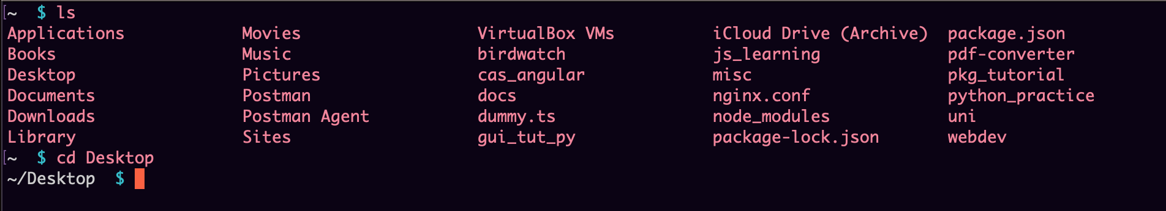
cd - Changes the directory. It's a basic command required to navigate through the directories in a Linux environment. Example usage: cd /home/user.

cp - Copies files or directories. This command is crucial for duplicating files or folders. Example usage: cp source.txt backup/source.txt.
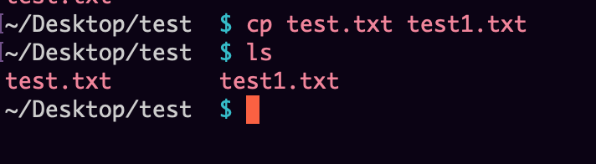
mv - Moves or renames files and directories. It helps in organising files or changing file names efficiently. Example usage: mv initial.txt newname.txt.
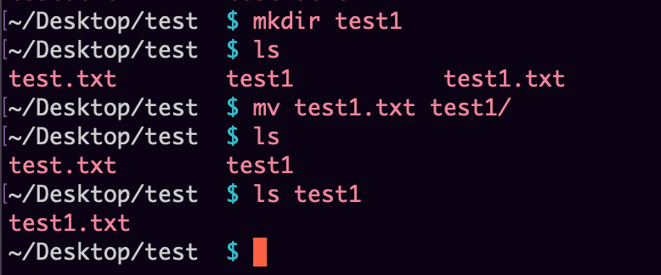
rm - Deletes files or directories. This command is vital for removing unwanted files or folders. Example usage: rm unwantedfile.txt.
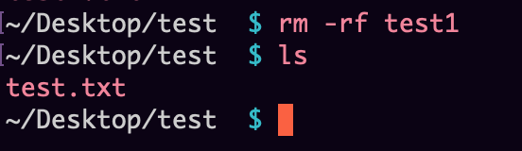
mkdir - Creates a new directory. It is used when organising files into new folders is necessary. Example usage: mkdir newfolder.
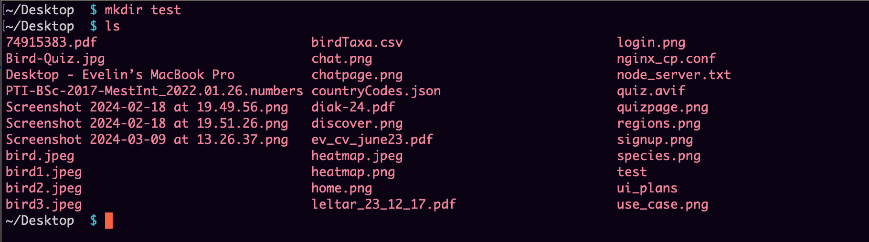
rmdir - Removes directories. This command is used to delete empty directories, helping keep the file system tidy. Example usage: rmdir emptyfolder.
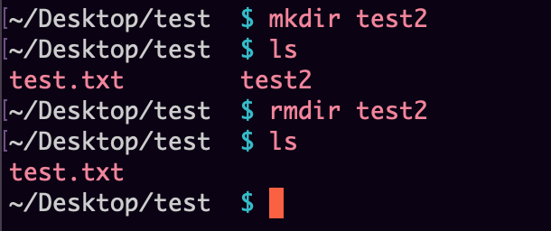
grep - Searches text or searches the given file for lines containing a match to the provided strings or words. Example usage: grep "search_pattern" file.txt.
chmod - Changes the file mode bits. Essential for setting or changing the access permissions of files and directories. Example usage: chmod 755 script.sh.
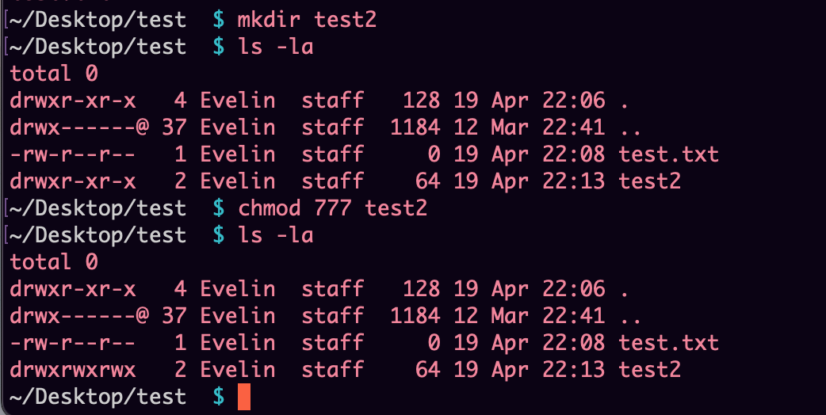
top - Displays active processes. It's a powerful tool for monitoring system performance in real-time. Example usage: top.
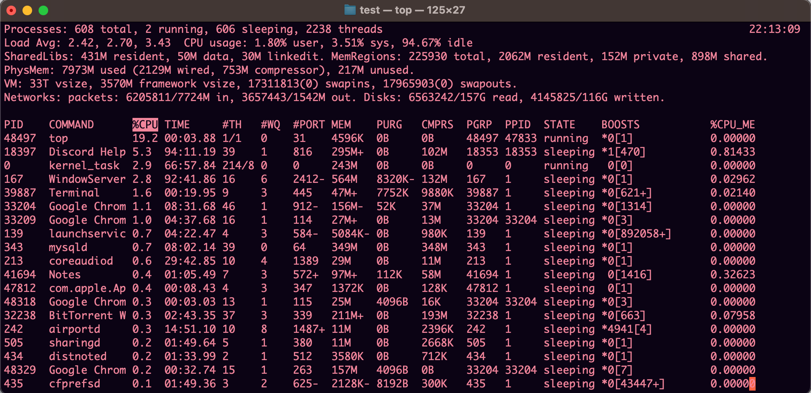
These commands form the backbone of daily tasks in a Linux environment, from system monitoring to file management and security settings.

References:

Shotts, W. E. Jr. (2019). The Linux Command Line, 2nd Edition. No Starch Press.
Ward, B. (2014). How Linux Works: What Every Superuser Should Know. No Starch Press.

Use of Windows OS Scripts

PowerShell is an advanced command-line shell and scripting language integrated into Windows that provides comprehensive control over the Windows environment. It is particularly effective for automation and data management. Below, we illustrate the use of key PowerShell scripting features.

Use of Linux OS Scripts

Bash, or Bourne Again Shell, is a powerful scripting language widely used in Linux environments. It offers extensive features like looping, conditionals, and function capabilities that are essential for automating tasks and managing system configurations. Below are examples of key Bash scripts. Bash Scripting: Streamlining Linux Operations

Bash (Bourne Again SHell) is a powerful scripting language commonly
used on Linux operating systems. It allows users to automate tasks,
manage files, and interact with system processes. Let's explore some
key features of Bash scripting through practical examples.

1. Variables and Environment:

In Bash, variables can hold values used throughout the script. They
are declared without specifying a data type. Consider this example:

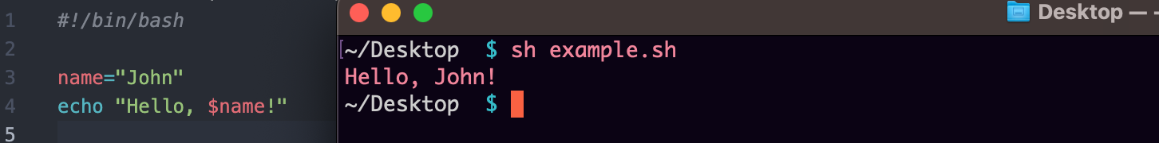
Here, the variable name stores the value "John" and is later used in
the echo command.

2. Control Structures:

Bash supports control structures like if-else statements and loops.
These are crucial for decision-making and iteration within scripts.
For instance:

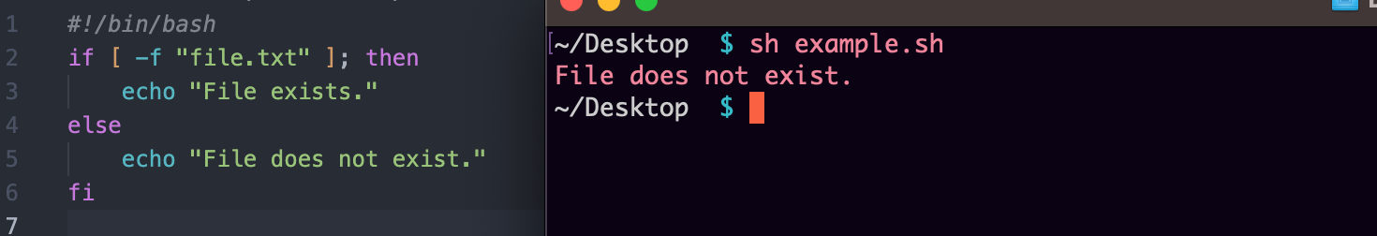

This script checks if the file "file.txt" exists in the current directory.

3. Input and Output:

Bash allows interaction with users through standard input and output.
The read command reads input from the user, while echo prints output
to the screen. Example:
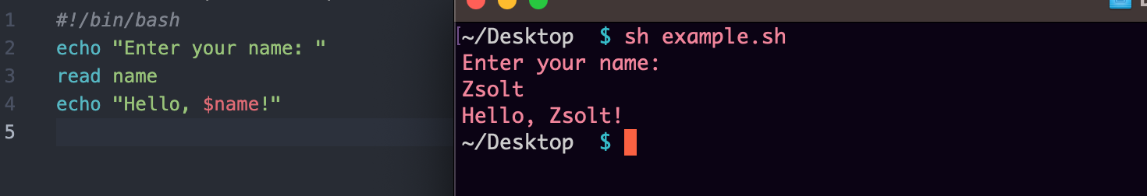

This script prompts the user for their name and greets them accordingly.
4. Functions:

Functions in Bash help modularize code for reuse and maintainability.
They are declared with the function keyword. Example:
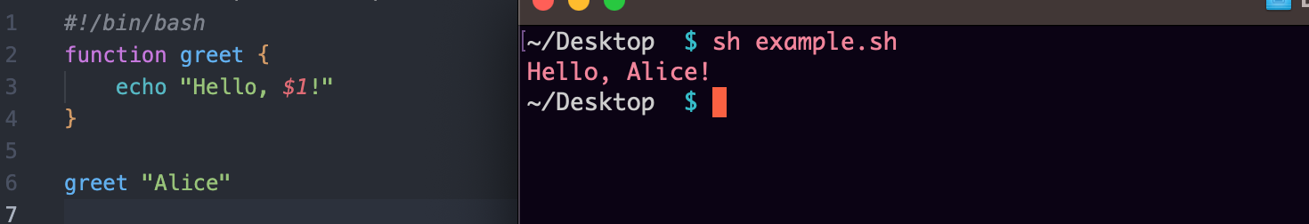

This script defines a function greet that takes a name as an argument
and greets the person.
Conclusion:

Bash scripting is a fundamental skill for Linux system administrators
and developers. By leveraging variables, control structures,
input/output operations, and functions, users can automate tasks and
streamline operations efficiently.

References:

Shotts, W. E. Jr. (2019). The Linux Command Line, 2nd Edition. No Starch Press.
Ward, B. (2014). How Linux Works: What Every Superuser Should Know. No Starch Pr

Conclusion

In addition, this report has highlighted the essential roles general-purpose operating systems play in managing hardware resources and ensuring smooth interaction with users. By exploring Microsoft Windows and Linux operating systems, we have demonstrated the importance of the command-line interfaces (CLI) and scripting in performing system administration tasks.

Throughout our assigment, while presenting some essential CLI commands and scripting capabilities in Windows and Linux, we also illustrated the power of these tools in simplifying administrative tasks from file management and system monitoring to automation. The ability to work on CLI and scripting provides a competitive edge as it helps to enhance resource utilisation for improved productivity and reliability of systems.

Ultimately, mastering CLI and scripting on an operating system is essential for modern system administrators to get the most out of their systems, simplify routine chores, and adapt to changing computing environments.

Appendix


