Professional Career Development in Health and Social Care (LCHS 4009)

ASSIGNMENT 2

Name of Student: Faye Marie Chamberlain

I.D. Number: 2413289

Name of Tutor: Christopher Mafuva

Acknowledgement of AI use: / have not used AI to complete my work.

Date submitted: 17.04.2026

Table of Contents Page Number

Curriculum Vitae (CV) ............................................... Page 3–5

Personal Statement .................................................. Page 6–9

Critical Reflection (Gibbs Reflective Model) .......... Page 9–10
3.1 Description
3.2 Feelings
3.3 Evaluation
3.4 Analysis
3.5 Conclusion
3.6 Action Plan

Practical Portfolio

Introduction:
A portfolio is a collection of your work that demonstrates your abilities, progression, and accomplishments. It can include projects, tasks, artwork, and certificates. Portfolios are used to demonstrate one's abilities when applying for school, jobs, or other chances (Indeed Editorial Team,2023). This portfolio will consist of my ability to qualify for the job, a SWOT analysis, and a personal growth plan. I will also provide a reflection based on Gibbs' (Gibbs,1988) reflective model on the presentation that I prepared for my assessment.

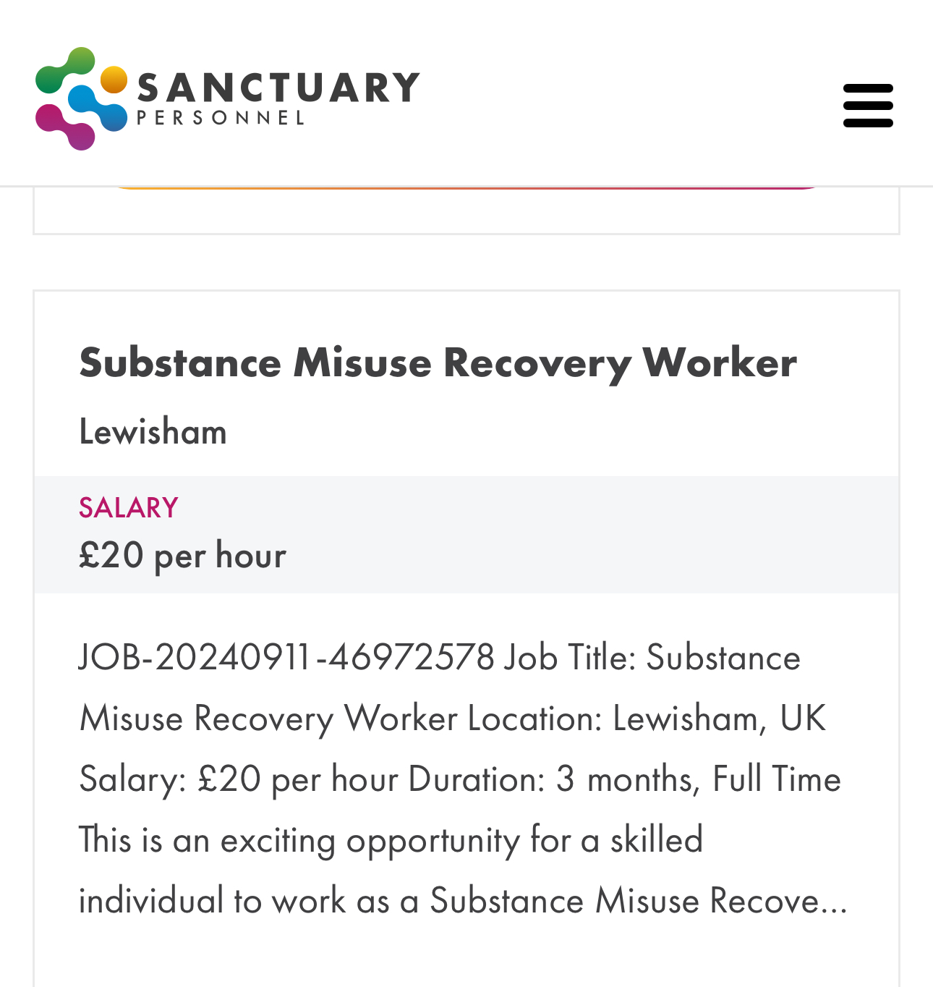

Task 1
CV
Name: Faye Marie Chamberlain
email :2413289@student.uwtsd.ac.uk
Telephone number: 07874846194
Address: 96 Nottingwood house clarendon road London W11 4JH
Personal profile:
A trustworthy dependable enthusiastic person seeking employment as a substance misuse worker in the health and social care sector. I am dedicated to assisting people with substance and drug abuse,supporting recovery and encouraging healthy lifestyle choices. I display great communication skills,compassion for others, a non judgemental attitude as well as complete knowledge of confidentiality,safety and person centred care. I am enthusiastic about supporting people to conquer obstacles,better their wellbeing and reach long term rehabilitation while collaborating effectively as a multidisciplinary team.
Education:
University of Wales Trinity Saint David
CERTHE skills for the Workplace (Health and Social Care)
Start date: June 2025 - June 2026 (expected)
Relevant modules:
- Academic and Employability skills certificate in higher education
- skills for the workplace (Health and social care)
- digital skills and research methods
- introduction to Health and social care
- introduction to Public Health
- professional career development within health and social care
- Psychology in Health and social care
Skills gained:
- good verbal and written communication skills

- Capability to explain important health information in an understandable and accessible way.

- Team building skills

Volunteer experience:
Community volunteer work
Kensington community centre
Local community centre dates: 23/01/24 - 01/07/2024
- In a communal setting, i supported people from different and sometimes vulnerable backgrounds
- Contributed to create a safe and welcoming environment for service consumers
- Working alongside staff and other volunteers to assist with community activities
Achievements:
- Succeeded in meeting academic deadlines while producing excellent work
- Maintained a composed,professional and respectful manner when addressing delicate or difficult topics
- Achieved a through understanding individual centred care mental health and addiction
Volunteer food bank
Notting hill church food bank
Dates 18.01.23 to 23.09.23
Assisted in day to day operations of a busy food bank, supporting people,families in need while delivering efficient and welcoming service.
Key responsibilities and achievements
- Managed the inventory and distribution of food donations supporting service users weekly
- Provided friendly and respectful support to individuals from diverse backgrounds
- Supporting the overall control of inventory,which includes ensuring accurate stock levels,assisting with replenishment and improving efficiency
- Collaborated with a volunteer team to maintain high service standards and ensure consistent output during busy shifts.
Key skills gained:
- Team work and collaboration
- Empathy and community awareness
- Customer service and communication

Interests:
- Interests in mental health and well being knowledge
- enthusiasm for promoting positive lifestyle choices and general well-being
- interest in health and fitness
skills :
- Awareness of social and psychological factors
- Analysing circumstances and making recommendations for improvements
- Setting priorities for tasks
- Excellent communication skills and active listening abilities
- Knowledge of recognising risks and safeguarding
Collaborating

References:
References available upon request

Task 2 of 4

Personal statement

I would like to be considered for the role of a substance misuse worker because I have a strong desire to assist those who are struggling with addiction and mental health issues. My long term professional goal is to have a fulfilling career in the health and social care sector, where I can positively impact vulnerable people in assisting them in achieving stability,recovery and enhanced wellness. Since I'm aware of the complicated profound effects it may impose on individuals,their families and the wider community,I am especially interested in substance abuse support.

I have an excellent understanding of important concepts like safeguarding,confidentiality,equality,diversity and person centred care as a result of my studies in health and social care.I currently have a better understanding of the psychological and physical consequences of substance misuse as well as the value of providing compassionate non judgemental support thanks to my higher education. My awareness of the responsibilities related to offering services to service users in a professional care context has been improved by this academic background.

Together with my education, [job knowledge/volunteering/higher education activities] has given me invaluable experience and helped me develop critical communication and interpersonal skills. I've had experience engaging with a wide variety of people, paying attention to their needs, and reacting in a composed, considerate, and encouraging way. This has given me more self-assurance in handling difficult circumstances and helping people who might be in pain or vulnerable.

One of my main skills is my ability to show empathy and understanding. I am a compassionate and kind person who values the importance of establishing a trustworthy relationship while working with people who use substances or alcohol. I am also an effective communicator, capable of presenting information clearly while making people feel listened, respected, and supported. Additionally, I am reliable, organised, and capable of managing my time well, allowing me to operate efficiently both solo and as part of a team.

I acknowledge just how vital it is to maintain professional boundaries and confidentiality in health and social care environments. I am committed to following policies and procedures that ensure the safety, respect, and psychological well-being of individuals who I support. Furthermore, I am willing to continue extending my expertise and skills through continued training and professional development, as I recognise the value of continuous improvement in my sector.

I believe my unique qualities, together with my knowledge and commitment, will allow me to make an important contribution to your organisation. I am passionate about supporting individuals on their recovery journey, promoting independence, and encouraging positive, long-term outcomes. I am dedicated to treating everybody with dignity, respect, and fairness, regardless of their circumstances.

Finally, I am significantly determined to pursue a profession as a Substance Misuse Worker and have a positive impact on the lives of others. I am enthusiastic to put my talents to use in a professional setting and further my career in health and social care. I am confident that I will be a supportive, credible, and dedicated member of the team.

Task 3 of 4 (approx. 800 words)

A SWOT analysis is used to identify strengths, weaknesses, opportunities, and threats linked to a particular position or situation, as well as to support planning and making decisions (dunne,2024).Below is a personal SWOT analysis relative to the job I submitted an application for.

Strengths | Weakness | Opportunities | Threats
Great communication | Lacking expertise in substance abuse environments | Additional health and social care education and training | High emotional demands and the possibility of burnout
A sense of empathy, compassion, and non-judgment | In stressful circumstances, confidence might decrease. | Opportunities for volunteer work or placement | Relapse or exposure to difficult behaviors
Strong knowledge of person-centered care, confidentiality, and safeguarding | Little experience managing challenging problems or crises | Availability of specialized training (safeguarding, mental health) | competitive employment market
The ability to establish healthy relationships and trust | competitive employment market | Professional development (e.g., counselor, recovery worker) | Budget or availability of services changes
Understanding of psychological and social aspects | might use notes or preparation in formal settings. | Gaining knowledge from qualified professionals | Possibility of emotional engagement influencing boundaries

PDP
A personal development plan assists me in identifying my strengths and areas for improvement, setting clear goals, and planning how to acquire the abilities required of a substance abuse worker (Richards,2023). A PDP (personal development plan) allows me to focus on my goals and reflect on my progress.

Goal | Smart description | Importance | Development & evaluation
Get practical experience in a health and social care environment over two years. | Develop hands-on experience working with people who are vulnerable. | Apply for voluntary or job placements, work together with a variety of individuals, and observe experienced professionals in action. | Over six months and continuing for two years
Develop knowledge on substance misuse and mental health | Complete necessary training courses; examine case studies; apply knowledge to assignments and practice. | Over 2 years | Record completed courses, use information in assignments, and verify your understanding consistently.

A Personal Development Plan (PDP) helps me progress by identifying areas for improvement and setting specific, achievable objectives. One of my primary aims is to gain practical work experience in a health and social care environment by applying to volunteer or placement opportunities, which will help me to develop hands-on skills while working with vulnerable people. Another important goal is to widen my awareness of substance abuse and mental health through taking relevant training courses and using what I've learned in both academic and practical settings. I will keep track of my progress by reflecting on my experiences, documenting completed training, and frequently assessing my knowledge and improvement over time.
Task 4 of 4
3.1 description
The assessment asked me to prepare and deliver a structured presentation regarding the importance of communication in a healthcare setting. The purpose of this assignment was to demonstrate both my area of knowledge and my ability to effectively deliver information to an audience. In addition to my talk, I prepared a PowerPoint presentation and showed it to my lecturer and colleagues. Following the presentation, I received verbal feedback that demonstrated major strengths as well as areas for further growth.This reflection was founded on the Gibbs reflective cycle (Gibbs,1988).

3.2 feelings
Before presenting, I had a great deal of nervousness and uncertainty, caused by the pressure of talking in the presence of an audience. I was particularly concerned about missing out important facts or losing confidence throughout the presentation. This is a normal reaction, since anxiety about speaking may lower confidence and performance (Jones et al.2011) .However, as the presentation continued on I became more calm and attentive. I felt a sense of fulfillment and achievement after successfully delivering the presentation. The feedback process was both reassuring and productive, acknowledging my skills while encouraging me to think more critically regarding areas for improvement (Sands,2024).
3.3 evaluation
Overall, my presentation showed a thorough understanding of the chosen subject. The subject matter was clear, relevant, and effectively focused, allowing for an organized flow of information. I used appropriate vocabulary throughout, displaying my academic knowledge and research.

Despite such advantages, a couple of areas for development were identified. I found myself unable to maintain continuous eye contact and really connect with the audience because I had depended too much on my notes. Further, there were some occasions when my delivery and expression missed range, which reduced the overall level of engagement. Though I was able to complete the talk successfully, I could not always express confidence.

This highlights the importance of balancing knowledge of the topic with effective communication skills. While preparation helped me to offer accurate and clear content, relying on notes shows a lack of confidence in delivering information independently(Soni,2025).This may have reduced my ability to speak naturally and successfully with my target audience.
3.4 analysis
The feedback from classmates I received after I presented pointed out the value of nonverbal communication, including eye contact, tone of voice, and body language. These are important skills in health and social care (Petty,2025) , as efficient communication is critical in developing a sense of confidence and connection with patients. Reflecting on this, it is obvious that developing my presentation skills would not only help my academic performance but would also prepare me for professional development.
3.5 conclusion
To summarise, this presentation was an excellent learning opportunity that helped me identify both my strengths and areas for improvement. While I displayed great topic knowledge and organisation, I recognize the need to improve my confidence and presentation skills. More specifically, reducing my reliance on notes and increasing audience involvement which are essential areas for development. Handling these challenges will positively impact both my academic achievements and my future career in healthcare.
3.6 action plan
To enhance my future performance, I intend to use a variety of approaches. Firstly, I intend to practice presentations more frequently to be able to develop confidence and knowledge with what is being presented. I aim to reduce my dependence on notes by using short suggestions instead of long scripts. Furthermore, I aim to improve nonverbal communication skills, including maintaining eye contact, using good body language, and adjusting my tone of voice, to be able to engage the audience. I will also strongly request input from lecturers and peers and use it productively to strengthen my development. By applying these approaches, I intend to further enhance my skills in communication and develop a more confident and effective presentation in educational as well as professional environments.

References:

dunne, kevin . “MindTools | Home.” Mindtools.com, 2024, www.mindtools.com/amtbj63/swot-analysis/. Accessed Apr. 16AD.

Indeed Editorial Team. “How to Build Your Work Portfolio.” Indeed Career Guide, 23 June 2023, www.indeed.com/career-advice/resumes-cover-letters/build-your-work-portfolio. Accessed 7 Apr. 2026.

Jones, Christopher R., et al. “Attentional Control Buffers the Effect of Public-Speaking Anxiety on Performance.” Social Psychological and Personality Science, vol. 3, no. 5, 5 Dec. 2011, pp. 556–561, www.ncbi.nlm.nih.gov/pmc/articles/PMC3424620/, https://doi.org/10.1177/1948550611430166. Accessed 15 Apr. 2026.

Petty, Louise. “Non-Verbal Communication in Health and Social Care.” The Hub | High Speed Training, 19 May 2025, www.highspeedtraining.co.uk/hub/non-verbal-communication-health-social-care/. Accessed 15 Apr. 2026.
Richards, Laura. “What Is a Personal Development Plan?” Www.intelligentpeople.co.uk, Intelligent People, 24 Aug. 2023, www.intelligentpeople.co.uk/candidate-advice/personal-development-plan/. Accessed 16 Apr. 2026.

Sands, Stephanie. “Deeper Signals.” Www.deepersignals.com, 27 Aug. 2024, www.deepersignals.com/blog/the-top-5-reasons-why-feedback-is-critical-to-success. Accessed 15 Apr. 2026.
Soni, Aanchal. “Common Mistakes to Avoid during a Presentation for Better Impact.” Planetspark.in, PlanetSpark, 13 Nov. 2025, www.planetspark.in/public-speaking/common-mistakes-to-avoid-during-a-presentation. Accessed 16 Apr. 2026.

The University of Edinburgh. “Gibbs’ Reflective Cycle.” The University of Edinburgh, 2024, reflection.ed.ac.uk/reflectors-toolkit/reflecting-on-experience/gibbs-reflective-cycle. Accessed 8 Apr. 2026.

