Qualification: CIPD Level 5 Diploma in Applied Human Resources

Module Name: Clare Louise Berner

Developing Professional Practice in Human Resources - 5CDPP

Word Count: 1100

Activity 4

4.1. Group/Team Dynamics
4.2. Political Behaviours and Impacts

Student Name: Clare Louise Berner
Student Number: 1810268
CIPD Membership Number: 53280348

By signing below, I confirm that the work/evidence presented is my own, unaided work. I understand the regulations pertaining to candidate malpractice and the action that may be taken as a result.

Signed: Clare Louise Berner
Date: 02/12/2018

4.1 Group/Team Dynamics

Group/Team dynamics are interactions and behaviours with various members of your group/team or how a group/team interacts and behaves with other groups. Influences within a team builds the overall makeup. HR professionals work with individuals within their function, across functions and other areas. Poor team working can cause detrimental effects to individual and organisational performance (Johns and Perkins, 2016).

“Team dynamics are unconscious, psychological forces that influence the directions of a team’s behaviour and performance. Team dynamics are created by the nature of the team’s work, personalities within the team, their working relationships with other people, and the environment” (Myers, 2013).

Teams go through various stages of development to form fully and eventually become effective. According to Tuckman and Jenson (1977) theory there are 5 stages a group should go through to grow, face challenges, overcome problems, find solutions, plan projects and deliver the desired results:

Forming: Uncertainly, guarded about information they give about themselves, getting to know your team, tasks and goals (Horn, 2009).

Storming: Strained relationships whereby there is competition to gain position within the team for leadership, conflict, tension, arguments through differences in opinions. A leader will need to address the problem, as the team cannot move to the norming stage until this has been resolved (Horn, 2009).

Norming: Resolves differences, established roles, agrees team goals and how to succeed. A leader will ensure the team is focused on completion (Horn, 2009).

Performing: When this stage is reached, the team is aligned and working together effectively to achieving teams’ objectives and goals, this is a time of high performance and productivity. A leader will give recognition when milestones are accomplished (Horn, 2009).

Adjourning/Mourning: This is the stage that the task/project has completed, the purpose fulfilled. Some may have moved to a new project, or the team may depart as the project is now complete. Some find this stage difficult and some relieved if the team was dysfunctional (Horn, 2009).

All these above stages can be seen on “The Apprentice” with Lord Sugar (BBC, 2018).

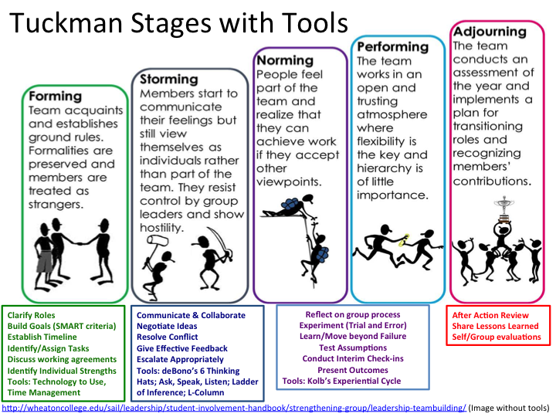
(Wentworth Institute of Technology, 2016)

Some teams/groups can get stuck at a stage, some stages blend in, some teams go back to an earlier stage; this happens when performance declines or if there is conflict. Conflict can occur at any stage; a negative characteristic is when another member of the team obstructs the achievement of another person’s goals, having an adverse effect on performance, causing dysfunctional consequences (Horn, 2009).

Conflict occurred within my own team. A staff member was undermining the manager; the manager mentioned capability issues due to inaccuracies/processes not being followed regards to policy. It led to a breakdown in performance, trust and respect, eventually the member of staff left the Health Board.

Belbin observed teams in the 1970’s and as a result defined a team role as “a tendency to behave, contribute and interrelate with others in a particular way” (Belbin, 2015). He uncovered three team roles that behave in one of nine ways to make a team more effective, these are:

Behaviours Team Roles
Action Orientated Shapers, Implementers, Completer-Finishers
People Orientated Co-ordinators, Teamworkers, Resource Investigators
Thought Orientated Plant, Monitor-Evaluators, Specialists

(Belbin, 2015)

Belbin’s theory states that teams which work more effectively have between three and nine people. For example, if there were no shapers, then there wouldn’t be the direction or drive; but too many would cause conflict, performance issues and low morale (Horn, 2009). A team with no plants would find difficulty in solving complex issues and innovative solutions, if there were too many, each would be working individually, causing too many bad ideas, not working as a team to bring one idea to be successful (Belbin, 2018), roles need to be balanced.

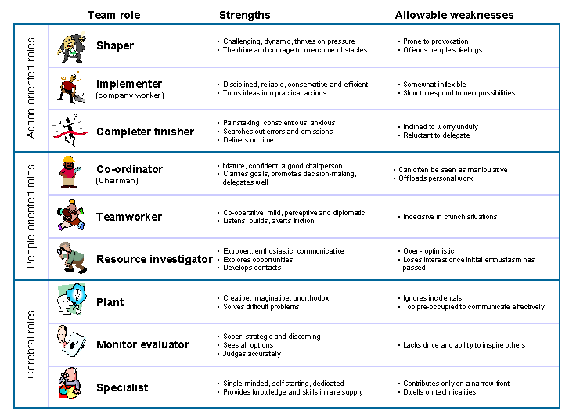
(University of Cambridge, n.d)

It’s important that HR Professional have an awareness of conflict management and collaborative working. Conflict in teams can occur and lead from poor communication; personality clashes; differences in opinion; hidden agendas; undermining; being negative; withdrawal from team; non-contributor to team work; power and status; refusing to collaborate; being unhappy and unproductive which affects organisational performance making the team ineffective and dysfunctional (Horn, 2009).

Team members not getting on requires a HR Professional to negotiate with parties to attempt to come to an agreement to try and work together collaboratively, mediation may be required to resolve the conflict.

Effective teams are committed and work together harmoniously; a diversity of skills and strengths, which increases morale; effective communication; trusting one another; continuously improving knowledge and expertise; task-orientated to achieving organisational objectives, goals/performance; building and maintaining a strong team (Horn, 2009).

This can be seen in the NHS whereby effective teamworking on wards centres around all disciplines working effectively/efficiently together; knowing each other’s role. A patient could be seen by a multi-disciplinary team or by a single professional, working within best practice, the whole team performing dynamically to achieve its successful outcome of patient-care (Paediatr, 2014).

4.2. Political Behaviours and Impacts
The definition of politics according to Andrew Kakabdase (1983):
‘Politics is a process, of influencing individuals or groups of people to your point of view, where you cannot rely on authority.’ (cited in Armstrong and Taylor, 2014 pp671-674)

Politics is closely linked to the use of power, which is the concept of organisational politics. Politics in an organisation can be positive and functional; an organisation can achieve its strategic purpose, organisational goals, objectives and organisational values as long as the hierarchy are politically skilled. The organisation will do well if everyone is working towards the same goals and objectives. Managers use their skills effectively to resolve conflict issues and at a time of organisational change; whereby managers utilise politics to seek support from their teams (M Libraries, 2017).

In organisations individuals can be driven by their own goals; strategy and self-interest, openly or covertly. Using their powers, they will play the game and use politics to further their own cause. Undesirable behaviour taken to excess can cause backbiting, hidden agendas, conspiracy between individuals and departments.

If an employee’s reputation has been tarnished by a colleague, this can be extremely upsetting, there is no trust and can have an adverse effect on performance and excessive emotional physical stress (Juneja, 2018).

“Organizational politics are informal, unofficial, and sometimes behind-the-scenes efforts to sell ideas, influence an organization, increase power, or achieve other targeted objectives” (Brandon & Seldman, 2004; Hochwarter, Witt, & Kacmar, 2000).

Organisational politics impacts on staff and mangers. Within the Health Board, there are policies and procedures in place to support them, along with HR Professionals.

HR Professionals need to be aware of political agendas but not be part of them.

References

Armstrong, M. and Taylor, S. (2014) Armstrong’s Handbook of Human Resource Management (13th ed.) Ashford Colour Press Ltd.

BBC (2018) The Apprentice [online] Available at:
http://www.bbc.co.uk/programmes/profiles/3hDdWTFzsLy3lVCVtl0rxSg/lord-sugar (Accessed 1 December 2018)

Belbin (2018) Team Role Spotlight Plant [online] Available at:
https://www.belbin.com/about/team-role-spotlight-plant/ (Accessed 2 December 2018)

Belbin, M. (2015) Team Roles in a nutshell [online] Available at: https://www.belbin.com/media/1336/belbin-for-students.pdf (Accessed 11 November 2018)
Brandon, R. & Seldman, M. (2004). Survival of the savvy: High-integrity political tactics for career and company success. New York: Free Press.
Hochwarter, W. A., Witt, L. A. & Kacmar, K. M. (2000). Perceptions of organizational politics as a moderator of the relationship between conscientiousness and job performance. Journal of Applied Psychology, 85, 472–478.
Horn, R (2009) The Business Skills Handbook CIPD: London I SBN 97818438218
Johns, T and Perkins, G. (2016). ‘Developing Professional Practice’, in Taylor, S. and Woodhams, C. (ed.) Studying Human Resource Management. 2nd ed. London: CIPD pp67-87
Juneja, P. (2018) Workplace Politics -Meaning and Reason for Office Politics [online] Available at: https://www.managementstudyguide.com/workplace-politics.htm (Accessed 2 December 2018)

M Libraries (2017) Organizational Behaviour [online] Available at:
https://open.lib.umn.edu/organizationalbehavior/ (Accessed 2 December 2018)
ISBN 978-1-946135-15-5 University of Minnesota Libraries

Myers, S. (2013) Definition of Team Dynamics [online] Available at: https://www.teamtechnology.co.uk/team/dynamics/definition/ (Accessed 24 November 2018)
Paediatr, S. (2014) Health Care Professional Development: Working as a team to improve patient care [online] Available at:
https://www.ncbi.nlm.nih.gov/pmc/articles/PMC4949805/ (Accessed 2 December 2018)

University of Cambridge (n.d) Belbin’s Team Roles [online] Available at:
https://www.ifm.eng.cam.ac.uk/research/dmg/tools-and-techniques/belbins-team-roles/ (Accessed 11 November 2018)

Wentworth Institute of Technology (2016) Empower Groups [online]
https://wit.edu/lit/engage/empower-groups (Accessed on 11 November 2018)
Tuckman, B. W. and Jensen, M.A.C. (1977), ‘Stages of small group development revisited’, Group and Organization Studies, vol.2, no.4, pp.419-27.

Bibliography

ACAS (2014) Managing Conflict at Work [online] Available at: http://m.acas.org.uk/media/pdf/j/o/Managing-conflict-at-work-advisory-booklet.pdf (Accessed 24 November 2018)

Allcorn, S. (1985) What makes groups tick, Personnel. September pp52-58.

Armstrong, M. and Taylor, S. (2014) Armstrong’s Handbook of Human Resource Management (13th ed.) Ashford Colour Press Ltd.

BBC (2018) The Apprentice [online] Available at:
http://www.bbc.co.uk/programmes/profiles/3hDdWTFzsLy3lVCVtl0rxSg/lord-sugar (Accessed 1 December 2018)

Belbin (2018) Team Role Spotlight Plant [online] Available at:
https://www.belbin.com/about/team-role-spotlight-plant/ (Accessed 2 December 2018)

Belbin, M. (2015) Team Roles in a nutshell [online] Available at:
https://www.belbin.com/media/1336/belbin-for-students.pdf (Accessed 11 November 2018)
Brandon, R. & Seldman, M. (2004). Survival of the savvy: High-integrity political tactics for career and company success. New York: Free Press.
CIPD, (2014) Podcast 95: Building the best team [online] Available at:
https://www.cipd.co.uk/podcasts/building-best-team (Accessed 11 November 2018)

Clegg, S., Kronberger, M. and Pitsis, T. (2005) Managing and Organizations London: Sage

George, J. and Jones, G. Contemporary Management Creating Value in Organisations (4th Ed.) /McGraw-Hill Irwin: New York. ISBN 0-07-111547-1
Hochwarter, W. A., Witt, L. A. & Kacmar, K. M. (2000). Perceptions of organizational politics as a moderator of the relationship between conscientiousness and job performance. Journal of Applied Psychology, 85, 472–478.
Horn, R (2009) The Business Skills Handbook CIPD: London I SBN 97818438218

Jarrett, M. (2017) Harvard Busness Review: The 4 Types of Organizational Politics [online] Available at:
https://hbr.org/2017/04/the-4-types-of-organizational-politics (Accessed 2 December 2018)

Jayaram, S. (2015) Six tips for HRs to deal with workplace politics [online] Available at:
http://www.hrinasia.com/general/six-tips-for-hrs-to-deal-with-workplace-politics/ (Accessed 11 November 2018)
Johns, T and Perkins, G. (2016). ‘Developing Professional Practice’, in Taylor, S. and Woodhams, C. (ed.) Studying Human Resource Management. 2nd ed. London: CIPD pp67-87
Juneja, P. (2018) Workplace Politics -Meaning and Reason for Office Politics [online] Available at: https://www.managementstudyguide.com/workplace-politics.htm (Accessed 2 December 2018)

Mindtools Video, (2017) Belbin’s 9 Team Roles [online] Available at:
https://www.youtube.com/watch?v=7LunroajlLE (Accessed on 10 November 2018)

M Libraries (2017) Organizational Behaviour [online] Available at:
https://open.lib.umn.edu/organizationalbehavior/ (Accessed 2 December 2018)
ISBN 978-1-946135-15-5 University of Minnesota Libraries

Mullins, L. (2005) Management and Organisational Behaviour. 7th ed. Pearson: Harlow [online] Available at:
http://www.mim.ac.mw/books/Laurie%20Mullins%27s%20Management%20&%20Organizational%20Behaviour,%207th%20edition.pdf (Accessed 12 November 2018)

Paediatr, S. (2014) Health Care Professional Development: Working as a team to improve patient care [online] Available at:
https://www.ncbi.nlm.nih.gov/pmc/articles/PMC4949805/ (Accessed 2 December 2018)
Schmidt, W. H. ‘Conflict: A Powerful Process for (Good or Bad) Change’, Management Review, 63, December 1974, pp. 4–10.
Senyucel, Z (2009) Managing the Human Resource in the 21st Century [online] Available at: https://bookboon.com/en/hrm-managing-the-human-ressource-ebook
Zorlu Senyucel & Ventus Publishing ApS ISBN 978-87-7681-468-7 (Accessed on 4 November 2018) pp35-43

Sinha, A (2017)The Role of Team Effectiveness in Quality of Health Care [online] Available at:
https://www.imedpub.com/articles/the-role-of-team-effectiveness-in-quality-ofhealth-care.php?aid=18179 (Accessed 10 November 2018)

Smith, M. K. (2005). ‘Bruce W. Tuckman – forming, storming, norming and performing in groups, the encyclopaedia of informal education. [online] Available at: http://infed.org/mobi/bruce-w-tuckman-forming-storming-norming-and-performing-in-groups/. (Accessed: 10 November 2018].

Spiral training (2008) Belbin Team Roles Training Bite [online] Available at:
https://www.youtube.com/watch?v=EKmDEDUdBKQ (Accessed on: 4 November 2018)
Tuckman, B. W. and Jensen, M.A.C. (1977), ‘Stages of small group development revisited’, Group and Organization Studies, vol.2, no.4, pp.419-27.
University of Cambridge (n.d) Belbin’s Team Roles [online] Available at:
https://www.ifm.eng.cam.ac.uk/research/dmg/tools-and-techniques/belbins-team-roles/ (Accessed 11 November 2018)

Watson. G, (2014) ‘Effective Team-building and Communication’, in Watson, G. and Reissner, S. (ed.) Developing skills for business leadership. 2nd ed. London: CIPD
ISBN: 9781843983163 (pp209-232)

Wentworth Institute of Technology (2016) Empower Groups [online]
https://wit.edu/lit/engage/empower-groups (Accessed on 11 November 2018)

Yardley, J (2014) NRC nursing & residential care Team dynamics: the role it plays in shaping service delivery [online] Available at: https://www.magonlinelibrary.com/doi/abs/10.12968/nrec.2014.16.5.284?mobileUi=0&journalCode=nrec (Accessed 10 November)

