LCBB5000 Data Handling and Business Intelligence
Anita Petreus 2024822
Assessment 1 coursework – Current trends in Business intelligence
Words-

Realizing the strategic impact of business intelligence utilization
( Yu Yin Lim and Ai Ping Teoh)

Business intelligence is holding all the strategies and technologies that enterprises uses for data analysis and information management. Basically is the process and the methods for collecting, storing, analysing data from business activities, for a better performance.
Is helping companies to make better decisions, helping to increase sales and revenue.
Business intelligence name was first used in 1865 by Richard Millar Devens, when he described a banker’s way to gain profit.
Business intelligence become inseparable from organisations, same to big and small organisations. Everyone want’s to analyse all the information available to find out possible future results to make decisions the best for the company. Today Business intelligence has software solutions for all types and sizes of businesses, however it wasn’t always like this, not long ago it was only for big enterprises who could afford sophisticated software.
With the benefits, Business intelligence taking the central role in the operation of businesses, every year more and more data will be generated so the demand of business intelligence tools will increase also.

The article, seeks to address how business intelligence is utilized in a highly competitive and dynamic business environment. The way of the business intelligence become an important concept, and how can help organizations to combine information, management practises and to make strategic decisions for the organisation’s best performance achievement. It is clear from the article that business intelligence utilization is a strategic resource that remarkably impacts the business achievability of Public Listed Companies (PLC’s) listed on Bursa Malaysia. This paper introduce the structured review of the concepts linked to business intelligence utilization, also it argues the consequences of business intelligence utilization, for example a data leakage.
Business intelligence include data integration, analytical capabilities, content quality in business processes, decision making.
( Eidizadeh et al., 2017)
In the article is argued that by only adopting the business intelligence and not using it permanently in key business processes than decision making will not be translated in business value, so strategic impact won’t be observed.
Failure to implement business intelligence will cause the business to lose money. Companies are looking for ways to achieve and maintain their competitive advantage.
Many businesses have already adopted business intelligence solutions because with it they can leave the competitors behind. A recent Forbes magazine article write about the 54% of companies say business intelligence is either critical or very important to their strategies, also interest are going high up in adoption of Cloud business intelligence due to the Covid 19 pandemic making work from home the new normal. Benefitting from business intelligence will be in form of improved pricing strategies, customer service, marketing, financial management and more. Business intelligence gives real time data and information about customers loose and the problem can be solved quickly after finding the cause, and solution can be made to retain the customers, and maybe new customers also. Business intelligence helps with identifying stock situations so it won’t happen over or understocking. There is many ways business intelligence will affect positively every company which embraces the use.

Public Listed Company, is a company whose ownership is in shared stocks which are freely traded on a stock exchange. Public companies are private enterprises in the private sector with trading on the public markets. This article is written about Malaysian Public Listed Companies.

Yu Yin Lim and Ai Ping Teoh in this article introduce us to the Malaysian Public Listed Companies, explaining and sustaining with the proofs of Malaysia being an upcoming emerging market, supported by privet investment and higher household spending, the economy grow by 4,5% and 4,9% in 2019.Also their vision for the future is that the economy to stay on the growth path.
( Bank Negara Malaysia, 2019)

As the 2019 BMN annual report shows Bank Negara continues to promote monetary and financial stability in the uncertain and challenging environment, when weakness in investment activity and supply disruption .also affected the economy.
Using business intelligence they decided to keep inflation low and predictable, maintain interest rates that were supportive of sustainable economic activity. The flexible exchange rate policy what they used, helped to absorb external shocks, they also make sure that the financial sector meet the needs of the economic efficiency. They also continue to support financial needs of individuals and businesses.
The bank also regulate a number of priorities for the year ahead, focusing in certain areas and reducing attention in areas that could wait. They continue with monetary policy, carried on to give advice to the Government on issues affecting the economy. They develop strategies to help households and businesses in the economic shocks of Covid.

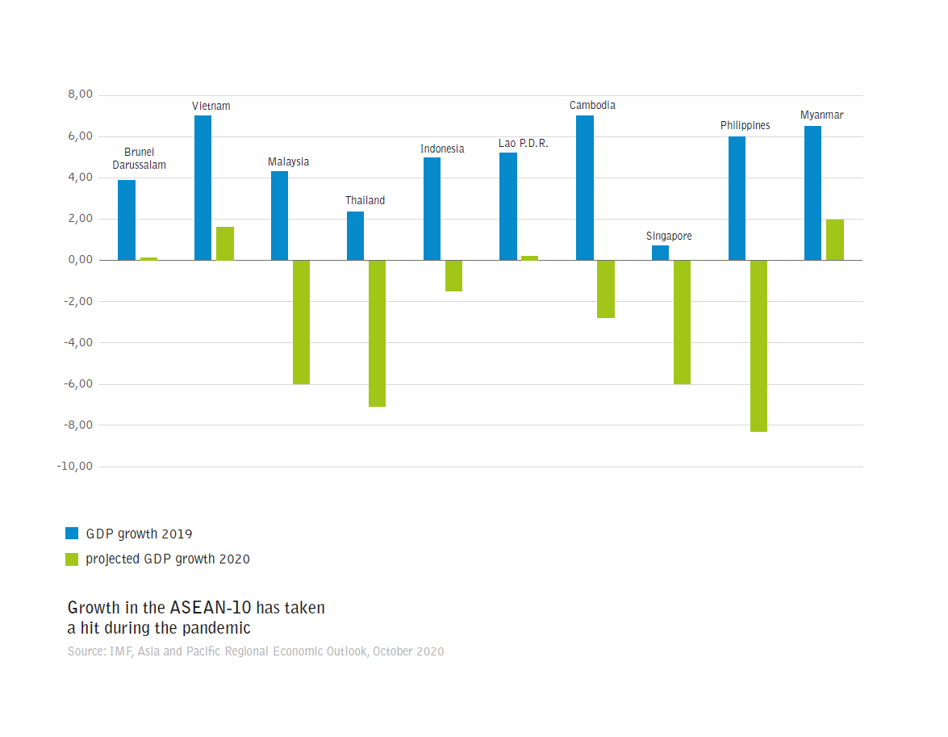
This Photo by Unknown Author is licensed under CC BY-NC-ND

Malaysian PLC notably contribute to the Malaysian economy. Among these companies
business sustainability is a critical concern, shown in reports and news. Worldwide political, social and global competition cause uncertainty at this companies making the stakeholders to have pressure on them. Pillars of the business intelligence are the business analysis, enterprise reporting and management performance.

Tree strategic impacts of PLC is presented in the article:
- Strategic impact 1 : Enhancing Economic Performance.
Business intelligence utilization has impact on marketing and sales, management and internal operation and obtainment.
( Puklavec et al., 2018)
Business intelligence helps determine sales, customer requests, complaints, customer behaviour, market demand, cost reduction, product development, income increase.
( Eidizadeh et al., 2017)

- Strategic impact 2 : Strengthening Environmental Performance
As studies shows business intelligence utilization allow organisations to have strategic planning, improvements in performance and competitive advantage by giving data and analytical capabilities for stakeholders decisions.
( Puklavec et al., 2018)

- Strategic impact 3: Reinforcing Social Performance
Business intelligence gives faster and easier access to information, spotting opportunities and threats in the market. Business intelligence helps companies to have understanding about their employees morale, their knowledge sharing and innovation, also reinforces the social performance of the companies.

This paper of Yu Yin Lim and Ai Ping Teoh highlights the strategic impact of business intelligence utilization and this increase the economic performance, strengthens the environmental performance and social performance is reinforced.
Business intelligence become an important concept with the availability of “big data” used for managerial decision making. Big data is important for discovering hidden patterns, market trends, customer preferences for companies.
Big data also known as data economy is concerned with the production of a large and constant stream of data which is monitored and analysed buy advanced technologies to provide awareness needed for better decision making and enhanced business performance, as well as to create value for the development.
( Accountants Today, Nov/Dec 2014)

Big data vendors provide services to help businesses to identify big data use and solutions to problems to improve business performance of companies.
Malaysia’s Ministry of Communications and Multimedia drives the Big data initiative willing to become the regional big data hub, expecting to generate a revenue of 270 million by 2020.

Benefits of big data analytics are based on the principles of management accounting, providing information for better decision making to improve efficiency and effectiveness of business. (Drury, 2012)
Business intelligence joined with regular work practices will extract “big data” very quick to make the right decisions.
Top 10 companies that provide big data analytics in Malaysia and abroad are top in sales volume. These companies are related to intelligence and research, global information services, analytic solutions, data technology, data and artificial intelligence companies.
As sustainability of Malaysian PLC’s may be at risk because of the worldwide political social changes and competitions their best decisions would be data based decisions, that will move the businesses to new heights and adaptable for changes.

References

Bank of Negara Malaysia (2019), ‘’ Economic and financial developments in Malaysia in the second quarter of 2019’’ , www.bnm.gov.my , (19.September 2019)

Eidizadeh, R., Salehzadeh, R. and Chitsaz Esfahani, A. (2017), ‘’Analysis the role of business intelligence, knowledge sharing and organisational innovation on gaining competitive advantage’’ , Journal of Workplace Learning, Vol 29 No. 4, pp. 250-267

Puclavec, B. Oliveira, T. and Popovic, A. (2018) , ‘’Understanding the determinants of business intelligence system adoption stages: An empirical study of SMEs’’, Industrial Management & Data Systems, Vol. 118 No. 1, pp. 236-261

https://www.emerald.com/insight

https://www.forbes.com/business

http://journals.business.com

