A Report Reviewing a Journal Article on a Current Business Trend

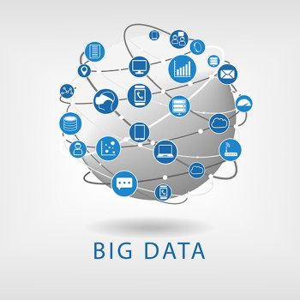
Figure 1: Big Data image (Galetto, 2016)

April 2019

Module Name: Data Handling and Business Intelligence – M5X00842
Title of Journal Article: Price/Performance Considerations in Building Data Warehouses for Big Data
Name: Shannon Jenkins
Student Number: 1706656

Table of Contents

- Executive Summary – page 1
- Introduction – page 2
  - Report Remit – page 2
  - A Description of Data Warehouses – page 2
  - A Description of the Importance of Data Warehouses – page 2
  - An Explanation of the Basis of the Study – page 3
  - Implications – page 3
  - Conclusions – page 3
- References used – page 3

List of Figures

Figure 1: Big Data image (Galetto, 2016)
Figure 2: Data Warehouse diagram (Panoply, N.D.)

1
Executive Summary

Within this report, there will be an analysis of the journal article titled “Price/Performance Considerations in Building Data Warehouses for Big Data.” This is an article which discusses a number of the things involved in a company deciding on which data warehouse they should use, or if they should create their own. Throughout the report, there will be a number of definitions. Moreover, there will be figures used where appropriate. Finally, there will be a description of data warehouses, a section on the importance of them, an explanation of the basis of the study and a paragraph on implications and conclusions.

2
2: Introduction

According to (Oracle, N.D.), big data is “larger, more complex data sets, especially from new data sources.” This simply means that there are groups of data of a significant size. For example, a sizeable client base or a considerable number of statistics that are relevant to the business’ goals. Often times, a company’s data sets are too large for the usual data processing systems to handle them efficiently. Therefore, companies must use a data warehouse. This is a significant database where data collected from various sources is stored. Following this, it is integrated and processed before a visualisation of the data takes place. (Edureka!, 2017)

2.1: Report Remit

This report seeks to review a journal article written on a current trend within the business world, namely data warehouses. It will include an assessment of the points brought forward in the journal article, along with the ideas mentioned by the author. Also, the use of relevant definitions and figures will be made throughout the report.

2.2: A Description of Data Warehouses

As aforementioned, a data warehouse is a significant database where data is stored, integrated and processed before a visualisation of the data takes place. According to (Kutemperor, 2015), the type of technology used in data warehouses is important, alongside how efficient the system is.
As stated by (Rouse, 2018), “a data warehouse is a federated repository for all the data collected by an enterprise's various operational systems, be they physical or logical.” An example of this would be the database that the NHS uses to store all of the patient information for every person in Great Britain. This is a considerable amount of data, which would inundate traditional databases. For this reason, a data warehouse would be more appropriate as it would be both more efficient and more technologically advanced.

2.3: A Description of the Importance of Data Warehouses

Within his journal article, (Kutemperor, 2015) mentions the importance of data warehouses. They have the power to impact on every employee in a workforce. This is due to the fact that top-level management makes strategic decisions only after receiving information from the data warehouse. Also brought up in the article are the main items that must be reviewed before one chooses to deploy a data warehouse. These include, but are not limited to Massively Parallel Processing, Scale-Up versus Scale-Out, and Multi-Modelling Architecture.

3
2.4: An Explanation of the Basis of the Study

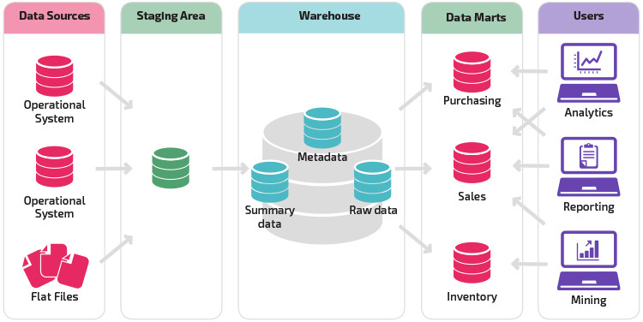
Figure 2: Data Warehouse diagram (Panoply, N.D.)
As seen in Figure 2, there are a number of different stages involved in data warehousing. The first stage is where all of the sources are thoroughly searched through for data, including the Operational Systems and Flat Files. Then, data is put through the Staging Area. Following this, it enters the data warehouse, where there three categories. Metadata, according to (Business Dictionary, N.D.), is a set of “data that serves to provide context or additional information about other data.” Furthermore, Summary Data is defined by (Borysowich, 2008), as the data that is “aggregated and/or summarised for performance reasons.” This means that the performance of the data warehouse is enhanced as there will be summary tables available to make it easier for businesses to run their queries. Raw Data is a self-explanatory term, simply meaning that the data involved has yet to go through any kind of processing. Data Marts are the next stage of the data warehouse. This is where data is available for purchasing, selling or is held in an inventory. Finally, those who use data warehouses to gather information for analytics will either purchase or sell data. Those who wish to report on the data will also purchase or sell information. Those who are data mining will either view the inventory or purchase information to use.

2.5: Implications and Conclusions

One major implication of using a data warehouse is the time-consuming preparation involved. Although the data warehousing system is meant to simplify data for use, “most of the work that will have to be done on your part is inputting the raw data.” (Author unknown, 2015.) In some ways, this defeats the objective of using the system. The purpose of using a data warehouse is to get the info0rmation you require sooner rather than later. If you have to spend a lot of time inputting the information yourself, this defeats the objective. According to (Kutemperor, 2015), in-memory technologies are made use of for their speed. However, “potential improvements are often overridden by inefficiencies inherent in standard databases.” This in itself is an issue as technology needs to have the ability to progress and mould to society’s ever-changing needs. Another point brought up by (Kutemperor, 2015) is the fact that “we get what we pay for.” According to the author of the journal article, there are a number of ways that a business could assess how much they should be spending on data warehouses. However, he states that “the best rule to apply is the price/performance ratio.” This simply means that a company should look into how effective a system is for the price that it costs. Despite all of the implications involved, there are also a number of positive aspects which may make it worthwhile for the right companies.

- References Used

Author Unknown, (2015), ‘The Pros & Cons of Data Warehouses’, Business Impact, 7th May, [available online at: http://businessimpactinc.com/blog/the-pros-cons-of-data-warehouses/], (accessed 26-04-2019)
Borysowich, C., (2008), Identifying Summary Tables (Data Warehouse), (accessed: 23-04-2019), [available online at: https://it.toolbox.com/blogs/craigborysowich/identifying-summary-tables-data-warehouse-112707]
Business Dictionary, (N.D.), Metadata, (accessed: 22-04-2019), [available online at: http://www.businessdictionary.com/definition/metadata.html]
Edureka!, (2017), Data Warehousing Tutorial for Beginners | Data Warehouse Concepts |Data Warehousing | Edureka, [available online at: https://www.youtube.com/watch?v=J326LIUrZM8], (accessed: 20-04-2019)
Galetto. M., (2016), How to Master Big Data Analytics: 51 Expert Tips for Learning Big Data Analytics, Education Opportunities and Getting More from Your Data, (accessed: 20-04-2019), [available online at: https://www.ngdata.com/mastering-big-data-analytics/]
Kutemperor. N. T., (2015), ‘Price/Performance Considerations in Building Data Warehouses for Big Data’, Business Intelligence Journal, Volume 20, Issue Number 2, pages 8-13.
Oracle, (date unknown), What is Big Data?, (accessed: 20-04-2019), [available online at: https://www.oracle.com/uk/big-data/guide/what-is-big-data.html]
Rouse. M, (2018), Data Warehouse, (accessed: 22-03-2019), [available online at: https://searchdatamanagement.techtarget.com/definition/data-warehouse]

