Cerys Versey (2217178)
Radio Frequency Systems (ACDA5019)
Investigating the Effect of Noise in SSB- SC and DSB- SC

Contents
- Contents
- Abstract
- Introduction
- Simulation models
- Results
- Discussion
- Conclusion
- References
Abstract
The following report hopes to give the reader a comprehensive review of Amplitude modulation(AM) , double side band suppressed carrier (DSB SC) and single side band supressed carrier (SSB SC) modulation as well as covering important concepts such as modulation index, SNR, noise tolerance and density. The report hopes to draw clear conclusion by following the full design, creation and analysis cycle.
Introduction
Task one will take the reader though the steps of creation of an AM modulation and demodulation as well as the effect critical, over and under modulation has on the carrier. There are a number of key terms the reader should be aware of before reading on.
Firstly carrier signal, this is the signal that is transmit and contains the message signal as well as the other signal that is used to modulate the signal. [1]
Another key concept to understand is a message signal as its name suggests this is the signal that contains the data that the user wants to send.
To be able to understand the different types of modulation you firstly need to understand what modulation does. Modulation is the ‘process by which data is converted into electrical / digital signals for transferring over a medium’ [2]. This is done by varying characteristics of the signal such as frequency, phase or amplitude [3].
Once modulation is understood the reader is able to understand the process of demodulation. This is the process by which date is converted back into its original form after being sent over a medium [4].
The final concept for the reader to be aware of before reading on is signal to noise ratio or SNR. SNR is a ratio of the amplitude of the message signal to that of the surrounding noise [5].
Task 1
Am modulation being where the carrier signal amplitude varies as the amplitude of the message varies. [6]
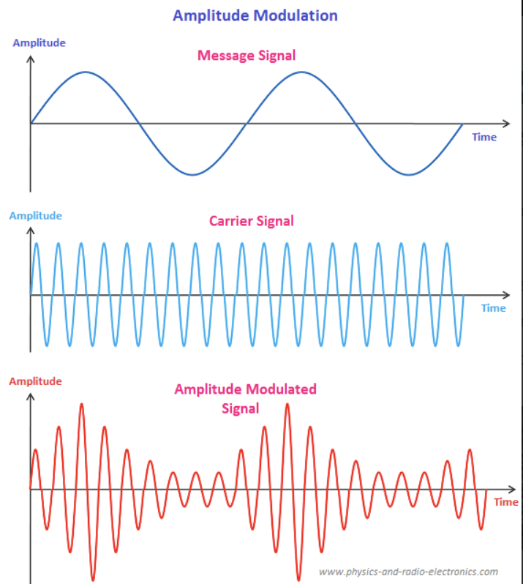
Figure 1 - Example of AM modulation (https://www.physics-and-radio-electronics.com/blog/amplitude-modulation/ )
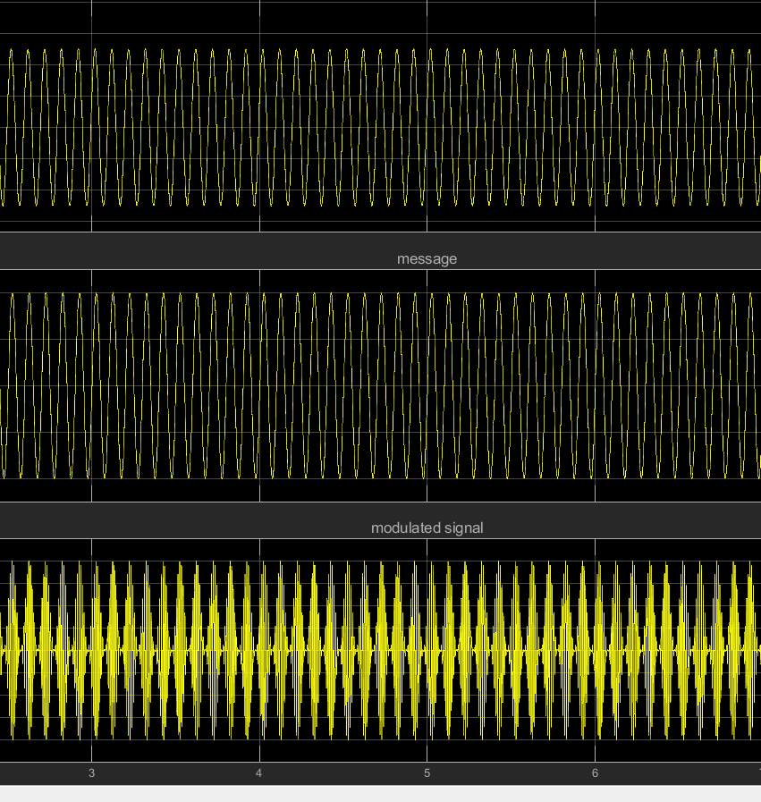
Figure 2 - Example of AM modulation made from a Simulink model
To create the initial AM modulation scheme, Simulink was used. The below diagram uses two colours to show the two parts of the transmission, transmit (in purple) which include the modulation and receive (in green) which includes the demodulation. Demodulation for AM signals can be done in two ways either by multiplying and then filtering or by using a peak detector in the below examples multiplication and filtering was chosen. To be able to check the accuracy of the modulation and demodulation a scope and spectrum analyser are used to compare the message signal before and after modulation and demodulation.
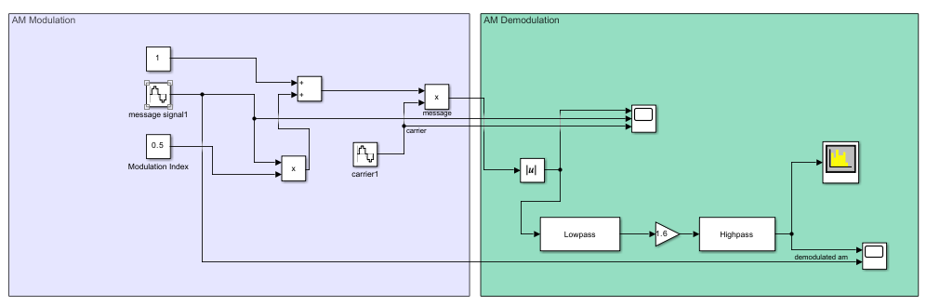
Figure 3 - AM Simulation model in Simulink
The modulation part of the model is designed using the expression for an amplitude modulated wave which is
$VAM=Ac sinωct(1+msinωt)$ [7]
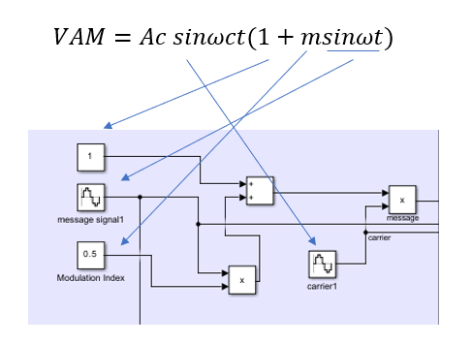
Figure 4 - Figure showing comparison between design and equation for AM modulation
You can directly relate different parts on the equation to parts of the model.
A signal that has been AM modulated has an associated modulation index. The modulation index is the ratio of the amplitude of the modulated signal to the amplitude of the carrier[8]. A modulation index less than one is considered under modulation, a modulation index of 1 is considered critical modulation this is where the amplitude of the carrier is equal to that of the modulated signal. When the modulation index is greater than one it is considered over modulation [9].
Initially a test was conducted using a modulation index of 0.8 (Last digit of student ID is 8) this is considered under modulation. The carrier frequency was 100 Hz and the message signal was at a frequency of 10 Hz.
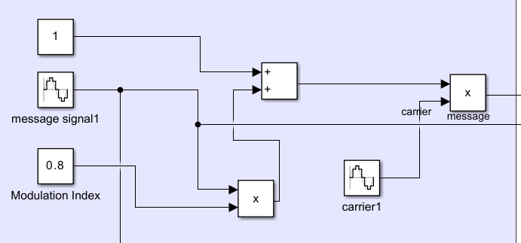
Figure 5 - AM modulation, modulation index of 0.8
This is considered under modulation, this causes the carrier to fall above zero but ultimately causes no distortion. As can be seen from the scope outputs. [10]
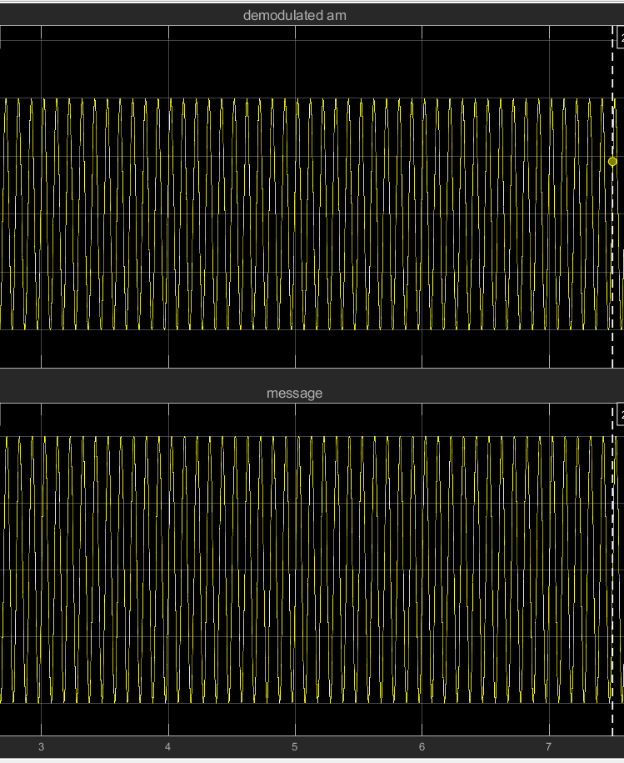
Figure 6 - Scope out from 0.8 AM modulation message and demodulated
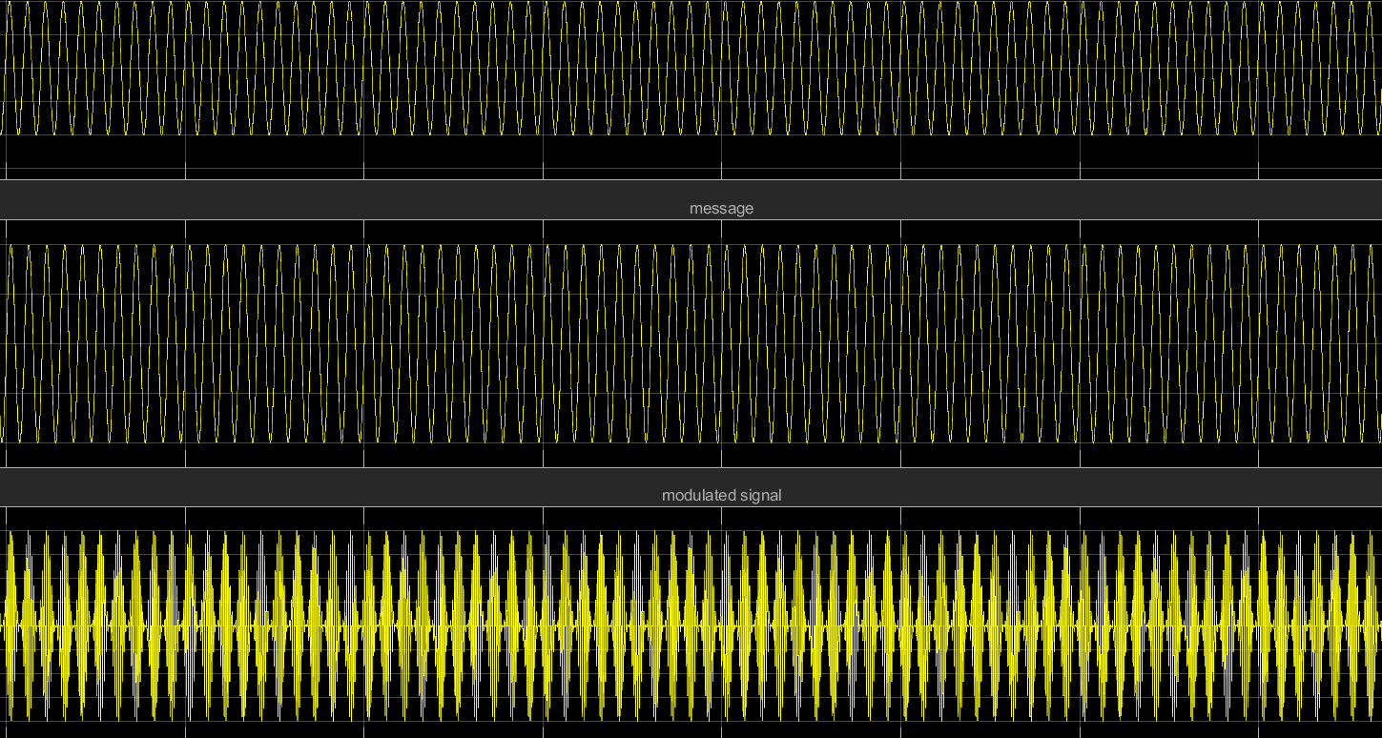
Figure 7 - Scope out from 0.8 modulation index message, modulated and demodulated
Critical modulation was then applied. This is where the modulation index is equal to 1. This is the ideal modulation index as the Amplitude of the carrier is equal to that of the message signal.
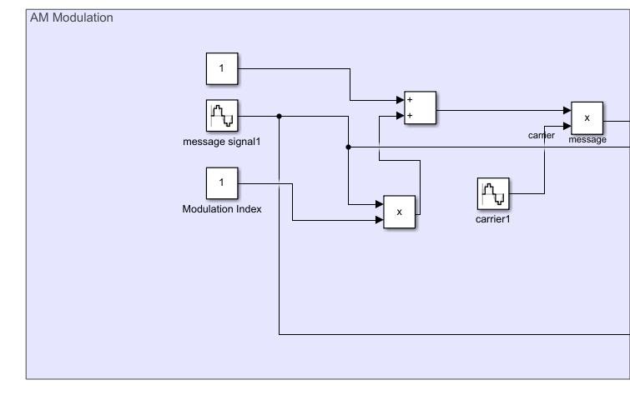
Figure 8 - AM modulation index of 1 (critical modulation)
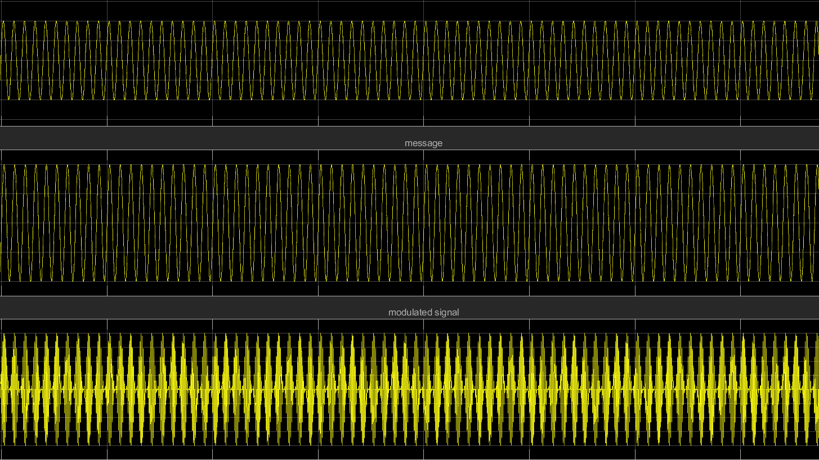
Figure 9 - scope output AM modulation critical modulation
As can be seen from the above scope trace this had no distortion affect on the signal at all.
Finally over modulation was tested. A value of 10 was chosen this is ten times the recommended modulation index, as can be seen from the below scope plots distortion has occurred.
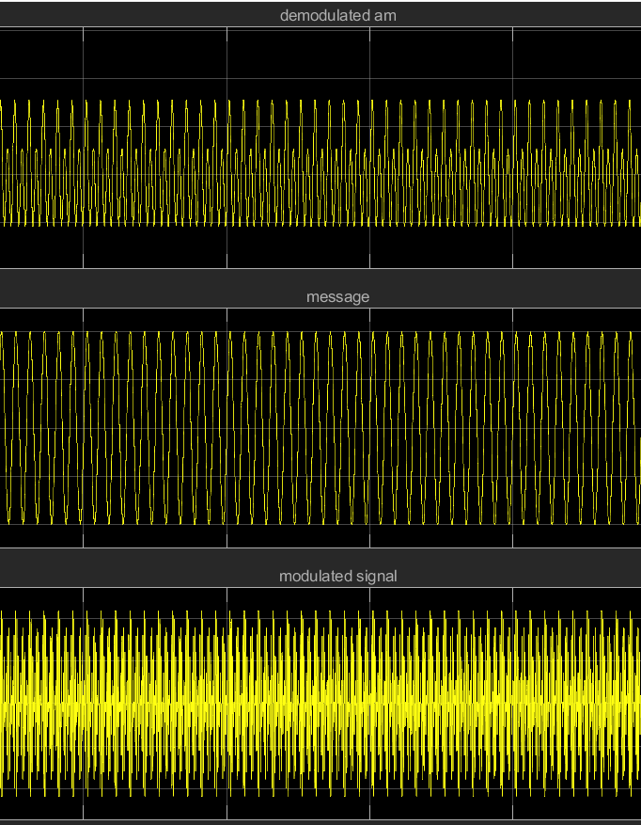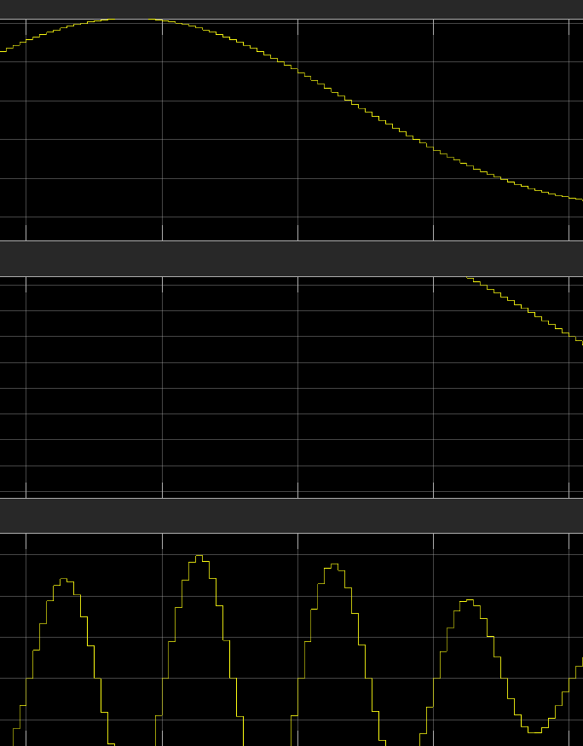
Figure 10 - am over modulation distortion
Figure 11 - scope out over modulation index of 10

This can be seen even clearer when comparing the message and demodulated signal which should look identical but has clear distortion.
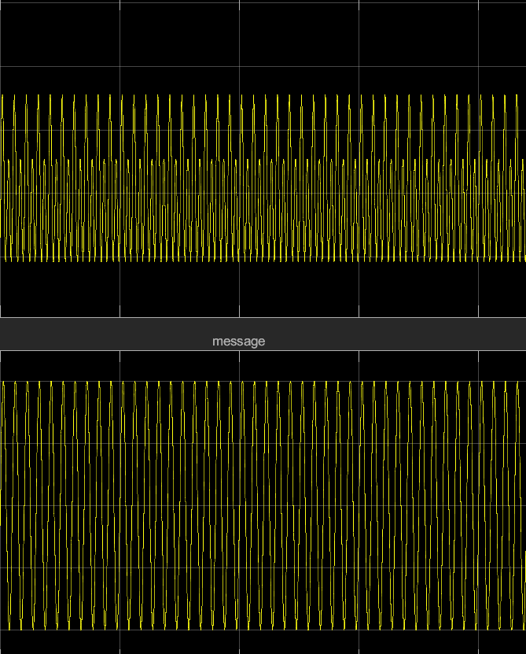
Figure 12 - AM modulation scope out message and demodulated
Task 2
Another type of modulation is Double side band supressed carrier (DSB SC) modulation this is a form of AM modulation [12]. This is where the sidebands of the signal are transmitted and the carrier signal is suppressed. This can be seen in the figure below.
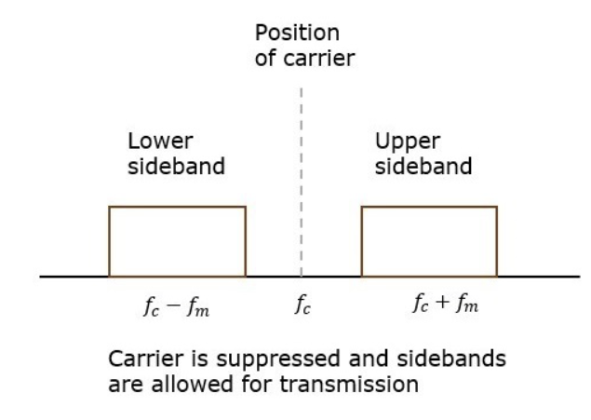
Figure 13 - Example of a DSB-SC transmission (Tutorials point)
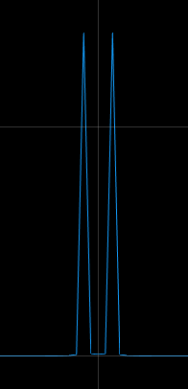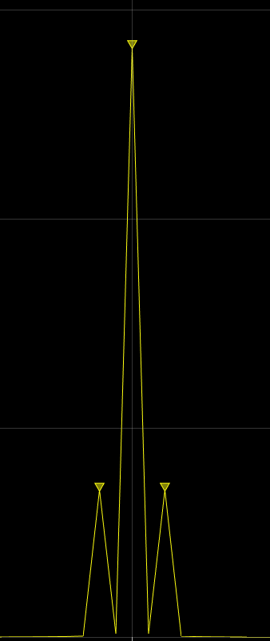
Figure 15 - Original message signal
Figure 14 - DSB SC Transmitted signal

This is done to improve efficiency to reduce the power loss as the carrier signal doesn’t carry any data and so power is being conserved by not transmitting the carrier [13]. To do this the message signal is copied into two. One is the carrier plus the message and one is the carrier minus the message signal. This gives the double side band aspect of DSBSC [14].
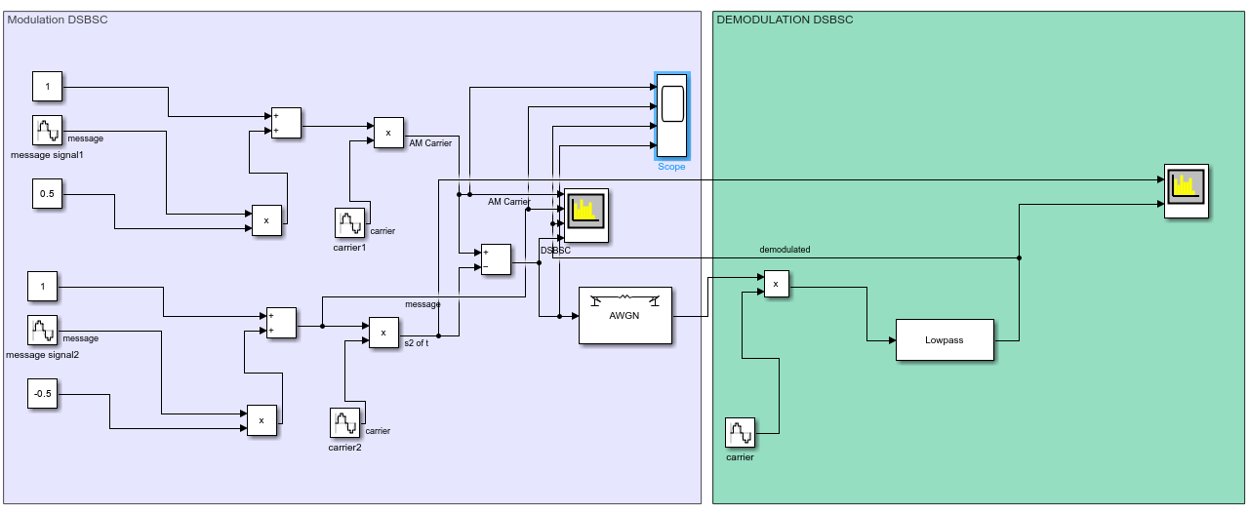
Figure 14 - DSBSC Simulink model NO AWGN modulation index 0.5
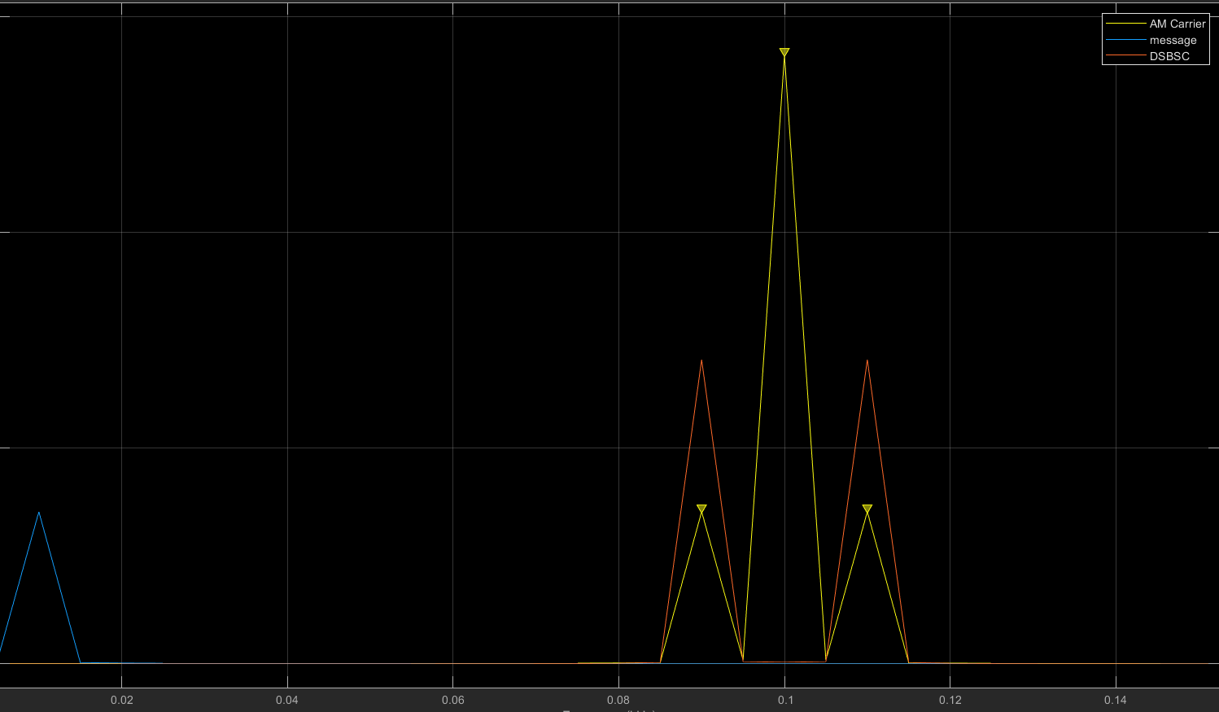
Figure 15 - DSBSC spectrum output Carrier, message, DSBSC
The above figure shows DSB-SC in the frequency domain, with a modulation index of 0.5. The message signal is at a frequency of 10 Hz and the carrier signal has a frequency of 100 Hz. This means the Side bands fall at 110 Hz (CF – MF) and 90 Hz (CF – MF) respectfully. This was done with no additive white Gaussian noise. As can be seen below the post modulation the message signal is the exact same frequency as initially transmitted.
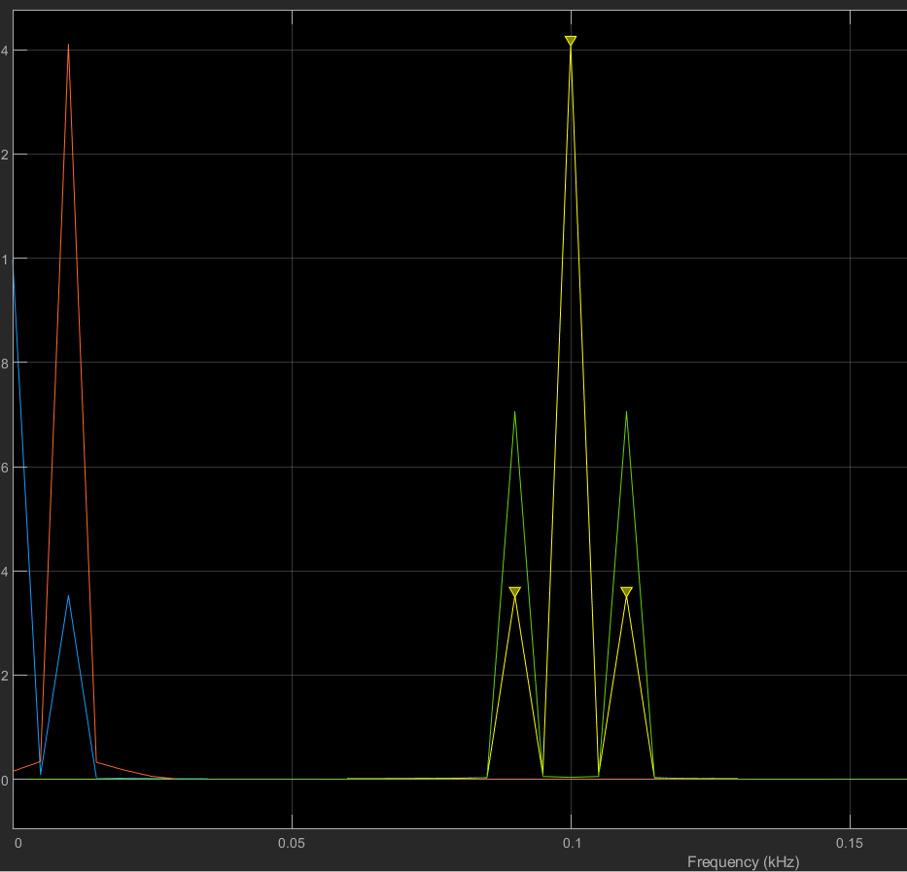
Figure 16 - Message, carrier, modulated and demodulated
This can also be seen from the scope output.
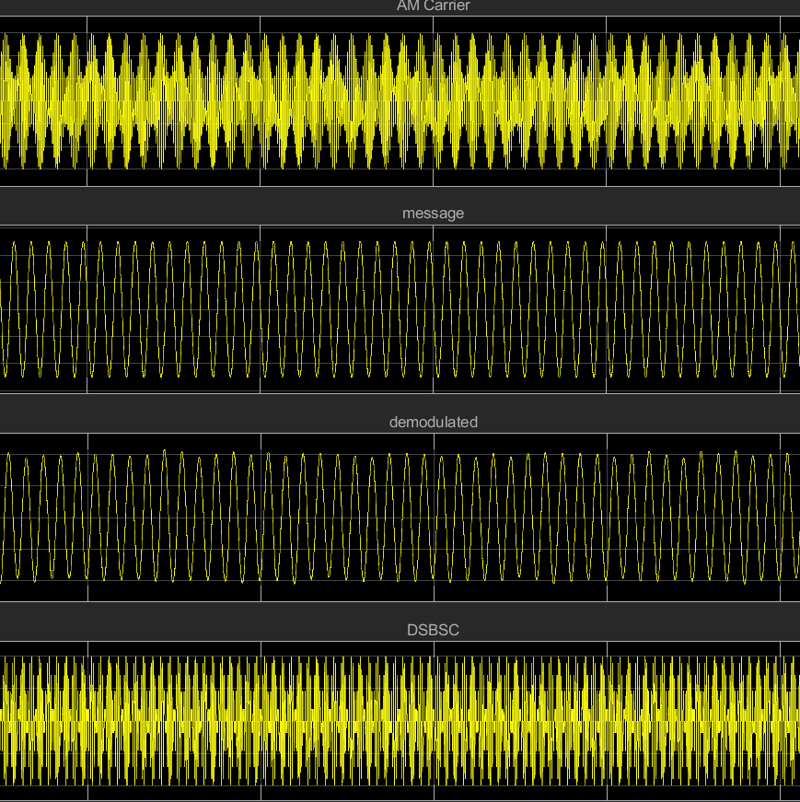
Figure 17 - DSB-SC scope output
AWGN was the added this was done by changing the SNR [15].
Initially no noise was added as a control, then the SNR was changed to 0.1 this means the signal is a 10th of the strength of the noise.
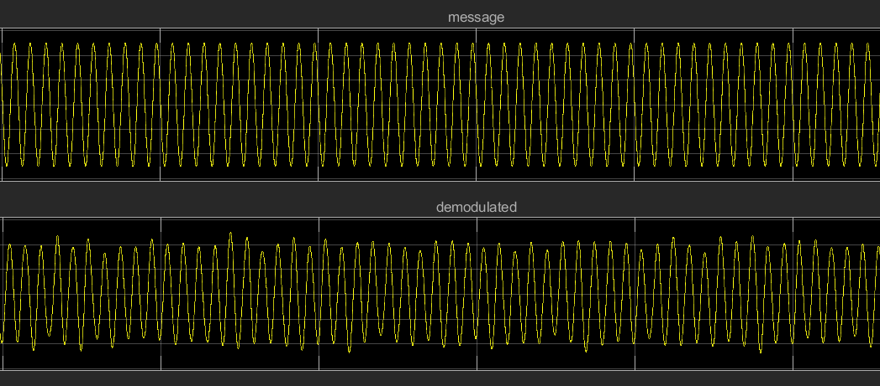
Figure 18 - DSBSC scope output message and demodulated signal noise (SNR 0.1)
Figure 19 - DSB-SC No noise and modulation index 0.5
As can be seen from the above figure the demodulated signal now has significant anomalies compared to the original message signal. This is further emphasised when looking at the scope with no added noise. This shows that with an increased noise level causes anomaly in the demodulated message signal.
It is important to note that like AM modulation DSB-SC can also be mathematically represented. This helps the reader to draw direct links between the equation and the model. [16]
s(t) = Ac [ m(t) cos(2πfct) - 1/2 m(t) cos(2π(f + fc)t) + 1/2 m(t) cos(2π(f - fc)t) [11]
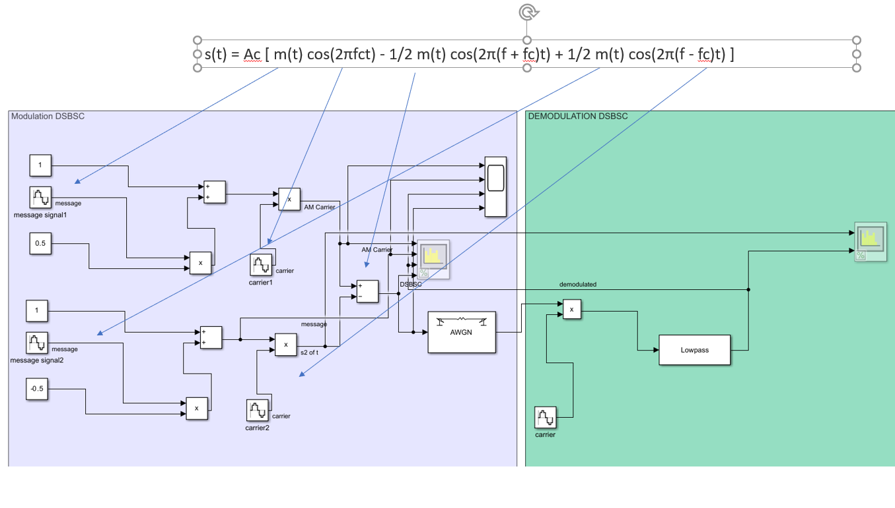
Figure 20 - DSBSC Model and equation
Task 3
Another type of AM modulation is SSB- SC or single side band suppressed carrier, this works the same as DSB -SC but with one side band not two.
The user can choose if they want to use the upper or lower side band.
As shown above modulation schemes can be expressed as equations, which can help the user to create the model. Depending on the which side band the user has chosen the middle block will be ++ or +-. In the below example it is ++ showing the upper side band was chosen[17].
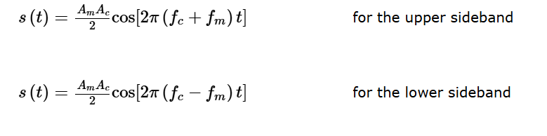
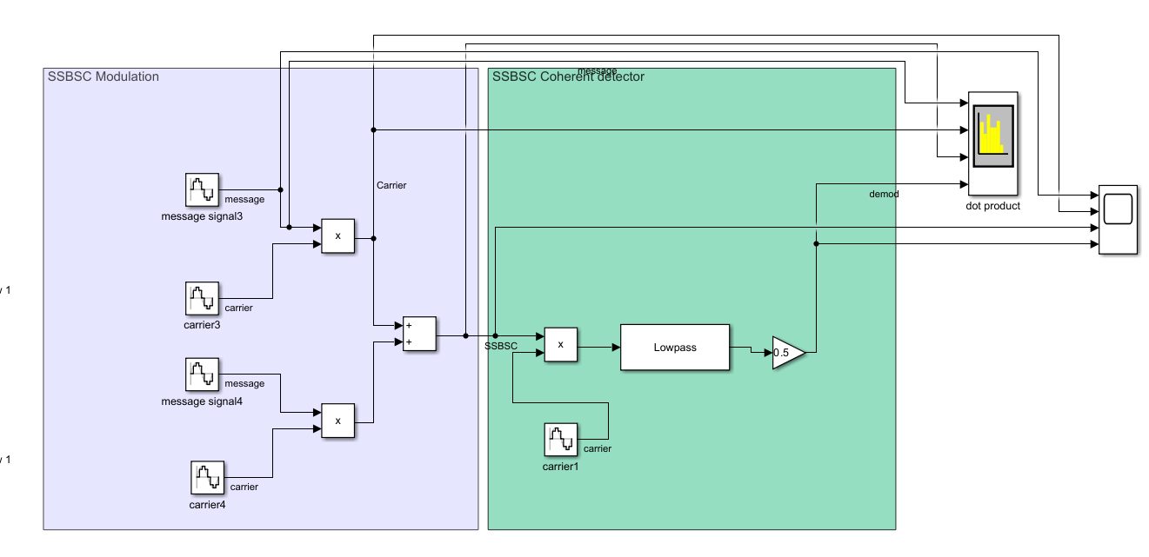
Figure 21 - SSB SC model and equation
When no noise is present the output in both the time and frequency domain is clear and distortion free.
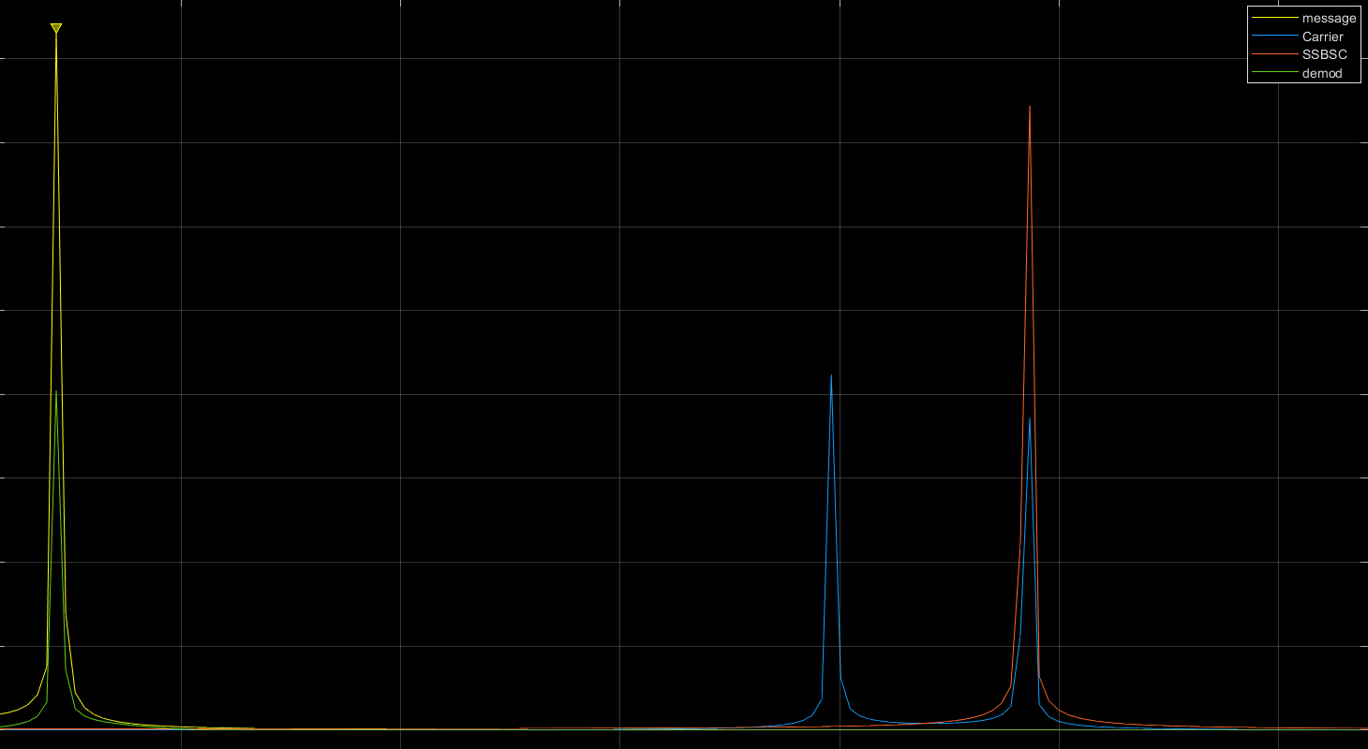
Figure 22 - SSB SC spectrum output
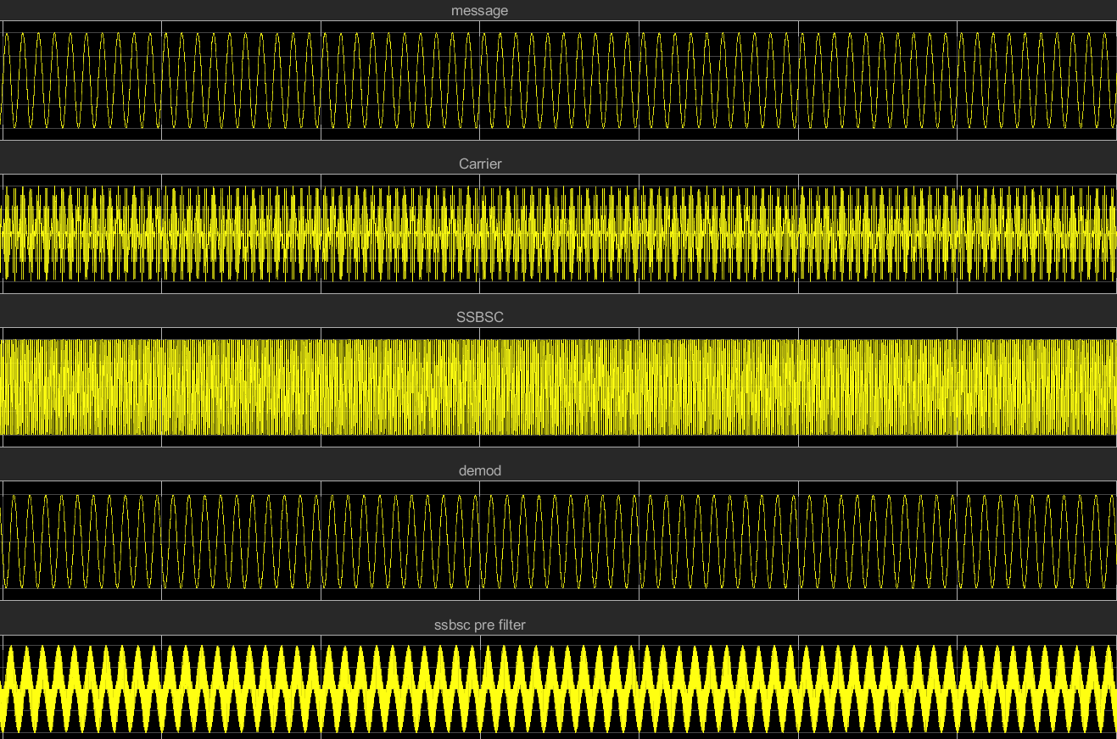
Figure 23 - SSB SC scope output
This is especially clear when you compare the message and the demodulated signal directly.
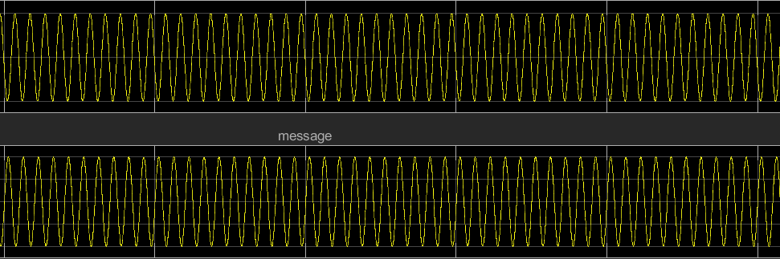
Figure 24 - SSB SC scope Message and Demodulated signal
Noise was then added to the SSB-SC scheme to see how it is affected by noise. This was done by adding an AWGN channel to be able to change the SNR.
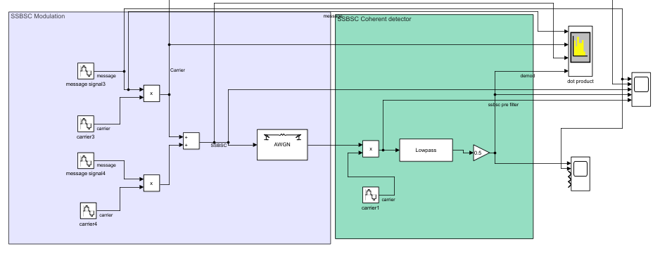
Figure 25 - SSB SC model
As done previously a test was done with no noise to have a set of control data the test was then reran with a SNR of 0.1, a 10th of the previous power to compare the effect noise has.
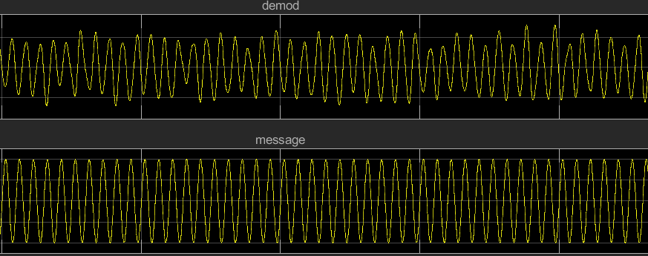
Figure 26 - message and demod SSBSC
As can be seen from the above schematic the noise increase had a significant effect to accuracy and quality of the demodulated message signal. Especially when compared to the demodulated output of the signal with no noise [18].
Figure 27 - SSBSC Demod no noise
Task 4
There are a number of ways to assess a modulation scheme, with the use of a spectrum analyser the user can review power levels, frequency shifts as well as any harmonics. With the use of a time scope the user can review distortion or delays in the signal. The signals can also be assessed using noise tolerance and power density. Bandwidth efficiency, power utilization and noise resistance are all key parameters that help the user to compare and contrast different modulation types for use in real world transmission [19].
AM, SSB-SC and DSB-SC will be reviewed in the above criteria to show the reader the performance of each modulation type, to help the reader select the correct option for there use case.
First each modulation scheme was review under a spectrum analyser.
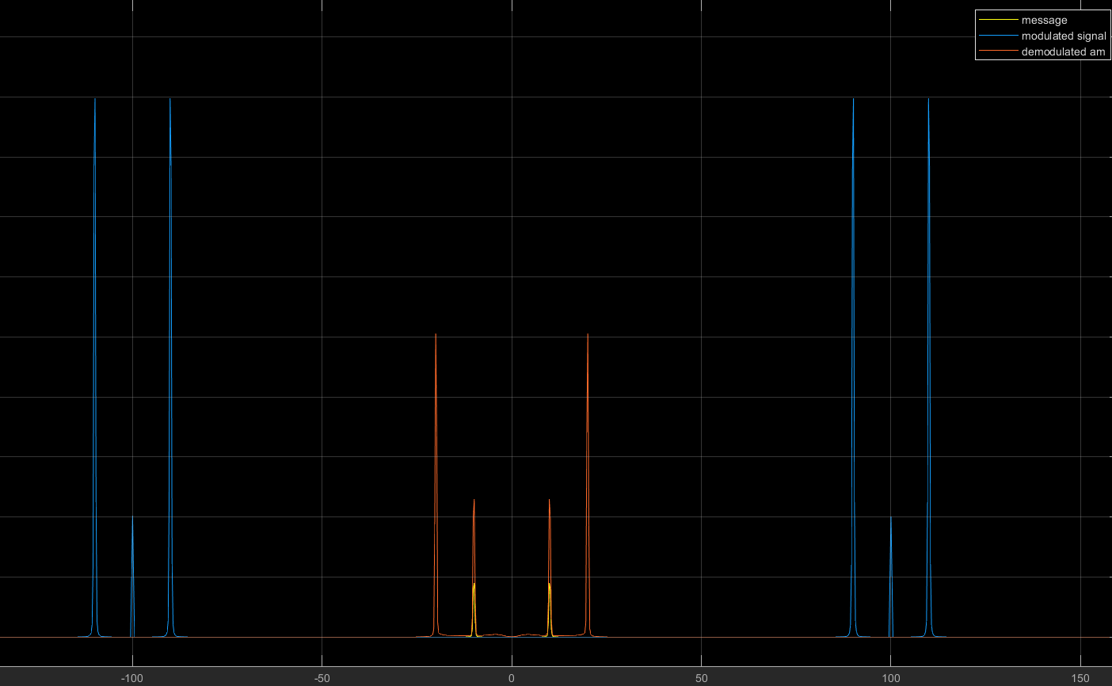
Figure 28 - AM Modulation, Message and Demodulation spectrum capture
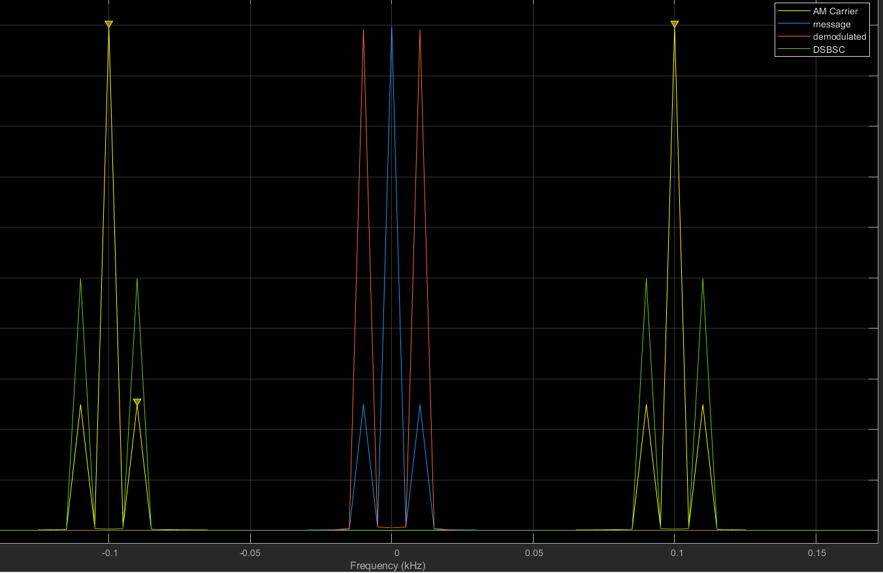
Figure 29- DSB-SC Modulation, Carrier, Message and Demodulation
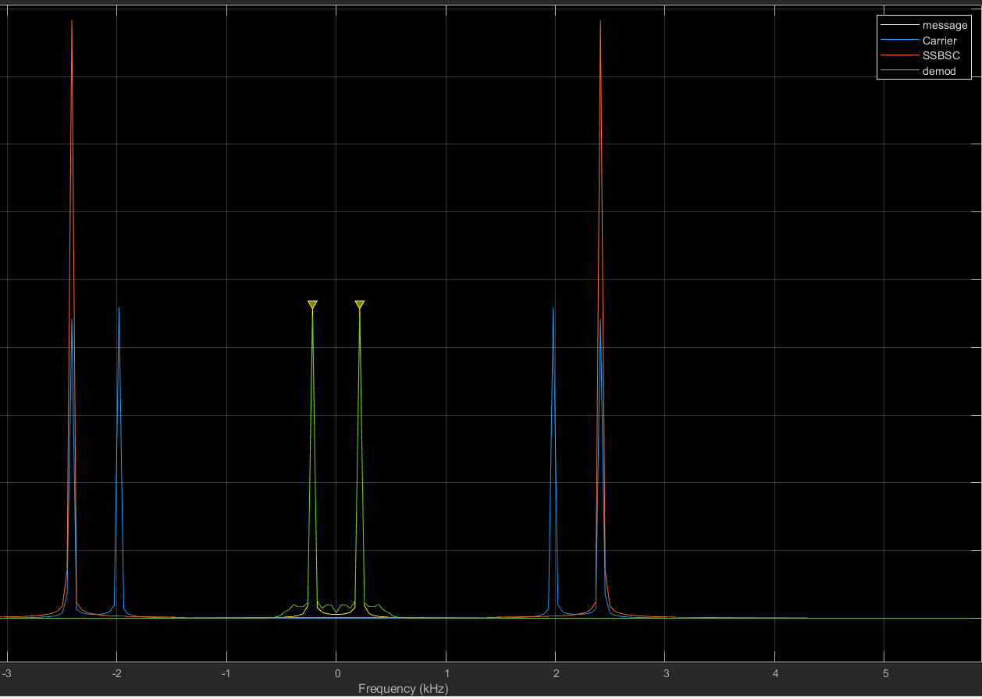
Figure 30 - SSB-SC Modulation, Carrier, Message and Demodulation
By viewing each modulation scheme with a spectrum analyser, you can first check each part of the modulation scheme is behaving as expected but can also use the features of the spectrum analyser to make power readings which can be used to calculate total power as well as power efficiency.
Power of signal power is half of the original message signal after modulation [19].
$$Ps=\frac{1}{2}Pm$$
Ps = 1 x 1 / 2 = 0.5 W
Carrier power is equal to that of the carrier and side bands and can be written as
$$Pc=\frac{1}{2}A^{2}$$
Pc = ½ x 2^2 = 2 W
This means the total power is the power of the message signal and the carrier and side bands.
$total power=Pc+Ps$ [20]
Total power = 0.5 + 2 = 2.5 W
Useful power is the message signal power after modulation.
Useful power = 0.5
Power efficiency is the proportion of useful power over total power
$$Power Efficency=\frac{Ps}{\left(Pc+Ps\right) }$$

Power efficiency for the AM modulated signal
Power efficiency = 0.5 / 2.5 = 0.2
Power efficiency for DSBBSC = 0.5 / 2.5
Power for SSB SC = 0.5 / 2.5
The power efficiency values above suggest that the power efficiency is all the same however this is incorrect, SSB SC is the most power efficient as it only uses half that of DSBSC, where as DSBSC uses less than AM ultimately making SSB SC the most power and spectrally efficient form of modulation.
Another value we can compare is SNR values we can also calculate the figure of merit. The figure of merit is the SNR of the demodulated output to the SNR of that at the receiver input.
$$Figure of merit=\frac{SNRo}{SNRc}$$
$$SNR C=\frac{Average power at reciever input}{average noise power at the recieever input}$$
$$SNR C=\frac{ AC^{2}\left(1+KA^{2}\right)P}{2WN0}$$
Ac = amplitude of the carrier
P = power of the message signal
Ka = m = 0.5
P noise = No x W
W = message bandwidth
$$SNRo=\frac{Average power of demodulayed message signal}{Average power of noise demodulated output }$$

$SNR 0=\frac{AC^{2}Ka^{2}p}{2WN0}$[21]
Figure of merit
For AM AWGN (SNR 0)
SNRO = 0.3080583 / 0.0190788
SNR C = 1.01076 / 0.00919122
Figure of merit = 16.14667348 / 109.97061672 = 0.14682
For SSB SC AWGN (SNR 0)
SNR 0 = 0.445949 / 0.020484
SNR C = 0.872419 / 0.0405286
Figure of merit = 21.77060145 / 215.2600879 = 0.10113626559
For DSB SC AWGN (SNR 0)
SNR O = 1.01332 / 0.0572615
SNR C = 0.515108 / 0.060541
Figure of merit = 17.69635794 / 8.508415784 = 2.079865205

For AM AWGN (SNR 0.1)
SNR 0 = 0.382214 / 0.195462
SNR C = 1.01608 / 0.0191556
Figure of merit = 1.955438909 / 85.27337364 = 0.02293141253
For SSB SC AWGN (SNR 0.1)
SNR O = 0.446038 / 0.0202635
SNR C = 0.872532 / 0.0400662
Figure of merit = 22.01189331 / 21.77725864 = 1.010774298
For DSB SC AWGN (SNR 0.1)
SNR O = 0.993363 / 0.0662247 = 14.99988675
SNR C = 0.514914 / 0.59848 = 8.60369603
Figure of merit = 1.743423605
For AM AWGN (SNR 0.01)
SNR O = 0.380746 / 0.0356199 = 10.68913725
SNR C = 1.01075 / 0.234147 = 4.316732651
Figure of merit = 2.47621016
For SSB SC AWGN (SNR0.01)
SNR O = 0.445958 / 0.0204621 = 21.79434173
SNR C = 0.87243 / 0.0404821 = 21.55100649
Figure of merit = 1.011290072
For DSB SC AWGN (SNR 0.01)
SNR O = 1.0133 / 0.066903
SNR C = 0.515089 / 0.0604713
Figure of merit = 15.14580811 / 8.517906842 = 1.778113936
(SNR) | 0 | 0.1 | 0.01
AM | 0.14682 | 0.02293141253 | 2.47621016
SSB SC | 0.10113626559 | 1.010774298 | 1.011290072
DSBSC | 2.079865205 | 1.743423605 | 1.778113936

As can be seen from the figure of merits above DSB SC always has a higher Figure of merit, this is twice that of SSB SC and almost ten times that of AM modulation.
Inconclusion SSBSC has the lowest overall bandwidth requirement with it being equal to that of the message frequency whereas the DSB SC has a bandwidth of twice the message frequency. SSB SC saves the most power as it has the least to transmit. However, SSB SC can easily be affected by noise as seen previously, however this does also apply to the other modulation schemes too. Despite using less power SSB SC and DSBSC both struggle with power efficiency but are overall both low power and low cost options.
Ultimately the best modulation scheme choice comes down to the requirements of the user and the priorities they have, if the user is looking for power efficiency AM is the best choice however is the user is more concerned with overall bandwidth then SSB SC is the best choice.
To help the user make a more informed decision it is recommended the user runs tests using all 3 types of modulates with a variety of noise and power levels and compares against there key criteria to further help the user understand the options available.

[1] | "Carrier Signal." Network Encyclopedia. Accessed: 30/12/2024. [Online]. Available: Carrier Signal - NETWORK ENCYCLOPEDIA
[3] | "What is modulation?" Electronics coach. Accessed: 30/12/2024. [Online]. Available: What is Modulation? Definition, Need of Modulation and Types of Modulation - Electronics Coach
[2] | "What is modulation?" Geeks for Geeks. Accessed: 30/12/2024. [Online]. Available: What is Modulation? - GeeksforGeeks
[4] | "Modulation and Demodulation" BYJU's . Accessed: 30/12/2024. [Online]. Available: What is Modulation and Demodulation? - Definition, Types, Differences, Video and FAQs
[5] | W. Amplifiers. "What is SNR and How Does it Affect Your Signal?." Wilson Amplifiers . Accessed: 30/12/2024. [Online]. Available: What is SNR and How Does it Affect Your Signal?
[6] | T. Roleandts "How Does Amplitude Modulation Work?" T omRoelandts Accessed: 30/12/2024. [Online]. Available: How Does Amplitude Modulation Work? | TomRoelandts.com
[7] | "What is amplitude modulation ? Definition, Derivation, Waveform and Formula." Electrical workbook. Accessed: 30/12.2024. [Online]. Available: What is Amplitude Modulation (AM)? Definition, Derivation, Waveform & Formula - ElectricalWorkbook
[8] | Sasmita "Modulation Index or Modulation Factor of AM Wave." Electronics Post. Accessed: 30/12.2024. [Online]. Available: Modulation Index or Modulation Factor of AM Wave - Electronics Post
[9] | "Amplitude Modulation: Understanding the Basics" RF Engineer. Accessed: 30/12.2024. [Online]. Available: Amplitude Modulation: Understanding the Basics | RF ENGINEER NETWORK
[10] | A.Shaik "Amplitude Modulation" Physics and radio-electronics. Accessed: 30/12.2024. [Online]. Available: Amplitude Modulation – Physics and Radio-Electronics
[12] | S. Arar "Understanding Double-Sideband Suppressed-Carrier Modulation" All about circuit . Accessed: 30/12.2024. [Online]. Available: Understanding Double-Sideband Suppressed-Carrier Modulation - Technical Articles
[11] | "DSBSC (Double Sideband Suppressed Carrier)." Telecom trainer. Accessed: 31/12/2024. [Online]. Available: DSBSC (Double Sideband Suppressed Carrier)
[13] | "Double Sideband Suppressed Carrier (DSB-SC) Modulation." Electronics Coach. Accessed: 2/01/2025. [Online]. Available: What is Double Sideband Suppressed Carrier Modulation (DSB-SC)? Definition, generation, applications of DSB-SC - Electronics Coach
[14] | D. S Arar "Understanding Double-Sideband Suppressed-Carrier Modulation" All about circuits. Accessed: 2/01/2025. [Online]. Available: Understanding Double-Sideband Suppressed-Carrier Modulation - Technical Articles
[15] | " AWGN Channel." Mathworks. Accessed: 02/1/2025. [Online]. Available: AWGN Channel
[16] | " |  | Chapter 6 | Double-Sideband | Suppressed-Carrier | Amplitude Modulation  ." UMD. Accessed: 02/1/2025. [Online]. Available: ch6.dvi
[17] | X.Lou . "Introduction to communication systems" Shanhai Univeristy. Accessed: 02/01/2024. [Online]. Available: Microsoft PowerPoint - Lecture7.pptx
[18] | K.Leung . "Communications 2." Computer Science. Accessed: 02/01/2025. [Online]. Available: Microsoft PowerPoint - Lecture4.ppt
[19] | J.Pauly . "Lecture 6: Modulators, Receivers, AM, and SSB." Stanford. Accessed: 02/01/2025. [Online]. Available: Lecture 6: Modulators, Receivers, AM, and SSB
[20] |  | . | "Calculate the power efficiency of AM signals  ". Accessed: 02/01/2025. [Online]. Available: Amplitite Modultion
[21] | "Analog Communication - SNR Calculation." Tutorials point. Accessed:02/01/2025. [Online]. Available: Analog Communication - SNR Calculations

Figure 1 - Example of AM modulation (https://www.physics-and-radio-electronics.com/blog/amplitude-modulation/ ) 2
Figure 2 - Example of AM modulation made from a Simulink model 2
Figure 3 - AM Simulation model in Simulink 3
Figure 4 - Figure showing comparison between design and equation for AM modulation 3
Figure 5 - AM modulation, modulation index of 0.8 4
Figure 6 - Scope out from 0.8 AM modulation message and demodulated 4
Figure 7 - Scope out from 0.8 modulation index message, modulated and demodulated 5
Figure 8 - AM modulation index of 1 (critical modulation) 5
Figure 9 - scope output AM modulation critical modulation 6
Figure 10 - am over modulation distortion 6
Figure 11 - scope out over modulation index of 10 6
Figure 12 - AM modulation scope out message and demodulated 7
Figure 13 - Example of a DSB-SC transmission (Tutorials point) 8
Figure 14 - DSBSC Simulink model NO AWGN modulation index 0.5 9
Figure 15 - DSBSC spectrum output Carrier, message, DSBSC 9
Figure 16 - Message, carrier, modulated and demodulated 10
Figure 17 - DSB-SC scope output 11
Figure 18 - DSBSC scope output message and demodulated signal noise (SNR 0.1) 11
Figure 19 - DSB-SC No noise and modulation index 0.5 12
Figure 20 - DSBSC Model and equation 12
Figure 21 - SSB SC model and equation 13
Figure 22 - SSB SC spectrum output 14
Figure 23 - SSB SC scope output 14
Figure 24 - SSB SC scope Message and Demodulated signal 15
Figure 25 - SSB SC model 15
Figure 26 - message and demod SSBSC 15
Figure 27 - SSBSC Demod no noise 16
Figure 28 - AM Modulation, Message and Demodulation spectrum capture 16
Figure 29- DSB-SC Modulation, Carrier, Message and Demodulation 17
Figure 30 - SSB-SC Modulation, Carrier, Message and Demodulation 17

