Student Number | 1806385
Programme Title | BA Business Management
Module Title | Managing People
Module Code | LCBB5004
Student Name | Nicoleta Claudia Burcus
Assignment Title | Assignment
Word Count | 2091 without references |  |  | Submission Deadline |  | 22.05.2020

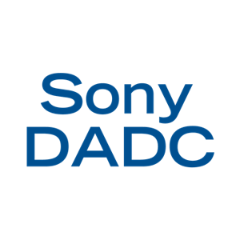
Training and Development
Employees are the backbone of a company. The management of a company manages the employees efficiently to increase employee morale. The employers and employees have certain responsibilities to each other so that cooperation can be ensured in the workplace. Employees training tries to improve skills or add to the existing level of knowledge so that employees are better equipped to do their present job, or to prepare them for higher position with increased responsibilities. However, individual growth is not and ends. Organisational growth needs to be measured along with individual growth.
Training refers to the teaching or learning activities done for the primary purpose of helping members of an organisation to acquire and apply the same. Broadly speaking, training is the act of increasing the knowledge and skills of an employee for doing a particular job.
In today’s scenario change is the order of the day and the only way to deal with it is to learn and grow. Employees have become central success or failure of an organisation. Another important asset of an organisation is human resource because with the help of the employees it can bring innovation and development in the organisation’s workplace.
The measurement of organisational performance helps to understand the outputs and inputs of a company. According to Katou (2015) it encloses three factors: the return of input, product market finance and financial performance. To measure the organisational performance a company needs to set smart goals for its employees. It is essential to manage the organisational performance to make sure that employees bring a substantial contribution to the organisation.

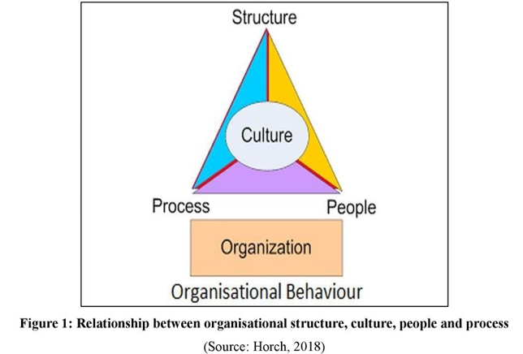
To perform the activities that have to be done an organisation needs to have experienced and very well-trained staff. If the requirements of the job are meet by the current occupants, then training is not necessary, but many times this is not the case and employees need to be well trained and acquire the necessary skills to meet the requirements of the job.
Today it is common for an individual to change their jobs several times in their lives, however, young individuals do not posses the skills necessary when they start a job so they need training.
Sony DADC is a leading disc and digital solution provider for the entertainment, information and education industries, offering world-class optical media replication services, digital and physical supply chain solutions and software services. The company’s network consists of service offices, optical media production, distribution and digital facilities in 19 countries around the world. The company designs, develops, produces and sells CDs, DVDs, UMDs, and Blu-ray Discs. (Sony DADC)
The first Sony DADC opened on 2nd of May 1983 in Terra Haute located in Indiana state and the first CD was produced in September 1984. At that time Sony DADC was manufacturing and selling the CDs in the United States, however, the distribution centre was located in Enfield, England and was distributing DVDs, CDs and LPs in over a hundred European countries. But not everything went well. In 2011, more precisely 8th of August, the warehouse from England was destroyed during the England riots. The fire destroyed stock worth of 3.5 million. However, this year Sony DADC closed its gates in Enfield and moved a part of the stock in another warehouse in Southwater.
The employees of the company receive training when they arrive at the site. None of the employees, even if they come through an agency or receive a contract is working without proper training. The training lasts three days for picking department, a week for forklift users and if they receive a contract for assistant team leader, team leader or above these positions the training can last longer. If the position is better, the responsibilities are greater, and the training lasts longer and includes more tasks that need to be accomplished.
Every employee is trained from the beginning about their role, what they have to do, what to pay attention to and, the most important thing, health and safety must be their main concern because if they pay attention to this then they can improve the workplace for them and for their colleagues.
In the organisation is a hierarchy. There are levels of authority starting from supervisors, assistant team leaders, team leaders, managers, etc. normal employees communicate their concerns to the supervisors and from there all the way up until the problem is solved. However, most employees came through an agency and if they have any kind of problem that is related to their payment or holiday only the agency can resolve it. This is an obstacle that is in the way of developing the organisation because the employees are not motivated to work anymore since most of their concerns and questions remain unanswered. The Sony staff can not do anything for them because they are employed by the agency and not by Sony DADC. This leads to a bigger problem. If the employees are not motivated to work efficiently then the growth of the company is stopped. Being the engine that makes an organisation grow and prosper, the employees need to be happy.
Sony DADC is an organisation that is structured in a way that encourages teamwork. Every department has its own team that works according to what they have to do. This way the productivity is enhanced.
According to Maduenyi (2015) to manage employees, organisational structure is very effective. To develop the organisation, the leaders, need to think about the development of the employees first. The organisation can not grow if its employees do not know well their role and what their work is. This is the reason why training is necessary. Training and development hold a very close relationship. They go hand in hand and they both have in their sight the employees. This is why the company needs to have very well-trained staff so that they can keep the employees happy.
Mintzberg stated in 2015 that managers and team leaders are a kind of slaves of the situation. They are in the middle between the employees and the company. Beside the responsibilities of their position, they must pay attention at the employee’s responsibilities and delegate tasks so that they are satisfied with their share of work.
In Sony DADC a team leader in picking department must manage about 20-30 employees. To be able to maintain the corporate culture of the organisation he/she uses different mechanisms. Their role is to lead the employees, to introduce visions so that the organisations goals are accomplished properly. As part of the team, the resources allocated to the employees have been the right amounts, in that way, the growth of the employees is in direct connection with the growth of the organisation.
To determine the effectiveness of management and leadership a few processes must be followed. According to Hindman (2019) gauging the employee feedback and financial data can help to measure the effectiveness of leaders and managers. To collect the data from the employees a survey is necessary and is a method that is used in most cases. The survey will be anonymous so that the personal information of the employees remains a secret and to help them feel safer when they do it.
A theory that refers to the human relation movement is the behavioural management and it addresses to the dimension of work people. By observing the nature of human behaviour in the workplace such as expectations, group dimensions, conflicts, friendships, a manager or a team leader can gain a better understanding of this theory.
According to Lee and Hanna (2015) the need for satisfaction motivates human behaviours. In the workplace employees seek love, esteem, self-actualisations, psychology and safety. To fulfil these requirements a manager or a team-leader needs to use behavioural approaches.
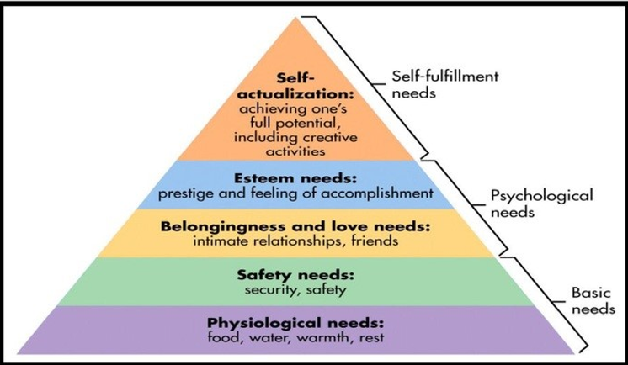
Figure 2: Maslow’s hierarchy of needs (Source: Lee and Hanna, 2015)
At Sony DADC, these tasks need to be fulfilled by the team leaders. They are the first ones that have contact with the employees, know their names, their struggles and try to make them motivated by all means. However, this is no easy task. Even if they want to help their team, not all of it depends on them. Above them are the managers and the managers of managers. Is a chain that goes all the way up in the offices.
According to Douglas McGregor (Lawter, L. 2015) there are two theories that divide managers. Theory X states that there are managers that view their subordinates in a negative way and Theory Y stating that there is a part of managers that feel that employees are capable of taking risks and that are trustworthy. To motivate the employees to work the behavioural approaches of management are a strong tool. These approaches are also beneficial to monitor the behaviours of the employees.
Sony DADC is training their staff in a way so that they can help their employees and keep them motivated. In that way they can work more effectively. Keeping them happy is assuring that the productivity of the organisation is good. Another factor about which the managers have to be assertive to is the interpersonal work. The manager s and team leaders have the duty to motivate the labours of the organisation. Managers have the figure role of being the figureheads and inspire authority. Their essential interpersonal work is to deal with relationships in the workplace.
To human resource development training is the most important technique because it develops efficiency and human skills. Many processes depend on training, such as productivity, organisational efficiency, development and progress. Acquiring these traits, the employees that are trained become a very valuable asset for a company or for an organisation. Through training it also can be achieved growth, stability and viability.
Training has a lot of benefits such as helping performance in employees, achieving the capacity of growth in the company, flexibility and stability, avoiding damages to machinery, scraps and accidents, is an effective source of recruitment, reduces turnover of employees, complaints, absenteeism and dissatisfaction, helps employees to handle conflicts, frustration, tension and also stress, improves organisational communications and the moral of workforce, helping to develop a sense of responsibility and adjusting to change.
There is a difference between training and development since training has the focus on skills and development in creating learning abilities. Training assumes a formal education and development is not education dependent. The needs of training depend on the lack or deficiency on skills whereas development is depending on ambition and personal drive. The training is based on need and development is voluntary. Being a narrow concept, training focus is on job related skills. Being a broad concept, development is focused on personality development. The most important difference between these two concepts is that training may not include development, whereas, development includes training if it is necessary.
The objectives of training are to prepare the employee to meet the requirements of the job and also of the organisation, to communicate new employees the knowledge and skill they need to acquire to perform decent at the job and to ensure efficient and smooth working of the company.
Also, training does not exclude costs. In this cost are included employment of trainees and trainers, the means to learn, running and maintenance of training centres and much more unpredictable costs.
At Sony DADC training is provided on the job. This is a method applied at the workplace while the employees are working. This is the best way to train an employee since he/she can see and understand the concepts that are explained to them by the trainer. Also, if the employee is trained to drive a forklift it can not be trained in another place since there will be the place where he/she will work. The organisation does not discriminate between males and females when it comes to train for forklift drivers. Many forklift drivers from Sony DADC are females and they are doing their job efficiently. The evaluation of training can be through questionnaires, mails and feedback from training department.
Conclusion
It can be observed that training and development in Sony DADC has been done thoughtfully and with consideration to health and safety for both the employees and employers. Since the employees are a very important asset of the organisation, they need to be considered at every step that the company takes. Even if they work with a contract or they came through an agency, they are the key for a successful business. That is why training and development of the employees is such an important task that every organisation needs to be aware of.

References
Elsmore, P., 2017. Organisational culture: organisational change
Hindman, H.J., 2019, Aesthetic management of emergency endovascular thrombectomy for acute ischemic stroke, part 1: patient characteristics, determinants of effectiveness, and effect of blood pressure on outcome. Anaesthesia & Analgesia, 128 (4), pp. 695-705
Horch, H.D., 2018, The intermediary organisational structure of voluntary associations. Voluntary sector Review, pp. 55-72
Katou, A. A., 2015, Transformational leadership and organisational performance: Three serially mediating mechanisms. Employee relations, 37 (3), pp. 329-353, Available at: http://www.kelloggs.co.uk/en_GB/home.html
Lawter, L., Kopelman, R.E., and Prottas D.J., 2015, McGregor’s theory X/Y and job performance: A multilevel, multi-source analysis. Journal of managerial issues, pp. 84-101
Lee, J.M., and Hanna, S.D., 2015. Saving goals and saving behaviour from a perspective of Maslow’s hierarchy of needs. Journal of Financial Counselling and Planning
Maduenyi, S., Oke, A.O., Fadeyi, O., and Ajagbe A.M., 2015. Impact of organisational structure on organisational performance
sony.net 2019. Sony Global - Sony Global Headquarters. [online] Sony.net. Available at: https://www.sony.net [Accessed 4 Apr. 2019]
Sony DADC. Retrieved from https://www.sonydadc.com/ [15.05.2020]

