Riverside Health Centre

Kelene’s Feasibility Sections
UPRN PROJECT REFERENCE: 6003
REF: 6003-UWTSD-XX-XX-T-X-0000-Feasibility
MAIN REPORT APRIL 2024


4.4 Contamination and Pollution

Dating back to the 1870s, the site location held the London Neath Pyle Train Station. Within the 1890s, opposite the site, there was both an Iron Foundry and Morgans & Morsel Tin Plate Works. Based on research the timeline indicates that the Iron Foundry remained until the 1880’s while the Tin Plate works functioned until 1910. The Tin Plate Works reopened in the 1930s known as Byoss Works within the exact location previously, it was then removed again in the 1940s permanently. In summary, this general location has hosted steel, engine, tin plate, and chemical works. There was also an Iron Foundry, Gasholder, Hydraulic pumps, Quarries, and Rail stations from the 1870s to the present. The maps below identify the locations of a few of these industrial activities taking place.
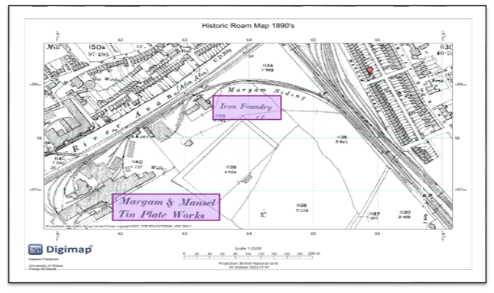 Figure 9 - Map showing the Tin Plate works and Iron Foundry opposite the chosen site area taken from Digimap, (1890)
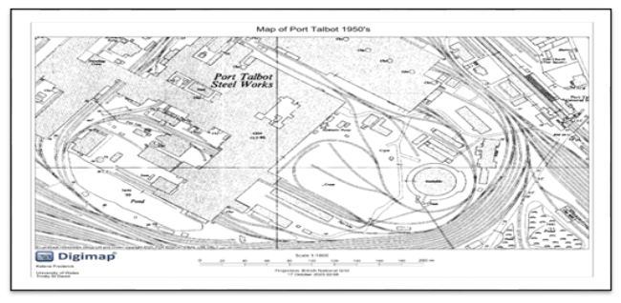Figure 10 - Map showing Steelworks, Gasholder and hydraulic pumps in the chosen site area taken from Digimap, (1950)
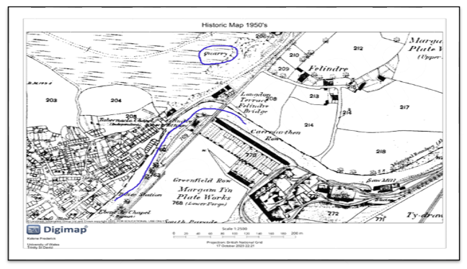Figure 11 - Map showing the Quarry adjacent to River Afan that runs along the chosen site area, taken from Digimap, (1950)

Monitoring and Testing
To improve the air quality the following gases are monitored in the Port Talbot region:
- Sulphur dioxide
- Particulate matter (PM₁₀)
- Heavy metals
- Nitrogen dioxide
- Ozone
- Carbon monoxide
The Neath Port Talbot County Borough Council, (2022) reports identify areas that are being monitored for example there is a monitor for particle matter levels alongside the Tabot Road. The report summary concluded that Lead (Pb), carbon monoxide (CO), and sulphur dioxide (SO2) were all within permissible limits. Gases such as radon and methane were not included in the report, therefore tests should be carried out for these naturally occurring gases before works begin.
Geotechnical and Geo-Environmental Consultants Ltd, (2022) mentioned that the company's reputation and ethics are built on its ability to consistently provide affordable, reliable, and comprehensive solutions to the multitude of issues caused by challenging ground conditions, at both greenfield and brownfield sites. The company is located at 677 Gower Road, Swansea, Wales, UK and would be sufficient in conducting tests for any naturally occurring gases.
In the Port Talbot Council, (2015) Land Contamination strategy report there were no mentions or proof of contaminated land located near or on the selected site. Nevertheless, Port Talbot Council, (2015) mentions that the Port Talbot Borough area has been subjected to considerable historic industrial use that has given rise to land that could be potentially affected by contamination. The report explains that using various sources of data, including historical maps, pollution and environmental assessment reports, it would been possible to identify where industrial activity has been concentrated. The Port Talbot Borough region historically had significant industrial usage, which has resulted in land that may be contaminated.
To properly identify the possibility of contaminated land a test must be conducted for confirmation, with the historical data gathered the site may be compromised. Geotechnical and Geo-Environmental Consultants Ltd, was chosen to carry out the contaminated land survey. The average cost for a contaminated land survey is £1200 it is also recommended that the client allow for multiple samples of different sections of the land to be surveyed.

UXO’s

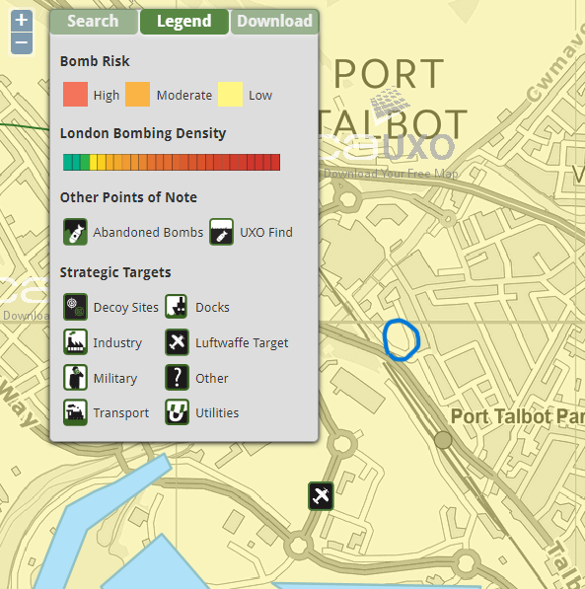
Figure 12 - Map Shows the potential risk of UXO in the proposed area, taken from Zetica UXO, (2016)

The overall risk is very low for there are no documents of unexploded devices found within this area of Port Talbot.

4.5 Site Topography and Boundary Features

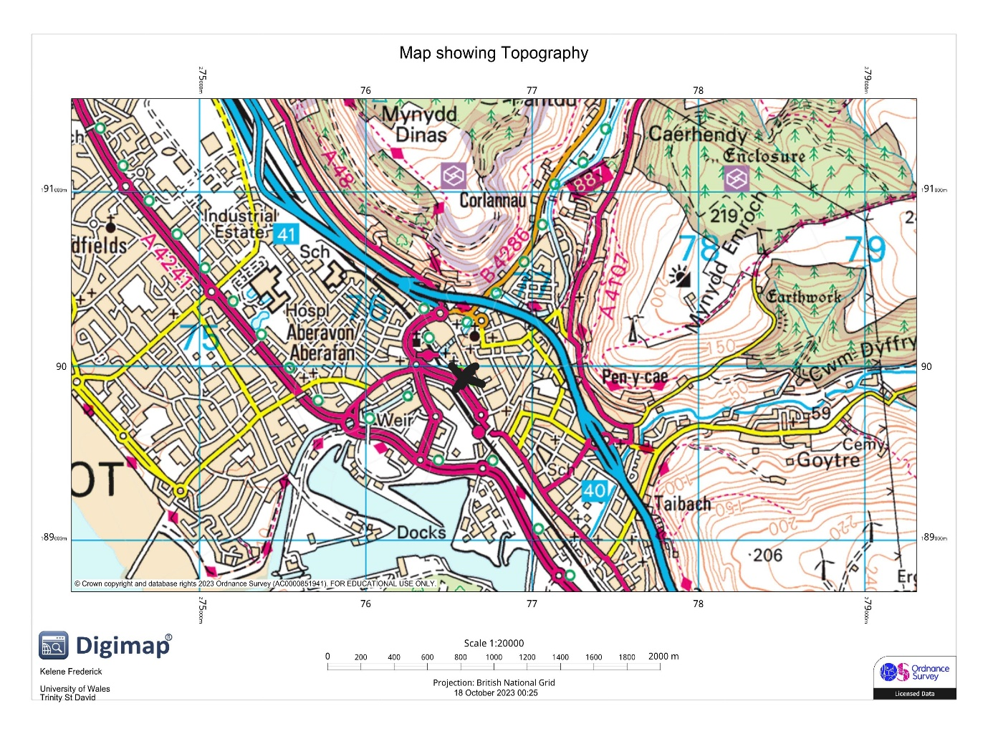
Figure 13. Map showing the topographical make of the site, taken from Digimap, (2023)
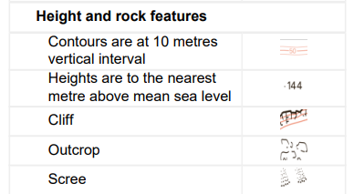
Figure 14. Legend showing height and rock features, taken from Digimap, (2023)
The map above indicates that to the northeast and southeast of the site, there are hills, while the site itself is relatively flat. Upon research, there is a short wall surrounding the car park where the site is located. There are no trees directly rooted where the building is to be erected. Further north of the site where there are existing buildings, there are a few trees.
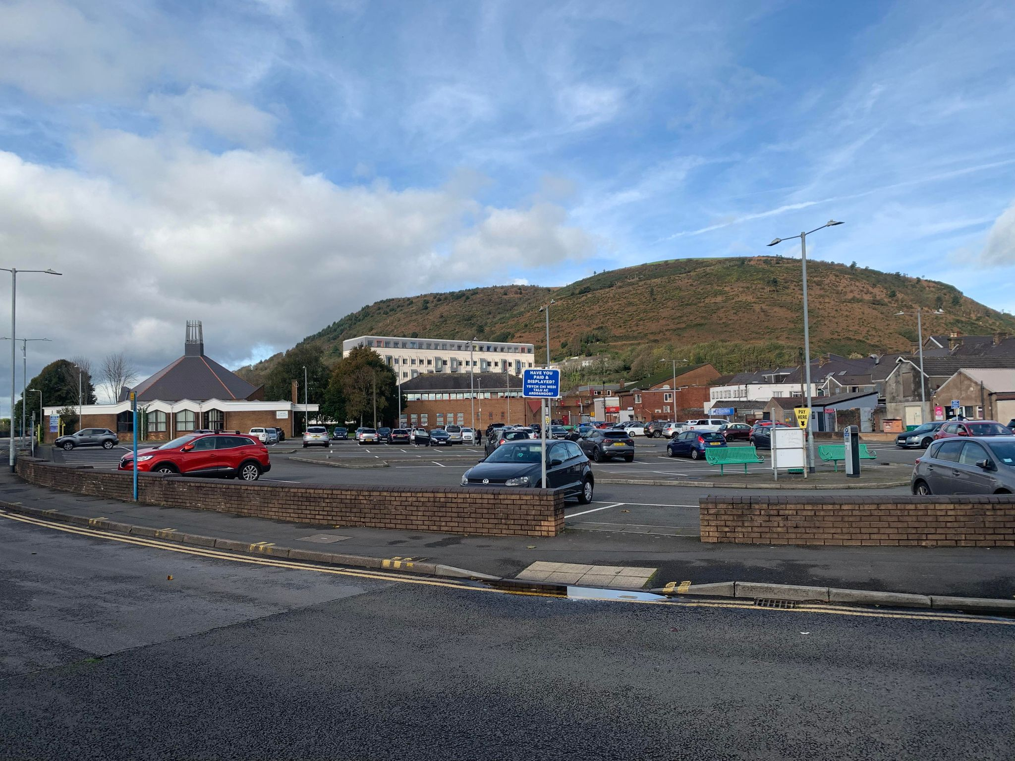
Figure 15. Image showing a visual of the car park, taken by Griffiths, S. (2023)

4.11 Site Condition
Wet and Dry Rot | Wales has a primarily marine climate, with weather that is overcast, damp, and windy. According to Britannica, (2000) for the country as a whole, yearly totals of precipitation average (1,385 mm), rain is very frequent and in abundance. There is neither a distinctly rainy nor dry season that exists. These types of climates tend to cause issues such as dry and wet rot. Permagard, (2017) explains that the exposure of timber to an external or interior humidity source causes wet rot. Wet rot is harmful because, if left untreated, the integrity of the timber is lost and becomes potentially unstable. Meanwhile, Richard and Starling, (2020) state that when airborne fungal spores come into contact with wet wood that isn't treated with a fungicide and has a moisture level of more than 20%, dry rot occurs. After that, these spores may sprout and produce white-rooted threads. The wood will be eaten by the fungus, which will then absorb moisture and significantly weaken it.  The windy and wet climate contributes to the possibility of both dry and wet rot within this area if timber elements are used within the superstructure of the Riverside Health Centre. Recommendations include treating timber elements to prevent dry rot and isolating any wooden elements from moist areas.
Asbestos | HSE, (2023) states that asbestos is a fibrous rock that was used until 1999 in households and other structures. Asbestos offers high fire-resistant qualities, resists corrosion, and functions as an insulation. As a result, it may be found in a variety of building supplies and fixtures, such as boilers, sprayed coatings, pipe insulation, and ceiling tiles according to HSE, (2023).  An Asbestos Survey was written in 2012 by Lead Surveyor Chris Jones on the Plaza Cinema located along Talbot Road, Port Talbot. One of the main aims of this report was to identify and document the asbestos type by sampling or by making an accurate assumption based on comparison to other samples according to Jones, (2012). The report concluded the existence of asbestos, and action for demolition and refurbishment was granted to remove the asbestos.

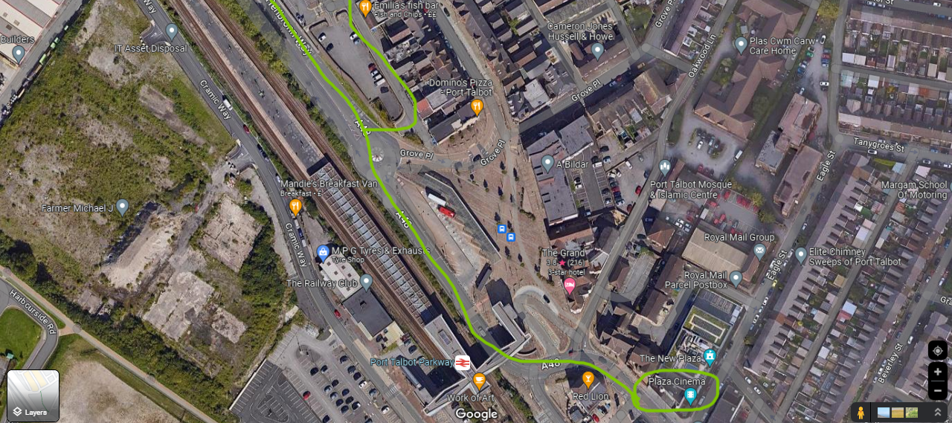
Figure 22. Map showing the proximity of the Plaza Cinema and the site location, taken from Google Maps, (2023)
The chosen area may have been contaminated with asbestos given that it was widely used in the past. To ensure that the area is safe for construction a test will be needed to identify any possible traces of asbestos. OMEGA Environmental Services Ltd, located at 7 Endeavour Close, Purcell Avenue, Sandfields, Port Talbot was selected to conduct the survey. The company provides both asbestos removal and testing services.
According to Oracle Solutions, (2023), if asbestos is found after evaluation an asbestos contamination survey should be created with details including the type of asbestos, the quantity, and where it would be deposited. The document should identify areas where excavation works are required. Before this, an asbestos contamination risk management plan should be created detailing how the contamination will be overseen to minimize the risks. This document will include the procedure used to remove the asbestos, it will outline the precise work schedule and control strategies used.
If there is even a remote chance that any of the site’s employees come into contact with asbestos-contaminated material while doing their duties, they should already be trained, the training will include the provision of respiratory protective equipment, personal protective equipment and necessary hygiene facilities. Detailed asbestos training can be found on the Health and Safety UK website.
Protected Species
Neath Port Talbot Council, (2013) states that Great Crested Newts (Triturus cristatus) may be found at Llandarcy and Margam Port Talbot. The Great Crested Newt is a protected species in Europe, and it is protected under Schedule 5 of the Wildlife and Countryside Act and the Conservation of Habitats and Species Regulations 2010. If any works are likely to have an impact on Great Crested Newts, a derogation licence from the Welsh Government may be acquired.
Figure 23. Showing a Great Crested Newt, taken from Udall Martin Associates, (2017)
Neath Port Talbot Council, (2013) declares that all of Port Talbot's native reptiles are protected by Section 9 of the Wildlife and Countryside Act 1981. The Conservation of Habitats and Species Regulations 2010 and revisions to Schedule 5 of the Wildlife and Countryside Act 1981 also protect all UK bat species. Should bats be found upon site investigation or during construction the Wales Bat Conservation Trust should be contacted immediately.
Unlike Bats and the Great Crested Newts when it comes to reptiles, there are no licenses available to work around them. In that case, the Amphibian and Reptile Conservation Trust should be contacted to avoid any legal implications.

4.17 Ecological Survey
Site Description
The site is located at Bethany Square Car Park, which brownfield of nature and has no existing structures or water courses running through. There is no natural vegetation, only manmade ground.
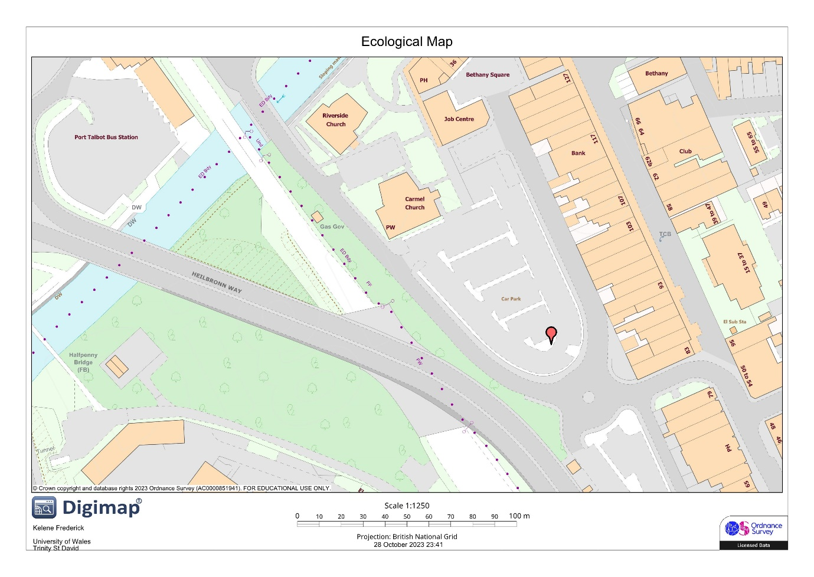
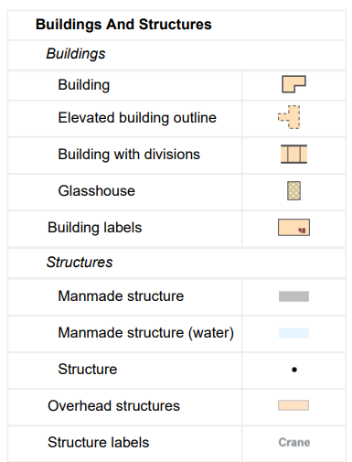
Figure 31. Map showing the ecological make of the site, taken from Digimap, (2023)
Method of Assessment
This ecological survey was conducted with the use of Digimap, onsite walk-throughs and previous ecological data found online.

Flora Assessment
There are no types of flora found within the area of the proposed site.
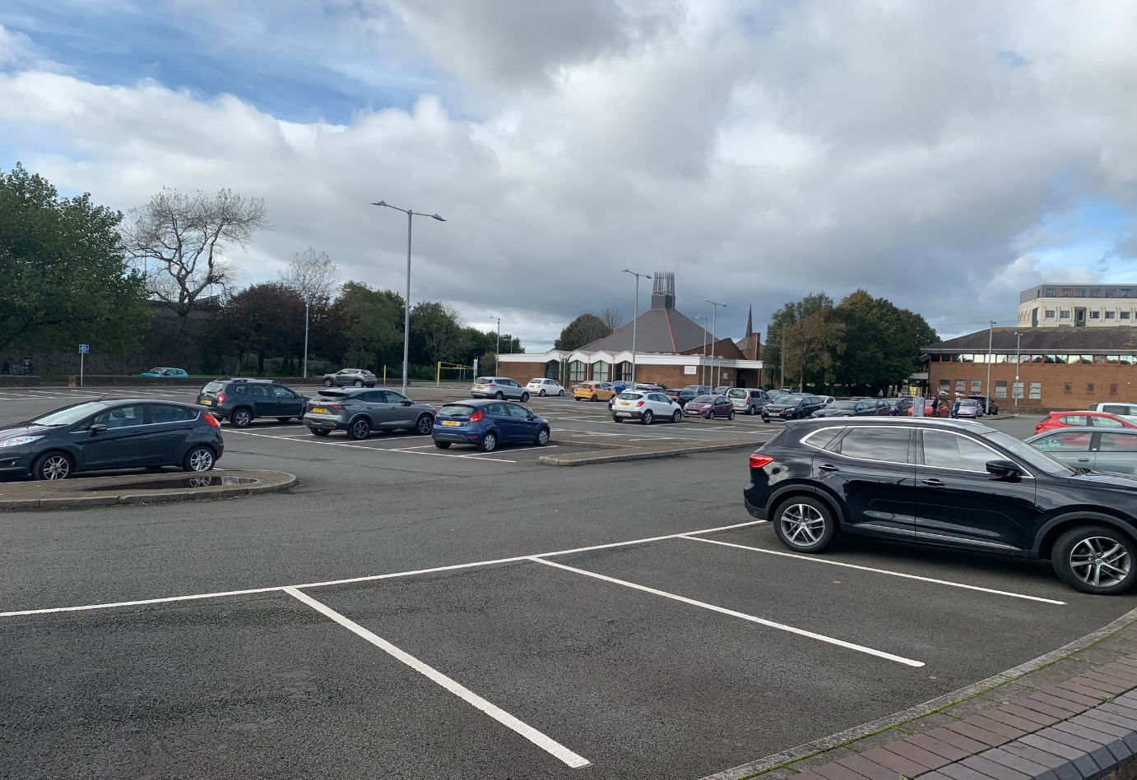
Figure 32. Image showing a visual of the car park, taken by Griffiths, S. (2023)

Fauna Assessment
Based on investigations the site has no visual evidence of bats and reptiles. There were no habitats found to host reptiles or bats.

Ecological Impacts
Any living creatures and or human occupants near the area are subjected to noise and dust pollution once work commences.

Regulations: | The HSE, (2019) says that according to the Control of Substances Hazardous to Health (COSHH) Regulations, you must protect yourself and others from the dangers of hazardous building dusts. Adhere to the Assess, Control, and Review methodology. The Health and Safety Executive, (2012) states that the Control of Noise at Work Regulations 2005 (the Noise Regulations) went into effect on 6 April 2006 for all industry sectors in the United Kingdom. The Noise Regulations aim to safeguard workers' hearing against excessive noise at work, which might cause them to lose their hearing and/or suffer from tinnitus.

The HSE, (2021) provides mitigation measures that deal with noise pollution. A few of these measures include:
Mitigation Measures | - Alter the pathways that noise takes through the air to reach the individuals who are exposed, for example, by erecting enclosures around machinery to limit the quantity of noise released into the workplace or surroundings.  - Block the direct route of sound using obstacles and screens.  - Implement a low-noise procurement policy for machinery and equipment.  - Avoid metal-on-metal contact by lining chutes with abrasion-resistant rubber and lowering drop heights.  - Workers are to wear proper protective equipment when dealing with loud machinery.

Conclusion
The site is brownfield and manmade nature showed no instances of protected species or their habitats. The main risk toward the immediate surrounding environment once work begins. Mitigation measures are set into place to reduce the impact of both noise and dust pollution on neighbouring residents and passing locals.

5.2 Flood Consequences Assessment

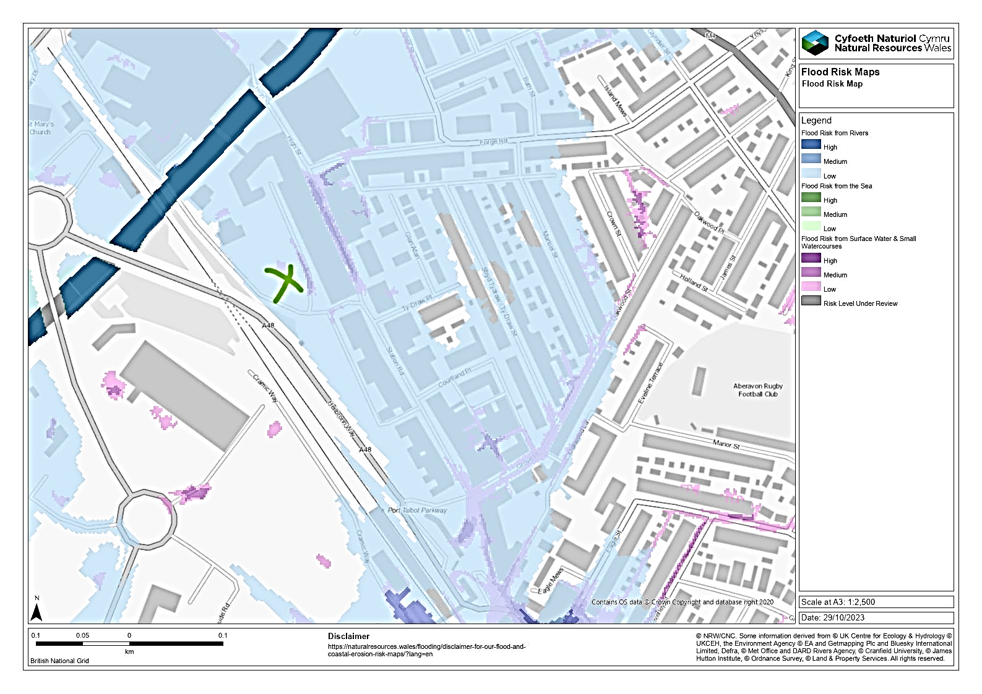
Figure 36. Map showing the flood risk around the chosen site, taken from Natural Resources Wales, (2023)

Based on research the current risk for flooding in this area is low. Nevertheless, the risk of the river northwest of the site flooding is high which increases the probability of the surrounding areas being affected by flooding when the river is in space.
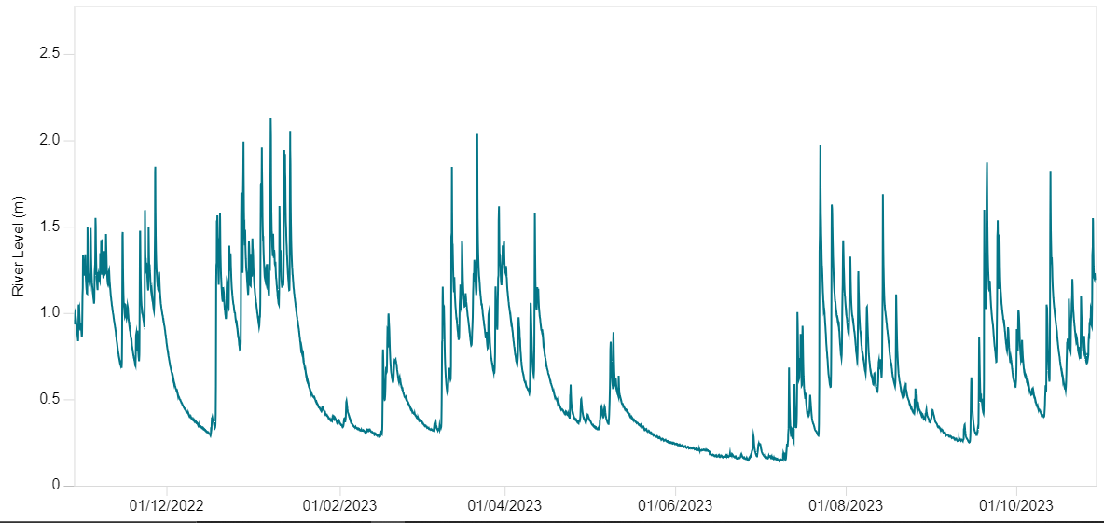
Figure 37. Map showing the river levels of the River Afan, taken from Natural Resources Wales, (2023)
The highest level that River Afan reached was 2.2m on the 7th of January 2023, this did not result in any flooding of surrounding areas. As of the 29th of October 2023, the current river level is 1.6m. The average level of the river throughout the year is 1.2m. According to Natural Resource Wales, (2023) they have not recorded any previous flood warning alerts for the year in the Port Talbot Area. The image below reiterates that there have been flood warning updates in this area since June 2018.

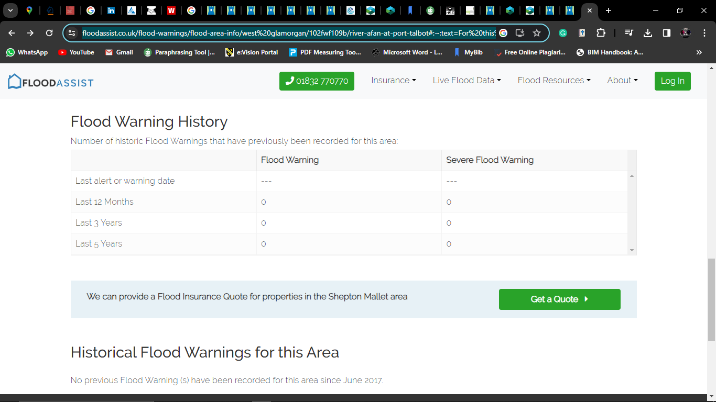
Figure 38. Map showing the flood alert history for the Port Talbot, taken from Flood Assist, (2017)

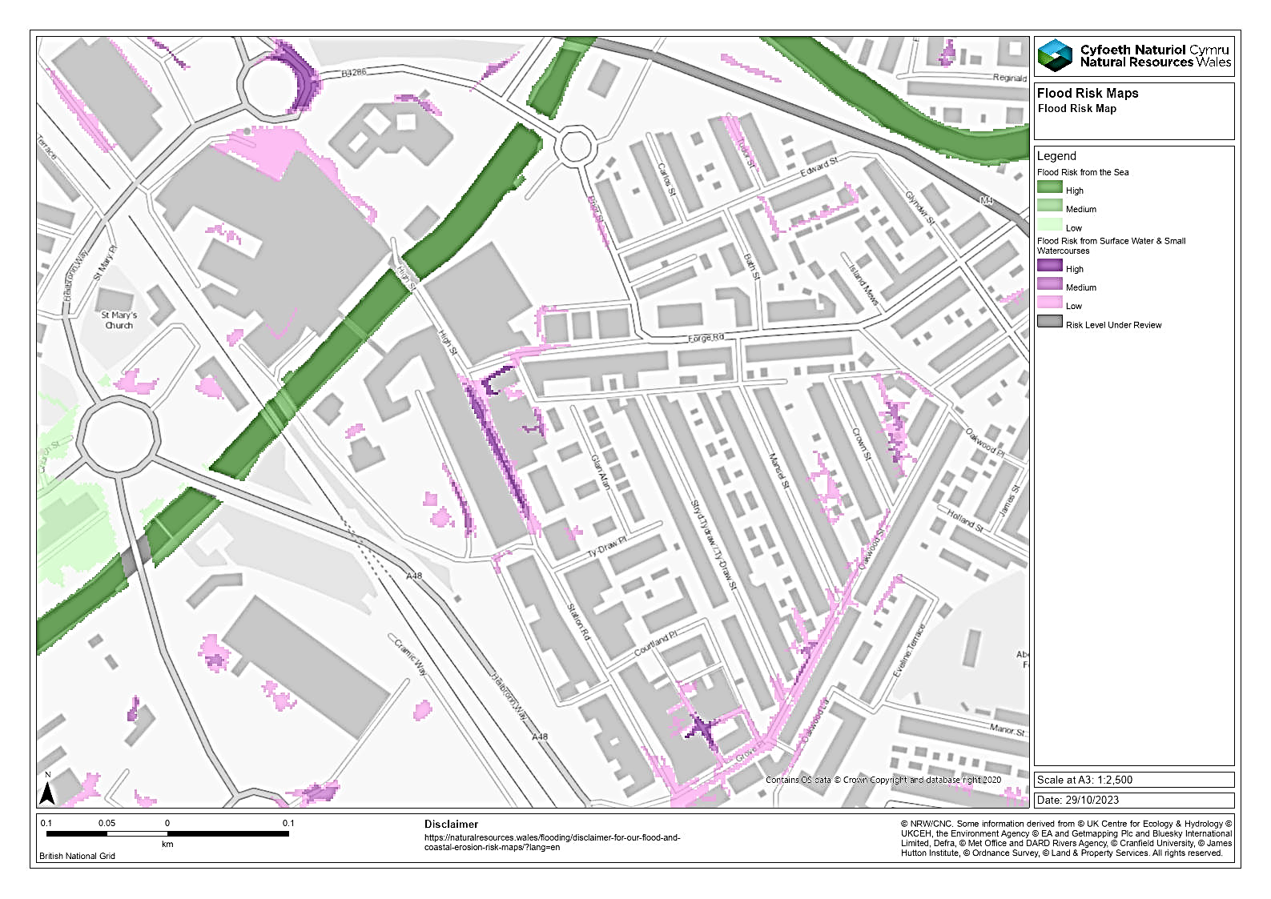
Figure 39. Map showing the flood risk around the chosen site from surface water and small watercourses, taken from Natural Resources Wales, (2023)
This map indicates that a small area found on the site and along the boundary is subjected to low and medium flood risks resulting from surface water and small water courses. In this case, it may be that drainage is poor, resulting in the settlement of water.

With the research done it is suitable to say that there is no immediate need for a flood consequence assessment (FCA). The Afan River does not pose a serious threat, nevertheless, preparation, mitigation and recovery measures will be provided. Surface water flooding proves to be more of a risk currently, therefore mitigation and management strategies will be provided.

5.3 Environmental Protection Requirements

The Contaminated Land Building Regulations (CLB) Approved Document C provides detailed instructions on resistance and mitigation to moisture and contaminants. Used as a guide to ensure that the building is protected from weather conditions, contaminants found in soil, and harmful gases such as radon and methane.
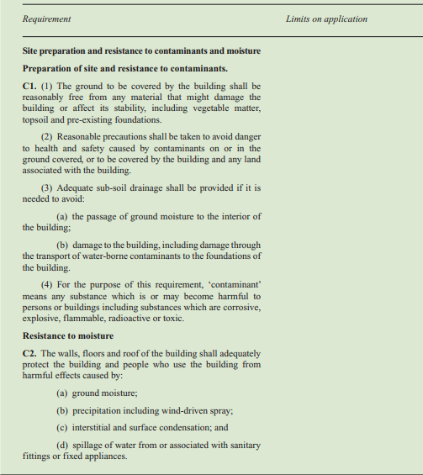
Figure 40. Showing a summary of the Environmental Protection Requirements, taken from Gov.UK, (2010)
The document categorised the site as a possible contaminated area because of its historical use being an old railway. Along with possible asbestos contamination from previous housing developments onsite. Therefore, site assessments and remediation must be conducted. This will ensure the health and safety of the workers, future occupants of the proposed building and the longevity of the structure. The CLB-approved document C prompts the developers to alert the local planning authority of any indications of contaminated land while conducting the site investigation. Many local planning authorities now demand Contaminated Land Reports, also known as phases 1 and 2:
Phase 1 | Contamination Risk Assessment, to accompany planning applications. The first face would usually include a desk study and site visit to offer a risk assessment, which should indicate if contamination exists. If a pollution risk is discovered, the phase 1 report may be used to indicate what planning requirements must be imposed in the event of further development.
Phase 2 | Involves site works such as soil sampling and analysis with the use of tools, and excavators. To identify the soil composition borehole drilling is recommended. The Phase 3 report will contain a full design, planning, and implementation stage, as well as plans for long-term monitoring and post-development monitoring. Assistance will be provided in negotiating with the local authority throughout the process.

Contaminated Land Remediation Measures
Heavy Metals | Studies indicate that the potential for heavy metal contamination of soil on site is high. The solution to avoid workers being in contact with these hazardous substances would be to excavate the top layer of the soil. Only trained experts with proper protective gear should take part in the removal.
Asbestos | The nature of the intended project at the site will determine how asbestos-contaminated land is removed. If asbestos contamination is found below the surface excavation is required. The asbestos may be in a fibrous form; therefore, a full removal of the topsoil is required and is to be transported to a licensed asbestos dump site for disposal. Extensive control measures are required for this approach and must be conducted in compliance with the asbestos regulations.

Radon & Methane Gas
Approved Document C provides detailed instructions for protection against radon and methane gas. According to the document investigation for hazardous soil gases is required if the ground or any associated land with the building was subjected to a usage that could involve oil, solvent or petrol spillage. This possibility is high due to the site’s previous history, with there being no reports available currently it is suggested that tests are conducted. Only trained personnel should conduct these tests, with appropriate protective equipment. Upon investigation and research, there were no signs of methane gas, therefore test must be conducted by Geotechnical and Geo-Environmental Consultants Ltd. If methane is detected all workers must wear appropriate protective equipment to ensure their health and safety while work is being conducted on-site.
Radon
Background | The NHS Wales, (2019) describes radon as Radon is a colourless, Odor-free radioactive gas produced by the radioactive decay of uranium, which occurs naturally in all rocks and soils. The radioactive elements produced by radon decomposition can enter our lungs. These atoms continue to break down and release radiation, most notably alpha particles, inside the lungs. These are absorbed by the surrounding lung tissues, causing acute injury. Lung cancer can result from this damage. Each year, radon causes around 1100 lung cancer deaths in the United Kingdom. Meanwhile, methane is the major component of natural gas without colour and, highly combustible gas. It is also known as biogas It can be kept and/or transported as a liquid gas under pressure. To identify the radon gas potential for a specific site, the United Kingdom Radon map may be utilized. As there are no records available for the exact site location testing can be done to update the records. Only trained workers with proper protective gear should conduct testing.

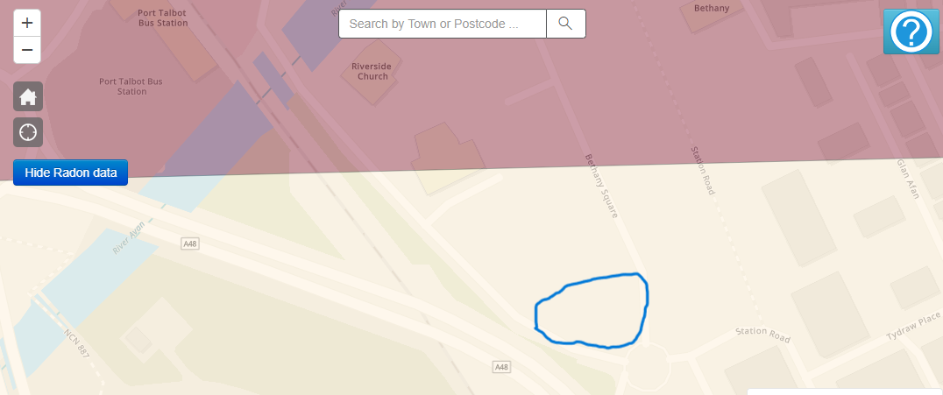
Figure 41. Map showing the site’s location on the UK Radon map, taken from Public Health England, (2019)
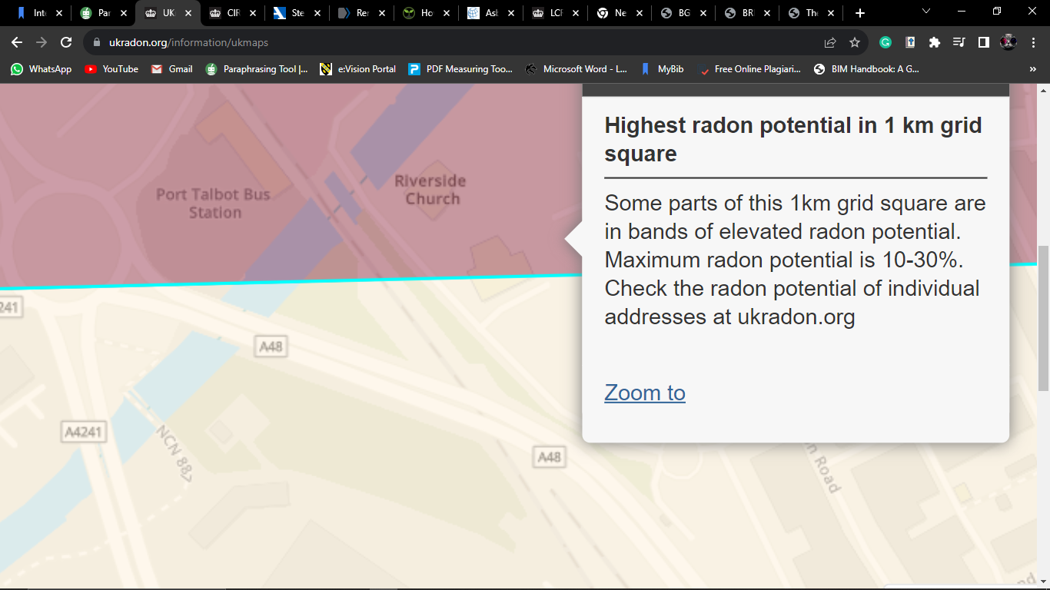
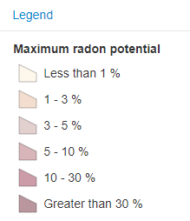
Figure 42. Map showing the radon potential found above the site location, taken from Public Health England, (2019)

The maps above show the proximity of high radon potential above the chosen site. Using this information, the property is below a radon-affected region, where it is believed that 10 to 30% of residences are at or over the action threshold according to BGS, (2022). The risk of radon contamination leaching over to the site is high. The high radon concentration adjacent to the site will require all staff to wear appropriate protective equipment such as gas masks to ensure health and safety as the project is being built.

7.7 Radon and Methane Detection and Protection Measures

Methane Remediation | According to Approved Document C gas controlling measures require a gas-resistant barrier covering the entire building (i.e., the floor and walls) above the ventilation layer where gasses are released into the atmosphere. The measures are usually passive meaning that wind and stack temperatures influence gas flow. The building layout and design should be taken into account to increase the benefits of natural ventilation. Considering that the building would have a large floor area it is crucial to ensure that the gas is properly distributed from beneath the floor. The implementation of mechanical systems as opposed to passive ones as well as monitoring and alert systems would be required. These systems will require ongoing calibration and maintenance. The BRE/ Environment Agency paper provides more advice on this as well as practical guides and building protective measures.

Radon Remediation | HSE, (2010) guides protecting workplaces from radon, the measures explain that new buildings can be safeguarded during construction by putting a radon-proof membrane inside the floor structure and, in places with a higher radon potential, providing a vented sub-floor void or a 'radon sump'.  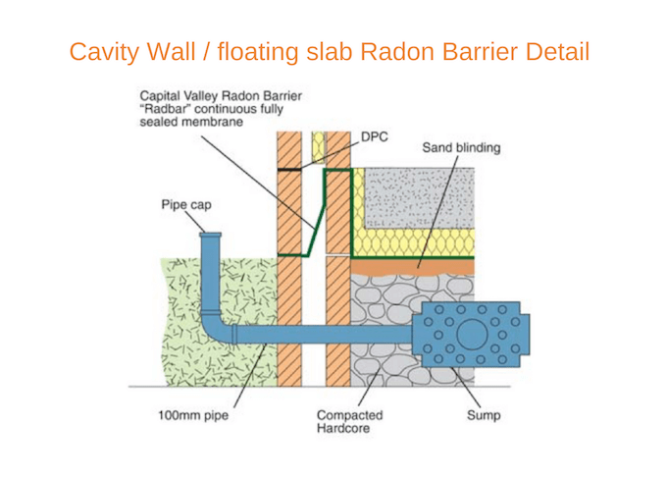  Figure 44. Showing a floating slab Radon Barrier Detail, taken from Permagard, (2017)  A radon sump is a tiny, bucket-sized hollow beneath the floor that is pumped with air by an electric pump. This lowers the typical underfloor pressure due to radon in the soil and vents the radon gas outside the structure, where it quickly evaporates. A radon sump would be required in this case because the specific site area has a high radon potential risk, therefore, full radon protection methods should be used.

7.8 Energy Efficiency, BREEAM, EPC Requirements & Sustainability Measures

BREEAM:
Energy, water, waste, pollution, transport, and ecology are among the ten areas in which BREEAM evaluates a building's environmental effect. The certification of a building is contingent upon meeting a minimum score in each area, which is weighted according to its environmental effect. According to CIM, (2023) After the certification date, the BREEAM In-Use certification is valid for three years. BREEAM facilitates continuous monitoring, reporting, and improvement of sustainability performance over time by permitting cyclical reassessment and recertification.
There has been a similar project that was completed recently known to be the first Passivhaus Health Centre which provides a notable example and template for our Riverside Health Centre.
Nicholson, (2021) explains the characteristics that make the Foleshill Health Centre Energy efficient and sustainable, therefore this can be used as a template for The Riverside Health Centre
Energy Efficiency & Sustainability Measures: | - Due to its excellent insulation, the structure stays cool in the summer and warm in the winter.  - Triple-glazed windows are one of the energy-efficient characteristics; they may be opened as needed.  - 100% fresh air, filtered through ceiling ducts, is provided to each room by ventilation machines that reclaim heat from outgoing stale air. An atmosphere of safety and cleanliness is guaranteed by air filtration that meets the same standards as an operating theatre (ISO ePM1 – June 2021).  - A small heating system also with small radiators coupled to air source heat pumps is in place.  - 100% fresh air, filtered through ceiling ducts, is provided to each room by ventilation machines that reclaim heat from outgoing stale air. An atmosphere of safety and cleanliness is guaranteed by air filtration that meets the same standards as an operating theatre (ISO ePM1 – June 2021).  - A small heating system also with small radiators coupled to air source heat pumps is in place.  - Electricity is produced on the roof via photovoltaic (solar) panels.  - Energy-efficient LED bulbs offer lighting for the entire space.  - The structure uses no fossil fuels.

Energy Performance Certificates:
The type of building proposed will require an energy performance certificate after construction. Government Digital Service, (2012) states that an authorised assessor will have to be located. After evaluating your property, they will present the certificate.

7.9 Maintenance

On behalf of the contractor who built the property, an Operations and Maintenance Manual will be handed to the client upon completion. The guidebook combines all of the information about a building's operation, maintenance, decommissioning, and demolition. Although a (0 & M Manual) is not needed by law, it is frequently requested once a project is finished or for contractor handover. All necessary building maintenance processes and requirements will be accurately noted and compiled in a handbook.
It would also be useful to provide the client with a building logbook, technical guidance, health and safety files, and a building owner’s guide.
BSRIA, (2023) according to the soft landings concept, prolonged aftercare should be offered for three years following occupation:
- In the first year, faults are detected, training is offered, and procedures are fine-tuned, with frequent evaluations.
- Following care user meetings may be arranged to explain how the facility works, answer questions, and gather feedback.
- Performance is assessed in years 2 and 3, although less frequently.
- Energy usage should be reviewed regularly, with a documented evaluation of energy and system performance every six months and a review meeting at least once a year.
- Yearly post-occupancy surveys might be conducted.
For this type of construction, it is advised to either directly hire contracted personnel to regularly inspect the building and its services or hire a local team to oversee the upkeep of the Health Centre to maximise the facility's potential. PBM Wales Ltd, (2015), provides care homes, nursing homes, sheltered accommodation, and housing associations as well as local authorities with prompt repairs, scheduled maintenance, upgrades, and cyclical redecoration work. This company is located in Caeau Duon, Pencoed, Bridgend, Wales and is capable of conducting all maintenance requirements needed. An estimated cost of maintenance will be provided once there is more understanding of what is required by the client.

7.10 CDM Regulations

According to HSE, (2015) regardless of your position within the construction business, the goal of CDM is to enhance health and safety. It applies to all construction work including design process, demolitions, extensions, maintenance, etc.
The Client, whether for a private residence or a commercial venture, is tasked with establishing proper management protocols for the project. Responsibilities encompass:
- Designating appropriate duty holders.
- Ensuring ample time and resources are devoted.
- Generating and distributing pertinent project information.
- Overseeing the Principal Designer and Principal Contractor to ensure they fulfil their roles.
- Providing necessary welfare amenities on site.
Four other persons hold responsibility under the CDM, these include:
The Principal Contractor | Selected by the Client for projects with multiple contractors, is tasked with orchestrating the health and safety aspects during the construction phase. This role involves coordinating health and safety planning, interfacing with the Client and Principal Designer, devising the Construction Phase Plan, and overseeing the contractors and their work. They must ensure proper safety inductions, prevent unauthorized site access, promote health and safety awareness among workers, and provide adequate welfare facilities.
The Contractor | Responsible for the actual execution of construction activities, must ensure that all operations under their control are conducted with an emphasis on health and safety. They must heed and act under the instructions provided by the Principal Designer and Principal Contractor.
The Principal Designer | Designated by the client for projects involving multiple contractors, is charged with overseeing the pre-construction phase. Their responsibilities include the orchestration of health and safety during this phase, with specific tasks such as mitigating foreseeable risks, ensuring that designers fulfil their obligations, and conveying essential information to other duty holders. Furthermore, the Principal Designer collaborates with the Principal Contractor for the health and safety oversight during the actual construction phase.
The Designer | The role of a Designer in the context of construction encompasses crafting and revising design plans for structures or developments. Their responsibility during the design process is to anticipate and mitigate potential risks that may arise during the building’s construction, future maintenance, or its use once completed.

7.11 Secure by Design

Orourkea, (2015) States that Secured by Design (SBD) is an endorsed security program by law enforcement, dedicated to enhancing the security of structures and their immediate environments, ensuring they serve as secure and safe environments for residence, employment, shopping, and recreation.
Police. Uk, (2023) provides crime rates in Port Talbot located around the proposed site. Within October 2023 there have been 60 crimes recorded specifically in the Port Talbot area. Crimes that have been recorded include, criminal damage & arson, violence and sexual offences, theft and anti-social behaviour.

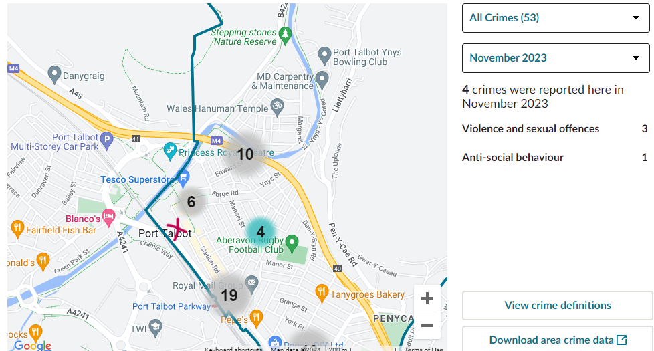 Figure 45. Images show the proximity of each type of crime to the proposed site, taken by the Police. Uk, (2024)

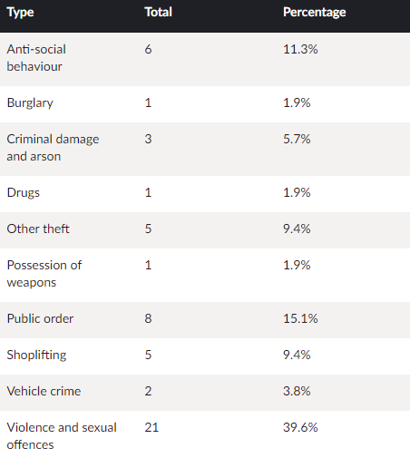
Figure 46. The image shows the total of each crime that took place in Port Talbot in November 2023, taken from the Police. Uk, (2024)

The crime rate for this small area is relatively high with a serious threat of arson. Due to this extra security measures must be taken to protect the structure and its occupants.

The table below security measures that must be taken into consideration provided by Orourkea, (2015):
Element | Characteristics
External Lighting | The purpose of lighting business spaces is to identify or discourage criminal activity. A lighting plan should have uniform lighting levels, accurate colour representation, and enough illumination to support the site's permitted after-dark activities. It ought to facilitate both official and unofficial site surveillance.
Construction | The architecture of the structure needs to be such that it can resist intruder attacks via the walls.
Internal Lighting | The majority of interior illumination should ideally be controlled by detecting devices that will turn lights on and off automatically in response to movement or lack thereof.
External Doors | Ensuring the protection of the doors is crucial. Doors must meet the requirements of STS 201 or STS202: Issue 3 BR2, PAS 24:2016, LPS 1175 Issue 7 SR2, and mean testing.
External Windows | It is crucial to protect the window opening. Windows must meet the following requirements to be means tested: LPS 1175 Issue 7:2010 Security Rating, PAS 24:2016, STS 204 Issue 3:2012, and LPS 2081 Issue 1:2014 Security Rating Design.
Letter Plates | There should be a slot found on the building where items can only be placed in and not retrieved.
Building Configuration | Maximises natural monitoring and thoughtful planning that addresses a lot of the issues related to crime.
Parking and Access | It is important to designate the exact pathways from the site entrance to the parking lots and the reception. It is advised to have a spot reserved for emergency vehicles at the building's entrance. CCTV surveillance can be required, depending on the danger. The design guidelines for parking lots have to adhere to the precepts established by the police-owned "ParkMark" programme.
Perimeter and boundary security and Site Access | Using a single main entrance for an enclosed commercial construction is advised by SBD. To identify what is private and what is public property, mark a border. Prevent thieves from breaking into the site. Security fencing heights are typically 1.8 metres. Risk will dictate the SBD fence needs. CPDA confirmation is required.
Footpath design | Every planned route ought to be created with a logical goal in mind, adhering to the lines of natural desire.  Unused lanes and detours might give criminals a place to hide and remain anonymous.
Outdoor amenities | Should be secured and in a clear view for surveillance.
Landscaping | When planting trees, care must also be taken to avoid blocking windows and doors, CCTV systems, and outside lighting placements.
Equipment Storage | Guard against theft and criminal damage by securing plants and materials, preferably storing them inside the main building. If indoor storage isn't feasible, utilize a secure covered compound externally. Additionally, consider the need for CCTV coverage.
Fitting and Fixture (External) | Ensure a durable design that is resistant to vandalism and graffiti. Secure furniture by firmly affixing it to the ground to deter theft, whenever feasible.
Recessed Doors & Natural Surveillance | To prevent the construction of recesses that are inaccessible from a room or building that is in use nearby. Additionally, wind-blown debris that can be used to ignite fires can gather in recessed doors.

7.12 Accessibility Issues
Critical aspects to consider are the influence of design and space on life quality. This involves, recognizing and overcoming both tangible and intangible barriers, ensuring safety, and removing any form of segregation.
Considerations should be made for the following:

Element | Description
Emergency routes | Accessible for individuals with disabilities, incorporating tactile and ramped features.
Proper lighting conditions | Marked and accessible, ensuring safe evacuation for all users. Allows for different activities and caters to individuals with light sensitivity.
Ramp Installations | Ramps should be installed at entrances to accommodate wheelchairs and those unable to use stairs.
Adequate Parking | Designated accessible parking spaces, close to the entrance.
Slip-Resistant Flooring | To prevent falls, especially in wet areas like pools and showers.
Contrast Markings | Visual cues for those with impaired vision, marking edges of steps or transitions between different types of flooring.
Adjustable Fitness Equipment | Equipment that is adaptable for users of varying heights and mobility levels.
Hearing Loop Systems | For those with hearing aids, especially at reception and in group class areas.
Wide Aisles and Doorways | To accommodate wheelchairs and mobility devices.
Braille and Tactile Signage | For wayfinding and equipment instructions.
Accessible Restrooms and Showers | With features like grab bars and roll-in showers.
Lowered Counters | At service points for wheelchair users.

7.13 Workplace Health, Safety & Welfare Regulations

(HSE, 2013) explains that the 1992 Regulations concerning health, safety, and welfare in the workplace set the standard for maintaining a secure and well-regulated working environment, applicable to a broad range of sectors apart from certain specific work areas like construction sites, ships, and mines. These directives have been updated through subsequent regulations including those from 1999, 2002, 2005, and most recently, the 2015 amendments, to further refine and enhance workplace safety protocols and environment standards.
7.14 Carbon Emission Targets

For Wales to achieve its climate objectives, our building must aim for nearly zero emissions by 2050. Achieving this goal will necessitate a significant shift in the way we heat and power structures. There must be a notable reduction in the energy consumption of our buildings, and the electricity utilized for lighting and heating should predominantly come from low-carbon and renewable sources.
As stated before the Foleshill Health Centre is a notable building that can be used to guide the construction of the Riverside Health Centre. Nicholson, (2021) explains that Foleshill sets an example for reducing carbon emissions in this category of buildings, showcasing substantial anticipated annual savings in carbon emissions, such as 411 tonnes of CO2 per year. The structure boasts an Energy Performance Certificate (EPC) rating of A, achieving a score of 12, which is close to achieving net-zero status.
The building Riverside Health Centre is 630m2 and Foleshill Health Centre is 619m2, indicating that they are similar in size. Once aspects such as offsite construction, using local companies, utilizing energy efficiency (lighting, heating &water), renewable energy, and using sustainable building materials the Riverside Health Centre would be able to replicate what the Foleshill Health Centre has done.

REFERENCES

- APEAL (2012). APEAL -The Association of European Producers of Steel for Packaging LIFE CYCLE ASSESSMENT ON TINPLATE. [online] Available at: https://www.apeal.org/wp-content/uploads/2012/04/APEAL-LCA_summary_paper11.pdf [Accessed 24 Oct. 2023].
- BGS (2022). Radon Report. [online] BGS. Available at: file:///C:/Users/kelen/Downloads/BGS_328889_38830.pdf [Accessed 20 Nov. 2023].
- Britannica (2000). Wales - Climate. [online] Encyclopedia Britannica. Available at: https://www.britannica.com/place/Wales/Climate [Accessed 29 Oct. 2023].
- BSRIA (2023). Soft Landing Framework or Guides, Building Design Process UK | BSRIA. [online] Bsria.com. Available at: https://www.bsria.com/uk/consultancy/project-improvement/soft-landings/#:~:text=Soft%20Landings%20is%20a%20building [Accessed 12 Dec. 2023].
- Chris Odgen (2019). Port Talbot is the worst in the UK for PM10 pollution. [online] AirQualityNews - The air quality news and information site. Available at: https://airqualitynews.com/health/port-talbot-worst-in-uk-for-pm10-pollution/#:~:text=The%20South%20Wales%20town%20of [Accessed 28 Oct. 2023].
- CIM (2023). The BREEAM Rating System is explained. [online] www.cim.io. Available at: https://www.cim.io/blog/the-breeam-rating-system-explained#:~:text=BREEAM%20measures%20a%20building [Accessed 12 Dec. 2023].
- Digimap (2023). Ordnance Survey. [online] Edina.ac.uk. Available at: https://digimap.edina.ac.uk/roam/map/os [Accessed 23 Oct. 2023].
- Digimaps (1870). Historical Roam. [online] wayf.ukfederation.org.uk. Available at: https://digimap.edina.ac.uk/roam/map/historic?unifiedClient=true [Accessed Oct. 2023].
- Digimaps (1890). Historical Roam. [online] wayf.ukfederation.org.uk. Available at: https://digimap.edina.ac.uk/roam/map/historic?unifiedClient=true [Accessed Oct. 2023].
- Digimaps (1950a). Historical Roam. [online] wayf.ukfederation.org.uk. Available at: https://digimap.edina.ac.uk/roam/map/historic?unifiedClient=true [Accessed Oct. 2023].
- Digimaps (1950b). Historical Roam. [online] wayf.ukfederation.org.uk. Available at: https://digimap.edina.ac.uk/roam/map/historic?unifiedClient=true [Accessed Oct. 2023].
- Flood Assist (2017). Flood Warning Info - River Afan at Port Talbot | Flood Assist Insurance. [online] Floodassist.co.uk. Available at: https://floodassist.co.uk/flood-warnings/flood-area-info/west%20glamorgan/102fwf109b/river-afan-at-port-talbot#:~:text=For%20this%20area%2C%20you%20may [Accessed 29 Oct. 2023].
- Geotechnical and Geo-Environmental Consultants Ltd (2022). Ground Investigation | Geotechnical Engineers, Engineering Geologists and Contaminated Land. [online] www.ground-investigation.com. Available at: https://www.ground-investigation.com/ [Accessed 28 Oct. 2023].
- Google Maps (2023). Google Maps. [online] Google Maps. Available at: https://www.google.com/maps/@51.5943616 [Accessed 23 Oct. 2023].
- Gov.UK (2010). The Building Regulations 2010- Site Preparations and Resistance to Contamination and Moisture. [online] Available at: https://assets.publishing.service.gov.uk/government/uploads/system/uploads/attachment_data/file/431943/BR_PDF_AD_C_2013.pdf [Accessed 20 Nov. 2023].
- Government Digital Service (2012). Buying or selling your home. [online] GOV.UK. Available at: https://www.gov.uk/buy-sell-your-home/energy-performance-certificates [Accessed 12 Dec. 2023].
- Griffiths, S. (2023). Image of the car park. Orginal.
- Health and Safety Executive (2012). HSE - Noise: Regulations. [online] Hse.gov.uk. Available at: https://www.hse.gov.uk/noise/regulations.htm [Accessed 20 Nov. 2023].
- HSE (2010). Radon in the workplace. [online] Hse.gov.uk. Available at: https://www.hse.gov.uk/radiation/ionising/radon.htm [Accessed 20 Nov. 2023].
- HSE (2013). Workplace health, Safety and Welfare - L24. [online] Hse.gov.uk. Available at: https://www.hse.gov.uk/pubns/books/l24.htm [Accessed 23 Dec. 2023].
- HSE (2015). Construction - Construction Design and Management Regulations 2015. [online] Hse.gov.uk. Available at: https://www.hse.gov.uk/construction/cdm/2015/index.htm [Accessed 23 Dec. 2023].
- HSE (2019). Construction dust - Controlling hazardous substances - Managing occupational health risks in construction. [online] www.hse.gov.uk. Available at: https://www.hse.gov.uk/construction/healthrisks/hazardous-substances/construction-dust.htm#:~:text=The%20Control%20of%20Substances%20Hazardous [Accessed 20 Nov. 2023].
- HSE (2021). HSE - Noise: How do I reduce noise? [online] www.hse.gov.uk. Available at: https://www.hse.gov.uk/noise/reducenoise.htm#:~:text=Modify%20the%20paths%20by%20which [Accessed 20 Nov. 2023].
- HSE (2023). Asbestos - Cancer and construction - Managing occupational health risks in construction. [online] www.hse.gov.uk. Available at: https://www.hse.gov.uk/construction/healthrisks/cancer-and-construction/asbestos.htm#:~:text=Asbestos%20acts%20as%20an%20insulator [Accessed 29 Oct. 2023].
- Jones, C. (2012). Asbestos Survey Report W-22514 Life Refurbishment / Demolition survey report (QM Template rev 3– Apr 2012) Page 1 of 144 Plaza Cinema Talbot Road Port Talbot. [online] Neath Port Talbot, p.3. Available at: https://maps.npt.gov.uk/iDocsPublic/ShowDocument.aspx?id=650739 [Accessed 29 Oct. 2023].
- Lucas, P.S., de Carvalho, R.G. and Grilo, C. (2017). Railway Disturbances on Wildlife: Types, Effects, and Mitigation Measures. Railway Ecology, [online] 1(978-3-319-57495-0), pp.81–99. doi https://doi.org/10.1007/978-3-319-57496-7_6.
- Natural Resource Wales (2023). River Afan at Port Talbot. [online] flood-warning. natural resources. wales. Available at: https://flood-warning.naturalresources.wales/Detail/102FWF109B [Accessed 29 Oct. 2023].
- Natural Resources Wales (2023). Flood and Coastal Erosion Risk Maps. [online] flood-risk-maps.naturalresources.wales. Available at: https://flood-risk-maps.naturalresources.wales/?locale=en.
- Neath Port Talbot Council (2013). Reptiles & amphibians and the law - Neath Port Talbot Council. [online] beta.npt.gov.uk. Available at: https://beta.npt.gov.uk/leisure-parks-and-culture/countryside-and-wildlife/wildlife-law-and-advice/wildlife-and-the-law/reptiles-amphibians-and-the-law/ [Accessed 29 Oct. 2023].
- Neath Port Talbot County Borough Council (2018). Neath Port Talbot Council. [online] www.npt.gov.uk. Available at: https://www.npt.gov.uk/1567 [Accessed 28 Oct. 2023].
- Neath Port Talbot County Borough Council (2022). Neath Port Talbot County Borough Council 2022 Air Quality Progress Report In fulfilment of Part IV of the Environment Act 1995 Local Air Quality Management. [online] npt.gov.uk, Wales: Neath Port Talbot County Borough Council, pp.34–48. Available at: https://www.npt.gov.uk/media/18603/2022-air-quality-progress-report.pdf?v=20230421131502 [Accessed 28 Oct. 2023].
- NHS Wales (2019). Radon. [online] Public Health Wales. Available at: https://phw.nhs.wales/topics/radon/ [Accessed 19 Nov. 2023].
- NHSWales (2018). Air Quality in Neath Port Talbot. [online] NHSWales. Available at: https://www2.nphs.wales.nhs.uk/environmentalphtdocs.nsf/815f97434d281f8b80257508003d3986/d2a79269418ce40480257705005b22d3/$FILE/Air%20Quality%20Eng%20version.pdf [Accessed 28 Oct. 2023].
- Nicholson, J. (2021). Foleshill wins the Sustainability Award at the CABE Awards. [online] Community Health Partnerships. Available at: https://communityhealthpartnerships.co.uk/news/foleshill-wins-sustainability-award-at-cabe-awards/ [Accessed 12 Dec. 2023].
- OMEGA Environmental Services Ltd (2020). Asbestos Removal and Testing. [online] www.omega-enviro.co.uk. Available at: https://www.omega-enviro.co.uk/ [Accessed 29 Oct. 2023].
- Oracle Solutions (2023). Asbestos in Soil: Working with Asbestos Contaminated Land. [online] Oracle Solutions. Available at: https://www.oracleasbestos.com/blog/contaminated-land/asbestos-in-soil-guide/#:~:text=There%20is%20only%20one%20real [Accessed 20 Nov. 2023].
- Orourkea, A. (2015). Interactive Design Guide. [online] www.securedbydesign.com. Available at: https://www.securedbydesign.com/guidance/interactive-design-guide [Accessed 22 Dec. 2023].
- PBM (2015). Healthcare – PBM Wales. [online] Property Building Maintenance. Available at: https://pbmwales.co.uk/healthcare/ [Accessed 12 Dec. 2023].
- Permagard (2017a). Gas Membrane Installation – How To Install Radon Gas Barriers. [online] https://www.permagard.co.uk. Available at: https://www.permagard.co.uk/advice/gas-membrane-installation-guide [Accessed 12 Dec. 2023].
- Permagard (2017b). Treat Dry Rot & Wet Rot - Identification And Treatment. [online] https://www.permagard.co.uk. Available at: https://www.permagard.co.uk/advice/treating-dry-rot-wet-rot#:~:text=Wet%20Rot%20occurs%20when%20excess [Accessed 29 Oct. 2023].
- Police.Uk (2023). Port Talbot. [online] Police. uk. Available at: https://www.police.uk/pu/your-area/south-wales-police/port-talbot/?yourlocalpolicingteam=about-us&tab=statistics [Accessed 22 Dec. 2023].
- Port Talbot Council (2015). Contaminated Land – Neath Port Talbot Council. [online] www.npt.gov.uk. Available at: https://www.npt.gov.uk/1453 [Accessed 28 Oct. 2023].
- Public Health England (2019). UKradon - UK maps of radon. [online] Ukradon.org. Available at: https://www.ukradon.org/information/ukmaps.
- Richard and Starling (2020). What Is Dry Rot? | Timber Decay Issues Explained. [online] Richardson & Starling. Available at: https://www.richardsonandstarling.co.uk/blog/what-is-dry-rot/#:~:text=Dry%20rot%20happens%20when%20spores [Accessed 29 Oct. 2023].
- The Metal Casting (2022). Environmental Issues. [online] www.themetalcasting.com. Available at: https://www.themetalcasting.com/enviornmental-issues.html#:~:text=Some%20of%20the%20environmental%20issues [Accessed 24 Oct. 2023].
- Udall Martin Associates (2017). Great Crested Newt Surveys. [online] Udall-Martin Associates. Available at: http://www.umassociates.co.uk/ecological-surveys/great-crested-newt-survey/ [Accessed 23 Dec. 2023].
- Waste to Wealth (2022). Mining and Quarrying Environmental Impacts. [online] www.linkedin.com. Available at: https://www.linkedin.com/pulse/mining-quarrying-environmental-impacts-revati-k#:~:text=Mining%20and%20quarrying%20can%20be.
- Zetica UXO (2016). Risk Maps - Zetica UXO. [online] Zetica UXO. Available at: https://zeticauxo.com/downloads-and-resources/risk-maps/ [Accessed 10 Jan. 2024].

