

Intercultural Competence Report

Module Name

Foreign Languages and Cultural Awareness (BMIH5003)

Lecturer’s Name
Giulia Chifari

Student’s Name: Abdur Rahman
Student ID: 2212899

Word Count
1,070 words

Executive Summary
Diversity and Spa is a UK-based five-star hotel company. The company’s expansion in China presents various challenges arising from the cultural differences between the UK and China. In all aspects of culture and business practices, China is different from the UK.

Contents
Executive Summary 2
Introduction 4
Cultural Overview 4
Culture and Leadership Study Using GLOBE Project 4
Importance of Cultural Intelligence and Sensitivity 6
Conclusion 7
Recommendations 7
Reference list 8

Figures
Figure 1 Cultural Dimensions 5
Figure 2 Leadership Dimensions 6

Introduction
The report provides an overview of the Chinese culture and different aspects of the cultural competency. The expansion of Diversity and Spa Hotel requires a solid understanding of the country’s culture. The content of the report will inform the general manager of the important aspects of the culture for business expansion.

Cultural Overview
China is one of the countries in the world that has a rich cultural history and it has ancient civilisation. To learn about China's culture, it is important to look into its various aspects such as religion, food, language, art, festivals, and so on. Buddhism, Taoism, Confucianism, Islam, Christianity, and folk beliefs are part of Chinese religion. These religions shape Chinese life, architecture and festivals (Zeng, 2019). Chinese cuisine is very popular worldwide because of the diverse items and flavours, and unique presentations. Dumplings, noodles, hot pots, Peking duck, and dim sum are some popular items of Chinese cuisine. Chinese is the official and prominent language in China. The language uses different dialects in different parts of the country. Among those dialects, Mandarin is mostly used (Chan and Franke, 2019). The rich and artistic heritage of China reflects Chinese values. Chinese New Year is the most significant festival that is celebrated throughout the country and even outside the country with fireworks, dragon dance and family reunions.
Chinese culture in business is different from the UK's business culture. The Chinese people value personal relationships while doing business. Any new business that expands in the Chinese market must show mutual respect to the partners and have mutual trust to strengthen the relationship (Hough, 2022). To establish hierarchy within the organisation is a common practice in Chinese culture. Because the Chinese people specify everyone's roles and status and they work according to their role in the hierarchy. The leader who is at the top of the hierarchy possesses the decision-making power that the subordinates abide by (Long, Parnell and Dent, 2019). Communication in Chinese culture is very complicated. Because they use indirect means which are not easily understood. For effective communication, one must pay attention to indirect cues, gestures, and expressions (Gonget al., 2020).

Culture and Leadership Study Using GLOBE Project
The GLOBE project has utilised two types of data: cultural and leadership. In the Cultural aspects of the project, 9 dimensions are used to explain Chinese culture. The scoring of the dimension ranges from 1 to 7. The nine dimensions are marketed in the diagram in two colours. One is marked as a country practice score in China and another one is a country value score which indicates how things should be (GLOBE Project, 2023). China has scored more in institutional collectivism, group collectivism, and power distance dimension which means people of China value more than the average global scores in those cultural dimensions. On the other hand, the country has scored less in performance orientation, assertiveness, future orientation, human orientation, gender egalitarianism, and uncertainty avoidance dimensions. The people of the country give less value to these dimensions than the average global scores.
The leadership aspects of the project show that China scores more in humane-oriented, autonomous, and self-protective dimensions than the average global scores. Hence, a new hotel establishment in China will require the leadership to exert more power in these dimensions than the global practices. On the other hand, the country has less of a score in the charismatic, team-oriented, and participative dimensions (House, 2014). Therefore, leadership in the Chinese market should exert less influence in these dimensions than the average global practices.
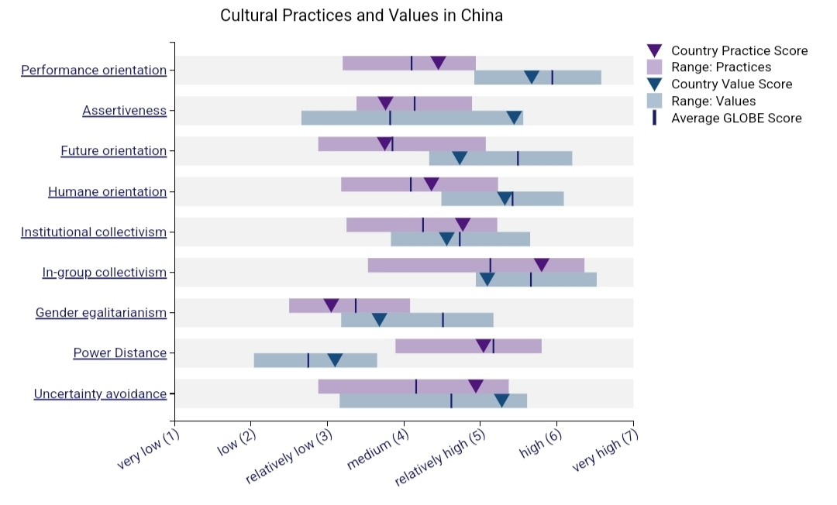
Figure 1 Cultural Dimensions
Source: (GLOBE Project , 2023)
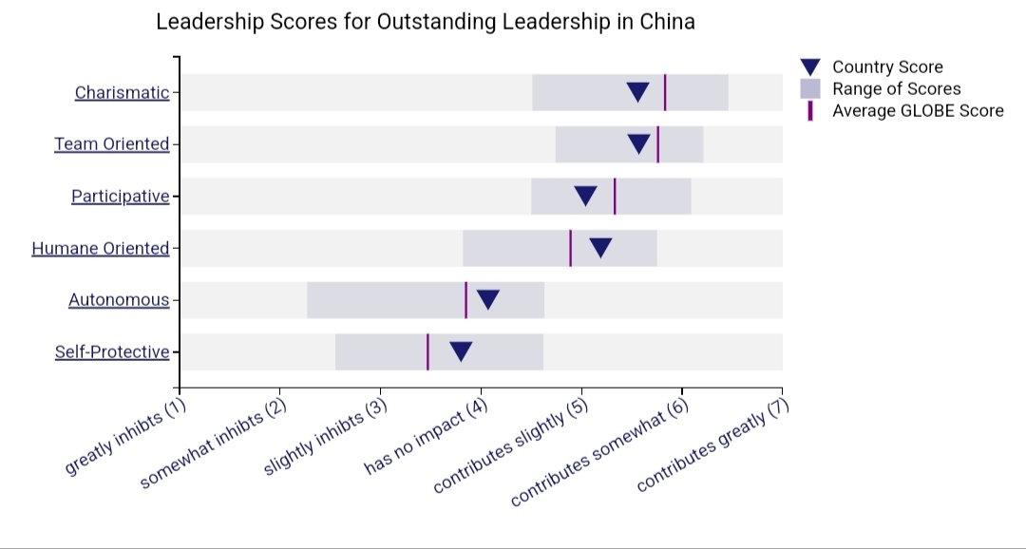
Figure 2 Leadership Dimensions
Source: (GLOBE Project , 2023)

Importance of Cultural Intelligence and Sensitivity
As the Diversity and Spa Hotel expands to the new Chinese market, the management of the company as well as the staff must have cultural intelligence and sensitivity. Because these are the abilities that will be used to understand the different cultural aspects and variations. Cultural intelligence and sensitivity will help the management and the staff in the following ways in the Chinese market:
- The guests in China have different needs and expectations. New hotel establishments in that country will require the employees to be used to the local people's expectations and needs so they can offer better customer service. Cultural intelligence and sensitivity can help them deal with people from diverse cultural backgrounds in the most effective ways (Deresky, 2017). As a result, the guests will have a memorable experience in the new hotel. Even, brand loyalty will be increased.
- International businesses are exposed to cross-cultural conflicts. The Diversity and Spa Hotel's expansion in China will create a situation that can lead to cross-cultural conflicts. The staff of the company can effectively handle and manage conflicts by cultural intelligence and sensitivity (Christiansen et al., 2020).
- Cultural Sensitivity and intelligence capabilities open the door to learning that the staff of the Diversity and Spa Hotels will be able to learn new cultural aspects, accept changes, and they will be able to advance their career with the achievement of the company's goals and objectives (Caputo et al., 2019).

Conclusion
The company should expand its business in China. Before the expansion, cultural issues should be addressed to make the entry successful. The Chinese culture is different from the UK culture so business practices need to be adjusted with the Chinese practices.

Recommendations
The general manager is recommended for the following aspects during the expansion of the Hotel in China:
- Provide Cultural Training to the Staff: The staff employed in the Chinese market should be given proper training on cross-cultural aspects so that they can understand the Chinese cultural nuances and serve the customers properly (Huang et al., 2020).
- Maintain Hierarchy: In the workplace, there should be a well-defined hierarchy and everyone's responsibilities. It is necessary to have a productive workforce in the Chinese market (Qiu and Dooley, 2019).
- Leadership Adaptation: The same leadership applied in the UK may not be effective in the Chinese market. Hence, the leadership should be adopted based on the GLOBE project's result.
- Localisation: The architecture, design of the hotel, cuisine and other important aspects of the hotel can be localised to attract customers quickly and create a strong position in the market (Ferraro and Briody, 2017).

Reference list
Caputo, A., Ayoko, O.B., Amoo, N. and Menke, C. (2019) The Relationship between Cultural Values, Cultural Intelligence and Negotiation Styles. Journal of Business Research, 99, pp.23–36.
Chan, H. and Franke, H. (2019) China | Culture, History, & People. In: Encyclopædia Britannica. [online] Available at: https://www.britannica.com/place/China.
Christiansen, B., Branch, J.D. and Karmowska, J. (2020) Cultural Factors and Performance in 21st Century Businesses. Hershey : IGI Global.
Deresky, H. (2017) International Management: Managing Across Borders and Cultures: Text and Cases. 9th Ed. Harlow: Pearson Education Ltd.
Ferraro, G.P. and Briody, E.K. (2017) The Cultural Dimension of Global Business. Florence: Taylor and Francis.
GLOBE Project (2023) Results - China GLOBE Project. [online] www.globeproject.com. Available at: https://globeproject.com/results/countries/CHN?menu=list#country.
Gong, Y., Gao, X., Li, M. and Lai, C. (2020) Cultural Adaptation Challenges and Strategies during Study abroad: New Zealand Students in China. Language, Culture and Curriculum, 34(4), pp.1–21. doi:https://doi.org/10.1080/07908318.2020.1856129.
Hough, M. (2022) Understanding Business Culture of China. [online] Global Business Culture. Available at: https://www.globalbusinessculture.com/cultural-awareness/understanding-the-business-culture-of-china/.
House, R.J. (2014) Strategic Leadership across Cultures : the GLOBE Study of CEO Leadership Behavior and Effectiveness in 24 Countries. Thousand Oaks, California: Sage Publications, Inc.
Huang, H., Liu, H., Huang, X. and Ding, Y. (2020) Simulated home: an effective cross-cultural adjustment model for Chinese expatriates. Employee Relations: The International Journal, 42(4), pp.1017-1042.
Long, Z., Parnell, J.A. and Dent, E.B. (2019) Individualism, Collectivism and Management in China: Does Atlas Shrug in China? Journal of Asia-Pacific Business, 20(3), pp.166–188. doi:https://doi.org/10.1080/10599231.2019.1647076.
Qiu, S. and Dooley, L. (2019) Servant Leadership. Leadership & Organization Development Journal, 40(2), pp.193–212. doi:https://doi.org/10.1108/lodj-04-2018-0148.
Zeng, M. (2019) Chinese Culture, Customs and Traditions in China. [online] Chinahighlights.com. Available at: https://www.chinahighlights.com/travelguide/culture/.

