Rumee Aktar
STUDENT id: 1804209
A Report into The Effectiveness of the Current Structure of NHS Wales.
Tania Davies

Contents Page

Page 2. Abstract
Page 3. Introduction to Report, Health Board,
Page 5. Funding
Page 6. Example of a Health Board Structure
Pages 7., 8. & 9. Diagram of Organisational Structure of NHS Wales
Page 10. Evaluation of NHS Wales
Pages 11. & 12. Conclusion and Recommendations
Pages 13., 14, 15, 16. &17. References

Abstract
This report focuses on the effectiveness of the current structure in NHS Wales. It covers how many Health Boards are in Wales and how the NHS Trust works in Wales. It then goes on to discuss the management structure in NHS Wales, there is an example of one health board in wales within the report that shows how it is structured and ran. Further in the report if focuses on where funding is coming from and what influences funding being overspent in the NHS. There is an evaluation of the NHS structure which highlights some positive and negatives of the NHS Wales. Lastly, to follow there is three recommendation given that may be useful to the current system.

Introduction to Report
This report will consist of the current structure of the National Health Service (NHS) Wales and how effective it is at this current time. It will include how management structures in the NHS Wales work within each health board, where funding comes from and what influences it, an evaluation of the current structure and recommendations for any improvements needed that could benefit the NHS Wales.
Wales services are delivered by NHS Wales through the department of health and social care of the Welsh assembly government. NHS Wales is accountable for measuring performances and standards’ policy in NHS trusts and health boards (Walkers, 2008).

Health Boards

There are seven Health Boards across Wales that provide health care services. The following seven health boards are:

- Aneurin Bevan University Health Board (ABUHB): This health board covers the areas of Blaenau Gwent, Caerphilly, Monmouthshire, Newport, Torfaen and South Powys (ABUHB, 2019).

- Abertawe Bro Morgannwg University Health Board (ABMU): This health board covers the areas Neath, Port Talbot and Swansea (Swansea Bay University Health Board, 2019).

- Cardiff & Vale University Health Board: This health board covers the area of Cardiff and the Vale of Glamorgan (Cardiff and Vale University Health Board, 2019).

- Hywel Dda University Health Board: This health board covers the area Carmarthenshire, Ceredigion and Pembrokeshire (Hywel Dda University Health Board, 2019).

- Cwm Taf Morgannwg University Health Board: This health board covers the area of Bridgend, Merthyr Tydfil and Rhondda Cynon Taf (Cwm Taf Morgannwg University Health Board, 2019).

- Betsi Cadwaladr University Health Board: This health board covers the areas of North Wales (Betsi Cadwaladr University Health Board, 2019)

- Powys Teaching Health Board: This health board covers the area of Powys and Mid Wales (BMA Cymru Wales, 2018)

Below is a table of the seven health boards showing each health boards expenditure. This table was cited in Statistic for Wales (2019).
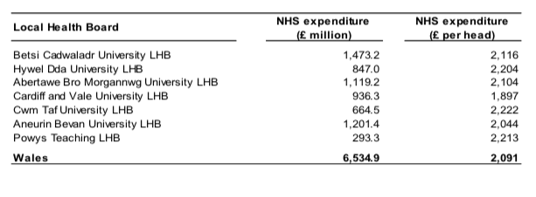
In Wales, there are four NHS Trusts. The following are:
- Velindre NHS Trust. They are a trust that has a variety of national support services as well as offers specialist services in cancer care
- Welsh Ambulance Services are there for the emergency services
- Public Health Wales
- Health Education and Improvement Wales – their role is in education, training, development (GP One, 2019).

Funding
There are core values assigned to the healthcare given in Wales (Simpson, 2016). The Health and Social Services Minister disclosed the latest set of principles for all employed staff by the NHS in Wales (Simpson, 2016). The principles were acknowledged and established in partnership with NHS Wales Employers, Welsh Government, British Medical Association and Trade Unions. They are the groundwork of how NHS staff should be working throughout Wales (Simpson, 2016). The following are the principles:
- Putting service users and patients at first
- Improving the quality of care given
- Putting more attention to prevention and on wellbeing
- Reflecting back on the experiences and learning from them to make improvements
- Working as a team and in partnership
- Valuing individuals who work for the NHS (Simpson, 2016).

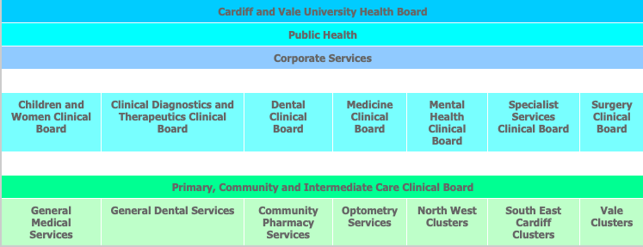
Example of a Health Board Structure
Below is an example of the Cardiff and Vale University Health Board structure cited in Cardiff and Vale University Health Board (2019).

We have a workforce of around 14,500 staff who consistently deliver high-quality services to all of our patients. Our organisation is structured and designed into eight Clinical Boards which cover our four main service areas and much more.
The Cardiff and Vale University Health Board have around 14,500 members of staff and it is spilt into eight Clinical Boards, structure has been effective as it provides good leadership in the clinical areas which have an excellent result in the running better decision making and having better positive results from the patients in their care (Cardiff and Vale University Health Board, 2019).

Diagram of Organisational Structure of NHS Wales
Below are diagram of the current organisational structure of how the health and social care work in Wales (Simpson, 2016), (Doheny, 2015).

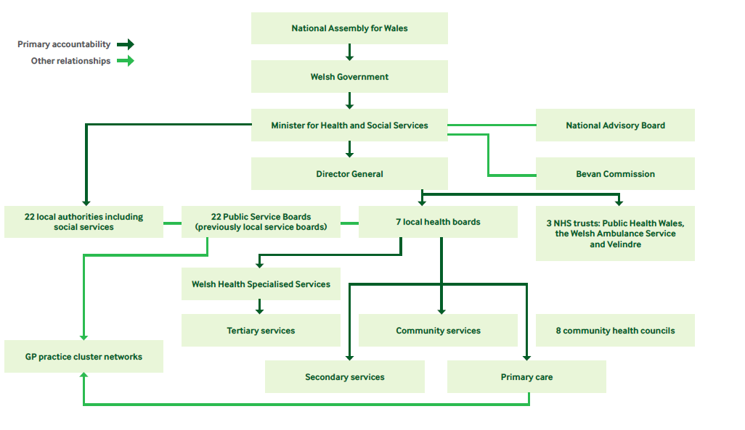
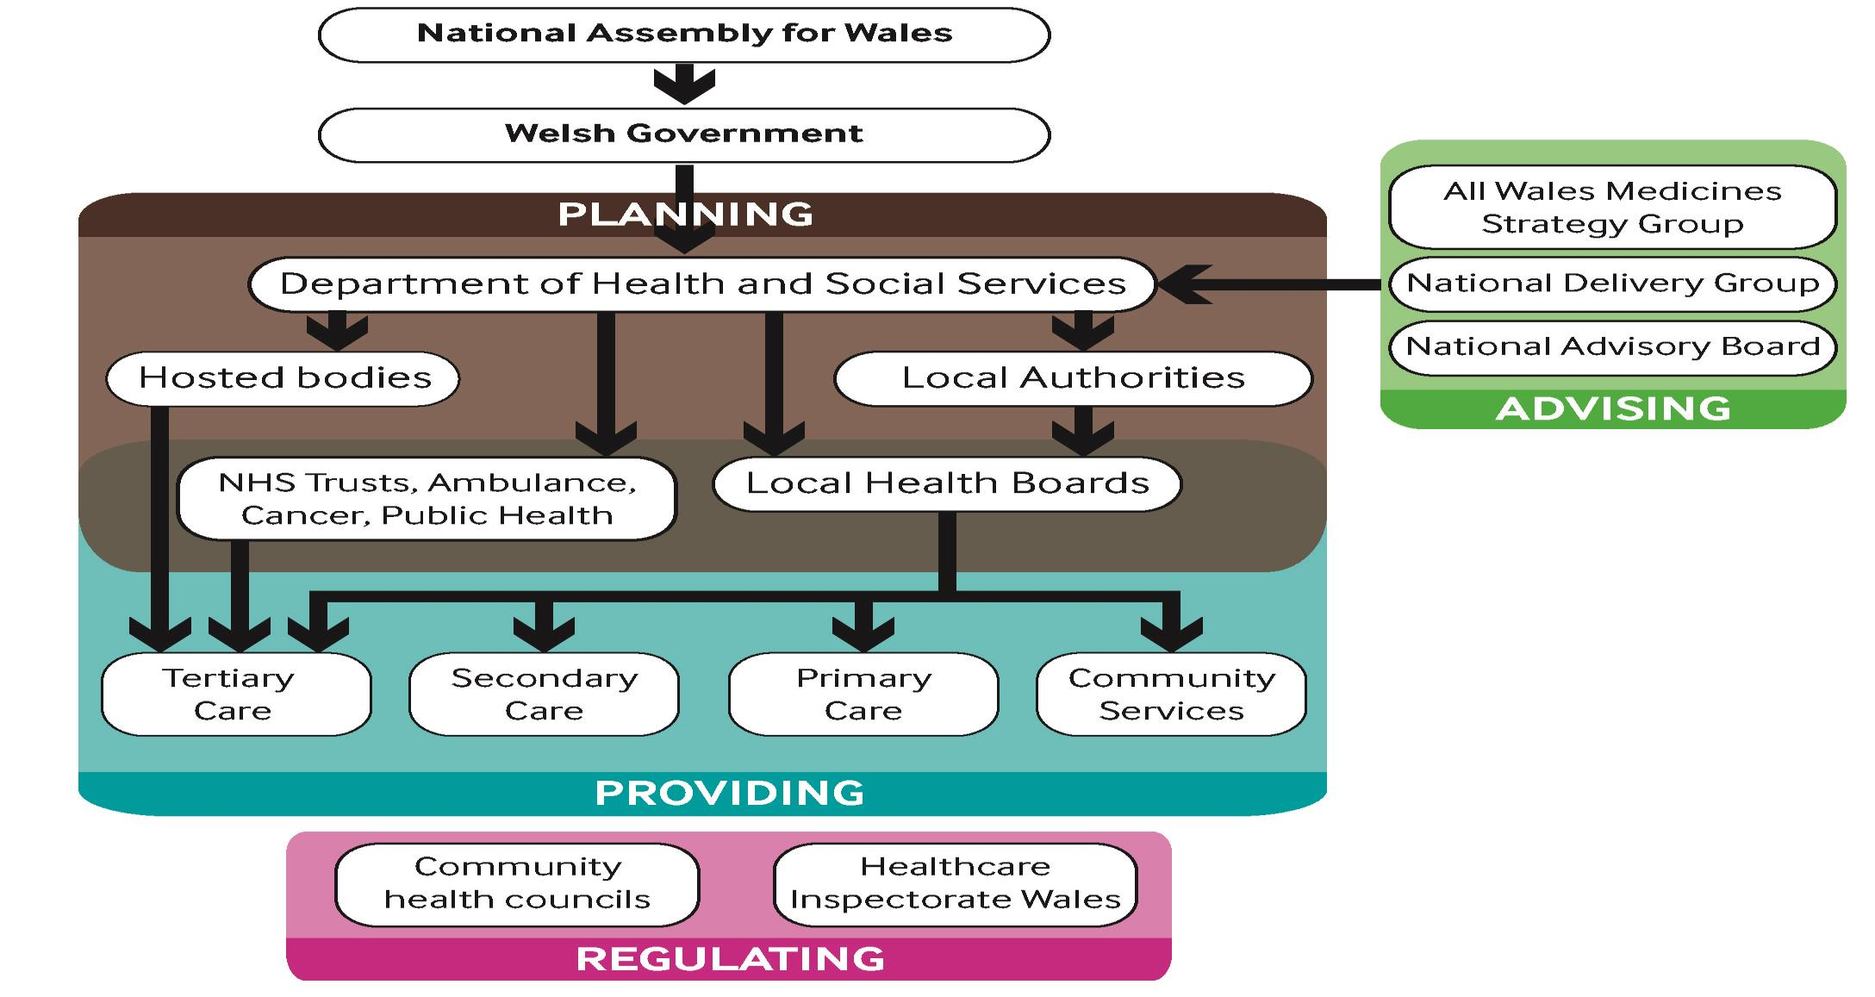

The National Assembly for Wales has given the responsibility to the Minister for Health and Social Care. The Minster is delivered by the National Advisory Board which is set to provide advice on regulating the NHS priorities. Ministerial advice is further offered by the Bevan Commissions but is not an official part of the NHS Wales (Simpson, 2016)
Simpson (2016) state health and social care are linked to the Department of Health and Social Services as they are responsible for it. The Department seeks out the Minister’s anticipations and perspective of the NHS through timelines and frameworks (Simpson, 2016). The Chief Executive of the NHS in Wales is also the Director-General (Simpson, 2016).
In Wales, there are 22 local authorities and they have the responsibility for social care (Simpson, 2016). However, they are anticipated to work with the health services to provide and include quality care (Simpson, 2016)
Public service boards manage and make cohesive plans for each local authority area through health and social care (Simpson, 2016). The public service board involves local authorities, including health services, police, the senior representative of the Welsh government and the third sector parties (Simpson, 2016).
There are eight Community Health Councils that inspect and regulate in NHS Wales. They perform as the bond between preparing to deliver the service (Simpson, 2016).
In Wales, there are 64 GP cluster networks and their purpose are to build a relationship to work together with other partners to satisfy the needs of patients as well as supporting them to meet the needs of the patient (Simpson, 2016). Every cluster network operates amongst 30 and 50 thousand patients (Simpson, 2016).
More funding for the NHS in Wales was declared in 2015 by the Welsh deputy health minister Vaughan Gething as he wants this funding for health services to use to maintain the focus on the vital plans to the health service to use this funding to maintain focus on these key plans and offer additional enhancements in patient care and outcomes (PharmacoEconomics & Outcomes News, 2015).
The NHS funding comes from the public who contribute to pay tax and national insurance. (The Kings Fund, 2019).
Majority of all of the funding for the NHS in Wales comes from the Welsh Government. People who live in Wales and are a Welsh citizen do not pay for any prescriptions for medication, however, some may be charged for visiting the optician or dentist. The spending in Wales is calculated to be £7.3 billion in 2017 and 2018, this is around £2,300 per person (Full Fact, 2017).
Factors that are affecting the funding in the NHS is that they do not have enough staff that they need, and they do not have enough funding to pay for those staff. Staff are doing the majority of the work to keep the system running yet paying less for what they are putting in resulting staff leaving (The Kings Fund).
As staff are retiring and aging, so is the general population, the most rapidly increasing group will be the over-75s, as they will be the demanding users of health and social services which will affect the funding. (Analyse, 2009). Some estimate that there will be a rise in the NHS expenditure around 1% a year because of the population is growing as well as life expectancy is increasing, more patients have long term conditions meaning the cost of preserving current quality is increasing drastically (Kmietowicz, 2012), (Roberts, 2015).
Fundamental investment in training and education has decreased from 5% of health expenditure in 2006/7 to now 3% in 2018/19. Had the prior portion of health expenditure been preserved, the investment would be £2bn higher (The Kings Fund).

Evaluation of the NHS Wales

In 2013 Robert Francis published a report of the public inquiry into the Mid Staffordshire NHS Foundation Trust (Tingle, 2014). The events written within the report was astonishing as there were incidents of the insignificant quality of care given to patients (Tingle, 2014).
Spicer (2009) and Mcdermott (2018) state patients in accident and emergency are made to wait four hours and when being admitted, staff members are directing patients to wrong departments causing tension and strain with doctors and nurses as there is lack of incomplete investigation on the inquiry of patients who admit themselves.
However, the NHS tops the world in regards to equity of access and certifying patients do not undergo financial difficulty when they are going through an illness (Dayan et al, 2018).
Everyone in Wales, Scotland and England are authorised to free health care. Individuals can access GP services, surgeries and many more health care facilities (Shelby, 2019).
The NHS’ overspending is increasing drastically that the Department of Health is at risk of not finding suitable funds to cover the expenditure. The Finance Director of the NHS has acknowledged that the financial strains are affecting the quality of care given to patients as 53% alleged that the care given to patients had gone worse (Torjesen, 2016).
The NHS is one of the biggest employers in Europe and there are more than 300 different careers to offer (NHS Jobs).
Overall, the NHS is the most important health care service in the United Kingdom, it is an effective system. The only concern and issues that seem to come up while balancing the positive and negatives is that they do not have enough funding to fix issues such as pay rise to nurses, lack of training and investigation. As they are trying to give patients what they need such as treatments, yet they are overspending still.

Conclusion
This report has looked at an overview of the NHS Wales, including the seven health boards and the three trusts. It then went onto discuss how management structures work within NHS Wales. Further, it outlined where funding comes from and what are the influences to funding and then looked at an evaluation of the issues of the current structure of the NHS. Recommendations are to follow.
Recommendations
As the NHS is overspending. There should be goals and targets to cut down on the overspending. The first recommendation is

This image was cited in Statistics for Wales (2019). As shown above, the pie chart shows that 34.0% is spent on the category of ‘other’. The category of other was expenditure for mental health problems (Statistics for Wales, 2019). To overcome the overspending on this category and saving the funding for alternative things, there should be effective health promotions. If there is effective health promotion on mental health and raising awareness, it would immensely minimise patients using the service as they would know what measures to take at the meantime until their last resort is to use the service. But this would then lead to my second recommendation which is adequate training. If the staff was given efficient training on mental health and other issues then they could produce health promotion leaflets, go out to schools, university and many other places to raise awareness and to show the risks and effects of mental health and what to do if they do have mental health issues what measure to take. However, this would not come automatically without funding. If staff presented a report on how much the NHS would benefit and minimise overspending it and took it up to the Minister for Health and Social Care and discussed it. The minister could then decide if it is an effective approach to take then taking it up to the Welsh Government. This will then get reviewed and then passed on to the Welsh National Assembly of Wales and they could then build an appropriate case/file to show to the central government and go through the house of commons procedure to get the funding. However, this funding would still mean that the NHS may be overspending, but after two years it would cut back down as they would have had the full training in how to produce and promote health promotion and give the successful training to staff, they would have produced the resources.
My last recommendation is to recruit more staff on to the NHS, as there is staff resigning because of reduced pay and pressured jobs (Campbell, 2017). Shortage of staff is becoming so severe that the NHS has to force patients to delay treatments (Campbell, 2018). If there is more staff, then patients do not need to suffer and wait for their treatments. The funding would come from the minister of the Department of Health and they can take it up to the Welsh Government to discuss the matter and patient care quality is important. If staff are happy so are patients and the system would run smoothly. Not only that funding would come from other health problems that have been minimised such as the mental health category (Smith, 2019).

References:

Analyse. (2009) Workforce planning tops agenda to prevent shortfall of nurses. Nursing Standard. 24 (3) pp. 12 – 13. Available at: https://journals-rcni-com.salford.idm.oclc.org/doi/full/10.7748/ns.24.3.12.s20 (Accessed 21st April 2019)
Aneurin Bevan University Health Board. (2019) About our organisation. Available at: http://www.wales.nhs.uk/sitesplus/866/page/40762 (Accessed 16th April 2019)

Betsi Cadwaladr University Health Board. (2019) About us. Available at: http://www.wales.nhs.uk/sitesplus/861/page/84723 (Accessed 17th April 2019)

British Medical Association (BMA) Cymru Wales (2018) In your area: BMA Cymru Wales. Available at: https://www.bma.org.uk/-/media/files/pdfs/about%20the%20bma/get%20involved%20with%20the%20bma/in-your-area-wales.pdf?la=en (Accessed 20th April 2019)

Campbell, D. (2017) NHS faces acute and growing staffing shortage, warns agency. Available at: https://www.theguardian.com/society/2017/dec/13/nhs-faces-acute-and-growing-staffing-shortage-warns-agency (Accessed 22nd April 2019)

Campbell, D. (2018) NHS ‘could be short of 350,000 staff by 2030’. Available at: https://www.theguardian.com/society/2018/nov/15/nhs-could-be-short-of-350000-staff-by-2030 (Accessed 22nd April 2019)

Cardiff and Vale of Glamorgan. (2019) Our Health Board Structure. Available at: http://www.cardiffandvaleuhb.wales.nhs.uk/our-health-board-structure (Accessed 1st May 2019)

Cardiff and Vale University Health Board. (2019) Our Services. Available at: http://www.cardiffandvaleuhb.wales.nhs.uk/our-services (Accessed 16th April 2019)

Cwm Taf Morgannwg University Health Board. We are Cwm Taf Morgannwg. Available at: https://cwmtaf.wales/we-are-cwm-tafmorgannwg/ (Accessed 17th April 2019)

Dayan, M., Ward, D., Gardner, T. and Kelly, E. (2018) The first of five briefings to inform and encourage a national conversation about the past, present, and future of the NHS. Available at: https://www.health.org.uk/publications/nhs-at-70-how-good-is-the-nhs (Accessed 21st April 2019)

Doheny, S. (2015) The organisation of the NHS in the UK: comparing structures in the four countries. Available at: http://www.assembly.wales/research%20documents/15-020%20-%20the%20organisation%20of%20the%20nhs%20in%20the%20uk%20comparing%20structures%20in%20the%20four%20countries/15-020.pdf (Accessed 20th April 2019)
Full fact. (2017) What is the NHS budget?. Available at: https://fullfact.org/health/what-is-the-nhs-budget/ (Accessed 20th April 2019)
GP One. (2019) Structure. Available at: http://www.gpone.wales.nhs.uk/nhs-wales-structure (Accessed 17th April 2019)

Hywel Dda University Health (2019) Overview of Hywel Dda University Health Board. Available at: http://www.wales.nhs.uk/sitesplus/862/page/40317 (Accessed 17th April 2019)

Kmietowicz, Z. (2012) Ageing population is not a drain on economy or NHS, says report. British Medical Journal. 244. pp 1. Available at: https://search-proquest-com.salford.idm.oclc.org/docview/1945184931/fulltextPDF/73EBA27AD2A0401BPQ/1?accountid=8058 (Accessed 21st April 2019)

Mcdermott, M. Aoife., Kitchener, M. and Exworthy, M. (2018) Managing Improvement in Healthcare Attaining, Sustaining and Spreading Quality. Switzerland: Palgrave Macmillian. Available at: https://ebookcentral-proquest-com.salford.idm.oclc.org/lib/salford/reader.action?docID=5102121 (Accessed 1st May 2019)

NHS Jobs. (2019) The NHS – A Rewarding Place to Work. Available at: https://www.jobs.nhs.uk/about_nhs.html (Accessed 1st May 2019)

PhamarcoEconomics & Outcomes News. (2015) More funding for Wales NHS. PharmarcoEconomics & Outcomes News. 731 (1) pp. 36 – 36. Available at: https://link-springer-com.salford.idm.oclc.org/article/10.1007/s40274-015-2265-9 (Accessed 20th April 2019)

Powys Teaching Health Board. (2019) About us. Available at: http://www.powysthb.wales.nhs.uk/about-us (Accessed 17th April 2019)

Roberts, A. (2015) Spending Review: The good, the bad and the ugly for the NHS; The health service is getting more money but costs are rising faster and social care services also need help. Available at: http://go.galegroup.com.salford.idm.oclc.org/ps/i.do?&id=GALE%7CA432202155&v=2.1&u=salcal2&it=r&p=AONE&sw=w (Accessed 21st April 2019)

Shelby, J. (2019) Do Asylum Seekers Have Free Access To Healthcare In The UK? Available at: https://rightsinfo.org/do-asylum-seekers-have-free-access-to-healthcare-in-the-uk/ (Accessed 21st April 2019)

Simpson, M. (2016) How is healthcare in Wales structured? Available at: https://www.bma.org.uk/-/media/files/pdfs/working%20for%20change/doctors%20in%20nhs/brief%20how%20is%20healthcare%20in%20wales%20structured.pdf?la=en (Accessed 16th April 2019)

Smith, A. (2019) International recruitment needed to fix NHS staff shortages says new report. Available at: http://www.pharmatimes.com/news/international_recruitment_needed_to_fix_nhs_staff_shortages_says_new_report_1282230 (Accessed 22nd April 2019)

Spicer, D. R. (2009) Targets Destroy Morale and do not help patients. British Medical Journal. 388 pp. 1. Available at: https://search-proquest-com.salford.idm.oclc.org/docview/1777691322/fulltextPDF/8A4B57624B314744PQ/1?accountid=8058 (Accessed 21st April 2019)

Statistics for Wales. (2019) NHS Expenditure Programme Budgets, 2017-18. Available at: https://gov.wales/sites/default/files/statistics-and-research/2019-04/nhs-expenditure-programme-budgets-april-2017-to-march-2018-168.pdf (Accessed 21st April 2019)

Swansea Bay University Health Board (2019) Swansea Bay UHB. Available at: https://sbuhb.nhs.wales/about-us1/swansea-bay-uhb/?CFID=cbb46b18-84ea-47d2-a305-3badc60f57ea&CFTOKEN=0 (Accessed 16th April 2019)

The King’s Fund. (2018) The Health Care Workforce in England: make or break? Available at: https://www.kingsfund.org.uk/publications/health-care-workforce-england (Accessed 21st April 2019)

The King’s Fund. (2019) How the NHS is Funded. Available at: https://www.kingsfund.org.uk/projects/nhs-in-a-nutshell/how-nhs-funded (Accessed 17th April 2019)

Tingle, J. (2014) The Francis Report: one year on. British Journal of Nursing. 22 (5) Available at: https://www-magonlinelibrary-com.salford.idm.oclc.org/doi/full/10.12968/bjon.2014.23.5.284 (Accessed 21st April 2019)

Torjesen, I. (2016) Treasury will take "incredibly dim view" of £2.3bn NHS overspend. British Medical Journal. 352 pp. 1. Available at: https://search-proquest-com.salford.idm.oclc.org/docview/1777829062/fulltextPDF/EBBB7F64B2BF4D93PQ/1?accountid=8058 (Accessed 1st May 2019)

Walker, C. (2008) Introducing UK Health Care. Nursing Standard. 23 (3) pp. 70 – 71. Available at: https://journals-rcni-com.salford.idm.oclc.org/doi/full/10.7748/ns.23.3.70.s62 (Accessed 16th April)

