INTRODUCING THE MODERN WORKPLACE

Table of Contents
Topic: A profile of chosen Organization 3
Introduction: 4
Profile of Curry pc –structure: 4
Curry PC culture: 5
Conclusion 7
References 7
Topic: An Organizational structure and its relationships with Organizational culture 8
Introduction: 9
The organizational structure and its relationship with organizational culture: 9
Leadership and management approaches within the organization: 10
Factors influencing Group and team behaviors 12
Performance management plan: 12
Conclusion: 14
References 15
Topic: How Motivation and perception are linked to Organizational performance. 16
Introduction: 17
Effective performance management and motivation techniques 17
Situational leadership and motivation perspective: 18
Discussion: 20
Conclusion: 20
References 21
POWER POINT PRESENTATION 22

Topic: A profile of chosen Organization

Student name: Sabina Ioana Ciobanu
Student Id Number: 2018269

Introduction:
It is fully managed because the Curry PC structure determines how functions and responsibilities such as the correspondence between different phases and regions are performed and how they are explored and how they relate to Curry PC goals. In monopoly structures, all dynamic forces are placed at the highest level of management and all the different sectors are strictly scrutinized and controlled. In contrast, the energy within the decentralized structure does not accelerate the allocation to the levels.
The Curry PC structure can be defined in two different dimensions vertically and horizontally. Vertical corporate structures with different levels of management or leadership occupy different positions (the controlling location is the number of non-mandated agents working under one person), which vary depending on the horizontal structure (Sen. et al., 2020). The low level of control is easy to manage and trigger. Additionally, due to the wide array of controls, less management experience is required at this stage to screen more individuals. Horizontal system configurations usually have a wide range of controls, and for example, many sub-managers are under the supervision of a manager or supervisor. Horizontal structures usually have better cross-sections and are often suitable for jobs that many managers do not require.

Profile of Curry pc –structure:
Businesses generally organize themselves in different ways depending on their needs. "A good Curry PC structure depends on the best practices of the company, its extraordinary customers, its components and its areas of interest and how these impacts propagate throughout the project and how to manage them. It is the most widely recognized type of Curry PC structure implemented by companies around the world. Its reputation is simple, but it applies. In this context, companies are divided into different areas (research and development, customer marketing, human resources management). Individuals with similar abilities are brought together in their respective fields. Unique structures differ from beneficial structures in that they are not based on bringing together individuals with similar abilities in different categories but rather generalize throughout the system wherever they are located. For example, in a regional structure assuming the outlet has branches in different urban areas; each city will have a different team to communicate with customers rather than having an office for the whole company. It is a combination of functional structures and division. It is made up of teachers from different parts of the Curry PC that come together for a specific project. It should be noted here that some companies, especially exceptionally large companies, use different types of structures in different regions rather than a completely individual structure.
These groups are generally not permanent but direct planning. It is the most efficient type in general. They are usually headed by project managers, who report directly to the management of the company (Udom, 2019).

Curry PC culture:
Curry PC culture is the set of characteristics and rules common to individuals and groups in a Curry PC that govern how they collaborate and are defined as "partners" outside the Curry PC. Explaining the culture of a Curry PC is not always easy, but it can be greatly felt or undoubtedly discovered. Curry PC culture is very specific and consistent (Antonakis. et al., 2019). It is a culture of intense adaptation that expresses control and the ability to run a system smoothly. Curry PC culture brings security and resilience. Curry PC culture resembles a hierarchical culture in which it focuses more on safety and strength, but the outcome is determined. It is a very dangerous work environment and the pinnacle of a job. The focal point for this type of Curry PC culture is Reliability is thrown away, and employees are approached to communicate more clearly.
The connection between the Curry PC structure, culture and its impact on the Curry PC:
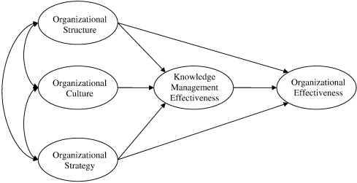
Figure 4: Relationship between organizational culture and structure
(Source: Science direct)
In order to achieve their goals properly, companies need a consistent and appropriate framework. It is very important to spread the word at different meetings to ensure that no one is involved in the same project or mission, making our information more lucrative. Since systems cannot be managed without people, they usually create different structures or informal conditions that express properties with different perspectives, visions, practices, and areas of different potential. Therefore, there is a specific goal when employees collaborate to achieve the boundaries of traditional structure; there are proven approaches to speaking, and participation is what can make the structure of Curry PC culture. Curry PC culture classifies the company's structure to some extent, but this Curry PC often characterizes the culture of the Curry PC (Spoelstra, 2018).
We can say that the structure is the cultural system to be implemented and that the culture will guide the Curry PC of the system. In this way, regardless of the size of the largest Curry PC, if its culture begins to crumble, that system will only be followed for a short time. It should be noted here that some companies, especially exceptionally large companies, use different types of structures in different regions rather than a completely individual structure.

Conclusion
This report concludes that Curry PC structure determines how functions as well as responsibilities such as the correspondence b/w different phases and regions are performed. It also concludes that how they are explored and how they relate to Curry PC goals. In monopoly structures, all dynamic forces are placed at the highest level of management and all the different sectors are strictly scrutinized and controlled.

References
Antonakis, J., Simonton, D.K. and Wai, J., 2019. Intelligence and leadership. Leader thinking skills, pp.14-45.
Sen, S., Kotlarsky, J. and Budhwar, P., 2020. Extending organizational boundaries through outsourcing: toward a dynamic risk-management capability framework. Academy of Management Perspectives, 34(1), pp.97-113.
Spoelstra, S., 2018. Leadership and organization: A philosophical introduction. Routledge.
Udom, A., 2017. Virtual Team Success: The Impact of Leadership Style and Project Management Experience.

Topic: An Organizational structure and its relationships with Organizational culture

Student name: Natalia Piwowarska
Student Id Number: 2014062

Introduction:
Curry PC is one of the leading retailers of electrical products in the UK and Ireland. It was founded in 1927 by Henry and Sons. Curry is one of the UK's leading retailers of electrical and household appliances located on the high streets. In this organization, there is an adage that "only constant performance" means performance is inevitable. The world is changing, the business environment is changing, which means the business community has to adapt to a growing environment. In today's strong business environment, Curry PC must be patient and respond to the changes that support them. This report also illustrates some of the company's issues, such as executives' performance, taking into account the internal and external factors regarding this speculation and these ideas for performance. This report examines the impact of performance within Curry PC and companies' measures to deal with it.

The organizational structure and its relationship with organizational culture:
Curry's organizational teams takes notes from his clients primarily on their long-term business issues while learning to dedicate the teams to their business and differentiate between long-term business issues. It would be a good idea to remember what has been going on in the business for a long time, but it would be very helpful to have trained professionals who understand how to identify issues (Herrera and Las Heras-Rosas, 2021).
The performance experiences the effects of assessing what needs to manage the performance. They can focus on creating impact based on detecting changes in the small details of the project. On the other hand, the company has chosen to focus on specific risks with changes, and the influence of this idea on resources, efforts and ratings can lead to many risks.

Leadership and management approaches within the organization:
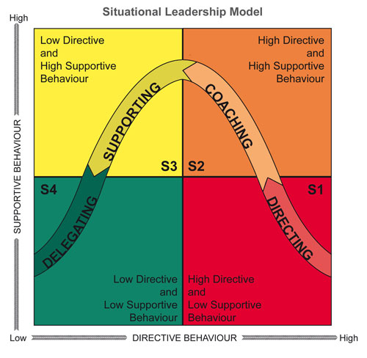
Figure 1: Situational leadership of curry PC
(Source: self-awareness)
The situational leadership of Leaders in the curry pcs can help influence and manage their branches so that curry can be more powerful in achieving its goals. Some management styles affected by external factors are hierarchical environment, reliable resources, work activities, reliable culture, political elements and innovation (Stewart, 2021). Curry PC have their workplaces with their characteristics. These qualities are the curry's opinion, its circles, its employees, financiers and clients, and determine how the company will be remunerated.
The pioneers are the resources of their curry such as innovation and achieving any commitment depends on how resources are managed and used.
Their duties and responsibilities indicate their position. Each employee has an alternative path to move towards, efforts that may affect their life. They also influence the curry through their hard work behavior and personal qualities. Every job faces the challenges that entrepreneurs face (Cheryan and Markus, 2020).
The curry's work style is a mix of present and past pioneers. Changing the work style at work is usually difficult as it has been an exercise at work for quite some time. It can affect the way the business owner expresses and resolves business options.
Managers need better information about their suppliers, customers and competitors, and they need to identify current economic and political factors affecting the company's status. The Innovation will radically transform the labor market. Leaders need to perform their management style in order to be able to help the company adapt to innovations. Innovative business leaders can help develop new strategies that make their jobs easier. Each team can have its work style. It affects the team's ability to keep promises, which can perform the curry's success. Internal factors determine how a bond can emerge.
Team leaders and individuals can improve results by moving the team efficiently and smoothly. This style of messaging allows everyone to engage with each other and share ideas. Uninformative teams have terrible leadership structures that can break the trust between team members.
Some external factors that can affect Curry PC are political, economic, social and mechanical. Internal factors affecting group growth also describe interactions with the surrounding outdoor climate. Leaders who can learn what they have accomplished and interact with their team can use and discuss current team situations, leading to an exchange of ideas that benefits the team and the community.
Workers are generally considered the best experts for a leader. Some internal factors that affect different employees' behavior are directly related to management (Leverso. and Matsueda, 2019). CEOs and managers are two completely different things. In a business, anyone who has authority over others is considered a leader. This position is not ideal for leadership as it requires more skills. Leaders must give momentum to the curry and show respect and inclusion for all. They need to know that motivation and their actions define them. They will get an analysis if they make serious but unacceptable choices.
External factors affecting workers' behavior can be generalized and irregular. The way an agent reacts to these factors will perform (Starbuck, 2017).

Factors influencing Group and team behaviors
The performance in engagement will affect key areas of the business, such as the employee. Often their loss is due to the registration fee and the time it takes to bring an employee to the business. Every time an employee leaves a company, important information is left with him. A performance management plan allows for smooth progress between changes and can ensure that the employees are satisfied with them. About 70% of performance operations are sustainable due to negative employee feedback and horrific management practices.

Performance management plan:
Effective performance management can help them avoid neglecting to make a difference (Kim and Chung, 2017). When partners understand performance interpretations, they are more committed to contributing to performance than resisting performance. They have to determine the degree, and they have to consider who will influence this performance and what will affect it. In this case, they need to differentiate between partners and the performance management team. Acceptable performance management measures are the implementation of a team or groups with credible performance. Creating this team is essential, and they need to be guided by a disciplined front. The management team will work with partners to address their concerns.
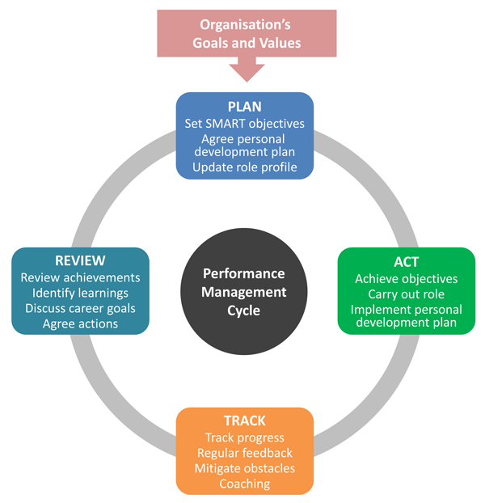
Figure 2: Performance management plan
(Source: Clear review)
Then they should explain the benefits and clearly distinguish between them so that everyone can understand what they are getting. Some different assessments can be taken to reduce employee safety during a performance. The only thing that comes from this performance is not thinking or accepting that there is disruption and hostility on employees. When all other things being equal, changes must be made with a positive attitude and Curry PC agree that staff should cooperate and enjoy what Curry PC has. If Curry PC implements these changes in the business, the employees will support the preferences.

Conclusion:
Ideally, every employee should have the opportunity to discuss and critique performance. It should be based on the extent of the performance and, therefore, the number of victims. Attempts for performance at the organizational level affect how employee information performance is implemented, but there is no need to reinforce improvements. Sometimes executive boards are formed. These groups have many employees throughout the curry. Alternatively, on the other hand, they are completely hired by business leaders and executives (Graham. et al., 2020)
If the community's news is a source of strength, information openings will connect with everyone in the community. However, this is not in the information and contributions of appraisal managers and recruiters.

References
Starbuck, W.H., 2017. Organizational learning and unlearning. The Learning Organization.
Stewart, B., 2021. Using Knowledge Management Practices in Small Business Organizations (Doctoral dissertation, Walden University).
Cheryan, S. and Markus, H.R., 2020. Masculine defaults: Identifying and mitigating hidden cultural biases. Psychological Review, 127(6), p.1022.
Herrera, J. and Las Heras-Rosas, D., 2021. The Organizational Commitment in the Company and Its Relationship With the Psychological Contract. Frontiers in Psychology, 11, p.3978.
Levers, J. and Matsueda, R.L., 2019. Gang organization and gang identity: An investigation of enduring gang membership. Journal of quantitative criminology, 35(4), pp.797-829.
Kim, J.S. and Chung, G.H., 2017. Implementing innovations within organizations: A systematic review and research agenda. Innovation, 19(3), pp.372-399.

Topic: How Motivation and perception are linked to Organizational performance.

Student name: Murgu Vasile
Student Id Number: 2019287

Introduction:
One of the barriers that Curry PC faces when they perform is that they are usually afraid of something new. If Curry PC stops, Curry PC is going in the opposite direction. There is no doubt that this is the position of companies that do not accept performance and the positive results that come from it. However, individuals who can overcome these fears about new things can effectively implement new technologies and practices for their business.
Ineffective management can also be a barrier to performance. Implementation can be frustrating if employees are unable to accept new changes in their work environment. Many business leaders who research new business practices say this is what they focus on the most. Usually, many employees, especially those who have worked in a curry for a long time, say that the performance implemented makes their work more difficult and will lose their jobs.
The third limitation is to sever the correspondence between the supervisors and the employees of the curry. Everyone has to live with the performance to ensure effective results. Also, clear and definitive correspondence is important at this stage. Performance, especially in large companies, can be confusing and a long cycle for some. Additionally, the limitation and complexity when replacing a card can be a major drawback.
Effective performance management and motivation techniques:
Performance is an essential part of the job. Managing performance seems difficult or testable to some, and attitude to performance can affect development. However, some pioneers can firmly embrace the performance. Trailblazers must manage performance and help others stay positive. Here are eight different ways to manage entrepreneurial performance .
They have to be adaptable and know from the start that some things are going to the performance, and in doing so, they have to embrace the pioneering performance and move forward. If the precursors persist, changes will occur, making them difficult to replace.
They need to take responsibility and realize that when the circumstances around them perform, they need to take responsibility. Leaders need to take responsibility for what is happening and work with their partners to help others manage the performance. If they manage to perform backward, their partners around them (Bhatt, 2020)

Situational leadership and motivation perspective:
Situational leadership is important for the development of a curry. Leaders can communicate their company's mission, assign tasks, and increase staff. Leadership styles generally depend on the personality of the directors. The organization should choose a leader who has a unique style that meets the staff's needs and desires to lead the work through performance. Situational leaders generally need a performance in leadership style, as evidenced by the style of their partner (Graham, 2020).
In this method of leadership and by considering the Maslow’s hierarchy of needs, the performance of an employee depends on whether he is awake or inexperienced in his work. For example, employees should not be overly enthusiastic and inferior in skills, forcing hosts to rise to employees' level and help them with anything. Encouraging employees to relocate will help create an interesting environment. Employees can get the help and support they need to do their jobs. A pioneering approach can be put in place with highly skilled workers and motivated to act as intended (Ćulibrk. et al., 2018)
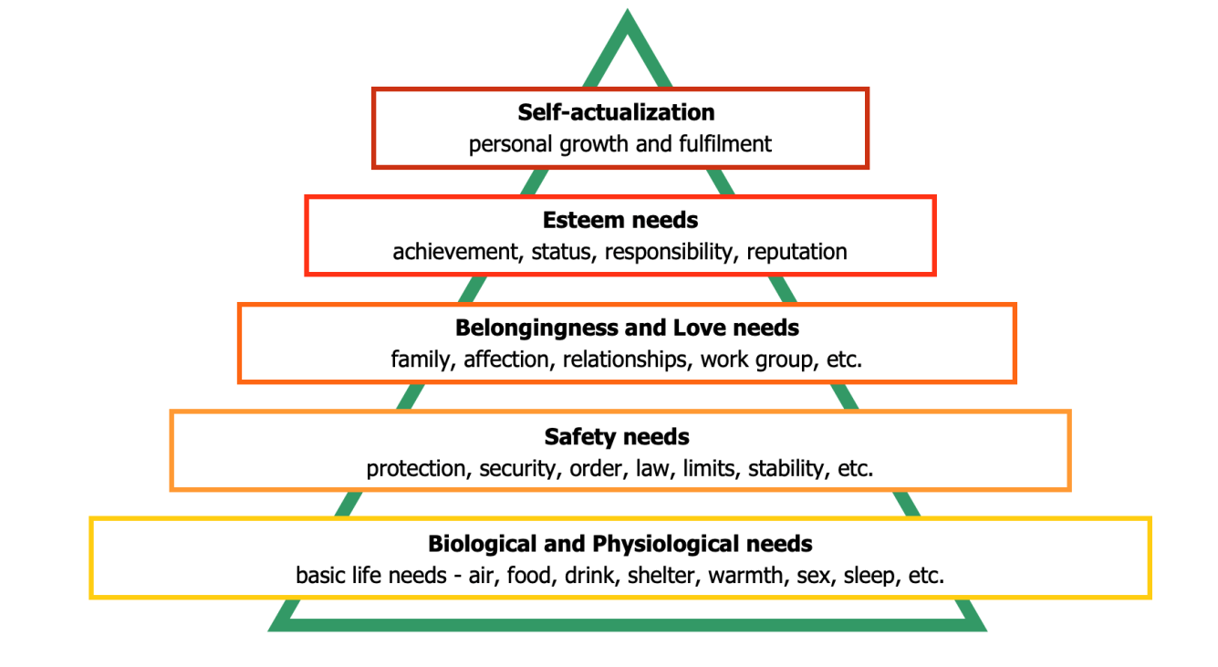
Figure 3: Maslow’s Hierarchy of needs
(Source: business balls)
An inspiring work environment can help increase motivation at work. The first duty of a manager or a pioneer is to create a positive atmosphere and support the employees. Using a situational leadership approach, leaders can mobilize emotions among employees and create a positive and positive atmosphere for the job. Motivation and support also affect worker retention. The representative income ratio comes at a significant cost to businesses that can add, hire, and transfer workers who can leave their income behind. The more determined the leaders, the more they would leave the aliens (Jabbar and Hussein, 2017). When a performance occurs, it is usually helpful for the system to accept it. Curry PC has to create the option to act quickly for a performance. It will help Curry PC make a difference. To do this, Curry PC need to give the employees a strong talk about what is going on in the climate around Curry PC and the opponents. If employees start discussing the performance, they can start without anyone else (Das, et. Al., 2019).

Discussion:
It would help if Curry PC convinced the employees that the performance is important. It may require strong leadership and the support of the highest leaders in the curry. Leaders do not have to face performance but rather lead it. To lead the transformation, Curry PC needs to build a team of masterpieces whose strengths vary from many sources, from business significance to efficiency. When thinking about performance, there are many ideas and steps to take. We need to bring each of these ideas together and create a bigger picture that everyone can understand. Reasonable intelligence will help everyone understand why they made the promises they received (Pudjiarti, 2018). Choosing how to manage the performance will help Curry PC determines whether Curry PC will be successful in creating it. The message should have strong competition with others in the business, so Curry PC should express it and spread it often. It would help if Curry PC held a scheduled conference to check the vision and discuss any opportunities Curry PC may have. They can think of anything and answer it because Curry PC can have something new in every person's brain (Bhatt, 2020).

Conclusion:
If these initiatives mentioned are followed, and the performance is currently being discussed, it is a good idea for staff to start thinking about our vision and making it a reality. Nothing can convince employees in terms of progress. Curry PC can provide an instant log of activity to everyone in the business. Everyone should pay close attention in a short period. Through this assessment, it can be known that many performance initiatives projects will soon be successful as curry PC makes sure they will be successful soon. The real performance takes a long time to complete and build. The start of this moment is that festivals do not have to be long-term performance.

References
Bhatt, P., 2020. Perceived Organizational Culture across Generation, Tenure, and Gender: An Exploratory Study. Organization Development Journal, 38(1).
Ćulibrk, J., Delić, M., Mitrović, S. and Ćulibrk, D., 2018. Job satisfaction, organizational commitment and job involvement: The mediating role of job involvement. Frontiers in Psychology, 9, p.132.
Das Swain, V., Saha, K., Rajvanshy, H., Sirigiri, A., Gregg, J.M., Lin, S., Martinez, G.J., Mattingly, S.M., Mirjafari, S., Mulukutla, R. and Nepal, S., 2019. A multisensor person-centered approach to understand the role of daily activities in job performance with organizational personas. Proceedings of the ACM on Interactive, Mobile, Wearable and Ubiquitous Technologies, 3(4), pp.1-27.
Graham, K.A., Resick, C.J., Margolis, J.A., Shao, P., Hargis, M.B. and Kiker, J.D., 2020. Egoistic norms, organizational identification, and the perceived ethicality of unethical pro-organizational behavior: A moral maturation perspective. Human Relations, 73(9), pp.1249-1277.
The role of leadership in strategic management. International Journal of Research-Granthaalayah, 5(5), pp.99-106.
Li, Y.N., Law, K.S. and Yan, M., 2019. Other-caring or other-critical? A contagious effect of leaders’ emotional triads on subordinates’ performance. Asia Pacific Journal of Management, 36(4), pp.995-1021.
Pudjiarti, E.S., 2018. Elements of entrepreneurship in private universities: Organizational performance capacity, innovative capability and the performance. Journal of Entrepreneurship Education, 21(2), pp.1-15.

POWER POINT PRESENTATION
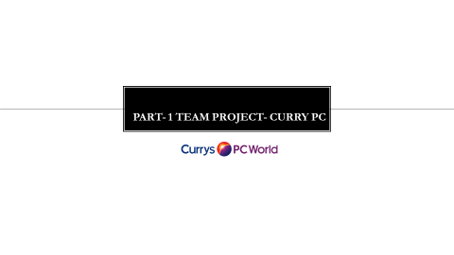

Group information

Name ​ | ID​ | Topic​
Student 1 Sabina Ioana Ciobanu​ | ​  Student Id Number: 2018269​ | - Profile of organization​  - Organization structure and culture​  - Leadership and management approaches ​  ​
Student 2 Vasile Murgu​ | Student Id Number: 2019287​  ​ | - Factors influencing Group and team behaviors ​  - Motivation perception and organizational performance​  ​
Student 3 Natalia Piwowarska​ | Student Id Number: 2014062​ | - The connection between the Curry PC structure, culture and its impact on the Curry PC​  ​
​ | ​ | ​



