An investigation into an individual’s experiences and perception regarding the impact of Exercise and Well-Being (Physiological and Psychological).

Abstract
Exercise is part of lots of people's everyday life. People exercise in many different ways, going for a walk or a run, going to the gym, or playing team sports. Research suggests that exercise has a positive effect on physical and mental well-being, it can even reduce depression (Choi et al, 2019). The current study utilized an open-ended questionnaire and a thematic analysis was carried out. The participant was a level 5 Applied Psychology student. The students on the course participated in each other studies as part of their assessment. During the analysis, 38 codes were detected and then clustered into four themes: Reasons behind exercising, Past experiences with exercise, The impacts of exercise on physical and psychological well-being, and The type of exercise. The current study focused on the impact of exercise on physical and psychological well-being exploring experiences and self-perception through one participant’s answer to the questions. Exploring and understanding individual experiences and self-perception is important when tailoring exercise plans for those who suffer from some kind of mental health issues or other physical problems. A personalised exercise plan from a professional who understands these differences might be more helpful for the individual to live a longer and happier life.
Introduction
Exercise is a type of physical activity that is planned, and repetitive, and it improves or maintains physical fitness (Caspersen, 1985). People choose to exercise for different reasons. To lose or control weight, improve the quality of their life, reduce the chance for certain diseases (cardiovascular disease for example) or reduce depression, for enjoyment or to socialize (Weinberg, 2019). There is a tremendous amount of research showing the positive benefits of exercise on physical and psychological well-being and that those who exercise throughout their life live a longer and healthier life (Ruegsegger, 2018). The NHS recommends a 150 minutes per week moderate intensity exercise for adults (aged between 19 – 64) spread out evenly throughout the week. There are different types of exercises. The NHS separates moderate-intensity activity and vigorous-intensity activity. Moderate can be walking, water aerobics, or dancing for example, vigorous can be running, sports like football or rugby, gymnastics, etc. Different intensity exercises can have different effects on the body. Exercise has many positive effects on physical health and well-being. For example, it has significant benefits for people with IBS (irritable bowel syndrome) (Zhon, 2019), and it is also beneficial for cardiovascular health (Nystoriak, 2019). However, Cerqueira (2020) found that long-lasting intense exercise is more likely to lead to chronic inflammation and injury than moderate exercising. What kind of exercise people choose depends on many factors. For example, according to Vuckovic (2024), those who exercise for stress management or enjoyment will mostly choose a form of exercise they can do alone. Those with motives related to their health or trying to avoid getting ill will most likely exercise with a personal trainer. Another factor that can have an impact on choosing a form of exercise is past experiences. Thedinga (2021) found that people who had negative previous experiences because of the weight stigma, reported avoiding going to sports and exercise settings, instead, they chose to exercise at a safe place, home for example. Also, past experiences can go as far back as the PE lessons in school. According to Standage (2012), those who were motivated to do PE in school are more likely to be motivated to take part in leisure time exercise. However, the leisure time activity, leisure time exercise, and exercise definitions are not quite clear and, in this case, only meant step counting for four days.
Exercise also affects psychological well-being. Today depression is one of the most common mental-health problems (Paolucci, 2018). The cost of treating depression is high and it keeps rising. Exercise could be a much cheaper alternative to manage depression, especially for those who do not experience severe symptoms. The positive effects of exercise on depression have been consistent across age groups, race, health status, gender, and socioeconomic status. (Weinberg, 2019). Based on the assumption that mental health is a positive thing, and it is a resource for well-being not solely the absence of mental illnesses Tamminen (2020) found that a lower level of physical activity is associated with lower levels of positive mental health, which includes self-esteem, optimism, resilience, and many more aspects. Chekroud (2018) had similar findings, they compared self-reported ‘bad mental health days’ in the months just before completing the questionnaire between individuals who do exercise and individuals who do not. Their results showed that those who exercised reported fewer days when they had poor mental health than those who did not exercise. They also found that the association was larger for team sports, cycling, and aerobic and gym activities (Chekroud, 2018). Moreover, Grasdalsmoen (2020) argued that not only does exercising or not have an effect on mental health, but the frequency, intensity, and duration of the exercise also need to be looked at. Their participants were college students. They found that the strongest effect sizes were for the frequency of exercise, but intensity and duration were also significantly associated with mental health. Their findings demonstrated an association between no exercise and poor mental health, self-harm, and suicide attempts (Grasdalsmoen, 2020). However, while many people exercise too little some will do too much. According to Zimanyi (2021), exercise can develop into an addiction, and it can lead to negative consequences to health, social and professional life.
As exercise is beneficial in many aspects of people’s life it is important to investigate individual experiences and perceptions and utilize these, so a more personalised exercise plan could be provided to those who wish to enhance all the benefits they could from exercising. Understanding how one feels about exercise and what are one's preferences could make it even more effective in treating mental health problems and improving quality of life. The current study shows that many aspects of exercise need to be looked at for it to be a more effective tool to improve and maintain good physical and psychological health.
Methodology
Design
A non-experimental qualitative approach was undertaken writing a thematic analysis on an open-ended questionnaire.
Participants
The participant was a level 5 Applied psychology student from the University of Wales Trinity Saint David. The students participated in each other studies as part of their assessment for the ECAP5006 Sport and Health Psychology module. The participant completed a questionnaire about their experiences with exercise.
The data was analysed by a level 5 Applied Psychology student.
Materials
The questionnaire was written on a laptop in MS Word and sent to the participant via email. The participant completed the questionnaire and sent it back to the researcher via email. The questionnaire was written by the researcher in MS Word and included 15 questions (for example: “Do you have any negative experience with exercise?” and “How does exercise affect your well-being?”) regarding exercise and mental and physical wellbeing (for the questionnaire see appendix 1) The researcher analysed the answers to the 15 questions. There were 83 lines altogether with an average 5.5 line answer per question. The codes have been noted down on paper (for the codes see appendix 3)
Procedure
For the procedure see appendix 4.
Results and Discussion
Exercising is a part of people’s everyday lives, but every person will have different experiences and preferences. The researcher read all the answers twice during the familiarization phase and noted down their initial thoughts. These included that the participant enjoys exercising with friends and outdoors and taking part in different types of exercises like running, walking, and cricket. The answers also showed that the participant mostly exercises for mental health benefits and to help with their IBS symptoms. They also talk about previous experiences like PE lessons in school that felt like a chore, and it felt like they were pressured to do it.

Table 1 – Summary of themes with supporting quotes from the data set with identifying question and line numbers
Themes | Quote | Question number and line
Reasons behind exercising | “If I’ve seen something on TV … which looks fun to do, I’m likely to try out”  “…or if a friend going for a walk or run, im likely to accompany them…”  “ I started to exercise for my own benefit”  “I used to struggle with IBS pain and exercising prevented those symptoms” | Question 1 Line 3-4  Question 1 Line 4-5  Question 4 Line 1  Question 1 Line 7-8
Past experiences with exercise | “In school primary and secondary … I really felt the pressure “  “When I hear the word ‘exercise’, I associate that with boring PE lessons in school…” | Question 3 Line 1-2  Question 2 Line 1
The impacts of exercise on physical and psychological well-being | “I find exercise to be good for your well-being as your getting your mind out of everything else…”  “…you gain a better mental state of mind, your musicality increases and exercise gives you that extra energy to do other things.”  “…due to stomach pain I had due to IBS, one of the resolutions was to do simple exercises…” | Question 13 Line 1-2  Question 6 Line 1-2  Question 4 Line 2
Types of exercise | “I found myself to be pretty good at cricket…”  “I don’t run very often but I enjoy it when I do, I also only do small exercise routines in my spare time but don’t regularly go to a gym”  “If I see someone doing a yoga class or running/walking in a nice, not busy place I would be more encouraged to do so as well” | Question 5 Line 2-3  Question 4 Line 3-5  Question 9 Line 1-2

Reasons behind exercising
People exercise for various reasons. It can be for improving or maintaining good physical and mental health, enjoyment, socialization, and many more (Weinberg, 2018). The participant highlighted managing IBS symptoms as one of their reasons:
“…due to stomach pain I had due to IBS, one of the resolutions was to do simple exercises…” (Question 4; Line 2)
and better mental health:
“I think exercise has a positive impact on my mental health and mental wellbeing” (Question 12; Line 1)
Exercise can help with many physical problems or diseases. The participant specifically mentioned that exercise helped them to reduce their IBS symptoms. They also highlighted the benefits of exercise on mental health however they did not specify any mental health problems. Research shows that exercise does have a positive effect on depression and anxiety (Carek, 2011) however most of the studies do not stretch out to explore the other aspects such as doing exercise alone or with others, exercising indoors or outdoors, or how different type or different intensity of exercise maybe have different effects.
Self-perception also can be a reason to exercise, however, the participant did not think this has any impact on why they are exercising:
“I’ve never really done exercise just because I looked at myself in a negative way” (Question 8; Line 1)
However, as there was only one participant it does not mean that other individuals who exercise do not care about how they look, especially when one of the reason’s why people choose to exercise is weight loss or weight management (Weinberg, 2019). Frayeh (2018) found that social physique anxiety elevated in situations when their participants were exercising in front of a mirror.
Past experiences with exercise
Past experiences in exercise have a great impact on exercise behaviour in later life. It can influence where and how an individual exercises (Thedinga, 2021) and how they feel about exercise generally. The participant pointed out their experience in school and how this affected them later:
“…I associated exercise with that pressure to be perfect at something, which is more school influenced.” (Question 3; Line 5-6)
This implies that healthy exercise behaviours start as early as young adolescents and depend a lot on the school environment. Those who did have a motivation to participate in PE classes and enjoyed it are more likely to engage in exercise outside of the school setting (Standage, 2012). There is a need for more and deeper research in this area to develop interventions in schools to promote exercise as part of healthy lifestyles and understand how big of an impact PE lesson experiences on exercise.
The impacts of exercise on physical and psychological wellbeing
Exercise is known to help with depression and anxiety (Paolucci, 2018) and help to maintain generally better mental health (Tamminen, 2020). The participant did not specify any mental health issues in their answers but pointed out how exercising helps with their self-esteem which is part of good mental health. Many people feel satisfied after accomplishing something they were not able to do before and this can lead to increased feelings of self-esteem (Weinberg, 2019):
“I do exercise for my self-esteem and my self-concept…” (Question 1; Line 6-7)
Exercise is also crucial to maintain good physical health. It is known to reduce the risk of cardiovascular diseases (Nystoriak, 2019) and helps with the symptoms of IBS (Zhou, 2019) that have been mentioned by the participant as well:
“I used to struggle with IBS pain and exercising prevented those symptoms” (Question 1; Line 7-8)
It is also a great tool for weight loss and weight control which is important as obesity keeps rising in the UK and it is not just dangerous but also costs more for the already far-stretched health system (Keaver, 2020).
Types of exercise
There is not a clear definition and categorization for exercise types. Different studies will use different categorisations based on where the exercise takes place, whether is it aerobic or anaerobic, what intensity is the exercise, team sport or exercise alone, etc. The participant mentions a couple of different types of exercise, and they state they mostly do “small exercise routines” (Question 4; Line 4). The participant also stated they enjoy going for a run or a walk with friends and outdoors. This implies that there is a social side to exercise habits and behaviours that require more research in terms of describing the impacts of other people and different places regarding the benefits of exercise. Moreover, research showed that outdoor exercise compared to indoor exercise will lead to a greater decrease in depression and greater satisfaction and enjoyment (Thompson Coon, 2011).
The participant also mentioned a team sport, cricket. According to the NHS, cricket counts as a moderate-intensity activity.
The participant also said they do not like people watching them exercise in the gym for example, so they would not choose this type of exercise:
“If I was going to a gym, I think I’d feel uncomfortable if people were watching me exercise.” (Question 15; Line 1)
The participant did not specify why they are uncomfortable when people watch them in the gym, but this supports Thedinga’s (2021) findings, that people who had negative experiences because of the weight stigma will not go to exercise settings like gyms, but are likely to choose a place to exercise where they feel safe and away from the watching eyes.
The results also showed that the participant feels much more comfortable and more likely to choose exercise types that they can do with a partner or friends. This implies that for some it might be more encouraging to offer exercise opportunities where they can bring a partner along.
The results showed that further research is needed deeper understanding of the different aspects that can affect how effective can exercise be regarding psychological and physical well-being. However, it is supported by many that frequent exercise improves overall health and quality of life by having a significant impact on psychological and physical wellbeing. Exercise has several physical benefits, including improved cardiovascular health, stronger muscles, and potential support for weight management. Exercise has major favorable effects on psychological well-being in addition to its physical benefits. It has been demonstrated to lessen anxiety and depressive symptoms. In summary, there is no denying the benefits of exercise for both mental and physical health. People can experience increases in their physical and mental resilience by adding regular physical activity into their daily routines, which can lead to a happier and more satisfying life.

References
Carek, P. J., Laibstain, S. E., & Carek, S. M. (2011). Exercise for the treatment of depression and anxiety. The international journal of psychiatry in medicine, 41(1), 15-28.
Caspersen, C. J., Powell, K. E., & Christenson, G. M. (1985). Physical activity, exercise, and physical fitness: definitions and distinctions for health-related research. Public health reports, 100(2), 126.
Cerqueira, É., Marinho, D. A., Neiva, H. P., & Lourenço, O. (2020). Inflammatory effects of high and moderate intensity exercise—a systematic review. Frontiers in physiology, 10, 489354.
Chekroud, S. R., Gueorguieva, R., Zheutlin, A. B., Paulus, M., Krumholz, H. M., Krystal, J. H., & Chekroud, A. M. (2018). Association between physical exercise and mental health in 1· 2 million individuals in the USA between 2011 and 2015: a cross-sectional study. The lancet psychiatry, 5(9), 739-746.
Choi, K. W., Chen, C. Y., Stein, M. B., Klimentidis, Y. C., Wang, M. J., Koenen, K. C., & Smoller, J. W. (2019). Assessment of bidirectional relationships between physical activity and depression among adults: a 2-sample Mendelian randomization study. JAMA psychiatry, 76(4), 399-408.
Frayeh, A. L., & Lewis, B. A. (2018). The effect of mirrors on women's state body image responses to yoga. Psychology of Sport and Exercise, 35, 47-54.
Grasdalsmoen, M., Eriksen, H. R., Lønning, K. J., & Sivertsen, B. (2020). Physical exercise, mental health problems, and suicide attempts in university students. BMC psychiatry, 20, 1-11.
Keaver, L., Xu, B., Jaccard, A., & Webber, L. (2020). Morbid obesity in the UK: A modelling projection study to 2035. Scandinavian Journal of Public Health, 48(4), 422-427.
NHS (2021,August 4) Exercise Exercise - NHS (www.nhs.uk)
Nystoriak, M. A., & Bhatnagar, A. (2018). Cardiovascular effects and benefits of exercise. Frontiers in cardiovascular medicine, 5, 408204.
Paolucci, E. M., Loukov, D., Bowdish, D. M., & Heisz, J. J. (2018). Exercise reduces depression and inflammation but intensity matters. Biological psychology, 133, 79-84.
Ruegsegger, G. N., & Booth, F. W. (2018). Health benefits of exercise. Cold Spring Harbor perspectives in medicine, 8(7), a029694.
Smith, P. J., & Merwin, R. M. (2021). The role of exercise in management of mental health disorders: an integrative review. Annual review of medicine, 72, 45-62.
Standage, M., Gillison, F. B., Ntoumanis, N., & Treasure, D. C. (2012). Predicting students’ physical activity and health-related well-being: A prospective cross-domain investigation of motivation across school physical education and exercise settings. Journal of Sport and Exercise Psychology, 34(1), 37-60.
Tamminen, N., Reinikainen, J., Appelqvist-Schmidlechner, K., Borodulin, K., Mäki-Opas, T., & Solin, P. (2020). Associations of physical activity with positive mental health: A population-based study. Mental Health and Physical Activity, 18, 100319.
Thedinga, H. K., Zehl, R., & Thiel, A. (2021). Weight stigma experiences and self-exclusion from sport and exercise settings among people with obesity. BMC Public Health, 21, 1-18.
Thompson Coon, J., Boddy, K., Stein, K., Whear, R., Barton, J., & Depledge, M. H. (2011). Does participating in physical activity in outdoor natural environments have a greater effect on physical and mental wellbeing than physical activity indoors? A systematic review. Environmental science & technology, 45(5), 1761-1772.
Vuckovic, V., & Duric, S. (2024). Motivational variations in fitness: A population study of exercise modalities, gender and relationship status. Frontiers in Psychology, 15, 1377947.
Weinberg, R.S. & Gould, R. (2019). Foundations of sport and exercise psychology. (7th ed.). Human Kinetics.
Zhou, C., Zhao, E., Li, Y., Jia, Y., & Li, F. (2019). Exercise therapy of patients with irritable bowel syndrome: a systematic review of randomized controlled trials. Neurogastroenterology & Motility, 31(2), e13461.
Zimanyi, Z., Wolff, W., & Schüler, J. (2021). Too much of a good thing? Exercise dependence in endurance athletes: relationships with personal and social resources. International journal of environmental research and public health, 18(6), 2966.

Appendices
Appendix 1 – The questionnaire made by the researcher
An investigation into an individual’s experiences and perception regarding the impact of Exercise and Well-Being (Physiological and Psychological).

1. Why do you exercise?
2. When you hear the word ‘exercise’ what is the first thing that comes to your mind?
3. Do you have any negative experience with exercise?
4. Why did you start to exercise?
5. Can you describe an experience with exercise that had a great impact on you?
6. What benefits do you gain from exercising?
7. How do you feel after exercising?
8. Is self-perception a big aspect in taking part in exercise?
9. Does seeing other people exercise, make you feel the need to participate also?
10. Do you think an exercise routine is important?
11. Do you prefer to participate in team sports or individual sports-why?
12. Do you feel that exercise impacts on your mental health? If so, how do you feel it does and can you give examples.
13. How does exercise affect your well-being?
14. How do you motivate yourself to participant in exercise?
15. When you are active, how do you feel about other people seeing you?

Appendix 2 – The completed questionnaire
An investigation into an individual’s experiences and perception regarding the impact of Exercise and Well-Being (Physiological and Psychological).
Z1. Why do you exercise?
- ‘Excercise’ to me isn’t doing a marathon for example, I see excercise as small activities for good well-being and self-esteem. There are several reasons why I exercise, it is dependent on what mood I'm in also. If I've seen something on tv to do with excercise which looks fun to do, im likely to try it out, or if a friend is going for a walk or run, im likely to accompany them, even though I enjoy exercising alone also. I do it for my own benefit, to blow away cobwebs if I've been inside all day for example, to make me feel refreshed and reguvinated. I do exercise for my self-esteem and my self-concept, I used to struggle badly with IBS pain and excercising prevented those symptoms from happening as often, as I was moving my body instead of sitting indoors, so overall I excercise to make myself feel better about myself mentally, especially being out in nature. I’m not a fan of gyms.
Z2. When you hear the word ‘exercise’ what is the first thing that comes to your mind?
- When I hear the word ‘excercise’, I associate that with boring PE lessons in school as i was never a sporty person and never enjoyed the concept of ‘excercise’, but thinking further about the word, It is associated with hardwork and dedication or it can be an escape for some people, who excercise for fun, I mostly saw excercise as a chore but I think that was affected by it being a pressure in school, that you ‘had to excercise’ or your unfit, but as I’ve grown older, excercise is something I see as something more then that, it is fun without that added pressure, and the freedom to walk or run or do what ever type of excercise you do can be very rewarding.
Z3. Do you have any negative experience with exercise?
- Yes, In school primary and secondary, as I was never that kid to be very sporty – I really felt the pressure that I had to be good at something, or that I was unfit if I didn’t do it. I found the world of excercise to be very judgemental also, as the really sporty people would be very competitive and be likely to criticise or get angry if we didn’t win a game, as ‘winning was the only objective’ when in sports class in school, so with that I associated excercise with that pressure to be perfect at something, which is more school influenced.
Z4. Why did you start to exercise?
- I started to exercise for my own benefit, to improve my self-esteem but also my physicallity, due to stomach pain I had due to IBS, one of the resolutions was to do simple excercises such as go for walks, so my love for going walking stemmed from this, I don’t run very often but I enjoy it when I do, I also only do small excercise routines in my spare time but dont regularly go to a gym.
Z5. Can you describe an experience with exercise that had a great impact on you?
- In terms of great experiences with excercise, I’d say going on more walks helped me feel more relaxed, as it is a time you can completely zone out. In school, I found myself to be pretty good at cricket and won a few school championships, so that made me feel good about myself! As with the added pressure of other people during other games, the thought that I knew I wasnt good at them didn’t help and I’d often bottle-up, in cricket games however, I’d be fully focused and be proud of myself after every game!
A6. What benefits do you gain from exercising?
- The benfits I gain from excercise is that you gain a better mental state of mind, your muscality increases and excercise gives you that extra energy to do other things,
A7. How do you feel after exercising?
- After excercising, I tend to feel tierd or more relaxed – dependent on the type of day I've had, it can relieve stress and if I've put myself up to a challenge of completing a certain amount of miles of running, and I've managed to complete it, it will give me a sense of acomplishement
A8. Is self-perception a big aspect in taking part in exercise?
- No, I’ve never really done excercise just because I looked at myself in a negative way – maybe in school I would have done excserice because someone else was fitter then me or had a better body, so I would do excercise because of my self-prerception at the time but that doesn’t matter anymore. I usually excercise for my own mentality and not because I want to look like someone else.
A9. Does seeing other people exercise, make you feel the need to participate also?
- Yes and no, depending on what type of excercise it is. If I see someone doing a yoga class or running/walking in a nice, not busy place I would be more encouraged to do so as well – But, seeing people exercise on the daily online, on social media doesn’t make me want to participate in a marathon the next day, I do wish sometimes that I could be at that fitness level as those people but I find it hard to gain the motivation to do so and I dont have many friends that enjoy exercise, I would much rather excercise with other people compared to going on my own. It is dependent on my mind-set on the day though, if I was to see someone on social media talk about their day and their ‘fitness routine’ I’m likely to feel guilty for just being home in a dressing gown with a cup of tea if I’m having a bad day.
A10. Do you think an exercise routine is important?
- Yes and no, Some people take routines to the extreme and these spout into exessive exercise and eating disorders, but if its a healthy routine and not strict or harming the perosn in any way then I think it’s good, I personally dont have a exercise routine, but I think If I was more active and look part in more activities – a routien would be really helpful, especially if you have a busy lifestyle.
C11. Do you prefer to participate in team sports or individual sports-why?
- I prefer to take part in Individual sports most the time, but since starting cricket that is the only team-sport I enjoyed, I think this is due to not having pressure by other people and enjoying the sport, I found participating with other people especially in school difficult and very pressured to ‘be the best’ at everything! There was no enjoyment. But I also think now that I’m older that I would enjoy team-sports more if people were on the same mind-frame as me and enjoyed the same things, but otherwise I enjoy doing things on my own.
C12. Do you feel that exercise impacts on your mental health? If so, how do you feel it does and can you give examples.
- Yes, I think excercise has a positive impact on my mental health and mental wellbing – doing excsercise gives you a sense of freedom and its a time when your mind isn’t thinking about anything else, your focused on one thing or if your on a run you might listen to music for a sense of relaxation, you might go with freinds for a walk, it can relieve stress and anxiety of anything and doing excercise in nature can be beneficial.
C13. How does exercise affect your well-being?
- I find excercise to be good for your well-being as your getting your mind out of everything else and your focusing your mind on one thing, and usually with excercise especially work out classes it needs strong concentartion on what is in front of you, you dont have time to think aboiut anything else, It can be a sense of relaxation and can be really beneficial
C14. How do you motivate yourself to participant in exercise?
- I motivate myself by watching vidoes on youtube/online, or if its a nice day your more likely to go outside and do excercise, if your going with a friend or partner this could be a motivation
C15. When you are active, how do you feel about other people seeing you?
- If I was to go to a gym, I think I'd feel uncomfortable if people were watching me excercise, more so if they were older men who excercise all the time and look around at everyone, or people who just look you up and down. If people looked at me and I didn’t know them, depending on my mind-set of the day I would either not care what they think or completely bottle up and get anxious and worry about what they think about me or if I’m doing something wrong.

Appendix 3 – Codes identified during coding
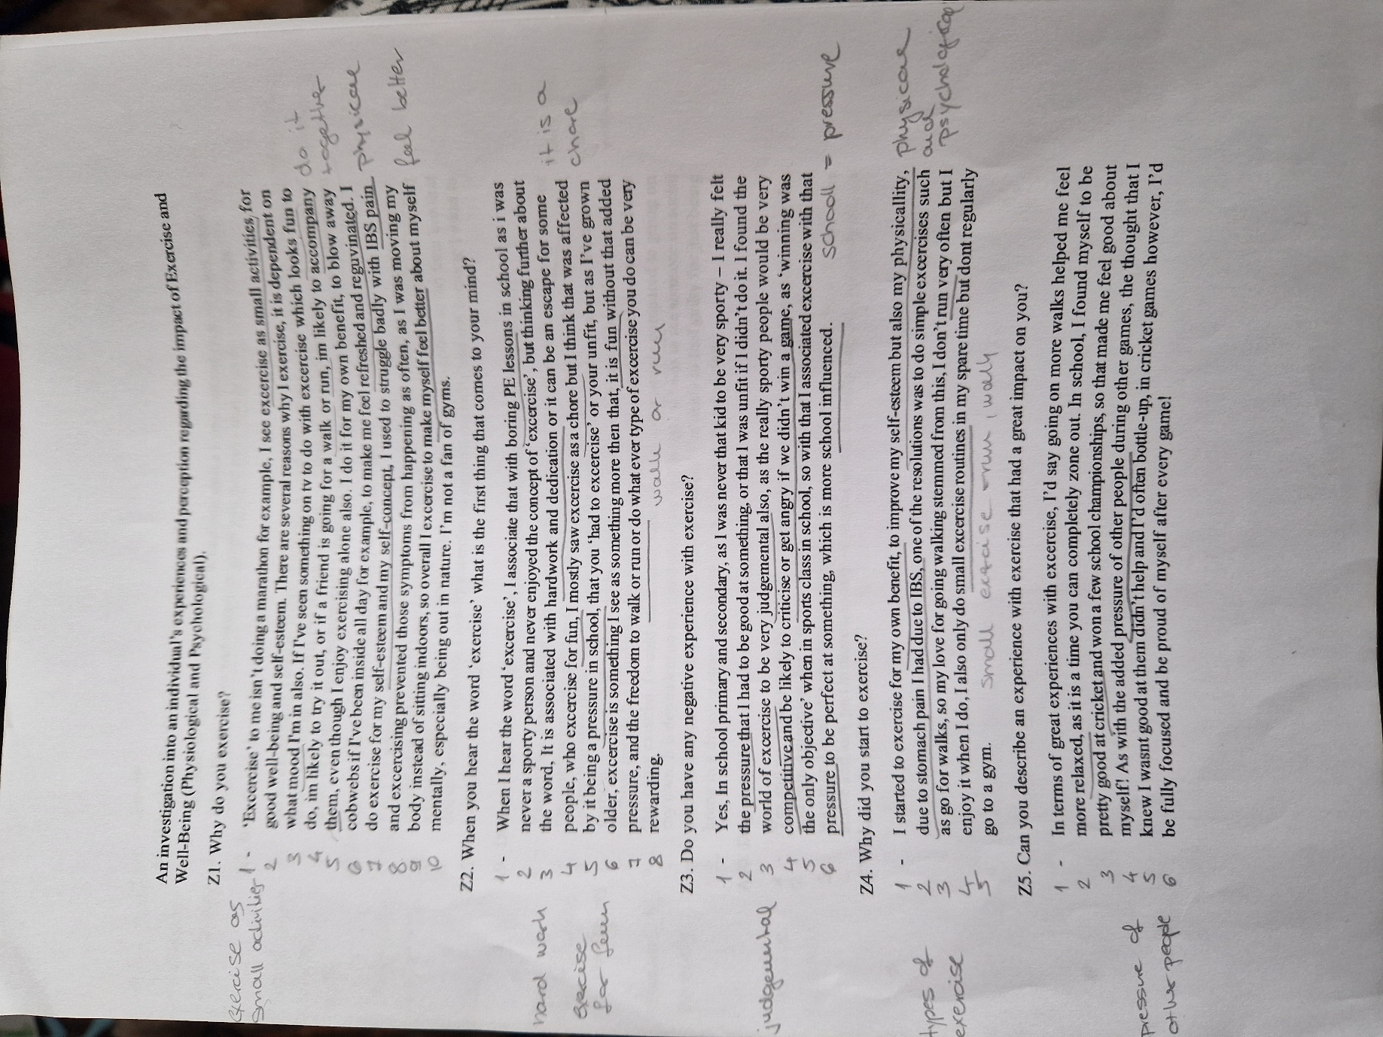

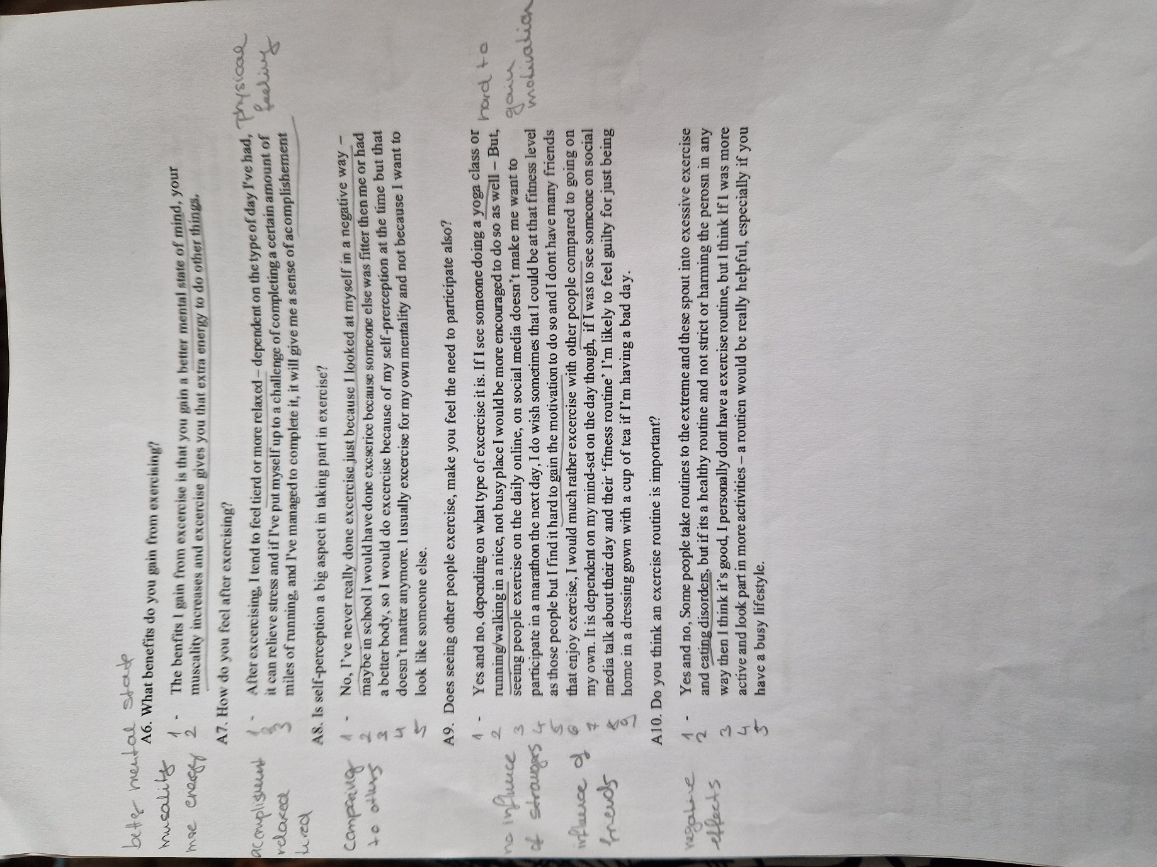
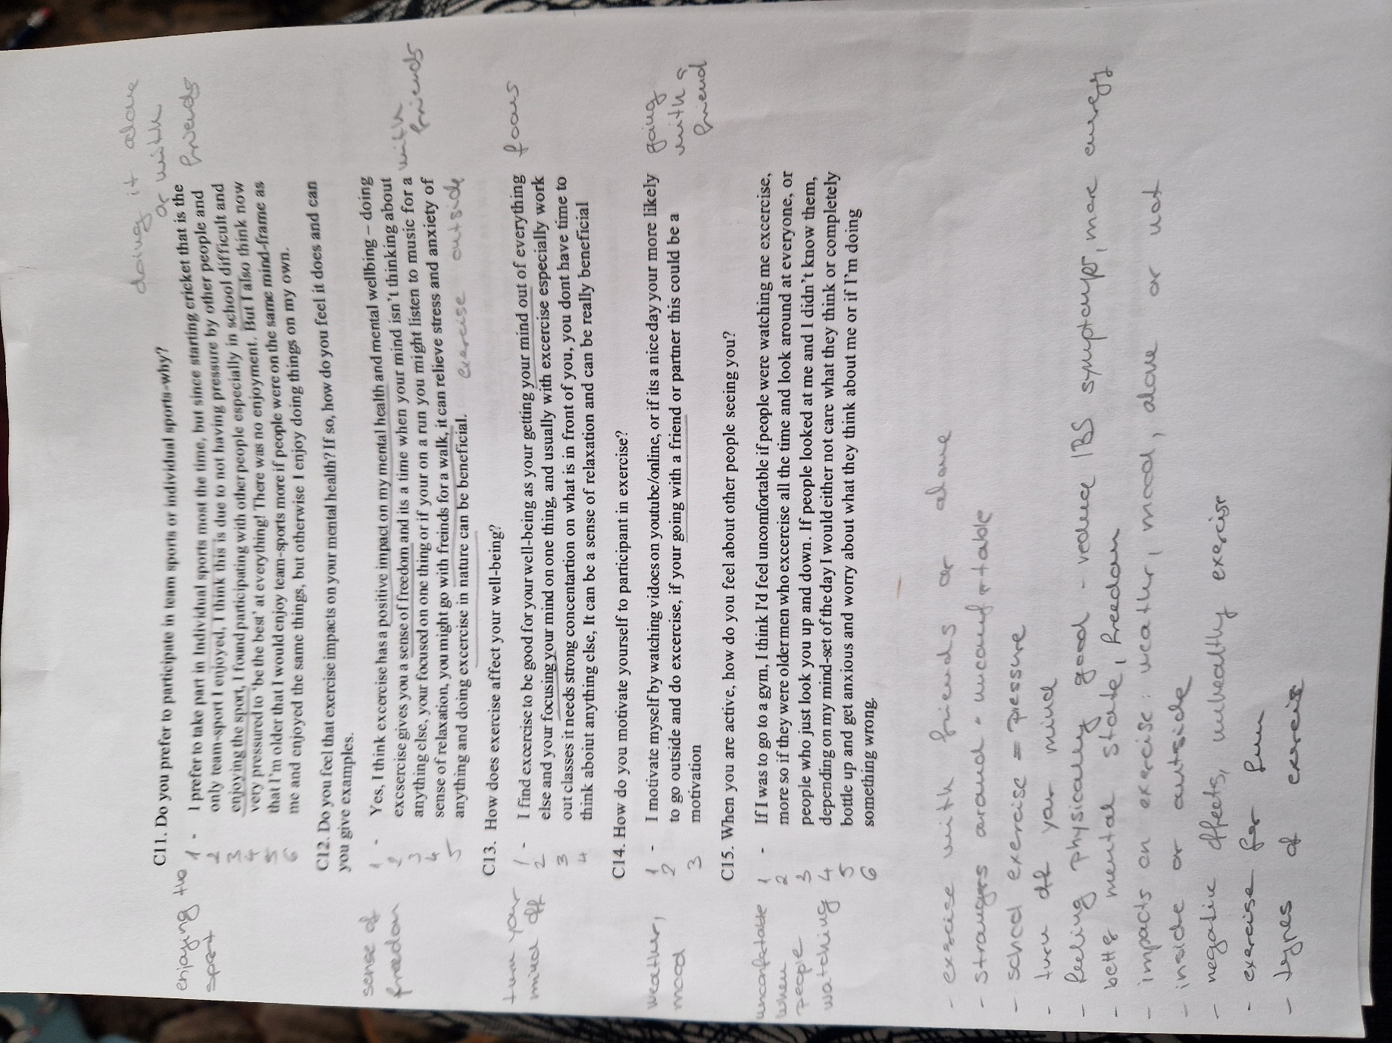
Appendix 4 – Procedure
A thematic analysis was carried out on an open-ended questionnaire. Thematic analysis is used on qualitative data to identify patterns of meaning and themes (Clarke, 2017). The researcher had to choose one of the given topics and write a questionnaire that included 15 questions regarding the topic. The first phase of thematic analysis is the familiarization phase during which the researcher read the answers twice and wrote down the initial thoughts about the dataset. These included how the participant felt about exercise in school and how much they prefer exercise like walking or running with friends and outdoors. It was also noticeable that the participant chose to exercise because of the psychological benefits. The next phase was the coding phase during which the researcher wrote down the identified codes next to the answers on paper. Codes are the smallest analytical units and are to help to identify relevant information in the dataset that are connected to the research question (Clarke, 2017). The researcher also numbered the lines under each question so it can be referred to by question number and the number of the line. Through the second coding, the researcher eliminated codes that appeared more than once and pulled similar codes together. After this, the researcher put the codes in groups by meaning to create themes that are the framework of the thematic analysis. Finally, the themes have been reviewed making sure that they do not overlap. The themes were named following the research question.
Limitations of the study included that there was only one participant who might not reflect everyone's opinion on exercise and regarding the questions but it showcases the importance of personal differences in experiences and perception. Also, the questions have been written by the researcher without utilising any existing questionnaire but it can be used as a pilot study for further research. The researcher made sure that the study was anonymous and that no identifying data would be stored. The completed questionnaire have been stored confidentially and no access been given to any other personnel. The researcher have been aware that the questions might trigger negative emotions so they made sure the participants have been verbally informed of the nature of the study beforehand.

Appendix 5 – Ethics form
APPLICATION FOR ETHICAL APPROVAL

RESEARCH STUDENTS
This form is to be completed by the student within SIX months for full-time students and TWELVE months for part time students, after the commencement of the research degree or following progression to Part Two of your course.

Once complete, submit this form via the MyTSD Doctoral College Portal at (https://mytsd.uwtsd.ac.uk).

This document is also available in Welsh.

RESEARCH STAFF ONLY
All communications relating to this application during its processing must be in writing and emailed to pgresearch@uwtsd.ac.uk , with the title ‘Ethical Approval’ followed by your name.

STUDENTS ON UNDERGRADUATE OR TAUGHT MASTERS PROGRAMMES should submit this form (and receive the outcome) via systems explained to you by the supervisor/module leader.

In order for research to result in benefit and minimise risk of harm, it must be conducted ethically. A researcher may not be covered by the University’s insurance if ethical approval has not been obtained prior to commencement.

The University follows the OECD Frascati manual definition of research activity: “creative work undertaken on a systematic basis in order to increase the stock of knowledge, including knowledge of man, culture and society, and the use of this stock of knowledge to devise new applications”. As such this covers activities undertaken by members of staff, postgraduate research students, and both taught postgraduate and undergraduate students working on dissertations/projects.

The individual undertaking the research activity is known as the “principal researcher”.

Ethical approval is not required for routine audits, performance reviews, quality assurance studies, testing within normal educational requirements, and literary or artistic criticism.

Please read the notes for guidance before completing ALL sections of the form.

This form must be completed and approved prior to undertaking any research activity. Please see Checklist for details of process for different categories of application.

SECTION A: About You (Principal Researcher)
1 | Full Name: |  | Zsuzsanna Telekesi
2 | Tick all boxes that apply: |  | Member of staff: | ☐ | Honorary research fellow: | ☐
 | Undergraduate Student | ☒ | Taught Postgraduate Student | ☐ | Postgraduate Research Student | ☐

3 | Institute/Academic Discipline/Centre: | Psychology and Counselling
4 | Campus: | Carmarthen
5 | E-mail address: | 2203653@student.uwtsd.ac.uk
6 | Contact Telephone Number: | 07598371458
 | For students:
7 | Student Number: | 2203653
8 | Programme of Study: | Bsc Applied Psychology
9 | Director of Studies/Supervisor: | Dr Stuart Jones

SECTION B: Approval for Research Activity
1 | Has the research activity received approval in principle?  (please check the Guidance Notes as to the appropriate approval process for different levels of research by different categories of individual) |  | YES | ☐ | NO | ☐
 |  |  |  |  | Date
2 | If Yes, please indicate source of approval (and date where known): Approval in principle must be obtained from the relevant source prior to seeking ethical approval | Research Degrees Committee |  | ☐
2 |  | Institute Research Committee |  | ☐
2 |  | Other (write in) |  | ☐

SECTION C: Internal and External Ethical Guidance Materials
 | Please list the core ethical guidance documents that have been referred to during the completion of this form (including any discipline-specific codes of research ethics, location-specific codes of research ethics, and also any specific ethical guidance relating to the proposed methodology). Please tick to confirm that your research proposal adheres to these codes and guidelines. You may add rows to this table if needed.
1 | UWTSD Research Ethics & Integrity Code of Practice | ☒
2 | UWTSD Research Data Management Policy | ☒
3 | [List any other relevant documents here] | ☐

SECTION D: External Collaborative Research Activity
If there are external collaborators then you should gain consent from the contact persons to share their personal data with the university. If there are no external collaborators then leave this section blank and continue to section E.
1 | Institution
2 | Contact person name
3 | Contact person e-mail address
4 | Is your research externally funded? |  | YES | ☐ | NO |  | ☐
5 | Are you in receipt of a KESS scholarship? |  | YES | ☐ | NO |  | ☐
6 | Are you specifically employed to undertake this research in either a paid or voluntary capacity? | Voluntary | YES | ☐ | NO | ☐
7 |  | Employed | YES | ☐ | NO | ☐
8 | Is the research being undertaken within an existing UWTSD Athrofa Professional Learning Partnership (APLP)? | If YES then the permission question below does not need to be answered. | YES | ☐ | NO |  | ☐
9 | Has permission to undertake the research has been provided by the partner organisation? | (If YES attach copy)  If NO the application cannot continue | YES | ☐ | NO |  | ☐

Where research activity is carried out in collaboration with an external organisation
10 | Does this organisation have its own ethics approval system? | YES | ☐ | NO | ☐
 | If Yes, please attach a copy of any final approval (or interim approval) from the organisation (this may be a copy of an email if appropriate).

SECTION E: Details of Research Activity
1 | Indicative title: | An investigation into an individual’s experiences and perception regarding the impact of Exercise and Well-Being (Physiological and Psychological).
2 | Proposed start date: | 26/02/2024 | Proposed end date: | 03/03/2024
Introduction to the Research (maximum 300 words per section)
Ensure that you write for a Non-Specialist Audience when outlining your response to the points below:
- Purpose of Research Activity
- Proposed Research Question
- Aims of Research Activity
- Objectives of Research Activity
Demonstrate, briefly, how Existing Research has informed the proposed activity and explain
- What the research activity will add to the body of knowledge
- How it addresses an area of importance.
3 | Purpose of Research Activity  For Level Five Applied Psychology students to complete a qualitative report as part of their assessment for the Sports and Health module. This will be an online questionnaire where one participant from the class will participate. Following participation in the task students will run a thematic analysis, analyse the data and write up the results using the APA report writing format.  The study is based on the following literature. Trajković et al. (2023) review highlighted several studies that explored the experiences of individual's impacts of exercise and the benefits they gained from participation (Trajković et al., 2023). Jan Freddy Hovland et al (2023) conducted a study that explored how physical activity affects young adults with serious mental illness (SMI) and how these experiences affect how they perceive their own health and well-being. Their results suggested that engaging in physical activity is mostly seen by those with SMI as a meaningful activity that enhances their sense of wellbeing and improves their health. In continuation, this study demonstrates the value of adapted physical exercise as a resistive resource that can support enhanced mental health, social engagement, and a stronger sense of self, all of which can lead to a better capacity to handle stress (Jan Freddy Hovland et al., 2023).  In relation to self-perception regarding exercise, Edwards et al., (2005) examined the physical and mental well-being of individuals who participate in sports, exercise, and other physical activities on a regular basis with a control group of non-participants. The main conclusions were that people who regularly exercised felt more in control of their own purpose, personal development, environmental mastery, positive interpersonal relationships, acceptance of who they are, proficiency in their sport, and conditioning than people who did not exercise. Compared to non-exercisers, regular exercisers also placed a higher value on strength, conditioning, sport, and physical appearance (Edwards et al., 2005). There is a large range of research within this topic, however, it does focus more on the psychological benefits rather than self-perceptions and how exercise makes people feel as a person.  Consequently, the aim of the research is for the students to participate in someone from their class’ study and independently analyse that individual's data from the questionnaire.  Reference list  Edwards, S., Ngcobo, H., Edwards, D., Palavar, K. (2005, January 1). Exploring the Relationship Between Physical Activity, Psychological Well-being and Physical Self-Perception in Different Exercise Groups. Sabinet African Journals. https://journals.co.za/doi/abs/10.10520/EJC108797  Jan Freddy Hovland, Langeland, E., Ness, O., & Bente Ovedie Skogvang. (2023). Experiences With Physical Activity, Health and Well-being Among Young Adults with Serious Mental Illness. International Journal of Qualitative Studies on Health and Well-Being, 18(1). https://doi.org/10.1080/17482631.2023.2221911  Trajković, N., Mitic, P., Baric, P., Bogataj, S. (2023, January 18). Effects of Physical Activity on Psychological Well-being. Frontiers in Psychology. https://www.frontiersin.org/journals/psychology/articles/10.3389/fpsyg.2023.1121976/full  ‌  (this box should expand as you type)
4 | Research Question  What are the positive and negative impacts of exercise on physical and psychological well-being?  (this box should expand as you type)
5 | Aims of Research Activity  For a level 5 Applied Psychology student to carry out a study as part of their assessment with the aim to investigate the effects of exercise on physical and psychological well-being.  (this box should expand as you type)
6 | Objectives of Research Activity  As part of their assessment level 5 Applied psychology student required to write up a qualitative report. The students will participate in another student’s study and analyse the data independently.  Through the study the student will analyse the data and explore the effects of exercise on physical and psychological well-being.  (this box should expand as you type)
Proposed methods (maximum 600 words) Alisha
Provide a brief summary of all the methods that may be used in the research activity, making it clear what specific techniques may be used. If methods other than those listed in this section are deemed appropriate later, additional ethical approval for those methods will be needed. You do not need to justify the methods here, but should instead describe how you intend to collect the data necessary for you to complete your project.

7 | This study is done through a qualitative method of a questionnaire which is emailed to the participant to be completed, The participant will receive the information sheet, containing all information needed surrounding the study and consent form, at this stage the participant will make the researcher aware if they would like to take part or not, if not, the choice to withdraw is available. These will then be sent back to the researcher, the documents will be stored on a password protected computer in aid of confidentiality. If consent is given, the participant will have access to the questionnaire. The quesstionnaire involves answering fifteen open ended questions about the psychological and physiological impact exercise may have on a person. Once the questionnaire is completed, and results are sent to the researcher. Results will be analysed through a thematic analysis. Firstly, through this process, familiarisation with the transcripts of the questionnaire will be done, followed by coding the text to identify patterns in the data in order to group familiar responses together, continued by searching for themes in the text which is done by clustering key codes together to create key patterns in the data, once that stage is completed the review of the themes is done, this is completed by the researcher assessing the themes in the text to assure that they fit with the coded and entire data set. Once themes are identified, they are named and defined within a thematic analysis report (Clarke et al 2016) the report will highlight all the key processess through out the analyse and key themes and codes will be prominant.  Reference list  Braun, V., Clarke, V., & Weate, P. (2016). Using thematic analysis in sport and exercise research. Routledge handbook of qualitative research in sport and exercise, 1, 191-205.  (this box should expand as you type)
Location of research activity
Identify all locations where research activity will take place.

8 | All research activity needed for this study will be done online.  (this box should expand as you type)
Research activity outside of the UK
If research activity will take place overseas, you are responsible for ensuring that local ethical considerations are complied with and that the relevant permissions are sought. Specify any local guidelines (e.g. from local professional associations/learned societies/universities) that exist and whether these involve any ethical stipulations beyond those usual in the UK (provide details of any licenses or permissions required). Also specify whether there are any specific ethical issues raised by the local context in which the research activity is taking place, for example, particular cultural and/or legal sensitivities or vulnerabilities of participants. If you live in the country where you will do the research then please state this.
9 | (this box should expand as you type)

10 | Use of documentation not in the public domain: Are any documents NOT publicly available? | NO | ☒
10 |  | YES | ☐
11 | If Yes, please provide details here of how you will gain access to specific documentation that is not in the public domain and that this is in accordance with the current data protection law of the country in question and that of England and Wales.  (this box should expand as you type)

 | Does your research relate to one or more of the seven aims of the Well-being of Future Generations (Wales) Act 2015? | YES | NO
12 | A prosperous Wales | ☐ | ☐
13 | A resilient Wales | ☐ | ☐
14 | A healthier Wales | ☐ | ☐
15 | A more equal Wales | ☐ | ☐
16 | A Wales of cohesive communities | ☐ | ☐
17 | A Wales of vibrant culture and thriving Welsh language | ☐ | ☐
18 | A globally responsible Wales | ☐ | ☐
19 | If YES to any of the above, please give details:
 | (this box should expand as you type)

SECTION F: Scope of Research Activity
 | Will the research activity include: | YES | NO
1 | Use of a questionnaire or similar research instrument? | ☒ | ☐
2 | Use of interviews? | ☐ | ☒
3 | Use of focus groups? | ☐ | ☒
4 | Use of participant diaries? | ☐ | ☒
5 | Use of video or audio recording? | ☐ | ☒
6 | Use of computer-generated log files? | ☐ | ☒
7 | Participant observation with their knowledge? | ☐ | ☒
8 | Participant observation without their knowledge? | ☐ | ☒
9 | Access to personal or confidential information without the participants’ specific consent? | ☐ | ☒
10 | Administration of any questions, test stimuli, presentation that may be experienced as physically, mentally or emotionally harmful / offensive? | ☐ | ☒
11 | Performance of any acts which may cause embarrassment or affect self-esteem? | ☐ | ☒
12 | Investigation of participants involved in illegal activities? | ☐ | ☒
13 | Use of procedures that involve deception? | ☐ | ☒
14 | Administration of any substance, agent or placebo? | ☐ | ☒
15 | Working with live vertebrate animals? | ☐ | ☒
16 | Procedures that may have a negative impact on the environment? | ☐ | ☒
17 | Other primary data collection methods. Please indicate the type of data collection method(s) below. | ☐ | ☒
 | Details of any other primary data collection method:  (this box should expand as you type) | ☐ | ☒
If NO to every question, then the research activity is (ethically) low risk and may be exempt from some of the following sections (please refer to Guidance Notes).

If YES to any question, then no research activity should be undertaken until full ethical approval has been obtained.

SECTION G: Intended Participants
If there are no participants then do not complete this section, but go directly to section H.

 | Who are the intended participants: | YES | NO
1 | Students or staff at the University? | ☒ | ☐
2 | Adults (over the age of 18 and competent to give consent)? | ☒ | ☐
3 | Vulnerable adults? | ☐ | ☒
4 | Children and Young People under the age of 18? (Consent from Parent, Carer or Guardian will be required) | ☐ | ☒
5 | Prisoners? | ☐ | ☒
6 | Young offenders? | ☐ | ☒
7 | Those who could be considered to have a particularly dependent relationship with the investigator or a gatekeeper? | ☐ | ☒
8 | People engaged in illegal activities? | ☐ | ☒
9 | Others. Please indicate the participants below, and specifically any group who may be unable to give consent. | ☐ | ☒
 | Details of any other participant groups:  (this box should expand as you type) | ☐ | ☒

Participant numbers and source
Provide an estimate of the expected number of participants. How will you identify participants and how will they be recruited?
10 | How many participants are expected? | One participant.  (this box should expand as you type)
11 | Who will the participants be? | The participant will be a level 5 Bsc Applied Psychology student from University of Wales Trinity Saint David.  (this box should expand as you type)
12 | How will you identify the participants? | A random level 5 Bsc Applied Psychology student will be asked to take part in the study. As there will be only one participant no further identification needed.  (this box should expand as you type)

 | Information for participants: | YES | NO | N/A
13 | Will you describe the main research procedures to participants in advance, so that they are informed about what to expect? | ☒ | ☐ | ☐
14 | Will you tell participants that their participation is voluntary? | ☒ | ☐ | ☐
15 | Will you obtain written consent for participation? | ☐ | ☒ | ☐
16 | Will you explain to participants that refusal to participate in the research will not affect their treatment or education (if relevant)? | ☒ | ☐ | ☐
17 | If the research is observational, will you ask participants for their consent to being observed? | ☐ | ☐ | ☒
18 | Will you tell participants that they may withdraw from the research at any time and for any reason? | ☒ | ☐ | ☐
19 | With questionnaires, will you give participants the option of omitting questions they do not want to answer? | ☒ | ☐ | ☐
20 | Will you tell participants that their data will be treated with full confidentiality and that, if published, it will not be identifiable as theirs? | ☒ | ☐ | ☐
21 | Will you debrief participants at the end of their participation, in a way appropriate to the type of research undertaken? | ☒ | ☐ | ☐
22 | If NO to any of above questions, please give an explanation
No written consent will be obtained as the questionnaire will be sent out by email along with the information sheet and consent form that will state that filling out the questionnaire and sending it back to the researcher means the participant gives consent.

(this box should expand as you type)

 | Information for participants: | YES | NO | N/A
24 | Will participants be paid? | ☐ | ☒ | ☐
25 | Is specialist electrical or other equipment to be used with participants? | ☐ | ☒ | ☐
26 | Are there any financial or other interests to the investigator or University arising from this study? | ☐ | ☒ | ☐
27 | Will the research activity involve deliberately misleading participants in any way, or the partial or full concealment of the specific study aims? | ☐ | ☒ | ☐
28 | If YES to any question, please provide full details
 | (this box should expand as you type)

SECTION H: Anticipated Risks

Outline any anticipated risks that may adversely affect any of the participants, the researchers and/or the University, and the steps that will be taken to address them.

If you have completed a full risk assessment (for example as required by a laboratory, or external research collaborator) you may append that to this form.
1 | Full risk assessment completed and appended? |  | Yes | ☐
1 |  |  | No | ☐
2 | Risks to participants  For example: sector-specific health & safety, emotional distress, financial disclosure, physical harm, transfer of personal data, sensitive organisational information
 | Risk to participants:  - Participant may be concerned with having to complete a questionnaire on their experience with exercise and well-being.  - The participant disclosing information about their well being and experience with exercise might trigger a negative emotion if they had a negative experience before (e.g. been bullied in a gym)  - Due to the nature of the task the participant might feel they have no choice but to take part in the study.  (this box should expand as you type) | How you will mitigate the risk to participants:  - The participant will be made aware of the nature of the study and that it involves completing a questionnaire on their experience with exercise and their wellbeing. This will happen before agreeing to take part in the study. The researcher will also inform the participant that the data will be anonymised and no identifying features will be stored.  - The participant will be made aware of the nature of the study and that it involves completing a questionnaire on their experience with exercise and their wellbeing. This will happen before agreeing to take part in the study. The researcher will also inform the participant that the data will be anonymised and no identifying features will be stored.  - The researcher will clearly verbalise information prior to the collection of the data to reassure that no coercion is involved. The student will be informed that taking part in the study will have no effect on their academic progress and there is no right or wrong answers to the questions. This will be also noted in the debrief form.  (this box should expand as you type)
3 | If research activity may include sensitive, embarrassing or upsetting topics (e.g. sexual activity, drug use) or issues likely to disclose information requiring further action (e.g. criminal activity), give details of the procedures to deal with these issues, including any support/advice (e.g. helpline numbers) to be offered to participants. Note that where applicable, consent procedures should make it clear that if something potentially or actually illegal is discovered in the course of a project, it may need to be disclosed to the proper authorities
N/A - See point 2.

(this box should expand as you type)
4 | Risks to the investigator  For example: personal health & safety, physical harm, emotional distress, risk of accusation of harm/impropriety, conflict of interest
 | Risk to the investigator:  - Risks to the investigator could be emotional distress while reading the answers (e.g. negative experience with exercise).  (this box should expand as you type) | How you will mitigate the risk to the investigator:  - The researcher has options to choose from for the topic of their study. The researcher will choose a topic they feel comfortable working on, and they will be fully aware it can have answers that shows negative experience.  (this box should expand as you type)
5 | University/institutional risks  For example: adverse publicity, financial loss, data protection
 | Risk to the University:  - The reputation and integrity of UWTSD and the discipline of Psychology and Counselling could be endangered if the researcher or the participant do not adhere to codes of ethics and research protocols.  - The data could be exposed, leaked or used for other purposes.  (this box should expand as you type) | How you will mitigate the risk to the University:  - The University Ethics and Integrity Code of Practice and the BPS Code of Ethics and Conduct and the Code of Human Research Ethics will be followed by both the researcher and participant at every stage of the study.  - The collected data will be stored in an anonymised format in accordance with UWTSD Research Data Management rules and only used for the purpose of the proposed study. The data will be stored securely by the researcher.  (this box should expand as you type)
6 | Environmental risks  For example: accidental spillage of pollutants, damage to local ecosystems
 | Risk to the environment:  N/A  (this box should expand as you type) | How you will mitigate the risk to environment:  N/A  (this box should expand as you type)

 | Disclosure and Barring Service
 | If the research activity involves children or vulnerable adults, a Disclosure and Barring Service (DBS) certificate must be obtained before any contact with such participants. | YES | NO | N/A
7 | Does your research require you to hold a current DBS Certificate? | ☐ | ☐ | ☒
8 | If YES, please give the certificate number. If the certificate number is not available please write “Pending”; in this case any ethical approval will be subject to providing the appropriate certificate number.

SECTION I: Feedback, Consent and Confidentiality

1 | Feedback  What de-briefing and feedback will be provided to participants, how will this be done and when?
In line with the BPS ethics guidelines the participant will receive a debrief form after completing the questionnaire. This will provide more information about the study including the aims and the research question. The researcher and supervisor’s contact details will be included if the participants have any concerns or questions after participating in the study.

(this box should expand as you type)
2 | Informed consent  Describe the arrangements to inform potential participants, before providing consent, of what is involved in participating. Describe the arrangements for participants to provide full consent before data collection begins. If gaining consent in this way is inappropriate, explain how consent will be obtained and recorded in accordance with prevailing data protection legislation.
As the study is part of a module assessment the students have been advised to participate in each other studies. The researcher will ask for verbal consent beforehand and will also provide the participant with a consent form that states that filling out the questionnaire and sending it to back to the researcher means the participant consent to take part of the study. The researcher will verbalise that participating in the study has no impact on the participant’s academic progress, they have the right to withdraw their data in the next 24 hours after completing the study.

(this box should expand as you type)
3 | Confidentiality / Anonymity  Set out how anonymity of participants and confidentiality will be ensured in any outputs. If anonymity is not being offered, explain why this is the case.
The participant will not be asked to provide their names or any other personal information that could identify them.

(this box should expand as you type)

SECTION J: Data Protection and Storage

 | Does the research activity involve personal data (as defined by the General Data Protection Regulation 2016 “GDPR” and the Data Protection Act 2018 “DPA”)? | YES | NO
1 | “Personal data” means any information relating to an identified or identifiable natural person (‘data subject’). An identifiable natural person is one who can be identified, directly or indirectly, in particular by reference to an identifier such as a name, an identification number, location data, an online identifier or to one or more factors specific to the physical, physiological, genetic, mental, economic, cultural or social identity of that natural person. Any video or audio recordings of participants is considered to be personal data. | ☐ | x
 | If YES, provide a description of the data and explain why this data needs to be collected:
2 | (this box should expand as you type)
 | Does it involve special category data (as defined by the GDPR)? | YES | NO
3 | “Special category data” means sensitive personal data consisting of information as to the data subjects’ –  (a) racial or ethnic origin,  (b) political opinions,  (c ) religious beliefs or other beliefs of a similar nature,  (d) membership of a trade union (within the meaning of the Trade Union and Labour Relations (Consolidation) Act 1992),  (e) physical or mental health or condition,  (f) sexual life,  (g) genetics,  (h) biometric data (as used for ID purposes), | ☐ | x
 | If YES, provide a description of the special category data and explain why this data needs to be collected:
4 | (this box should expand as you type)

 | Will data from the research activity (collected data, drafts of the thesis, or materials for publication) be stored in any of the following ways? | YES | NO
5 | Manual files (i.e. in paper form)? | ☐ | ☒
6 | University computers? | ☐ | ☒
7 | Private company computers? | ☐ | ☒
8 | Home or other personal computers? | ☐ | ☒
9 | Laptop computers/ CDs/ Portable disk-drives/ memory sticks? | ☒ | ☐
10 | “Cloud” storage or websites? | ☒ | ☐
11 | Other – specify: | ☐ | ☒
12 | For all stored data, explain the measures in place to ensure the security of the data collected, data confidentiality, including details of backup procedures, password protection, encryption, anonymisation and pseudonymisation:
Data collection will happen via a questionnaire in a word document. No names or any other identifying data will be collected therefore the data will be anonymous. The document will be stored on a personal laptop that is password protected and only the researcher has access to. The report will be stored on a personal laptop and on One Drive. The laptop and the One Drive account are both password protected and only the researcher has access to them.
(this box should expand as you type)

 | Data Protection
 | Will the research activity involve any of the following activities: | YES | NO
13 | Electronic transfer of data in any form? | ☒ | ☐
14 | Sharing of data with others at the University outside of the immediate research team? | ☐ | ☒
15 | Sharing of data with other organisations? | ☐ | ☒
16 | Export of data outside the UK or importing of data from outside the UK? | ☐ | ☒
17 | Use of personal addresses, postcodes, faxes, emails or telephone numbers? | ☐ | ☒
18 | Publication of data that might allow identification of individuals? | ☐ | ☒
19 | Use of data management system? | ☐ | ☒
20 | Data archiving? | ☐ | ☒
21 | If YES to any question, please provide full details, explaining how this will be conducted in accordance with the GDPR and Data Protection Act (2018) (and any international equivalents, where appropriate):
The participant will be required to send the completed questionnaire back to the researcher via email. The document will be saved under the name ‘completed questionnaire’ to the researcher’s personal laptop and their Student One Drive account. It will have no indication about any of the participant’s personal data. No name or any other demographic information will be recorded.

(this box should expand as you type)
22 | List all who will have access to the data generated by the research activity:
Only the researcher will have access to the data.

(this box should expand as you type)
23 | List who will have control of, and act as custodian(s) for, data generated by the research activity:
The researcher.

(this box should expand as you type)
24 | Give details of data storage arrangements, including security measures in place to protect the data, where data will be stored, how long for, and in what form. Will data be archived – if so how and if not why not.
The researcher will store the data on a password protected laptop and password protected One Drive account.

(this box should expand as you type)
25 | Please indicate if your data will be stored in the UWTSD Research Data Repository (see https://researchdata.uwtsd.ac.uk/ ). If so please explain. (Most relevant to academic staff)
 | (this box should expand as you type)
26 | Confirm that you have read the UWTSD guidance on data management (see https://www.uwtsd.ac.uk/library/research-data-management/) | YES | ☒
27 | Confirm that you are aware that you need to keep all data until after your research has completed or the end of your funding | YES | ☒

SECTION K: Declaration
The information which I have provided is correct and complete to the best of my knowledge. I have attempted to identify any risks and issues related to the research activity and acknowledge my obligations and the rights of the participants.

In submitting this application I hereby confirm that I undertake to ensure that the above named research activity will meet the University’s Research Ethics and Integrity Code of Practice which is published on the website: https://www.uwtsd.ac.uk/research/research-ethics/
1 | Signature of applicant: |  | Date:

For STUDENT Submissions:
2 | Director of Studies/Supervisor: |  | Date:
3 | Signature: |  | Date:

For STAFF Submissions:
4 | Academic Director/ Assistant Dean: |  | Date:
5 | Signature: |  | Date:

Checklist: Please complete the checklist below to ensure that you have completed the form according to the guidelines and attached any required documentation:
☒ | I have read the guidance notes supplied before completing the form.
☒ | I have completed ALL RELEVANT sections of the form in full.
☒ | I confirm that the research activity has received approval in principle
☐ | I have attached a copy of final/interim approval from external organisation (where appropriate)
☐ | I have attached a full risk assessment (where appropriate) ONLY TICK IF YOU HAVE ATTACHED A FULL RISK ASSESSMENT
☒ | I understand that it is my responsibility to ensure that the above named research activity will meet the University’s Research Ethics and Integrity Code of Practice.
☒ | I understand that before commencing data collection all documents aimed at respondents (including information sheets, consent forms, questionnaires, interview schedules etc.) must be confirmed by the DoS/Supervisor, module tutor or Academic Director.

RESEARCH STUDENTS ONLY
Once complete, submit this form via the MyTSD Doctoral College Portal at (https://mytsd.uwtsd.ac.uk).

RESEARCH STAFF ONLY
All communications relating to this application during its processing must be in writing and emailed to pgresearch@uwtsd.ac.uk , with the title ‘Ethical Approval’ followed by your name.

STUDENTS ON UNDERGRADUATE OR TAUGHT MASTERS PROGRAMMES should submit this form (and receive the outcome) via systems explained to you by the supervisor/module leader.

Appendix 6 – Study information sheet, consent form and debrief form
Study Information Sheet
This document provides key information regarding the study and provides details about what will be expected of you as a participant. Therefore, please read this information carefully before providing consent to take part.
During this study you will be required to do the following:
· You will be taking part in a questionnaire study, focusing on the psychological and psychlogical impact excericise may have on a person
· You will be emailed the questionnaire, once consent is given to the researcher
· Once consent is given, you will be presented with a list of 15 open-ended questions regarding the psychological and psychiological impact of excercise
· You will be expected to give strong reasoning behind your answers to the questions, which will then be analysed through the process of thematic analysis
· Once all the questions are answered in full, it will be emailed back to the researcher
At the end of the study, a debrief sheet will be emailed to you after the compliation of the quesstionaire.
If you feel uncomfortable about any questioning of this subject surrounding excercise, you are advised not to take part in this study.
If you have any questions surrounding the study, please ask the researcher prior to taking part.
If you are happy to take part in this study, please continue to the consent form and read carefully

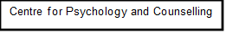

Study Consent Form
I understand that this research study is being carried out by a level 5 Applied Psychology Student for their assessment and that taking part in this study will involve filling out a questionnaire and sending it back to the researcher by email.

This questionnaire will take approximately 30 minutes to complete.

I understand that participation in this study is voluntary and I am free to withdraw participation during or at the end of the study without giving a reason. I understand that once I send the questionnaire back I will have 24 hours to withdraw my data. I am aware that if I have concerns about the study, I can discuss these concerns with the researcher at any time during or after the study. I understand that I will be provided with the contact details of the research supervisor at the end of the study, should I have any concerns.

I understand that the information I provide will be held confidentially and anonymously. These data will be stored till the researcher finishes writing up their report in accordance with the Data Protection Act.

I also understand that at the end of the study, I will be provided with a debrief form and the opportunity to discuss any issues with the researcher.

I understand that by filling out the questionnaire and sending it back to the researcher I give consent to the researcher to use the data provided by me.

Study Debrief Sheet
Study title: An investigation into an individual's experiences and perception regarding the impact of exercise and well-being?
Thank you for taking part in the study.
The aim of this study was to explore the experiences and perceptions of individuals regarding the impact of exercise and well-being. We specifically wanted to find out the effects of exercise on psycial and psychological well-being.
If you wish to withdraw your data from the study, you must tell the researcher now. After this, all your data will remain confidential, and we will not trace it back to you.
If taking part in this study has raised any questions, please speak to the researchers on or contact the academic supervisor – Stuart Jones s.a.jones@uwtsd.ac.uk
Thank you once again for taking time to participate in this study.
Zsuzsanna Telekesi
BSc Honours Applied Psychology Level 5 student
University of Wales Trinity Saint David, Carmarthen

